Sales and Inventory Analytics Database
RDBMS Course Project Report
Submitted by
Aditya Kashyap
Registration number
<REG_NO>
Supervisor
<SUPERVISOR_NAME>
Department
Department of Computer Science and Engineering
University
Manipal University Jaipur
October 2026

Abstract
This project designs a retail database and analytics application for products, inventory, suppliers, customers, employees, sales, and purchasing. A MySQL 8.0 transactional schema enforces key business rules through foreign keys, CHECK constraints, triggers, stored procedures, views, and role-based permissions. Python provides deterministic sample data, a pandas ETL pipeline to a small dimensional warehouse, monthly demand forecasts, and reorder suggestions. A Streamlit application presents the resulting sales, inventory, purchasing, forecast, and audit information. The design separates operational transactions from historical analysis, records price changes over time, and makes warehouse refreshes safe to repeat. A pytest integration suite targets a dedicated test database, and GitHub Actions supplies a MySQL 8.0 service for automated checks.
The report describes the business scope, user scenarios, requirements, relational design, warehouse grain, forecasting method, and implementation workflow. Registration number and supervisor details remain as placeholders for completion before submission.

Table of Contents
Abstract
Table of Contents
List of Figures
List of Tables
1 Introduction
2 Scope of the Work
3 Product Scenarios
4 Requirement Analysis
4.1 Functional requirements
4.2 Non-functional requirements
4.3 Use case scenarios
4.4 Software engineering methods
5 System Design
5.1 Design goals
5.2 System architecture
5.3 Detailed design
5.4 Schema and normalization
6 Conclusion
References
Appendix

List of Figures
Figure 1. Primary use cases
Figure 2. System architecture
Figure 3. Core transactional entity relationship diagram

List of Tables
Table 1. Included capabilities
Table 2. Product scenarios
Table 3. User scenarios
Table 4. Use case scenarios
Table 5. Core transactional schema
Table 6. Warehouse schema
Table 7. Analytics query outputs

1 Introduction

1.1 Background
Retail businesses coordinate sales, stock, suppliers, customers, and purchasing across many daily transactions. When these records are separated or updated manually, staff can lose track of available stock, sales totals, and products that need replenishment. A relational database provides a consistent place to validate transactions and preserve the relationships between these records.

1.2 Problem statement
The project addresses the need for a small, auditable retail information system that can record sales and purchases, protect stock levels, report business performance, and estimate future product demand. Operational data must remain accurate while still supporting historical questions that are easier to answer through a warehouse model.

1.3 Objectives
- Build a normalized MySQL schema for the retail transaction cycle.
- Enforce price, quantity, discount, and relationship rules in the database.
- Automate sales totals, inventory changes, price history, and low-stock alerts.
- Load reproducible data, analyze performance, and reconcile warehouse facts.
- Compare simple monthly forecasting methods and expose reorder guidance.
- Provide staff-facing pages and integration tests for database behavior.

2 Scope of the Work
The application covers retail master data, point-of-sale transactions, purchasing, inventory monitoring, reporting, warehouse loading, forecasting, and role-controlled database access. It is a course project designed for a single MySQL 8.0 server and a Python 3.10 or later environment.

2.1 Included capabilities
Area | Included work
Transactions | Products, categories, suppliers, customers, staff, inventory, purchase orders, sales orders, and line items.
Integrity | Foreign keys, positive-value checks, discount limits, triggers, and transactional stored procedures.
Analysis | Reporting views, sixteen SQL analyses, a date index demonstration, and rollup queries.
Analytics | A sales-line star schema, repeatable ETL, monthly demand comparison, and reorder suggestions.
Interface | Streamlit dashboard, inventory, sales, purchasing, forecast, and audit pages.
Quality | Dedicated MySQL test database, pytest integration coverage, and GitHub Actions CI.

Table 1. Included capabilities

2.2 Boundaries
The design does not include payment-gateway integration, multi-branch inventory, supplier delivery scheduling, tax filing, or production credential management. The forecasting model uses monthly unit demand and a linear time trend; it is a teaching baseline rather than an automated procurement guarantee.

3 Product Scenarios
Scenario | User action | System response
Checkout | A sales staff member selects a customer, product, quantity, discount, and payment mode. | The place_order procedure locks stock, rejects insufficient quantity, records a sale line, updates stock, and computes the order total.
Replenishment | An inventory manager reviews stock alerts and forecast-based reorder suggestions. | The system finds a lowest-price supplier, drafts a pending purchase order, and receives it once through a stored procedure.
Business review | An analyst reviews revenue, product ranking, category mix, and customer behavior. | SQL views and analytical queries summarize the transaction history.
Forecast refresh | An analyst runs ETL and monthly forecasting. | The warehouse is refreshed idempotently; two model forecasts and error measures are saved for each eligible product.

Table 2. Product scenarios

3.1 User scenarios
Actor | Primary goals
Sales staff | Place a valid order, check recent sales, and see product stock.
Inventory manager | Maintain products and supplier offers, inspect alerts, draft replenishment, and receive purchase orders.
Administrator | Review access, audit changes, and oversee reporting.
Analyst | Refresh warehouse facts, compare forecast errors, and inspect business trends.

Table 3. User scenarios

4 Requirement Analysis

4.1 Functional requirements
- Maintain category, product, supplier, supplier offer, customer, and employee records.
- Capture purchase orders and sale orders with item-level quantities and prices.
- Reject invalid prices, non-positive quantities, invalid discounts, and missing foreign keys.
- Create an inventory row and initial price-history version when a product is added.
- Record price changes and low-stock threshold crossings automatically.
- Place sales and receive purchases with atomic stock and status updates.
- Provide monthly sales, low-stock, ABC, and sixteen analytical query results.
- Build an idempotent warehouse, evaluate forecasts, and propose restocking.
- Allow Streamlit users to review data and invoke approved database procedures.

4.2 Non-functional requirements
- Integrity: InnoDB transactions, foreign keys, CHECK constraints, and row locks protect concurrent operations.
- Security: credentials come from environment variables or a gitignored .env file; SQL role passwords are placeholders that must be changed before use.
- Maintainability: SQL responsibilities are separated into schema, support, triggers, procedures, views, roles, and analytics files.
- Repeatability: seed randomness is fixed, warehouse loads use upserts, and scripts are written to be safely rerun.
- Portability: setup targets Windows PowerShell, Python 3.10+, and MySQL Server 8.0.
- Testability: integration checks use a separate retail_db_test database and CI supplies MySQL 8.0.

4.3 Use case scenarios
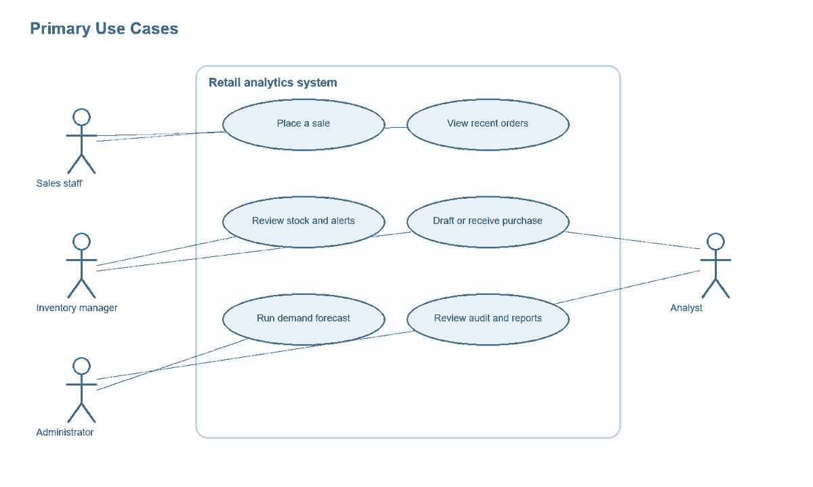
Figure 1. Primary use cases
Use case | Precondition | Main success flow | Failure handling
Place a sale | Customer, sales employee, product, and stock exist. | Call place_order; save order and line; trigger updates stock and total. | Insufficient stock or invalid inputs signal an error and roll back.
Receive purchase | Purchase order is PENDING and contains item lines. | Lock order, add ordered quantities to inventory, mark RECEIVED. | A second receipt is rejected without changing stock.
Draft replenishment | Forecast and supplier offers are available. | Choose cheapest supplier and insert a pending order with lines. | No order is created when all suggested quantities are zero.
Review audit | User has audit read access. | Display the most recent product price updates and values. | Database errors are displayed in a friendly app message.

Table 4. Use case scenarios

4.4 Software engineering methods
The project follows an incremental delivery plan. Each commit adds one logical layer, while the warehouse, forecasting, and application work are isolated on feature branches and integrated through merge commits. The test suite uses integration checks for transaction behavior and schema rules; GitHub Actions runs those checks against a MySQL 8.0 service. Version control protects the sequence of design decisions and implementation changes.

5 System Design

5.1 Design goals
- Keep operational facts and analytical aggregates separate.
- Put validation and atomic stock changes close to the stored data.
- Preserve price at sale time while keeping product history for later analysis.
- Make warehouse refreshes safe to repeat without duplicating order-line facts.
- Use small, explicit interfaces between SQL, Python processing, and Streamlit pages.

5.2 System architecture
The Streamlit app calls the shared Python database helper. MySQL retail_db stores current transactions, inventory, history, audit entries, alerts, and routines. Python ETL reads retail_db and populates retail_dw, where dimensional facts support historical analysis. Forecasting reads warehouse demand and stores predictions; purchasing suggestions connect the selected forecast back to current stock and supplier offers. GitHub Actions runs MySQL-backed tests.
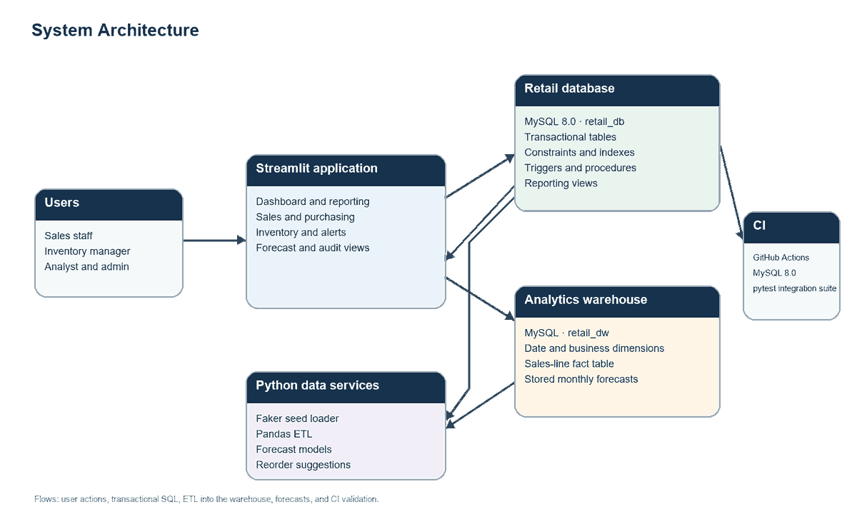
Figure 2. System architecture

5.3 Detailed design

Transactional schema
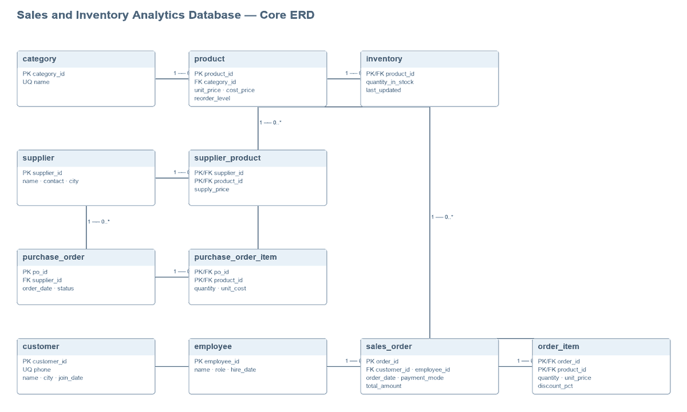
Figure 3. Core transactional entity relationship diagram
The core model contains eleven tables. Category-to-product is one-to-many. Inventory is a one-to-one extension of product. Supplier-product and the order-line tables resolve many-to-many relationships with composite keys. Sales and purchase headers retain their customer, employee, or supplier reference; item rows retain the transaction-specific quantity and price.
Table | Primary key | Purpose
category | category_id | Product grouping and unique category names.
supplier | supplier_id | Supplier contact and city details.
customer | customer_id | Customer identity, unique phone, city, and join date.
employee | employee_id | Staff identity, role, and hire date.
product | product_id | Category, retail price, cost price, and reorder level.
inventory | product_id | Current quantity and update timestamp.
supplier_product | supplier_id + product_id | Supplier offers and supply prices.
purchase_order | po_id | Supplier purchase header and status.
purchase_order_item | po_id + product_id | Purchase quantities and unit cost.
sales_order | order_id | Customer, staff, date, payment mode, and total.
order_item | order_id + product_id | Sales quantity, captured unit price, and discount.

Table 5. Core transactional schema

Supporting and analytical structures
The support tables hold SCD Type 2 product price history, product price audit events, and stock-threshold alerts. The warehouse uses dim_date, dim_product, dim_customer, and dim_employee with fact_sales at one sales-order-line grain. Fact measures are quantity, gross amount, discount, net amount, cost, and profit. A demand_forecast table stores both model predictions and holdout errors by product and forecast month.
Warehouse table | Role
dim_date | Calendar attributes for daily, monthly, quarterly, and yearly analysis.
dim_product | Product and category attributes used to group sales facts.
dim_customer | Customer identity and city for customer segmentation.
dim_employee | Sales employee and role for staff ranking.
fact_sales | One row per order line with keys and additive sales measures.
demand_forecast | Next-month product predictions, MAE, and MAPE by model.

Table 6. Warehouse schema

Normalization to third normal form
First normal form is supported by atomic values and one row per entity or transaction line. The purchase_order_item and order_item composite keys identify each product line within its parent transaction; repeating product lists are not stored in header columns. Second normal form is satisfied because each line attribute depends on the full composite key: quantity, unit cost, sale price, and discount describe that specific order-product pair. Third normal form is supported by keeping category names in category, supplier details in supplier, and customer and employee details in their own tables. Product rows reference category IDs rather than copying category descriptions, and order headers reference customer and employee IDs rather than copying their mutable attributes. The order total is a controlled transaction summary maintained by a trigger; it is not used as a substitute for the line facts.

Forecast and replenishment logic
Monthly demand is completed with zero-demand months. A three-month trailing mean is compared with scikit-learn linear regression in chronological order: the earliest 80 percent of observations train the model, while the latest 20 percent form the holdout. Mean absolute error is reported per product and model. Mean absolute percentage error excludes zero actual demand to avoid division by zero. Next-month predictions are clamped at zero. Safety stock uses 1.65 times recent monthly-demand standard deviation as a one-month lead-time buffer; suggested quantity is max(0, forecast + safety stock - current stock), rounded up to whole units. Pending purchase-order creation is opt-in.

Security and transaction boundaries
The database roles separate administrative, inventory, and sales access. Multi-step procedures begin a transaction, lock affected rows, and roll back and re-signal on SQL exceptions. The sales procedure captures the current price and creates one requested order line. The receiving procedure rejects any non-pending purchase order with the message “Purchase order already received”. Sample role passwords in roles.sql are placeholders and must be changed before use.

6 Conclusion
The project combines relational transaction design with a small analytical pipeline. Database constraints and routines protect sales and purchasing changes, while history and alerts preserve information needed by staff. A separate warehouse provides a clear order-line grain for reporting and forecast features. The Streamlit interface connects these database capabilities to common retail tasks, and the dedicated test database plus CI workflow provides a repeatable place to verify the design. Before academic submission, replace the registration and supervisor placeholders and run the full SQL, seed, ETL, forecasting, app, and CI workflow against a configured MySQL 8.0 environment.

References
[1] Oracle. MySQL 8.0 Reference Manual. https://dev.mysql.com/doc/refman/8.0/en/ (accessed 19 October 2026).
[2] Python Software Foundation. Python 3 Documentation. https://docs.python.org/3/ (accessed 19 October 2026).
[3] The pandas development team. pandas Documentation. https://pandas.pydata.org/docs/ (accessed 19 October 2026).
[4] scikit-learn developers. scikit-learn User Guide. https://scikit-learn.org/stable/user_guide.html (accessed 19 October 2026).
[5] Streamlit, Inc. Streamlit Documentation. https://docs.streamlit.io/ (accessed 19 October 2026).
[6] SQLAlchemy authors. SQLAlchemy Documentation. https://docs.sqlalchemy.org/ (accessed 19 October 2026).
[7] Faker contributors. Faker Documentation. https://faker.readthedocs.io/ (accessed 19 October 2026).

Appendix

A. Key SQL examples
The excerpts below show the principal integrity and transaction mechanisms. The complete definitions are in the repository SQL files.
CONSTRAINT chk_order_item_quantity CHECK (quantity > 0),
CONSTRAINT chk_order_item_discount CHECK (discount_pct BETWEEN 0 AND 100)
UPDATE inventory
SET quantity_in_stock = quantity_in_stock - NEW.quantity
WHERE product_id = NEW.product_id;
UPDATE sales_order
SET total_amount = total_amount
+ ROUND(NEW.quantity * NEW.unit_price * (1 - NEW.discount_pct / 100), 2)
WHERE order_id = NEW.order_id;
WITH monthly AS (
SELECT `month`, revenue FROM monthly_sales_summary
), lagged AS (
SELECT `month`, revenue, LAG(revenue) OVER (ORDER BY `month`) AS previous_month_revenue
FROM monthly
)
SELECT `month`, revenue, previous_month_revenue
FROM lagged ORDER BY `month`;

B. Analytics query outputs
The query pack returns the following result shapes. Values are produced from the database at execution time; the query set is designed to run after the deterministic seed script.
Query | Output columns
Monthly revenue and profit | month, orders, revenue, profit
Top products | product_id, name, net_revenue, units_sold
Category revenue | category, net_revenue
Top cities | city, orders, revenue
Above-average customers | customer_id, name, city, spend
Customer segments | customer_segment, customers
Salesperson ranking | employee_id, name, revenue, revenue_rank
Month-over-month growth | month, revenue, previous_month_revenue, growth_pct
Cumulative revenue | month, revenue, cumulative_revenue
Products bought together | product pair and orders_together
Cheapest supplier | product, supplier, supply_price
Slow movers | product_id, name, units_last_90_days, last_sold_at
Payment share | payment_mode, orders, revenue, order_share_pct
Category best seller | category_name, product_id, product_name, units_sold
ABC summary | abc_class, products, class_revenue
Low-stock list | product, stock, suggested_order_qty, cheapest_supplier

Table 7. Analytics query outputs

C. Validation commands
# Apply the transactional database scripts in order
mysql -u root -p < sql/schema.sql
mysql -u root -p < sql/support_tables.sql
mysql -u root -p < sql/triggers.sql
mysql -u root -p < sql/procedures.sql
mysql -u root -p < sql/views.sql
# Build the sample data and analytical outputs
python python/seed_data.py
python python/etl.py
python python/forecast.py
streamlit run python/app/main.py
pytest -q

