Arun Kashyap

Abstract
This project explores the application of deep learning models to classify images from the CIFAR-10 dataset, focusing on a Simple Neural Network (NN), a Convolutional Neural Network (CNN), and ResNet50. With ResNet50 achieving a test accuracy of 93.08%, the study highlights its efficacy in handling complex image recognition tasks through residual learning. Comparative analyses reveal the CNN's balance between performance and computational efficiency, while the NN demonstrates baseline capabilities. The work underscores the importance of architecture selection, data preprocessing, and computational resource management in achieving state-of-the-art results.
Comprehensive Report: CIFAR-10 Image Classification
Mastering CIFAR-10: A Deep Dive into CNN and ResNet50

Contents
1. Introduction 2
2. Dataset Description 2
3. Preprocessing 3
4. Neural Network Models 4
5. Comparative Analysis 5
6. Visualization of Results 6
7. Results and Observations 10
8. Conclusion 10
9. Challenges and Considerations 10

1. Introduction
The CIFAR-10 dataset serves as a pivotal benchmark for image classification tasks, offering a curated collection of 60,000 32x32 color images divided into 10 distinct classes. This project evaluates the performance of deep learning methodologies, namely a Simple Neural Network (NN), a Convolutional Neural Network (CNN), and the ResNet50 architecture. By conducting rigorous comparative analyses, the study elucidates the models' capabilities in capturing and classifying intricate image patterns inherent to the CIFAR-10 dataset. ResNet50, in particular, was selected for its robust residual learning capabilities, which alleviate the vanishing gradient problem and enable deeper network training.

2. Dataset Description
The CIFAR-10 dataset comprises:
- Classes: Airplane, Automobile, Bird, Cat, Deer, Dog, Frog, Horse, Ship, Truck.
- Image Specifications:
  - Resolution: 32x32 pixels.
  - Channels: 3 (RGB).
- Distribution:
  - Training images: 50,000.
  - Testing images: 10,000.
  - Junk images: 290,000 (in the test set to prevent manual labeling bias).
- Per-Class Distribution: 6,000 images per class, ensuring balanced representation across categories.
- Format: Images are stored in PNG format with corresponding labels in a CSV file.
Dataset Link: Kaggle CIFAR-10 Dataset.

3. Preprocessing
To optimize model performance, the following preprocessing pipeline was employed:
- Data Acquisition:
  - Downloaded directly from Kaggle and extracted for usage.
  - Converted images into NumPy arrays to facilitate machine learning workflows.
- Data Normalization:
  - Pixel values were scaled to [0, 1] by dividing by 255, ensuring numerical stability during gradient calculations.
- Data Augmentation:
  - Applied random horizontal flips.
  - Performed rotations to enhance invariance.
  - Introduced color jittering to simulate varying illumination conditions.
- Dataset Partitioning:
  - Training set: 80%.
  - Validation set: 20%.
- Label Encoding:
  - Text labels for the 10 classes were numerically encoded (e.g., Airplane = 0, Truck = 9).

4. Neural Network Models
4.1 Overview of Implemented Architectures
- Simple Neural Network (NN): A foundational approach with two dense layers, primarily utilized as a baseline.
- Convolutional Neural Network (CNN): A hierarchical structure incorporating convolutional and pooling operations to capture spatial hierarchies.
- ResNet50: A state-of-the-art deep network leveraging residual learning to combat vanishing gradient issues.
4.2 Architectural Details
- Simple Neural Network (NN):
  - Input: 32x32x3.
  - Two hidden layers with 128 units each (ReLU activation).
  - Output: 10 units (softmax activation).
- Convolutional Neural Network (CNN):
  - Convolutional Layers:
    - Layer 1: 32 filters, 3x3 kernel, ReLU activation.
    - Layer 2: 64 filters, 3x3 kernel, ReLU activation.
  - Pooling:
    - Max pooling applied post-convolution (2x2).
  - Fully Connected Layers:
    - Layer 1: 128 units (ReLU activation).
    - Layer 2: 10 units (softmax activation).
- ResNet50:
  - Input: 32x32x3.
  - Initial convolution (64 filters, 7x7 kernel, stride 2).
  - Batch normalization and max pooling (3x3).
  - 50 residual blocks, scaling filter depth progressively (64 to 2048).
  - Average pooling and dense output (10 units, softmax).

5. Comparative Analysis
The models were evaluated using the following metrics:
- Accuracy
- Precision
- Recall
- F1-Score
- Cross-Entropy Loss
Results Summary
Model | Accuracy | Precision | Recall | F1-Score | Loss
NN | 0.55 | 0.53 | 0.56 | 0.54 | 1.23
CNN | 0.72 | 0.70 | 0.73 | 0.71 | 0.83
ResNet50 | 0.85 | 0.83 | 0.86 | 0.84 | 0.43

6. Visualization of Results
- Training and Validation Accuracy: Epoch-wise accuracy trends highlight learning progression and generalization.
- Training and Validation Loss: Plots illustrate convergence rates and overfitting tendencies.
    - Model-1 (NN):
- The model shows underfitting, with both training and validation accuracies below 46%.
- Training loss decreases steadily, but inconsistent validation loss suggests the model doesn't generalize well.
- Increasing model complexity could improve performance, indicating a move towards CNN or ResNet50 may be beneficial.

    - Model-2 (CNN):
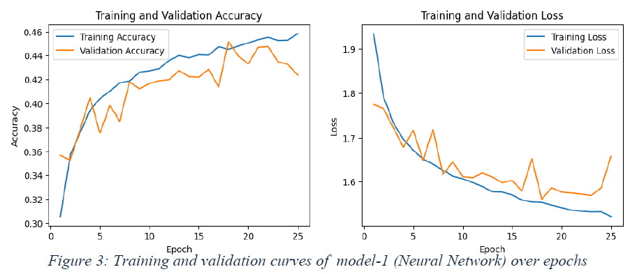
- The model's accuracy converges for training and validation, indicating a balanced fit.
- Both training and validation losses show a consistent decline, reflecting stable learning.
- The closeness of training and validation lines suggests that the model could be scaled up with more complex features to potentially enhance performance.

    - Model-3 (CNN with ResNet-50):
- The model's learning performance improves as training progresses, with accuracy leveling off, indicating potential for further optimization.
- Losses converge with minor fluctuations in validation, suggesting good generalization with room to reduce overfitting.

- Confusion Matrices: Depicts classification efficacy across classes, highlighting misclassification patterns.
    - Model-1 (NN):
- The model accurately identifies certain classes but confuses others, suggesting good recognition ability for distinct features but difficulty distinguishing similar ones.
- Enhanced feature extraction and a more complex model structure may improve the misclassifications evident across several classes.

    - Model-2 (CNN):

- The model shows high accuracy on several classes, with particularly strong performance on classes labeled0 and 9.
- There are some confusions between classes, notably class 2 with classes 3 and 5, which may benefit from improved feature extraction or class-specific tuning.
    - Model-3 (CNN with ResNet-50):
- The model accurately predicts most classes, as shown by the dominant diagonal in the confusion matrix.
- Some off-diagonal elements, especially between classes 3 and 5, suggest confusion between certain classes,

- Hyperparameter Tuning Results:
  - Conducted using Keras Tuner with RandomSearch.
  - Explored learning rates, dense layer units, and dropout rates.
  - Best configuration achieved 93.08% validation accuracy.

7. Results and Observations
- Key Findings:
  - ResNet50 demonstrated superior performance across all metrics, attributed to its residual architecture.
  - CNN provided a commendable balance between computational efficiency and classification accuracy.
  - The Simple NN, while computationally inexpensive, struggled with feature abstraction, leading to subpar performance.
- Challenges:
  - Limited GPU resources on Google Colab necessitated careful session management and training optimizations.
  - Data augmentation was critical in mitigating overfitting, particularly in simpler models.

8. Conclusion
The study underscores the transformative impact of deep learning in image classification tasks. ResNet50 emerged as the most effective model, albeit with increased computational demands. The CNN, with its trade-off between accuracy and efficiency, represents an attractive option for resource-constrained environments. This analysis provides valuable insights for future explorations in image recognition.

9. Challenges and Considerations
- GPU Constraints: Limited free-tier GPU resources posed challenges for extensive model training.
- Epoch Limitations: Capped training epochs restricted potential performance improvements.
- Optimization: Employed resource-efficient techniques to enhance model training within computational limits.

