**PIZZA SALES SQL QURIES**

1. **KPI’s**
2. **Total Revenue:**

select

SUM(total_price) As Total_Revenue

from pizza_sales;

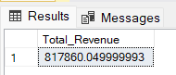

1. **Average Order Value**

select

count(Distinct order_id) As Total_Orders

from pizza_sales;

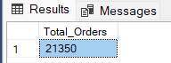

1. **Total Pizza Sold**

select

Sum(quantity) As Total_Pizza_Sold

from pizza_sales;

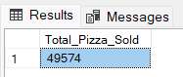

1. **Average order value**

select CAST(SUM(total_price) / count(Distinct order_id) As decimal(10,2)) As Average_Order_Value

from pizza_sales;

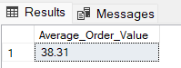

1. **Average Pizza Per Order**

select CAST(SUM(quantity) / CAST(count(Distinct order_id) AS decimal(10,2)) AS decimal(10,2)) As Avg_Pizza_Per_Order

from pizza_sales;

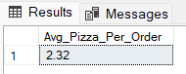

1. **Daily Trend for Total Orders**

select

DATENAME(DW, order_date) AS order_day , COUNT(Distinct order_id) AS Total_order

from pizza_sales

group by DATENAME(DW, order_date);

Output

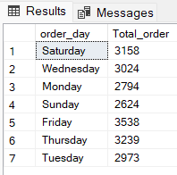

1. **Hourly Trend for Orders**

select

DATENAME(HOUR, order_time) AS order_hours , COUNT(Distinct order_id) AS Total_order

from pizza_sales

group by DATENAME(HOUR, order_time)

order by DATENAME(HOUR, order_time);

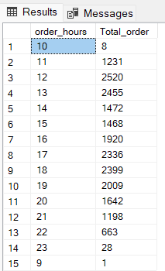

1. **% of Sales by Pizza Category**

select

pizza_category , CAST ( SUM(total_price) * 100 / (select SUM(total_price) from pizza_sales) AS decimal(10,2)) As Percentage_of_sales

from pizza_sales

Group by pizza_category;

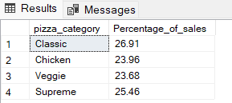

1. **% of Sales by Pizza Size**

select

pizza_size , CAST ( SUM(total_price) * 100 / (select SUM(total_price) from pizza_sales) AS decimal(10,2)) As Percentage_of_sales

from pizza_sales

Group by pizza_size

order by Percentage_of_sales;

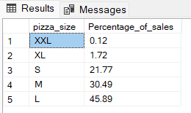

1. **Top 5 Best seller pizza by revenue**

select top 5 pizza_name, SUM(total_price) as revenue_by_pizza_name from pizza_sales

group by pizza_name

order by revenue_by_pizza_name desc;

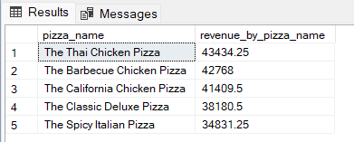

1. **Least 5 Seller pizza by revenue**

select top 5 pizza_name, SUM(total_price) as revenue_by_pizza_name from pizza_sales

group by pizza_name

order by revenue_by_pizza_name asc;

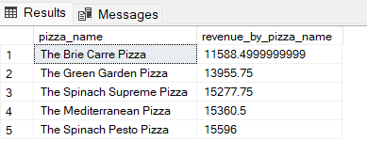

1. **Top 5 Seller pizza by Total Orders**

select top 5 pizza_name, Count(distinct order_id) as Total_orders from pizza_sales

group by pizza_name

order by Total_orders desc;

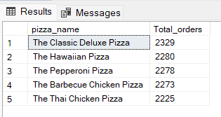

1. **Least 5 Seller pizza by Total orders**

select top 5 pizza_name, Count(distinct order_id) as Total_orders from pizza_sales

group by pizza_name

order by Total_orders asc;

