**Assignment – 1**

**Install Power BI Desktop and share the final screenshot of the report view page which appears when power desktop starts.**

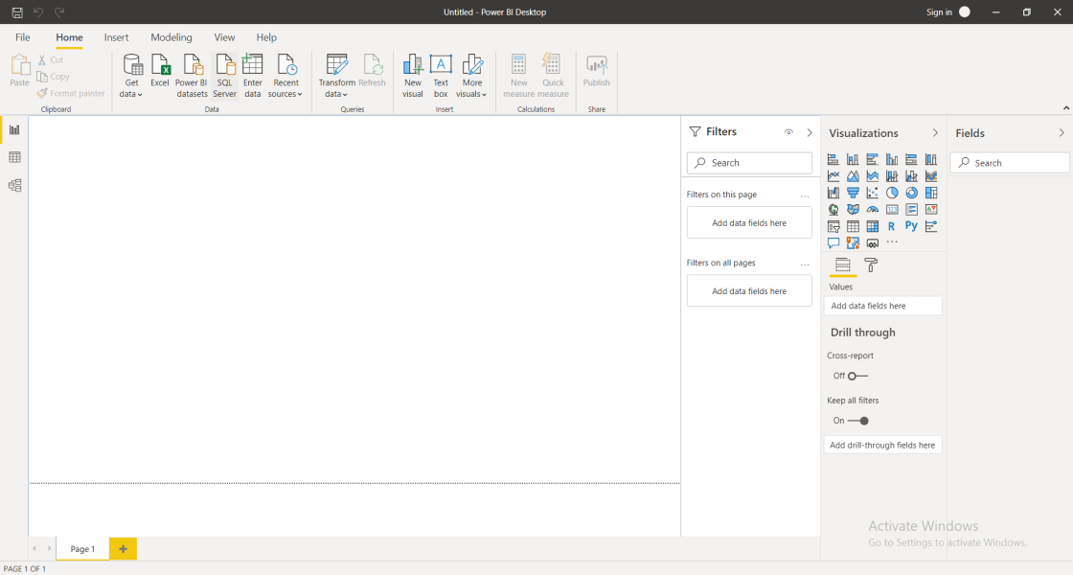

* **Prepare a document and with the following screenshot**

Report View

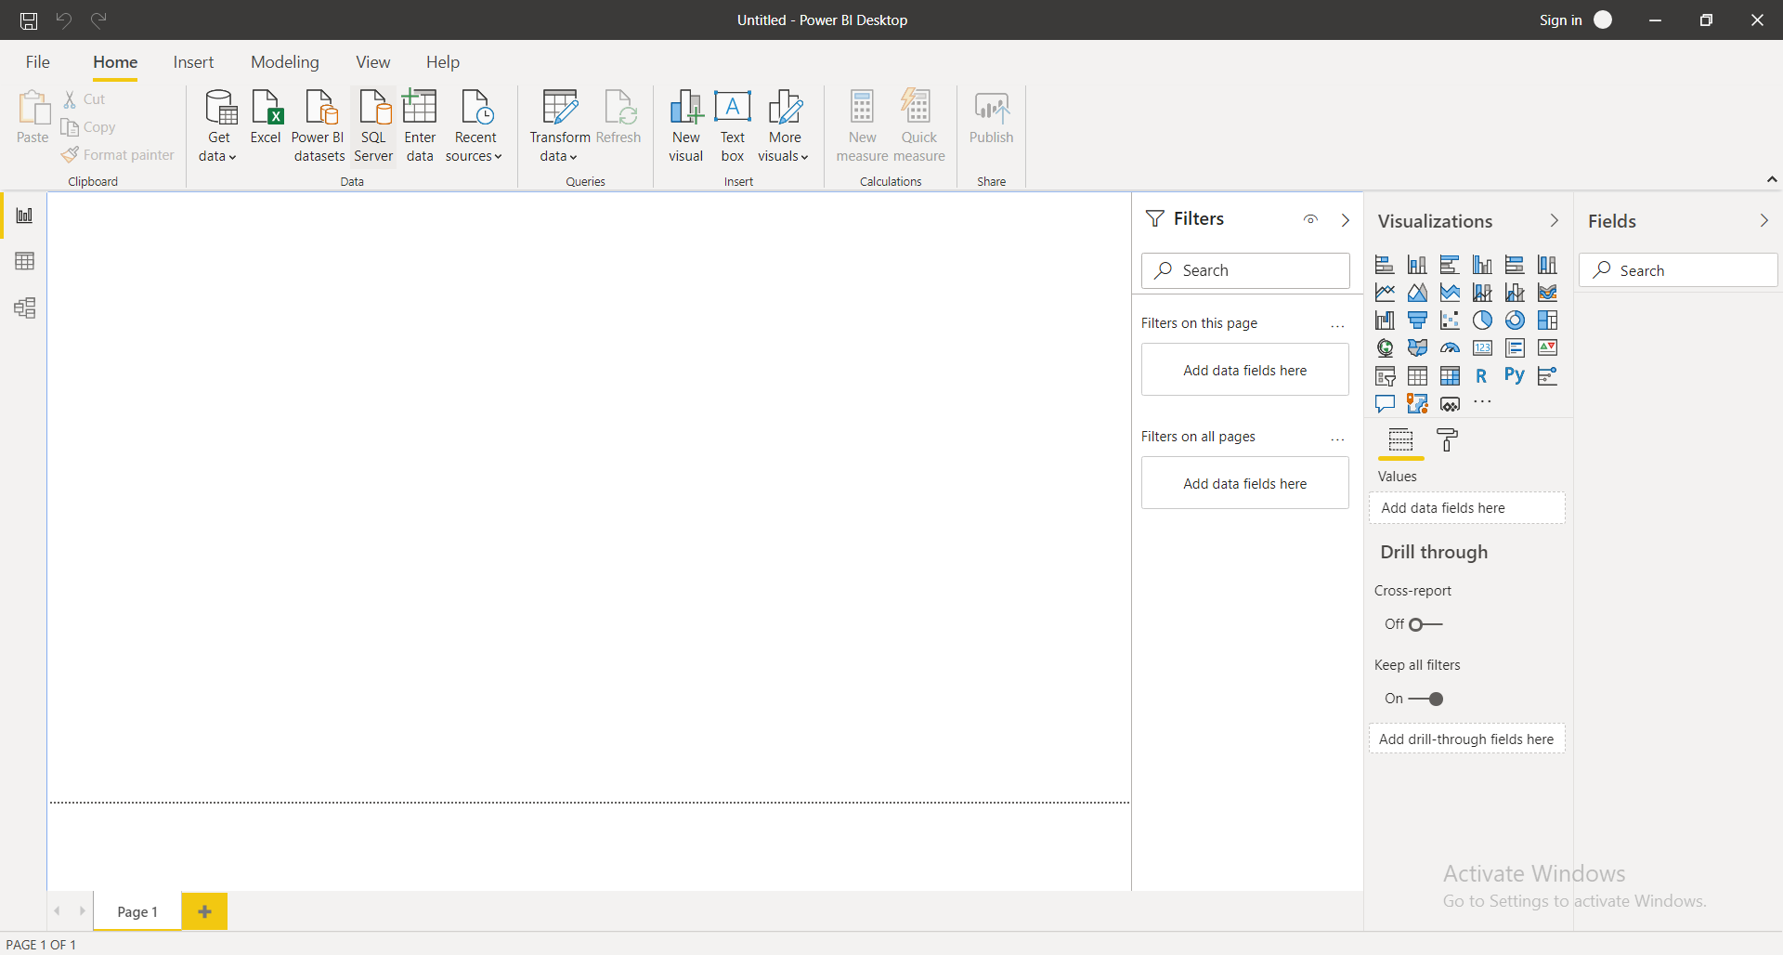

* Data View

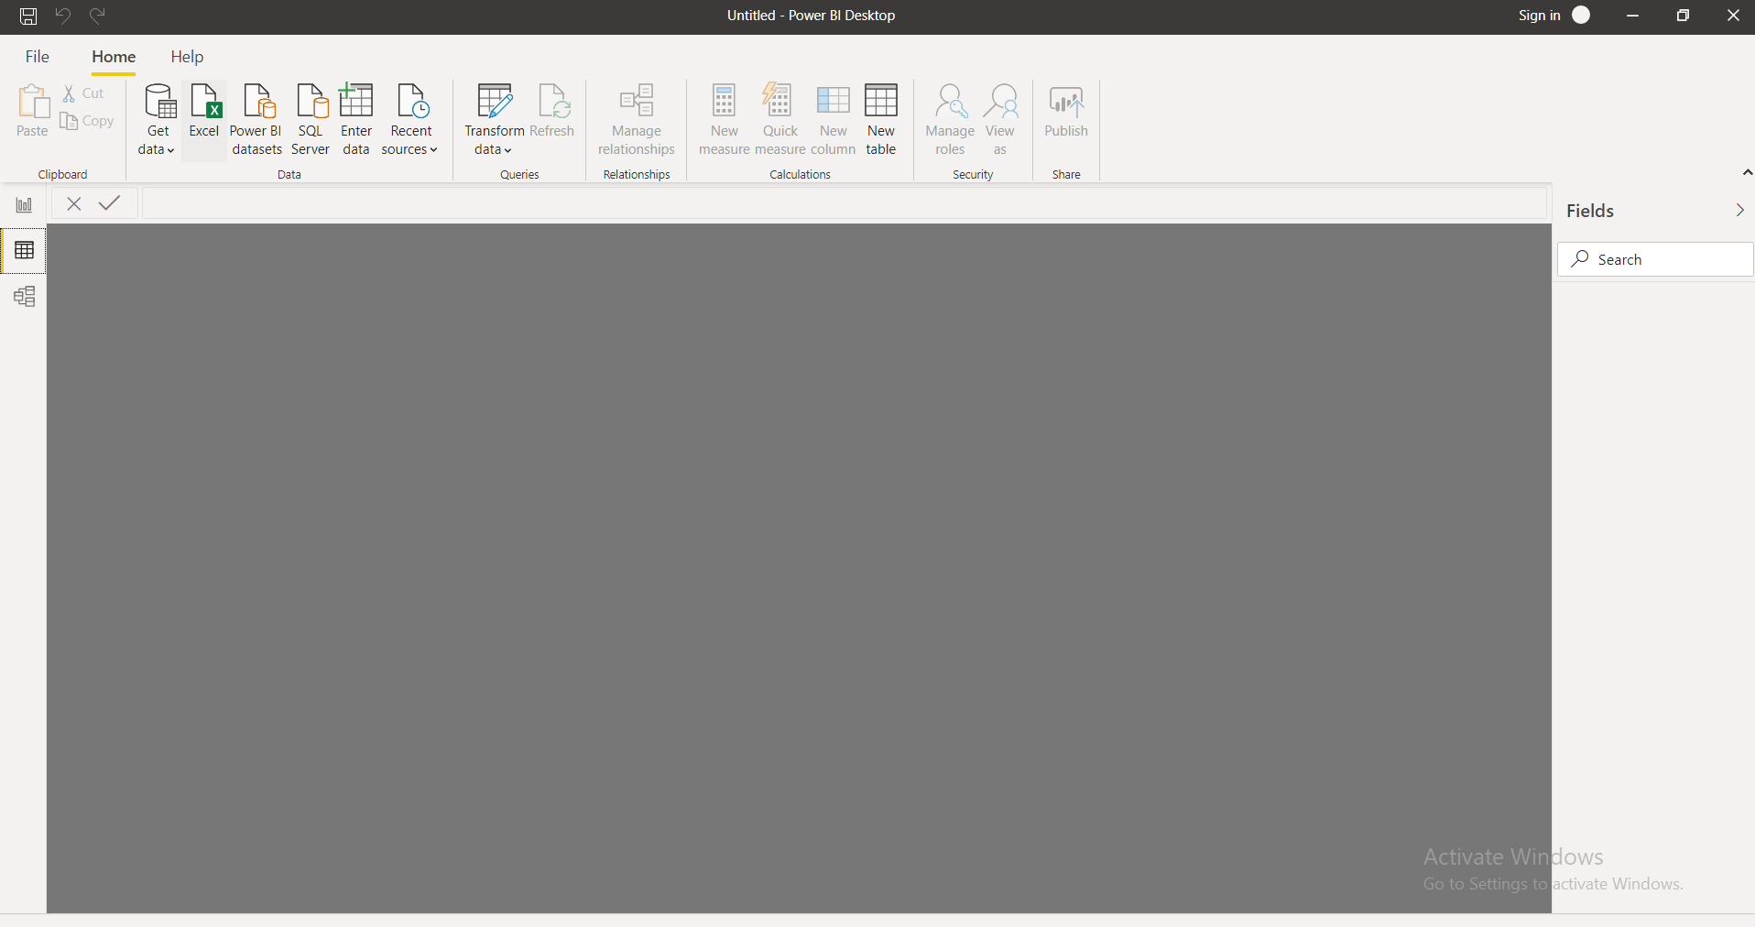

* Model View

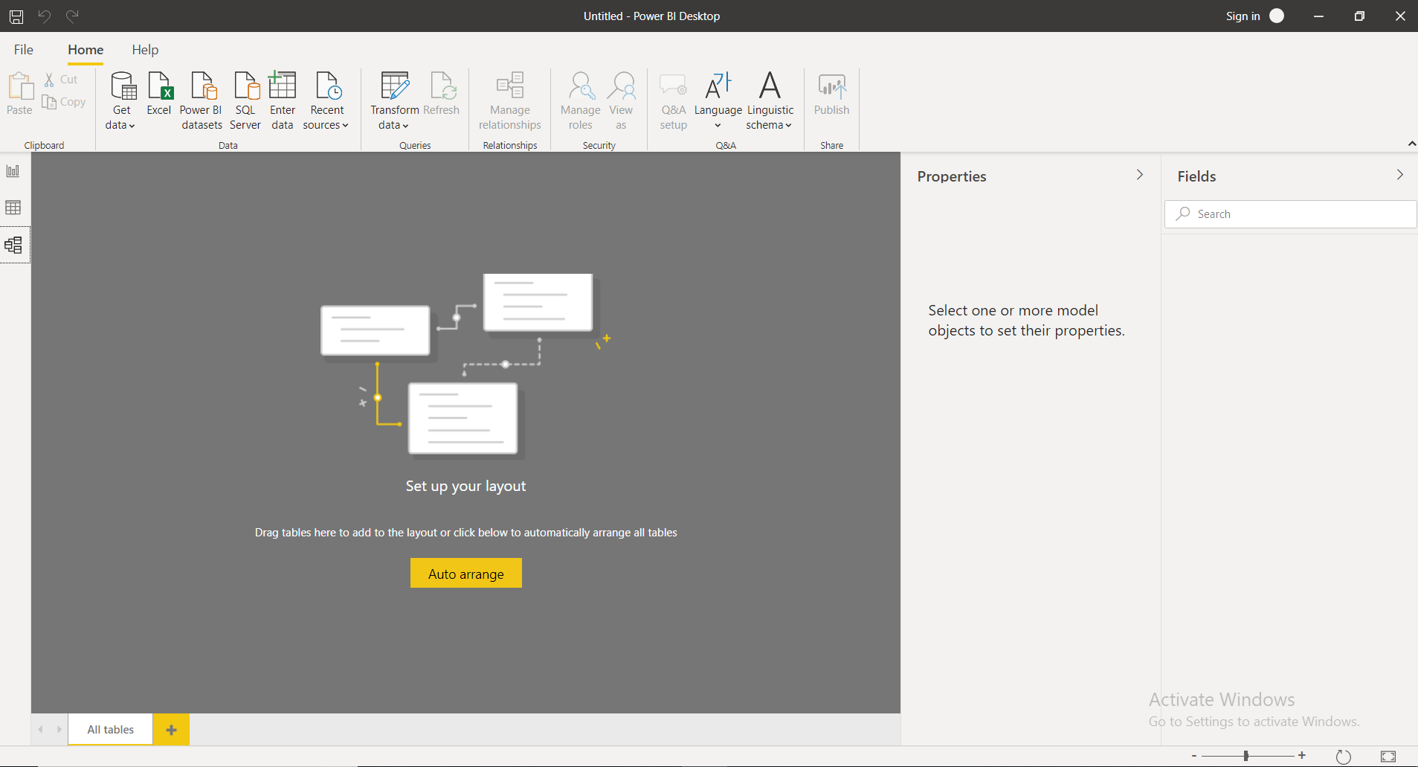

* Power Query Editor

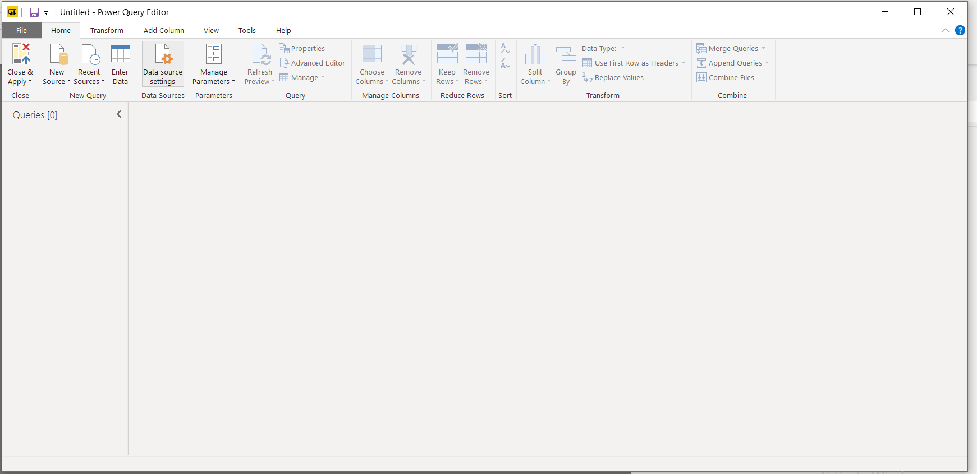

* Advance Editor

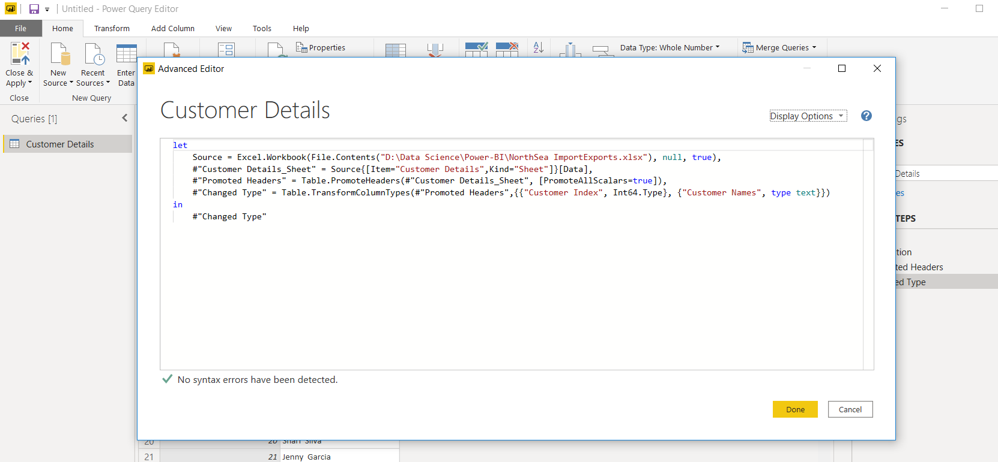

* **Prepare a document with details of the following along with their price**

Power BI Desktop : Free

Power BI Pro : $9.99 per month

Power BI Premium : $4995 per month