Marwadi University
Faculty of Computer Applications

BCA 4E Python TW Exam
SET - 1

Enrollment No. : 92400527298
Name :Kashyap Pansuriya
Class : BCA-4E
Date : 3 April 2026

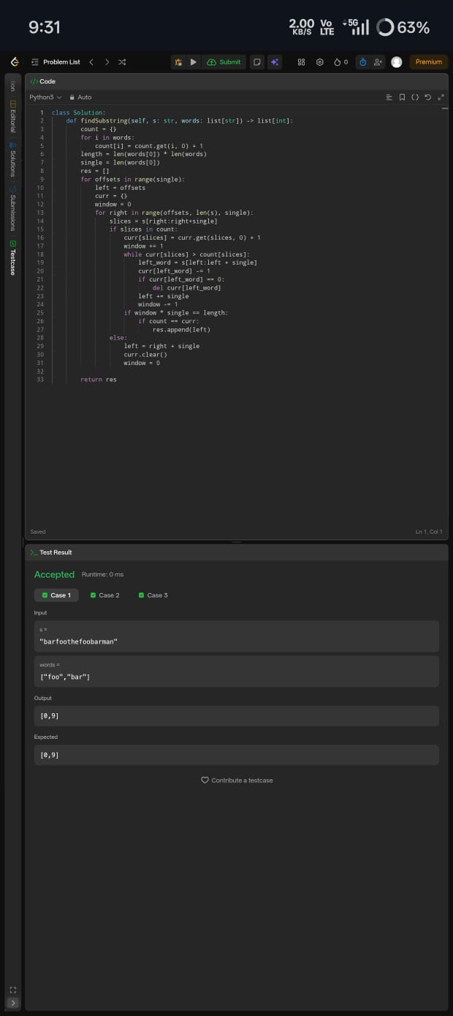
Answer – 1

Answer – 2

Answer – 3

Answer – 4

Answer - 5

