Marwadi University
Faculty of Computer Applications

BCA 4E Python Mid-1 Exam

Enrollment No. : 92400527298
Name :Pansuriya Kashyap
Class : 4E
Date : 12/03/2026

Answer – 1
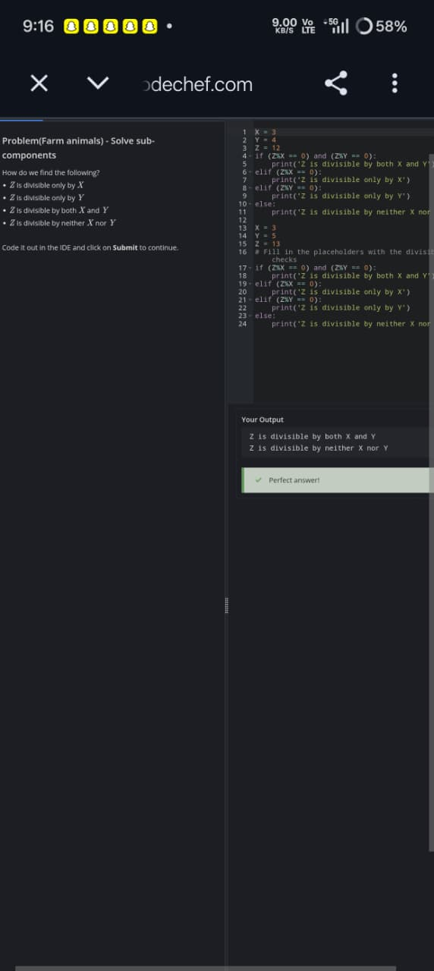
Answer – 2

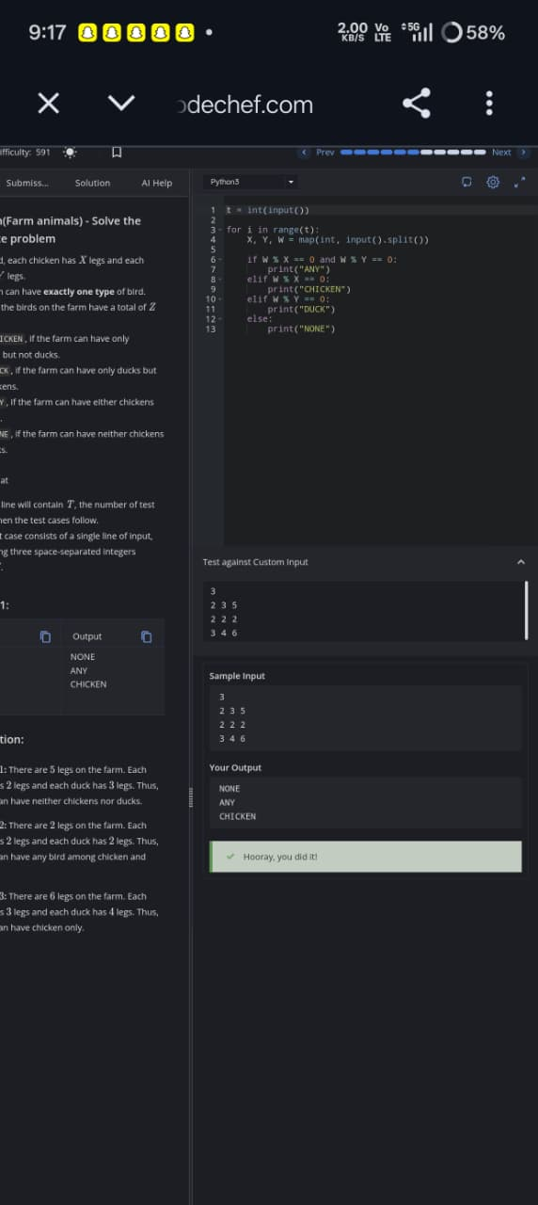

Answer – 3
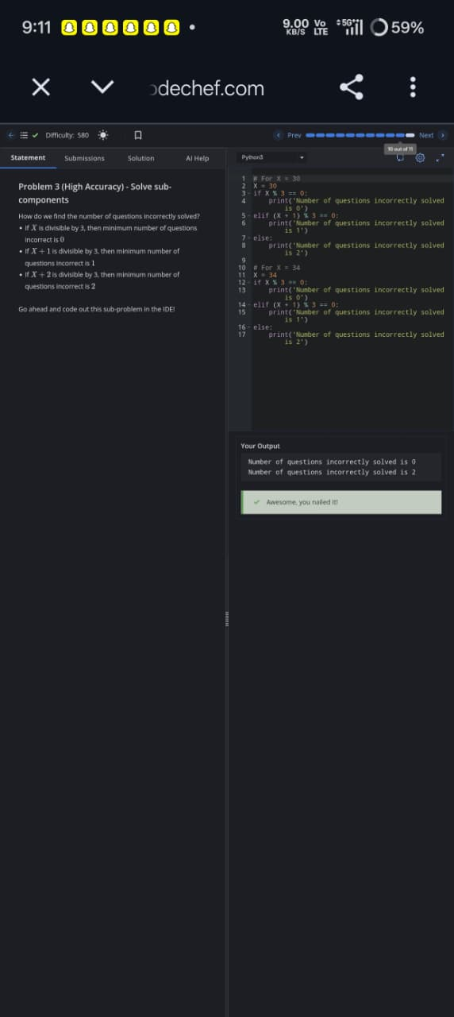

Answer – 4
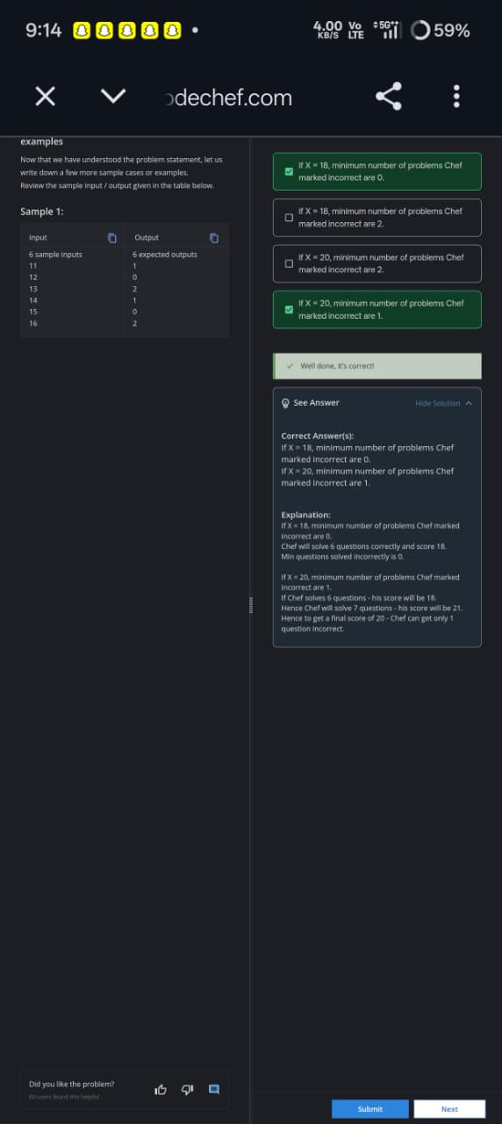
Answer – 5

––––––