

Date: DD.MMM.YYYY

INTERNSHIP CERTIFICATE

<<Employee Name>>

This is to certify that Mr./Miss <<Employee Name>> has successfully completed his/her <<Month>> -month internship at Rigved Infotech Pvt. Ltd. from <<Start Date>> to <<End Date>> in the domain of <<Domain>>.
During the internship period, we found <<Employee Name>> to be sincere, enthusiastic, and result oriented. He/She demonstrated a keen interest in learning and contributed effectively to the assigned module. His/Her performance throughout the internship was commendable, and He/she displayed a positive attitude and a good understanding of the subject matter.
We at Rigved Infotech Pvt. Ltd. have thoroughly enjoyed having him/her as an intern and wish her all the very best in her future endeavors.

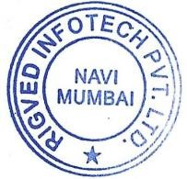
Yours faithfully

Rigved Infotech Private limited
Dr. Nitin Pitty Director

RIGVED INFOTECH PVT. LTD.
Unit No. 405 & 406, Building-2, Sector-1, +91 22 46176951
Millennium Business Park, Mahape, +91 70214 52285 Navi Mumbai – 400 710, MH – India

 www.rigvedit.com info@rigvedit.com

