**DOUBT**

**7.10.25 —-------------------------------------**

**Doubt facing based on development and 1 programming**

1. **Question on programming**

**Q: Problem Statement**

**Given an integer n, return true if n is a prime number and false otherwise.**

**A prime number is a natural number greater than 1 that has no positive divisors other than 1 and itself.**

**Example 1:**

**Input: n = 2**

**Output: true**

**Explanation: 2 is a prime number.**

**Example 2:**

**Input: n = 3**

**Output: true**

**Explanation: 3 is a prime number.**

**Example 3:**

**Input: n = 4**

**Output: false**

**Explanation: 4 is divisible by 2.**

**Example 4:**

**Input: n = 1**

**Output: false**

**Explanation: 1 is not a prime number.**

**Example 5:**

**Input: n = 0**

**Output: false**

**Explanation: 0 is not a prime number.**

**Why does my program give both "Prime" and "Not Prime" output for the number 2?**

**MY APPROACH**

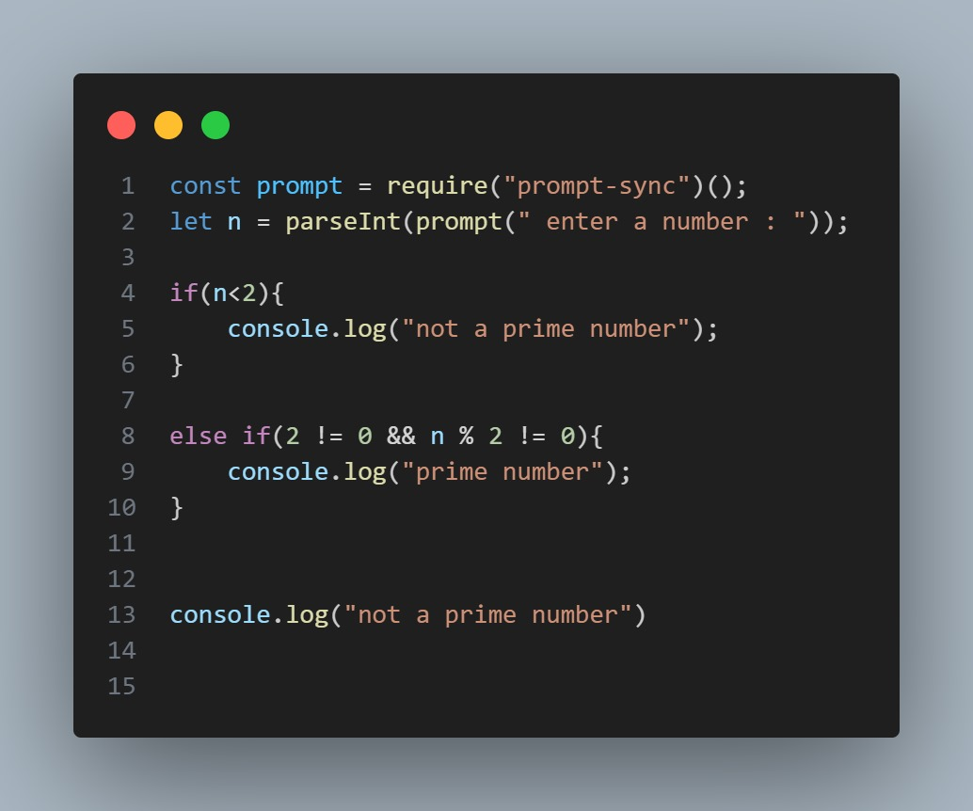

**—---------------------------------------------------------------------------------------------**

**2.NOW IN DEVELOPMENT PART**

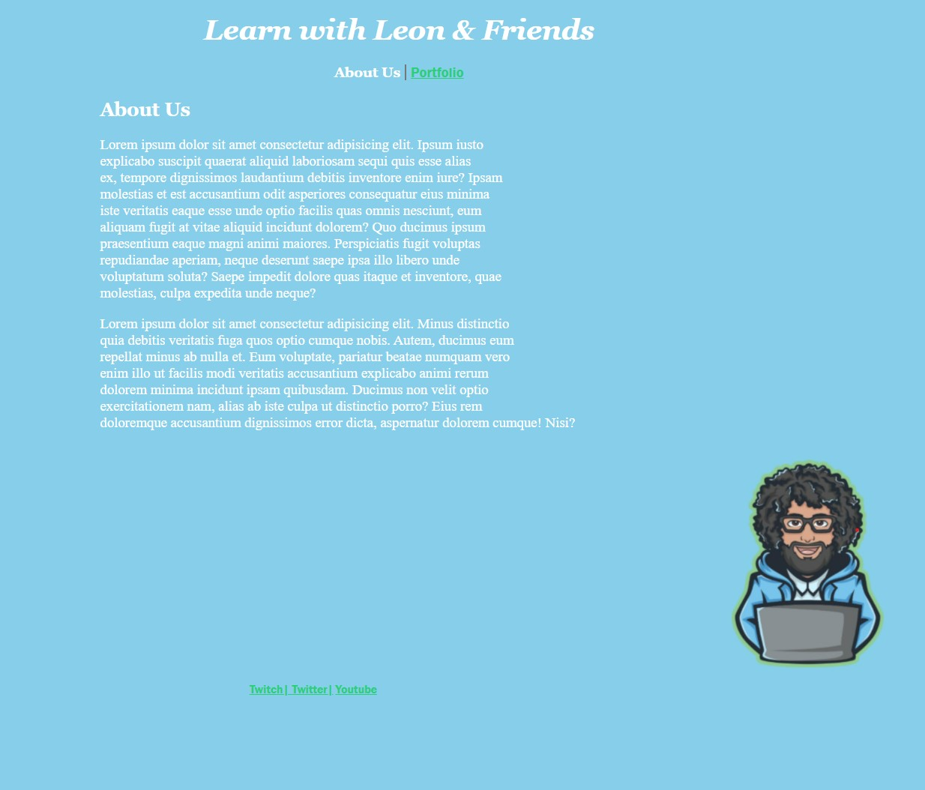

### **1.**

**"I want to place an image of a lion next to a paragraph (side by side)."**

**🔹 This means you want the image and paragraph to appear horizontally aligned, not one above the other.**

### **2.**

**"I want to add borders between the Twitch, Twitter, and YouTube icons."**

**🔹 You want to visually separate the social media icons using borders or lines between them.**

### **3.**

**"I want to move the footer higher (closer to the main content)."**

**🔹 This means you don't want the footer to stay at the very bottom — you want to position it closer to the top or above a certain section.**

**8.10.25**

**Doubt**

* + - 1. **Bbc logo ko upar karna hai**
      2. **Box ke andar text ko center karna**
      3. **Try this in flexbox**

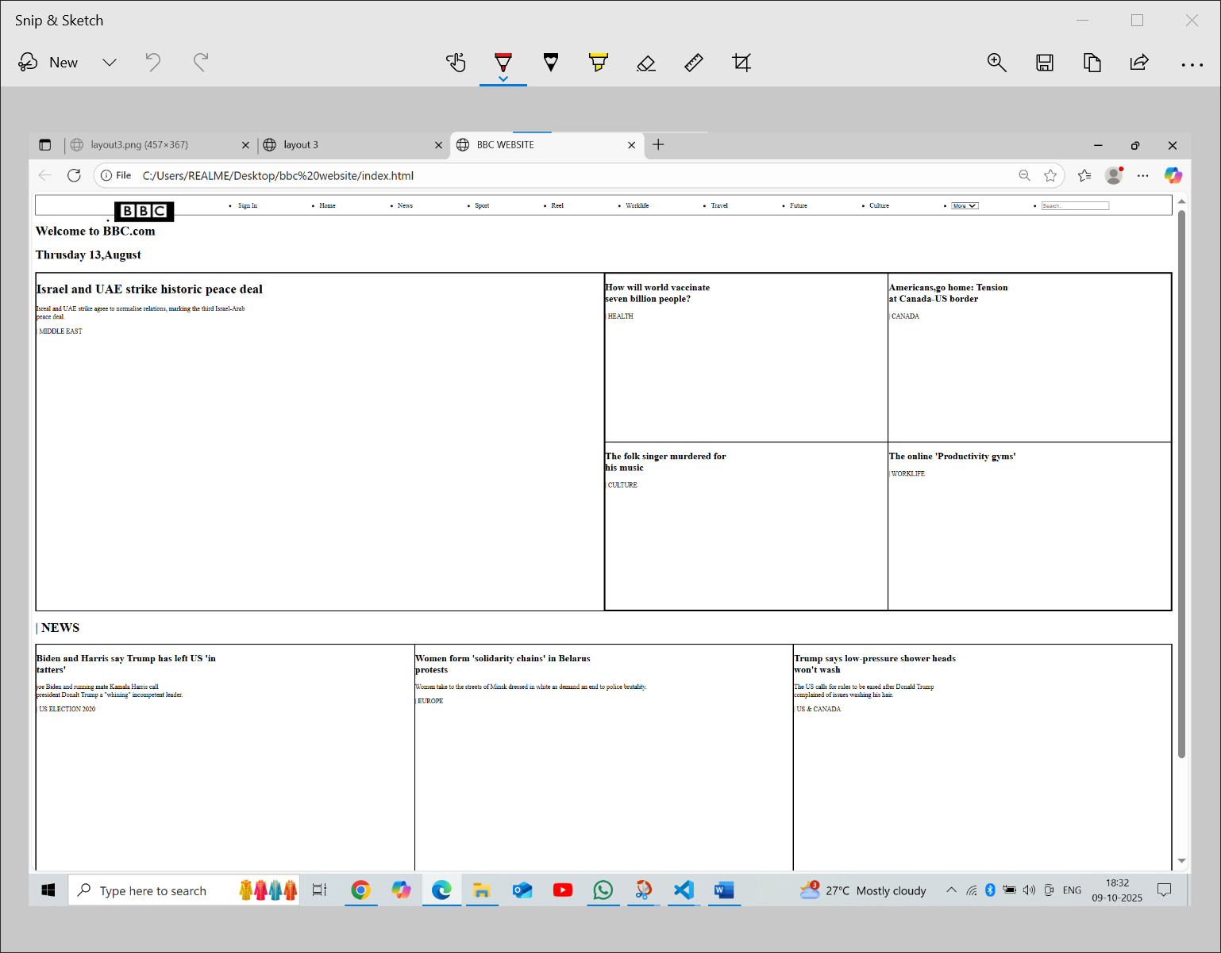

**9.10.25**

**Doubt**

**1.flexbox mein thoda confidence issue give trick**

**2.coding section: i want to know better approach for factorial of number and factor of a number**

**10.10.25**

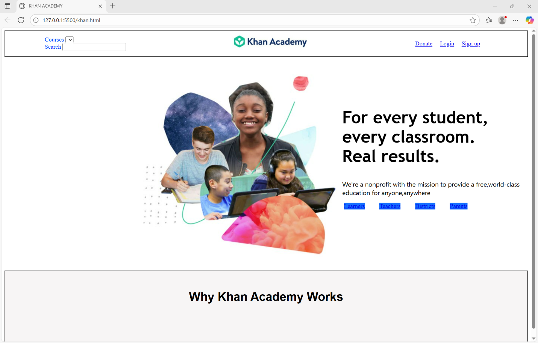

**Doubt: 1. In navbar , I want Search courses ke bagal mein ho**

1. **Section mein jo blue box banaye hai text white krna chahte hai**