* Gather the following data for your aircraft type. Normally you can get this data from a document called AHM 560 or the AOM (Aircraft operations manual).
  + Index values for cargo holds
  + Index values for fuel mass
  + Index values for seat rows
  + Pantry codes
  + Mass and balance envelopes for
    - Takeoff
    - Inflight
    - Landing
    - Zero fuel mass
    - (Ferry)
* Once you have the data you have to update the following Tables
  + Aircraft Data   
    Fill in the passenger masses you want to use and the pantry codes. In the rows 37 to 53 you have to set the adjust the values for the different crew compositions. The default setup is for 2-3 pilots and 3-5 cabin crews.   
    In case you add or delete rows and columns make sure to check the procedure setDomDoi()
  + Pax  
    Update the table with the index values for each seat row and/or cabin section.  
    Make sure that the cross-references to the tables “Section Trim” and “Seatrow Trim” are still in working as expected.
  + Cargo  
    Update the table with the index values for the cargo holds. If there are more than 2 cargo holds, you will have to adjust the “Loadsheet OCC”.
  + Fuel  
    Update the table with the index values for the fuel mass and check if the function fuelIndex(fuelMass As Integer) still works as expected.
  + To unprotect a Table use the password “Fokker 100”
* Select the aircraft registration

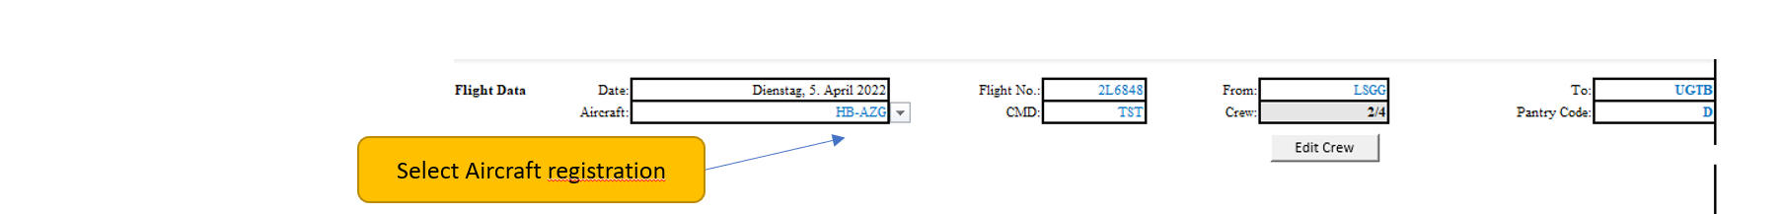

This will reset the crew composition back to the standard.

* Fill in the rest of the flight data
  + Flight Number
  + Commander Name
  + Departure Airport (IATA/ICAO)
  + Arrival Airport (IATA/ICAO)
  + Pantry Code
  + Edit the crew composition if necessary, by clicking on the  Button

**Editing the crew:**

* + Tick the checkboxes according to the actual crew seating distribution on board the flight  
    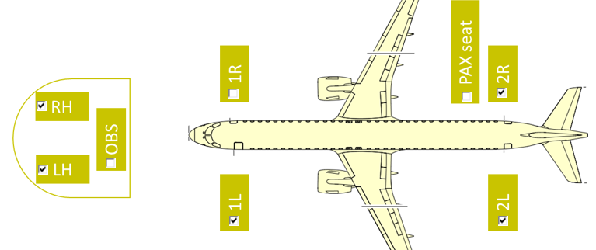
  + Click on the  Button
* Add the passenger distribution either based on section trim or on seatrow trim. In case of low pax figures it is advised to use the seatrow trim. Due to the higher precision.

**Add Passenger distribution via section trim**

* Click on the button Ein Bild, das Text enthält.

  Automatisch generierte Beschreibung
* Select the type of flight (charter or scheduled)
* If there are more than 23% of the passenger are female the male female button can be clicked, and the passenger numbers can be entered separated by gender
* Distribute all passengers in the cabin sections according to the actual seating distribution on board the aircraft  
  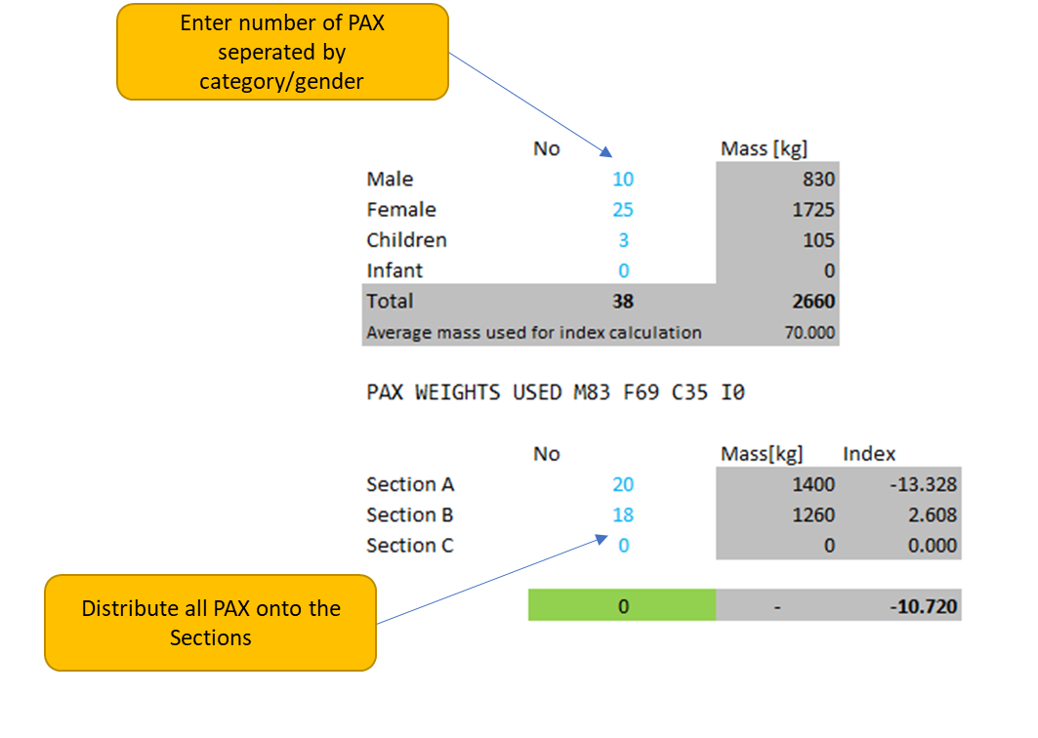
* Click on the  Button
* If no error message is displayed click on the Ein Bild, das Text enthält.

  Automatisch generierte Beschreibung Button

**Add Passenger distribution via seatrow trim**

* Click on the button Ein Bild, das Text enthält.

  Automatisch generierte Beschreibung
* Select the type of flight
* Fill out the passenger seat table according to the actual seating distribution on board the aircraft. You may use the following characters:  
  f - for female passengers  
  m - for male passengers  
  c - for children  
  o - for unoccupied seats (unfilled fields are treated as unoccupied)
* Enter the number of infants on board the aircraft
* Click on the Button and check if the number of passengers displayed in the overview table matches the actual number of passengers on board

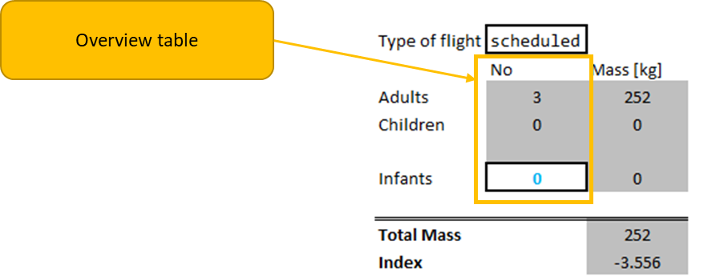

* Click on 

Enter the remaining data

* Enter the masses of the deadload loaded in the forward and aft cargo compartments in kilograms
* Enter the mass of the take-off fuel in kilograms
* Enter the mass of the trip fuel in kilograms
* Click on the calculate button
* Check that all values are marked in green and the envelope check returns “OK”  
  In case one value is out of limits a warning will be displayed and now text loadsheet will be generated

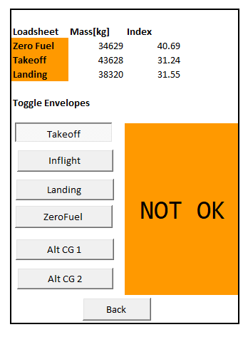Example for a mass distribution which is out of limits:  
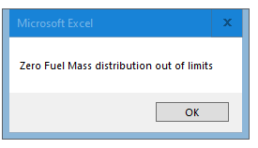

* In case the mass distribution is within limits the the text loadsheet can be transmitted to the crew via ACARS.

Further information about the application

When going in the menu to change the passenger figures, all previous entered passenger figures are deleted.

All calculated loadsheets are saved in a log where the timestamp of the calculation and the logged in user is saved.