CMPE 483- Introduction to Robotics
Sample Questions for Quiz 2
Student Name: ____________________________________ ID: __________________
(PLEASE WRITE the correct answer’s letter ONLY in the right hand column)
1 | 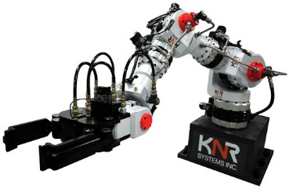  In an industrial hydraulic robotic arm, (as shown), ______ is needed to provide the necessary force that transmits through the oil in the tubes.  (a) Syringes (b) Gears (c) Pump (d) None of these | C
2 | 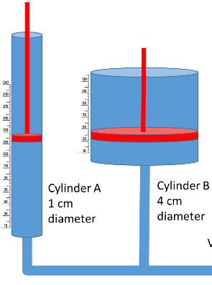  Consider the following Hydraulic actuation system for the arm shown in 1. Cylinder A provides 1N force while cylinders B connected to the gripre receives this force. If the piston in cylinder A moves down by 20 cm, how much will the piston in cylinder B move up? | 1.25
3 | Using 6-wire stepper motor is preferred over 4-wire stepper motor due to:  (a) less winding needed (b) unipolar drive (c) H-bridge (d) None of these | B
4 | A 12V and 2A servo motor can be driven by a 5V TTL logic circuit if:  (a) the power for motor is taken directly from the TTL circuit (b) the motor is powered from a separate un-connected power source (c) the motor is powered from a separate power source having common ground connection with the TTL circuit (d) None of these | C
5 | Following motor is usually not used for accurate angular position control of the shaft:  (a) stepper motor (b) servo motor (c) geared DC motor with very low gearing down ratio (d) None of these | D
6 | In an oil-based hydraulic system, the force multiplication takes place due to:  (a) different lengths of pipes (b) larger diameter cylinders for load (c) smaller diameter cylinders for load (d) None of these. | B
7 | Main advantage of using hydraulic actuation over motor based actuation is:  (a) it produces smoother motion (b) it can transmit force in any direction not circular only (c) it can lift heavier weights (d) None of these. | B
8 | Consider A DC motor whose full speed is achieved with a 10 volts DC input. If this 10 volts input is now replaced with a pulse train with 60% Duty Cycle, then the speed will:  (a) Reduced by 40% (b) increased by 60% (c) reduced by 60% (d) None of these. | A
9 | For a 6-wire stepper motor (shown below diagrammatically), ________ must be used as the drive circuit.  (a) H-bridge (b) 6 Relays (c) 6 NPN transistors (d) None of these.  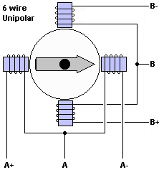 | D  4 NPN
10 | The best motor for most precise angular movement to be used in a robotic arm is:  (a) Simple DC motor (b) Servo motor (c) Stepper motor (d) None of these | C
11 | The motor in Q#10 is, however, not the most commonly used one for small robotic kits due to:  (a) very heavy in design (b) large drive currents are needed (c) too many wires to be connected (d) None of these. | D  All
12 | For the conventional electronic current, following is used to represent the force on a current carrying conductor in a stationary magnetic field:  Flemming’s Right hand rule (b) Flemming’s Left hand rule (c) Left hand curled fingers’ rule (d) None of these. | B

