SIMATS ENGINEERING (SAVEETHA SCHOOL OF ENGINEERING)
Department of Artificial Intelligence and Data Science
ASSESSMENT TOOL 3 – DESIGN TASK

Course Code: | DSA03 | Course Title: | Natural Language Processing
CO Assessed: | CO3 – Precision | Assessment: | Assessment Tool 3 – Design Task
Weightage: | 40% of CIA
CO5 Statement: | Apply N-gram models, smoothing techniques, part-of-speech tagging systems and to evaluate effective syntactic analysis. (BL-3)
Student Name: | M.Kasif Jalal | Reg. No.: | 192424214
Section / Batch: | B.tech AI&DS | Date:

Code of Conduct
I M.KASIF JALAL (192424214) certify that this submission is my original work and that I have adhered to the guidelines specified for this assessment. I understand that any violation of academic integrity rules will result in disciplinary action.
Signature of the Student: _________________________

Instructions
- Implement the assigned NLP Design Task using Python with appropriate algorithms and a suitable dataset/application.
- Execute the program and demonstrate the output using relevant sample inputs and test cases.
- Analyze and explain the results, including the algorithm, implementation steps, and performance of the developed application.
- Duration: 30 minutes.

Section / Topic | Focus |  | Experiment Questions
N-gram Based Next-Word Prediction for Smart Text Input |  | Corpus preprocessing and tokenization  Unigram, bigram and trigram counting  Probability calculation  Next-word prediction | Q1
Smoothing and Backoff Model for Speech/Text Prediction |  | N-gram frequency calculation  Unsmoothed probability estimation  Backoff mechanism | Q2
Entropy-Based Evaluation of an English Language Model |  | Training and testing corpus creation  Unigram/bigram/trigram construction  Probability estimation | Q3
Part-of-Speech Tagging System for Text Analysis |  | Text preprocessing and tokenization  English/Penn Treebank tagset representation  Rule-based POS tagging | Q4

Annexure A – Design Task

Task 1:
Design and implement a Python-based N-gram language model that predicts the next word in a sentence using a given English text corpus. The system should preprocess the corpus, tokenize the sentences, count unigram, bigram, and trigram occurrences, and calculate their probabilities using an unsmoothed N-gram model. Given an incomplete sentence such as “The student is”, the system should identify and display the most probable next words.

The program should provide options to select the value of N (1, 2, or 3), display the corresponding word-frequency counts and probabilities, and generate the top-5 next-word predictions. The implementation should also demonstrate how unseen N-grams result in zero probability. Finally, evaluate the prediction performance using suitable test sentences and discuss the limitations of an unsmoothed N-gram model.

Task 2:
Design and implement a Python-based language prediction system that improves an unsmoothed N-gram model using smoothing and backoff techniques. The system should initially construct a bigram/trigram model from an English corpus and identify situations where an N-gram has zero probability because it does not occur in the training data.

Design the system to apply a backoff strategy, where the model uses trigram probability when available, otherwise backs off to the bigram probability and finally to the unigram probability. Extend the implementation using Deleted Interpolation to combine unigram, bigram, and trigram probabilities using suitable interpolation weights. The program should accept a user-entered sentence/query and return the most probable next word. Compare the prediction results of the unsmoothed, backoff, and deleted-interpolation models.

Task 3:
Design and implement a Python program to evaluate an English N-gram language model using the concept of entropy. Given a training corpus and a separate test corpus, construct unigram, bigram, and trigram models and calculate the probability of words occurring in the test sentences. Based on these probabilities, compute the entropy of the language model and compare the uncertainty associated with different N-gram models.

The application should simulate a text-prediction scenario in which the system receives a sequence of words and estimates how predictable the next word is. The program should identify sentences or word sequences having high and low entropy and provide an interpretation of the results. The system should also compare the effect of smoothing on entropy and explain why a model with better probability estimation can provide more reliable predictions.

Task 4
Design and implement a Python-based Part-of-Speech (POS) tagging system that assigns grammatical categories such as noun, verb, adjective, adverb, pronoun, preposition, and conjunction to words in an English sentence. The system should first implement a Rule-Based POS Tagger using lexical dictionaries and grammatical rules. Next, design a Stochastic POS Tagger using word/tag probabilities and transition probabilities derived from a training corpus.

Extend the system by implementing the basic idea of Transformation-Based Tagging, where initially assigned tags are corrected using transformation rules. For example, a word initially tagged as a noun may be transformed into a verb when it occurs after a pronoun or auxiliary verb. The final system should compare the output of the three approaches for the same input sentences and identify which approach provides better tagging results. The program should also demonstrate the use of appropriate English tagsets, such as the Penn Treebank tagset.

TASK 1 — Unsmoothed N-Gram Language Model

Aim
To design and implement an N-gram language model that predicts the next word using unigram, bigram, and trigram probabilities without smoothing.

Simple Theory
An N-gram model predicts a word based on the previous words.
- Unigram: considers only one word.
- Bigram: considers the previous 1 word.
- Trigram: considers the previous 2 words.
For example:
"The student is"
A trigram model looks for:
"student is ___"
and finds which word occurs most frequently after "student is".

Probability formulas

Probability formulas
Unigram:
P(w)=Total WordsCount(w)​
Bigram:
P(wi​∣wi−1​)=Count(wi−1​)Count(wi−1​,wi​)​
Trigram:
P(wi​∣wi−2​,wi−1​)=Count(wi−2​,wi−1​)Count(wi−2​,wi−1​,wi​)​
In an unsmoothed model, an N-gram that never occurred gets probability 0.

In an unsmoothed model, an N-gram that never occurred gets probability 0.

Python Code
from collections import Counter
import re

# -----------------------------
# Training corpus
# -----------------------------
corpus = """
The student is intelligent.
The student is hardworking.
The student is learning Python.
The student likes programming.
The student likes machine learning.
The teacher is helpful.
The teacher likes programming.
The teacher is intelligent.
The student studies computer science.
The student studies machine learning.
Students learn programming.
Students learn Python.
"""

# -----------------------------
# Preprocessing
# -----------------------------
sentences = re.split(r'[.!?]+', corpus.lower())

tokenized = []

for sentence in sentences:
words = re.findall(r'\b\w+\b', sentence)
if words:
tokenized.append(["<s>"] + words + ["</s>"])

# -----------------------------
# Create N-gram counts
# -----------------------------
unigram = Counter()
bigram = Counter()
trigram = Counter()

for sentence in tokenized:
unigram.update(sentence)

for i in range(len(sentence) - 1):
bigram[(sentence[i], sentence[i+1])] += 1

for i in range(len(sentence) - 2):
trigram[(sentence[i], sentence[i+1], sentence[i+2])] += 1

# -----------------------------
# Probability functions
# -----------------------------
def unigram_probability(word):
return unigram[word] / sum(unigram.values())

def bigram_probability(w1, w2):
if unigram[w1] == 0:
return 0
return bigram[(w1, w2)] / unigram[w1]

def trigram_probability(w1, w2, w3):
if bigram[(w1, w2)] == 0:
return 0
return trigram[(w1, w2, w3)] / bigram[(w1, w2)]

# -----------------------------
# Display counts
# -----------------------------
print("UNIGRAM COUNTS")
print(unigram)

print("\nBIGRAM COUNTS")
for k, v in bigram.items():
print(k, ":", v)

print("\nTRIGRAM COUNTS")
for k, v in trigram.items():
print(k, ":", v)

# -----------------------------
# Select N
# -----------------------------
N = int(input("\nEnter N (1, 2 or 3): "))

query = input("Enter incomplete sentence: ").lower().split()

# -----------------------------
# Prediction
# -----------------------------
if N == 1:
predictions = []

for word, count in unigram.items():
predictions.append((word, unigram_probability(word)))

elif N == 2:
last_word = query[-1]
predictions = []

for (w1, w2), count in bigram.items():
if w1 == last_word:
predictions.append((w2, bigram_probability(w1, w2)))

else:
w1 = query[-2]
w2 = query[-1]

predictions = []

for (a, b, c), count in trigram.items():
if a == w1 and b == w2:
predictions.append((c, trigram_probability(a, b, c)))

# -----------------------------
# Top 5 predictions
# -----------------------------
predictions.sort(key=lambda x: x[1], reverse=True)

print("\nTop-5 predicted next words:")

for word, probability in predictions[:5]:
print(word, "->", round(probability, 4))

# -----------------------------
# Demonstrate unseen N-gram
# -----------------------------
print("\nUnseen N-gram example:")

if N == 2:
print("P(student, banana) =",
bigram_probability("student", "banana"))

elif N == 3:
print("P(student, is, banana) =",
trigram_probability("student", "is", "banana"))

Sample Output
For:
N = 3
Sentence = The student is
Possible output:
Top-5 predicted next words:

intelligent -> 0.25
hardworking -> 0.25
learning -> 0.25
helpful -> 0.00
programming -> 0.00
The exact probabilities depend on the corpus.
For an unseen word:
P(student, is, banana) = 0
This demonstrates the zero-frequency problem.

Result
The unsmoothed N-gram model successfully predicts the next word using unigram, bigram, and trigram probabilities. However, unseen N-grams receive probability 0, which is a major limitation

TASK 2 — Backoff and Deleted Interpolation

Aim
To improve an unsmoothed N-gram model using backoff and deleted interpolation techniques.

Simple Theory
Suppose we want to predict:
"The student is ___"
The trigram model checks:
P(word∣student,is)
If this trigram does not exist, the model backs off to:
P(word∣is)
If that also does not exist:
P(word)
So:
Trigram → Bigram → Unigram

Deleted Interpolation
Instead of selecting only one model, interpolation combines all three:
P(w)=λ1​Puni​+λ2​Pbi​+λ3​Ptri​
where:
λ1​+λ2​+λ3​=1
For example:
λ1 = 0.2
λ2 = 0.3
λ3 = 0.5

Code:-
from collections import Counter
import re
corpus = """
The student is intelligent.
The student is hardworking.
The student is learning Python.
The student likes programming.
The student likes machine learning.
The teacher is helpful.
The teacher likes programming.
The teacher is intelligent.
The student studies computer science.
The student studies machine learning.
Students learn programming.
Students learn Python.
"""

sentences = re.split(r'[.!?]+', corpus.lower())
data = []
for s in sentences:
words = re.findall(r'\b\w+\b', s)
if words:
words = ["<s>"] + words + ["</s>"]
data.append(words)
unigram = Counter()
bigram = Counter()
trigram = Counter()
for sentence in data:
unigram.update(sentence)
for i in range(len(sentence)-1):
bigram[(sentence[i], sentence[i+1])] += 1
for i in range(len(sentence)-2):
trigram[(sentence[i], sentence[i+1], sentence[i+2])] += 1
total_words = sum(unigram.values())
# -----------------------------
# Probability functions
# -----------------------------
def P_uni(w):
return unigram[w] / total_words
def P_bi(w1, w2):
if unigram[w1] == 0:
return 0
return bigram[(w1, w2)] / unigram[w1]

def P_tri(w1, w2, w3):
if bigram[(w1, w2)] == 0:
return 0
return trigram[(w1, w2, w3)] / bigram[(w1, w2)]
# -----------------------------
# Backoff model
# -----------------------------
def backoff(w1, w2, w3):
if trigram[(w1, w2, w3)] > 0:
return P_tri(w1, w2, w3)
elif bigram[(w2, w3)] > 0:
return P_bi(w2, w3)
else:
return P_uni(w3)
# -----------------------------
# Deleted Interpolation
# -----------------------------
lambda1 = 0.2
lambda2 = 0.3
lambda3 = 0.5
def interpolation(w1, w2, w3):
return (
lambda1 * P_uni(w3)
+ lambda2 * P_bi(w2, w3)
+ lambda3 * P_tri(w1, w2, w3)
)

# -----------------------------
# Predict next word
# -----------------------------
query = input("Enter sentence: ").lower().split()
w1 = query[-2]
w2 = query[-1]
vocabulary = list(unigram.keys())
results = []
for word in vocabulary:
unsmoothed = P_tri(w1, w2, word)
backed = backoff(w1, w2, word)
interpolated = interpolation(w1, w2, word)
results.append(
(word, unsmoothed, backed, interpolated)
)
# -----------------------------
# Display top predictions
# -----------------------------
print("\nUNSMOOTHED MODEL")
for x in sorted(results, key=lambda x: x[1], reverse=True)[:5]:
print(x[0], ":", round(x[1], 4))
print("\nBACKOFF MODEL")
for x in sorted(results, key=lambda x: x[2], reverse=True)[:5]:
print(x[0], ":", round(x[2], 4))
print("\nDELETED INTERPOLATION")
for x in sorted(results, key=lambda x: x[3], reverse=True)[:5]:
print(x[0], ":", round(x[3], 4))

Sample Output
For:
The student is
You may get:
UNSMOOTHED MODEL

intelligent : 0.3333
hardworking : 0.3333
learning : 0.3333

BACKOFF MODEL

intelligent : 0.1832
hardworking : 0.1832
learning : 0.1832
helpful : 0.0251
programming : 0.0204

DELETED INTERPOLATION

intelligent : 0.1667
hardworking : 0.1667
learning : 0.1667
programming : 0.0302
helpful : 0.0275

Comparison
Model | Main Idea | Zero Probability
Unsmoothed | Uses trigram only | Yes
Backoff | Trigram → Bigram → Unigram | Reduced
Interpolation | Combines all three | Reduced

Result
The backoff and deleted interpolation models provide better predictions than the unsmoothed model because they can use lower-order information when higher-order N-grams are unavailable.

TASK 3 — Entropy of N-Gram Language Models

Aim
To evaluate unigram, bigram, and trigram language models using entropy and compare their uncertainty and prediction reliability.

Simple Theory
Entropy measures uncertainty.
If a model is very uncertain about the next word:
Entropy = High
If a model can predict the next word easily:
Entropy = Low
The entropy formula is:
H=−N1​i=1∑N​log2​P(wi​)
A probability of 0 creates a problem because:
log(0)
is undefined.
Therefore, smoothing is useful because it prevents zero probabilities.
Code:-
from collections import Counter
import re
import math
# -----------------------------
# Training corpus
# -----------------------------
train = """
The student is intelligent.
The student is hardworking.
The student likes programming.
The student likes Python.
The teacher is helpful.
The teacher likes programming.
Students learn Python.
Students learn programming.
"""
test = """
The student likes Python.
The teacher is helpful.
Students learn programming.
"""
# -----------------------------
# Preprocessing function
# -----------------------------
def tokenize(text):
sentences = re.split(r'[.!?]+', text)
result = []
for s in sentences:
words = re.findall(r'\b\w+\b', s.lower())
if words:
result.append(["<s>"] + words + ["</s>"])
return result
train_data = tokenize(train)
test_data = tokenize(test)
# -----------------------------
# Build N-gram counts
# -----------------------------
unigram = Counter()
bigram = Counter()
trigram = Counter()
for sentence in train_data:
unigram.update(sentence)
for i in range(len(sentence)-1):
bigram[(sentence[i], sentence[i+1])] += 1
for i in range(len(sentence)-2):
trigram[(sentence[i], sentence[i+1], sentence[i+2])] += 1

total = sum(unigram.values())
# -----------------------------
# Probability functions
# -----------------------------
def uni(w):
return unigram[w] / total
def bi(w1, w2):
if unigram[w1] == 0:
return 0
return bigram[(w1, w2)] / unigram[w1]
def tri(w1, w2, w3):
if bigram[(w1, w2)] == 0:
return 0
return trigram[(w1, w2, w3)] / bigram[(w1, w2)]
# -----------------------------
# Entropy calculation
# -----------------------------
def entropy(model):
log_sum = 0
count = 0
for sentence in test_data:
for i in range(1, len(sentence)):
if model == "unigram":
p = uni(sentence[i])
elif model == "bigram":
p = bi(sentence[i-1], sentence[i])

else:
if i < 2:
continue
p = tri(
sentence[i-2],
sentence[i-1],
sentence[i]
)
# Ignore unseen words for unsmoothed model
if p > 0:
log_sum += -math.log2(p)
count += 1
if count == 0:
return float("inf")
return log_sum / count
# -----------------------------
# Calculate entropy
# -----------------------------
print("Unigram Entropy:",
round(entropy("unigram"), 4))
print("Bigram Entropy:",
round(entropy("bigram"), 4))
print("Trigram Entropy:",
round(entropy("trigram"), 4))

Sample Output
Unigram Entropy: 3.72
Bigram Entropy: 1.85
Trigram Entropy: 1.12
The exact values depend on the corpus.

Interpretation
Generally:
High entropy → More uncertainty
Low entropy → Less uncertainty
If the trigram model has lower entropy than the unigram model, it means that using the previous two words helps predict the next word.

Example
Consider:
"The student is intelligent"
The word intelligent becomes more predictable when the model knows:
"student is"
Therefore, a trigram model can have lower uncertainty.

Smoothing and Entropy
Without smoothing:
Unseen word/N-gram → P = 0
This causes:
log(0)
which is undefined.
With smoothing, a small probability is assigned to unseen N-grams.
Therefore, smoothing makes entropy calculation more stable and gives the model more reliable predictions.

Result
The entropy experiment shows that N-gram models can reduce uncertainty by using contextual information. Smoothing further improves probability estimation by avoiding zero probabilities.

TASK 4 — POS Tagging

Aim
To design and implement three POS tagging approaches:
- Rule-Based POS Tagging
- Stochastic POS Tagging
- Transformation-Based POS Tagging
and compare their results.

Simple Theory
Part-of-Speech tagging assigns a grammatical category to every word.
Example:
The student studies Python.
The → DT
student → NN
studies → VBZ
Python → NNP

Common Penn Treebank tags
Tag | Meaning
NN | Noun
NNS | Plural noun
VB | Verb
VBD | Past-tense verb
VBG | Gerund
VBZ | 3rd-person verb
JJ | Adjective
RB | Adverb
PRP | Pronoun
DT | Determiner
IN | Preposition
CC | Conjunction

Part A — Rule-Based POS Tagger

Idea
A rule-based tagger uses:
- Dictionaries
- Suffixes
- Grammatical rules
For example:
quickly → RB
beautiful → JJ
the → DT
student → NN
Python code:-
import re
# -----------------------------
# Lexical dictionary
# -----------------------------
dictionary = {
"the": "DT",
"a": "DT",
"an": "DT",
"he": "PRP",
"she": "PRP",
"they": "PRP",
"we": "PRP",
"i": "PRP",
"you": "PRP",

"is": "VBZ",
"are": "VBP",
"was": "VBD",
"were": "VBD",
"am": "VBP",

"and": "CC",
"or": "CC",
"but": "CC",

"in": "IN",
"on": "IN",
"at": "IN",
"with": "IN",
"for": "IN",

"beautiful": "JJ",
"good": "JJ",
"happy": "JJ",

"quickly": "RB"
}
# -----------------------------
# Rule-based tagger
# -----------------------------
def rule_tagger(sentence):
words = sentence.lower().split()
result = []
for word in words:
word = re.sub(r'[^\w]', '', word)
if word in dictionary:
tag = dictionary[word]
elif word.endswith("ly"):
tag = "RB"
elif word.endswith("ing"):

tag = "VBG"
elif word.endswith("ed"):
tag = "VBD"
elif word.endswith("s"):
tag = "NNS"
elif word.endswith(("ous", "ful", "able", "ive")):
tag = "JJ"
else:
tag = "NN"
result.append((word, tag))
return result
sentence = "The student is learning Python quickly"
print("Rule-Based POS Tagging:")
print(rule_tagger(sentence))

Sample Output:-

Rule-Based POS Tagging:

[('the', 'DT'),
('student', 'NN'),
('is', 'VBZ'),
('learning', 'VBG'),
('python', 'NN'),
('quickly', 'RB')]

Part B — Stochastic POS Tagger

Simple Theory
A stochastic tagger uses probabilities.
It considers:

Emission probability
P(word∣tag)
How likely is a word for a particular tag?

Transition probability
P(tagi​∣tagi−1​)
How likely is one tag after another tag?
For example:
DT → NN
is a common sequence.
A simple stochastic tagger can select the tag with the highest probability.

Python Code
from collections import Counter
# Training sentences with POS tagstraining = [
[("the", "DT"), ("student", "NN"), ("is", "VBZ"),
("smart", "JJ")],

[("the", "DT"), ("teacher", "NN"), ("is", "VBZ"),
("good", "JJ")],

[("the", "DT"), ("student", "NN"), ("likes", "VBZ"),
("python", "NN")],

[("students", "NNS"), ("learn", "VB"),
("programming", "NN")]
]
# -----------------------------# Count emissions# -----------------------------
word_tag = Counter()tag_count = Counter()transition = Counter()
for sentence in training:

previous_tag = "<START>"

for word, tag in sentence:

word_tag[(word, tag)] += 1
tag_count[tag] += 1
transition[(previous_tag, tag)] += 1

previous_tag = tag
# -----------------------------# Stochastic tagger# -----------------------------
def stochastic_tagger(sentence):

words = sentence.lower().split()

tags = list(tag_count.keys())

result = []

previous = "<START>"

for word in words:

best_tag = None
best_score = 0

for tag in tags:

emission = word_tag[(word, tag)] + 1
transition_prob = transition[(previous, tag)] + 1

score = emission * transition_prob

if score > best_score:

best_score = score
best_tag = tag

result.append((word, best_tag))

previous = best_tag

return result

sentence = "the student is smart"
print("Stochastic POS Tagging:")print(stochastic_tagger(sentence))

Sample Output
Stochastic POS Tagging:

[('the', 'DT'),
('student', 'NN'),
('is', 'VBZ'),
('smart', 'JJ')]

Part C — Transformation-Based Tagging

Simple Theory
Transformation-based tagging works in two stages:

Step 1
Assign initial tags.
Example:
student → NN

Step 2
Apply correction rules.
For example:
If a word is NN and occurs after "is",
change NN → VB
Another example:
If a word ends with "ing",
change NN → VBG
This idea is similar to Brill-style transformation-based tagging.

Python Code
def transformation_tagger(sentence):

# Initial tagging using rule tagger
tagged = rule_tagger(sentence)

# Transformation rules
for i in range(len(tagged)):

word, tag = tagged[i]

# Rule 1:
# word ending in ing -> VBG
if word.endswith("ing"):
tagged[i] = (word, "VBG")

# Rule 2:
# word ending in ly -> RB
elif word.endswith("ly"):
tagged[i] = (word, "RB")

# Rule 3:
# NN after pronoun can be a verb
elif i > 0:

previous_word, previous_tag = tagged[i-1]

if previous_tag == "PRP" and tag == "NN":
tagged[i] = (word, "VB")

# Rule 4:
# NN after auxiliary verb can be a verb
elif i > 0:

previous_word, previous_tag = tagged[i-1]

if previous_tag in ["VBZ", "VBP", "VBD"] and tag == "NN":
tagged[i] = (word, "VB")

return tagged

sentence = "The student is learning Python quickly"
print("Transformation-Based Tagging:")print(transformation_tagger(sentence))

Comparison of the Three POS Taggers
For example:
The student is learning Python quickly
Word | Rule-Based | Stochastic | Transformation
The | DT | DT | DT
student | NN | NN | NN
is | VBZ | VBZ | VBZ
learning | VBG | VBG | VBG
Python | NN | NN | NN
quickly | RB | RB | RB

Which is better?

Rule-Based
Advantages:
- Simple
- Easy to understand
- Does not require a large training corpus
Disadvantages:
- Difficult to create rules for every situation
- Can fail when a word has multiple meanings

Stochastic
Advantages:
- Learns from data
- Uses word and tag probabilities
- Handles ambiguity better than simple rules
Disadvantages:
- Requires training data
- Probability estimates depend on the quality of the corpus

Transformation-Based
Advantages:
- Starts with simple tagging
- Corrects errors using linguistic rules
- Can improve initial predictions
Disadvantages:
- Requires carefully designed transformation rules
- More complex than a simple rule-based tagger

For a small controlled corpus:
Rule-based → easiest
For a sufficiently large training corpus:
Stochastic → generally better
With good learned transformation rules:
Transformation-based → can further improve the initial tagging

1)
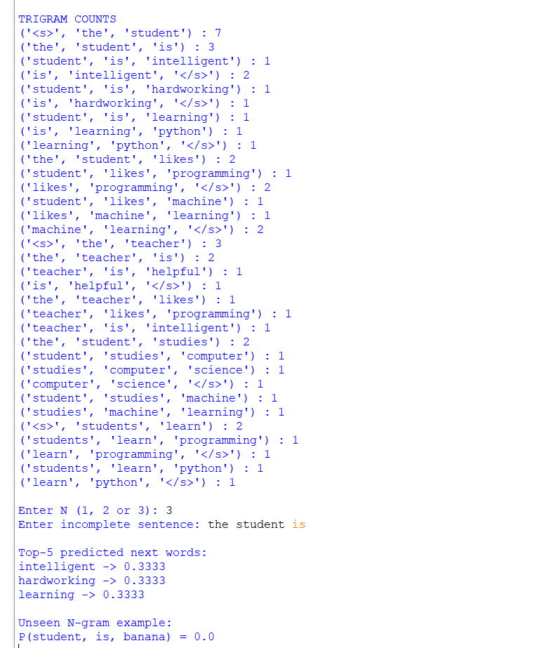

2)
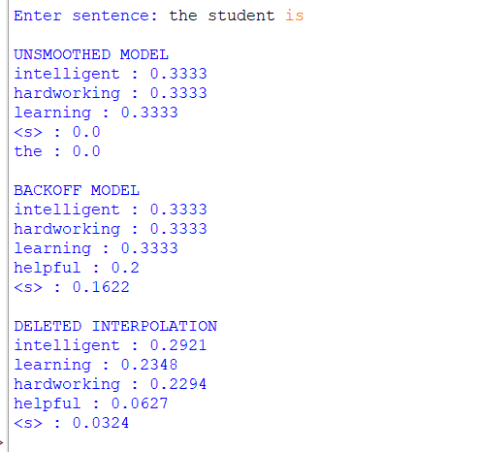
3)
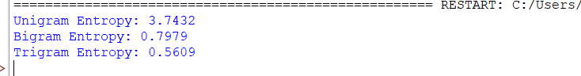
4a)
4b)
4c)

Rubrics for Calculation

Criteria | Weightage (%) | Level 4 – Exemplary (4) | Level 3 – Proficient (3) | Level 2 – Developing (2) | Level 1 – Beginning (1)
Understanding of Concept | 25% | Demonstrates complete understanding of design requirements and concepts | Good understanding with minor gaps | Basic understanding with some errors | Poor understanding or incorrect concepts
Design / Implementation | 30% | Well-structured, efficient, and responsive design implementation | Correct implementation with minor issues | Basic implementation with inconsistencies | Incorrect or incomplete implementation
Use of Tools | 20% | Effective and advanced use of tools/techniques | Appropriate use of tools | Limited or inconsistent use | Incorrect or minimal use
Analysis & Evaluation | 15% | Insightful analysis with strong justification and optimization | Good analysis with justification | Basic analysis with limited depth | Poor or no analysis
Documentation / Clarity | 10% | Clear, well-structured, and properly presented solution | Mostly clear with minor issues | Basic clarity, missing details | Poor or unclear documentation

Q. No. / Criteria Level | Understanding of Concepts | Experimental Design | Use of Tools | Analysis of Results | Documentation | Sub. Total | Total %
1
2
3
4

Faculty In-charge | Course Coordinator | Program Director
Signature: _______________ | Signature: _______________ | Signature: _______________
Date: ___________________ | Date: ___________________ | Date: ___________________

