horizontal line

## Software Requirements Specification

New Rich World

**12th July 2017**

Version 2.0

# 

# TABLE OF CONTENTS

I. OVERVIEW 2

II. GOALS 2

III. ASSSUMPTIONS 2

IV. USER REQUIREMENTS 3

1. Actors 3

2. Use Case Model 1

3. Use Case Catalogue 1

4. Application Flows 1

V. FUNCTIONAL REQUIREMENTS 3

1. UC 1: Register Account 3

2. UC 2: Login/Logout 6

3. UC 3: Forgot Password 7

4. UC 4: Launch Home Page 9

5. UC 5: Send Message 11

6. UC 6: Notification Page 13

7. UC 7: Create New Service 15

8. UC 8: Edit Service 16

9. UC 9: Join Service 18

10. UC 10: Create New Goal 20

11. UC 11: Edit Goal 22

12. UC 12: Update My Profile 24

13. UC 13: View Statistic 26

VI. NON-FUNCTIONAL REQUIREMENTS 29

VII. SUPPORTING INFORMATION 29

1. Pop-up Layout 29

2. Messages 29

# RECORD OF CHANGES

|  |  |  |  |
| --- | --- | --- | --- |
| **Version** | **Date** | **Author** | **Detail** |
| 1.0 | 13 July, 2017 |  | Initial Software Requirements Specification. |
| 2.0 | 27 July, 2017 |  | Update use case |

# OVERVIEW

This section of the Software Requirements Specification (SRS) provides an overview of the entire SRS with purpose, business objectives, scope, glossary, assumptions, constraints, and dependencies of the project.

The software described in this document is the newrichworld.com application and associated support pages. The purpose of this project is to create a New Rich World application for connecting mentee and mentor with their interested learning course.

# GOALS

This document seeks to provide the SRS for the New Rich World application. The purpose of this document is to record the requirements for the design and development of the application. There may be a need for future updates of the application. The document reflects the current requirements of the project as understood by the project team. This document presents an initial description of the various functionalities and services that the application provides. The document will also serve as the basis for acceptance testing by the user.

# ASSSUMPTIONS

|  |  |
| --- | --- |
| **Ref** | **Assumption** |
| 1 | For technology, we will follow the application <http://www.newrichworld.com/>. |
| 2 | We will use default roles in the system: Mentee and Mentor. |
| 3 | Language: English only. |
| 4 | Product Owner is client. |
| 5 | No Database migration. |
| 6 | Main testing device is IPhone 6 and later. |
| 7 | Screen resolution as 1334 x 750 pixels, matching the density of the 326ppi and over. |
| 8 | Support iOS version 0.9 and later, Android version 4.4 and later. |

# USER REQUIREMENTS

## Actors

|  |  |
| --- | --- |
| Actor | Description |
|  | End users who want to set goal of studying some general knowledge. These users are not permitted to update services of the application. |
|  | End users who want to open a service and allow Mentee to join their course to teach or transfer some general knowledge. These users are not permitted to update services of the application. |

## 

## Use Case Model

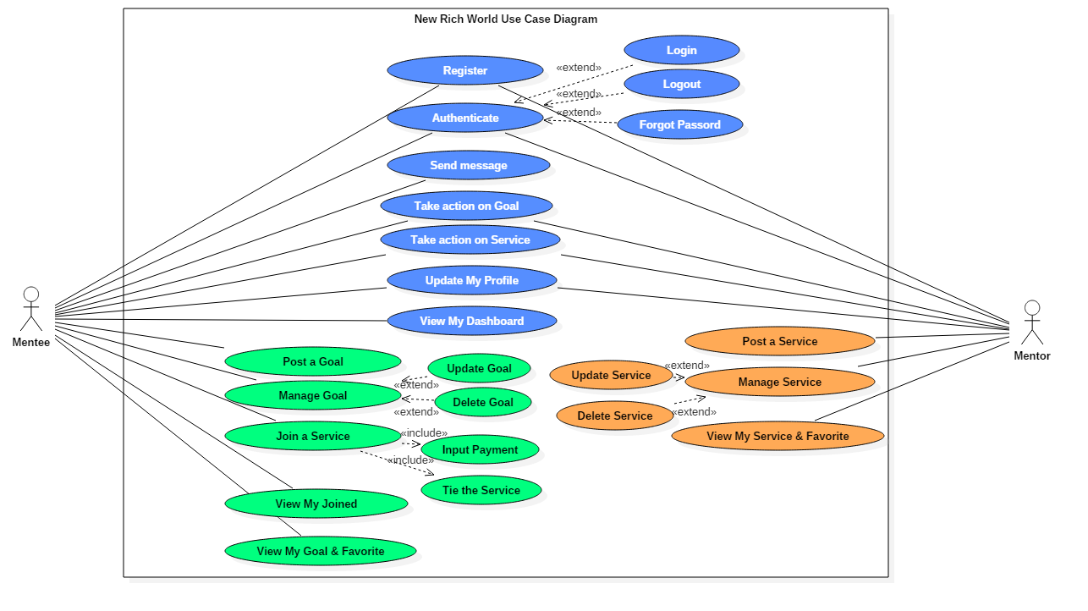

## Use Case Catalogue

|  |  |  |
| --- | --- | --- |
| Use Case | Primary Actor | Description |
| Register account | Mentee, Mentor | Mentee and Mentor can Create a new account which is not existing in New Rich World system. |
| Login/Logout | Mentee, Mentor | Mentee and Mentor can authenticate an account which is existing in New Rich World system. |
| Send message | Mentee, Mentor | Mentee and Mentor can send a message to another user in New Rich World system. |
| Create/Update/Delete Goal | Mentee | Mentee can create and manage a Goal which he or she owned in New Rich World system. |
| Create/Update/Delete Service | Mentor | Mentor can create and manage a Goal which he or she owned in New Rich World system. |
| Join a service | Mentee | Mentee can join a Service which Mentor created in New Rich World system. |
| Bookmark/Like/Dislike/Comment/Share/Add to Favorite a Goal | Mentee, Mentor | Mentee and Mentor can take actions on a Goal in New Rich World system. |
| Bookmark/Like/Dislike/Comment/Share/Add to Favorite a Service | Mentee, Mentor | Mentee and Mentor can take actions on a Goal in New Rich World system. |
| View My Profile | Mentee, Mentor | Mentee and Mentor can send their own profile in New Rich World system. |
| View My Dashboard | Mentee, Mentor | Mentee and Mentor can send their own Dashboard in New Rich World system. |
| View My Goal/Favorite | Mentee | Mentee and Mentor can view their all Goal list and favorite list and in New Rich World system. |
| View My Service/Favorite | Mentor | Mentee and Mentor can view their all Service list and favorite list and in New Rich World system. |
| View My Joined | Mentee | Mentee can join a Service which created by Mentor in New Rich World system. |

## Application Flows

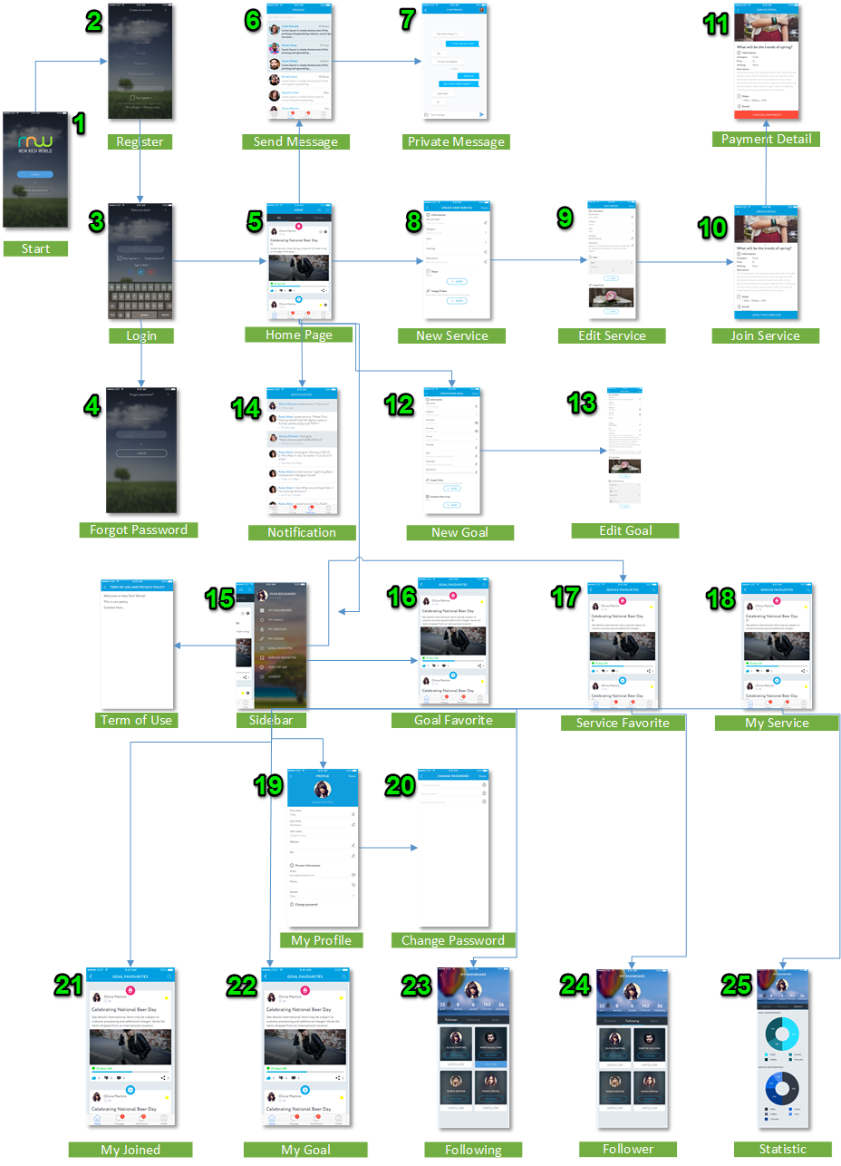

# FUNCTIONAL REQUIREMENTS

All the Use Cases in this New Rich World application will be defined specifically as case by case below. However, there are some duplicated User Interfaces in some Use Cases, the Use Case Description will not be mentioned again as more detail. Please refer the Application Flow and Use Case Catalogue for more information.

## UC 1: Register Account

|  |  |
| --- | --- |
| Objective | This UC is allowed user to register a new account in the New Rich World application. |
| Actor | Mentee and Mentor |
| Trigger | From the first launch application, user click on the button “Create an account” |
| Pre-conditions | User has no existing account on the system. |
| Post-condition | Create a new account successfully. |

### **User Interface**

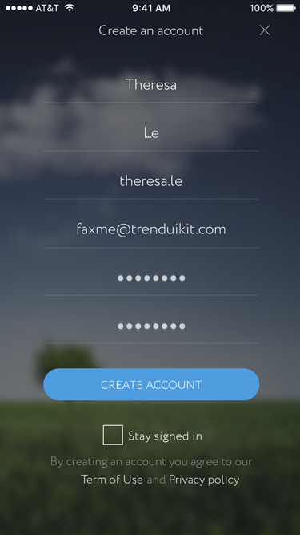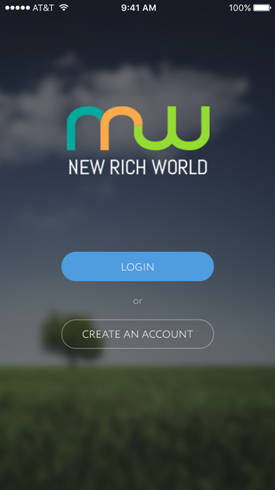

*1.1 – Started Page 1.2 – Register Page*

### **UC Description**

|  |  |  |  |
| --- | --- | --- | --- |
| Current screen | Description | Action | Next |
| Started Page | New Rich World logo | User can just View. |  |
| Started Page | Create An Account button | Click on. | 1.2 Register Page |
| Register Page | First Name textbox (*) | * Free text and number. * Type: Required . |  |
| Register Page | Last Name textbox (*) | * Free text and number. * Type: Required. |  |
| Register Page | Email textbox (*) | * Input text and number, free text & number. * Type: required * Format: abc@def.com * Include “@”. If users does not input @, the system will notify warning message. * Include “.” In the address * Condition: register email address is not existing on the current system (count on the day User registers) * Example: faxme@trenduikit.com | * Successful: **Error! Reference source not found.**   Unsuccessful: **Error! Reference source not found.** |
| Register Page | Password textbox | * Input text and number as following rules: * Has 8 Characters, Minimum * Includes Numbers, Symbols, Capital Letters, and Lower-Case Letters * Isn’t a Dictionary Word or Combination of Dictionary Words * Doesn’t Rely on Obvious Substitutions | * Show “notification” depends on number of rules: * Very Strong: 4 rules * Strong Enough: 3 rules * Weak: 2 rules * Very weak: 1 rule ONLY |
| Register Page | Password Repeat textbox (*) | * Type: required. * Input text and number has been matched with input password above as following rules: * Has 8 Characters, Minimum * Includes Numbers, Symbols, Capital Letters, and Lower-Case Letters * Not a Dictionary Word or Combination of Dictionary Words * Not rely on Obvious Substitutions | Password Not match: MSG 3 |
| Register Page | Create An Account button | Click on. | * Successful: MSG 4 * Unsuccessful: MSG 5 |
| Register Page | Term of Use link | Click on. | Term of Use pop-up. |
| Register Page | Privacy Policy | Click on. | Privacy Policy pop-up. |

## UC 2: Login/Logout

|  |  |
| --- | --- |
| Objective | This UC is allowed user to login or logout for an account in the New Rich World application |
| Actor | Mentee and Mentor |
| Trigger | For the first launch application, user click on the button “Login”. |
| Pre-conditions | N/A. |
| Post-condition | Login into the system successfully. |

### **C:\Users\THANH AN\Google Drive\HTGSoft - NewRichWorld\BA upload\DesignUI\01-Login-2.pngUser Interface**

*2.1 – Login Page*

### **UC Description**

|  |  |  |  |
| --- | --- | --- | --- |
| Current screen | Description | Action | Next |
| Login Page | Email textbox | * Input text and number, free text & number. * Format: abc@def.com * Include “@”. If users does not input @, the system will notify warning message. * Include “.” In the address * Validation condition: register email address is not existing on the current system (count on the day User registers) * Example: faxme@trenduikit.com | * Successful: **Error! Reference source not found.**   Unsuccessful: **Error! Reference source not found.** |
| Login Page | Password textbox | * Input text and number as following rule: |  |
| Login Page | Login button | * Click on. * Validation condition: The system check with the authentication information of user input and validate.   + If the authentication information is correct, system returns the successful message   + If the authentication information is incorrect, system returns the unsuccessful message | * Successful: MSG 6 * Unsuccessful: **Error! Reference source not found.** |
| Login Page | Stay signed in checkbox | * User can check/uncheck on the checkbox:   + Check: the system will auto login for the next time.   + Uncheck: the system will NOT auto login for the next time, user has to login again. |  |
| Login Page | Forgot password | Click on. | 3.1 - Forgot Password Page |
| Login Page | Sign in with | * There are 3 types of social network for user chooses when he/she has already had account then:   + Facebook   + Twitter   + Google Plus |  |

## UC 3: Forgot Password

|  |  |
| --- | --- |
| Objective | This UC is allowed user to register a new account in the New Rich World application |
| Actor | Mentee and Mentor |
| Trigger | For the first launch application, user click on the button “Create an account” |
| Pre-conditions | User has no existing account on the system. |
| Post-condition | Create a new account successfully. |

### **User Interface**

**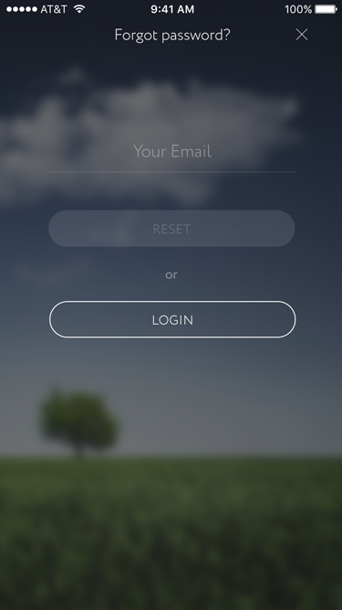***3.1 – Forgot Password*

### **UC Description**

|  |  |  |  |
| --- | --- | --- | --- |
| Current screen | Description | Action | Next |
| Forgot Password | Email textbox | * Input text and number, free text & number. * Format: abc@def.com * Include “@”. If users does not input @, the system will notify warning message. * Include “.” In the address * Condition: register email address is not existing on the current system (count on the day User registers) * Example: faxme@trenduikit.com |  |
| Forgot password | Reset button | * Click on. * Validation condition: The system will send the auto-password to user’s email (authentication information) right after clicking.   + If the email sends successfully, system would have pop-up to notify.   + If the email sends with error, the system will have pop-up to notify.   Click on. | * Send reset email without error: MSG 8 * Send reset email with error: MSG 9 |
| Forgot password | Login button | Click on. | 2.1 Login Page |

## UC 4: Launch Home Page

|  |  |
| --- | --- |
| Objective | This UC is allowed user to launch the Home Page in the New Rich World application |
| Actor | Mentee and Mentor |
| Trigger | After authentication, the system will automatically launch the Home Page. |
| Pre-conditions | N/A. |
| Post-condition | User can launch the Home Page and take action on page successfully. |

### **User Interface**

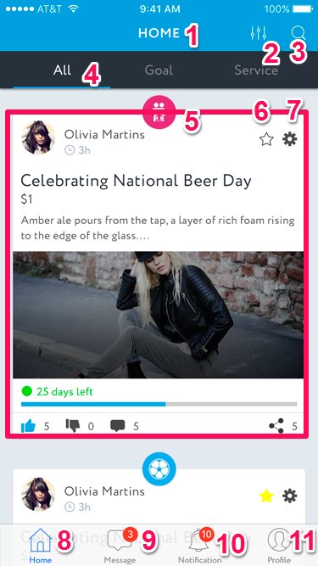

*4.1 – Home Page*

### **UC Description**

|  |  |  |  |
| --- | --- | --- | --- |
| Current screen | Description | Action | Next |
| Home Page | 1. Page Title | The system will show the title which is consistent with the page name. |  |
| Home Page | 1. Filter button | * Click on * Filter as category of the post. |  |
| Home Page | 1. Search button | * Click on, input free text * This function is supported searching for specific Category, Goal, Service all over the system. | * Search Page (see Application Flow) |
| Home Page | 1. Taskbar | * Click on (view Login Page as detail in part 3.2) * Format: There are 3 tabs as following:   + All   + Goal   + Service | * Home Page * All tab * Goal tab * Service tab |
| Home Page | 1. Category and Post information | * Click on wherever in the post area. * The system show the icon which is consistent with category of the post. There are many categories: * Health * Fitness * Leisure * Happiness * Food * Career * Love * Relationship * Spirituality * Wealth and Family * Faith * Nonprofit * Finance * Business… | Goal detail Service detail |
| Home Page | 1. Favorite button | * Click on * For user who wants to add Goal or Service into Goal Favorite Page or Service Favorite Page | * Goal Favorite * Service Favorite (see Application Flow) |
| Home Page | 1. Edit or Delete button | * Click on * There are 2 options for user who created their own post to choose:   + Edit Goal or Service   + Delete Goal or Service | * 7.1- Edit Goal or 10.1- Edit Service   Delete Goal or Delete Service message: MSG 10 |
| Home Page | 1. Home button | Click on | 4.1 - Home Page |
| Home Page | 1. Message button | Click on | 5.1 – Send Message |
| Home Page | 1. Notification button | Click on | 6.1 - Notification Page |
| Register Page | 1. Profile | Click on | * 1. – Update My Profile |

## UC 5: Send Message

|  |  |
| --- | --- |
| Objective | This UC is allowed user to send message to another user in the New Rich World application |
| Actor | Mentee and Mentor |
| Trigger | From the Home Page, user click on the icon “Send message” |
| Pre-conditions | N/A. |
| Post-condition | Send message to another user successfully. |

### **User Interface**

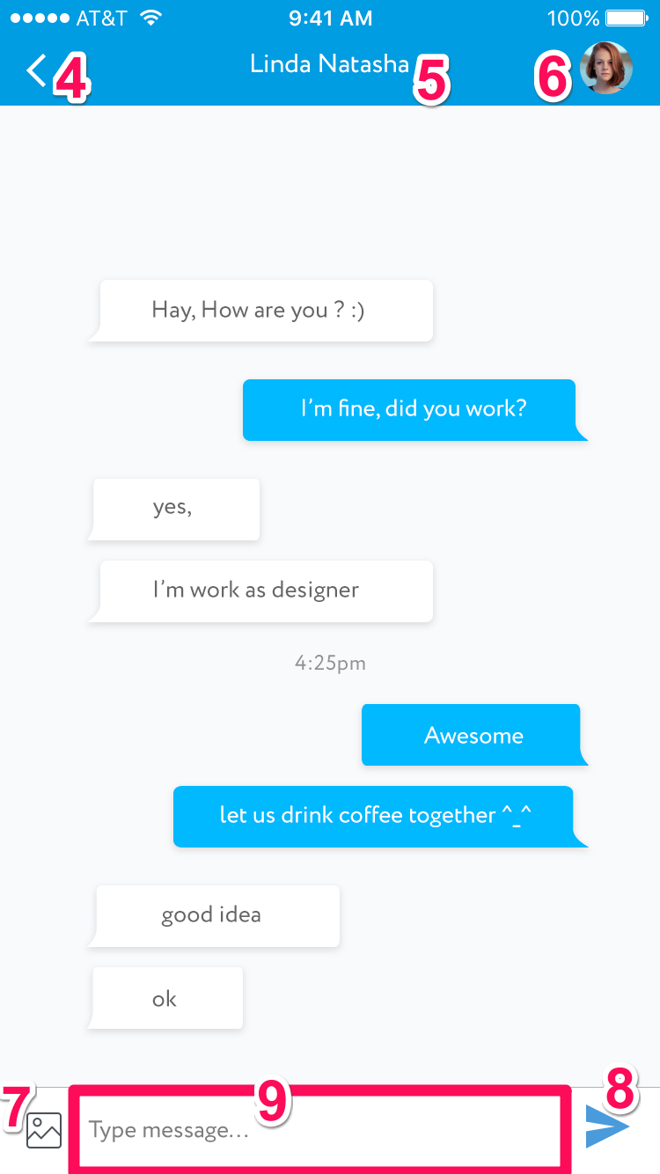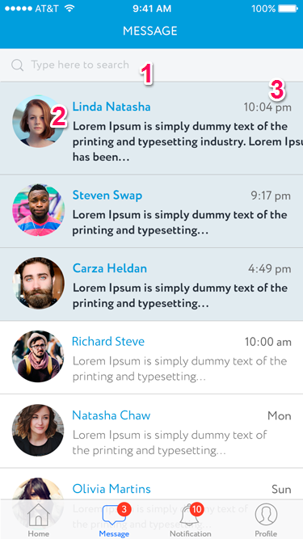

### *5.1 - Send Message 5.2 – Private Message*

### **UC Description**

|  |  |  |  |
| --- | --- | --- | --- |
| Current screen | Description | Action | Next |
| Message Page | 1. Search area | * Free text. * When user type any search information, the system will show the real-time suggestion. User pick one option to view search result below. This function is supported search with Goal/Service/Category/All |  |
| Message Page | 1. Profile picture | The system shows Profile picture of User. |  |
| Message Page | 1. Chat info and chat time | The system shows Username and chat summary and the last time of last message. Unread message will be highlighted as dark blue bar.  Format: hh:mm | 5.2 - Private Message |
| Private Message Page | 1. Back button | Click on. | 5.1 - Message Page |
| Private Message Page | 1. Username | User just view the other username who is chatting with. |  |
| Private Message Page | 1. Picture icon | The system shows Profile picture of User. |  |
| Private Message Page | 1. Picture button | * Click on. * User chooses existing pictures in mobile library |  |
| Private Message Page | 1. Send button | * Click on. * The message content will be put as one more message into the Private Message Page. |  |
| Private Message Page | 1. Type message area | * Free text and number. |  |

## UC 6: Notification Page

|  |  |
| --- | --- |
| Objective | This UC is allowed user to launch the Notification Page and take action on page in the New Rich World application |
| Actor | Mentee and Mentor |
| Trigger | From the Home Page, user click on the icon “Notification” |
| Pre-conditions | N/A. |
| Post-condition | User can launch and take action on page successfully. |

### **User Interface**

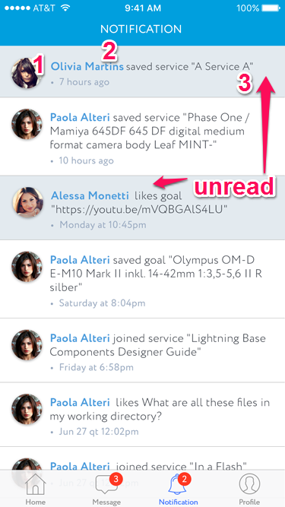

*6.1 – Notification Page*

### **UC Description**

|  |  |  |  |
| --- | --- | --- | --- |
| Current screen | Description | Action | Next |
| Notification Page | Profile picture | The system shows Profile picture of User. |  |
| Notification Page | Username | The system shows Username and chat summary of last message |  |
| Notification Page | Notification | The system shows the activities of users who has the connection with current user. |  |

## UC 7: Create New Service

|  |  |
| --- | --- |
| Objective | This UC is allowed Mentor to create a new service in the New Rich World application. |
| Actor | Mentor |
| Trigger | From the Home Page application, user click on the button “Create Service”. |
| Pre-conditions | N/A. |
| Post-condition | User can create a Service successfully. |

### **User Interface**

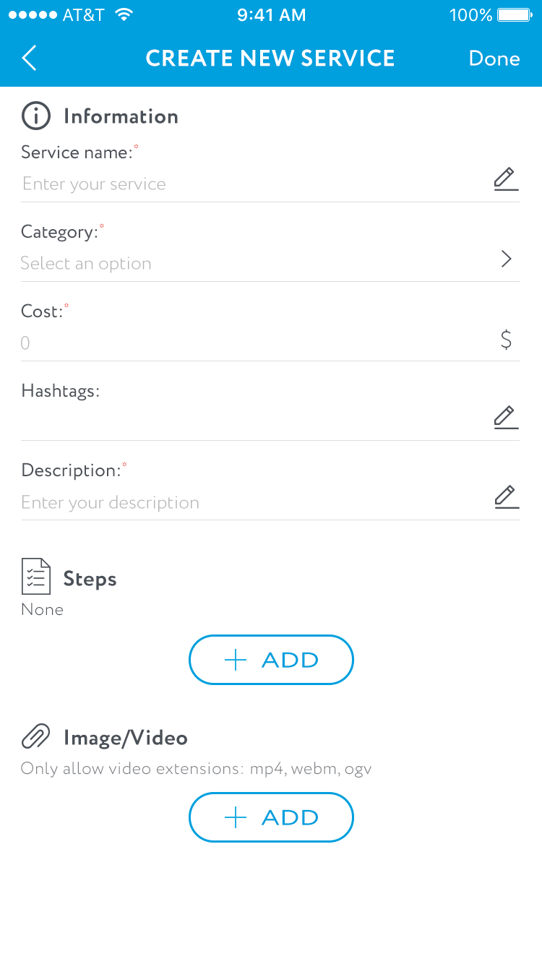

*7.1 – New Service Page*

### **UC Description**

|  |  |  |  |
| --- | --- | --- | --- |
| Current screen | Description | Action | Next |
| New Service Page | Service Name textbox (*) | * Format: Free text and number. * Type: required field. |  |
| New Service Page | Category dropdown box (*) | * Format: Free text and number. * Type: required field. |  |
| New Service Page | Cost textbox (*) | * Format: Number only. * Type: required field. |  |
| New Service Page | Hashtags textbox | * Format: Free text and number. * Type: optional field. |  |
| New Service Page | Description textbox (*) | * Format: Free text and number. * Type: required field. |  |
| New Service Page | Add Step button | * User adds step by step. |  |
| New Service Page | Add Video/Image button | * User adds video or image step by step. |  |

## UC 8: Edit Service

|  |  |
| --- | --- |
| Objective | This UC is allowed Mentor to edit service in the New Rich World application. |
| Actor | Mentor |
| Trigger | From the Home Page application, user click on the button “Edit Service”. |
| Pre-conditions | N/A. |
| Post-condition | User can edit a Service successfully. |

### **User Interface**

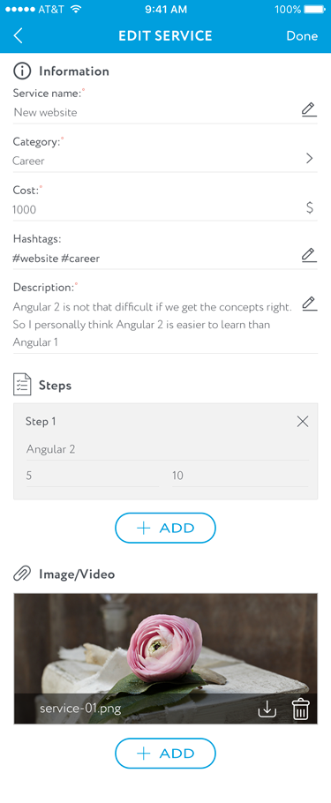

*8.1 – Edit Service Page*

### **UC Description**

|  |  |  |  |
| --- | --- | --- | --- |
| Current screen | Description | Action | Next |
| Edit Service Page | Service Name textbox (*) | * Format: Free text and number. * Type: required field. |  |
| Edit Service Page | Category dropdown box (*) | * Format: Free text and number. * Type: required field. |  |
| Edit Service Page | Cost textbox (*) | * Format: Number only. * Type: required field. |  |
| Edit Service Page | Hashtags textbox | * Format: Free text and number. * Type: optional field. |  |
| Edit Service Page | Description textbox (*) | * Format: Free text and number. * Type: required field. |  |
| Edit Service Page | Add Step button | * User adds step by step. |  |
| Edit Service Page | Add Video/Image button | * User adds video or image step by step. |  |

## UC 9: Join Service

|  |  |
| --- | --- |
| Objective | This UC is allowed user to join Service and access payment in the New Rich World application. |
| Actor | Mentee |
| Trigger | * From the Service Detail Page, user click on the button “Join Service”. * Click on the “Payment” button |
| Pre-conditions | N/A. |
| Post-condition | User can join Service and access payment successfully. |

### **User Interface**

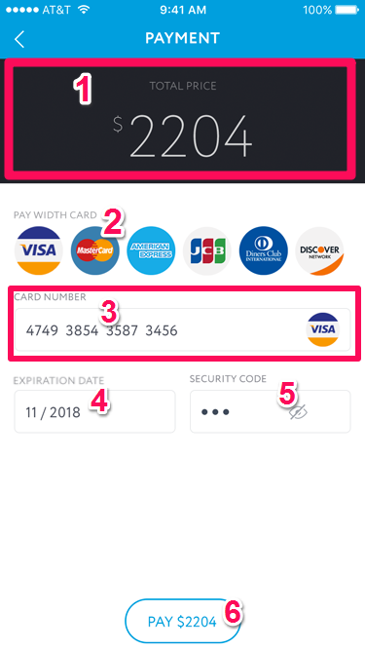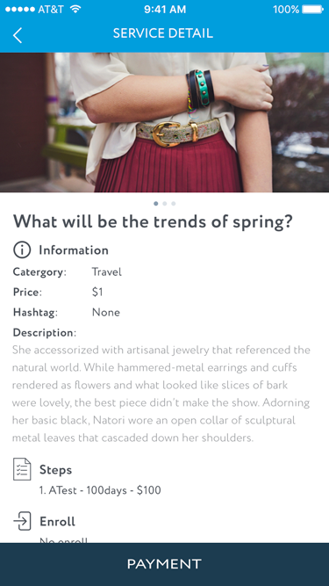

*9.1 – Payment Page 9.2 – Payment Detail Page*

### **UC Description**

|  |  |  |  |
| --- | --- | --- | --- |
| Current screen | Description | Action | Next |
| Payment Detail Page | 1. Total Price | * Format: Number. * This is the Price field of Service which Mentor inputs |  |
| Payment Detail Page | 1. Pay With Card | * Click on * The system shows available supported card on New Rich World for user to choose. |  |
| Payment Detail Page | 1. Card Number textbox (*) | * Format: Number ONLY. * Type: required field. |  |
| Payment Detail Page | 1. Expire Date textbox (*) | * Format: MM/YYYY. * Type: required field. |  |
| Payment Detail Page | 1. Security Code (*) | * Format: number ONLY. * Type: required field. |  |
| Payment Detail Page | 1. Total Pay button | * This is sum of all paid part above and continue to confirm payment. | Processing Payment of the specific user’s bank. |

## UC 10: Create New Goal

|  |  |
| --- | --- |
| Objective | This UC is allowed Mentor to create a new goal in the New Rich World application. |
| Actor | Mentee |
| Trigger | From the Home Page application, user click on the button “Create Goal”. |
| Pre-conditions | N/A. |
| Post-condition | User can create a new Goal successfully. |

### **User Interface**

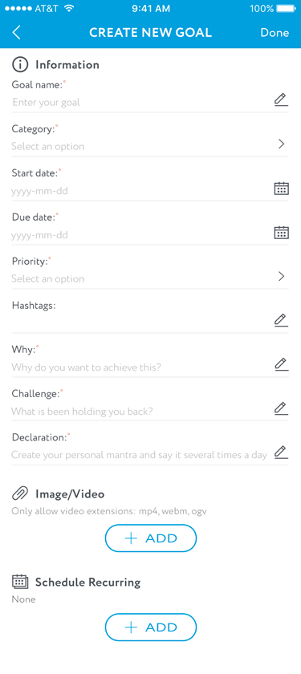

* 1. *- New Goal Page*

### **UC Description**

|  |  |  |  |
| --- | --- | --- | --- |
| Current screen | Description | Action | Next |
| New Goal Page | Goal Name textbox (*) | * Format: Free text and number. * Type: required field. |  |
| New Goal Page | Category dropdown box (*) | * Free text and number. * Type: required field. |  |
| New Goal Page | Start Date picker (*) | * Format: DD/MM/YYYY. * Type: required field. |  |
| New Goal Page | Due Date picker (*) | * Free text and number. * Type: required field. |  |
| New Goal Page | Priority dropdown box (*) | * Data: * Critical - 1 * High - 2 * Medium - 3 * Low - 4 * Type: required field. |  |
| New Goal Page | Hashtags textbox | * Free text and number. * Type: optional field. |  |
| New Goal Page | Why (*) | * Format: DD/MM/YYYY. * Type: required field. |  |
| New Goal Page | Challenge (*) | * Free text and number. * Type: required field. |  |
| New Goal Page | Declaration (*) | * Free text and number. * Type: required field. |  |
| New Goal Page | Add Video/Image button | * User adds step by step. |  |
| New Goal Page | Add Schedule button | * User adds video or image step by step. |  |

## UC 11: Edit Goal

|  |  |
| --- | --- |
| Objective | This UC is allowed Mentor to update goal in the New Rich World application. |
| Actor | Mentee |
| Trigger | From the Home Page application, user click on the button “Edit Goal”. |
| Pre-conditions | N/A. |
| Post-condition | User can update Goal successfully. |

### **User Interface**

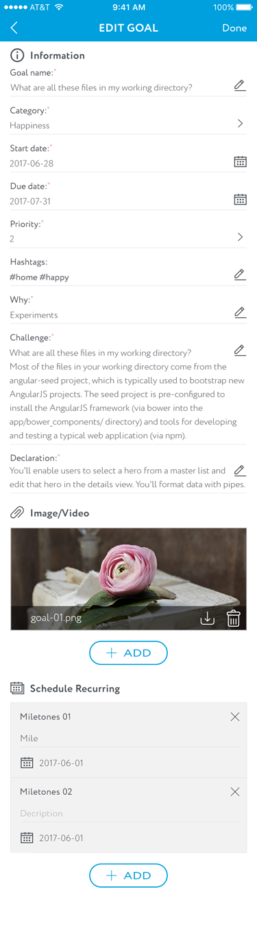

*11.1 - Update Goal Page*

### **UC Description**

|  |  |  |  |
| --- | --- | --- | --- |
| Current screen | Description | Action | Next |
| New Goal Page | Goal Name textbox (*) | * Format: Free text and number. * Type: required field. |  |
| New Goal Page | Category dropdown box (*) | * Free text and number. * Type: required field. |  |
| New Goal Page | Start Date picker (*) | * Format: DD/MM/YYYY. * Type: required field. |  |
| New Goal Page | Due Date picker (*) | * Free text and number. * Type: required field. |  |
| New Goal Page | Priority dropdown box (*) | * Data: * Critical - 1 * High - 2 * Medium - 3 * Low - 4 * Type: required field. |  |
| New Goal Page | Hashtags textbox | * Free text and number. * Type: optional field. |  |
| New Goal Page | Why (*) | * Format: DD/MM/YYYY. * Type: required field. |  |
| New Goal Page | Challenge (*) | * Free text and number. * Type: required field. |  |
| New Goal Page | Declaration (*) | * Free text and number. * Type: required field. |  |
| New Goal Page | Add Video/Image button | * User adds step by step. |  |
| New Goal Page | Add Schedule button | * User adds video or image step by step. |  |

## UC 12: Update My Profile

|  |  |
| --- | --- |
| Objective | This UC is allowed Mentor to update user profile in the New Rich World application. |
| Actor | Mentee |
| Trigger | From the Home Page application, user click on the button “My Profile”. |
| Pre-conditions | N/A. |
| Post-condition | User can update user profile successfully. |

### **User Interface**

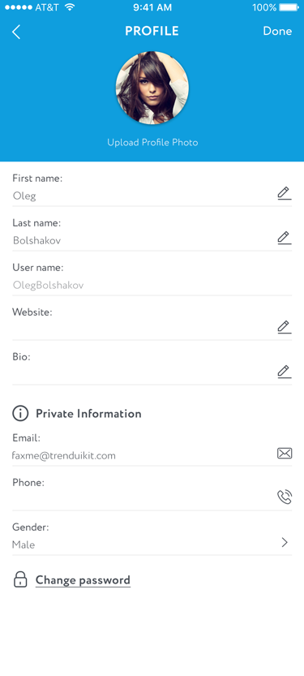

*12.1 - Update My Profile*

### **UC Description**

|  |  |  |  |
| --- | --- | --- | --- |
| Current screen | Description | Action | Next |
| Update My Profile | First Name textbox | Free text and number. |  |
| Update My Profile | Last Name textbox | Free text and number. |  |
| Update My Profile | Username textbox | Free text and number. |  |
| Update My Profile | Website textbox | * Input text and number, free text & number. * Format: www.def.com * Include “www”. If users does not input @, the system will notify warning message. * Include “.” In the address * Condition: register email address is not existing on the current system (count on the day User registers). |  |
| Update My Profile | Bio textbox | * Input text and number, free text & number. * 200 characters MAX. |  |
| Update My Profile | Email textbox | * Input text and number, free text & number. * Format: abc@def.com * Include “@”. If users does not input @, the system will notify warning message. * Include “.” In the address * Condition: register email address is not existing on the current system (count on the day User registers) * Example: faxme@trenduikit.com |  |
| Update My Profile | Phone textbox | * Input number ONLY. |  |
| Update My Profile | Gender dropdown box | * User chooses 3 types of gender: * Male * Female * Others |  |
| Update My Profile | Change Password button | Click on. | Change Password Page (See Application Flow) |

## UC 13: View Statistic

|  |  |
| --- | --- |
| Objective | This UC is allowed Mentor to update user profile in the New Rich World application. |
| Actor | Mentee |
| Trigger | From the Home Page application, user click on the button “My Profile”. |
| Pre-conditions | N/A. |
| Post-condition | User can update user profile successfully. |

### **User Interface**

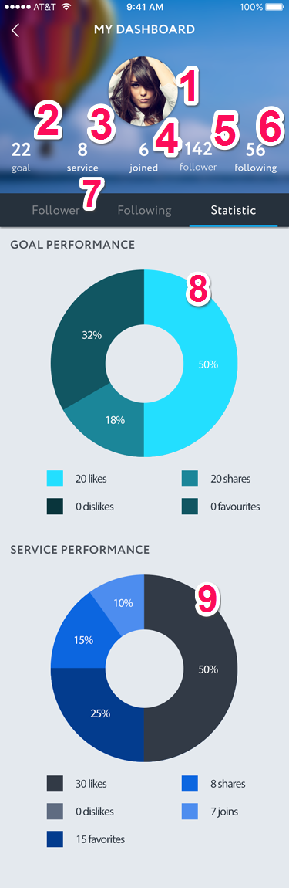

*13.1 – View Statistic*

### **UC Description**

|  |  |  |  |
| --- | --- | --- | --- |
| Current screen | Description | Action | Next |
| View Statistic | 1. Profile picture | The system shows Profile picture of User. |  |
| View Statistic | 1. Number of Goals | * Format: number ONLY. * This is the data of User owner. |  |
| View Statistic | 1. Number of Services | * Format: number ONLY. * This is the data of User owner. |  |
| View Statistic | 1. Number of Joined | * Format: number ONLY. * This is the data of User owner. |  |
| View Statistic | 1. Number of Follower | * Input text and number, free text & number. * 200 characters MAX. |  |
| View Statistic | 1. Number of Following | * Input text and number, free text & number. * Format: abc@def.com * Include “@”. If users does not input @, the system will notify warning message. * Include “.” In the address * Condition: register email address is not existing on the current system (count on the day User registers) * Example: faxme@trenduikit.com |  |
| View Statistic | 1. Accessing Tab | * Click on * There are 3 type of tabs for user to choose:   + Follower   + Following   + Statistic | For more information of Follower Page and Following Page, see Application Flow. |
| View Statistic | 1. Goal Performance pie chart | * The system will show the number of user interaction from the first launch to present with below elements: * Likes * Shares * Dislikes * Favorites |  |
| View Statistic | 1. Service Performance pie chart | * The system will show the number of user interaction from the first launch to present with below elements: * Likes * Shares * Dislikes * Favorites * Joins |  |

# NON-FUNCTIONAL REQUIREMENTS

*To base on the Assumption.*

# SUPPORTING INFORMATION

## Pop-up Layout

*To base on the Mockup Design Version 1.0 package.*

## Messages

| Message | Title | Body | Remark |
| --- | --- | --- | --- |
| MSG 1 |  | This email address does not exist in our system. |  |
| MSG 2 |  | This email address is currently existing in our system. |  |
| MSG 3 |  | Password does not match. |  |
| MSG 4 |  | New account created successfully. Please check your account for confirmation! |  |
| MSG 5 |  | There is some missing information. Please check again! |  |
| MSG 6 |  | Login successfully! |  |
| MSG 7 |  | Login unsuccessfully! Please check your email or your password again. |  |
| MSG 8 |  | Your account has been reset. Please check your email for the confirmation. |  |
| MSG 9 |  | There some issue when reset your email. Please try to reset it again. |  |
| MSG 10 | Delete Goal (or Delete Service) | Are you sure you want to delete this Goal (or Service)? | * Type: Confirmation pop-up * Choices: Yes, No |