EuroGrid

- how far are open prices from each other?

First 5 means: 1.26, 2.19, 3.23, 4.12, 5.12

First 5 medians: 0.8, 1.6, 2.5, 3.4, 4.1

- lot sizes? 0.01 yes

- if trade has no SL, what % is it closing on? how many pips is it going against direction? average p/l sl & pip

- why is it opening at 0.01 lot size? (until it goes to a certain pips that it uses incremental pip size)

- when it’s starting to use increments, what’s the max trades before it gives up (by TP/SL)?

56% of trades doesn’t start with 0.01 lot size

- average number of trades to close out in profit for incremental hedges

Mean number of trades: 12 trades (incl. initial trade) = 11 hedges

Median number of trades: 6 trades (incl. initial trade) = 5 hedges

- what are the drawdowns of initial hedges?

Mean drawdown in pips: -9.1 pips

Median drawdown in pips: -4.0 pips

- lot sizes increases by a factor of 0.01??

no, lot size mostly stays constant at 0.01

- max trades per hedging within max lot starting with min lot?

There are no max trades per hedging.

- find daily profit on average

Mean Daily Profit in dollars: $4.65

Median Daily Profit in dollars: $1.59

- average profit of all hedges

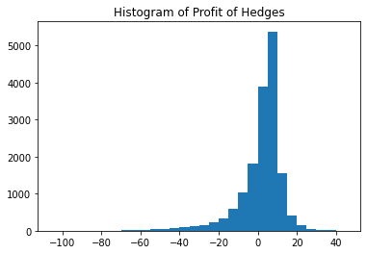

Mean profit of all hedges: 1.73 pips

Median profit of all hedges: 4.67 pips

