SPICY BITES

Food Ordering Webpage
Consolidated Project Report
Delicious Food. Premium Taste.
HTML + CSS | Beginner Web Development Project
Prepared from the HTML and CSS code provided for the Spicy Bites food menu webpage.

Project Overview
Project name: Spicy Bites – Food Ordering Webpage
Objective: To create a clean food menu page that displays food items, prices, ratings, promotional offers, and Order Now buttons.
Technologies used: HTML for webpage structure and CSS for styling and layout.
Design theme: Navy blue, gold, white, and a light grey background for a premium restaurant look.
Feature | Description
Header | Displays the SPICY BITES brand name and tagline.
Food cards | Three menu items: Chicken Biryani, Veg Pizza, and Classic Burger.
Price and rating | Each card displays a price in rupees and a star rating.
Offers | Shows 10% OFF, Free Delivery, and Fresh & Tasty labels.
Order buttons | Buttons are visual only; no JavaScript or ordering backend is connected.

Webpage Screenshot
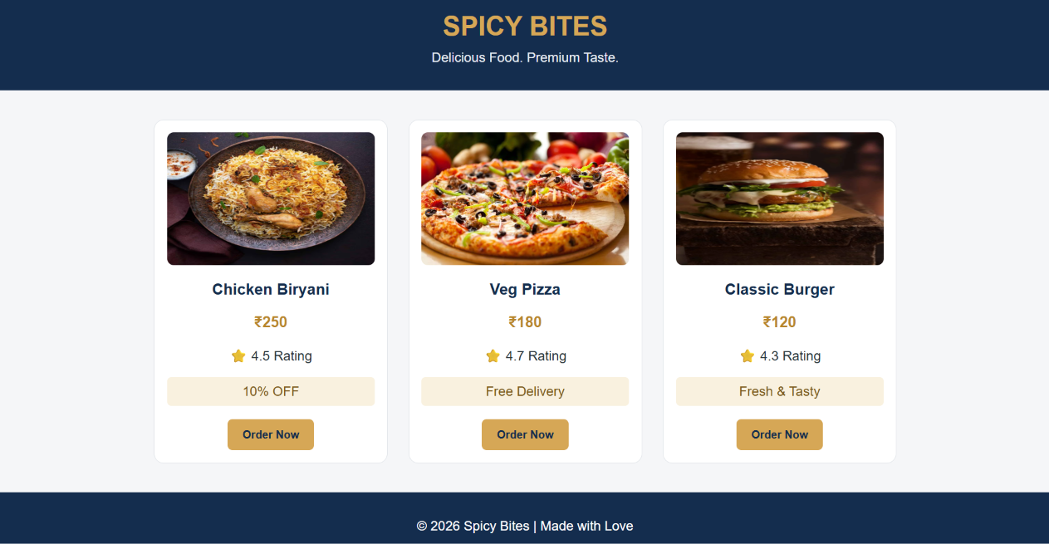
Figure 1. Visual preview of the webpage layout. Food illustrations are placeholders because the external image URLs could not be loaded in the rendering environment.

Main Features
Feature | Description
Responsive layout | Flexbox and flex-wrap allow the cards to wrap on narrower screens.

HTML and CSS Summary
HTML defines the page sections, menu cards, food images, prices, ratings, offers, buttons, and footer. CSS controls colors, spacing, borders, rounded corners, typography, and Flexbox layout.

Conclusion
Spicy Bites is a beginner-friendly static webpage demonstrating core HTML and CSS concepts. To make it functional, JavaScript and an order form or cart can be added later.

Appendix A – Source Code
Source HTML used for the webpage preview:
<!DOCTYPE html>
<html>
<head>
<meta charset="UTF-8">
<meta name="viewport" content="width=device-width, initial-scale=1.0">
<title>Spicy Bites - Food Ordering</title> <style> body { font-family: Arial, sans-serif; margin: 0; background: #F5F6F8; color: #263238; } header { background: #142D4E; color: white; text-align: center; padding: 30px; } header h1 { margin-bottom: 10px; color: #D6A756; } header p { margin: 0; color: #E8EDF3; } .menu { display: flex; flex-wrap: wrap; justify-content: center; gap: 25px; padding: 35px 20px; } .food-card { background: white; width: 250px; border: 1px solid #E0E4E8; border-radius: 12px; text-align: center; padding: 15px; } .food-card img { width: 100%; height: 160px; object-fit: cover; border-radius: 8px; } h3 { color: #142D4E; } .price { color: #B8862B; font-weight: bold; font-size: 18px; } .offer { background: #F9F1DF; color: #795719; padding: 8px; border-radius: 5px; } button { background: #D6A756; color: #142D4E; border: none; padding: 11px 18px; border-radius: 6px; fontweight: bold; cursor: pointer; } button:hover { background: #C29440; } footer { background: #142D4E; color: white; text-align: center; padding: 15px; } </style>
</head>
<body>
<header><h1>SPICY BITES</h1><p>Delicious Food. Premium Taste.</p></header>
<div class="menu">
<div class="food-card">
<img src="https://media-assets.swiggy.com/swiggy/image/upload/f_auto,q_auto,fl_lossy/RX_THUMBNAIL/IMAGES/
VENDOR/2024/7/7/34bc033e-d8fb-45b5-bee5-c7814bf30812_918647.jpg" alt="Chicken Biryani">
<h3>Chicken Biryani</h3><p class="price">■250</p><p>■ 4.5 Rating</p><p class="offer">10% OFF</p><button type="button">Order Now</button> </div>
<div class="food-card">
<img src="https://media-cdn.tripadvisor.com/media/photo-s/1b/3d/36/a0/fresh-hand-stretched.jpg" alt="Veg
Pizza">
<h3>Veg Pizza</h3><p class="price">■180</p><p>■ 4.7 Rating</p><p class="offer">Free Delivery</p><button type="button">Order Now</button> </div>
<div class="food-card">
<img src="https://www.recipetineats.com/tachyon/2019/08/Avocado-Chicken-Burgers_9.jpg" alt="Burger"> <h3>Classic Burger</h3><p class="price">■120</p><p>■ 4.3 Rating</p><p class="offer">Fresh &amp; Tasty</ p><button type="button">Order Now</button> </div>
</div>
<footer><p>© 2026 Spicy Bites | Made with Love</p></footer>
</body>
</html>

