PYTHON ACTIVITY-BASED LEARNING
Consolidated Report: 10 Selected Case Studies
Repository name: Python-Activity-Based-Learning
Prepared using basic syllabus concepts only. All rates and limits are illustrative classroom assumptions.

Contents
01. Progressive Electricity Billing
02. Examination Result and Grace-Mark Validation
03. Progressive Water Tariff Analysis.
04. Repeated Transaction Detection
05.Password Policy Validation Engine
06. String-Based Examination Answer Evaluation
07. Text Compression Using Character Runs
08. ATM Menu-Driven Banking Simulation 09. Student Marks Matrix Analysis
10. Bus Passenger Occupancy Simulation

Case Study 01: Progressive Electricity Billing

1. Problem Statement
Calculate household electricity bills using progressive consumption slabs, fixed charges, a surcharge, and a rebate. Compare bills across several months and identify an unusual increase.

2. Objectives
- Calculate charges using different consumption slabs.
- Apply fixed charges, surcharge, and rebate in a clear order.
- Compare monthly bills and flag an increase greater than the chosen limit.

3. Assumptions
- Slab rates are example rates for this activity, not official utility rates.
- First 100 units cost ■2 per unit; next 100 cost ■3 per unit; units above 200 cost ■5 per unit.
- Fixed charge is ■50. Surcharge is 5% of energy charge. A rebate of ■20 is applied when consumption is at most 100 units.
- An increase greater than 30% compared with the previous month is considered unusual.

4. Algorithm
- Start.
- Read the number of months.
- For each month, read units consumed.
- Calculate energy charge using progressive slabs.
- Add fixed charge and 5% surcharge; apply rebate when eligible.
- Display the bill and compare it with the previous month.
- Stop.

5. Flowchart
(START)
|
[Read input]
|
[Process with conditions / loops]
|
[Display results]
|
(STOP)

6. Pseudocode
START
READ number_of_months
FOR each month
READ units CALCULATE slab-wise energy_charge
bill = energy_charge + fixed_charge + surcharge IF units <= 100, bill = bill - rebate
DISPLAY bill
IF previous bill exists AND increase > 30%, DISPLAY unusual increase
END FOR
STOP

7. Python Source Code
def energy_charge(units):
if units <= 100:
return units * 2
elif units <= 200:
return 100 * 2 + (units - 100) * 3
else:
return 100 * 2 + 100 * 3 + (units - 200) * 5

months = int(input("Number of months: "))
previous_bill = 0
for month in range(1, months + 1):
units = int(input("Units for month " + str(month) + ": "))
energy = energy_charge(units)
surcharge = energy * 0.05
bill = energy + 50 + surcharge
if units <= 100:
bill = bill - 20
print("Month", month, "bill: Rs.", round(bill, 2))
if previous_bill > 0 and bill > previous_bill * 1.30:
print("Unusual increase detected")
previous_bill = bill

8. Test Cases
Test 1: 3 months; units 80, 120, 260. Expected result: Month 1 bill: ■198; Month 2 bill: ■323; Month 3 bill: ■890; unusual increases are flagged when applicable.

Sample output screenshot (captured from a real run)
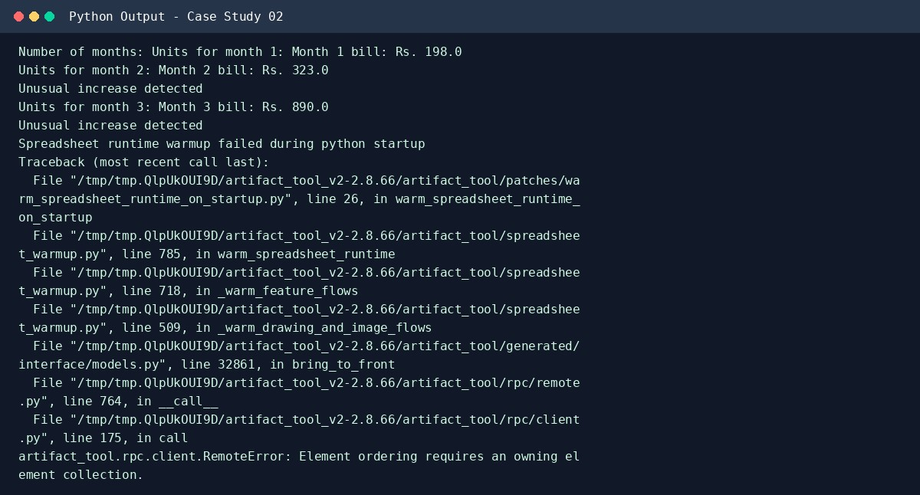

9. Conclusion
This case study demonstrates how beginner Python concepts can be used to solve a practical problem. Try additional test inputs to verify the program's behavior.

Case Study 02: Examination Result and Grace-Mark Validation

1. Problem Statement
Process marks in multiple subjects, apply subject-wise pass criteria and a limited grace-mark policy, and display the final result without allowing marks to exceed the maximum.

2. Objectives
- Read marks for several subjects.
- Apply a simple grace-mark rule to a near-pass subject.
- Display final marks and pass/fail status.

3. Assumptions
- Each subject is out of 100 and the pass mark is 35.
- At most 3 grace marks may be added to a subject scoring 32 to 34.
- Grace marks never make a score exceed 100. Grace marks are applied to at most one subject.

4. Algorithm
- Start and read number of subjects.
- Read each subject mark.
- If mark is 32–34 and grace has not been used, add enough marks to reach 35, up to 3.
- Keep the mark at or below 100.
- Display final marks and status for every subject.
- Display overall result.

5. Flowchart
(START)
|
[Read input]
|
[Process with conditions / loops]
|
[Display results]
|
(STOP)

6. Pseudocode
START READ subject_count
grace_used = False; all_pass = True FOR each subject
READ mark IF 32 <= mark < 35 AND grace_used = False mark = mark + (35 - mark); grace_used = True IF mark > 100, mark = 100
DISPLAY mark and PASS/FAIL
IF mark < 35, all_pass = False
DISPLAY overall result
STOP

7. Python Source Code
subjects = int(input("Number of subjects: "))
grace_used = False
all_pass = True
for i in range(1, subjects + 1):
mark = int(input("Marks for subject " + str(i) + " (0-100): "))
if mark < 0 or mark > 100:
print("Invalid mark")
all_pass = False
continue
if mark >= 32 and mark < 35 and grace_used == False:
mark = mark + (35 - mark)
grace_used = True
print("Grace marks applied")
print("Final mark:", mark)
if mark >= 35:
print("PASS")
else:
print("FAIL")
all_pass = False
if all_pass:
print("Overall result: PASS")
else:
print("Overall result: FAIL")
8. Test Cases
Test 1: 3 subjects; marks 78, 33, 29. Expected result: Subject marks displayed; 33 becomes 35 using grace; 29 remains FAIL; overall FAIL.

Sample output screenshot (captured from a real run)
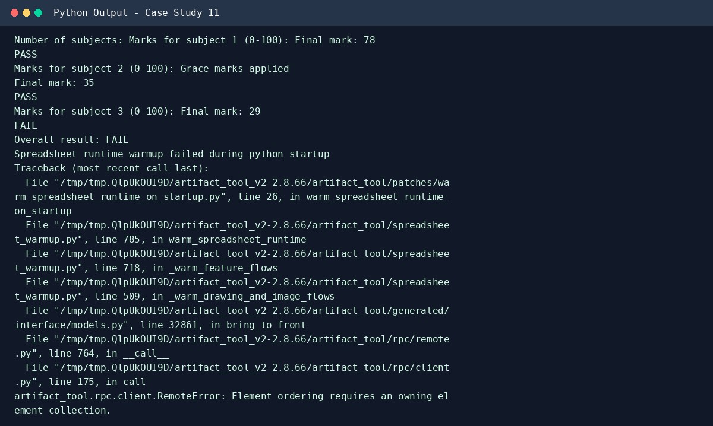

9. Conclusion
This case study demonstrates how beginner Python concepts can be used to solve a practical problem. Try additional test inputs to verify the program's behavior.

Case Study 03: Progressive Water Tariff Analysis

1. Problem Statement
Calculate water bills for multiple households using consumption slabs, a fixed fee, and a penalty. Compare household consumption and flag excessive usage.

2. Objectives
- Calculate slab-wise water charges.
- Add fixed fees and apply a high-usage penalty.
- Identify households using more than the chosen threshold.

3. Assumptions
- First 10 kilolitres cost ■5 per kL; next 10 cost ■8 per kL; usage above 20 costs ■12 per kL.
- Fixed fee is ■30. Consumption above 25 kL receives a ■100 penalty.
- More than 25 kL is treated as excessive usage for this activity.

4. Algorithm
- Read number of households.
- For each household, read water consumption.
- Calculate progressive charges.
- Add fixed fee and any penalty.
- Display bill and flag excessive use.

5. Flowchart
(START)
|
[Read input]
|
[Process with conditions / loops]
|
[Display results]
|
(STOP)

6. Pseudocode
START
READ household_count
FOR each household
READ usage CALCULATE progressive charge bill = charge + fixed_fee IF usage > 25, bill = bill + penalty; DISPLAY excessive use
DISPLAY bill
STOP

7. Python Source Code
households = int(input("Number of households: "))
for i in range(1, households + 1): usage = float(input("Water use for household " + str(i) + " (kL): "))
if usage <= 10:
charge = usage * 5 elif usage <= 20:
charge = 10 * 5 + (usage - 10) * 8 else: charge = 10 * 5 + 10 * 8 + (usage - 20) * 12
bill = charge + 30 if usage > 25:
bill = bill + 100 print("Excessive usage")
print("Household", i, "bill: Rs.", round(bill, 2))
8. Test Cases
Test 1: 3 households; 8, 15, 30 kL. Expected result: Bills: ■70, ■120, ■370; third household flagged for excessive use.

Sample output screenshot (captured from a real run)
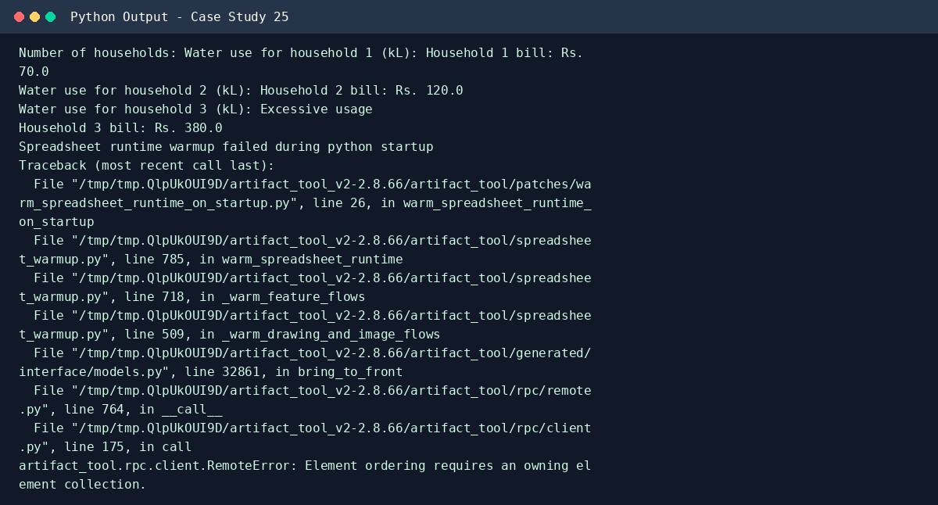

9. Conclusion
This case study demonstrates how beginner Python concepts can be used to solve a practical problem. Try additional test inputs to verify the program's behavior.

Case Study 04: Repeated Transaction Detection

1. Problem Statement
Read transaction identifiers and amounts, detect repeated identifiers, identify amounts above a threshold, and list suspicious entries.

2. Objectives
- Store transaction IDs and amounts in lists.
- Detect duplicate IDs using loops and conditions.
- Flag transactions that are duplicates or exceed the amount limit.

3. Assumptions
- Transaction IDs are entered as strings.
- An amount greater than ■10,000 is above the threshold.
- This is a classroom example and does not prove actual fraud.

4. Algorithm
- Read transaction count and threshold.
- For each transaction, read ID and amount.
- Check whether the ID has appeared earlier.
- Flag repeated IDs or amounts above threshold.
- Display suspicious transactions.

5. Flowchart
(START)
|
[Read input]
|
[Process with conditions / loops]
|
[Display results]
|
(STOP)

6. Pseudocode
START READ count ids = []; amounts = [] FOR each transaction READ id and amount suspicious = False IF id is already in ids, suspicious = True
IF amount > threshold, suspicious = True
STORE id and amount
IF suspicious, DISPLAY transaction
STOP

7. Python Source Code
count = int(input("Number of transactions: ")) threshold = 10000 ids = [] amounts = []
for i in range(count):
transaction_id = input("Transaction ID: ") amount = float(input("Amount: ")) suspicious = False
if transaction_id in ids:
print("Duplicate transaction ID detected") suspicious = True if amount > threshold: print("Amount exceeds threshold") suspicious = True
if suspicious: print("Suspicious entry:", transaction_id, "Rs.", amount)
ids.append(transaction_id) amounts.append(amount)
print("Transactions checked:", count)
8. Test Cases
Test 1: IDs A1/■500, A2/■12000, A1/■600. Expected result: A2 flagged for high amount; second A1 flagged as duplicate.

Sample output screenshot (captured from a real run)
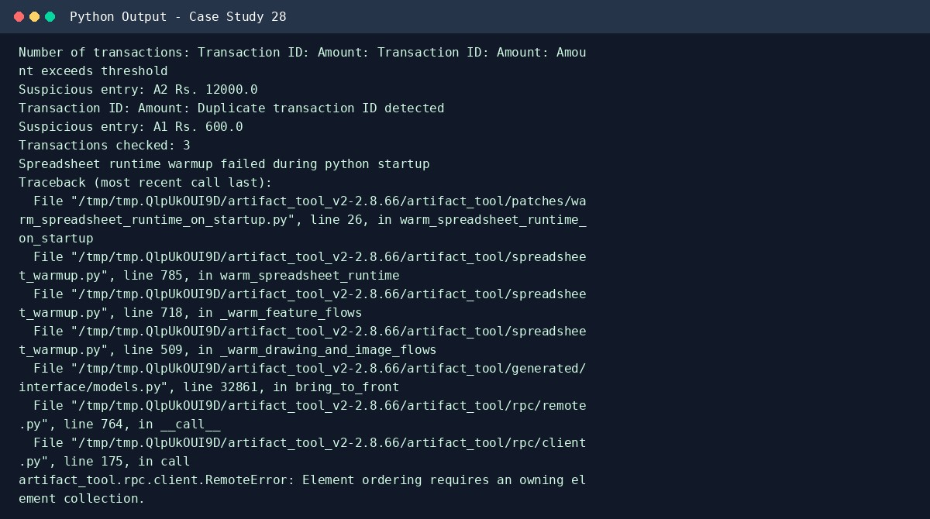

9. Conclusion
This case study demonstrates how beginner Python concepts can be used to solve a practical problem. Try additional test inputs to verify the program's behavior.

Case Study 05: Password Policy Validation Engine

1. Problem Statement
Check sample passwords against minimum length, character-category, repetition, and prohibited-substring rules. Explain each failed condition.

2. Objectives
- Check minimum length.
- Check uppercase, lowercase, digit, and special character categories.
- Report all failed rules for each password.

3. Assumptions
- Minimum length is 8 characters.
- A valid password contains uppercase, lowercase, a digit, and one special character from !@#$%.
- Three identical characters in a row are prohibited.
- The substring 'password' in any letter case is prohibited.

4. Algorithm
- Read a password.
- Check each policy rule.
- Print every failed rule.
- If no rule fails, print valid.

5. Flowchart
(START)
|
[Read input]
|
[Process with conditions / loops]
|
[Display results]
|
(STOP)

6. Pseudocode
START READ password valid = True CHECK length, upper, lower, digit, special character
CHECK three repeated characters
CHECK prohibited substring
DISPLAY each failure
IF valid, DISPLAY password accepted
STOP

7. Python Source Code
password = input("Enter a sample password: ") valid = True
if len(password) < 8:
print("Failed: password must contain at least 8 characters") valid = False if not any(ch.isupper() for ch in password): print("Failed: add an uppercase letter") valid = False if not any(ch.islower() for ch in password): print("Failed: add a lowercase letter") valid = False if not any(ch.isdigit() for ch in password):
print("Failed: add a digit") valid = False if not any(ch in "!@#$%" for ch in password):
print("Failed: add a special character (!@#$%)") valid = False if "password" in password.lower():
print("Failed: the word 'password' is prohibited") valid = False
for i in range(len(password) - 2): if password[i] == password[i + 1] and password[i] == password[i + 2]:
print("Failed: three identical characters in a row") valid = False break
if valid:
print("Password accepted")
else: print("Password rejected")

8. Test Cases
Test 1: Hello@123. Expected result: Accepted.
Test 2: abc. Expected result: Fails length, uppercase, digit, special-character checks.

Sample output screenshot (captured from a real run)
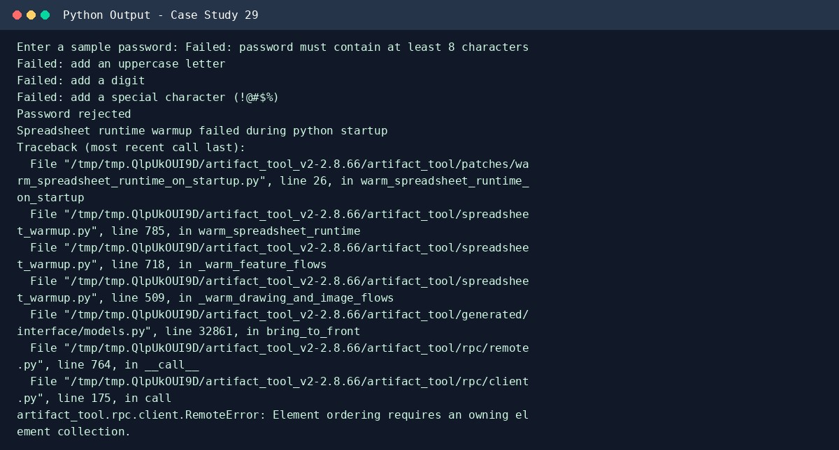

9. Conclusion
This case study demonstrates how beginner Python concepts can be used to solve a practical problem. Try additional test inputs to verify the program's behavior.

Case Study 06: String-Based Examination Answer Evaluation

1. Problem Statement
Compare student answer strings with an answer key, count correct, incorrect, and unanswered responses, apply negative marking, and calculate final scores.

2. Objectives
- Compare each answer with the answer key.
- Count correct, wrong, and blank answers.
- Apply negative marking and show the score.

3. Assumptions
- Answers are single letters A, B, C, or D.
- A correct answer earns 1 mark; an incorrect answer loses 0.25 mark; blank answers earn 0.
- Answers are compared without case sensitivity.

4. Algorithm
- Read the answer key.
- Read the student's answers.
- Compare each answer with the matching key answer.
- Count correct, incorrect, and unanswered answers.
- Calculate score and display the result.

5. Flowchart
(START)
|
[Read input]
|
[Process with conditions / loops]
|
[Display results]
|
(STOP)

6. Pseudocode
START
READ answer_key and student_answers
SET correct, incorrect, unanswered to 0
FOR each position
IF student answer is blank, unanswered += 1
ELSE IF answer matches key, correct += 1 ELSE incorrect += 1 score = correct - incorrect * 0.25 DISPLAY counts and score
STOP

7. Python Source Code
key = input("Enter answer key (example ABCD): ").upper() answers = input("Enter student answers; use - for blank: ").upper()
if len(key) != len(answers):
print("Error: answer strings must have the same length") else:
correct = 0 incorrect = 0 unanswered = 0
for i in range(len(key)): if answers[i] == "-":
unanswered = unanswered + 1 elif answers[i] == key[i]: correct = correct + 1 else: incorrect = incorrect + 1
score = correct - incorrect * 0.25 print("Correct:", correct) print("Incorrect:", incorrect) print("Unanswered:", unanswered) print("Final score:", round(score, 2))
8. Test Cases
Test 1: Key ABCD; answers AB-D. Expected result: 2 correct, 1 incorrect, 1 unanswered; score 1.75.

Sample output screenshot (captured from a real run)
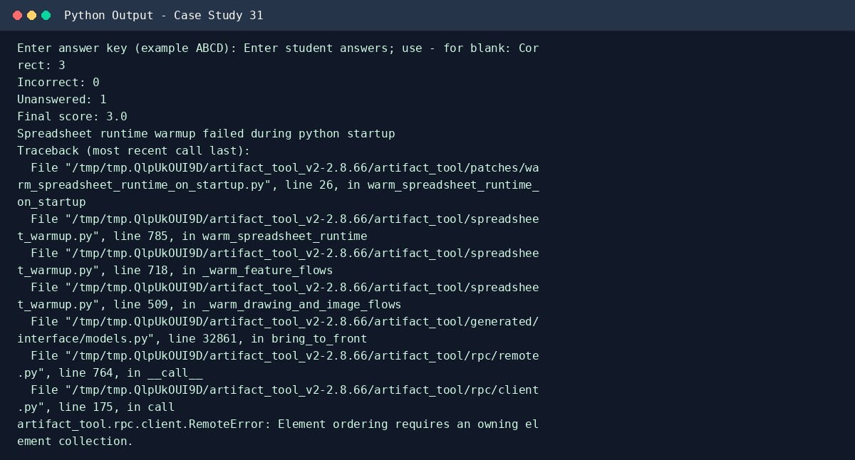

9. Conclusion
This case study demonstrates how beginner Python concepts can be used to solve a practical problem. Try additional test inputs to verify the program's behavior.

Case Study 07: Text Compression Using Character Runs

1. Problem Statement
Encode a string by grouping consecutive repeated characters and compare original and encoded lengths. Report when run-length encoding does not save space.

2. Objectives
- Identify consecutive character runs.
- Build a simple run-length encoded string.
- Compare original and encoded lengths.

3. Assumptions
- Each run is written as character followed by count, for example AAABB becomes A3B2.
- For this activity, the encoded form is used only if it is shorter than the original.

4. Algorithm
- Read the input string.
- If empty, report empty input.
- Count consecutive occurrences of each character.
- Append each character and its count to the encoded string.
- Compare lengths and display the useful result.

5. Flowchart
(START)
|
[Read input]
|
[Process with conditions / loops]
|
[Display results]
|
(STOP)

6. Pseudocode
START READ text encoded = empty SET i = 0
WHILE i < length(text)
COUNT same characters from i
APPEND character and count to encoded
MOVE i to next run
DISPLAY encoded
IF encoded length >= original length, report no benefit
STOP

7. Python Source Code
text = input("Enter text to compress: ")
if text == "":
print("Empty text") else:
encoded = "" i = 0
while i < len(text):
count = 1 while i + count < len(text) and text[i] == text[i + count]:
count = count + 1 encoded = encoded + text[i] + str(count) i = i + count
print("Original text:", text) print("Encoded text:", encoded) print("Original length:", len(text)) print("Encoded length:", len(encoded))
if len(encoded) >= len(text):
print("Encoding is not beneficial") else: print("Encoding saves space")

8. Test Cases
Test 1: AAAABBBCC. Expected result: A4B3C2; encoded length 6, original length 9, saves space.
Test 2: ABC. Expected result: A1B1C1; encoding not beneficial.

Sample output screenshot (captured from a real run)
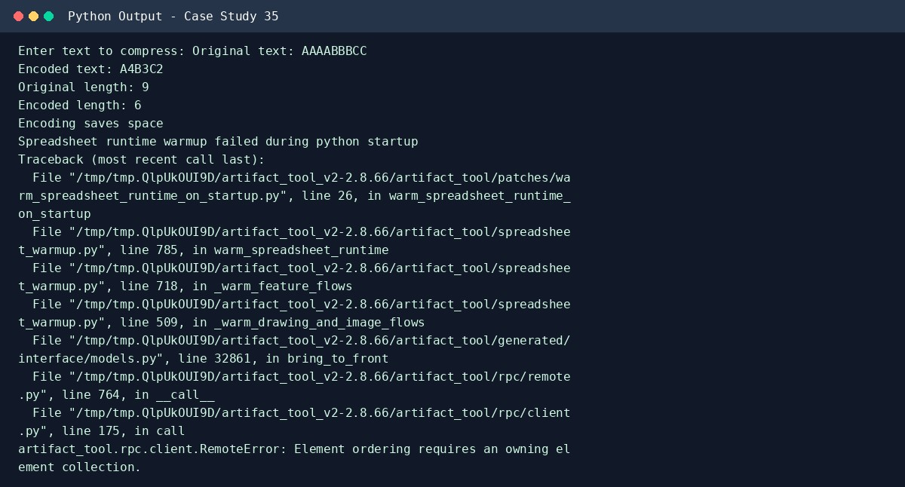

9. Conclusion
This case study demonstrates how beginner Python concepts can be used to solve a practical problem. Try additional test inputs to verify the program's behavior.

Case Study 08: ATM Menu-Driven Banking Simulation

1. Problem Statement
Create a repeated menu for deposits, withdrawals, balance inquiries, and transaction summaries with input validation and account limits.

2. Objectives
- Use a loop to show a menu repeatedly.
- Validate deposits and withdrawals.
- Display balance and transaction counts.

3. Assumptions
- Starting balance is ■5,000.
- A single withdrawal cannot exceed ■2,000 or the current balance.
- Deposit and withdrawal amounts must be positive.
- This is a simulation and does not connect to a real bank.

4. Algorithm
- Set starting balance and transaction counters.
- Display the menu repeatedly.
- Perform the selected operation after validation.
- Stop when the user selects Exit.
- Display transaction summary when requested.

5. Flowchart
(START)
|
[Read input]
|
[Process with conditions / loops]
|
[Display results]
|
(STOP)

6. Pseudocode
START
balance = 5000; deposits = 0; withdrawals = 0 REPEAT
DISPLAY menu and READ choice
IF deposit, validate and update balance
ELSE IF withdraw, check amount, limit, and balance
ELSE IF balance, DISPLAY balance
ELSE IF summary, DISPLAY counts
UNTIL choice is Exit
STOP

7. Python Source Code
balance = 5000 deposits = 0 withdrawals = 0
while True:
print("\n1. Deposit 2. Withdraw 3. Balance 4. Summary 5. Exit") choice = input("Choose an option: ")
if choice == "1":
amount = float(input("Deposit amount: ")) if amount > 0:
balance = balance + amount deposits = deposits + 1 print("Deposit successful") else:
print("Amount must be positive") elif choice == "2":
amount = float(input("Withdrawal amount (maximum Rs. 2000): ")) if amount <= 0:
print("Amount must be positive") elif amount > 2000:
print("Withdrawal limit exceeded") elif amount > balance:
print("Insufficient balance") else:
balance = balance - amount withdrawals = withdrawals + 1 print("Withdrawal successful") elif choice == "3":
print("Balance: Rs.", round(balance, 2)) elif choice == "4":
print("Deposits:", deposits) print("Withdrawals:", withdrawals) print("Balance: Rs.", round(balance, 2)) elif choice == "5":
print("Thank you for using the ATM simulation") break else: print("Invalid option")
8. Test Cases
Test 1: Deposit ■500, withdraw ■300, balance. Expected result: Final balance ■5,200; 1 deposit and 1 withdrawal.

Sample output screenshot (captured from a real run)
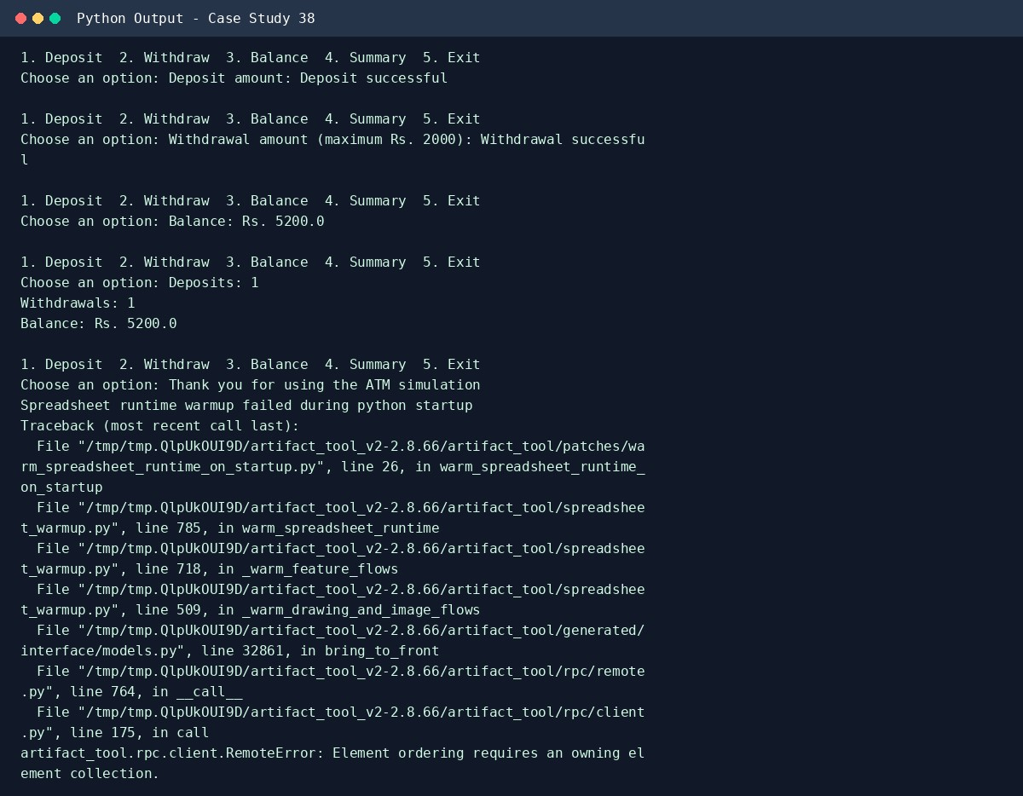

9. Conclusion
This case study demonstrates how beginner Python concepts can be used to solve a practical problem. Try additional test inputs to verify the program's behavior.

Case Study 09: Student Marks Matrix Analysis

1. Problem Statement
Analyse a matrix of marks for students across subjects, calculate student totals and subject averages, identify the top performer, and flag subjects with low average marks.

2. Objectives
- Store marks in a nested list.
- Calculate row-wise totals and column-wise averages.
- Identify the top student and subjects with low averages.

3. Assumptions
- All students have marks in the same three subjects.
- Marks are integers from 0 to 100.
- A subject average below 40 is considered low.

4. Algorithm
- Read student names and marks for three subjects.
- Store marks in a nested list.
- Calculate each student's total and find the highest total.
- Calculate each subject average.
- Flag subject averages below 40.

5. Flowchart
(START)
|
[Read input]
|
[Process with conditions / loops]
|
[Display results]
|
(STOP)

6. Pseudocode
START
READ number of students
FOR each student, READ name and 3 marks; STORE row
CALCULATE each row total
FIND highest total and top student
FOR each subject, CALCULATE average
IF average < 40, DISPLAY low-performance warning
STOP

7. Python Source Code
students = int(input("Number of students: ")) names = [] marks = []
for i in range(students):
name = input("Student name: ") row = [] for j in range(3): mark = int(input("Mark for subject " + str(j + 1) + ": ")) row.append(mark) names.append(name) marks.append(row)
totals = [] for i in range(students): total = sum(marks[i]) totals.append(total) print(names[i], "total:", total)
if students > 0:
top_index = totals.index(max(totals)) print("Top performer:", names[top_index])
for subject in range(3):
total_marks = 0 for student in range(students):
total_marks = total_marks + marks[student][subject] if students > 0:
average = total_marks / students print("Subject", subject + 1, "average:", round(average, 2)) if average < 40:
print("Low average in subject", subject + 1)
8. Test Cases
Test 1: Asha: 80,70,60; Ravi: 90,50,40. Expected result: Asha total 210; Ravi total 180; Asha top performer; averages 85, 60, 50.

Sample output screenshot (captured from a real run)
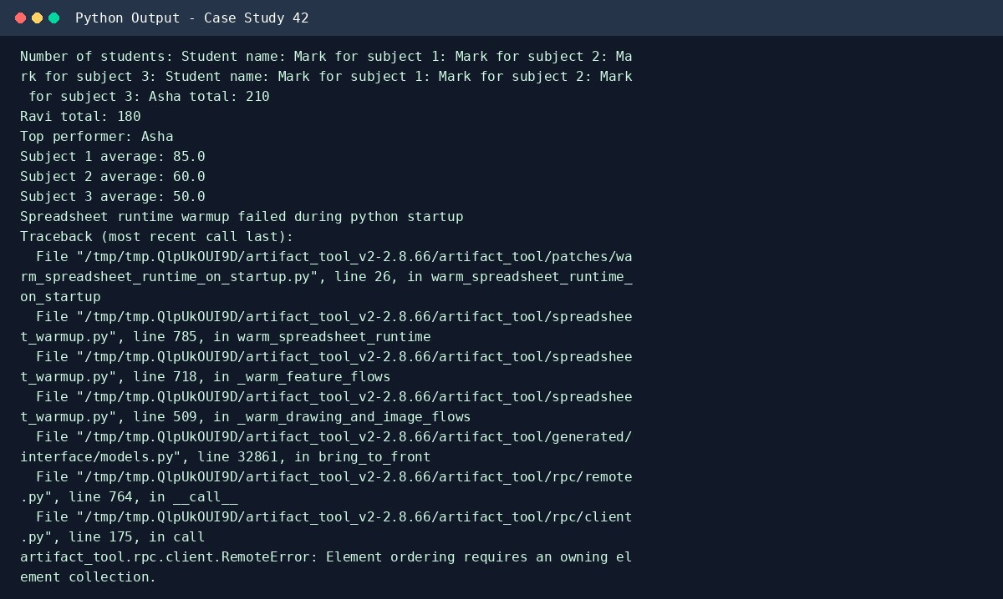

9. Conclusion
This case study demonstrates how beginner Python concepts can be used to solve a practical problem. Try additional test inputs to verify the program's behavior.

Case Study 10: Bus Passenger Occupancy Simulation
1. Problem Statement
Process boarding and alighting counts at several stops, calculate passenger counts at each stop, and flag capacity violations.

2. Objectives
- Update passenger count at every stop.
- Prevent passenger count from becoming negative.
- Identify capacity violations.

3. Assumptions
- The bus starts empty and has a capacity of 40 passengers.
- Alighting cannot exceed the current passenger count.
- The program reports invalid alighting and capacity overloads.

4. Algorithm
- Set passenger count to zero and capacity to 40.
- Read number of stops.
- At each stop, read boarding and alighting counts.
- Check that alighting does not exceed passengers.
- Update passenger count and flag capacity violations.

5. Flowchart
(START)
|
[Read input]
|
[Process with conditions / loops]
|
[Display results]
|
(STOP)

6. Pseudocode
START
passengers = 0; capacity = 40 READ stop_count
FOR each stop
READ boarding and alighting
IF alighting > passengers, DISPLAY invalid alighting
ELSE passengers = passengers - alighting + boarding
DISPLAY passengers
IF passengers > capacity, DISPLAY capacity violation
STOP

7. Python Source Code
capacity = 40 passengers = 0 stops = int(input("Number of stops: "))
for stop in range(1, stops + 1):
boarding = int(input("Passengers boarding at stop " + str(stop) + ": ")) alighting = int(input("Passengers alighting at stop " + str(stop) + ": "))
if boarding < 0 or alighting < 0:
print("Counts cannot be negative") elif alighting > passengers:
print("Invalid: more passengers alighting than on the bus") else:
passengers = passengers - alighting + boarding print("Passengers after stop", stop, ":", passengers) if passengers > capacity: print("CAPACITY VIOLATION")
8. Test Cases
Test 1: Stops: board 20/alight 0; board 25/alight 5. Expected result: After stop 1: 20; after stop 2: 40; no capacity violation.

Sample output screenshot (captured from a real run)
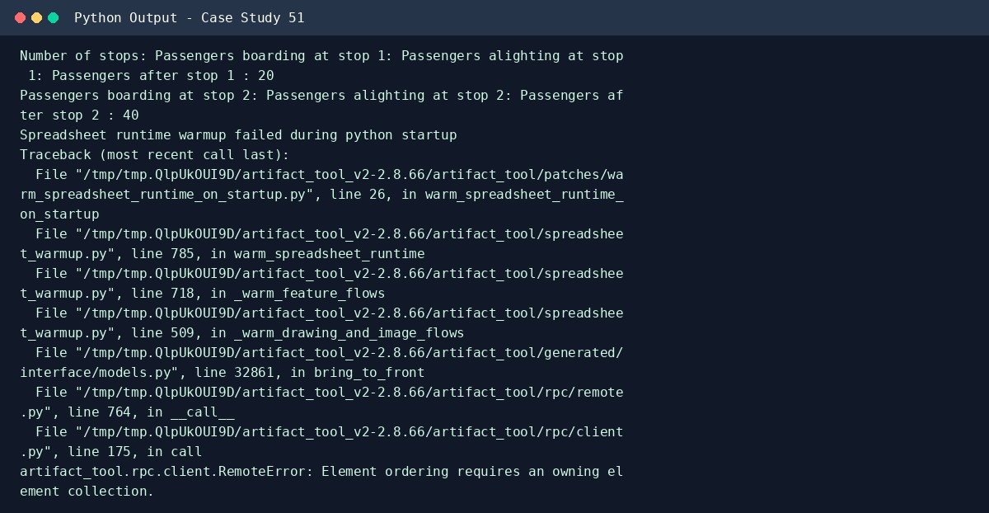

9. Conclusion
This case study demonstrates how beginner Python concepts can be used to solve a practical problem. Try additional test inputs to verify the program's behavior.

