FAST FOOD ORDERING SYSTEM — TO‘LIQ TEXNIK TOPSHIRIQ (TZ)

1. Loyiha nomi
FastFood Online Ordering Web Application

2. Loyihaning maqsadi
Foydalanuvchilarga fast food mahsulotlarini onlayn ko‘rish, savatga qo‘shish, buyurtma berish, Stripe orqali xavfsiz to‘lov qilish va admin panel orqali buyurtmalarni boshqarish imkonini beruvchi to‘liq veb-platforma yaratish.

3. Arxitektura diagrammasi
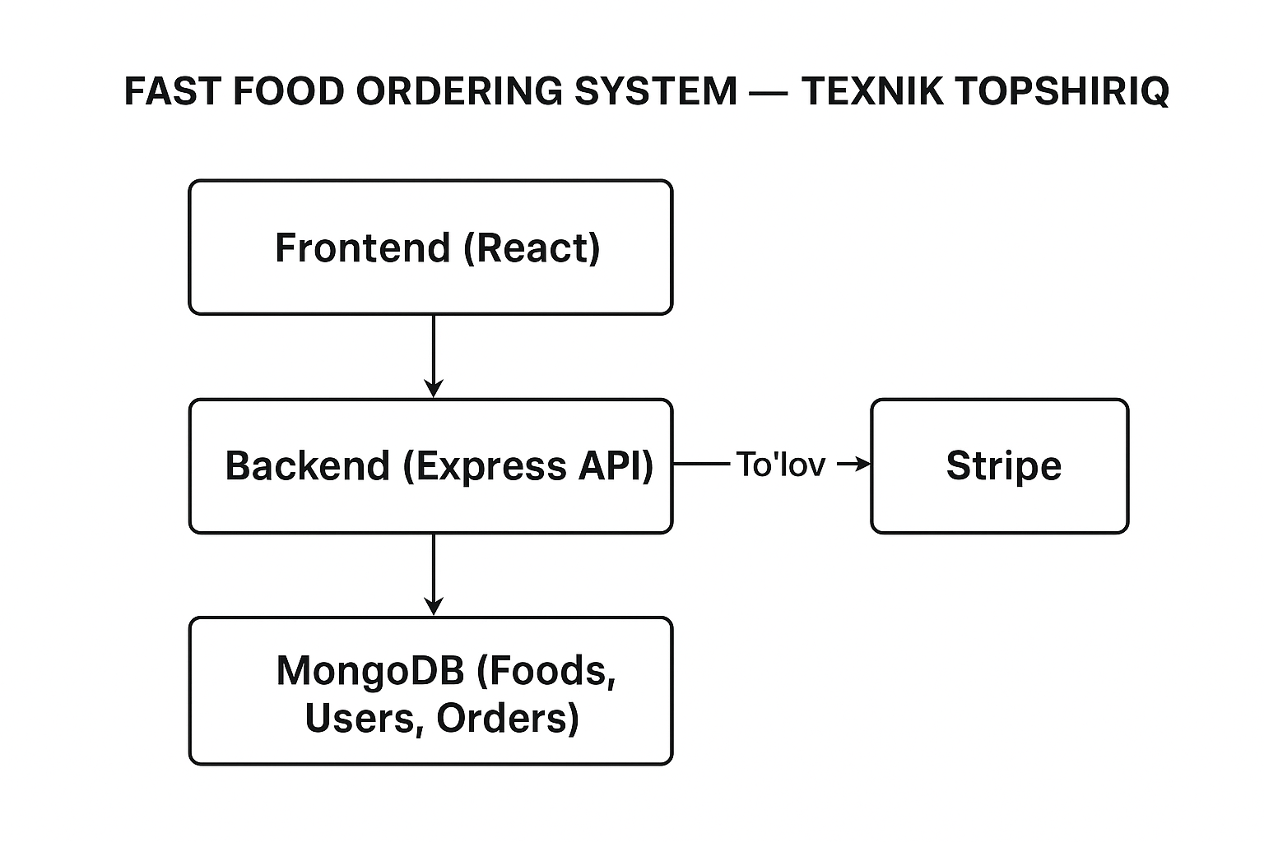

4. Foydalanuvchi funksiyalari (Frontend)
• Ro‘yxatdan o‘tish va login (email + parol)
• JWT orqali himoyalangan sahifalarga kirish
• Mahsulotlar ro‘yxatini ko‘rish
• Kategoriya bo‘yicha filtrlash
• Savatga qo‘shish, miqdorni o‘zgartirish, o‘chirish
• Buyurtma sahifasi: manzil kiritish + tasdiqlash
• Stripe Checkout orqali to‘lov qilish
• To‘lovdan so‘ng “Order Successful” sahifasi
• Buyurtmalar tarixini ko‘rish
• Profil bo‘limi (Foydalanuvchi ma’lumotlari)

5. Admin Panel funksiyalari
• Mahsulot qo‘shish (rasm, nom, narx, kategoriya)
• Mahsulotlarni tahrirlash yoki o‘chirish
• Barcha buyurtmalar ro‘yxatini ko‘rish
• Har bir buyurtmaning statusini boshqarish:
- Pending (Yangi buyurtma)
- Cooking (Tayyorlanmoqda)
- Out for delivery (Yuborildi)
- Delivered (Yetkazildi)

6. Buyurtma jarayoni (bosqichma-bosqich)
1️⃣ Foydalanuvchi mahsulotni savatga qo‘shadi
2️⃣ Savat sahifasida jami narx hisoblanadi
3️⃣ Foydalanuvchi manzilni to‘ldiradi
4️⃣ “Proceed to Payment” bosadi
5️⃣ Stripe Checkout ochiladi
6️⃣ To‘lov muvaffaqiyatli bo‘lsa:
• Backend Stripe sessiyani tasdiqlaydi
• Yangi buyurtma Orders kolleksiyasiga yoziladi
• Admin panelda **Pending** holatida ko‘rinadi
7️⃣ Admin buyurtmani:
• “Cooking”
• “Out for delivery”
• “Delivered”
holatlariga o‘tkazadi
8️⃣ Foydalanuvchi buyurtma tarixida statuslarni real vaqtda ko‘radi

7. Texnologiyalar steki
Frontend:
• React.js 19
• Vite
• React Router DOM
• Axios
Backend:
• Node.js
• Express.js
• Stripe SDK
• JWT Authentication
• Multer (rasm yuklash bo‘lsa)
Database:
• MongoDB + Mongoose

8. Database strukturasi

Foods kolleksiyasi
{
_id,
name,
description,
price,
image,
category,
createdAt,
updatedAt
}

Users kolleksiyasi
{
_id,
name,
email,
password,
cardData: Object,
createdAt,
updatedAt
}

Orders kolleksiyasi
{
_id,
user: ObjectId (User),
items: [
{
itemId,
name,
price,
quantity
}
],
totalAmount,
paymentStatus,
stripeSessionId,
orderStatus (Pending, Cooking, Out for delivery, Delivered),
deliveryAddress,
createdAt
}

9. Foydalanuvchi sahifalari (UI bo‘limlari)
• Home Page — Banner + Mahsulotlar
• Categories Page — Kategoriya bo‘yicha filter
• Product Detail Page — Bitta mahsulot tafsilotlari
• Cart Page — Savat
• Checkout Page — Manzil + tasdiqlash
• Payment Page — Stripe Checkout
• Order Success Page — To‘lov tasdiqlangan xabar
• Profile Page — Foydalanuvchi ma’lumotlari
• Order History Page — Tarix

10. Admin sahifalari
• Dashboard — Umumiy statistika
• Products Management — CRUD
• Orders Management — Status o‘zgartirish
• Users List

