Meghavi Kiosk System - Hardware & Integration Documentation

This document provides an in-depth guide to the hardware, software technologies, and configuration steps required to deploy the Meghavi Kiosk System in an airport environment for spa service ordering.
1. Technologies & Tools Used
Hardware
- 43" Portrait Touchscreen Monitor
- Windows-based Mini-PC
- Raspberry Pi Zero 2 W with Pi Camera v2
- HDMI and USB connections, USB power supplies
Operating Systems
- Windows 10 IoT or Windows 11 Pro (for the PC)
- Raspbian OS (for Raspberry Pi)
Programming Languages
- Python 3.9 or higher
Computer Vision
- OpenCV 4.x
- Ultralytics YOLOv8 for face detection (model from Hugging Face)
Web Framework
- Flask 2.x used on both the Windows PC and Raspberry Pi for serving content
UI Display Tools
- Python-webview 3.x for rendering full-screen screensaver interface
- Chromium or Microsoft Edge in kiosk mode for the ordering web app
GUI Library
- Tkinter is used for displaying the video download progress popup window
Packaging and Utilities
- zipfile, requests, tqdm for downloading and managing video content from the server
Miscellaneous Tools
- Task Scheduler (for automating app launch on Windows)
- Registry Editor and batch scripts (for customizing boot logo and auto-start behavior)

2. System Architecture
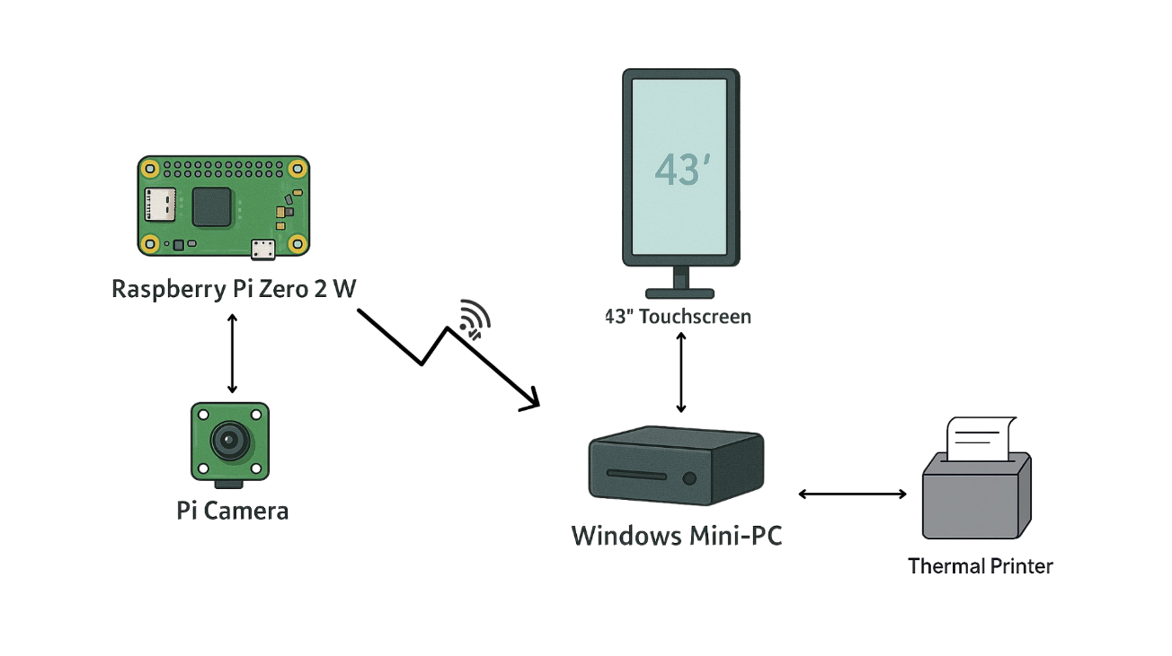
Fig : Architecture of Meghavi kioske system

3. Boot Logo Customization
By default, Windows displays its own logo during boot. To replace it with the Meghavi logo:
- Prepare Image: Create a logo.bmp at 720×400 px, 24-bit BMP.
- Use OEM Logo Tool (e.g., OEM Logo Changer):
  - Run tool as Administrator.
  - Select logo.bmp and apply to system partition.
- UEFI Method (for modern hardware):
  - Copy logo.bmp to C:\Windows\System32\oobe\info\backgrounds.
  - Edit Registry:
[HKEY_LOCAL_MACHINE\SOFTWARE\Microsoft\Windows\CurrentVersion\Authentication\LogonUI]
"OEMBackground"=dword:00000001
- Reboot and verify the Meghavi logo appears.
Note: Steps may vary by manufacturer. Consult hardware vendor documentation if OEM tool unsupported.

4. Auto-Start Ordering Application
To ensure the web application launches immediately after login:
A. Startup Folder Method
- Create a batch script start_meghavi.bat:
@echo off
timeout /t 5
start "" "C:\Program Files\Microsoft\Edge\Application\msedge.exe" --kiosk http://localhost:5000 --edge-kiosk-type=fullscreen.
- Place start_meghavi.bat in %APPDATA%\Microsoft\Windows\Start Menu\Programs\Startup.
- On next login, the kiosk brow ser opens automatically.
B. Task Scheduler Method
- Open Task Scheduler → Create Task.
- General: Run whether user is logged on or not; highest privileges.
- Triggers: At log on of any user.
- Actions: Start a program → Program/script: C:\Windows\System32\cmd.exe; Add arguments: /c start_meghavi.bat.
- Conditions: Uncheck “Start the task only if the computer is on AC power.”
- OK and enter credentials.

5. Distance Calibration Procedure
The system uses bounding‐box pixel area to estimate user distance using a power-law model:
Calibration Formula
The formula used for estimating the distance based on bounding box area is:
distance = a * (area ** b)
Where:
- distance is the estimated distance from the camera in centimeters (cm)
- area is the area of the detected face's bounding box in pixels (width × height)
- a and b are calibration coefficients obtained from curve fitting

A. Data Collection (caliberation.py)
- Ensure models/model.pt exists (downloaded YOLOv8 face model).
- Run:
- python caliberation.py --model_path models/model.pt --output calibration.json
- Steps in GUI:
  - Place face at a known distance (e.g., 50 cm) from camera.
  - Press c, input distance (cm).
  - Repeat for 10–15 distances (20 cm to 150 cm).
  - Press q to finish.
- Output: calibration.json includes list of {area, distance} pairs and computed constant K.
B. Curve Fitting (caliberation_fit.py)
- Run:
- python caliberation_fit.py
- Outputs:
- a = <value>
- b = <value>
- RMSE = <error> cm
- Copy a and b into meghavi_script.py:
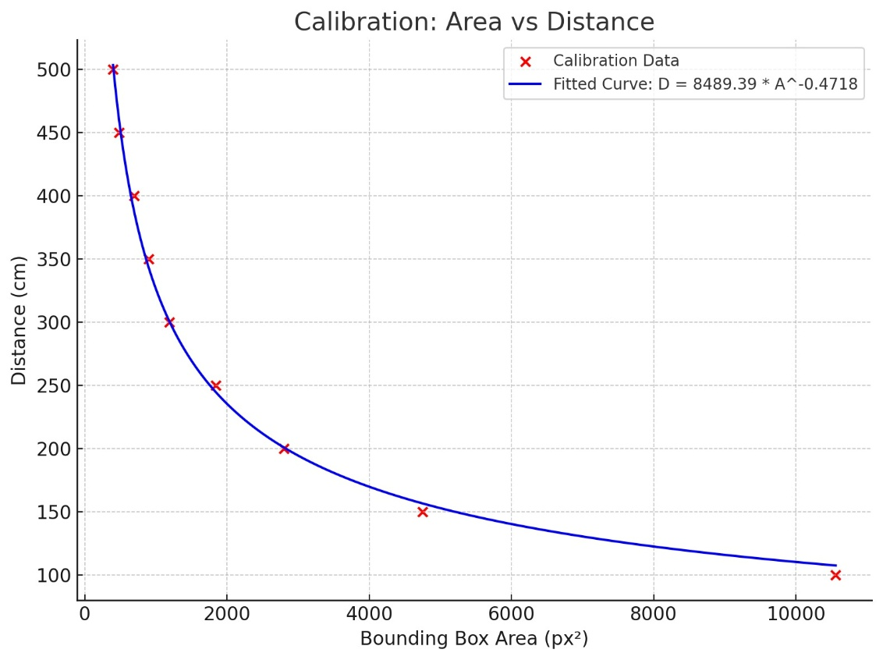
- distance = a * (area_px ** b)
Fig: example calibration points done at different distances

6. Human Detection & Screensaver Logic
- Camera Stream: Pi Zero Flask app → http://<pi_ip>:5000/video.
- Main Script: meghavi_script.py on Windows:
  - Loads YOLO model (ultralytics).
  - Computes area_px → distance_cm.
  - If no face within 1 m for 10 s, launch screensaver:
open_screensaver()
  - If face reappears, call:
close_screensaver()
- Screensaver App:
  - screensaver.py: Uses webview.create_window(..., fullscreen=True).
  - Videos served via local app.py at http://localhost:5000.

7. Daily Video Update & Management
File: meghavi_functions.py
- Reads last update date from textFiles/date_txt.txt.
- Hits IDS_API_URL to fetch video IDs.
- Compares with previous IDs (textFiles/ids.txt).
- On change, downloads ZIP from ZIP_URL using download_zip_popup.py UI.
- Extracts videos, shuffles, and renames to videos/###_filename.

8. Flask Backend Setup (Windows)
File: app.py
@app.route('/')
def index():
return render_template('index.html')
@app.route('/videos/list')
def list_videos():
files = [f for f in os.listdir(VIDEO_FOLDER) if f.endswith(SUPPORTED_EXTENSIONS)]
return jsonify(files)
@app.route('/videos/<path:filename>')
def serve_video(filename):
return send_from_directory(VIDEO_FOLDER, filename)
- Ensure templates/index.html contains ordering UI.
- Place video files in videos/.
- Start server: python app.py

9. Maintenance & Troubleshooting
- Camera Change: Re-run Sections 5A–5B for new calibration.
- Boot Logo Fails: Verify image format & paths; consult OEM tool logs.
- App Auto-Start: Test batch/script manually; check Task Scheduler history.
- Network Issues: Ensure Pi and PC are on same LAN; open port 5000.

