# Part- 2 Report

**1. Color Quantization:**

For the color quantization we have used python and used k means technique.

* The packages used for this are : numpy, os and cv2.
* The criteria we used for clustering is (cv2.TERM_CRITERIA_EPS + cv2.TERM_CRITERIA_MAX_ITER, 30, 0.1) here **cv2.TERM_CRITERIA_EPS** means that it stop the algorithm iteration if specified accuracy, *epsilon*, is reached. **TERM_CRITERIA_MAX_ITER** - stop the iteration when any of the above condition is met. Epsilon is 0.1 and max iterations is 30.
* For generating k means we have done KMEANS_RANDOM_CENTERS. Later converting to the original image.
* Hence, The generated images are stored in “quantizedImages” folder.
* The original images used are image_1, image_2, image_3 respectively :
* Image_1
* 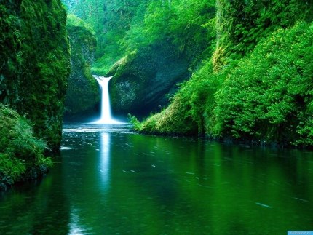
* Image_2
* 
* Image_3
* 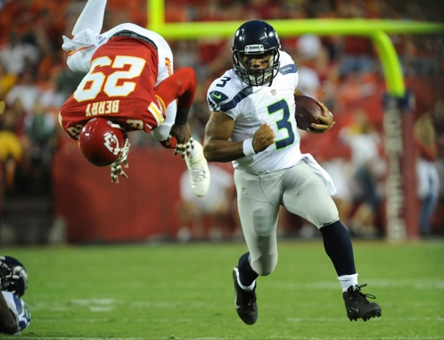

|  |  |  |  |  |
| --- | --- | --- | --- | --- |
| **Image** | **Original File size** | **Value of k used** | **Image quality** | **Image Size** |
| **Image_1** | **614 KB** | **3** | **Appears very blurry with less colors in image.** | **786 KB** |
| **Image_2** | **262 KB** | **3** | **Appears very blurry** | **45 KB** |
| **Image_3** | **287 KB** | **3** | **Image has less colors and blurred.** | **385 KB** |
| **Image_1** | **614 KB** | **6** | **The image has got better quality than when k=3** | **967 KB** |
| **Image_3** | **262 KB** | **6** | **Image is little blurry, but has got better quality compared to when k=3** | **111 KB** |
| **Image_1** | **287 KB** | **6** | **The image has better colors and quality but still blurred** | **967 KB** |
| **Image_1** | **614 KB** | **10** | **Image Appears with a very good quality** | **1 MB** |
| **Image_2** | **262 KB** | **10** | **Appears Still blurry but has better quality compared to k=6** | **123 KB** |
| **Image_3** | **287 KB** | **10** | **Image has a lot of colors and the clarity has increased.** | **520 KB** |