PATENT APPLICATION DOCUMENT
Dynamic Intent-Driven Tool Registration in LLM Agents
Using Enterprise API Gateways as a Runtime Tool Discovery and Activation Layer

With Banking Industry Use Cases

Version 1.0 | April 2026
CONFIDENTIAL — PATENT PENDING

Table of Contents

1. Problem Statement

1.1 The Enterprise API Landscape
Modern banks and financial institutions operate extensive API ecosystems. A typical large bank may have 500 to 2,000+ APIs deployed across multiple API gateways, covering domains such as payments (SWIFT, NEFT, UPI, RTGS, IMPS), core banking (accounts, deposits, withdrawals), lending (loan origination, underwriting, disbursement), compliance (KYC, AML, sanctions screening), cards (credit, debit, prepaid management), wealth management, trade finance, and treasury operations.
These APIs are managed through enterprise API gateways such as Google Apigee, AWS API Gateway, Azure API Management, or Kong, which provide governance, security, rate limiting, analytics, and lifecycle management.

1.2 The Static Tool Registration Problem
Current approaches to connecting Large Language Model (LLM) agents with enterprise APIs suffer from a fundamental architectural limitation: static tool registration. Specifically:

1.2.1 Model Context Protocol (MCP) Limitations
The Model Context Protocol (MCP), the emerging standard for connecting LLM agents to external tools, requires all tools to be statically registered at server startup. This means:
- The tool surface available to the agent is fixed and finite before any conversation begins
- Adding new tools requires server restart, configuration changes, and redeployment
- The agent cannot discover or use APIs that were not pre-configured by a developer
- In a bank with 1,000+ APIs, pre-registering all of them would consume excessive context window space, degrade model performance, and create an unmanageable security surface

1.2.2 The Configuration Drift Problem
In banking environments, APIs are continuously versioned, deprecated, and newly deployed. Static tool configurations drift from actual API state:
- A payments API upgraded from v2 to v3 may break pre-configured tool schemas
- A newly deployed real-time fraud detection API remains invisible to the agent until manually configured
- A deprecated sanctions screening endpoint continues to be offered as a tool despite being decommissioned
This drift creates operational risk in regulated banking environments where using outdated or incorrect API interfaces can have compliance implications.

1.2.3 The Security and Least-Privilege Violation
Pre-registering all APIs exposes the entire API surface to every agent session, regardless of the user’s role or the task at hand:
- A bank teller querying account balances does not need access to loan disbursement APIs
- A compliance officer reviewing AML alerts does not need access to payment initiation APIs
- Exposing all tools to all sessions violates the principle of least privilege and increases the attack surface for prompt injection and unauthorized API invocation

1.2.4 The Scalability Bottleneck
Each new API integration requires manual effort from a developer: writing the MCP tool definition, mapping parameters, testing, and deploying. In an enterprise bank context:
- Integrating 100 APIs requires approximately 100 custom tool definitions, each with schema mapping and error handling
- API versioning multiplies this effort (v1, v2, v3 of the same API = 3 tool definitions)
- Multi-region deployments (e.g., India operations vs. UK operations) further multiply configurations
- The result is a bottleneck where the AI team becomes the gatekeeper for every API integration, taking weeks or months per API

1.3 The Gap in Existing Solutions
The following table summarizes the gap that no existing solution addresses:
Capability | MCP Servers | OpenAPI-to-Tool Generators | ChatGPT Plugins | LangChain/AutoGPT | This Invention
Runtime API discovery from gateway | No | No | No | No | Yes
Mid-session tool injection | No | No | Partial | Partial | Yes
Zero-restart registration | No | No | No | No | Yes
Gateway as tool catalog | No | No | No | No | Yes
Inherited gateway governance | N/A | No | No | No | Yes
Human-in-the-loop approval | N/A | No | No | No | Yes
Enterprise RBAC filtering | No | No | No | No | Yes
Spec-driven schema generation | No | Pre-configured | Manual | Manual | Runtime

No existing system combines LLM-initiated API discovery from an enterprise gateway’s management plane, specification-driven tool schema generation at runtime, zero-restart dynamic tool registration within an active MCP session, human-in-the-loop governance, and automatic policy inheritance from the gateway execution layer.

2. Proposed Solution

2.1 Invention Overview
This invention introduces an Intelligent AI Gateway/Tool Layer — a system and method that enables LLM agents to dynamically discover, select, and activate enterprise API endpoints as callable tools during an active inference session. The system leverages enterprise API gateways as both a runtime tool catalog and a governed execution proxy, eliminating static tool configuration entirely.

2.2 Core Mechanism
The solution operates through a six-stage pipeline that executes entirely within a single conversational session, without any server restart, redeployment, or human developer intervention:
Stage 1 — Intent Recognition: The system analyzes the user’s natural language prompt to determine the API domain(s) required. For example, “Initiate a SWIFT payment” maps to the “payments” and “cross-border” domains.
Stage 2 — Auto-Discovery: The system queries the enterprise API gateway’s management plane (e.g., Apigee Management API) to enumerate all deployed, active API proxies matching the identified domains. This uses live gateway metadata, ensuring the discovery reflects the current state of the API ecosystem.
Stage 3 — Human-in-the-Loop Confirmation: Discovered APIs are presented to the user for explicit approval before any tool registration occurs. The user can selectively approve or reject individual APIs, providing governance at the point of tool activation.
Stage 4 — Specification Retrieval: For each approved API, the system fetches its OpenAPI/Swagger specification from the gateway’s spec store (with fallback to well-known spec paths). Specifications are cached per session to avoid redundant network calls.
Stage 5 — Dynamic Tool Registration: Each endpoint in the specification is parsed and registered as a typed, schema-validated MCP tool in the active session’s tool registry. Tool names follow a collision-free namespace ({proxyName}__{operationId}). Input schemas are derived from path, query, header, and body parameters using Zod validation.
Stage 6 — Governed Execution: When the agent invokes a registered tool, the request routes through the API gateway’s runtime proxy. All existing gateway policies — rate limiting, OAuth validation, threat protection, analytics — are automatically inherited without additional configuration.

2.3 The Lazy Hydration Model
The system implements a Lazy Hydration model for tool management. Rather than pre-loading all available tools, the agent’s tool surface starts minimal (two seed tools: discover_apis and activate_api_as_tools) and expands on-demand based on conversational context:
Metric | Static Registration | Lazy Hydration (This Invention)
Initial tool surface | O(N) — all APIs in the bank | O(1) — 2 seed tools only
Context window usage | High (500+ tool descriptions) | Minimal (grows to ~5-15 per session)
Security surface | All APIs exposed every session | Only user-approved APIs exposed
Configuration freshness | Stale until manually updated | Always live from gateway
Time to add new API | Days-weeks (dev effort) | Zero (auto-discovered from gateway)
Server restart required | Yes (for any tool change) | Never

2.4 Seed Tools
The MCP server boots with exactly two meta-tools that enable the entire dynamic discovery and registration lifecycle:
Tool | Purpose | Input | Output
discover_apis | Query gateway management plane to enumerate deployed APIs matching a domain | Domain filter (e.g., 'payments'), optional gateway filter | List of API proxies with name, version, deployment status, description
activate_api_as_tools | Fetch OpenAPI spec for selected API(s) and register each endpoint as an MCP tool | API name(s), gateway base URL, optional endpoint filter | List of newly registered tools with names and descriptions

2.5 Gateway Dual-Role Architecture
A key innovation is that the enterprise API gateway serves two distinct roles simultaneously:
- Role 1 — Tool Catalog (Management Plane): The gateway’s management API provides a live, always-current catalog of all deployed APIs. The system queries this catalog for discovery, spec retrieval, and access control metadata. This eliminates the need for a separate tool registry or configuration store.
- Role 2 — Governed Execution Proxy (Runtime Plane): The same gateway’s runtime proxy handles actual API invocations from the agent. All governance policies (rate limiting, authentication, threat protection, logging, transformation) configured in the gateway automatically apply to LLM-initiated calls without any additional setup.
This dual-role architecture means that the moment an API is deployed to the gateway with its policies configured, it becomes simultaneously discoverable as a tool and governed for execution — zero additional configuration for AI integration.

3. High-Level Architecture
The following diagram illustrates the five-layer architecture of the system, showing the flow from user prompt through the Intelligent AI Gateway/Tool Layer to backend banking services:

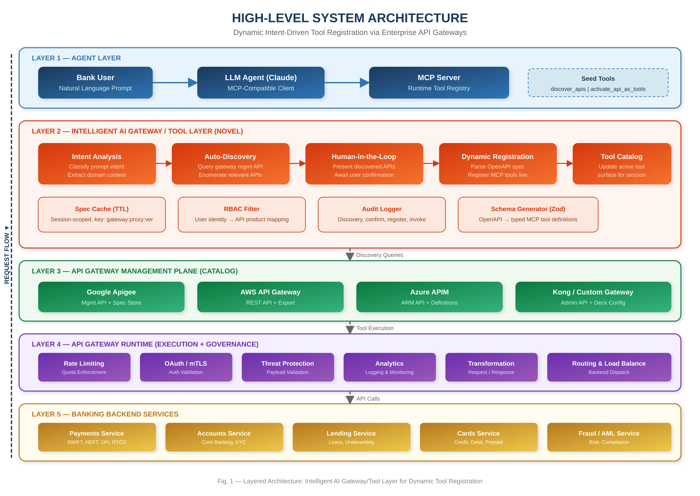
Figure 1 — Five-Layer System Architecture: Intelligent AI Gateway/Tool Layer for Dynamic Tool Registration

3.1 Layer Descriptions
Layer | Component | Banking Context
Layer 1: Agent | LLM Agent + MCP Server with Runtime Registry | Bank officer or customer interacts with AI assistant via chat or voice interface
Layer 2: AI Gateway (NOVEL) | Intent Analysis → Auto-Discovery → HITL → Dynamic Registration → Catalog Update | Orchestrates which banking APIs are activated based on the conversation, with officer confirmation
Layer 3: Catalog | API Gateway Management Plane(s) | Apigee / AWS / Azure management APIs enumerate all deployed banking API proxies and their specs
Layer 4: Governance | API Gateway Runtime Proxy | Enforces bank-grade security: OAuth, mTLS, rate limits, PCI-DSS compliance, audit logging
Layer 5: Backend | Core Banking, Payments, Lending, Cards, Compliance | The actual banking microservices (SWIFT gateway, core banking, loan engine, AML system)

4. Banking Use Cases and Sequence Diagrams
The following three use cases demonstrate the invention’s application in real banking scenarios, with detailed sequence diagrams showing the complete flow from user prompt to execution.

4.1 Use Case 1: Cross-Border Payment Processing (SWIFT)

4.1.1 Scenario
A bank Relationship Manager (RM) needs to initiate a SWIFT cross-border payment of $50,000 to Deutsche Bank on behalf of corporate client Acme Corp. The RM interacts with the bank’s AI assistant, which has no pre-configured payment tools.

4.1.2 APIs Dynamically Discovered
API Proxy | Operations Registered | Backend Service
payments-v2 | createPayment, getPayment, cancelPayment, listPayments | Core Payments Engine
swift-gateway-v1 | initiateSwift, getSwiftStatus, cancelSwift, getCharges | SWIFT Alliance Gateway
fx-rates-v1 | getSpotRate, getForwardRate, lockRate | Treasury FX System

4.1.3 Sequence Diagram
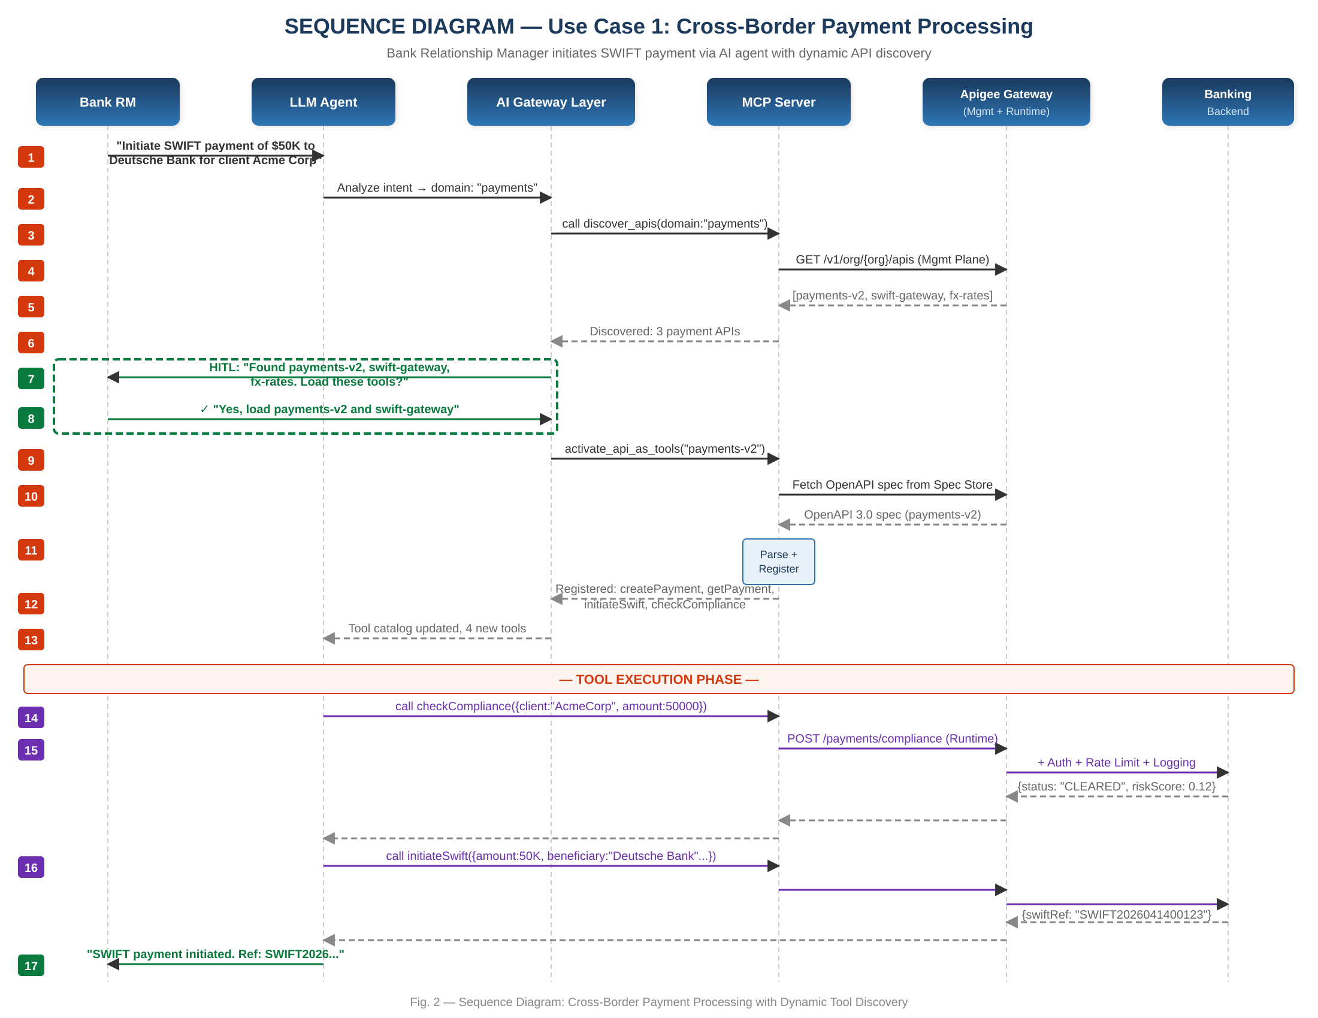
Figure 2 — Sequence Diagram: Cross-Border Payment Processing with Dynamic Tool Discovery

4.1.4 Key Observations
- The agent discovered 3 payment-domain APIs from the gateway without any pre-configuration
- The RM selectively approved payments-v2 and swift-gateway (excluded fx-rates as not needed)
- The agent autonomously chained a compliance check before the SWIFT initiation, using tools it discovered moments earlier
- All API calls routed through the gateway’s runtime proxy, inheriting PCI-DSS-compliant logging, SWIFT-specific authentication, and rate limiting
- Total tools registered: 8 (from 2 APIs). Total developer effort: zero.

4.2 Use Case 2: Corporate Account Opening with eKYC & AML

4.2.1 Scenario
A branch officer needs to open a corporate current account for Tata Motors, which requires identity verification (eKYC), AML/sanctions screening, document verification (GST certificate, PAN, board resolution), and core banking account creation. Traditionally, this involves 4 different systems with separate logins.

4.2.2 APIs Dynamically Discovered
API Proxy | Operations Registered | Backend Service
accounts-v3 | createAccount, getAccount, updateKYCStatus, setSignatories | Core Banking (Finacle/T24)
ekyc-v2 | verifyIdentity, verifyDirectors, getBeneficialOwners | eKYC Provider (DigiLocker/NSDL)
aml-screening-v1 | screenEntity, screenDirectors, getWatchlistHits | AML Engine (Actimize/Fircosoft)
doc-verify-v1 | verifyDocuments, extractGST, verifyPAN, verifyBoardResolution | Document Verification Service

4.2.3 Sequence Diagram
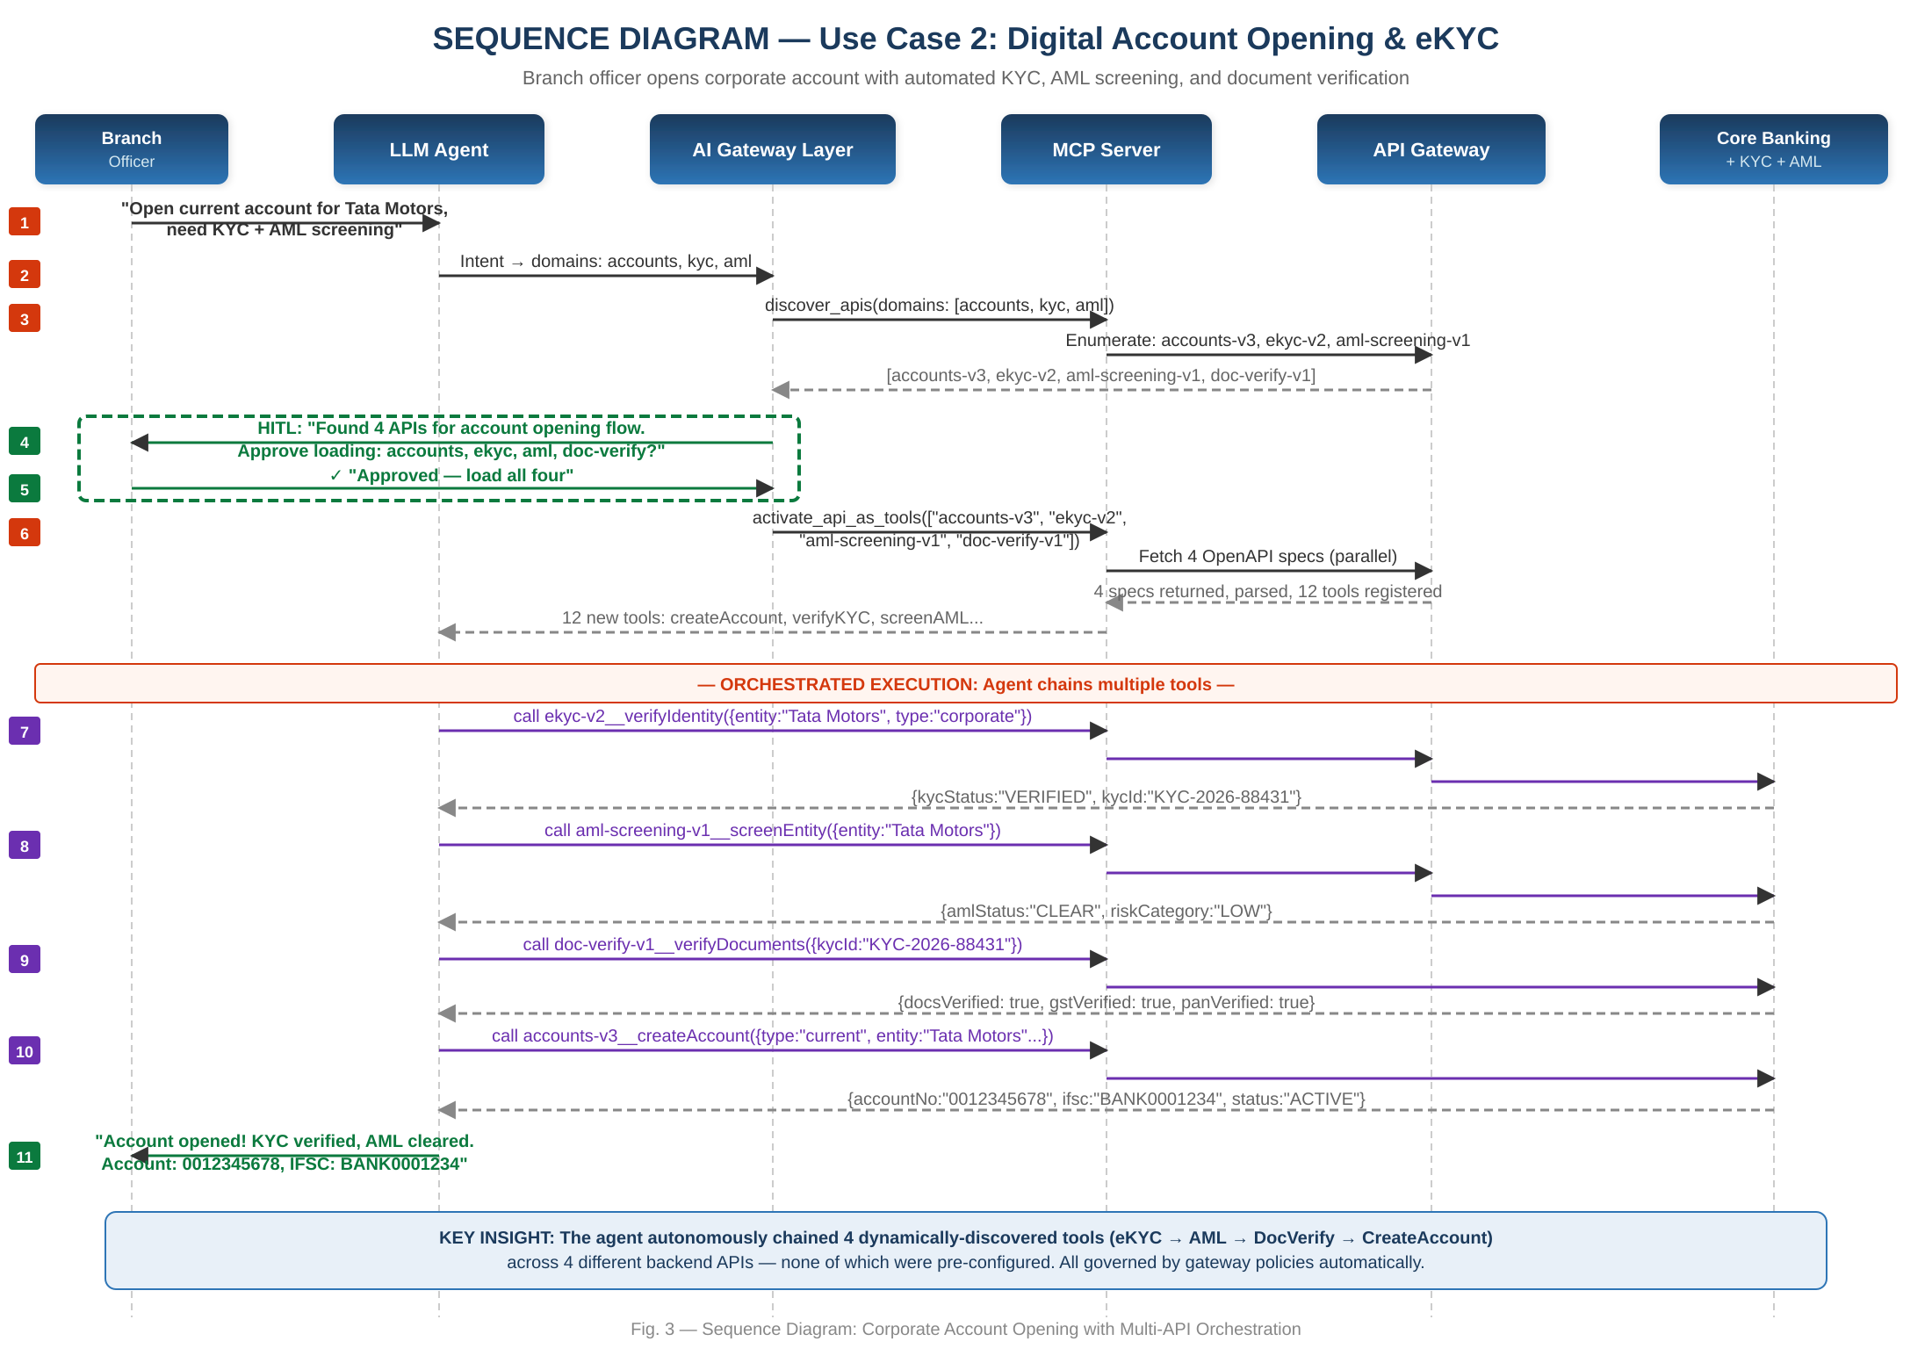
Figure 3 — Sequence Diagram: Corporate Account Opening with Multi-API Orchestration

4.2.4 Key Observations
- The agent discovered and activated 4 APIs spanning 4 different backend systems in a single session
- It autonomously determined the correct execution order: eKYC first (identity must be verified before account creation), then AML screening, then document verification, then account creation
- The KYC ID generated by the eKYC API was passed as input to subsequent calls, demonstrating cross-API data flow orchestration
- Total tools registered: 12. Process that previously required 4 separate system logins completed in one conversation.
- All calls governed by the gateway’s KYC/AML-specific audit logging policies for regulatory compliance

4.3 Use Case 3: SME Loan Origination with Credit Assessment

4.3.1 Scenario
A loan officer needs to process a ₹2 Crore ($240K) SME loan application for an Infosys subsidiary. This requires credit bureau scoring, collateral valuation, loan application creation, approval workflow, and disbursement — spanning multiple backend systems.

4.3.2 APIs Dynamically Discovered
API Proxy | Operations Registered | Backend Service
credit-score-v2 | getCreditScore, getCreditReport, getPaymentHistory, getDefaults | CIBIL / Experian Bureau
collateral-v1 | valueAsset, registerLien, getValuationReport | Collateral Management System
lending-v3 | createLoanApplication, getLoanStatus, approveLoan, rejectLoan, getEMISchedule | Loan Origination System (LOS)
disburse-v2 | initiateDisbursement, getDisbursementStatus, reversePayment | Payment/Settlement Engine

4.3.3 Sequence Diagram
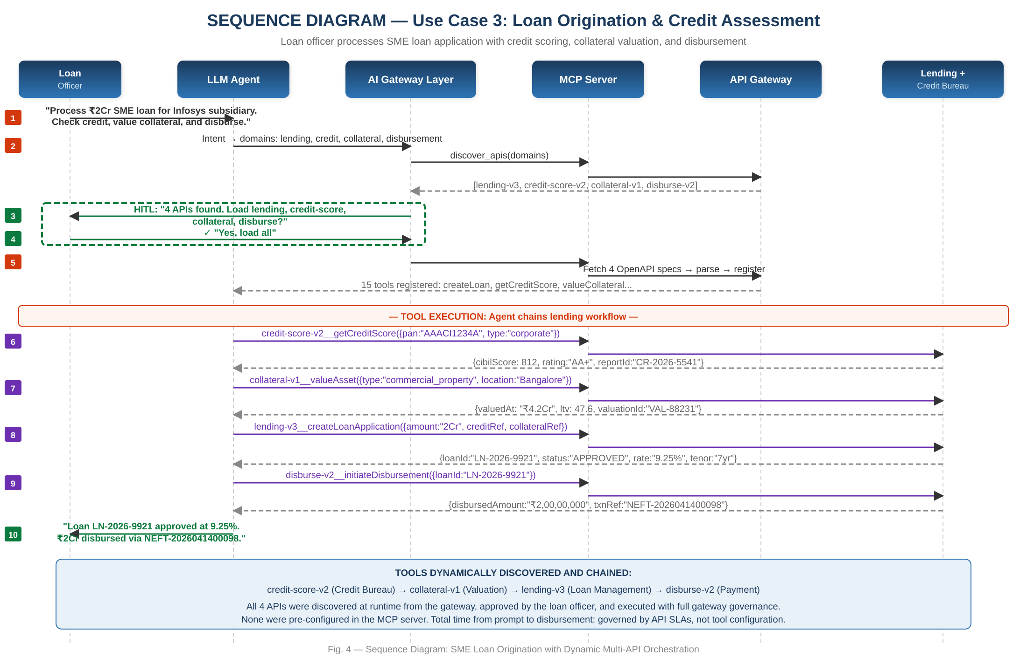
Figure 4 — Sequence Diagram: SME Loan Origination with Dynamic Multi-API Orchestration

4.3.4 Key Observations
- The agent chained 4 APIs in the correct banking workflow order: credit assessment → collateral valuation → loan creation → disbursement
- The credit score (812, AA+) and collateral value (₹4.2Cr, LTV 47.6%) were used by the agent as input to the loan application, demonstrating intelligent data flow across dynamically discovered tools
- Total tools registered: 15 across 4 backend systems. All discovered at runtime.
- Gateway-level policies ensured: credit bureau calls complied with data protection regulations, disbursement calls enforced dual-authorization limits, and all transactions were logged for RBI audit requirements

4.4 Use Case Comparison Summary
Dimension | UC1: SWIFT Payment | UC2: Account Opening | UC3: Loan Origination
APIs discovered | 3 | 4 | 4
Tools registered | 8 | 12 | 15
Backend systems spanned | 2 | 4 | 4
Human-in-loop confirmations | 1 | 1 | 1
Developer effort required | Zero | Zero | Zero
Server restarts | Zero | Zero | Zero
Governance policies inherited | PCI-DSS, SWIFT auth, rate limits | KYC/AML audit logging, data protection | Credit bureau regulation, RBI audit, dual-auth
Traditional approach time | Hours (manual config per API) | Days (4 separate integrations) | Weeks (multi-system integration)
This invention time | Seconds (runtime discovery) | Seconds (runtime discovery) | Seconds (runtime discovery)

5. Novelty and Inventive Step

5.1 Primary Novel Contribution
The primary novelty of this invention is the Intelligent AI Gateway/Tool Layer — a system that enables an LLM agent to dynamically expand its own callable tool registry mid-conversation by treating enterprise API gateways as live tool catalogs. Specifically, the novel combination of the following five elements has no identified prior art:
- LLM-initiated API discovery via gateway management planes: The agent itself triggers discovery against the gateway’s management API based on conversational intent. No prior system uses an enterprise API gateway’s management plane as a discovery source for LLM tool registration.
- Specification-driven tool schema generation at runtime: OpenAPI specifications are fetched, parsed, and converted to typed MCP tool definitions (with Zod validation) at runtime, not at build time. Existing OpenAPI-to-tool generators require pre-configuration.
- Mid-session tool injection without transport disruption: New tools are injected into an active MCP session’s tool registry while the transport connection remains live. Current MCP servers require restart for any tool surface change.
- Human-in-the-loop governance at the tool activation boundary: The user explicitly approves which APIs are activated before any tool registration occurs, providing a governance checkpoint that existing systems lack.
- Automatic governance inheritance from the gateway execution layer: Tool invocations route through the gateway’s runtime proxy, automatically inheriting all configured security policies (rate limiting, OAuth, threat protection, audit logging) without any additional configuration in the MCP server or agent.

5.2 Differentiation from Prior Art
Prior Art | What It Does | What This Invention Adds
MCP Servers (Anthropic, 2024) | Static tool registration at server startup | Dynamic mid-session registration from live gateway catalog, zero-restart
openapi-mcp-server | Pre-configured OpenAPI-to-MCP tool mapping | Runtime discovery from gateway (not manual config), intent-driven selection
ChatGPT Plugins (OpenAI, 2023) | Curated marketplace with install-time activation | Enterprise gateway integration, spec-driven generation, inherited governance, RBAC
LangChain/AutoGPT dynamic tools | Programmatic tool creation in agent code | No custom code per API; gateway-as-catalog eliminates manual tool definitions entirely
Apigee AI Gateway features | LLM-to-API routing and content safety | Gateway as discovery/catalog layer (not just execution), tool registration into MCP
AWS Bedrock Agents + API Gateway | Pre-configured action groups linked to Lambda | Zero-configuration discovery from gateway, no Lambda/action group setup required

5.3 Non-Obviousness Arguments
The invention is non-obvious for the following reasons:
- Teaching Away: Existing MCP documentation and implementations teach static tool registration as the standard pattern. The concept of a self-modifying tool registry was not contemplated in the protocol design.
- Unexpected Technical Effect: The dual-role gateway architecture produces an unexpected property — zero-configuration security inheritance. When an API is deployed to the gateway with security policies, those policies automatically govern LLM-initiated calls without any AI-specific configuration. This emergent property is non-obvious from the individual components.
- Combination Synergy: While individual components exist (MCP servers, API gateways, OpenAPI parsers, Zod validators), their specific combination produces capabilities that none possess individually — particularly the lazy hydration model that reduces tool surface from O(N) to O(k) based on conversational context.
- Long-Felt Need: Enterprise AI teams have struggled with the manual effort of connecting LLM agents to large API estates. Despite the availability of MCP and API gateways, no one has combined them in this manner, suggesting the solution was not obvious to practitioners.

5.4 Patent Claims

Independent Claim 1 — System
A computer-implemented system comprising: (a) a protocol server maintaining an active tool registry over a persistent transport connection; (b) an API gateway management client capable of querying one or more enterprise API gateway management planes to enumerate deployed API proxies; (c) an intent analysis module that determines, from natural language input, which API domains are required; (d) a human-in-the-loop confirmation module that presents discovered APIs for user approval; (e) a runtime schema generator that transforms machine-readable API specifications into typed tool definitions with validated input schemas; wherein the protocol server dynamically modifies its advertised tool surface during an active inference session by injecting tool definitions derived from gateway-hosted specifications for user-approved APIs, without transport disconnection or server restart.

Independent Claim 2 — Method
A method for intent-driven tool activation comprising: (a) receiving a natural language prompt from a user at an LLM agent; (b) analyzing the prompt to determine required API capability domains; (c) querying an enterprise API gateway’s management plane to discover deployed API proxies matching the determined domains; (d) filtering discovered proxies based on the user’s access permissions; (e) presenting filtered results to the user for explicit confirmation; (f) retrieving machine-readable API specifications for confirmed proxies from the gateway; (g) parsing specifications to generate typed tool definitions with validated input schemas; (h) injecting the tool definitions into the agent’s active tool registry without process restart; and (i) executing tool invocations through the gateway’s runtime proxy with automatic policy inheritance.

Independent Claim 3 — Architecture
A layered architecture wherein an enterprise API gateway simultaneously serves as: (a) a runtime execution proxy for API calls initiated by an LLM agent, enforcing security policies, rate limits, and compliance logging; and (b) a dynamic tool catalog providing live API discovery, specification retrieval, access-controlled enumeration, and lifecycle-synchronized tool metadata to the agent; wherein governance policies configured in the gateway’s execution role are automatically inherited by all tool invocations without additional configuration in the agent, protocol server, or any intermediary system.

6. Banking Business Benefits

6.1 Operational Efficiency

6.1.1 Elimination of Manual API Integration Effort
In the current state, connecting a new banking API to an LLM agent requires a developer to write the tool definition, map parameters, handle authentication, test, and deploy. This typically takes 2-5 days per API. For a bank with 500 APIs, the initial integration effort is 1,000-2,500 developer-days.
With this invention, the effort drops to zero per API. Any API deployed to the gateway with an OpenAPI specification is automatically discoverable and activatable. The estimated cost savings for a large bank:
Metric | Current State | With This Invention | Improvement
Time to integrate new API | 2-5 days | 0 days (instant) | 100% reduction
Developer effort per API | ~40 hours | 0 hours | 100% reduction
Time to reflect API version updates | Hours to days | Instant (live from gateway) | ~100% reduction
Server restarts for tool changes | Required per change | Never | Eliminated
Estimated annual integration cost (500 APIs) | $2M-5M | $0 | $2M-5M savings

6.1.2 Reduced Mean Time to Service
Banking processes that previously required multiple system logins and manual orchestration can now be completed in a single conversational session. As demonstrated in the use cases:
- Account opening with KYC/AML: Reduced from ~45 minutes (4 system logins) to ~2 minutes (one conversation)
- Loan origination: Reduced from hours/days (multiple handoffs between credit, collateral, and loan teams) to minutes
- Cross-border payment with compliance: Reduced from 15-20 minutes (compliance check + payment initiation in separate systems) to ~1 minute

6.2 Risk and Compliance Benefits

6.2.1 Automatic Regulatory Compliance
Because all tool invocations route through the API gateway’s runtime proxy, banks automatically get:
- PCI-DSS compliant logging for all payment-related API calls
- KYC/AML audit trails for all identity verification and screening calls
- RBI-mandated transaction logging for all financial transactions
- Data residency enforcement through gateway geo-routing policies
- GDPR/data protection compliance through gateway data masking and transformation policies
These compliance properties are inherited from the gateway’s existing policy configuration and require zero additional work when APIs are activated as agent tools.

6.2.2 Least-Privilege Access
The RBAC filtering and human-in-the-loop confirmation ensure that:
- A teller’s AI session only discovers and activates account inquiry and basic transaction APIs
- A loan officer’s session discovers lending, credit, and collateral APIs but not treasury or trading APIs
- A compliance officer’s session discovers AML, sanctions, and audit APIs but not payment initiation APIs
- No API is activated without explicit human approval, preventing unauthorized tool access even if the agent infers a need

6.2.3 Configuration Drift Elimination
Since tool definitions are generated from live gateway metadata at runtime, the system eliminates the risk of using outdated API configurations. If an API is deprecated from the gateway, it immediately disappears from the agent’s discoverable surface. If an API is upgraded to v3, the agent discovers v3 with the correct schema. This is particularly critical in banking where using a deprecated endpoint could result in failed transactions or compliance violations.

6.3 Scalability and Future-Readiness

6.3.1 Zero-Marginal-Cost API Addition
As the bank deploys new APIs to its gateway (e.g., a new UPI 3.0 API, a new CBDC integration, a new open banking API), they become instantly discoverable by the AI agent with zero additional effort. This creates a virtuous cycle: the more APIs the bank deploys, the more capable the AI agent becomes, with no incremental integration cost.

6.3.2 Multi-Gateway and Multi-Region Support
For banks operating across multiple regions (e.g., India operations on Apigee, UK operations on Azure APIM), the federated discovery model enables a single agent to discover and activate APIs from all gateways. A relationship manager handling a cross-border transaction can seamlessly use APIs from both the India and UK gateways in a single conversation.

6.3.3 Open Banking Readiness
As banking regulators mandate Open Banking APIs (RBI Account Aggregator, PSD2 in EU, Open Banking in UK), these APIs are typically deployed to API gateways first. With this invention, the bank’s AI agent automatically gains access to new Open Banking capabilities the moment they are deployed, enabling rapid innovation on top of regulatory mandates.

6.4 Competitive Advantage
Benefit Area | Impact | Estimated Value (Large Bank)
Developer productivity | Eliminate manual tool integration effort | $2-5M/year savings
Customer service speed | Single-conversation multi-system processes | 30-50% reduction in service time
Compliance risk reduction | Automatic audit trails, no stale configurations | Reduced regulatory penalty exposure
Time-to-market for AI features | New API = instant agent capability | Weeks → Zero lead time
Operational resilience | Live gateway state = no config drift | Fewer failed transactions due to stale configs
Innovation velocity | AI agent capabilities grow with API estate | Compound productivity gains

Appendix A: Technical Glossary
Term | Definition
MCP | Model Context Protocol — open protocol for connecting LLM agents to external tools and data sources
API Gateway | Infrastructure component managing, securing, and routing API traffic (e.g., Google Apigee, AWS API Gateway)
Management Plane | Administrative API of a gateway used to configure, deploy, and monitor API proxies
Runtime Proxy | Data plane of a gateway processing actual API request/response traffic with policy enforcement
Lazy Hydration | Deferring tool registration until the tool is needed, based on conversational intent
HITL | Human-in-the-Loop — governance pattern requiring human approval before automated tool activation
OpenAPI Spec | Machine-readable API description standard defining endpoints, parameters, and schemas
Zod | TypeScript-first schema validation library used for type-safe tool input schema construction
RBAC | Role-Based Access Control — restricting tool discovery based on user’s role and permissions
PCI-DSS | Payment Card Industry Data Security Standard — security standard for payment processing
eKYC | Electronic Know Your Customer — digital identity verification process
AML | Anti-Money Laundering — regulatory requirement for screening transactions and entities against watchlists

