R&D: AI-Based Requirement Classification Framework for Intelligent Test Case Generation

Document Information
Property | Value
Project | Agentic AI for Test Automation
Author | Punith B N
Version | 1.0
Status | Draft

Executive Summary
This document proposes an AI-powered Requirement Classification Agent that reads Jira or external requirements, identifies the correct testing category, and routes each requirement to the appropriate AI test case generation agent.

Business Background
Manual requirement classification is time-consuming and inconsistent. An AI-driven approach standardizes classification and accelerates testing.

Existing Process
Current testing workflow:
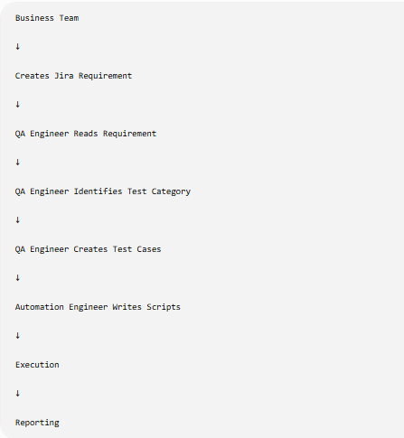
Problems:
Entire classification depends on QA experience
No standard rules
Different testers classify differently
Slow process
Human errors
Not scalable

Problem Statement
QA engineers manually classify requirements before creating test cases. This limits scalability and introduces inconsistencies.
Proposed Solution
The proposed solution introduces an AI-powered Requirement Classification Agent capable of automatically analyzing requirements and assigning one or more testing categories.

Business Benefits
The proposed AI-driven approach provides several advantages over traditional manual classification.
Standardization
Faster Test Design
Scalability
Improved Test Coverage
Reduced Human Dependency
Better Traceability

Objectives
Read requirements, analyze business intent, classify into one or more testing categories, assign confidence, and route to test generation.

Scope
In Scope: ingestion, AI analysis, categorization, routing. Out of Scope: execution, defect management, CI/CD.

High-Level Architecture
Jira/XML/JSON/DB -> Requirement Repository -> Requirement Reader -> AI Classification Engine -> Category-specific Test Generators -> QA.
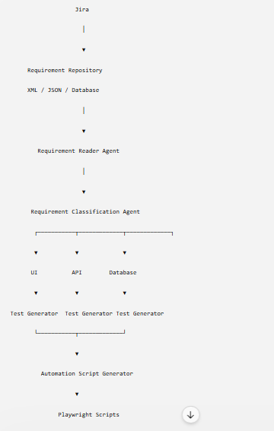

Requirement Repository Design
Supports Jira, XML, JSON, CSV, Excel, Database, and Text repositories using a standard requirement schema.

Repository Architecture
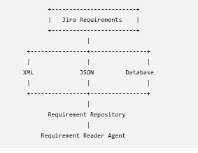

Requirement Processing Pipeline
Read -> Preprocess -> Keyword Extraction -> Business Context -> LLM Classification -> Confidence -> Routing.
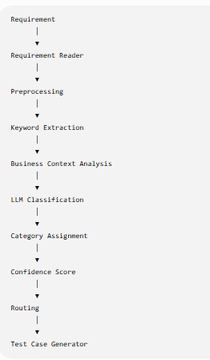

AI Classification Engine
Combines rule engine, keyword matching, NLP, business context analysis, LLM reasoning, and historical patterns.
Internal Architecture :-
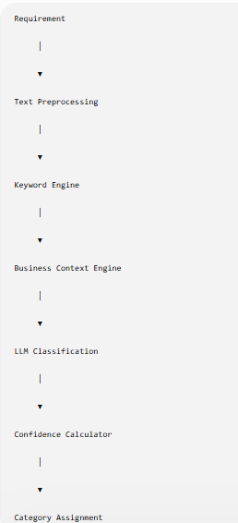

Prompt Engineering
Provide structured prompts requesting primary category, secondary category, priority, automation feasibility, confidence, and reasoning.
The AI should receive structured prompts.
Example Prompt

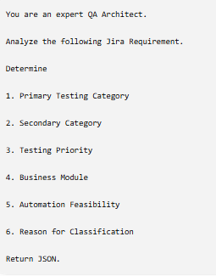

Expected Output

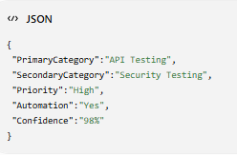

Classification Algorithm
Extract keywords, identify intent, apply rules, invoke LLM if required, assign categories, calculate confidence, and store results.
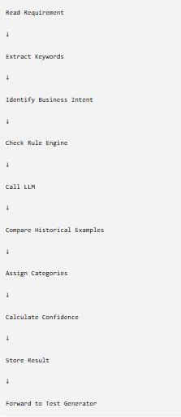

Confidence Scoring
Keyword Match 30%, Business Context 25%, LLM 25%, Historical Similarity 10%, Completeness 10%.

Testing Categories
UI, API, Regression, Smoke, Sanity, Component, Integration, Database, Security, Performance, Load, Stress, Accessibility, Responsive, Cross Browser, Authentication, Authorization, Session, Notification, Workflow, Business Rule, End-to-End, Compliance, Logging, Monitoring.

Requirement Mapping Matrix
Example: Login Page->UI, Login API->API, Password Encryption->Security, Customer Table->Database, Dashboard Load->Performance.

Sample Jira Requirements
REQ-001 Verify Login Page(UI), REQ-002 Verify Login API(API), REQ-003 Password Encryption(Security), REQ-004 Customer Table(Database), REQ-005 Dashboard Load(Performance). Continue similarly to REQ-100 covering all categories.

Sequence Diagram
User -> Repository -> Reader Agent -> Classification Agent -> Category Engine -> Test Generator -> QA.
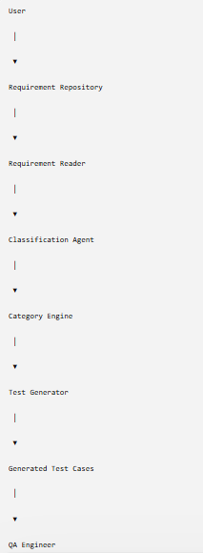

Decision Tree
API? -> API Testing; else UI? -> UI Testing; else SQL? -> Database; else Authentication? -> Security; otherwise LLM.

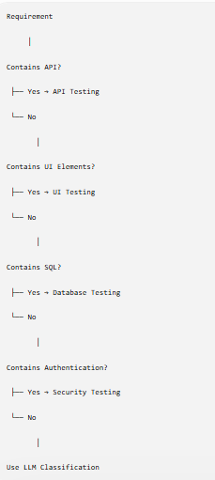

Error Handling
Handle empty requirements, duplicate IDs, unsupported formats, low confidence, and multi-label classifications.

KPIs
Accuracy >95%, Precision >94%, Recall >93%, Auto Classification >90%, Routing Accuracy >97%.

Future Roadmap
Integrate with Jira, Azure DevOps, Zephyr, Playwright generation, self-learning models, risk-based testing, autonomous regression planning.

Conclusion
The Requirement Classification Agent is the foundation for an enterprise Agentic AI testing ecosystem enabling intelligent, scalable, and standardized test generation.

