DBSE & DBD WEEK 1 PRACTICAL

Name: K. Srihitha
Roll No: 2520020153
Course Code: 25CS1302E

WEEK 1: DDL COMMANDS AND CONSTRAINTS

Aim:
To practice Data Definition Language (DDL) commands and constraints using MySQL Workbench.

Software Used:
MySQL Workbench

Database Name:
bookflow_db

SQL Operations Performed:
- Created a database named bookflow_db.

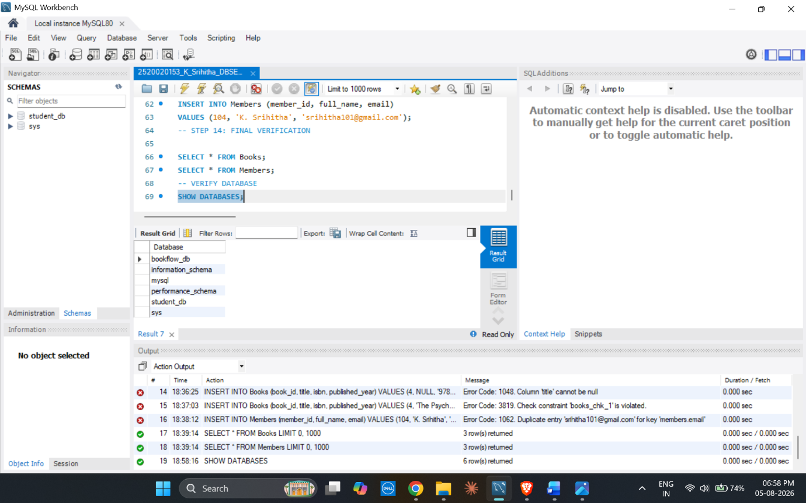
- Created the Books table using PRIMARY KEY, NOT NULL, UNIQUE and CHECK constraints.
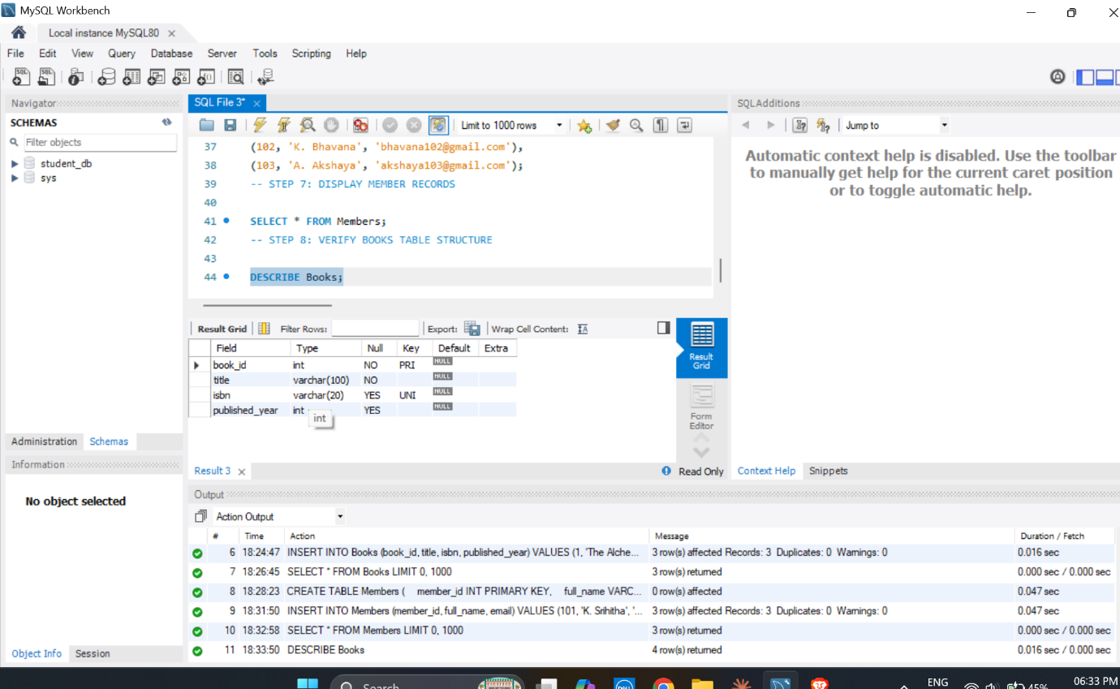

- Inserted records into the Books table.
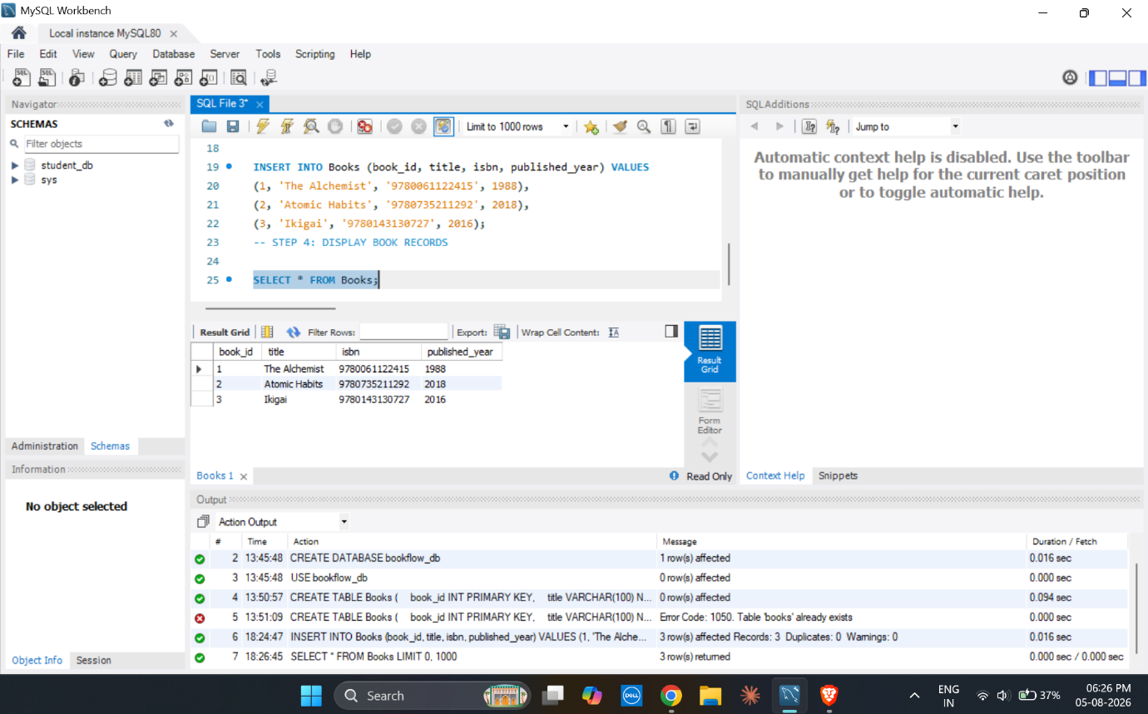
- Created the Members table using PRIMARY KEY, NOT NULL and UNIQUE constraints.
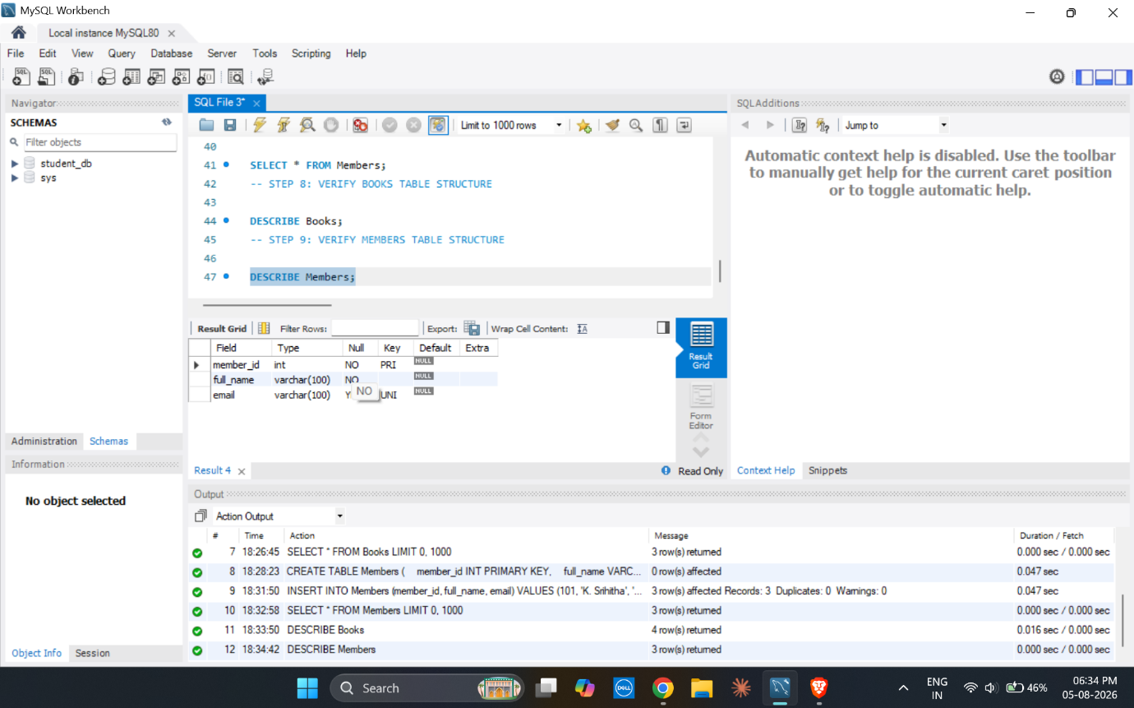
- Inserted records into the Members table.
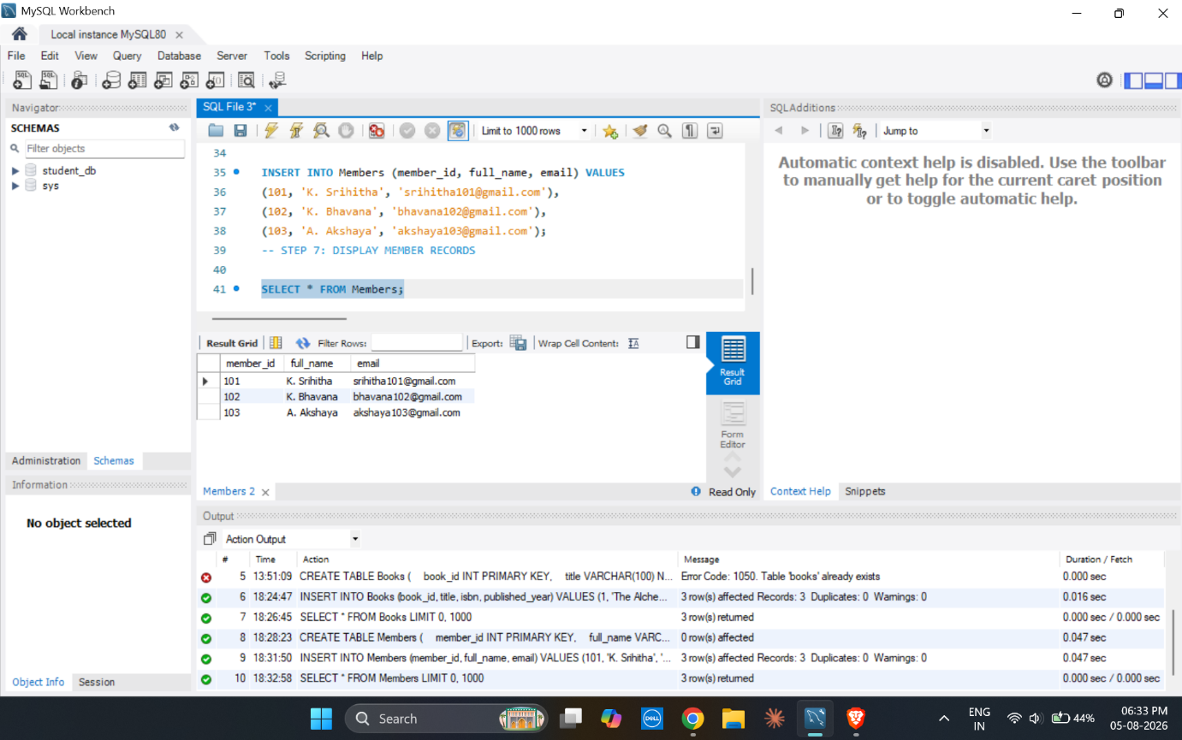
- Displayed the records using SELECT statements.

- Verified the structure of Books and Members tables using DESCRIBE.


- Tested UNIQUE, NOT NULL and CHECK constraints.
