WEEK 2

DSE & DBD WEEK 2 PRACTICAL
Name: K. Srihitha
Roll No: 2520020153
Course Code: 25CS1302E
JOINS, AGGREGATIONS, TRANSACTIONS AND INDEXING
Aim:
To practice SQL JOIN operations, aggregate functions, transaction management, foreign keys and indexing using MySQL Workbench.
Software Used:
MySQL Workbench
Database Name:
bookflow_db

SQL Operations Performed
- Verified the existing Books and Members tables.
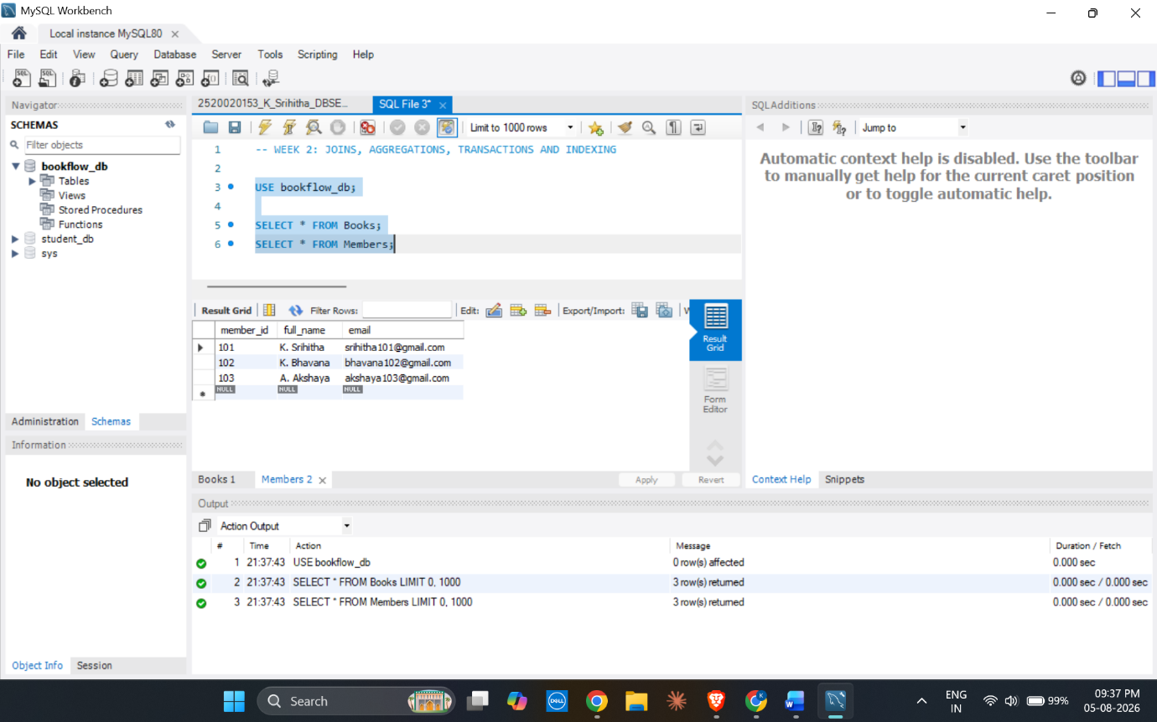
- Created the Loans table using PRIMARY KEY and FOREIGN KEY constraints.
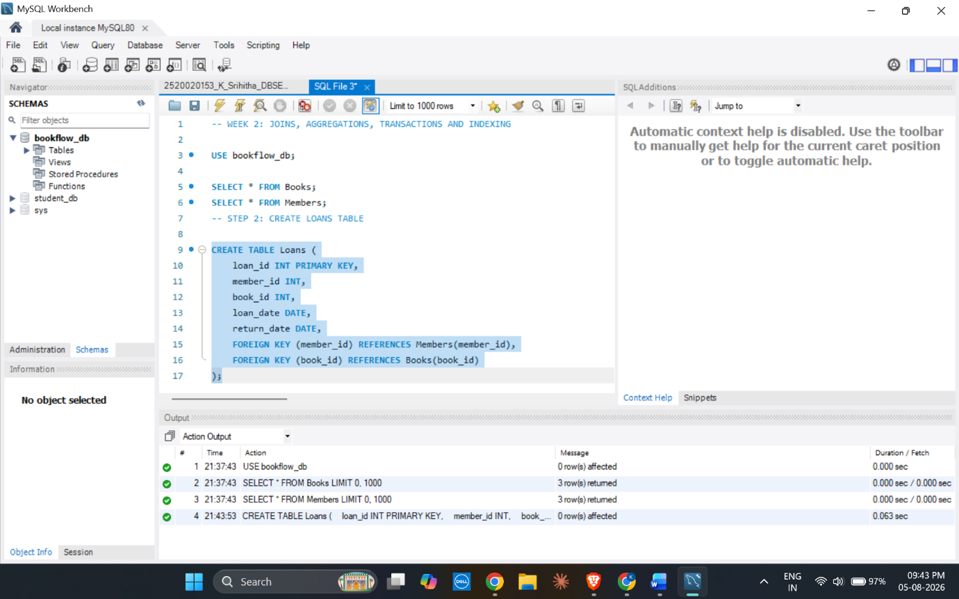
- Inserted records into the Loans table.
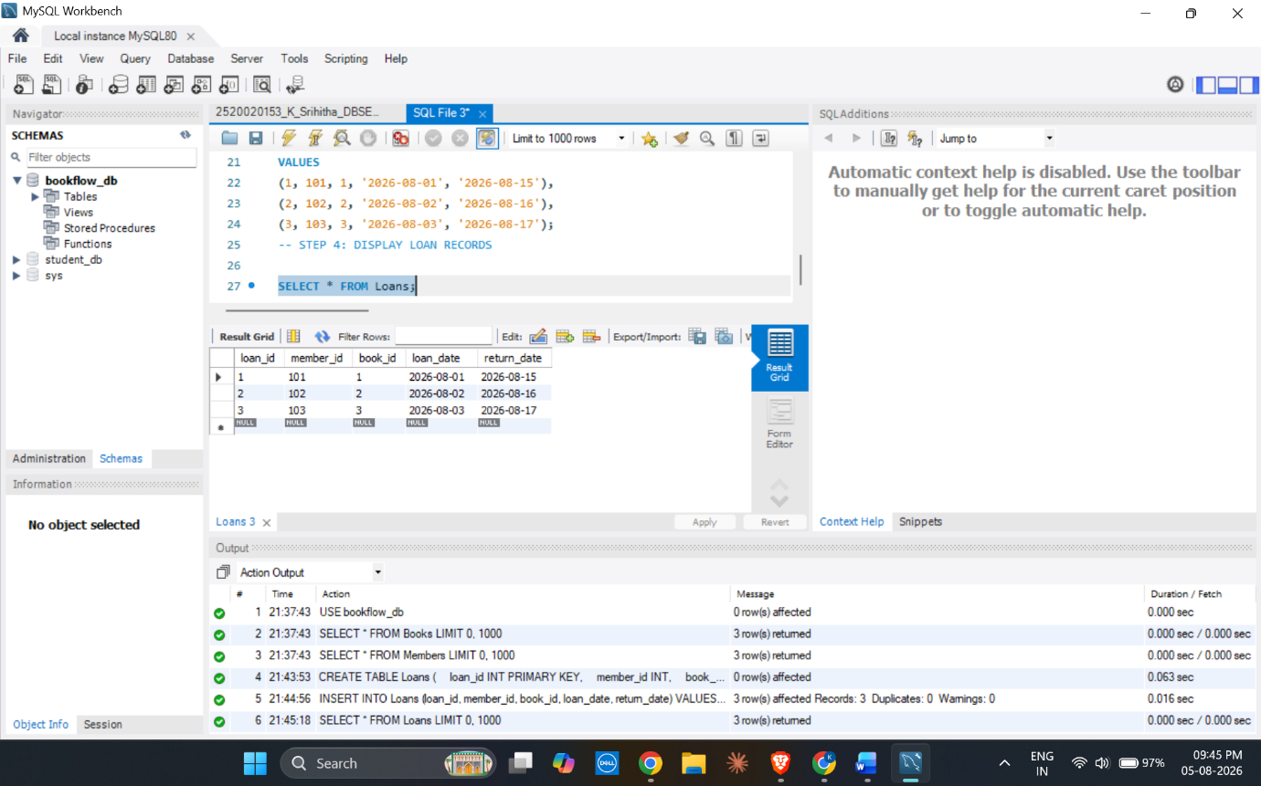
- Displayed the Loan records.

- Displayed Loan Details Using INNER JOIN.
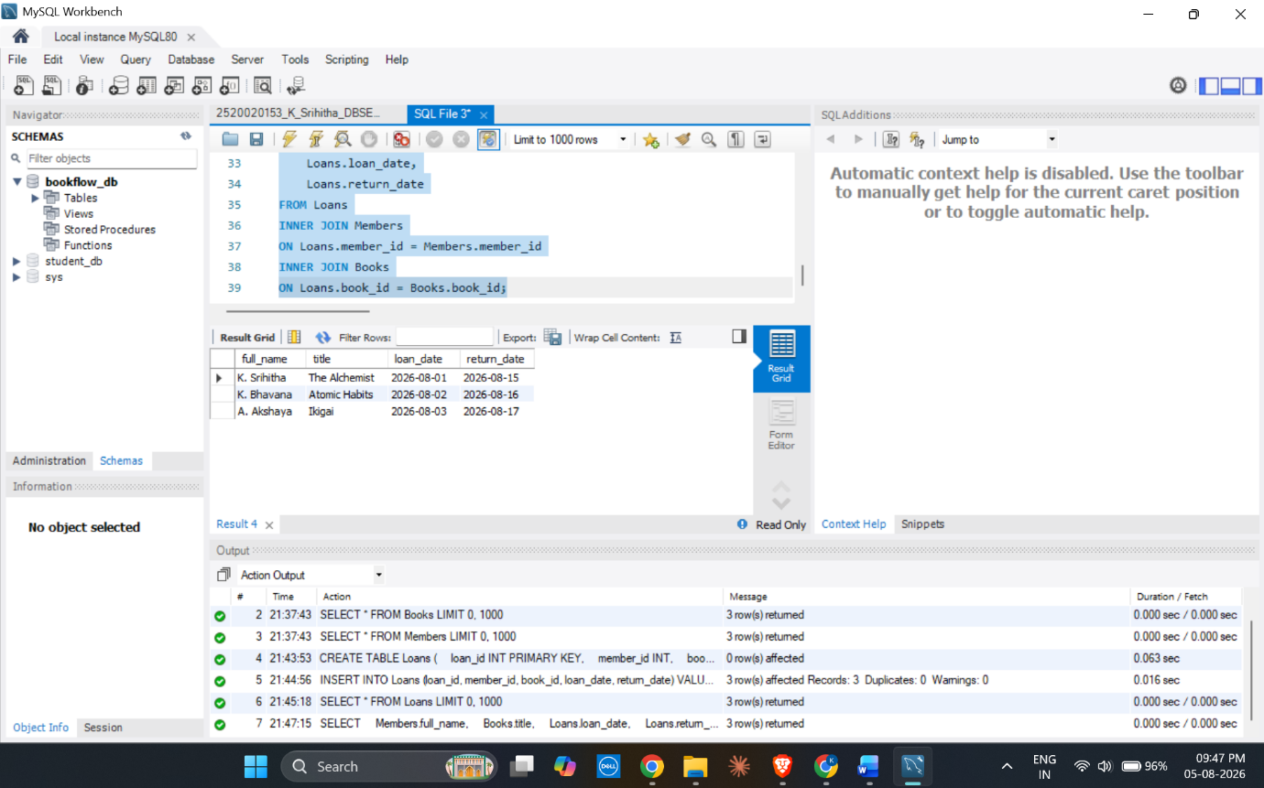
- Counted Books Borrowed by Each Member Using GROUP BY and COUNT.
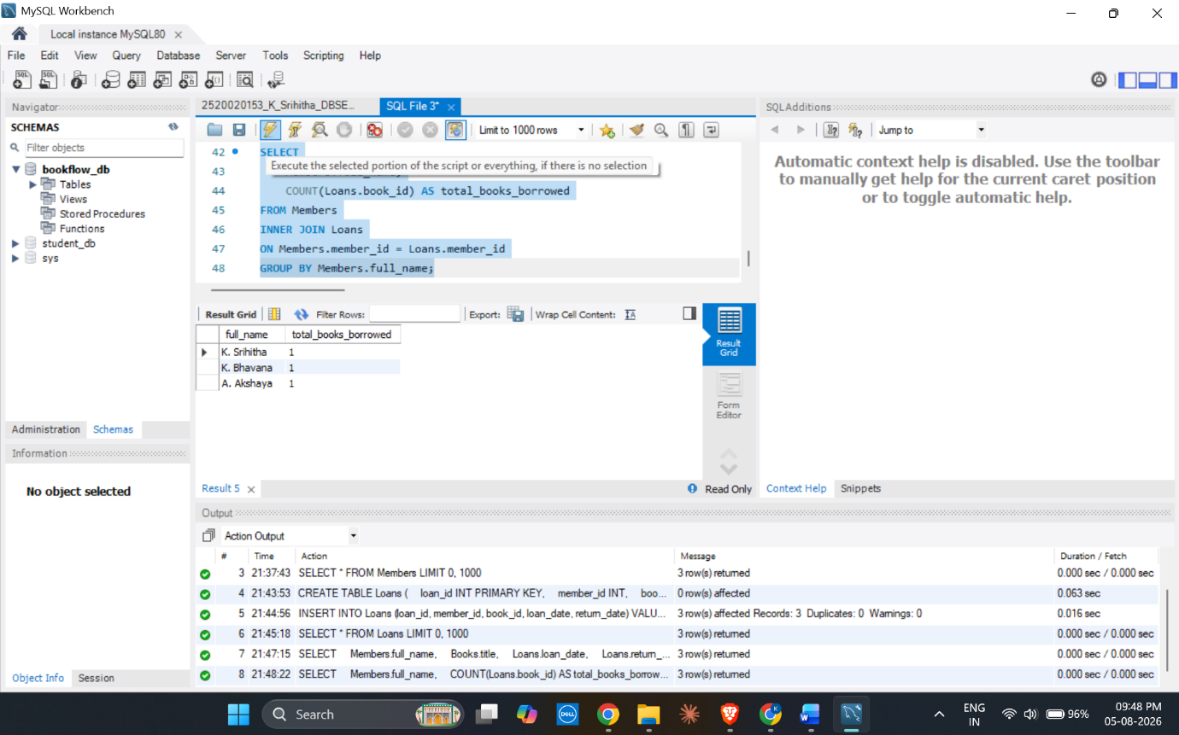
- Demonstrated Transaction Management Using COMMIT.
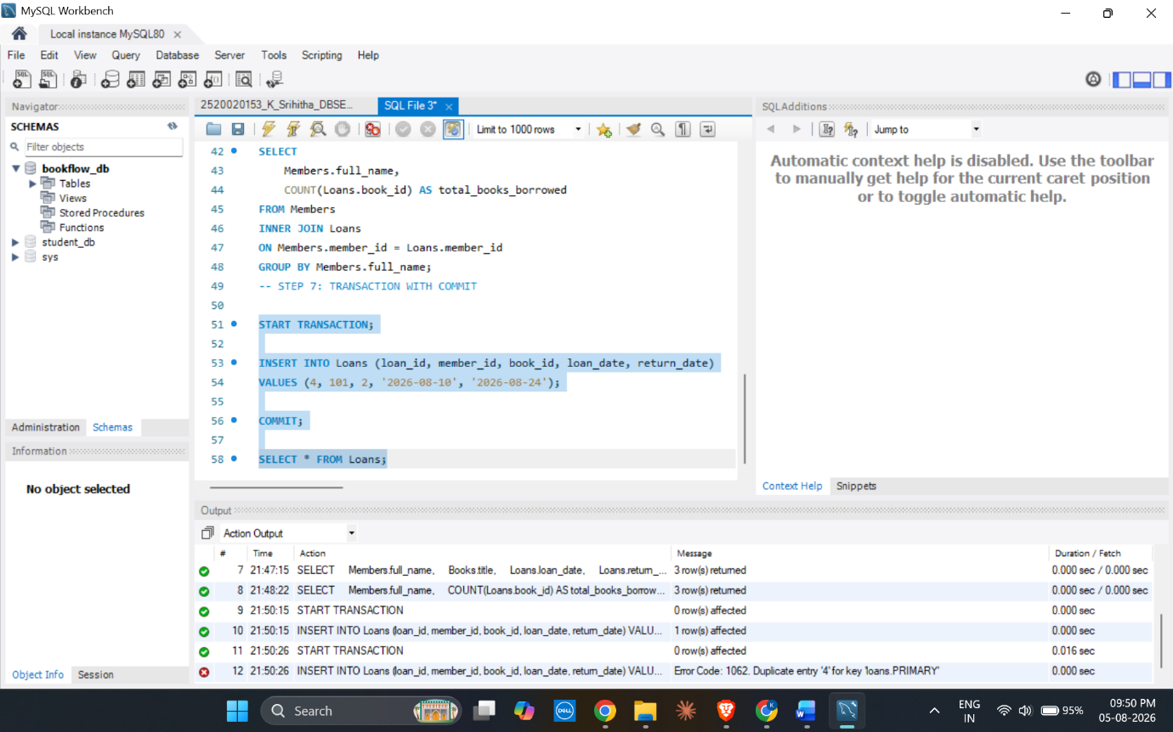
- Demonstrated Transaction Management Using ROLLBACK.
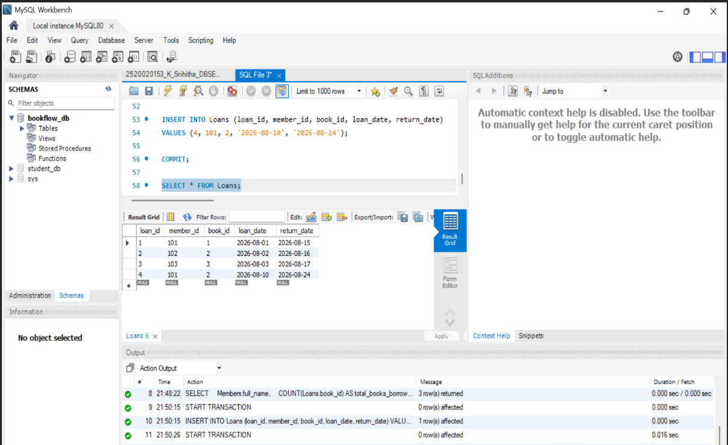
- Created an Index on the Books Table to Improve Search Performance.
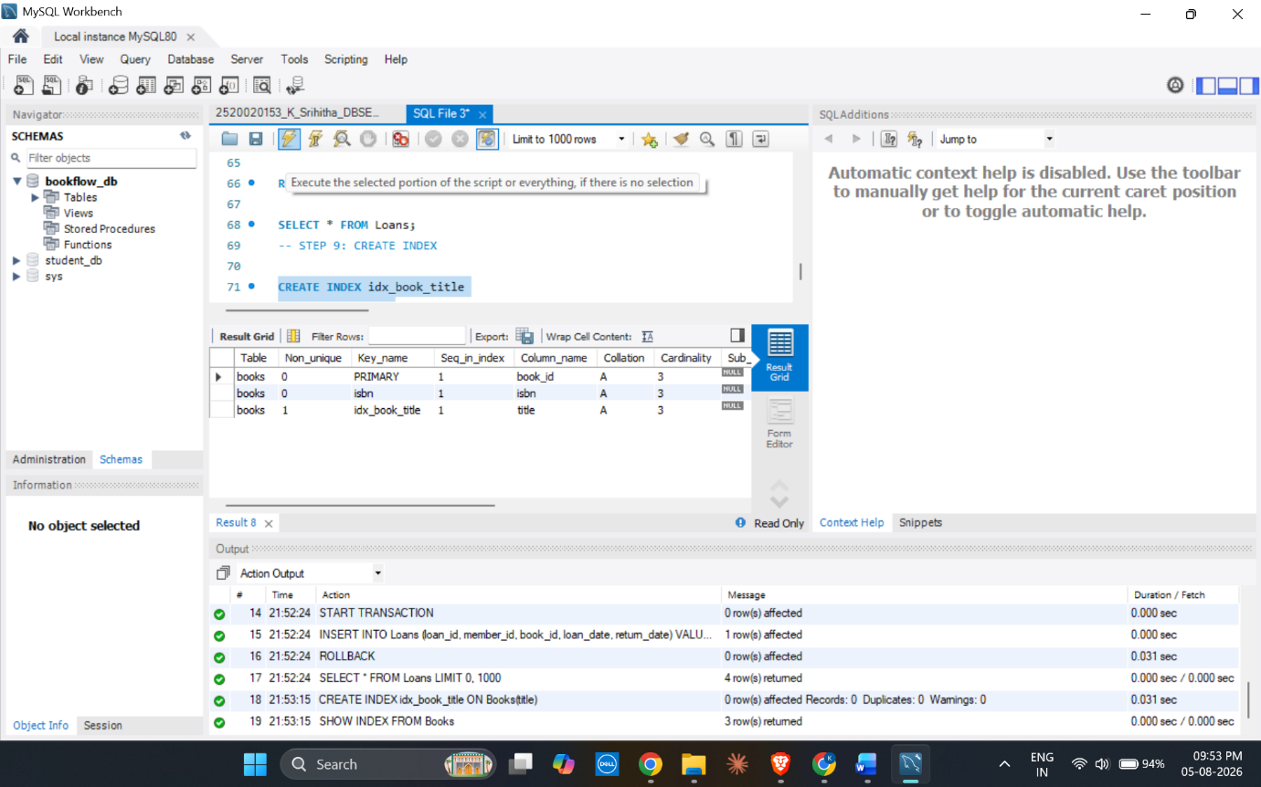

Result:
Successfully performed JOIN operations, aggregate functions, transaction management, and indexing using MySQL Workbench.

