OSSP (Operating Systems and Systems Programming) – 25CS2104E
OSSP LAB – PRACTICAL-2

Aim
To develop a C program using the system calls open(), read(), write(), and close() to copy the contents of one file to another, and to use the strace utility to trace and analyze the system calls generated by cat sample.txt, thereby understanding the interaction between user space and kernel space.
Algorithm
- Start the program.
- Open the source file using open() in read-only mode.
- Open or create the destination file using open() in write mode.
- Read data from the source file using read() into a buffer.
- Write the data from the buffer to the destination file using write().
- Repeat the read and write operations until the entire file is copied.
- Close both files using close().
- Execute strace cat sample.txt in the terminal.
- Observe and analyze the system calls such as execve(), openat(), read(), write(), and close().
- Relate these system calls to the corresponding kernel services and user-space/kernel-space transitions.
- Stop.
Steps
Step 1
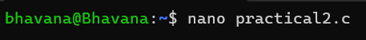

Step 2
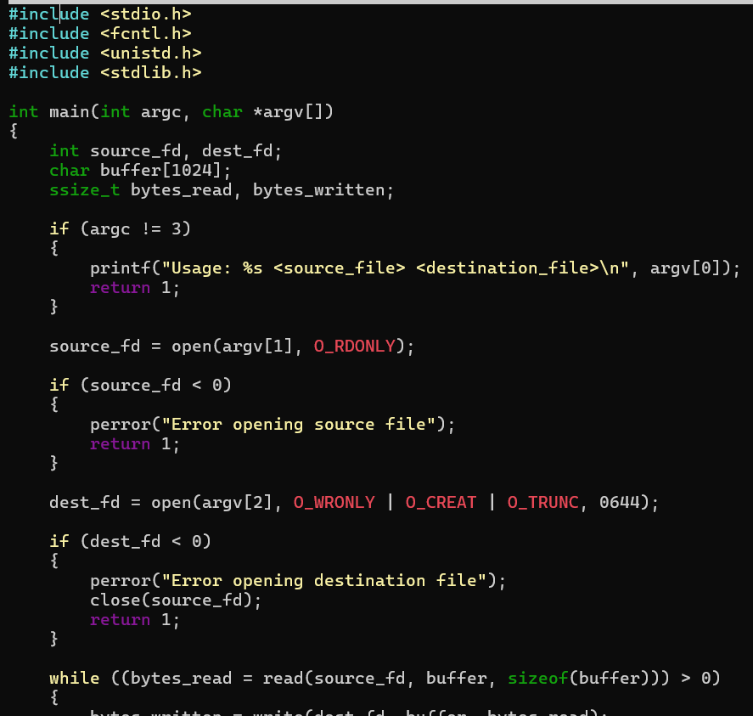
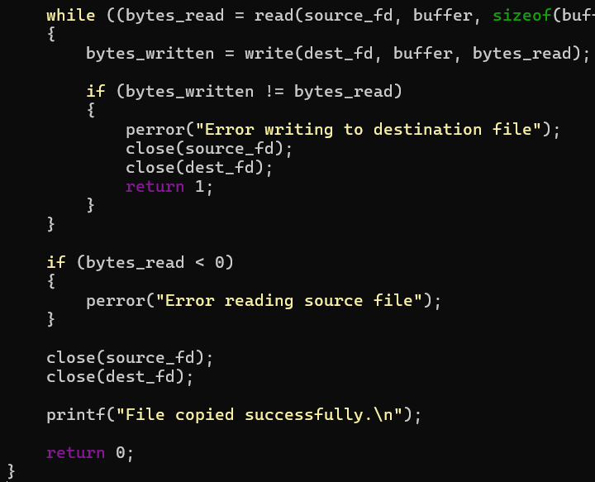
Step 3
Swtep 4
Step 5
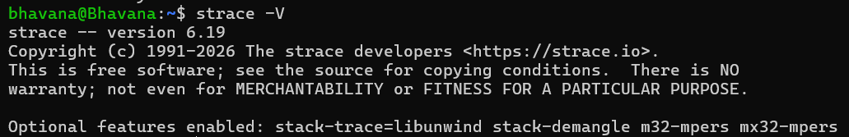
Step 6
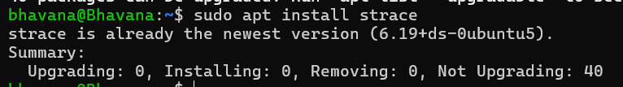
Step 7
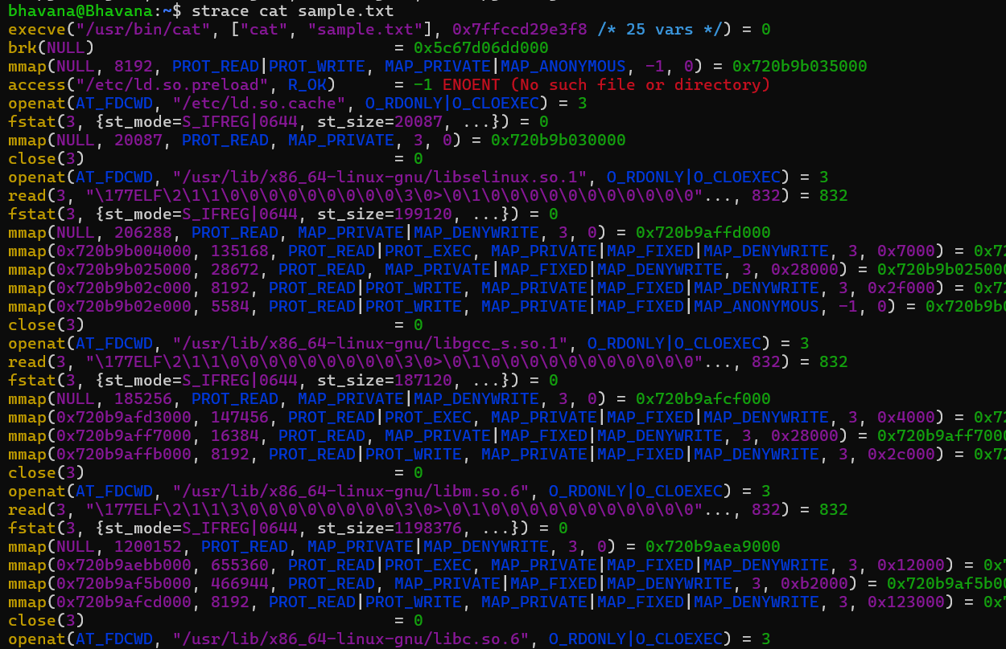
Conclusion
The file-copy operation was successfully implemented using Linux system calls, and the strace utility was used to trace the system calls generated by cat sample.txt. The experiment demonstrated how user-space programs interact with the Linux kernel through system calls for file access, reading, writing, and closing operations.

