OSSP (Operating Systems and Systems Programming) – 25CS2104E
OSSP LAB – PRACTICAL-3
Aim
To develop a C program using fork() to create a parent and child process, display their Process ID (PID), Parent Process ID (PPID), and process states at different stages, and design an experiment using Linux monitoring tools such as ps, top, and /proc to observe process state transitions between Ready, Running, Waiting, and Terminated.
Algorithm
- Start the program.
- Display the PID and PPID of the initial parent process.
- Call fork() to create a child process.
- Check the return value of fork():
  - If it is negative, display an error.
  - If it is zero, execute the child process.
  - If it is positive, execute the parent process.
- In the child process, display its PID and PPID and perform some operations with a delay to observe its state.
- In the parent process, display its PID and PPID and wait for the child using wait().
- Use ps to observe the PID, PPID, and current process state.
- Use top to continuously monitor the processes and observe their CPU activity and states.
- Use /proc/<PID>/status or /proc/<PID>/stat to obtain detailed process-state information.
- Observe the process during different stages:
  - Ready: process is waiting for CPU scheduling.
  - Running: process is currently executing.
  - Waiting: process is waiting for an event or resource.
  - Terminated: process has completed execution.
- Record the observations from ps, top, and /proc.
- After the child terminates, the parent continues and terminates.
- Stop the program.
Steps
Step 1
Step 2
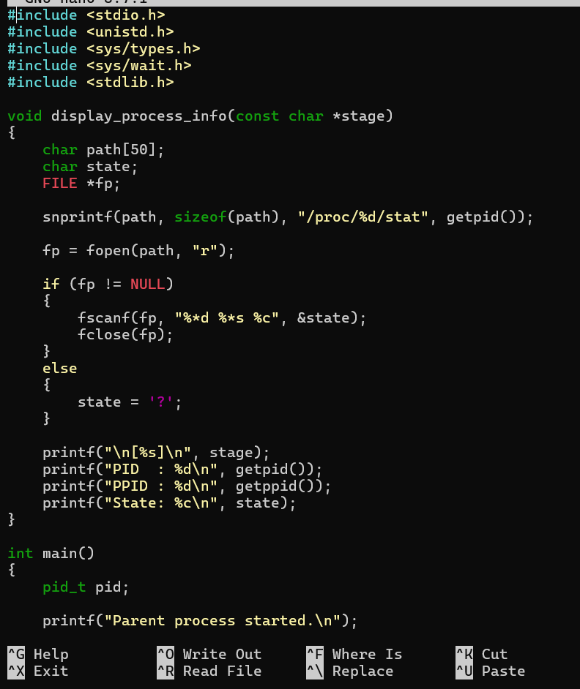

Step 3
Step 4
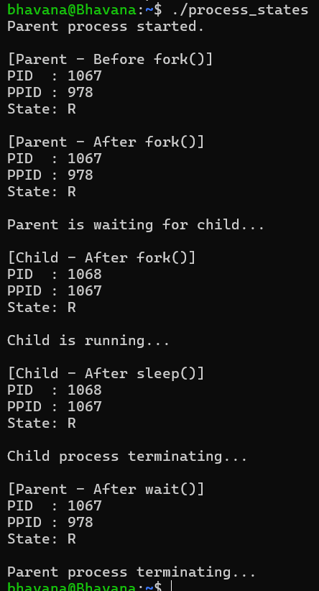

Step 5
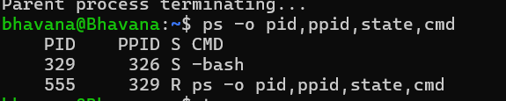
Step 6
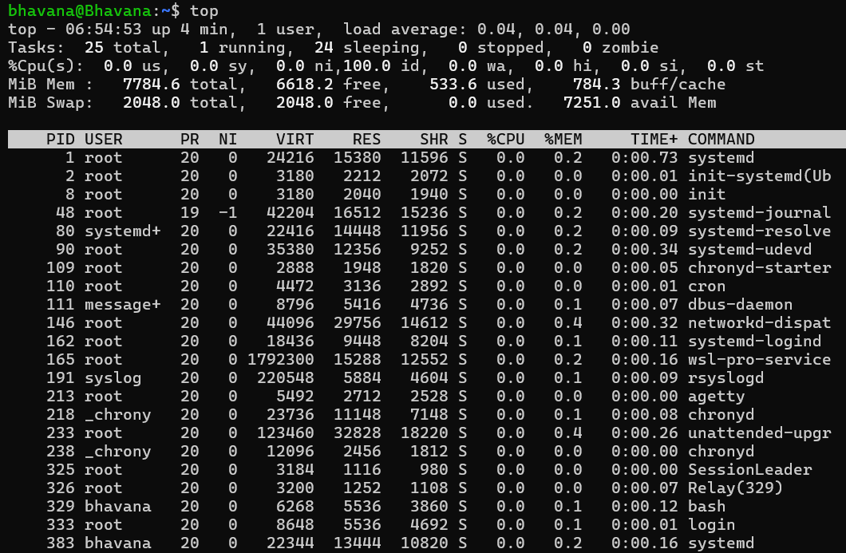
Step 7
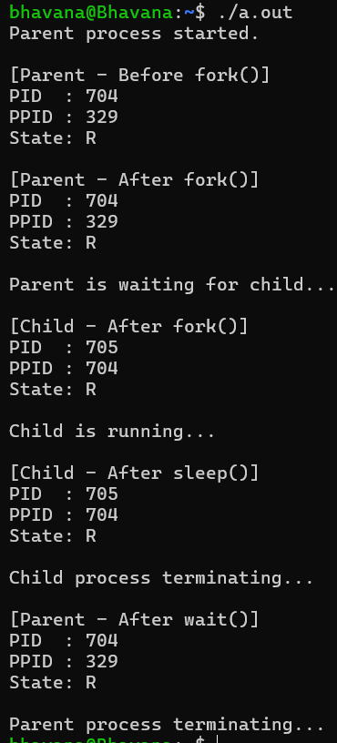

Conclusion
The experiment successfully demonstrated the creation and execution of parent and child processes using fork(). The PID, PPID, and process states were observed at different stages using ps, top, and /proc. The experiment showed how a process transitions through Ready, Running, Waiting, and Terminated states during its lifetime, providing a practical understanding of Linux process management and scheduling.

