Operating Systems and System Programming
Skill-5

Aim
To implement single and double quote handling in a shell, preserve literal content and spaces, support variable expansion, store quoted strings, validate parsing results, and test different inputs.
Algorithm
- Start the program.
- Read input from the user.
- Identify single and double quotes.
- Preserve the content inside single quotes without variable expansion.
- Preserve spaces inside double quotes and allow variable expansion.
- Store the processed strings in a buffer.
- Display the parsed output.
- Test different inputs and validate the results.
- Stop the program.

Task-1:
Step-1:
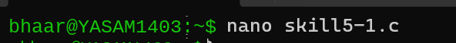

Step-2:
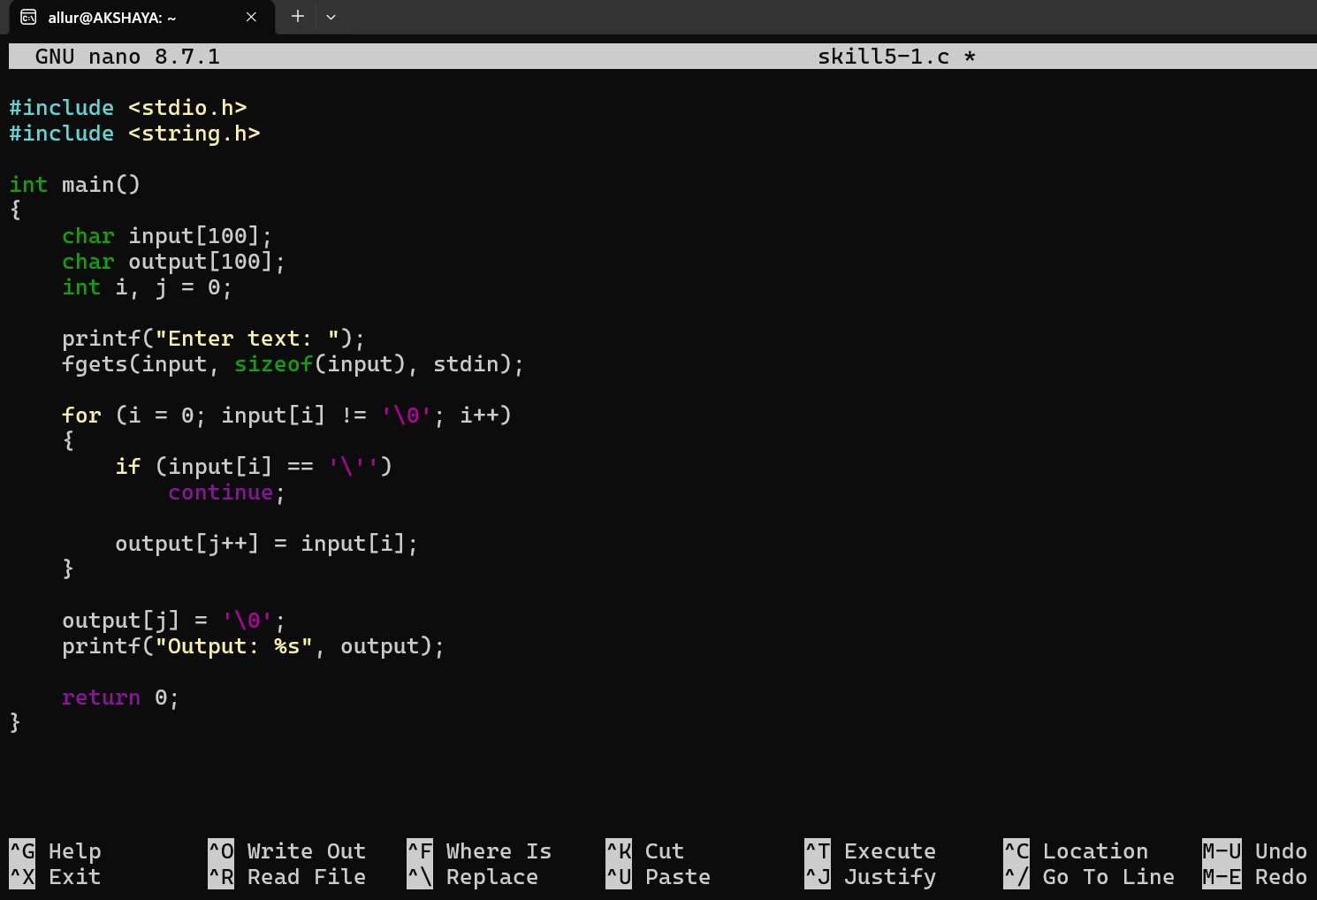

Step-3: Compile and Run
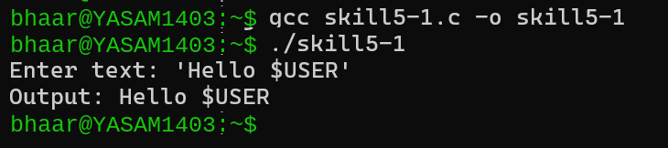
Explanation: This program removes single quotes and displays their contents literally. It does not expand $USER.

Task-2:
Step-1:
Step-2:
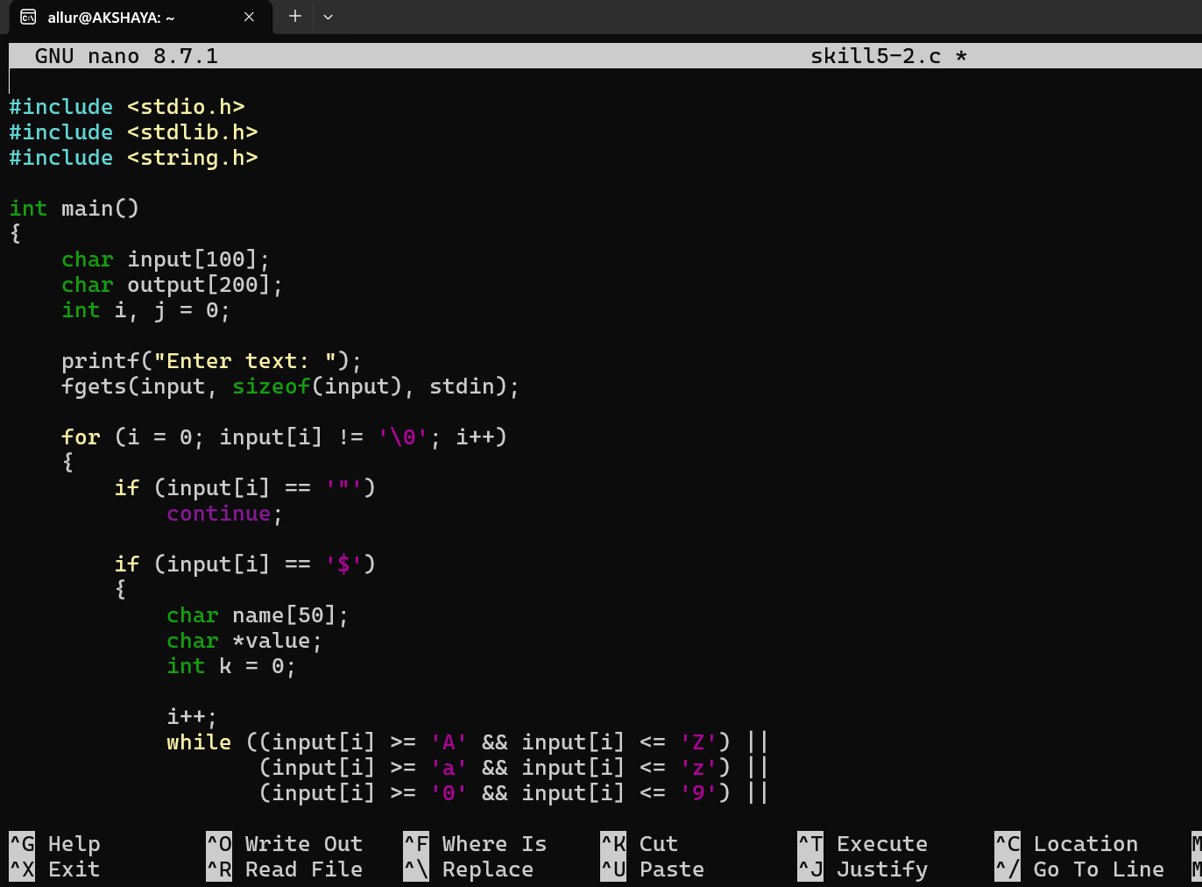
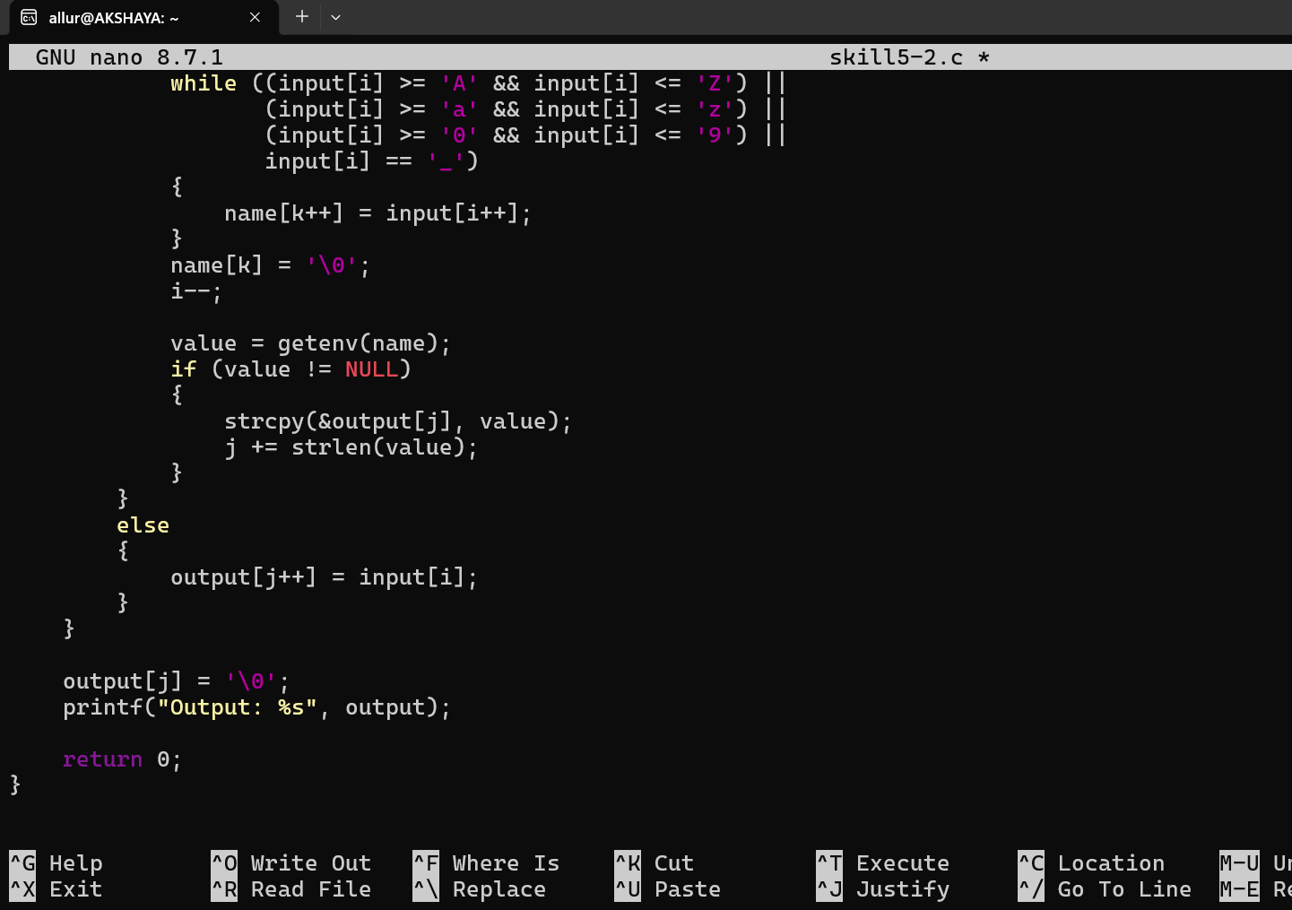

Step-3: Compile and Run
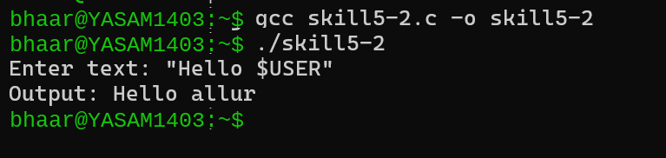
Explanation: This program removes double quotes, preserves spaces, and expands environment variables such as $USER.

Result
Single and double quote handling was successfully implemented. Single quotes preserved literal content without variable expansion, while double quotes preserved spaces and allowed variable expansion. The parsing results were tested and verified successfully.

