Operating Systems and System Programming Practical – 4

Task-1:
Aim
To create multiple child processes and synchronize their completion using wait() and waitpid(), and to create, observe, and eliminate zombie processes using proper synchronization techniques.
Algorithm
- Start the program.
- Create multiple child processes using fork().
- Display the PID of each child process.
- Use wait() to wait for any child process to complete.
- Use waitpid() to wait for a specific child process.
- Create a zombie process by allowing the child to terminate while the parent does not call wait().
- Use ps to observe the zombie process.
- Modify the program to use wait() and collect the terminated child.
- Verify that the zombie process is eliminated.
- Stop the program.

Step-1:
Step-2:
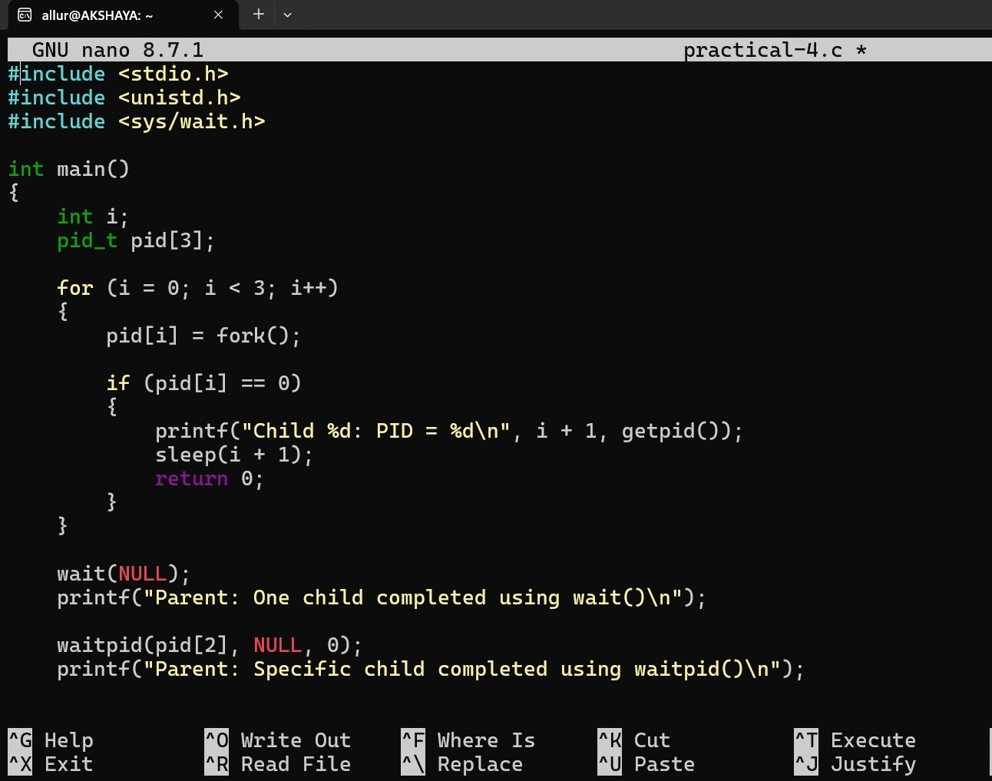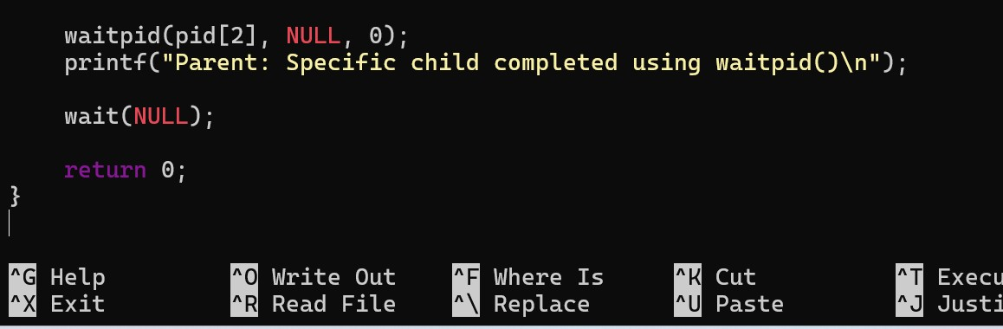

Step-3:
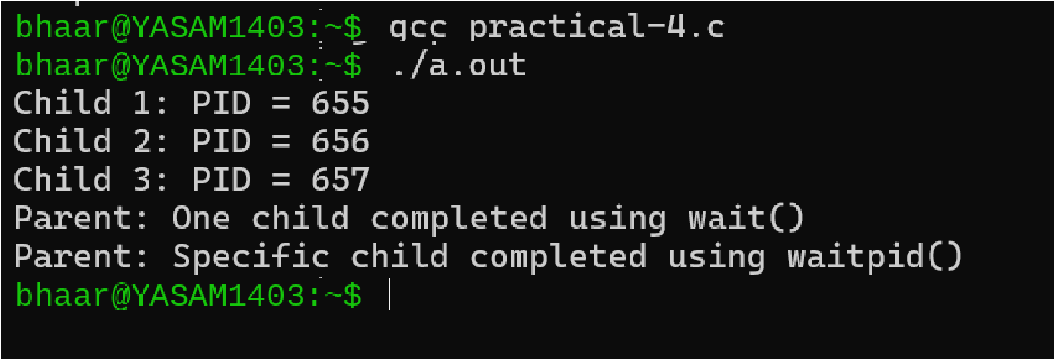

Task-2:
Step-1: Program to Create a Zombie
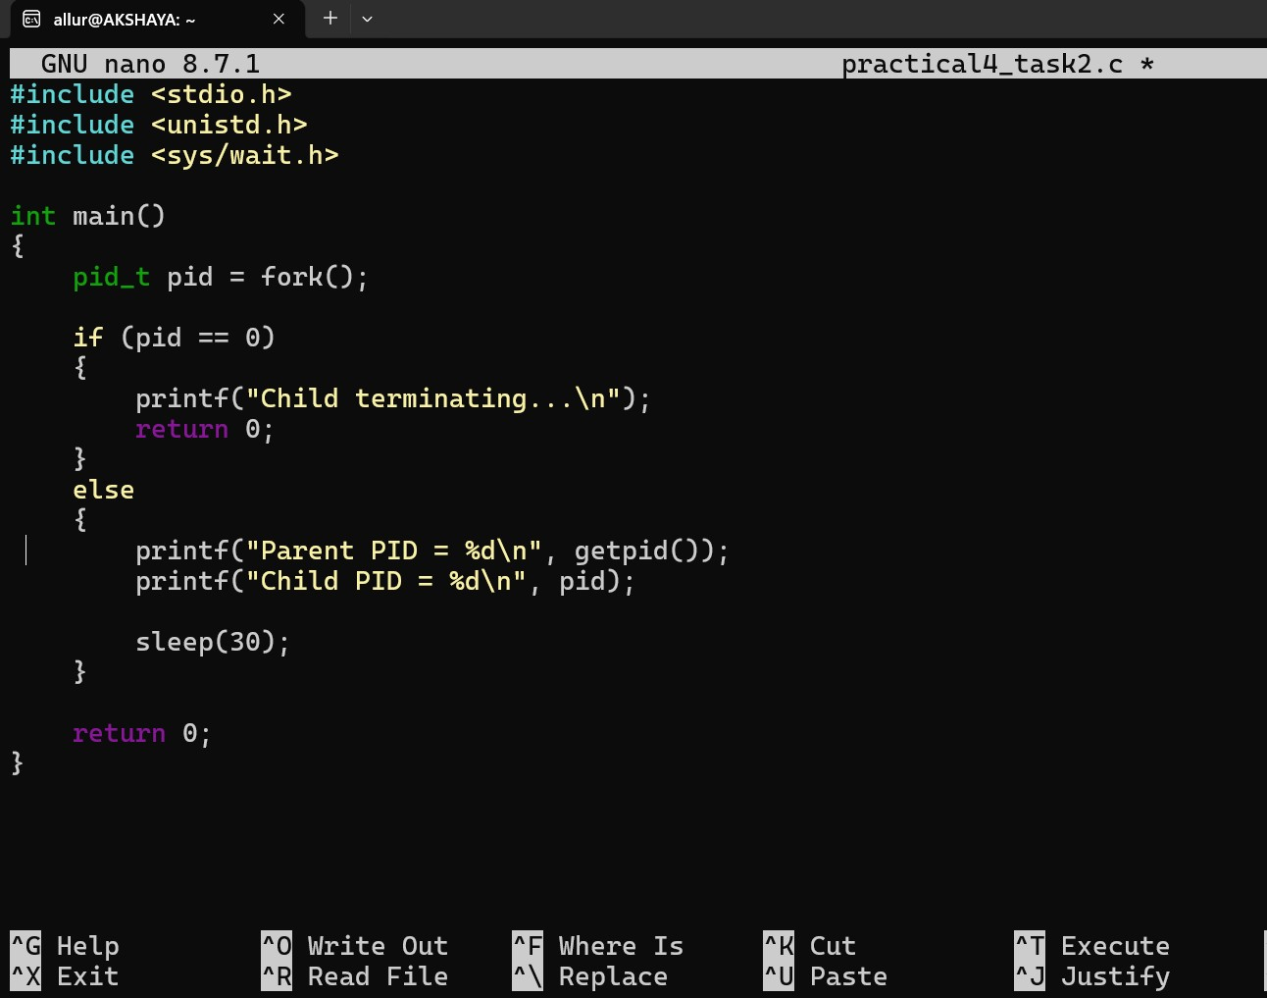
Step-2: Compile and Run
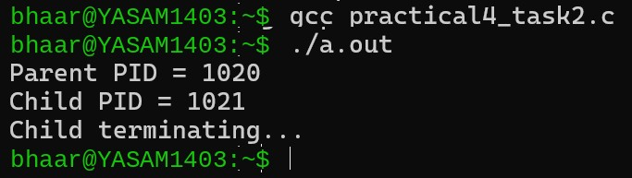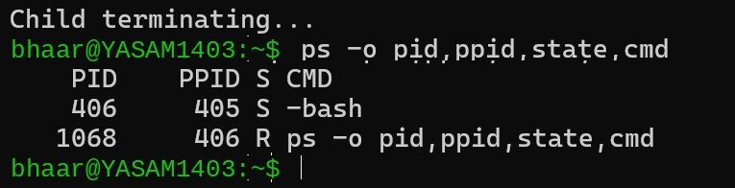

Modified Program to Prevent Zombie
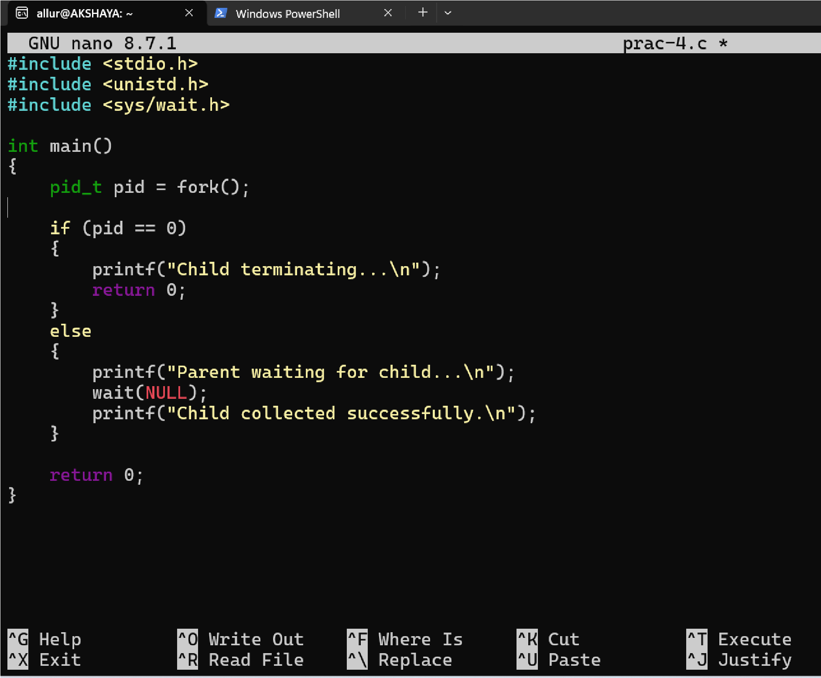
Step-3:
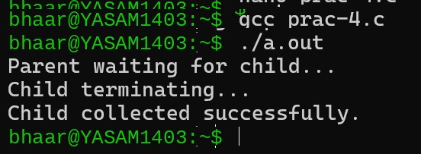

Result
Multiple child processes were successfully created and synchronized using wait() and waitpid(). A zombie process was successfully observed using the process table and was eliminated by using proper wait() synchronization.

