Operating Systems and System Programming
Practical – 5

Aim
To implement producer-consumer communication using an anonymous pipe, where the parent process generates data and the child process consumes it, measure communication time, and execute the command ls -l | grep ".c" using fork(), pipe(), dup2(), and exec() system calls.

Algorithm
- Start the program.
- Create an anonymous pipe using pipe().
- Create a child process using fork().
- The parent writes data into the pipe, and the child reads and displays it.
- Measure and display the communication time.
- Create another pipe for executing ls -l | grep ".c".
- Create two child processes using fork().
- Redirect the output of ls to the pipe using dup2().
- Redirect the input of grep from the pipe using dup2().
- Execute ls -l and grep ".c" using exec().
- The parent waits for both child processes using waitpid().
- Close the pipes and terminate the program.

Step-1:


Step-2: Code 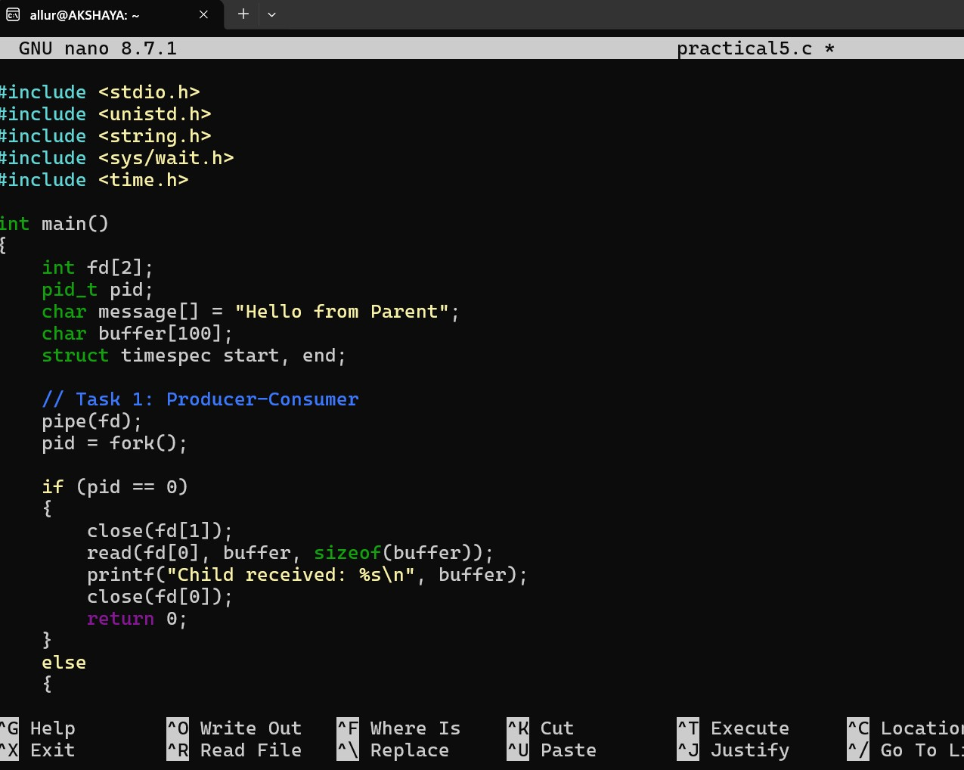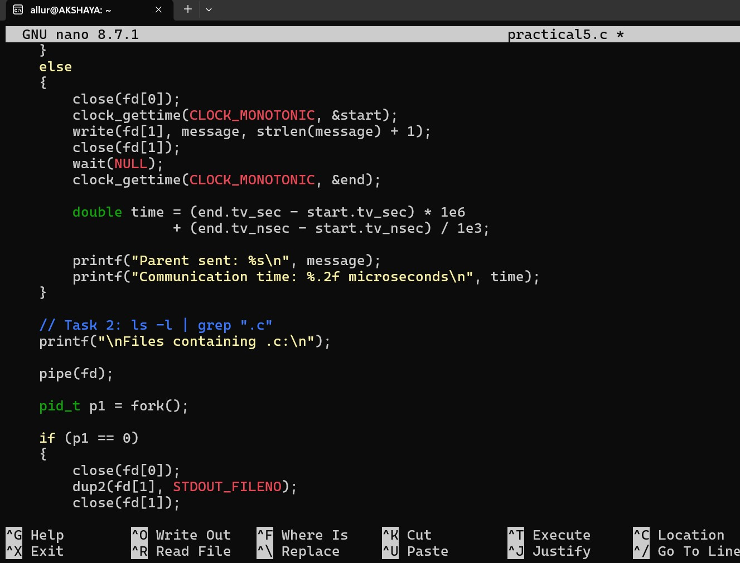

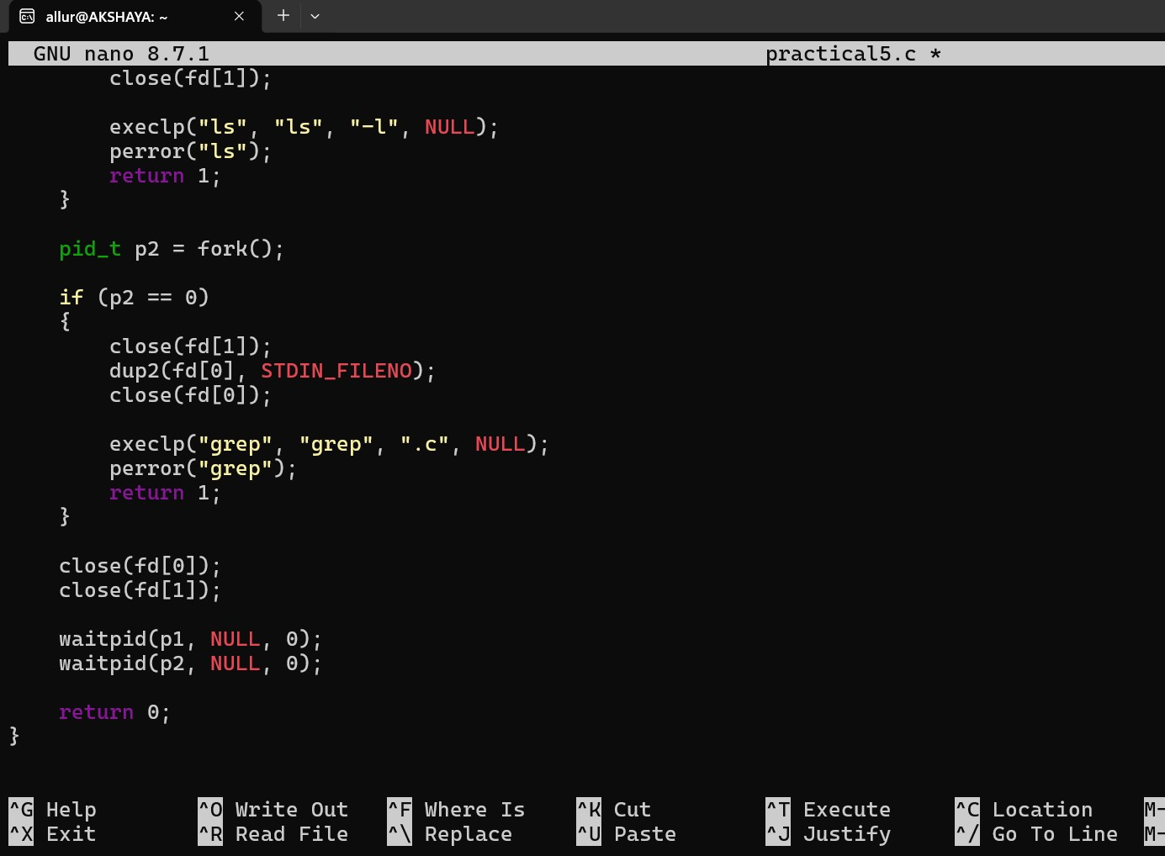

Step-3: Compile and Run
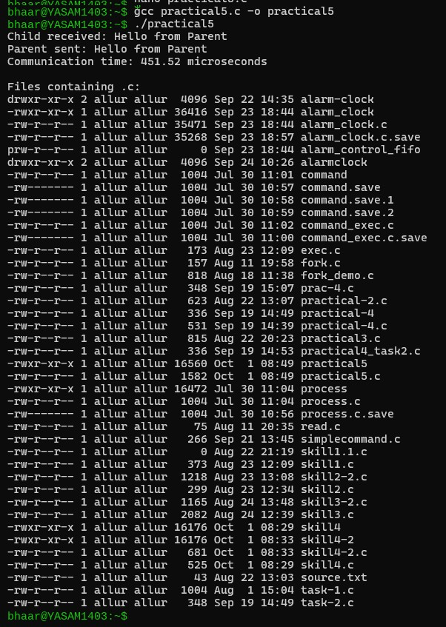

Result
The producer-consumer communication system was successfully implemented using an anonymous pipe, and the communication time was measured. The command ls -l | grep ".c" was successfully executed using fork(), pipe(), dup2(), and exec() system calls.

