Practical - 03
Process Creation and Process State Observation Using fork ()
1. Aim
To develop a C program using the fork () system call to create a parent and child process and observe their Process ID (PID), Parent Process ID (PPID), and process states using Linux monitoring tools such as ps, top, and the /proc filesystem.
2. Theory
In Linux, every executing program is represented as a process. Each process has:
- PID – Process ID, which uniquely identifies a process.
- PPID – Parent Process ID, which identifies the process that created it.
The fork () system call creates a new process called the child process.
After executing fork ():
- The parent process receives the PID of the child.
- The child process receives 0.
- A negative value indicates that process creation failed.
A process may move through different states during execution:
State | Meaning
Ready | Process is prepared to execute and waiting for CPU
Running | Process is currently executing
Waiting/Sleeping | Process is waiting for an event or time delay
Terminated | Process has completed execution
3. Algorithm
- Start the program.
- Display the PID and PPID of the original process.
- Call fork () to create a child process.
- Check whether fork () was successful.
- In the child process, display its PID and PPID.
- Introduce a delay using sleep () to observe the waiting state.
- In the parent process, display its PID and PPID.
- Keep the parent active for a sufficient amount of time to observe both processes.
- Use ps, top, and /proc to monitor the process states.
- Terminate both processes.
Step 1: Create the C program
Paste this code:
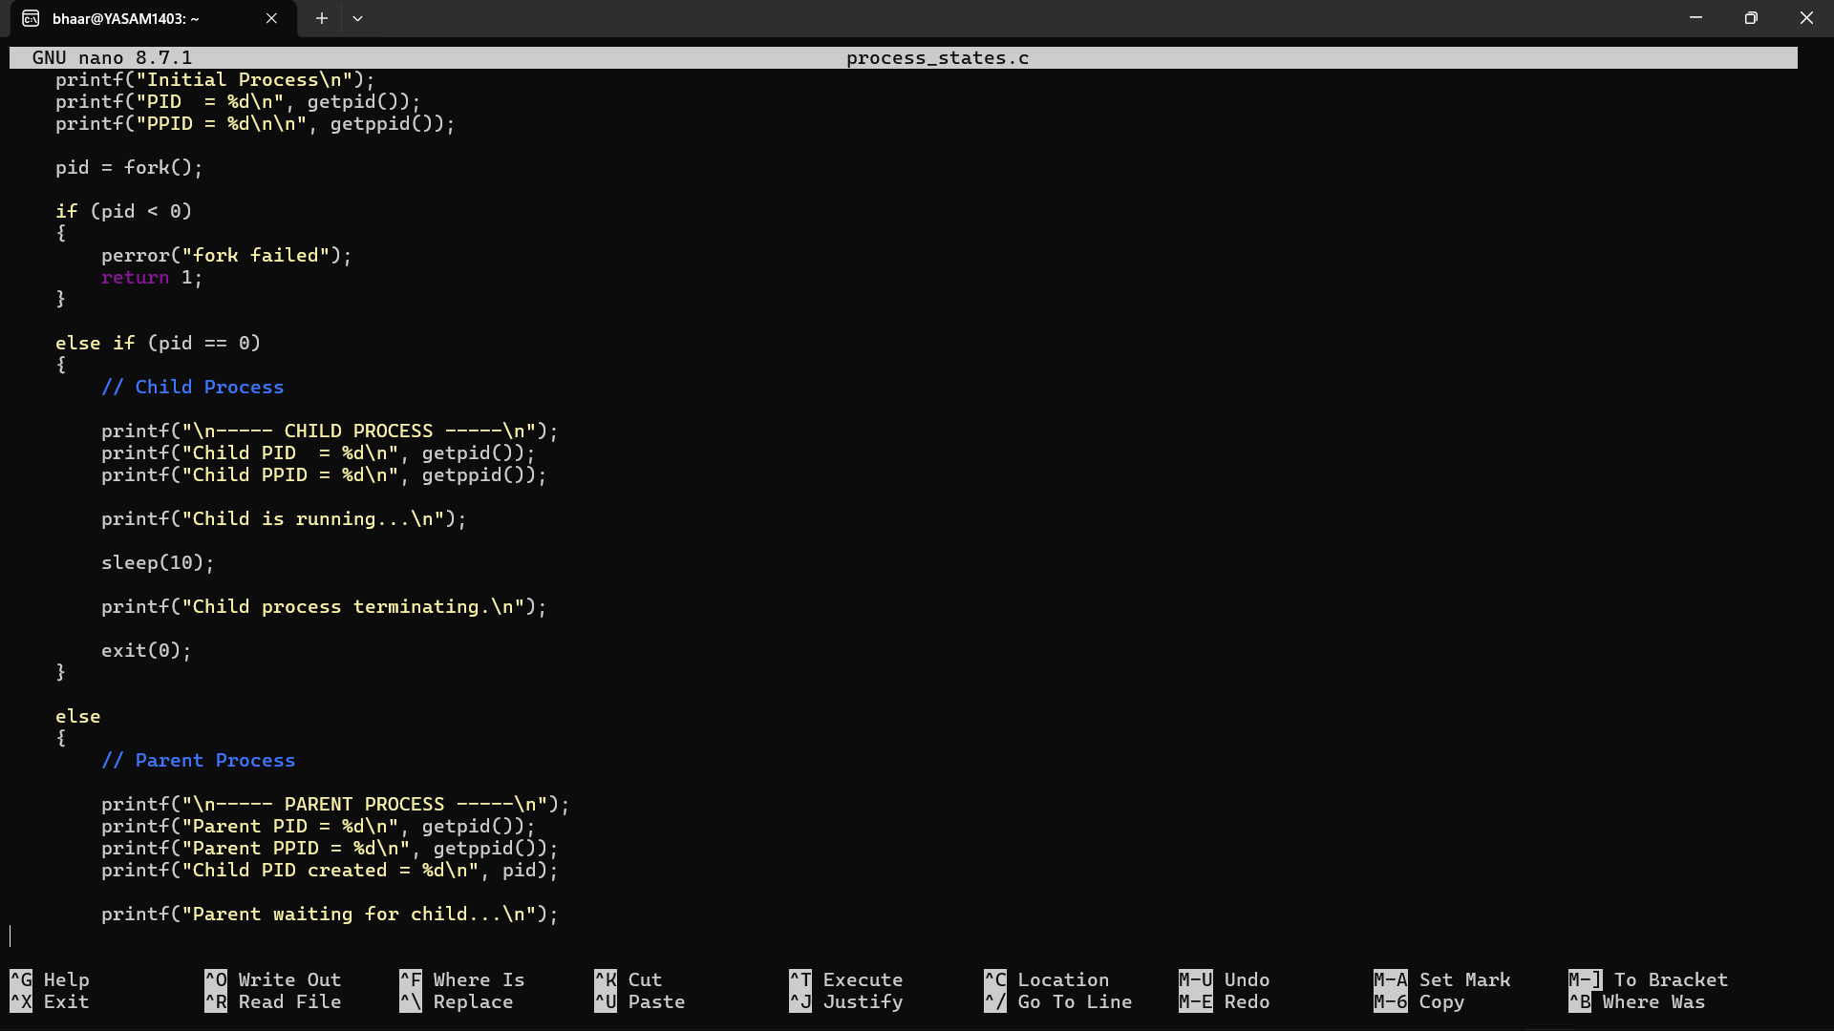
Save:
Ctrl + O
Enter
Ctrl + X

Step 2: Compile the program
Run:

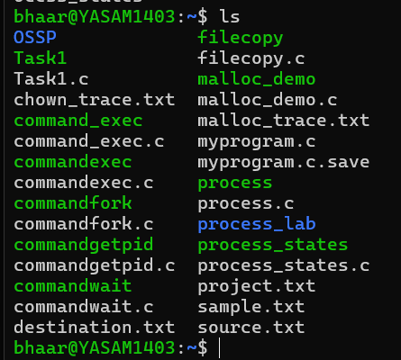

Step 3: Run the program
Execute:
./process_states
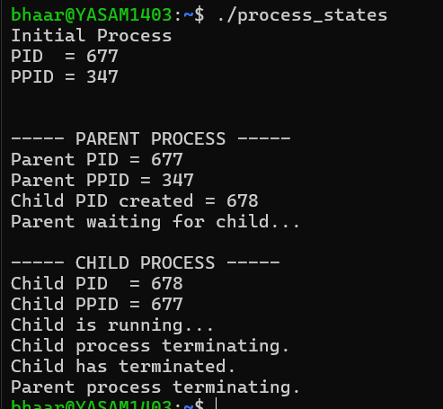
The PID values will be different on your system.

Step 4: Make the experiment easier to observe
The process only runs for 10 seconds, so it may disappear before you can inspect it.
Change:
sleep(10);
to:
sleep(30);
Also, change the parent waiting part so you have enough time to inspect both processes.
Your child section should be:
printf("Child is running. Sleeping for 30 seconds...\n");
sleep(30);
printf("Child process terminating.\n");
Compile again:
gcc process_states.c -o process_states
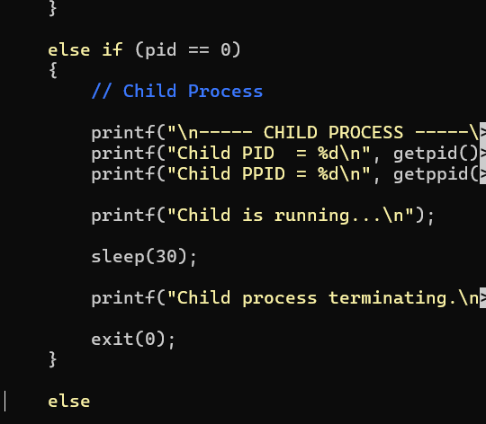

Step 5: Run the program in the background
This is important.
Run:
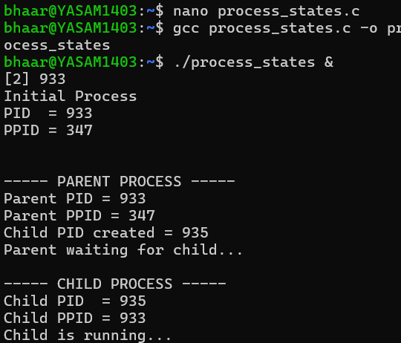
The & allows the program to run in the background so you can execute monitoring commands.
You may see:
[1] 2450
Here 2450 is the background job's PID, usually the parent process PID.

Step 6: Observe using ps
First run:
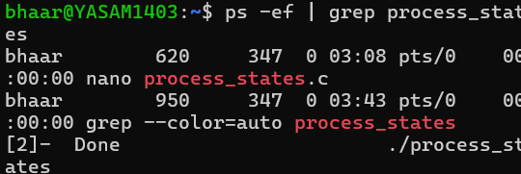

Step 7: Observe the parent waiting state
The parent executes:
wait(NULL);
While the child is sleeping, the parent waits for the child to finish.
Run:
ps -o pid,ppid,state,stat,cmd -C process_states
You will likely see the parent in:
S
because it is sleeping/waiting for the child.
The child may also show:
S
because the child is executing:
sleep(30);
So your interpretation is:
Parent → Waiting for child
Child → Sleeping temporarily

Step 8: Inspect the process tree
Run:
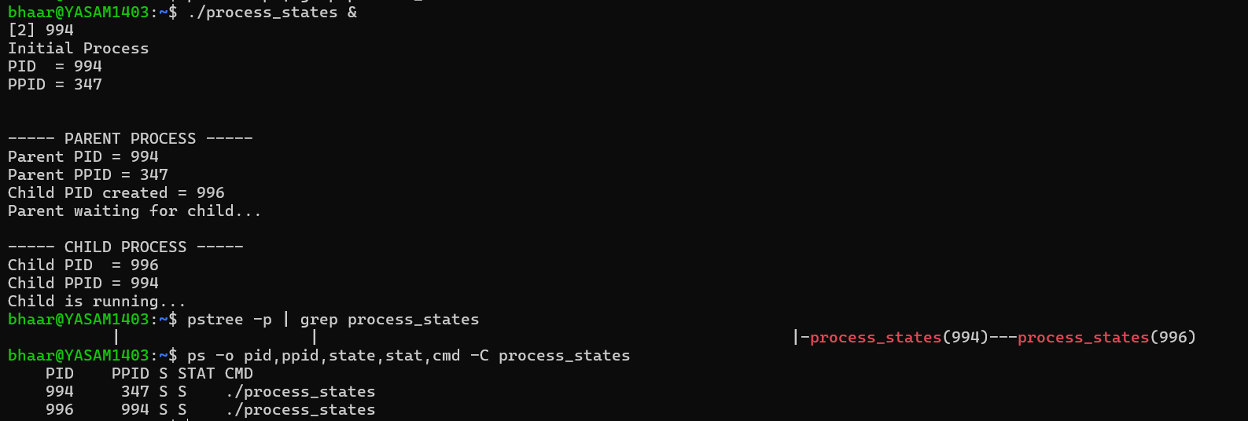

Step 9: Observe using /proc
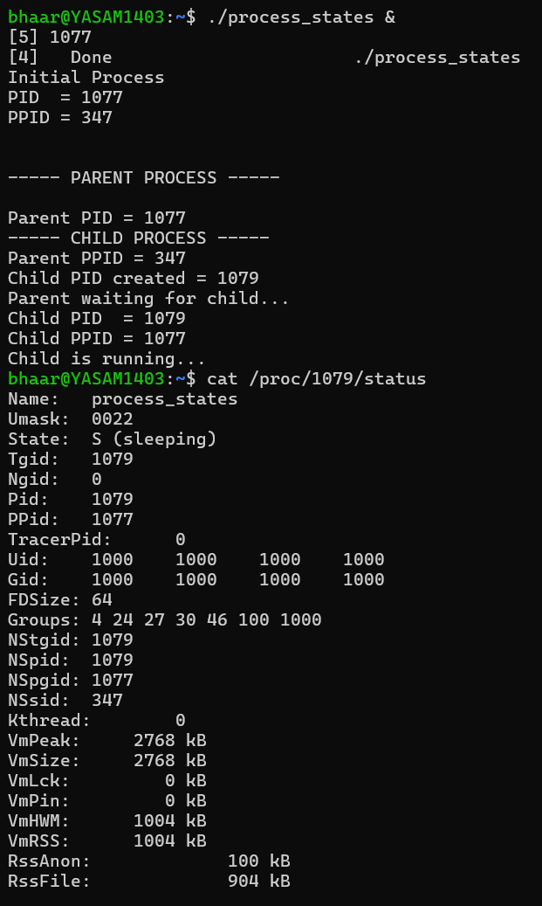

Step 10: Observe using top
