PRATICAL - 01

Part 1 — C program using fork(), exec(), and wait()
Step 1: Open Ubuntu terminal
You can open Ubuntu from Windows Start Menu, or use your WSL terminal.
Check that Linux is working:
uname -a
Step 2: Create the C file
Run:
nano command_exec.c
Paste this program: 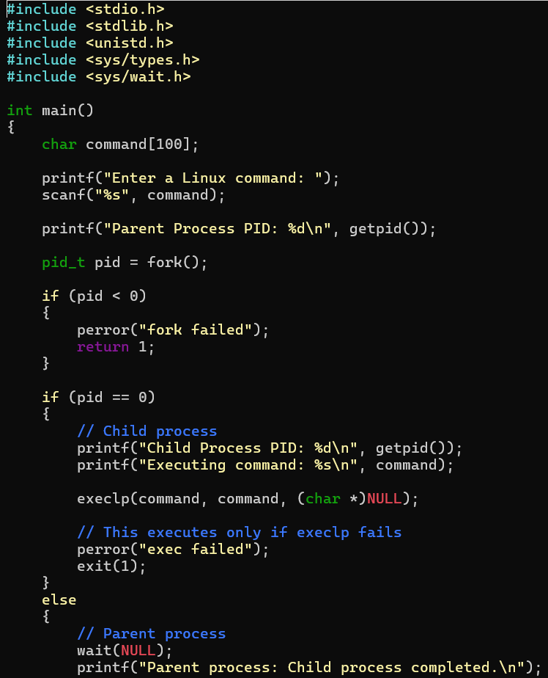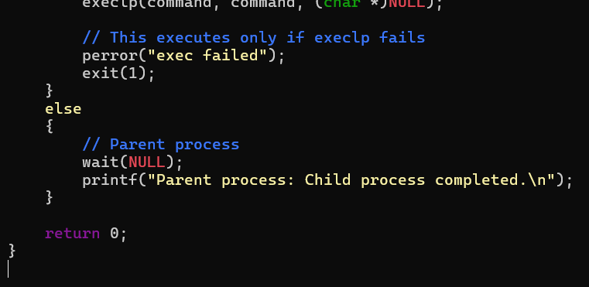

Step 3: Save the file
In nano:
- Press Ctrl + O
- Press Enter
- Press Ctrl + X
Step 4: Compile
Run:
gcc command_exec.c -o command_exec
If there is no error, compilation is successful.
Check:
ls
Output:
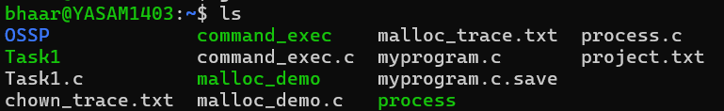
Step 5: Run the program
./command_exec
Try:
Enter a Linux command:
ls
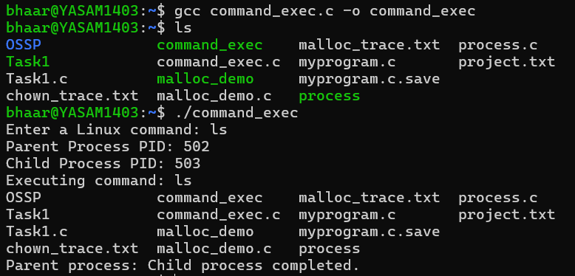
The exact PIDs will be different on your system.
pwd
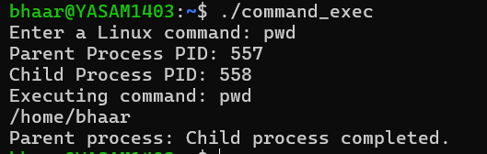
Date
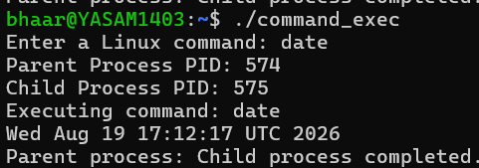
whoami
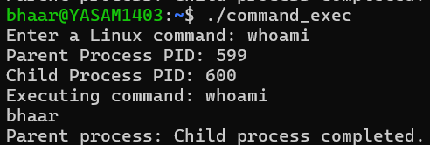
uname
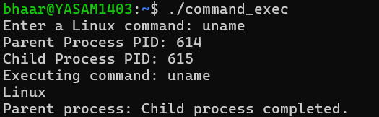

fork()
Creates a new child process.
C – Program
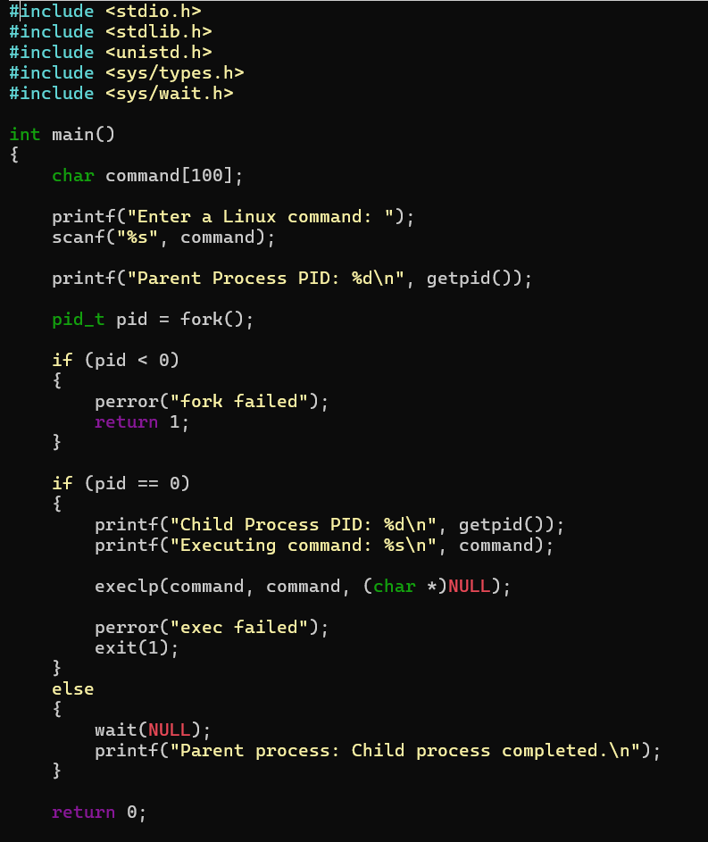

Enter Linux command: ls
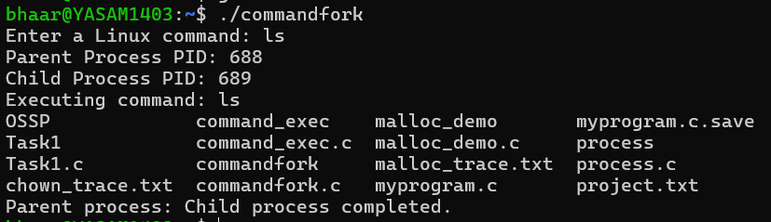
exec()
The child uses execlp() to replace itself with the requested Linux command.
C – Program:
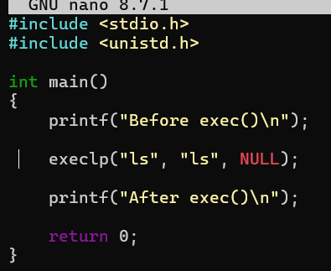
Enter Linux command:

wait()
C – Program:
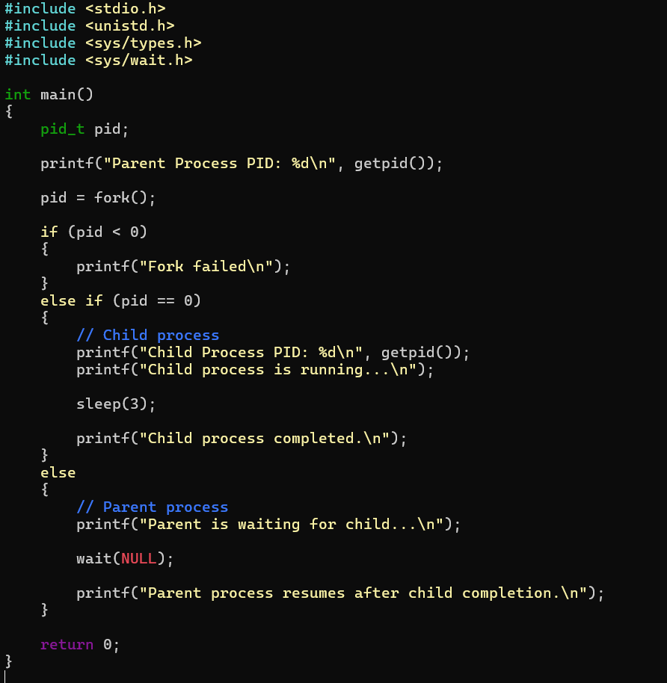
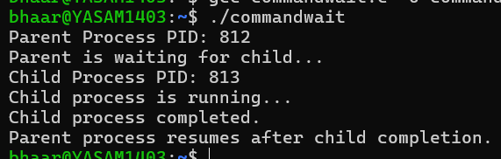

getpid()
C – Program:
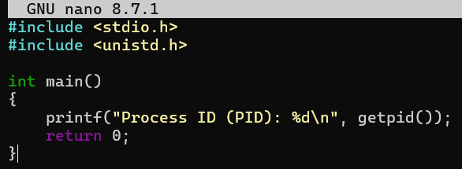
Output:

Part 2 — Investigating hardware and OS services
Now you need to use these five commands:
uname
lscpu
lsblk
ps
top
You can run them directly in Ubuntu.

1. uname
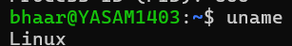
uname provides information about the operating system and Linux kernel. It helps identify the kernel running on the system.

2. lscpu
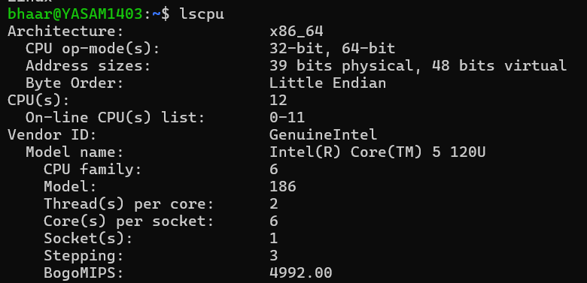
lscpu displays CPU hardware information. Linux uses this hardware information to manage processor resources and schedule processes.

3. lsblk
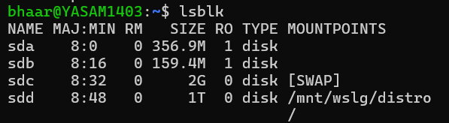
lsblk displays storage devices and partitions. Linux abstracts physical storage devices as block devices so that applications can access files without directly controlling the hardware.

4. ps
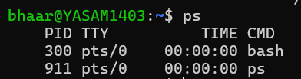
ps displays currently running processes. The operating system assigns each process a PID and manages CPU and memory resources for it.

5. top
To exit:
q
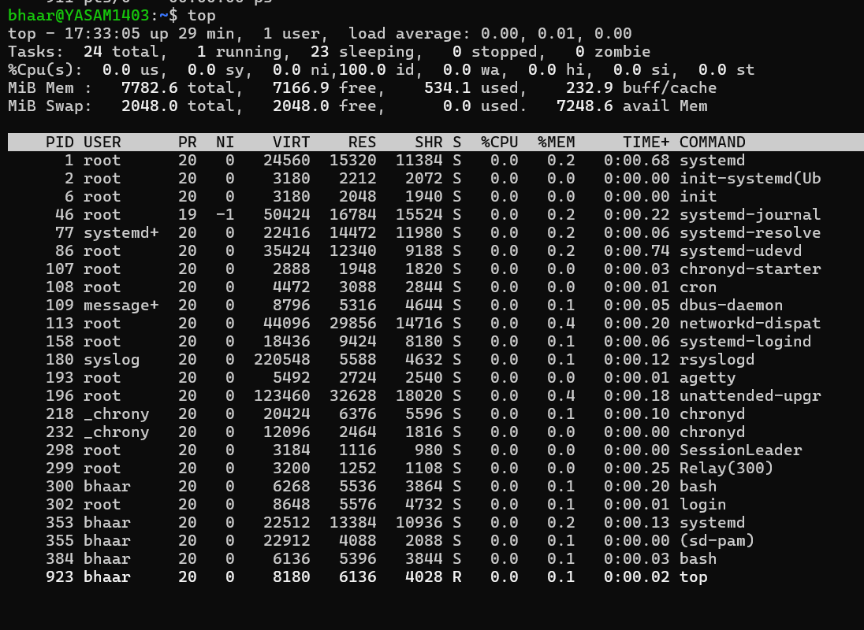
top provides real-time information about running processes and resource usage, including CPU and memory utilization.

