Operating Systems and System Programming
Skill-3
Task-1:
Aim
To implement command history and navigation using escape sequences, and to manage dynamically allocated buffers and linked lists while preventing buffer overflow and memory leaks.
Algorithm
- Start the program.
- Read and store user commands in the input buffer.
- Use Up/Down arrow escape sequences to navigate through command history.
- Dynamically allocate memory for storing commands.
- Resize the buffer when it becomes full.
- Store commands using a linked list.
- Display the stored commands.
- Free all allocated memory.
- Verify memory usage using Valgrind.
- Stop.

Step-1:
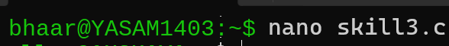

Step-2:
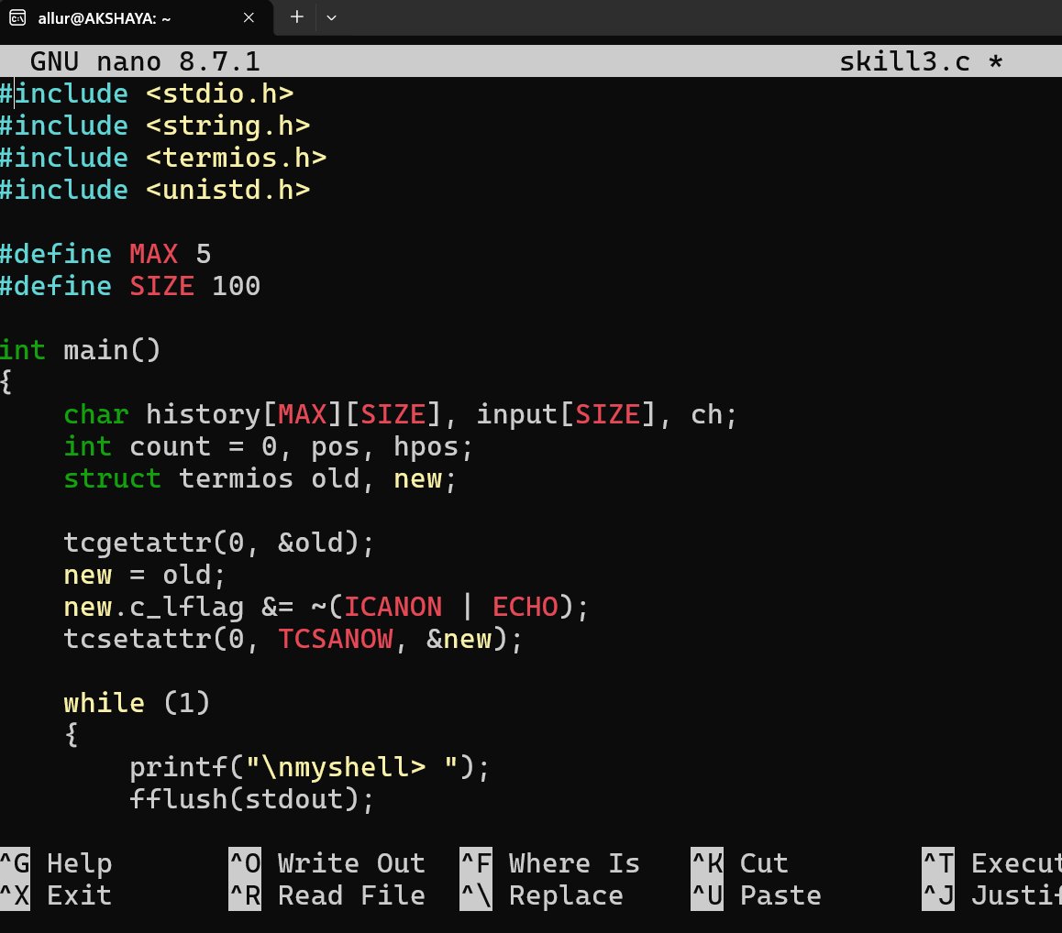
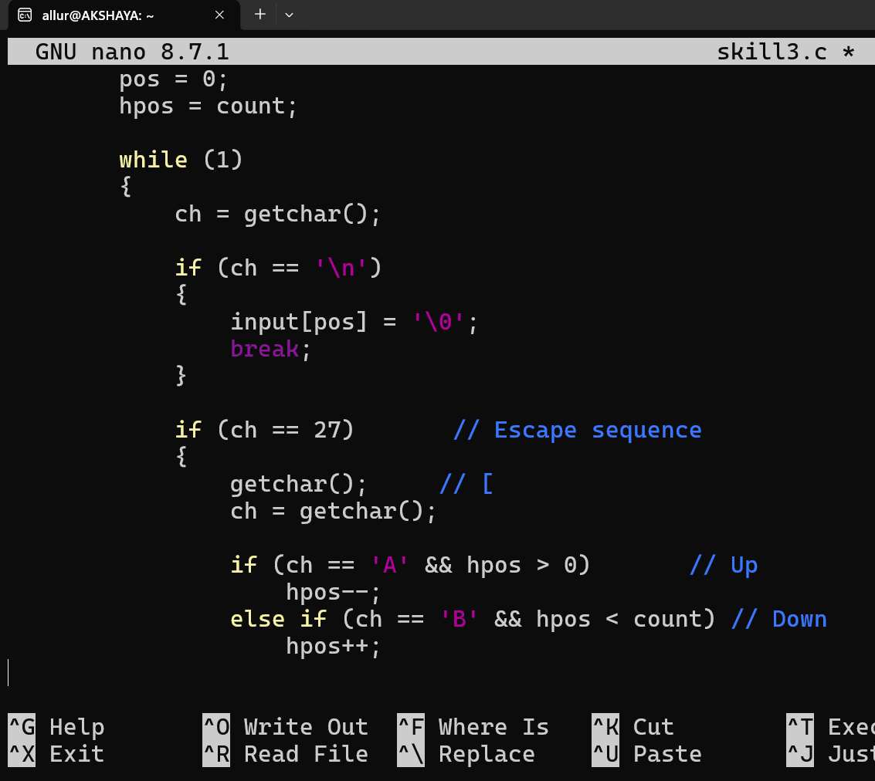
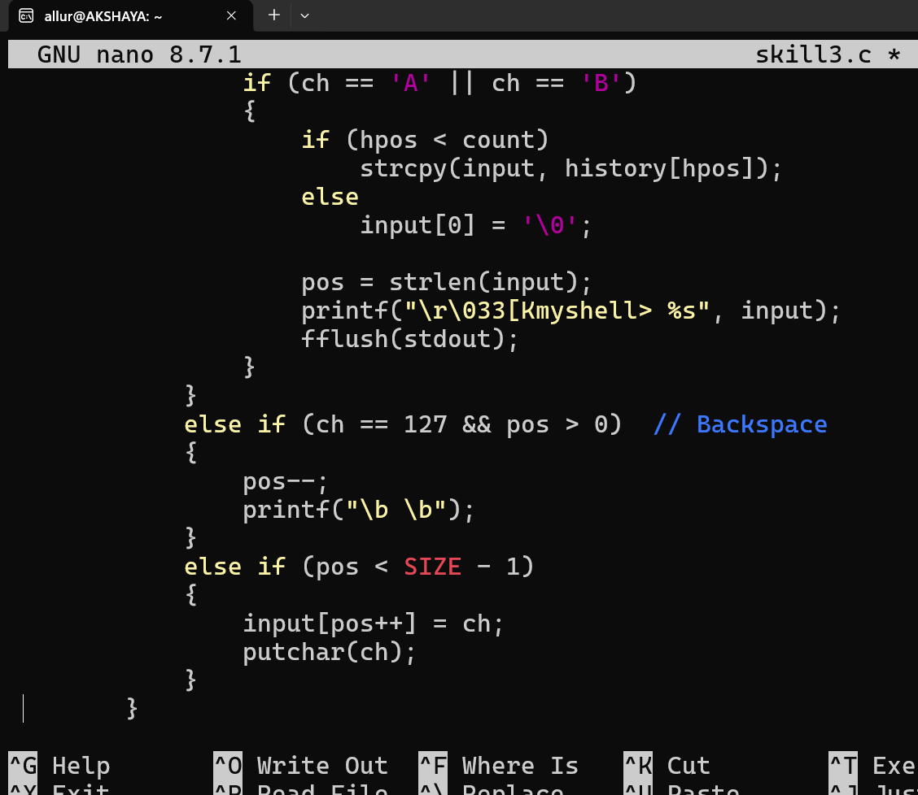
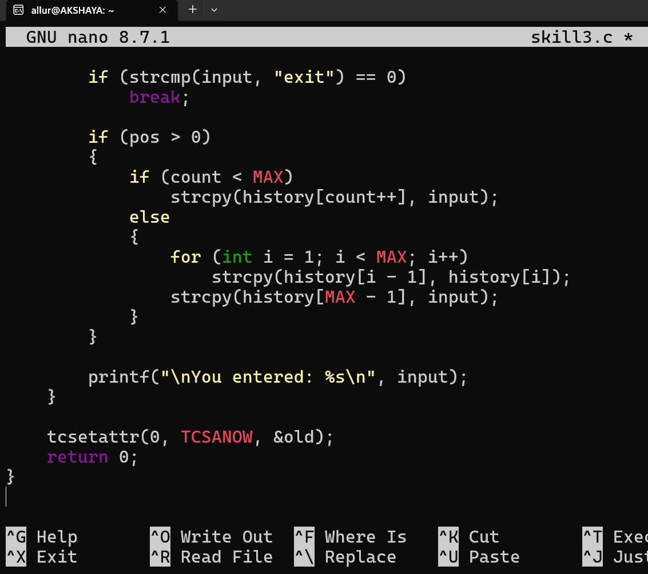

Step-3:
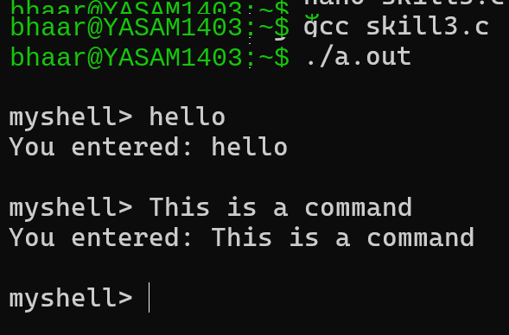

Press the ↑ Up Arrow key once.
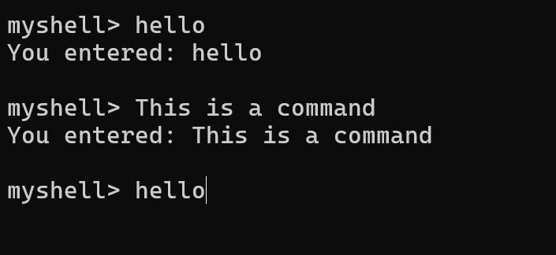

press ↓ Down Arrow
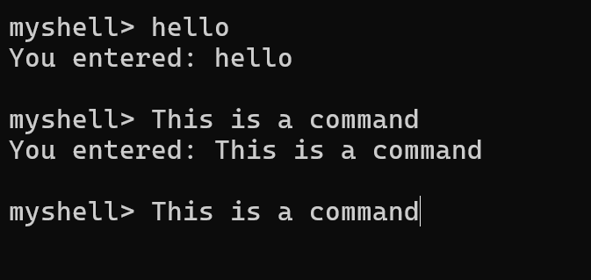
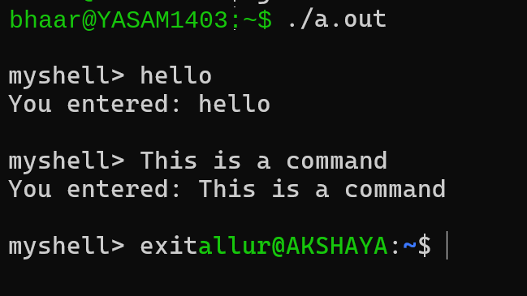

Task-2:
Step-1:
Step-2:
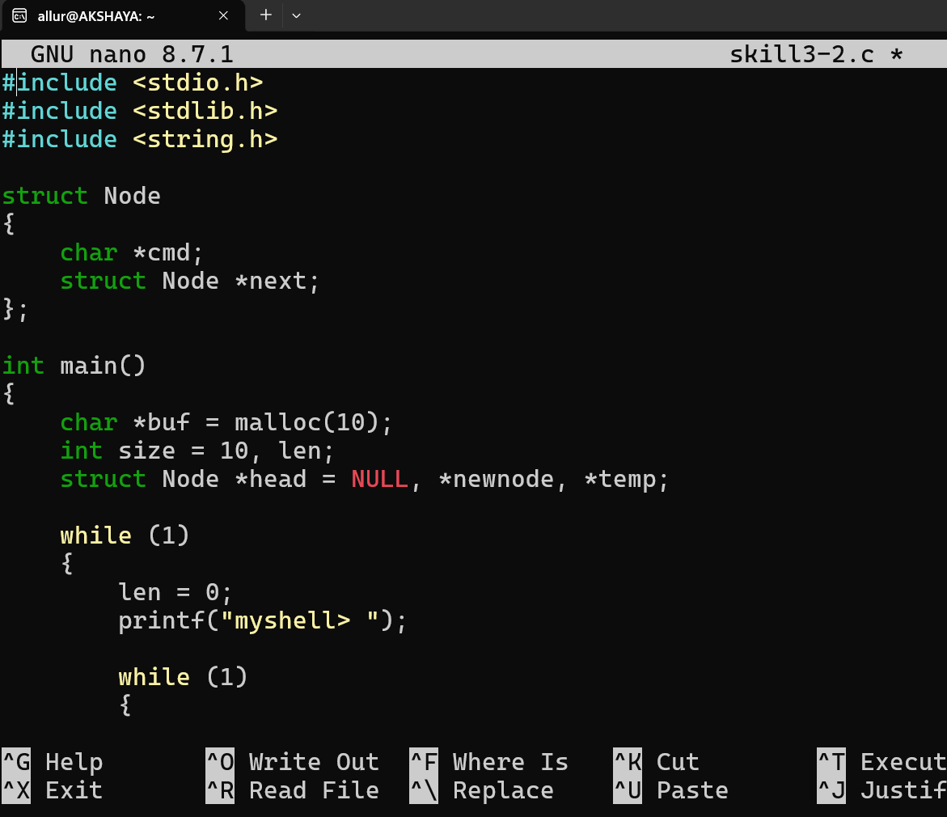
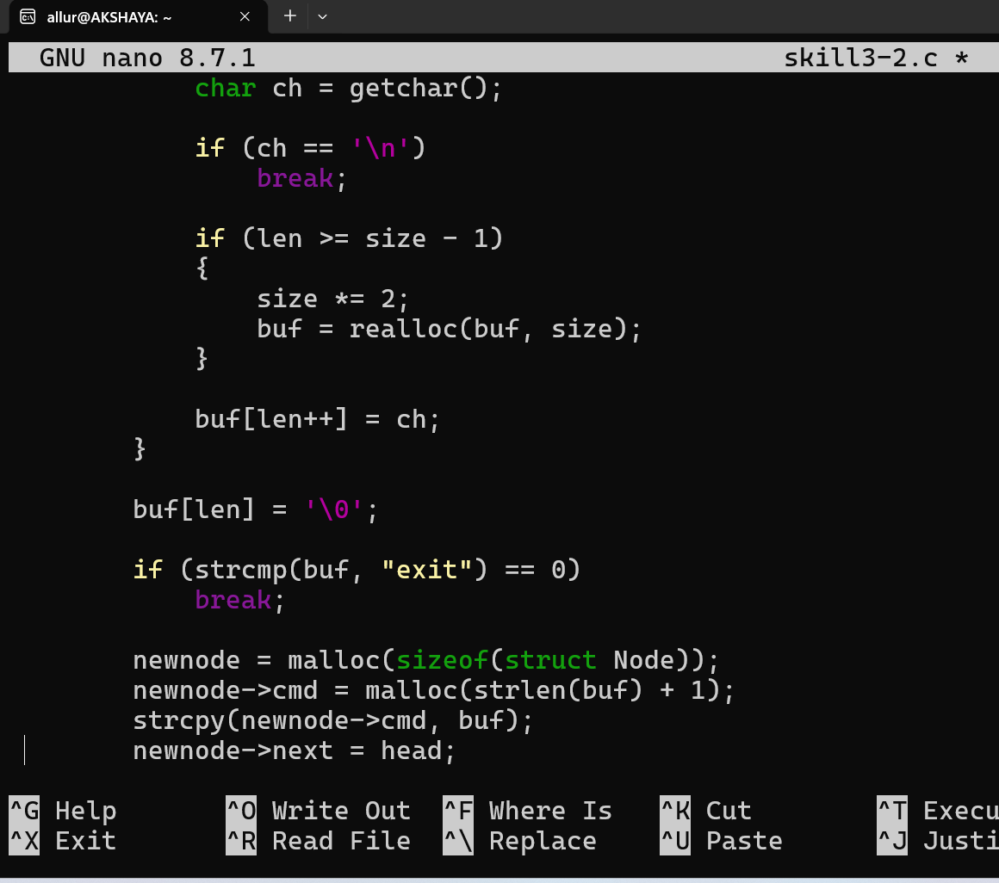
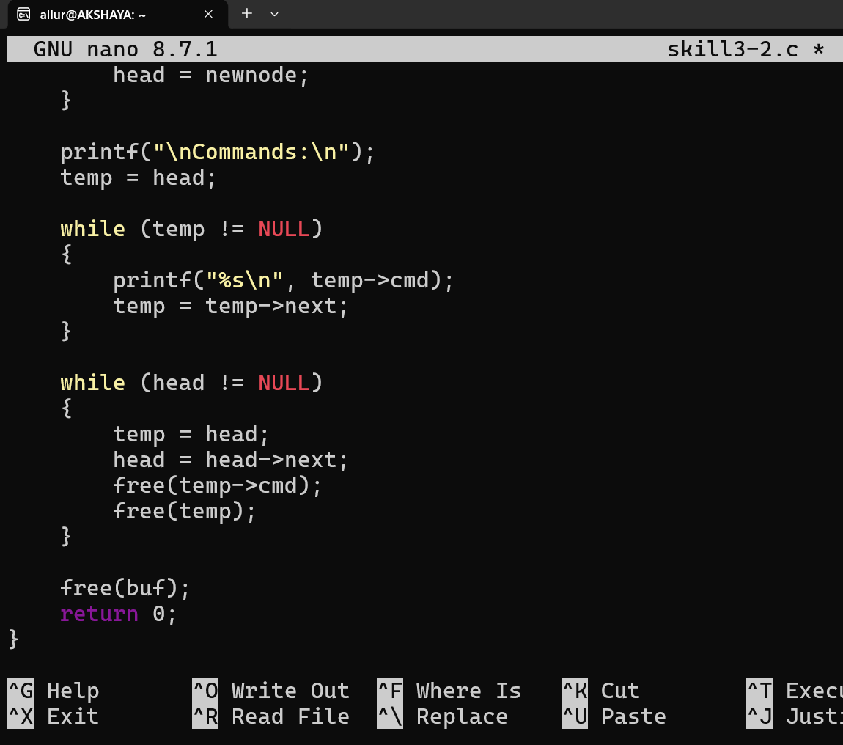
Step-3:
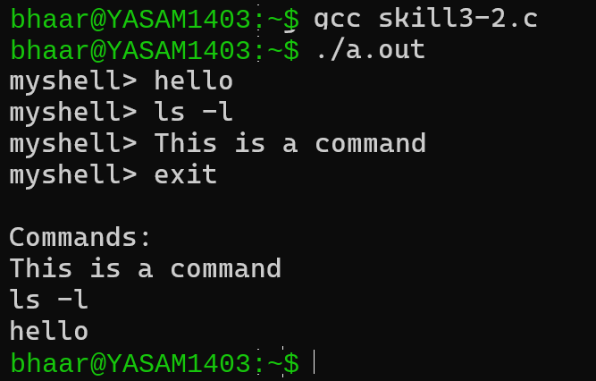
Step-4: Install Valgrind
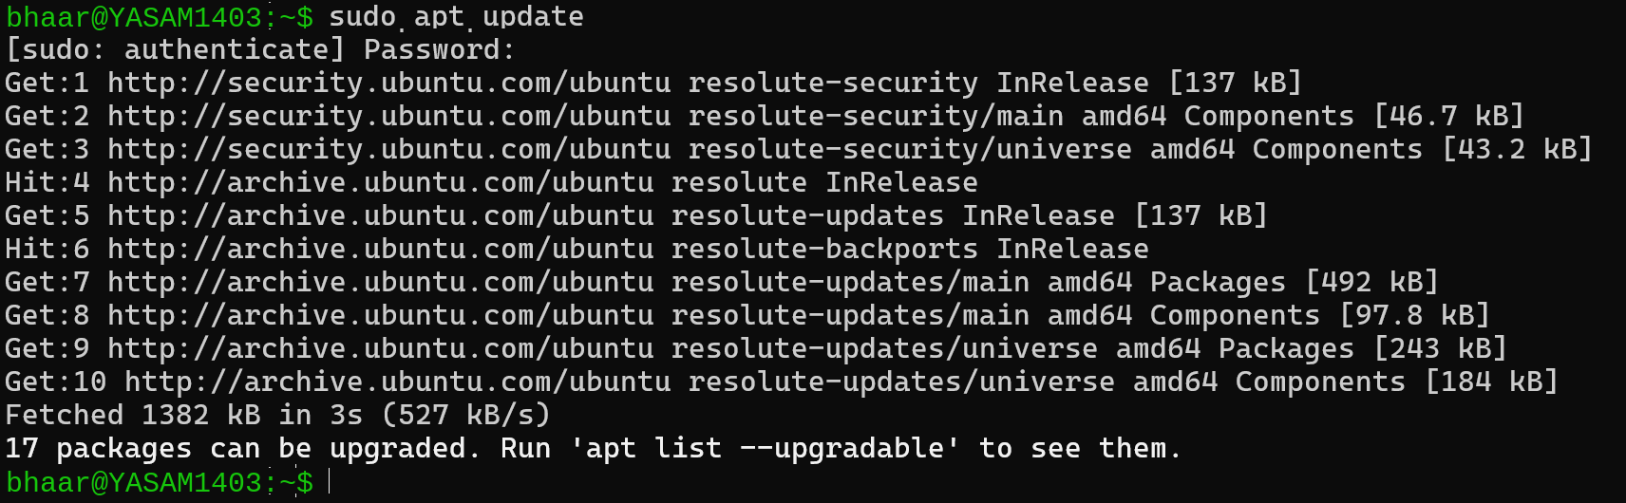
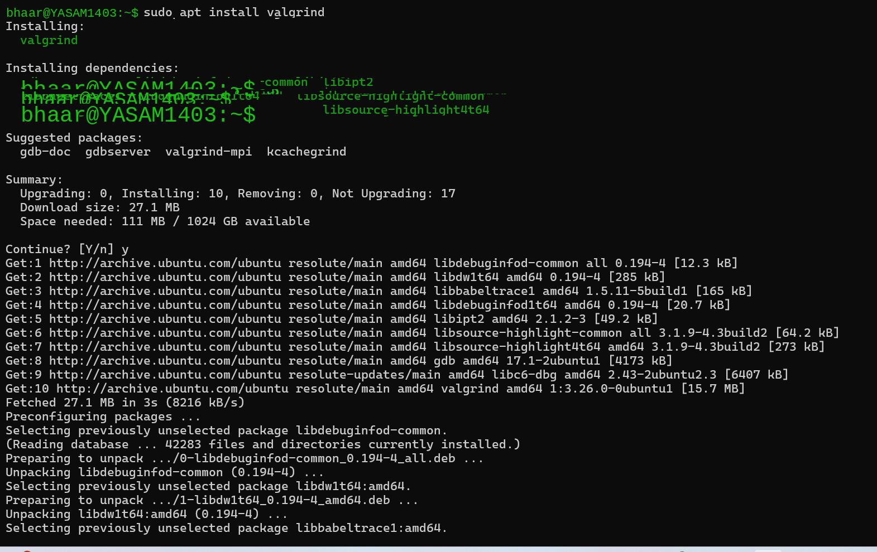
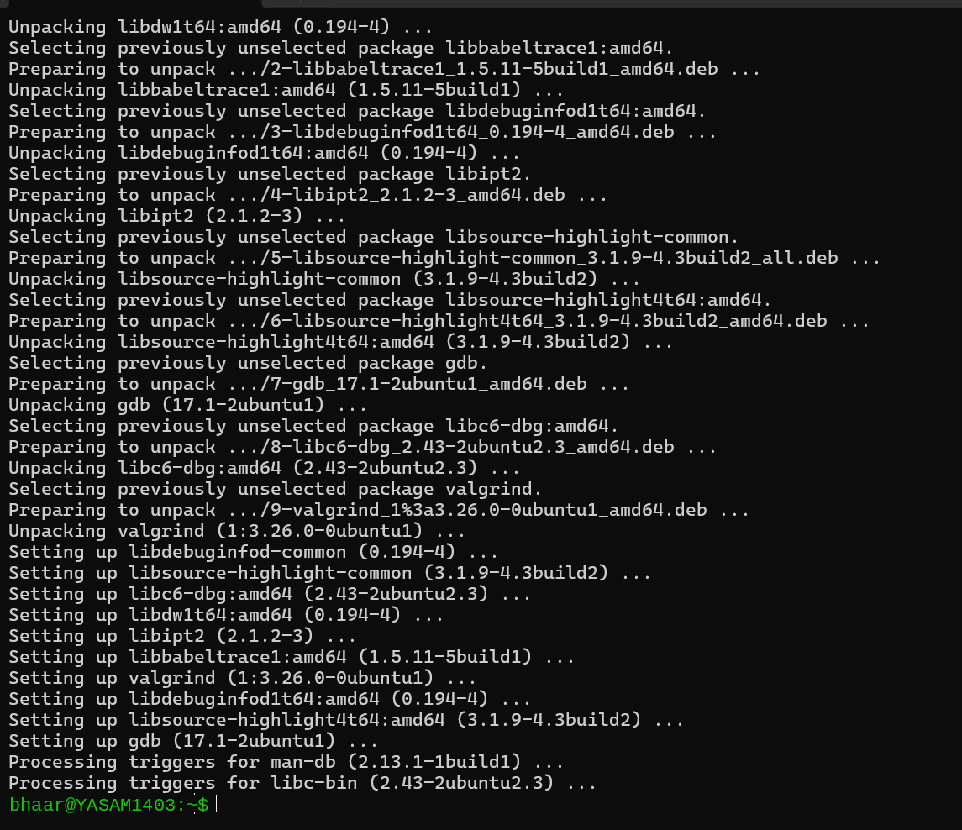

Step-5: Check that it installed
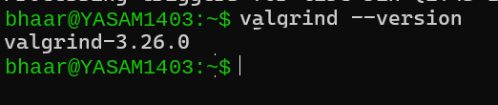

Step-7: Run your program with Valgrind
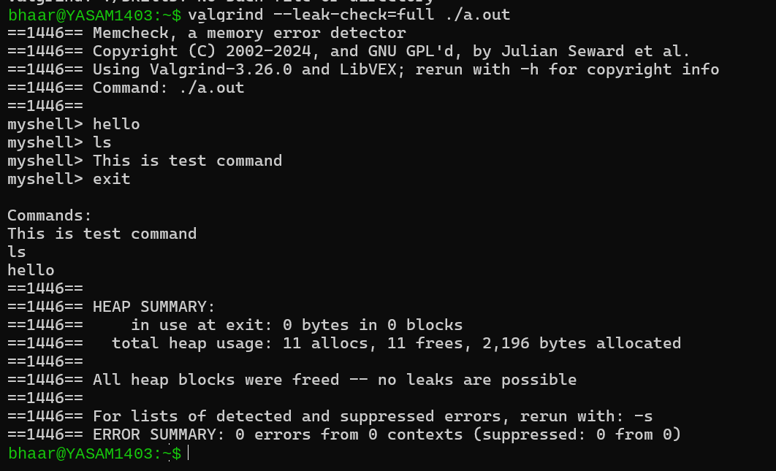
Result
Command history, arrow-key navigation, dynamic buffer allocation, buffer resizing, and linked-list management were successfully implemented. Valgrind confirmed that all allocated memory was freed with zero errors and no memory leaks.

