Operating Systems and System Programming
Skill-4
Task-1:
Aim
To implement a simple command-line tokenizer and parser that splits user input into tokens, handles whitespace and delimiters, validates the input, detects syntax errors and empty commands, and produces a basic execution structure.
Algorithm
- Start the program.
- Read the command from the user.
- Check whether the input is empty.
- Identify delimiters such as spaces and tabs.
- Split the input into individual tokens.
- Store and display the tokens.
- Identify the command and its arguments.
- Validate the command syntax.
- Detect invalid or empty input.
- Display the parsed/execution structure.
- Stop the program.

Task-1: Tokenization
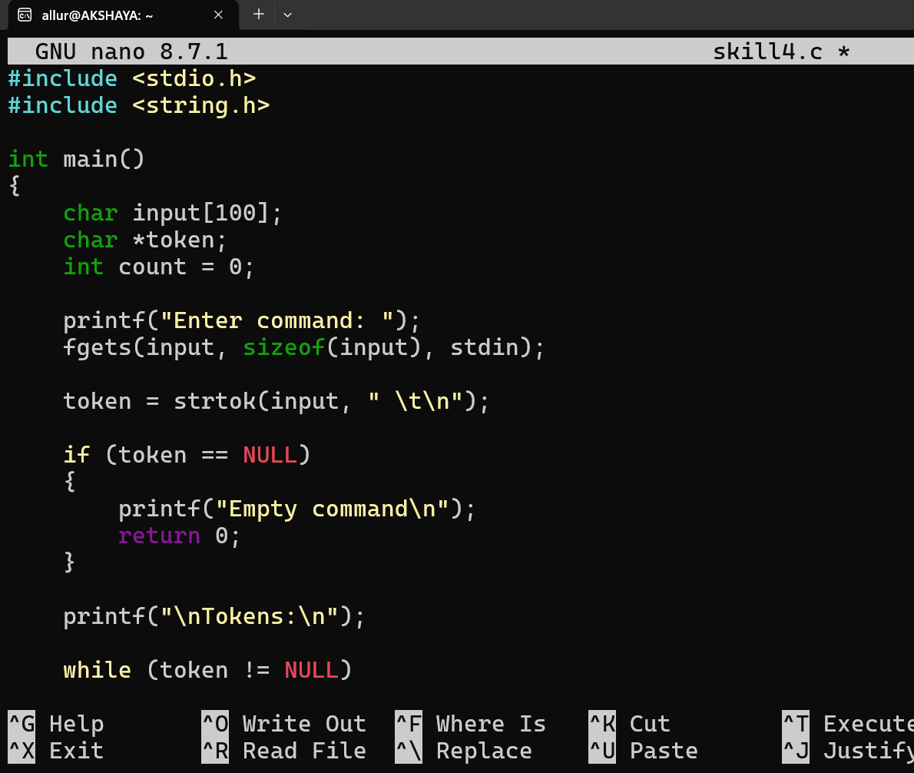
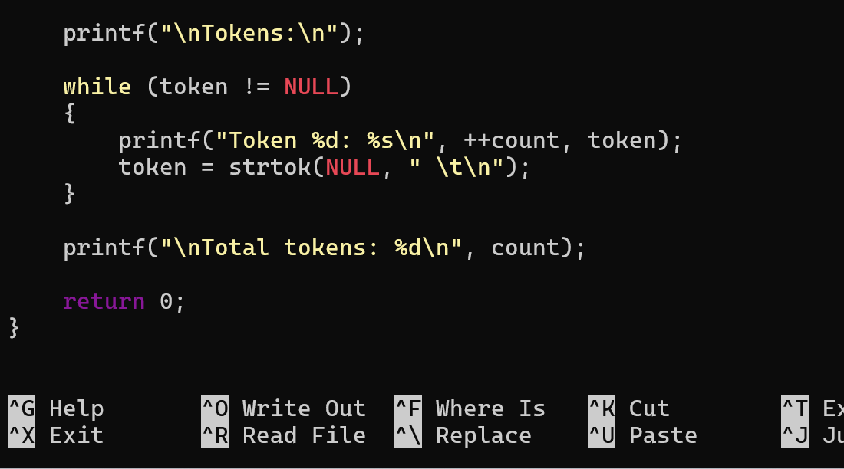

Compile and Run
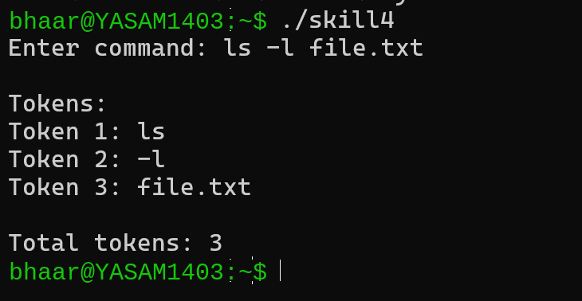

Task-2: Parser
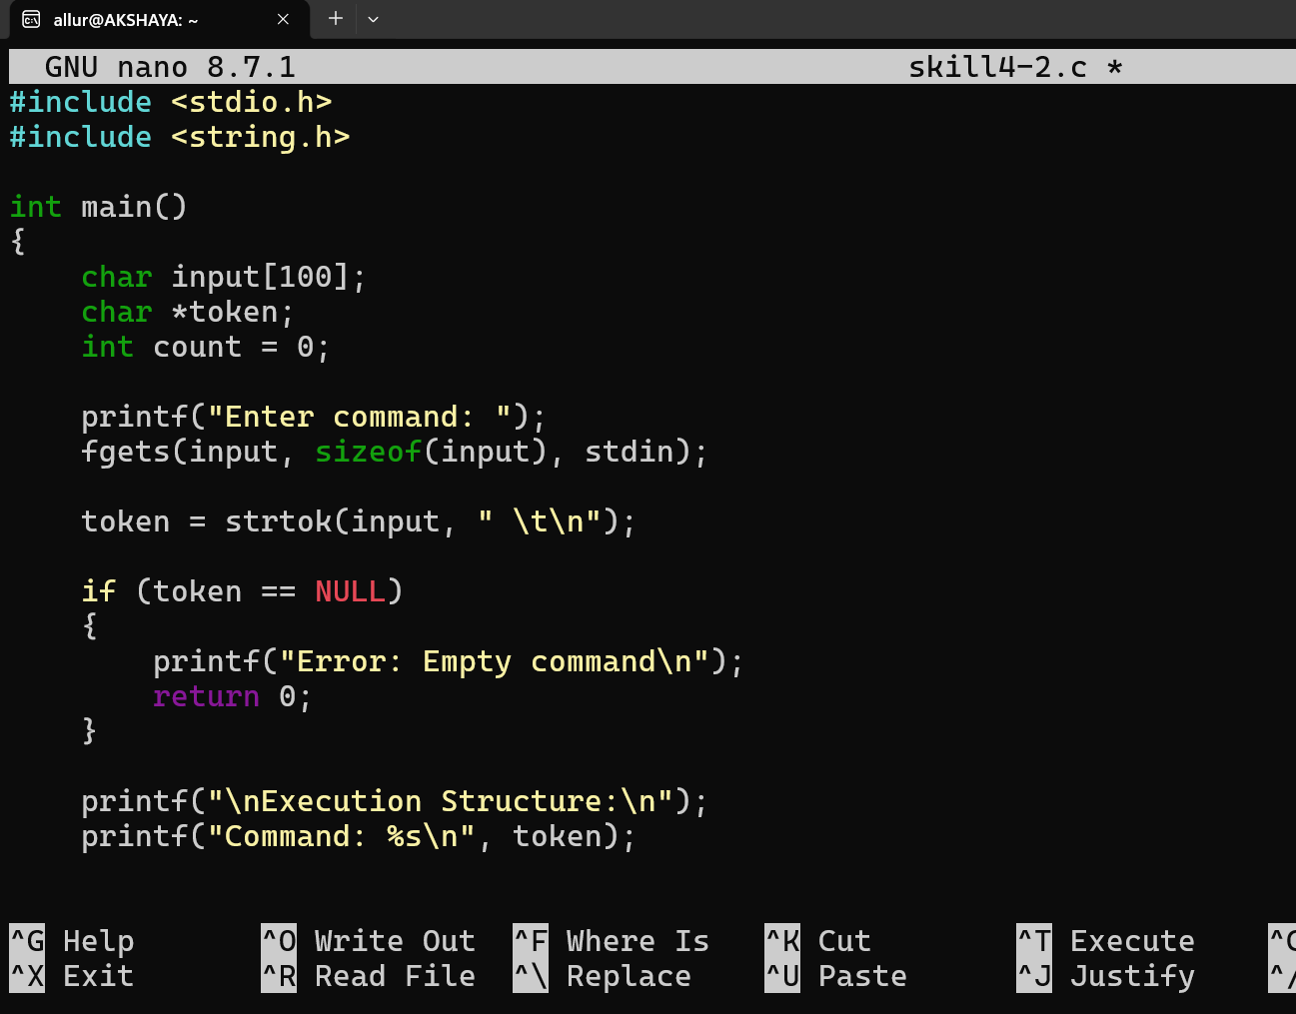
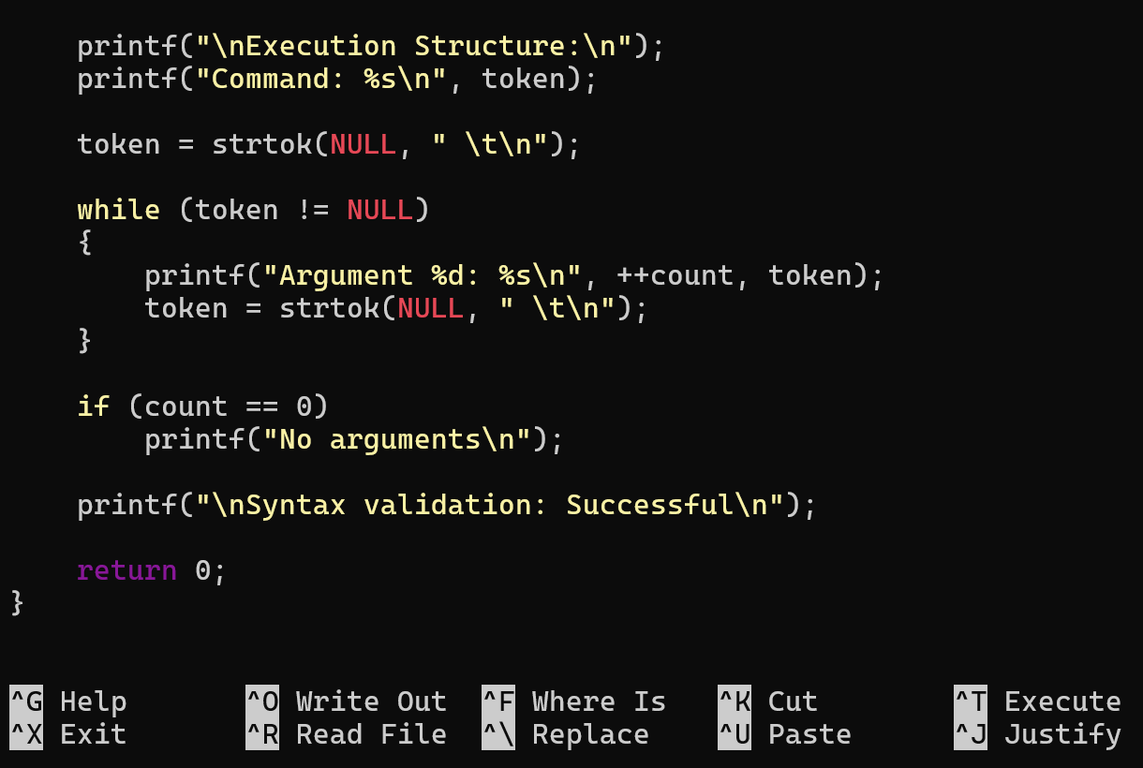
Compile and Run
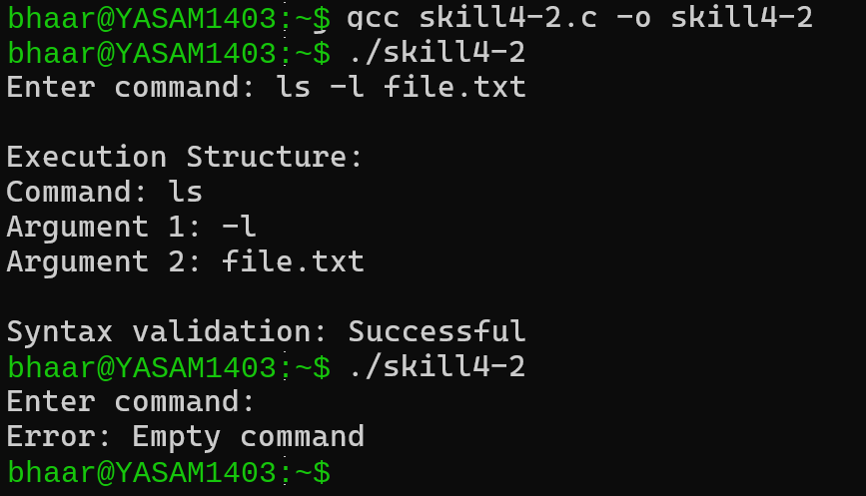
Result
The command input was successfully tokenized and parsed. Whitespace and delimiters were handled correctly, tokens and arguments were identified, empty commands were detected, and the resulting execution structure was displayed successfully.

