Part 1 — File Copy using open(), read(), write(), close()
Step 1: Create the C program
nano filecopy.c
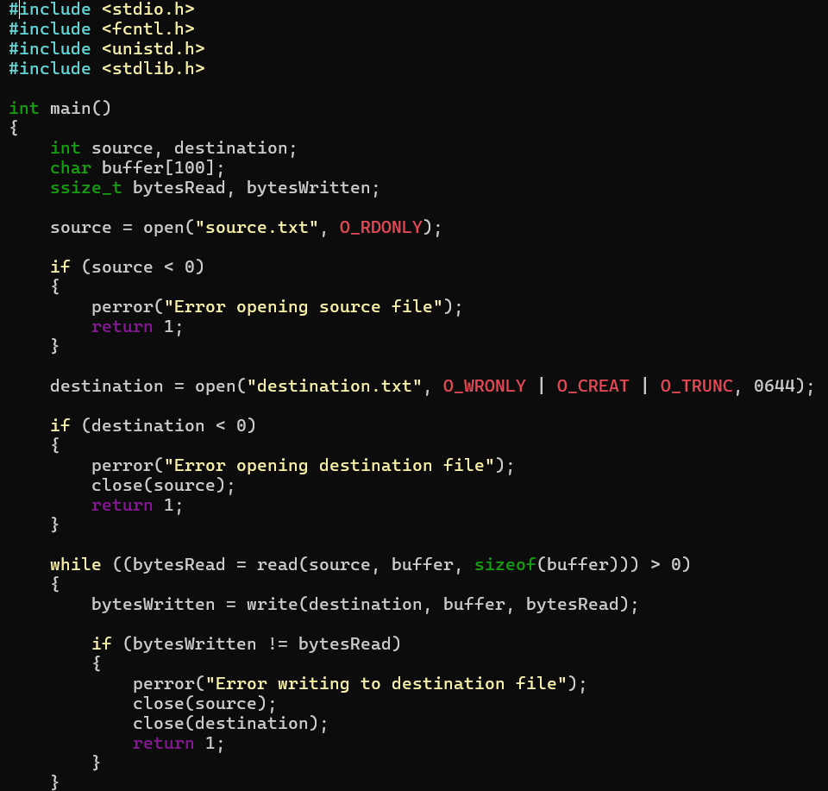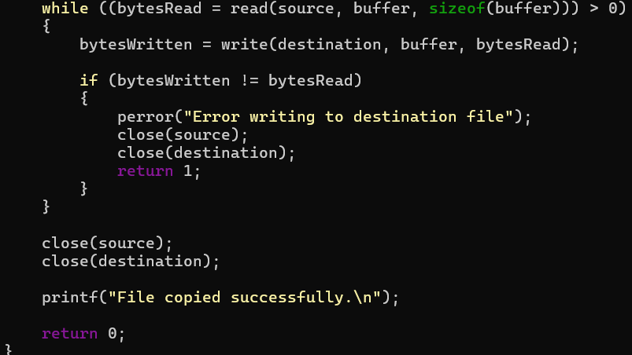
Step 2: Save the program
In nano:
Ctrl + O → Enter → Ctrl + X
Step 3: Create the source file
Step 4: Compile
gcc filecopy.c -o filecopy
Check:
ls
Step 5: Execute
./filecopy
Output:
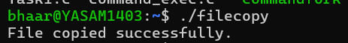
Now check the destination:
cat destination.txt
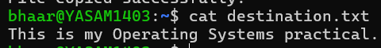

Part 2 — Understand the system calls
The program uses four important system calls.
open()
source = open("source.txt", O_RDONLY);
Opens the source file.
read()
read(source, buffer, sizeof(buffer));
Reads data from the file into the buffer.
write()
write(destination, buffer, bytesRead);
Writes the data from the buffer into the destination file.
close()
close(source);
close(destination);
Closes the files after the operation is complete.

Part 3 — User Space → Kernel Space
This is very important for your viva.
Your C program initially runs in user space.
When it needs to access a file, it cannot directly access the hardware. It requests the Linux kernel through a system call.
USER SPACE
│
C Program
│
open()/read()
│
System Call
↓
════════════════════════════
KERNEL SPACE
│
Linux Kernel
│
File System
│
Device Driver
│
Storage
│
════════════════════════════
↑
Data returned
│
USER SPACE
│
C Program
For example:
open()
↓
User → Kernel
↓
Kernel opens file
↓
File descriptor returned
↓
Kernel → User
Then:
read()
↓
User → Kernel
↓
Kernel reads file data
↓
Data copied to user buffer
↓
Kernel → User
And:
write()
↓
User → Kernel
↓
Kernel writes data to destination

What each system call means
System call | Purpose
openat() | Opens sample.txt
read() | Reads contents from the file
write() | Writes the contents to standard output
close() | Closes the file

