“Course Recommendation System”

Project Report submitted for the partial fulfilment of grade for the course

Data Structures and Algorithms -3 (25CS2103E)

in

DEPARTMENT OF COMPUTER SCIENCE ENGINEERING

by

KASIREDDY SRIHITHA :2520030153

RISHITHA :2520030101

SHRAVYA :2520030322

Team Number: 07
Section: 08

Under the Guidance of

Sireesha Vikkurty

Department of Computer Science and Engineering





2026-27

DEPARTMENT OF COMPUTER SCIENCE ENGINEERING

Declaration

The Project Report entitled “Course Recommendation System” is a record of Bonafide work of Kasireddy Srihitha – 2520030153, Rishitha – 2520030101, Shravya – 2520030322 submitted in partial fulfillment for the award of B. Tech in Computer Science and Engineering. The results embodied in this report have not been copied from any other departments/University/Institute.

Kasireddy Srihitha – 2520030153
Rishitha – 2520030101
Shravya – 2520030322

DEPARTMENT OF COMPUTER SCIENCE ENGINEERING

CERTIFICATE

This is certify that the mini project based report entitled “Course Recommendation System” is a bonafide work done and submitted by KASIREDDY SRIHITHA – 2520030153, RISHITHA – 2520030101, SHRAVYA – 2520030322 in partial fulfillment of the requirements for the award of the degree of BACHELOR OF TECHNOLOGY in Department of Computer Science Engineering, during the academic year 2026-27.

Signature of the Guide Signature of the HOD
(Sireesha Vikkurty) (Dr. P. Venkateshwara Rao)

Signature of the External Examiner
ACKNOWLEDGEMENT

We express our sincere gratitude to our project guide, Sireesha Vikkurty, Department of Computer Science and Engineering, for her constant guidance, valuable suggestions and encouragement throughout the Data Structures and Algorithms-3 project. Her feedback helped us choose suitable algorithms and present the work clearly.
We are thankful to Dr. P. Venkateshwara Rao, Associate Professor and Head of the Department of Computer Science and Engineering, for providing the facilities and a supportive environment to carry out this work.
We also thank the faculty members of the department, our classmates and our families for their support and motivation during the development of this project.

Kasireddy Srihitha – 2520030153
Rishitha – 2520030101
Shravya – 2520030322

Abstract

Choosing the right course from a large catalogue is difficult for students because course descriptions, prerequisites, skills and career outcomes are scattered across many places. This project, the Course Recommendation System, addresses the problem with a Java application whose core features are built from hand-written data structures and algorithms instead of external libraries. Course data is read from an external text file (data/courses.txt) by a FileHandler, validated, and stored in a CourseDatabase.

The system provides ranked course search, prefix auto-suggestion, personalised recommendation, prerequisite and eligibility checking, side-by-side course comparison, learning-path generation, semester planning and course-unlock analysis. Search combines the Knuth-Morris-Pratt (KMP) and Rabin-Karp string-matching algorithms with an Edit Distance (dynamic programming) fallback for misspelled queries, and a Trie provides fast prefix suggestions. Recommendations are scored with a weighted fuzzy-matching model and ordered with a Merge Sort. Course prerequisites are modelled as a directed graph; Kahn’s topological sorting detects cycles and gives a valid learning order, a reverse breadth-first traversal extracts the courses needed for a target, a greedy scheduler builds the semester plan, and a forward breadth-first traversal reports what a course unlocks.

The algorithms are exposed through a Java HTTP server (com.sun.net.httpserver) with eleven JSON API endpoints and a six-page HTML/CSS/JavaScript web front end. The completed project was verified with 206 Java unit and integration checks, 107 live API checks, 1,500 randomised API requests and 42 front-end DOM checks, all of which passed, and the working screens are documented in this report with real screenshots.

Table of Contents

 |  |  | Page No.
 | Acknowledgement
 | Abstract
 | Table of Contents
 | List of Figures
1 | Introduction | 1.1 Overview  1.2 Problem Statement  1.3 Scope of the Project  1.4 Objectives  1.5 Organisation of the Report | 1–3
2 | System Requirements | 2.1 Background and Related Work  2.2 Functional Requirements  2.3 Non-Functional Requirements  2.4 Hardware and Software Specifications | 4–6
3 | System Design | 3.1 High-level Architecture Diagram  3.2 Description of each Layer  3.3 Dataset  3.4 Data Structures Used  3.5 Search Workflow  3.6 Prerequisite Graph Design  3.7 Choice of Algorithms | 7–12
4 | Implementation | 4.1 Module-wise Implementation  4.2 Front-end Logic (UI Rendering, State Management)  4.3 API Integration  4.4 Console Application | 13–25
5 | Results | 5.1 Testing Approach and Environment  5.2 Test Results  5.3 Defects Found and Fixed  5.4 Output Screens  5.5 Observations | 26–32
6 | Challenges & Limitations | 6.1 Issues Faced during Development  6.2 Solutions Applied  6.3 Limitations of the System | 33–34
7 | Conclusion & Future Work | 7.1 Conclusion  7.2 Future Work  7.3 Skills Learned during Development | 35–36
 | References | Books, papers and documentation used | 37–37

List of Figures

1.1 Home page of the Course Recommendation System web interface 1
3.1 Layered architecture of the Course Recommendation System 7
3.2 Search workflow: KMP, Rabin-Karp, Edit Distance fallback and Merge Sort 10
3.3 Prerequisite dependency graph built from data/courses.txt (18 vertices, 16 edges) 11
5.1 Terminal showing the server start-up and 14 courses loaded from data/courses.txt 28
5.2 Search page: query “data” returns suggestions from the Trie 28
5.3 Trie prefix search: query “Mach” suggests Machine Learning Fundamentals 29
5.4 Recommendation results for a sample student profile, ranked by score 30
5.5 Course details page for Deep Learning with Neural Networks 31
5.6 Course unlock panel and learning path with semester plan (2 courses per semester) 31
5.7 Side-by-side comparison of Machine Learning Fundamentals and Data Science Essentials 32

- INTRODUCTION
1.1 Overview
Universities and online platforms offer a growing number of courses in areas such as artificial intelligence, data science, web development, cybersecurity and cloud computing. A student who wants to pick the next course must compare descriptions, check prerequisites, judge whether his or her skills match, and relate the course to a career goal. Recommender systems are widely used to support such decisions by ranking items according to how well they fit a user profile [1].
The Course Recommendation System developed in this project is a Java application that helps a student explore a course catalogue, search it, obtain a ranked list of recommended courses, understand prerequisites, and plan a sequence of courses (a learning path) towards a target course. The home page of the web interface is shown in Fig. 1.1.

Fig. 1.1 Home page of the Course Recommendation System web interface
The project is also a demonstration of the Data Structures and Algorithms-3 course content. Instead of calling ready-made search or sorting libraries, the important operations are implemented explicitly: file parsing, KMP, Rabin-Karp, Edit Distance by dynamic programming, Merge Sort, a Trie, a prerequisite graph with topological sorting and cycle detection, learning-path generation, semester planning and breadth-first traversal for course unlocking. The course catalogue itself is not hard-coded; it is loaded from the external file data/courses.txt.
1.2 Problem Statement
Students lack a single tool that can (i) find a course even when the query is incomplete or misspelled, (ii) rank courses according to their own interests, skills, qualifications and career goals, (iii) tell them whether they are eligible for a course and which prerequisites are missing, and (iv) show the order in which prerequisite courses should be studied. Manually reading a catalogue is slow and error-prone, and prerequisite chains between courses are hard to see. The problem addressed here is to design and implement a course recommendation system, based on efficient data structures and algorithms, that answers these questions from a catalogue stored in an external data file.
1.3 Scope of the Project
The scope of the implemented system is as follows.
- The catalogue is read from a pipe-separated text file (data/courses.txt). The supplied file contains 14 courses; a different file with the same format can be used by passing the Java system property courses.file.
- Features: course search with prefix suggestions, keyword search and typo tolerance; personalised recommendations; prerequisite and eligibility checking; course details; side-by-side comparison of two courses; prerequisite dependency graph; learning-path generation; semester planning; and course-unlock analysis.
- Interfaces: a console menu (Main.java) and a web application served by WebServer.java on port 8080 with a JSON API and a browser front end.
- Out of scope: user accounts, a database server, machine-learning models, real-time enrolment data and multi-user concurrency. The system works on the data in the file and keeps it in memory.
1.4 Objectives
- To load and validate course data from an external file with a dedicated FileHandler and store it in a CourseDatabase.
- To implement KMP, Rabin-Karp and Edit Distance for exact, keyword and fuzzy course search, and a Trie for prefix auto-suggestion.
- To rank search results and recommendations using a hand-written Merge Sort.
- To recommend courses from a student profile (interests, skills, qualifications, career goals) and report eligibility and missing prerequisites.
- To model prerequisites as a directed graph and apply topological sorting, cycle detection, learning-path generation, semester planning and unlock traversal.
- To expose the functionality through a Java HTTP API and a web front end, and to verify it with automated tests.
1.5 Organisation of the Report
Chapter 2 lists the functional and non-functional requirements and the software and hardware used. Chapter 3 describes the architecture, the dataset and the data structures. Chapter 4 explains each algorithm with pseudocode, together with the front end and the API. Chapter 5 presents the test results and the output screens. Chapter 6 discusses the challenges and limitations, and Chapter 7 concludes the report and suggests future work.

- SYSTEM REQUIREMENTS
2.1 Background and Related Work
Recommender systems are commonly classified as content-based (matching item attributes to a user profile), collaborative (using the behaviour of similar users) or hybrid [1]. Collaborative methods need a large amount of past user behaviour, which a newly created course catalogue does not have. A content-based approach, in which the attributes of a course (category, skills, career paths and interest tags) are compared with the profile entered by the student, works from the catalogue alone and its result can be explained to the student.
String-matching algorithms such as KMP [2] and Rabin-Karp [3] are classical solutions to substring search, Edit Distance [4] measures how close two strings are and is the basis of spelling tolerance, and the Trie [5] supports prefix lookup. Topological sorting [6] orders the vertices of a directed acyclic graph so that every prerequisite comes before the item that depends on it. These techniques are described in standard textbooks [7], [8].
The gap that this project addresses is the combination of these techniques in one small, transparent and dependency-free system for course selection: a recommendation that is computed from explicit weights, search that tolerates typing errors, and prerequisite analysis that is derived from the same data file as the rest of the application. The system does not use machine learning or user-behaviour data, so it cannot learn preferences over time (see Section 6.3).
2.2 Functional Requirements
Table 2.1 Functional requirements
ID | Requirement | Description
FR1 | Load course data | Read data/courses.txt, validate every line, skip malformed lines with a warning and keep the valid courses.
FR2 | Search courses | Search by name, category, description or skill; return results ranked by confidence; tolerate spelling errors.
FR3 | Prefix suggestions | Suggest course names while the user types a prefix (for example “Mach”).
FR4 | Recommend courses | Accept interests, skills, qualifications and career goals and return all courses ranked by score with eligibility information.
FR5 | Check eligibility | List the prerequisites that a student is missing for each course.
FR6 | View and explore | List all courses, filter by category or text, and show the full details of one course.
FR7 | Compare courses | Show two selected courses side by side.
FR8 | Dependency graph | Build the prerequisite graph and report cycles, levels and the topological order.
FR9 | Learning path | For a target course and a list of already-known topics, return the foundations and courses that must be learnt.
FR10 | Semester plan | Distribute the learning path over semesters with a chosen number of courses per semester.
FR11 | Course unlock | List the courses that become reachable after completing a course, with their distance.
FR12 | Web API and UI | Provide the above through JSON endpoints and a browser interface; also provide a console menu.

2.3 Non-Functional Requirements
Table 2.2 Non-functional requirements
Attribute | Requirement and how it is met
Performance | Interactive response for the supplied catalogue. In the test report a 5,000-course dataset was served with /api/suggest in 18–35 ms, /api/search in 60–157 ms and /api/recommend in about 110 ms (informational timings from one run).
Usability | Six simple web pages with a common navigation bar, input validation messages, empty-state messages and a typo-tolerant search box.
Reliability | Missing, empty or malformed data files do not crash the program; invalid ids and parameters return HTTP 404/405 with a JSON error; 1,500 random requests produced no HTTP 5xx response.
Scalability | Algorithms are linear or polynomial in the input size; the dataset is replaceable without changing code.
Portability | Pure Java with no external libraries; the front end uses plain HTML, CSS and JavaScript.
Maintainability | Separate classes for data loading, search, recommendation, graph, JSON output and HTTP handling; automated tests are kept in the test/ folder.
Security / robustness | Static files are served only from the public/ folder; path-traversal attempts and illegal paths return 404; user text is escaped in the pages.

2.4 Hardware and Software Specifications
Table 2.3 Software and hardware used
Item | Specification
Programming language | Java (JDK 17.0.20.1, Temurin build, as shown in Fig. 5.1; the Phase 4 tests were also run with OpenJDK 21)
Server | JDK built-in HTTP server (com.sun.net.httpserver), port 8080
Front end | HTML5, CSS3 and JavaScript (fetch API); fonts Source Serif 4 and Inter loaded from Google Fonts
Data store | Plain text file data/courses.txt (UTF-8, 8 fields separated by “|”)
Development tools | Visual Studio Code, javac and java command line tools
Test tools | Java test classes, Python 3 scripts (standard library only), Node.js with jsdom for DOM checks
Hardware | Any ordinary laptop or desktop able to run a JDK and a web browser; no GPU, database server or special hardware is needed
Operating system | Windows (development machine, Fig. 5.1); Ubuntu Linux (automated test run)

- SYSTEM DESIGN
3.1 High-level Architecture Diagram
The system follows a layered design, shown in Fig. 3.1. The browser pages call the API layer; the API layer calls the search, recommendation and graph engines; all engines read the course objects held by CourseDatabase, which in turn obtains them from FileHandler and the external file data/courses.txt.
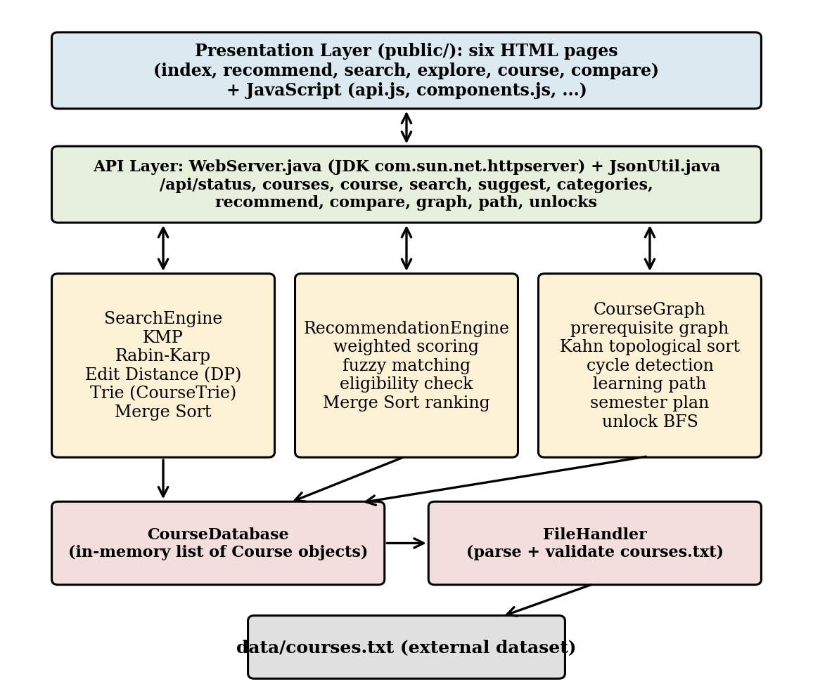
Fig. 3.1 Layered architecture of the Course Recommendation System
3.2 Description of each Layer
Table 3.1 Layers and classes of the system
Layer | Class / folder | Responsibility
Presentation | public/*.html, public/js/*.js, public/css/style.css | Six pages (home, recommend, search, explore, course, compare); fetch wrappers in api.js; shared rendering in components.js.
API | WebServer.java, JsonUtil.java | Registers 11 API contexts and a static-file handler; converts Java objects to JSON text; returns error codes.
Search | SearchEngine.java, CourseTrie.java | KMP, Rabin-Karp, Edit Distance, search workflow, Trie-based suggestions.
Recommendation | RecommendationEngine.java | Student profile, weighted scoring, missing prerequisites, Merge Sort.
Graph | CourseGraph.java | Prerequisite graph, topological sort, cycle detection, components, learning path, semester plan, unlocks.
Data | FileHandler.java, CourseDatabase.java | Parse and validate the data file; keep the list of Course objects; look up by id; list categories.
Console | Main.java | Text menu: recommend, search, view all, view details, compare, exit.

3.3 Dataset
The dataset is the external file data/courses.txt. Each non-comment line describes one course with eight fields separated by the character “|”; list fields use “;” between items. Lines that are blank or start with “#” are ignored. The file supplied with the project contains 14 courses. The field layout is given in Table 3.2.
Table 3.2 Record format of data/courses.txt
No. | Field | Meaning
1 | id | Positive integer, unique within the file
2 | name | Course name (required)
3 | category | Category such as AI/ML, Data Science, Web Development (required)
4 | description | One-sentence description (required)
5 | prerequisites | List of prerequisite names separated by “;”; may be empty
6 | requiredSkills | List of skills (required)
7 | careerPaths | List of career paths (required)
8 | interestTags | List of interest tags (required)

The 14 courses are: Machine Learning Fundamentals, Data Science Essentials, Deep Learning with Neural Networks, Full Stack Web Development, Cybersecurity Fundamentals, Cloud Computing with AWS, Mobile App Development with Android, Software Engineering Principles, Database Management Systems, Computer Networking, UI/UX Design Principles, Blockchain and Smart Contracts, Game Development with Unity and Data Structures and Algorithms. Prerequisite names that are not the name of a course (Basic Programming, Statistics, Linear Algebra and Networking Basics) are treated as foundation topics in the graph.
3.4 Data Structures Used
Table 3.3 Data structures and their use
Data structure | Where it is used | Reason
ArrayList<Course> | CourseDatabase, search and recommendation results | Ordered storage of the catalogue and of result lists
HashSet<Integer> | FileHandler duplicate-id check | Constant-time test for repeated ids
int[] dp[][] table | Edit Distance | Dynamic-programming table of sub-problem results
int[] lps | KMP | Longest-prefix-suffix table for the pattern
Trie (128-way nodes) | CourseTrie (two instances) | Prefix lookup in time proportional to the prefix length
Adjacency lists (IntList) | CourseGraph out[] and in[] | Compact storage of prerequisite edges in both directions
Arrays used as queues | Kahn sort, BFS traversals | First-in-first-out processing without extra objects
boolean[] / int[] marks | Visited, needed, known, in-degree, level | Constant-time vertex state

3.5 Search Workflow
A search query is processed in the order shown in Fig. 3.2. KMP is applied to the course name and category (strong match, confidence 100), Rabin-Karp to the description and to every required skill (keyword match, confidence 90). If neither stage finds a course, the system falls back to Edit Distance similarity (accepted at 50 % or more). The result list is ordered by a Merge Sort on the confidence value.
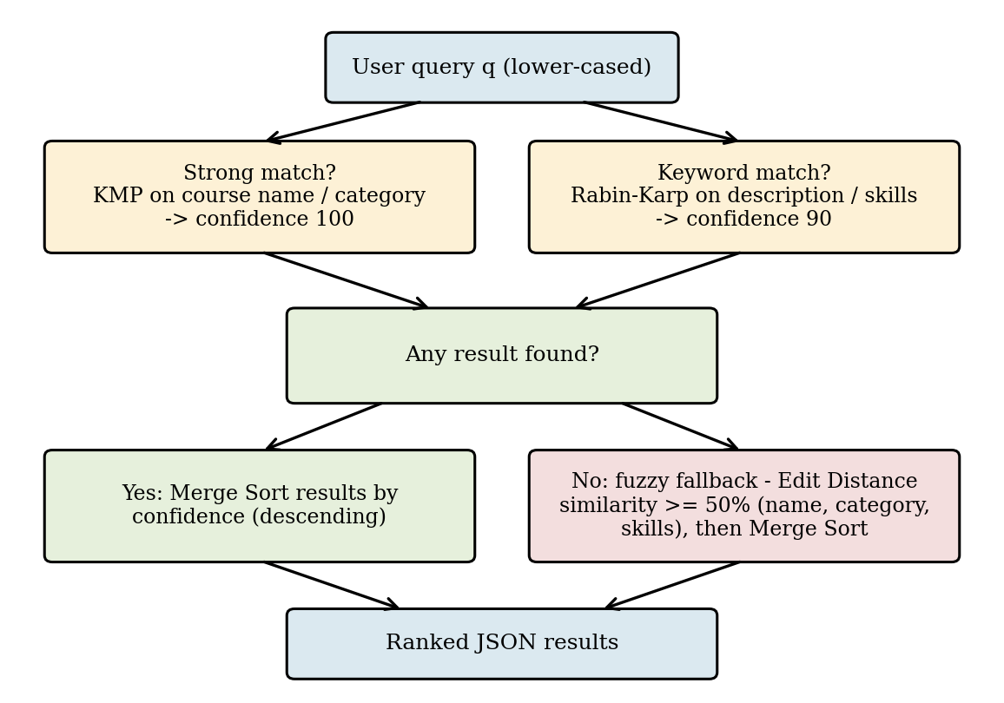
Fig. 3.2 Search workflow: KMP, Rabin-Karp, Edit Distance fallback and Merge Sort
3.6 Prerequisite Graph Design
Every course and every unknown prerequisite name becomes a vertex; each prerequisite relation “P is required for C” becomes a directed edge P → C. For the supplied dataset the graph has 18 vertices (14 courses and 4 foundation topics), 16 edges and 3 weakly connected components, and it contains no cycle (Phase 4 test report, Section 7). It is drawn in Fig. 3.3.
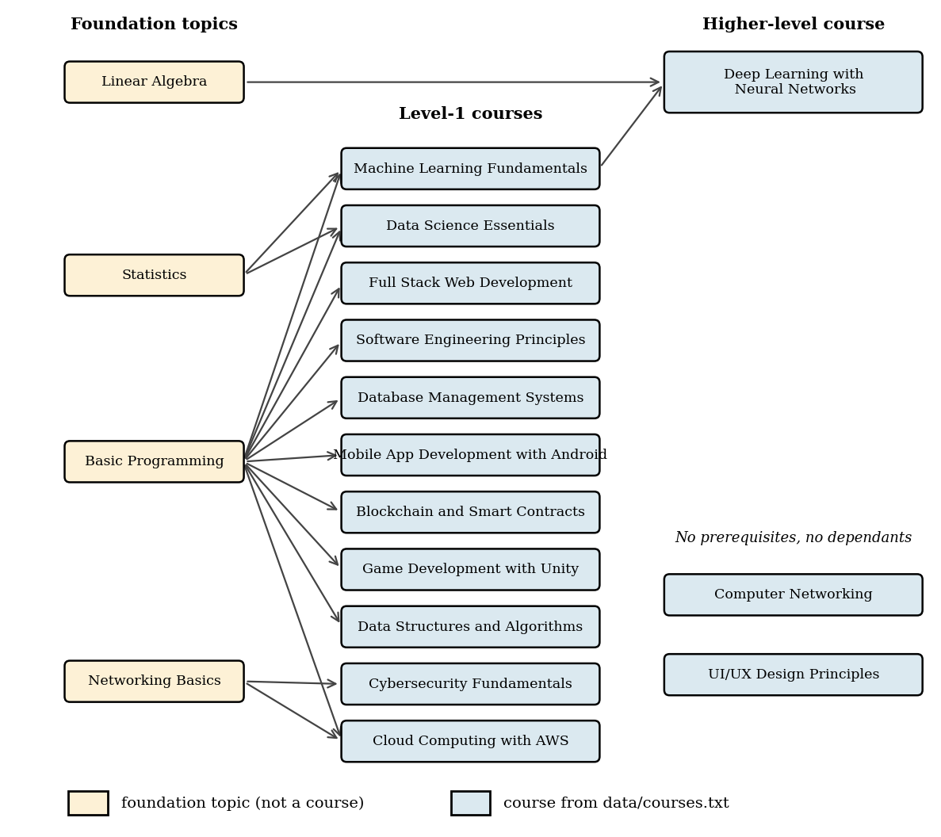
Fig. 3.3 Prerequisite dependency graph built from data/courses.txt (18 vertices, 16 edges)
3.7 Choice of Algorithms
Table 3.4 Algorithms, purpose and complexity (n = text length, m = pattern length, V = vertices, E = edges)
Algorithm | Purpose in the project | Time | Space
KMP | Exact substring search in name and category | O(n + m) | O(m)
Rabin-Karp | Keyword search in description and skills | O(n + m) average, O(nm) worst | O(1)
Edit Distance (DP) | Typo-tolerant matching and similarity score | O(n × m) | O(n × m)
Merge Sort | Rank results and recommendations | O(N log N) | O(N)
Trie | Prefix suggestions | O(p) walk + subtree | O(nodes × 128)
Kahn topological sort | Order, levels, cycle detection | O(V + E) | O(V + E)
Reverse BFS | Courses needed for a target | O(V + E) | O(V)
Greedy scheduling | Semester plan | O(S × V + E) | O(V + E)
Forward BFS | Course unlock analysis | O(V + E) | O(V)

- IMPLEMENTATION
4.1 Module-wise Implementation
This section explains each algorithm of the implementation. For every algorithm, a table states its purpose, the problem it solves, the reason for choosing it, the place where it is used in the project, its input and output and its complexity; the pseudocode follows the actual Java methods. Source code is not reproduced; only the method names are given.
4.1.1 File Handling (FileHandler.loadCourses)
Purpose | Read the external course file and produce validated Course objects.
Problem solved | Course data must not be hard-coded; a bad file must not crash the program.
Why it is used | A line-by-line parser with explicit checks reports exactly which line is wrong and keeps all valid lines.
Use in this project | CourseDatabase calls FileHandler once at start-up; the Trie, search, recommendation and graph all use only the courses it returns. The path can be changed with -Dcourses.file.
Input | File path (default data/courses.txt).
Output | LoadResult: list of valid courses, list of line-numbered warnings, an error message (if the file is unusable) and the number of skipped lines.
Time complexity | O(T) where T is the number of characters in the file; each line is split once.
Space complexity | O(N) for N stored courses (plus a set of N ids).

Algorithm 1: loadCourses(path)
if file does not exist or is not readable: error; return empty result
seenIds = empty set; lineNo = 0
for each line of the file (UTF-8):
lineNo = lineNo + 1; strip BOM on line 1; trim the line
if line is empty or starts with '#': continue
fields = split(line, '|')
if count(fields) != 8: warn(lineNo); skip
id = parseInt(fields[0]); skip if not a number, id <= 0, or id in seenIds
if name, category or description is empty: warn; skip
split the list fields on ';' and trim every item
if skills, careers or interest tags is empty: warn; skip
add id to seenIds; add Course to result.courses
if result.courses is empty: error = 'no valid courses'
return result

4.1.2 KMP Pattern Search (SearchEngine.kmpContains)
Purpose | Decide whether a pattern occurs inside a text without re-reading characters.
Problem solved | Naive substring search may compare the same characters many times.
Why it is used | KMP never moves backwards in the text; the LPS table tells how far the pattern can be shifted after a mismatch [2].
Use in this project | Strong match: the lower-cased query is searched in the course name and the category (confidence 100).
Input | text, pattern (both lower-cased strings).
Output | true if the pattern occurs in the text, otherwise false.
Time complexity | O(n + m): O(m) to build the LPS table and O(n) to scan the text.
Space complexity | O(m) for the LPS array.

Algorithm 2: KMP(text, pattern)
if pattern is empty: return true
lps = computeLPS(pattern)
i = 0; j = 0
while i < length(text):
if text[i] == pattern[j]:
i = i + 1; j = j + 1
if j == length(pattern): return true
else if j > 0: j = lps[j - 1]
else: i = i + 1
return false

computeLPS(pattern):
lps[0] = 0; len = 0; i = 1
while i < length(pattern):
if pattern[i] == pattern[len]: len = len + 1; lps[i] = len; i = i + 1
else if len > 0: len = lps[len - 1]
else: lps[i] = 0; i = i + 1
return lps

4.1.3 Rabin-Karp Search (SearchEngine.rabinKarpContains)
Purpose | Find a pattern in a text using a rolling hash.
Problem solved | Long descriptions and many skills must be scanned quickly for a keyword.
Why it is used | The hash of the next window is computed from the previous one in constant time; only windows whose hash equals the pattern hash are compared character by character, so hash collisions never give a wrong answer [3].
Use in this project | Keyword match: the query is searched in the course description and in each required skill (confidence 90). It is used when the strong match fails.
Input | text, pattern (lower-cased); base 256, modulus 1,000,000,007.
Output | true if the pattern occurs in the text, otherwise false.
Time complexity | O(n + m) on average; O(n × m) in the worst case of many collisions.
Space complexity | O(1) extra space.

Algorithm 3: RabinKarp(text, pattern)
n = length(text); m = length(pattern)
if m == 0: return true; if m > n: return false
highOrder = base^(m-1) mod M
patternHash = hash(pattern); windowHash = hash(text[0..m-1])
for i = 0 to n - m:
if patternHash == windowHash and text[i..i+m-1] == pattern:
return true
if i < n - m:
windowHash = (base*(windowHash - text[i]*highOrder) + text[i+m]) mod M
if windowHash < 0: windowHash = windowHash + M
return false

4.1.4 Edit Distance / Dynamic Programming (SearchEngine.editDistance)
Purpose | Measure how many single-character edits (insert, delete, replace) turn one string into another.
Problem solved | Users misspell queries and profile terms, so exact matching fails.
Why it is used | The Levenshtein distance [4] is computed by dynamic programming: each sub-problem (prefix pair) is solved once and reused.
Use in this project | (1) Fuzzy search fallback when KMP and Rabin-Karp find nothing (similarity ≥ 50 %). (2) Recommendation: a profile term matches a course term at similarity ≥ 65 %. (3) Graph: a known skill matches a vertex name at ≥ 65 %. Similarity % = (1 − distance / longer length) × 100.
Input | Two strings a and b (compared in lower case).
Output | Integer distance; similarityPercent returns a value from 0 to 100.
Time complexity | O(n × m).
Space complexity | O(n × m) for the full DP table.

Algorithm 4: EditDistance(a, b)
s1 = lower(a); s2 = lower(b); n = length(s1); m = length(s2)
dp[0..n][0..m]
for i = 0 to n: dp[i][0] = i
for j = 0 to m: dp[0][j] = j
for i = 1 to n:
for j = 1 to m:
if s1[i-1] == s2[j-1]: dp[i][j] = dp[i-1][j-1]
else: dp[i][j] = 1 + min(dp[i-1][j-1], dp[i-1][j], dp[i][j-1])
return dp[n][m]

similarity(a, b): L = max(length(a), length(b))
if L == 0: return 100
return max(0, (1 - EditDistance(a, b) / L) * 100)

4.1.5 Merge Sort (RecommendationEngine.mergeSortDescending)
Purpose | Sort a list in descending order of a numeric key.
Problem solved | Search confidences and recommendation scores must be shown best first.
Why it is used | Merge Sort has guaranteed O(N log N) time and is stable: when two items have the same key, the one that was earlier stays earlier, so equal scores keep the catalogue order.
Use in this project | The same generic method sorts SearchResult objects by confidence (exact, keyword and fuzzy stages) and ScoredCourse objects by recommendation score.
Input | A list and a function that returns the key of an element.
Output | A new list in descending key order; the input list is not changed.
Time complexity | O(N log N) in the best, average and worst case.
Space complexity | O(N) for the temporary lists.

Algorithm 5: MergeSortDescending(list, key)
if size(list) <= 1: return copy of list
mid = size(list) / 2
left = MergeSortDescending(list[0..mid-1], key)
right = MergeSortDescending(list[mid..end], key)
return Merge(left, right)

Merge(left, right):
result = empty; i = 0; j = 0
while i < size(left) and j < size(right):
if key(left[i]) >= key(right[j]): append left[i]; i = i + 1
else: append right[j]; j = j + 1
append the remaining items of left and right
return result

4.1.6 Trie-based Prefix Search (CourseTrie, SearchEngine.suggestCourses)
Purpose | Store keys character by character so that all keys with a given prefix are found by one walk down the tree [5].
Problem solved | A search box needs instant suggestions after each key press.
Why it is used | The cost of finding the prefix node depends on the prefix length and not on the number of courses.
Use in this project | Two tries are built from the loaded courses: nameTrie (full course name) and wordTrie (the start of every word after the first). “Mach” finds Machine Learning Fundamentals through nameTrie, and “learn” finds Deep Learning with Neural Networks through wordTrie. The /api/suggest endpoint and the console search call suggestCourses; the search page calls it on every keystroke.
Input | Insert: key and course. Query: a prefix and a result limit.
Output | List of distinct courses whose name (or a later word of the name) starts with the prefix; empty for a blank or unmatched prefix.
Time complexity | Insert O(min(m, 64)); query O(min(p, 64)) to reach the prefix node plus O(S) to collect the S nodes of its subtree.
Space complexity | O(128 × number of nodes) because each node holds an array of 128 child links.

Algorithm 6: Trie insert and prefix search
insert(key, course):
k = lower(trim(key)); if k is empty: return
cur = root
for each of the first 64 characters c of k:
if cur.child[slot(c)] is null: create node
cur = cur.child[slot(c)]
if (course, k) not already stored at cur: store course and k at cur

startsWith(prefix):
p = lower(trim(prefix)); if p is empty: return empty list
cur = root
for each of the first 64 characters c of p:
cur = cur.child[slot(c)]; if cur is null: return empty list
collect(cur): add stored courses whose stored key starts with p (no duplicates)
then visit children in character order (depth-first)

4.1.7 Search Workflow (SearchEngine.search)
Purpose | Combine the previous algorithms into one ranked search.
Problem solved | A single algorithm cannot handle exact words, keywords inside descriptions and spelling errors together.
Why it is used | Cheap exact matching is tried first; the more expensive fuzzy matching runs only when nothing was found.
Use in this project | Called by /api/search and by the console search; shown in Fig. 5.2.
Input | Query text.
Output | List of (course, confidence) pairs sorted by confidence; empty for a blank query or gibberish.
Time complexity | O(N × (n + m)) for the exact and keyword stages; the fuzzy fallback adds O(N × k × l²) for k terms of length l per course; plus O(R log R) to sort R results.
Space complexity | O(R) for the result list (plus the DP table of the fuzzy stage).

Algorithm 7: search(query)
if query is null or blank: return empty list
q = lower(trim(query)); results = empty
for each course c:
if KMP(lower(c.name), q) or KMP(lower(c.category), q): add (c, 100)
else if RabinKarp(lower(c.description), q) or any skill s of c
with RabinKarp(lower(s), q): add (c, 90)
if results is not empty: return MergeSortDescending(results, confidence)
for each course c: // fuzzy fallback
best = max(similarity(q, c.name), similarity(q, c.category),
similarity(q, s) for every skill s of c)
if best >= 50: add (c, best)
return MergeSortDescending(results, confidence)

4.1.8 Recommendation and Eligibility Logic (RecommendationEngine.recommend)
Purpose | Score every course against a student profile and rank the courses.
Problem solved | The student needs a personalised, explainable order of courses and a statement of what is missing.
Why it is used | A weighted sum of four overlap fractions is easy to understand and to tune; fuzzy matching accepts small spelling differences.
Use in this project | Used by /api/recommend and the console. The profile has four comma-separated lists: interests, skills, qualifications and career goals (Fig. 5.4). A blank profile returns no recommendation.
Input | StudentProfile (four lists of terms).
Output | List of ScoredCourse (course, score out of 100, eligible flag, missing prerequisites) in descending score order.
Time complexity | O(N × T × k × l²) for N courses, T profile terms, k course terms per field and term length l, plus O(N log N) for the sort.
Space complexity | O(N) for the scored list (plus the DP table of one comparison).

Algorithm 8: recommend(profile)
if profile is null or empty: return empty list
for each course c:
known = profile.skills + profile.qualifications
missing = [p for p in c.prerequisites if no term of known matches p]
eligible = (missing is empty)
fI = overlap(profile.interests, c.interestTags)
fS = overlap(profile.skills, c.requiredSkills)
fC = overlap(profile.careerGoals, c.careerPaths)
fE = 1 if c has no prerequisites else (count(prereq) - count(missing)) / count(prereq)
score = 30*fI + 35*fS + 25*fC + 10*fE
add (c, score, eligible, missing)
return MergeSortDescending(list, score)

overlap(studentTerms, courseTerms): 0 if courseTerms is empty;
else (number of course terms matched) / size(courseTerms)
matched(term t): some student term s has similarity(s, t) >= 65

4.1.9 Prerequisite Graph Construction (CourseGraph constructor)
Purpose | Turn the prerequisite lists of all courses into a directed graph.
Problem solved | Prerequisite chains must be analysed as a whole, not course by course.
Why it is used | Adjacency lists store both outgoing (what a vertex unlocks) and incoming (its prerequisites) edges, which suits all later traversals.
Use in this project | Built from the courses loaded from the file. A prerequisite name that equals a course name links to that course; any other name becomes a foundation vertex. Self-prerequisites and duplicate prerequisites are ignored with a warning.
Input | List of courses.
Output | Graph with vertex names, course/foundation flags, out[] and in[] lists, edge count and warnings.
Time complexity | O(V × (V + P)) for P prerequisite references, because each name lookup scans the vertices.
Space complexity | O(V + E).

Algorithm 9: buildGraph(courses)
for each course c: addVertex(c.name, isCourse = true)
for each course c (vertex ci):
for each prerequisite name p of c:
pi = findVertexByName(p) (ignore case)
if pi does not exist: pi = addVertex(p, isCourse = false)
if pi == ci: warn 'self prerequisite'; continue
if edge pi -> ci already exists: warn 'duplicate'; continue
out[pi].add(ci); in[ci].add(pi); edgeCount = edgeCount + 1

4.1.10 Topological Sort and Cycle Detection (CourseGraph.topologicalSort)
Purpose | Produce a valid study order (every prerequisite before its course), the depth level of each vertex, and detect circular prerequisites.
Problem solved | If A requires B and B requires A, no order exists and learning paths would be wrong.
Why it is used | Kahn’s algorithm [6] repeatedly removes vertices with no unmet prerequisites; if some vertices are never removed, they lie on or behind a cycle.
Use in this project | Used by /api/graph and internally by learningPath to refuse a path that depends on a cycle (status BLOCKED_BY_CYCLE). The level of a vertex is the longest prerequisite chain below it.
Input | The graph.
Output | TopoResult: order (processable vertices), level[] (−1 for blocked vertices), hasCycle, blocked vertices and cyclic core.
Time complexity | O(V + E).
Space complexity | O(V + E).

Algorithm 10: Kahn topological sort with levels and cycle detection
indeg[v] = number of prerequisites of v; level[v] = -1
queue = all v with indeg[v] == 0; set level[v] = 0 for them
while queue is not empty:
u = dequeue(); append u to order
for each v in out[u]:
level[v] = max(level[v], level[u] + 1) // longest-path DP
indeg[v] = indeg[v] - 1
if indeg[v] == 0: enqueue(v)
hasCycle = (size(order) < V)
if hasCycle:
blocked = vertices not in order; set their level to -1
cyclicCore = blocked vertices left after repeatedly removing
blocked vertices that have no blocked successor
return order, level, hasCycle, blocked, cyclicCore

4.1.11 Learning Path Generation (CourseGraph.learningPath)
Purpose | Find exactly the foundations and courses a student must still study to reach a target course.
Problem solved | A student who already knows some topics should not be asked to repeat them.
Why it is used | A reverse traversal from the target visits only the prerequisites that matter; it stops at topics the student already knows.
Use in this project | /api/path and the course page (“Learning path to this course”, Fig. 5.6). Known topics are matched to vertex names ignoring case or with similarity ≥ 65 %.
Input | Target course id, list of known topics, courses per semester.
Output | PathResult: status (OK, ALREADY_KNOWN, NOT_FOUND or BLOCKED_BY_CYCLE), the steps with semester numbers, semesters used, minimum possible semesters, skipped known topics and blocked vertices.
Time complexity | O(V + E) for the traversal and cycle check, plus the scheduling cost of Algorithm 12; name matching of K known terms costs O(K × V × l²).
Space complexity | O(V + E).

Algorithm 11: learningPath(target, known, perSemester)
clamp perSemester to the range 1..6 (default 2)
t = vertex of the target; if none: status = NOT_FOUND
mark = vertices matching the known topics
if mark[t]: status = ALREADY_KNOWN; return
needed = {t}; queue = [t]
while queue is not empty:
v = dequeue()
for each u in in[v] (its prerequisites):
if u already seen: continue
if mark[u]: record u as already known; continue // do not expand
needed.add(u); enqueue(u)
if any needed vertex has level == -1: status = BLOCKED_BY_CYCLE; return
semesters = schedule(needed, perSemester)
minSemesters = schedule(needed, unlimited)
output foundations (semester 0), then courses by semester; status = OK

4.1.12 Semester Planning (CourseGraph.schedule)
Purpose | Distribute the needed courses over semesters so that every course comes after its prerequisites and no semester has more than the allowed number of courses.
Problem solved | The learning path must be a feasible timetable, not just a set of names.
Why it is used | A greedy rule is simple and always yields a valid plan on an acyclic graph. It is a valid plan but is not guaranteed to be the shortest plan when the per-semester limit is small; the unlimited run gives the lower bound shown as “minimum possible”.
Use in this project | Called twice by learningPath: once with the chosen limit and once with no limit. Foundation topics are placed in semester 0 (“Learn first”).
Input | needed[], per-semester cap.
Output | Semester number for each needed vertex; the number of semesters used.
Time complexity | O(S × V + E), where S is the number of semesters (S ≤ V).
Space complexity | O(V + E).

Algorithm 12: schedule(needed, cap)
pending[v] = number of needed prerequisites of v
for each needed foundation f: semester[f] = 0; reduce pending of its successors
remaining = number of needed courses; sem = 0
while remaining > 0:
sem = sem + 1; picked = empty
for v in vertex order while size(picked) < cap:
if v is a needed course, not yet scheduled, and pending[v] == 0: add v to picked
if picked is empty: break
for v in picked: semester[v] = sem; remaining = remaining - 1
for v in picked: reduce pending of the needed successors of v
return sem

4.1.13 Course Unlock Traversal (CourseGraph.unlocks)
Purpose | List every course that depends, directly or through other courses, on a given course.
Problem solved | A student wants to know which courses will become available after completing a course.
Why it is used | Breadth-first search visits vertices in order of distance, so direct unlocks (distance 1) come before indirect ones.
Use in this project | /api/unlocks and the “What this course unlocks” panel of the course page. For Deep Learning with Neural Networks the panel reports that no course lists it as a prerequisite (Fig. 5.6).
Input | Course id.
Output | List of (course id, name, distance); empty if the id is unknown or nothing depends on the course.
Time complexity | O(V + E); the initial lookup of the id is O(V).
Space complexity | O(V).

Algorithm 13: unlocks(courseId)
s = vertex of courseId; if none: return empty list
dist[all] = -1; dist[s] = 0; queue = [s]
while queue is not empty:
u = dequeue()
for each v in out[u]:
if dist[v] == -1: dist[v] = dist[u] + 1; enqueue(v); add (v, dist[v]) to result
return result

4.1.14 Course Comparison and Details
Course comparison is not an algorithmic module. The /api/compare endpoint looks up two courses by id in CourseDatabase and returns both records; the compare page shows name, category, description, prerequisites, required skills and career paths in two columns (Fig. 5.7). The course details page and the console option “View Course Details” read one record in the same way.
4.2 Front-end Logic (UI Rendering, State Management)
The front end is made of six static pages in the public/ folder that share one stylesheet (css/style.css) and a set of scripts. There is no front-end framework; every page keeps its state in JavaScript variables and the address bar parameters (for example course.html?id=3 and compare.html?id1=1). The scripts call the API with the fetch function and build the page by creating HTML elements.
Table 4.1 Pages and scripts
Page | Script | Function
index.html | nav.js | Home page with three call-to-action buttons (Fig. 1.1).
recommend.html | recommend.js | Four input boxes; validates that at least one is filled; shows ranked cards with score, category, an Eligible badge and a View details button (Fig. 5.4).
search.html | search.js | Search box with Trie dropdown on every keystroke, keyword search on submit, fuzzy fallback and a message when nothing is found (Figs. 5.2, 5.3). The script also contains a small JavaScript copy of Edit Distance used for the typo fallback of the dropdown.
explore.html | explore.js | Cards for all courses with a category filter and a text filter.
course.html | course.js | Course details, unlock panel, and the learning-path form with the “what you already know” box and the courses-per-semester selector (Figs. 5.5, 5.6).
compare.html | compare.js | Two drop-down lists and a comparison table (Fig. 5.7).

Shared files: api.js contains one wrapper function for each API endpoint; components.js contains the common rendering functions (course card, tag list, empty and error states); nav.js builds the navigation bar and highlights the current page.
4.3 API Integration
WebServer.java starts the JDK HttpServer [9] on port 8080, registers the contexts in Table 4.2 and serves the files of the public/ folder for every other path. All API handlers accept GET requests and return JSON produced by JsonUtil; other methods return status 405 with a JSON message, and an unknown or non-numeric id returns 404 with a JSON error. Decimal numbers are formatted independently of the system locale.
Table 4.2 API endpoints
Endpoint | Parameters | Returns / backing component
/api/status | – | Number of courses, search algorithms in use, graph vertex and edge counts
/api/courses | – | All courses (CourseDatabase)
/api/course | id | One course with its details
/api/search | q | Ranked search results (SearchEngine.search)
/api/suggest | q | Prefix suggestions (CourseTrie)
/api/categories | – | List of distinct categories
/api/recommend | interests, skills, qualifications, careerGoals | Scored courses with eligibility (RecommendationEngine)
/api/compare | id1, id2 | Two course records
/api/graph | – | Vertices, edges, levels, topological order, cycles (CourseGraph)
/api/path | target, known, perSemester | Learning path and semester plan
/api/unlocks | id | Courses unlocked by a course with distances

4.4 Console Application
Main.java provides a text menu with six options: 1. Get Course Recommendations, 2. Search Courses, 3. View All Courses, 4. View Course Details, 5. Compare Courses and 6. Exit. The console uses the same CourseDatabase, SearchEngine and RecommendationEngine classes as the web server. The graph features are available only through the web API and pages.

- RESULTS
5.1 Testing Approach and Environment
Testing was completed in Phase 4 of the project and is recorded in FINAL_TEST_REPORT.md [10], which is the source of the results reported here; the tests were not repeated for this document. The program was compiled with javac -Xlint:all (0 warnings) and tested on Ubuntu 24 with OpenJDK 21, Node.js 22 with jsdom and Python 3.12. No external library is needed to build or run the project. The application screens in Section 5.4 were captured from the running application on the development machine.
5.2 Test Results
Table 5.1 Summary of executed tests (from FINAL_TEST_REPORT.md)
Suite | What it checks | Result
TrieTest | Prefix search, case-insensitivity, word-start index, no-match and blank input | 22 / 22 passed
GraphTest | Graph build, topological order, cycles, learning path, unlocks, 500-course chain | 36 / 36 passed
FileHandlerTest | Valid, missing, empty, malformed, duplicate-id, BOM, CRLF and non-ASCII files | 55 / 55 passed
IntegrationTest | KMP, Rabin-Karp, Edit Distance and Merge Sort against reference oracles; recommendation; graph on 600 random graphs | 93 / 93 passed
api_test.py (live server) | Every endpoint: status codes, JSON validity, valid and invalid input, empty results | 107 / 107 passed
fuzz_check.py | 1,500 randomised API requests | 0 dropped connections, 0 HTTP 5xx
edge_dataset_check.py | Server started with missing, comment-only and hostile data files | 0 problems
frontend_jsdom_check.js | All six pages and their scripts in a simulated DOM | 42 / 42 passed

In total 206 Java checks, 107 API checks, 1,500 fuzz requests, 3 hostile-dataset runs and 42 front-end checks passed. The algorithm tests compared the implementations with independent reference results: KMP and Rabin-Karp agree with the Java String.contains method on 30,000 random text/pattern pairs, Edit Distance agrees with a separate reference implementation on 20,000 random pairs, and Merge Sort agrees with a stable reference sort on 3,000 random lists. For the supplied dataset the graph has 18 vertices, 16 edges and 3 components and is acyclic. A differential test showed that the output of the original Phase 3 build and the final build is identical for normal data.
5.3 Defects Found and Fixed
Table 5.2 Defects found during Phase 4 and their fixes
No. | Defect | Fix
1 | Graph: a vertex on a cycle that also had an outside prerequisite kept a valid level, so a path into a cycle was reported as OK | Vertices that cannot be processed receive level −1
2 | Turkish default locale changed “I” to a dotless letter and broke case-insensitive search | Locale.ROOT used in all 11 case-folding places
3 | Trie: all non-ASCII characters shared one slot and returned unrelated courses | Each entry stores its full key and results are verified against it
4 | Trie: very long course names caused StackOverflowError | Trie path capped at 64 characters
5 | Null or blank input threw errors or matched every course; a blank profile was recommended two courses | Null-safe StudentProfile and guards in search and recommend
6 | Static handler could serve a file from a sibling folder whose name starts with “public” | Path must start with the public folder plus a separator
7 | Request for /%00 dropped the connection | Illegal path returns 404

5.4 Output Screens
This section shows the working application. The terminal output in Fig. 5.1 shows that the server was started with java -cp bin WebServer and that the course database printed “Loaded 14 course(s) from data/courses.txt”. The file explorer on the left shows the compiled classes CourseDatabase, CourseGraph, CourseTrie, FileHandler, JsonUtil, Main, RecommendationEngine, SearchEngine and WebServer in the bin folder and the data/courses.txt file.
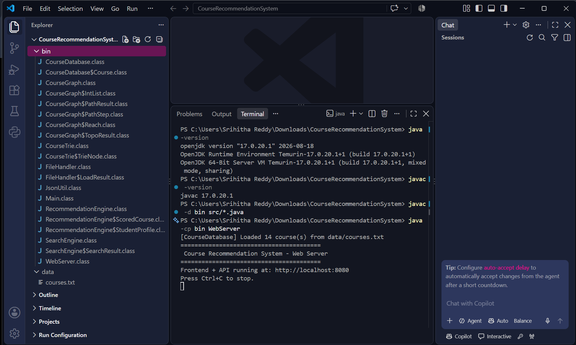
Fig. 5.1 Terminal showing the server start-up and 14 courses loaded from data/courses.txt
In Fig. 5.2 the query “data” is typed on the Search page. The suggestion list shows Data Science Essentials, Data Structures and Algorithms and Database Management Systems together with their categories. These are the courses whose names start with the typed prefix.

Fig. 5.2 Search page: query “data” returns suggestions from the Trie
Fig. 5.3 shows prefix search with the query “Mach”. The Trie returns the single course whose name starts with these letters, Machine Learning Fundamentals (category AI/ML).

Fig. 5.3 Trie prefix search: query “Mach” suggests Machine Learning Fundamentals
Fig. 5.4 shows the Get Recommendations page. The sample profile has interests “machine learning”, skills “sql”, qualifications “basic programming” and career goals “software engineer”. The five best-ranked courses are Database Management Systems (27.5), Full Stack Web Development (27.1), Mobile App Development with Android (18.3), Software Engineering Principles (18.3) and Computer Networking (18.3), each marked Eligible, with its career paths. The scores are produced by the weighted formula of Algorithm 8.

Fig. 5.4 Recommendation results for a sample student profile, ranked by score
Fig. 5.5 shows the details page of Deep Learning with Neural Networks (category AI/ML). It lists the description, the prerequisites (Machine Learning Fundamentals and Linear Algebra), the required skills (Python, TensorFlow, Linear Algebra), the career paths (AI Researcher, ML Engineer, Computer Vision Engineer) and the interest tags. The buttons “Compare this course” and “Back to all courses” are on the right.

Fig. 5.5 Course details page for Deep Learning with Neural Networks
Fig. 5.6 shows the lower part of the same page. The unlock panel reports that nothing in the catalogue lists Deep Learning as a prerequisite, so it unlocks no further course. The learning-path panel was run with 2 courses per semester and returned: learn first (foundations) Basic Programming, Statistics and Linear Algebra; semester 1 Machine Learning Fundamentals; semester 2 Deep Learning with Neural Networks. The message “2 semester(s) at 2 per semester (minimum possible: 2)” shows that the plan equals the lower bound. This agrees with the graph in Fig. 3.3, where Deep Learning depends on Machine Learning Fundamentals and Linear Algebra, and Machine Learning Fundamentals depends on Basic Programming and Statistics.
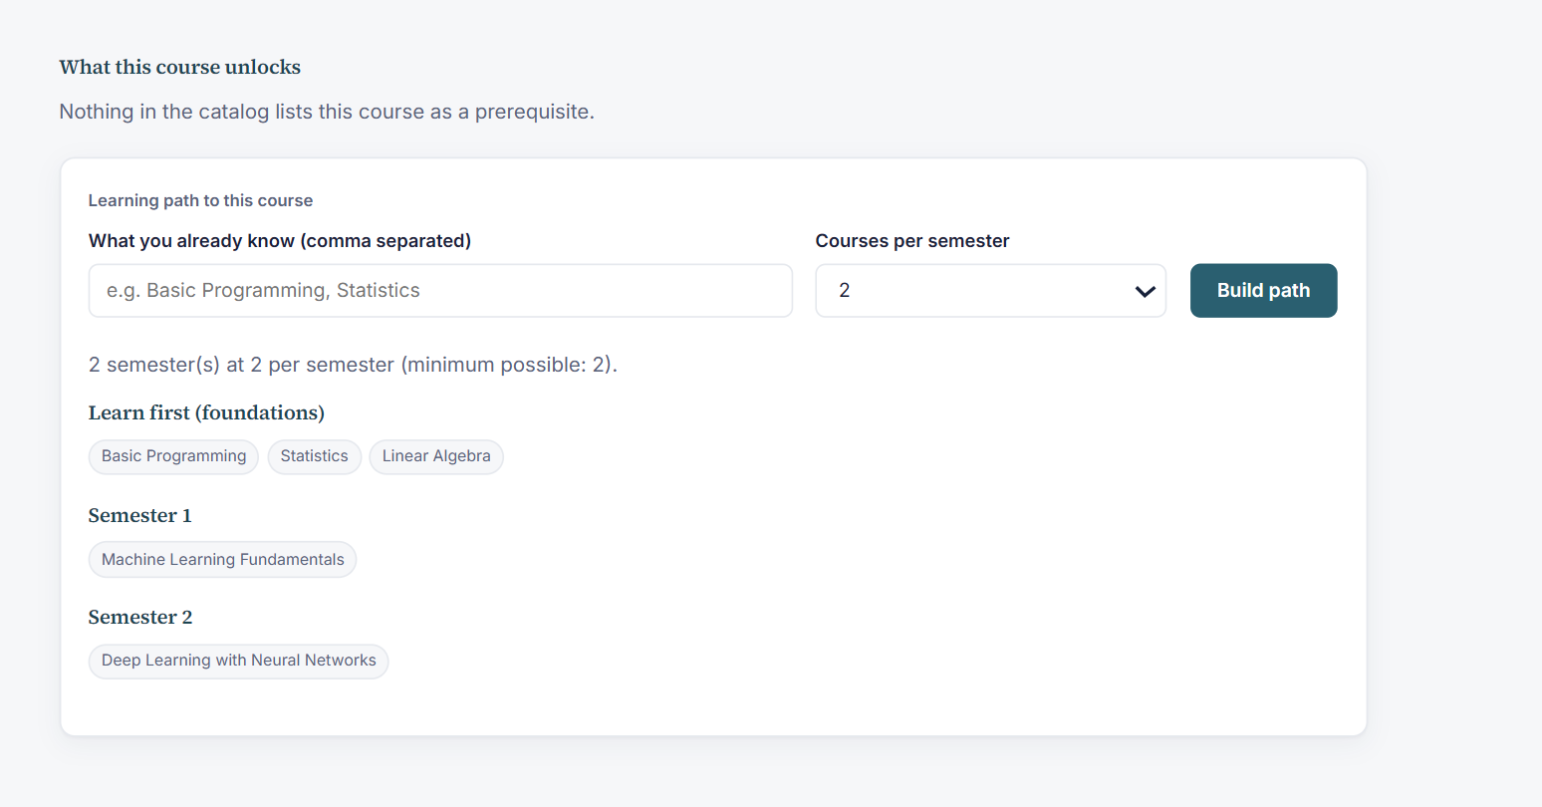
Fig. 5.6 Course unlock panel and learning path with semester plan (2 courses per semester)
Fig. 5.7 shows the comparison of Machine Learning Fundamentals and Data Science Essentials. Both courses require Basic Programming and Statistics; they differ in required skills (Python, Linear Algebra, Probability versus Python, SQL, Statistics) and in career paths.

Fig. 5.7 Side-by-side comparison of Machine Learning Fundamentals and Data Science Essentials
5.5 Observations
- Every feature listed in the objectives is reachable from the web interface, and the algorithms operate on the data loaded from the external file.
- Exact and prefix queries return immediately for the 14-course catalogue; the fuzzy fallback runs only when needed.
- The learning-path result in Fig. 5.6 matches the prerequisite structure of the dataset.
- All executed automated tests passed after the fixes of Table 5.2.

- CHALLENGES AND LIMITATIONS
6.1 Issues Faced during Development
- Handling imperfect data: the file may be missing, empty, contain malformed lines, duplicate ids, a byte-order mark or non-ASCII text.
- Correct cycle handling: vertices on or behind a prerequisite cycle must never appear in a learning path (defect 1 of Table 5.2).
- Locale and character-set problems: case conversion depended on the default locale and the Trie treated all non-ASCII characters alike (defects 2 and 3).
- Robustness of the Trie and the HTTP server for very long inputs and illegal paths (defects 4, 6 and 7).
- Choosing thresholds for fuzzy matching so that small spelling errors are accepted while unrelated terms are rejected (50 % for search and 65 % for profile and known-topic matching).
6.2 Solutions Applied
- FileHandler skips each bad line with a line-numbered warning and never throws for a bad file; the application starts with an empty catalogue if nothing can be loaded.
- Kahn’s algorithm marks blocked vertices with level −1, and learningPath returns BLOCKED_BY_CYCLE instead of an invalid plan.
- Locale.ROOT is used for all case folding; each Trie entry keeps its full key for verification; the Trie depth is capped at 64.
- The static-file handler checks the path prefix with a separator, and illegal paths return 404.
- Every algorithm was compared with an independent reference implementation in the tests (Section 5.2).
6.3 Limitations of the System
- No automated real-browser test was run; the front-end checks use a simulated DOM (jsdom), and the screens in Section 5.4 were captured by manual use of the application.
- The semester plan is greedy: it is always valid, but it is not guaranteed to use the fewest semesters when the per-semester limit is small; the unlimited run gives only a lower bound.
- A recommendation for nonsense input (for example skills “zzzz”) still lists the two courses without prerequisites with 10 points, because the eligibility part of the score does not depend on a content match. Only a completely blank profile is rejected.
- The server uses the JDK default executor and was tested with sequential requests only; heavy concurrent load was not tested.
- The catalogue is small (14 courses) and recommendations use only the text of the profile; there is no learning from user behaviour, no user accounts and no stored history.
- The /api/graph, /api/status and /api/categories endpoints exist and were tested directly, but the current pages do not use them. Name lookup in the graph is linear, which is acceptable for the present catalogue size.
- The JavaScript front end contains a small copy of Edit Distance with a 60 % threshold for the search dropdown, which differs from the server threshold.

- CONCLUSION AND FUTURE WORK
7.1 Conclusion
The project delivered a working Course Recommendation System in which the main functions are implemented with explicit data structures and algorithms. Course data is loaded from an external file; KMP, Rabin-Karp and Edit Distance provide exact, keyword and typo-tolerant search; a Trie gives instant prefix suggestions; Merge Sort ranks search results and recommendations; and a prerequisite graph supports topological sorting, cycle detection, learning-path generation, semester planning and unlock analysis. The functions are available through a Java HTTP API and a web interface, and the Phase 4 test suites passed completely.
The project showed that algorithms taught in the course can be combined in a practical application and that the choice of algorithm affects both correctness (for example cycle handling) and usability (for example spelling tolerance).
7.2 Future Work
- Use a real course database or a larger catalogue, and keep student profiles and history to improve recommendations.
- Add collaborative or machine-learning based ranking and learn the score weights from feedback.
- Replace the greedy semester planner by an optimal or heuristic planner that minimises the number of semesters under the per-semester limit.
- Add a graph visualisation page that uses /api/graph, and show unlock chains on the course page.
- Use a hash map for name lookup in the graph and a multi-threaded server for many simultaneous users.
- Run automated real-browser tests and add user authentication.
7.3 Skills Learned during Development
- Designing and implementing string-matching, dynamic-programming, sorting, trie and graph algorithms and stating their time and space complexity.
- Parsing and validating external data and writing defensive code for bad input.
- Building a Java HTTP server, a JSON API and a plain JavaScript front end.
- Writing unit, integration, API and fuzz tests, finding defects with them and fixing them.
- Teamwork, version-by-phase development and technical documentation.

REFERENCES
[1] F. Ricci, L. Rokach and B. Shapira, Eds., Recommender Systems Handbook, 3rd ed. New York, NY, USA: Springer, 2022.
[2] D. E. Knuth, J. H. Morris Jr. and V. R. Pratt, “Fast pattern matching in strings,” SIAM Journal on Computing, vol. 6, no. 2, pp. 323–350, 1977.
[3] R. M. Karp and M. O. Rabin, “Efficient randomized pattern-matching algorithms,” IBM Journal of Research and Development, vol. 31, no. 2, pp. 249–260, 1987.
[4] V. I. Levenshtein, “Binary codes capable of correcting deletions, insertions and reversals,” Soviet Physics Doklady, vol. 10, no. 8, pp. 707–710, 1966.
[5] E. Fredkin, “Trie memory,” Communications of the ACM, vol. 3, no. 9, pp. 490–499, 1960.
[6] A. B. Kahn, “Topological sorting of large networks,” Communications of the ACM, vol. 5, no. 11, pp. 558–562, 1962.
[7] T. H. Cormen, C. E. Leiserson, R. L. Rivest and C. Stein, Introduction to Algorithms, 4th ed. Cambridge, MA, USA: MIT Press, 2022.
[8] R. Sedgewick and K. Wayne, Algorithms, 4th ed. Upper Saddle River, NJ, USA: Addison-Wesley, 2011.
[9] Oracle, “Package com.sun.net.httpserver,” Java SE API documentation, jdk.httpserver module. [Online]. Available: https://docs.oracle.com/en/java/javase/17/docs/api/jdk.httpserver/com/sun/net/httpserver/package-summary.html
[10] Course Recommendation System project files: README.md, GRAPH_DESIGN.md and FINAL_TEST_REPORT.md (Phase 4 Integrated), 2026.

