WINE QUALITY PREDICTION USING RIDGE, LASSO AND ELASTIC NET REGRESSION

Project Report submitted for the partial fulfilment of grade for the course

Machine Learning - (25SC210&E)

in

DEPARTMENT OF COMPUTER SCIENCE ENGINEERING

by

SRIHITHA KASIREDDY :2520030153

BHAVANA MANASWINI :2520030154

Team Number:12
Section:8

Under the Guidance of

Asif Shaik
Assistant Professor
Department of Computer Science and Engineering





2026-27

DEPARTMENT OF COMPUTER SCIENCE ENGINEERING

DECLARATION

We hereby declare that the project entitled “Wine Quality Prediction Using Ridge, Lasso and Elastic Net Regression” is our academic work carried out as part of the academic requirements of KLH University, Department of Computer Science and Engineering, during the academic year 2026–2027.

We have developed this project using the WineQT dataset and applied machine learning techniques to analyze and predict wine quality based on various physicochemical characteristics. The project involves data exploration, data preprocessing, model training, prediction, and performance evaluation using Ridge Regression, Lasso Regression, and Elastic Net Regression. The results obtained from these models have been analyzed to understand their effectiveness in predicting wine quality scores.

We declare that the information presented in this documentation is prepared based on the project work, the supplied dataset, the implementation notebooks, and the project presentation. We have made our best efforts to present the methodology, results, and conclusions clearly and accurately. This report is submitted for academic evaluation and has not been submitted by us for any other academic qualification.

SRIHITHA KASIREDDY-2520030153
BHAVANA MANASWINI-2520030154

DEPARTMENT OF COMPUTER SCIENCE ENGINEERING

CERTIFICATE

This is to certify that the project entitled “Wine Quality Prediction Using Ridge, Lasso and Elastic Net Regression” is a bonafide work carried out by Srihitha Kasireddy (Roll No: 2520030153) and Bhavana Manaswini (Roll No: 2520030154), students of Section 8, Department of Computer Science and Engineering, KLH University, Bowrampet, Hyderabad, Telangana, during the academic year 2026–2027.

This project has been completed under the guidance and supervision of Asif Shaik, Assistant Professor, Department of Computer Science and Engineering. The work focuses on analyzing the WineQT dataset and applying Ridge Regression, Lasso Regression, and Elastic Net Regression techniques to predict wine quality based on its physicochemical properties. The models are evaluated using appropriate regression performance metrics to compare their predictive capabilities.

The project work has been carried out as part of the academic requirements of the university. To the best of our knowledge, the work presented in this report is suitable for submission and evaluation.

Signature of the Guide Signature of the HOD
(Asif Shaik)

Signature of the External Examiner

ACKNOWLEDGEMENT

We express our sincere gratitude to our project guide, Asif Shaik, Assistant Professor, Department of Computer Science and Engineering, for the guidance and support throughout this project. We thank our university and faculty members for providing the opportunity to learn and apply machine learning concepts. We also acknowledge the dataset and software tools that helped us perform data analysis, train regression models, and evaluate their performance.

SRIHITHA KASIREDDY-2520030153
BHAVANA MANASWINI-2520030154

Abstract

Wine quality prediction is an important application of machine learning that helps analyze the relationship between the physicochemical properties of wine and its quality score. Traditional wine quality assessment may require expert knowledge and laboratory analysis. Machine learning techniques provide a data-driven approach to estimate quality based on measurable characteristics. The main objective of this project is to develop and compare regression models for predicting wine quality using the WineQT dataset.
The dataset used in this project contains 1,143 records and 13 columns, including an identifier, physicochemical measurements, and the wine quality score. The input features include fixed acidity, volatile acidity, citric acid, residual sugar, chlorides, free sulfur dioxide, total sulfur dioxide, density, pH, sulphates, and alcohol. The identifier column is excluded from the model inputs because it does not represent a physicochemical property of wine. Exploratory Data Analysis (EDA) is performed to understand the dataset, examine the distribution of quality scores, identify patterns among the features, and study the correlations between different variables.
Three regularized regression algorithms, namely Ridge Regression, Lasso Regression, and Elastic Net Regression, are implemented and evaluated. Ridge Regression applies L2 regularization, Lasso Regression applies L1 regularization, and Elastic Net combines both L1 and L2 regularization techniques. These algorithms are compared using standard evaluation metrics such as Mean Absolute Error (MAE), Mean Squared Error (MSE), Root Mean Squared Error (RMSE), and the coefficient of determination (R²). These metrics help measure prediction errors and assess how effectively each model estimates wine quality scores.
The dataset was split into 80% training and 20% test data, the features were standardized using a scaler fitted on the training data only, and the hyperparameters of each model were tuned with 5-fold cross-validation (GridSearchCV). On the held-out test set, the hyperparameters selected by GridSearchCV gave test R² values of 0.327 (Ridge), 0.340 (Lasso) and 0.331 (Elastic Net), with Lasso best on all four metrics. With the hyperparameters stated in the project presentation, Elastic Net achieved the highest R² (0.337) and the lowest MSE (0.369), while Lasso achieved the lowest MAE (0.474). The differences between the three models are small compared with the fold-to-fold variation seen in cross-validation, and the best model changes with the hyperparameters used, so this evidence does not show any model to be clearly superior; each explains roughly one third of the variance in wine quality.
In conclusion, this project provides practical experience in data preprocessing, exploratory data analysis, machine learning model development, and performance evaluation using Python and its machine learning libraries. The project also highlights the usefulness of data-driven approaches for quality prediction while recognizing that model performance depends on the available dataset and the relationships between its features.
Keywords: Wine Quality Prediction, Machine Learning, Ridge Regression, Lasso Regression, Elastic Net Regression, Exploratory Data Analysis, Regression Metrics.

Table of Contents
Page No.
Acknowledgement 4
Abstract 5
Table of Contents 6
List of Figures 8
List of Tables 8
Chapter 1: Introduction 9
1.1 Introduction 9
1.2 Problem Statement 9
1.3 Objectives of the Project 10
1.4 Scope of the Project 10
1.5 Significance of the Project 10
1.6 Organization of the Report 11
Chapter 2: Literature and Background 12
2.1 Introduction 12
2.2 Machine Learning in Wine Quality Prediction 12
2.3 Linear Regression 13
2.4 Ridge Regression 13
2.5 Lasso Regression 13
2.6 Elastic Net Regression 14
2.7 Exploratory Data Analysis 14
2.8 Model Evaluation Techniques 14
2.9 Comparative Background of the Algorithms 15
2.10 Summary 15
Chapter 3: System Design 17
3.1 High-level Architecture Diagram 17
3.2 Description of Each Layer 17
Chapter 4: Implementation 20
4.1 System Workflow 20
4.2 Development Environment 20
4.3 Dataset Description 20
4.4 Exploratory Data Analysis 21
4.5 Feature–Target Separation and Train–Test Split 23
4.6 Feature Scaling 23
4.7 Model Training and Hyperparameter Tuning 24
4.8 Model Evaluation 24
4.9 Additional Checks 24
4.10 Summary 24
Chapter 5: Results 25
5.1 Overview of the Result Sets 25
5.2 Results with GridSearchCV-Selected Hyperparameters (Set A) 25
5.3 Results at the Presentation Hyperparameters (Set B) 26
5.4 Comparison of the Two Result Sets 26
5.5 Generalization: Training, Cross-Validation and Test Performance 27
5.6 Robustness Checks 27
5.7 Feature Coefficient Analysis 28
5.8 Summary of Results 28
5.9 Graphical Analysis (Set A) 30
Chapter 6: Challenges and Limitations 35
6.1 Issues Faced During Development 35
6.2 Solutions Applied 35
6.3 Limitations of the System 36
Chapter 7: Conclusion and Future Work 37
7.1 Conclusion 37
7.2 Future Work 37
7.3 Skills Learned During Development 37
References 38

List of Figures
Figure 3.1: High-Level Architecture Diagram 17
Figure 4.1: Distribution of wine quality scores in WineQT.csv 21
Figure 4.2: Correlation matrix of the 11 features and the quality score 22
Figure 4.3: Alcohol versus volatile acidity, coloured by quality score 23
Figure 5.1: Test-set MAE, MSE, RMSE and R² of the three models (Set A) 26
Figure 5.2: Actual versus predicted wine quality on the test set 30
Figure 5.3: Residual distribution of each model on the test set 31
Figure 5.4: Standardized coefficients of Ridge, Lasso and Elastic Net 32
Figure 5.5: Top six features by absolute standardized coefficient for each model 33
Figure 5.6: Prediction error versus actual quality for each model 34

List of Tables
Table 2.1: Comparison of Ridge, Lasso and Elastic Net Regression 15
Table 4.1: Summary statistics of the WineQT features and their Pearson correlation with quality 21
Table 4.2: Number of wines per quality score 22
Table 4.3: Hyperparameter grids searched with GridSearchCV 24
Table 5.1: Hyperparameters selected by GridSearchCV and cross-validated MSE (Set A) 25
Table 5.2: Test-set performance with GridSearchCV-selected hyperparameters (Set A; best value per metric highlighted) 25
Table 5.3: Test-set performance at the hyperparameters stated in the presentation (Set B; best value per metric highlighted) 26
Table 5.4: Best model for each metric under the two sets of hyperparameters 26
Table 5.5: Training R², cross-validated MSE and test performance (Set A) 27
Table 5.6: Results of the robustness checks 27
Table 5.7: Standardized coefficients of the Set A models (zero = removed by the model) 28

CHAPTER 1: INTRODUCTION

1.1 Introduction
In today's world, machine learning plays an important role in analyzing data, identifying patterns, and making predictions. It is widely used in various fields, including healthcare, agriculture, manufacturing, finance, and food quality assessment. By learning from existing data, machine learning models can identify relationships between different variables and use those relationships to predict outcomes for new observations. One such application is wine quality prediction, which focuses on estimating wine quality based on its physicochemical properties.
Wine quality is influenced by several characteristics, such as acidity, alcohol content, sugar content, density, pH, sulphates, and chloride concentration. These properties can be measured and represented numerically, making them suitable for analysis using machine learning algorithms. Understanding the relationship between these characteristics and wine quality can help identify patterns in the dataset and develop models that estimate quality scores.
The project “Wine Quality Prediction Using Ridge, Lasso and Elastic Net Regression” aims to apply machine learning regression techniques to predict wine quality using the WineQT dataset. The project involves examining the dataset, performing Exploratory Data Analysis (EDA), preparing the input features, training regression models, and evaluating their performance. The main focus is to compare Ridge Regression, Lasso Regression, and Elastic Net Regression and understand how their predictions differ when applied to the same dataset.
Ridge Regression uses L2 regularization to control the magnitude of model coefficients, while Lasso Regression uses L1 regularization, which can reduce some coefficients to zero. Elastic Net combines both regularization techniques. These methods help control model complexity and provide different approaches to learning relationships between input features and the target variable.
The models are evaluated using Mean Absolute Error (MAE), Mean Squared Error (MSE), Root Mean Squared Error (RMSE), and the coefficient of determination (R²). These metrics help assess prediction errors and compare the effectiveness of the models. Through this project, the practical use of Python, data analysis libraries, and machine learning techniques is demonstrated.

1.2 Problem Statement
Wine quality assessment involves understanding several physicochemical characteristics that may influence the final quality score. Examining these characteristics manually can be time-consuming, and identifying relationships among multiple variables may be difficult without systematic analysis.
The problem addressed in this project is to develop machine learning regression models that estimate wine quality scores using the physicochemical measurements available in the WineQT dataset. The project also aims to compare the performance of Ridge Regression, Lasso Regression, and Elastic Net Regression using standard evaluation metrics and identify which model performs better in the reported experiment.

1.3 Objectives of the Project
The main objectives of the project are:
- To understand the structure and characteristics of the WineQT dataset.
- To perform Exploratory Data Analysis to identify patterns and relationships among the features.
- To examine the distribution of wine quality scores and correlations between variables.
- To prepare the dataset for machine learning by separating input features and the target variable.
- To implement Ridge Regression, Lasso Regression, and Elastic Net Regression.
- To evaluate the models using MAE, MSE, RMSE, and R².
- To compare the results obtained from the three regression algorithms.
- To identify the advantages and limitations of regularized regression for wine quality prediction.

1.4 Scope of the Project
The scope of this project is limited to predicting wine quality using the numerical physicochemical features provided in the WineQT dataset. The project includes data loading, data exploration, visualization, model training, prediction, and evaluation.
The three selected regression algorithms are compared to understand their performance on the same prediction task. The project primarily focuses on implementing and evaluating these techniques using Python and relevant machine learning libraries.
The system is intended for academic learning and experimental analysis. It demonstrates how machine learning can support quality estimation but does not replace professional laboratory testing or expert wine evaluation. The accuracy and reliability of predictions depend on the quality, size, and characteristics of the dataset used.

1.5 Significance of the Project
This project is significant because it demonstrates how machine learning can be applied to a practical prediction problem using numerical data. By analyzing physicochemical properties, the project helps illustrate the relationships that may exist between measurable characteristics and wine quality scores.
Comparing Ridge, Lasso, and Elastic Net also provides an understanding of regularization techniques and their role in regression. Evaluating the models with multiple metrics gives a more complete view of their predictive performance than relying on a single measure.
Furthermore, the project provides practical experience in data preprocessing, visualization, model development, and performance analysis. These skills are useful for understanding and developing machine learning applications in other areas of data-driven quality assessment.

1.6 Organization of the Report
This report is organized into seven chapters. Chapter 1 introduces the project, problem statement, objectives, scope, and significance. Chapter 2 explains the background of machine learning and the regression algorithms used. Chapter 3 presents the system design, including the high-level architecture and the eight layers of the workflow. Chapter 4 describes the implementation: the software environment, the dataset, exploratory data analysis, the train-test split, feature scaling, hyperparameter tuning and the evaluation procedure. Chapter 5 presents the results and the performance comparison of the three models. Chapter 6 discusses the challenges encountered and the limitations of the project. Chapter 7 presents the conclusion, future work and the skills gained. The references are listed at the end of the report.

CHAPTER 2: LITERATURE AND BACKGROUND

2.1 Introduction
Machine learning has become an important technology for analyzing data, identifying patterns, and making predictions in various fields. In quality assessment, machine learning algorithms can be used to study the relationship between measurable product characteristics and quality scores. Wine quality prediction is one such application in which physicochemical properties are used to estimate the quality of wine.
Traditional wine quality evaluation may involve expert assessment and laboratory testing. Although these methods are valuable, analyzing several chemical properties together can be challenging. Machine learning provides a data-driven approach that can identify relationships among multiple variables and generate predictions based on previously available data.
This project focuses on three regression algorithms: Ridge Regression, Lasso Regression, and Elastic Net Regression. These algorithms are based on linear regression and use regularization techniques to control model complexity. Their performance is compared to understand their suitability for predicting wine quality.

2.2 Machine Learning in Wine Quality Prediction
Machine learning is a branch of artificial intelligence that enables computer systems to learn patterns from data and use them to make predictions. Depending on the problem, machine learning techniques can be classified into supervised learning, unsupervised learning, and reinforcement learning.
Wine quality prediction can be treated as a supervised learning problem because the dataset contains input features and corresponding quality scores. The model learns relationships between the physicochemical properties and the known quality scores during training. After training, it uses these relationships to estimate quality scores for unseen data.
The WineQT dataset contains measurements such as acidity, residual sugar, chlorides, density, pH, sulphates, and alcohol. These measurements are used as input features, while the quality column is the target variable. Exploratory Data Analysis helps understand the dataset, identify patterns, examine correlations, and prepare the data for model development.

2.3 Linear Regression
Linear Regression is a supervised learning algorithm used to predict a numerical target variable from one or more input features. It attempts to establish a linear relationship between the input variables and the target.
In wine quality prediction, the input variables represent the physicochemical characteristics of wine, and the target variable represents its quality score. The model estimates coefficients for the input features and uses them to calculate predicted quality scores.
However, ordinary Linear Regression may produce large coefficient values when features have strong relationships with one another or when the model is sensitive to the training data. Regularization techniques can help control coefficient magnitudes and improve the model's ability to generalize to unseen observations.

2.4 Ridge Regression
Ridge Regression is a regularized version of Linear Regression that uses L2 regularization. It adds a penalty based on the squared values of the model coefficients to the original regression objective.
The regularization parameter, alpha, controls the strength of the penalty. A larger alpha generally applies stronger regularization, reducing coefficient magnitudes. Ridge Regression usually retains all input features but reduces their influence when necessary.
In this project, Ridge Regression is used to estimate wine quality from physicochemical measurements. Its performance is assessed using MAE, MSE, RMSE, and R². This helps determine how effectively the model predicts wine quality and how its results compare with the other regression algorithms.

2.5 Lasso Regression
Lasso Regression is another regularized regression algorithm that uses L1 regularization. Unlike Ridge Regression, Lasso can reduce some model coefficients exactly to zero, which can effectively remove less useful features from the model.
The alpha parameter controls the strength of regularization. A suitable value can help balance prediction accuracy and model simplicity. However, excessive regularization may cause underfitting and reduce predictive performance.
In this project, Lasso Regression is applied to the WineQT dataset to predict quality scores. Its results are compared with those of Ridge Regression and Elastic Net Regression to evaluate prediction errors and overall performance.

2.6 Elastic Net Regression
Elastic Net Regression combines the L1 and L2 regularization techniques used by Lasso and Ridge Regression. It includes two important parameters: alpha, which controls the overall regularization strength, and l1_ratio, which controls the balance between L1 and L2 penalties.
The combination of both penalties allows Elastic Net to reduce coefficient magnitudes while also enabling some coefficients to become zero. This can be useful when input features are correlated and when a balance between coefficient reduction and feature selection is desirable.
In this project, Elastic Net Regression is trained using the physicochemical features of the WineQT dataset. Its predictions are evaluated using the same metrics as the other models, allowing a consistent comparison of performance.

2.7 Exploratory Data Analysis
Exploratory Data Analysis (EDA) is the process of examining and summarizing data before building machine learning models. It helps identify data patterns, understand feature distributions, detect possible data-quality issues, and investigate relationships among variables.
For the WineQT dataset, EDA includes examining the dataset shape, column names, data types, descriptive statistics, quality-score distribution, and feature correlations. Visualizations such as histograms and correlation heatmaps can help communicate these observations.
In the supplied dataset, quality scores 5 and 6 are the most frequent. The reported analysis also shows a positive correlation between alcohol and quality and a negative correlation between volatile acidity and quality. These are statistical associations and do not, by themselves, prove that one variable causes a change in wine quality.

2.8 Model Evaluation Techniques
Model evaluation is necessary to understand how closely predicted quality scores match the actual values. This project uses four common regression metrics.
Mean Absolute Error (MAE): Measures the average absolute difference between actual and predicted quality scores. A lower MAE indicates smaller average absolute errors.
Mean Squared Error (MSE): Calculates the average of squared prediction errors. It gives greater weight to larger errors, and lower values are preferred.
Root Mean Squared Error (RMSE): Represents the square root of MSE. It expresses the prediction error in the same units as the target variable. Lower values indicate better performance.
Coefficient of Determination (R²): Indicates how much of the variation in the target is explained by the model relative to a baseline. A higher value generally indicates a better fit, although the metric must be interpreted in the context of the dataset and evaluation method.
Using these metrics together provides a more complete understanding of the strengths and limitations of each model.

2.9 Comparative Background of the Algorithms
Ridge, Lasso, and Elastic Net are related regression algorithms, but they use different regularization approaches. Ridge reduces coefficient magnitudes, Lasso can eliminate some coefficients, and Elastic Net combines both approaches.
The following table summarizes their main differences.
Table 2.1: Comparison of Ridge, Lasso and Elastic Net Regression
Feature | Ridge Regression | Lasso Regression | Elastic Net Regression
Regularization | L2 | L1 | L1 and L2
Coefficients reduced | Yes | Yes | Yes
Can set coefficients to zero | Generally no | Yes | Yes
Main purpose | Control coefficient magnitude | Regularization and feature selection | Combine coefficient control and feature selection
Important parameters | Alpha | Alpha | Alpha and l1_ratio

2.10 Summary
This chapter introduced the machine learning concepts and regression algorithms used in the Wine Quality Prediction project. It explained supervised learning, Linear Regression, Ridge Regression, Lasso Regression, Elastic Net Regression, Exploratory Data Analysis, and regression evaluation metrics.
The background provides the foundation for understanding the project methodology and the comparison of the three models. The next chapter presents the system design and the layers of the prediction workflow.

CHAPTER 3: SYSTEM DESIGN

3.1 High-level Architecture Diagram
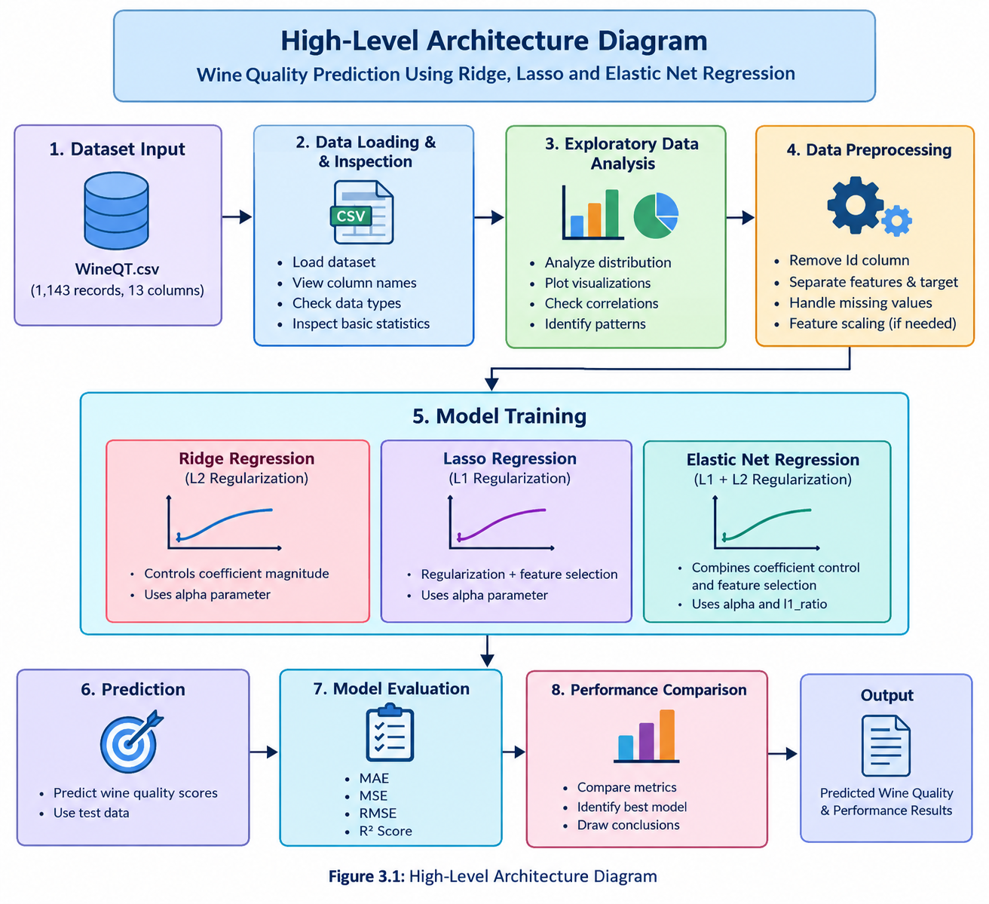
Note: In the implemented workflow the dataset contained no missing values, so no values were removed or imputed, and feature scaling (StandardScaler, fitted on the training data only) was applied before model training.

3.2 Description of Each Layer
The high-level architecture of the Wine Quality Prediction system consists of eight major layers. Each layer performs a specific function, starting from dataset input and ending with the final prediction and performance results.
1. Dataset Input Layer
This is the initial layer of the system, where the WineQT.csv dataset is provided as input. The dataset contains 1,143 records and 13 columns, including an identifier, 11 physicochemical properties, and the wine quality score. The physicochemical properties are fixed acidity, volatile acidity, citric acid, residual sugar, chlorides, free sulfur dioxide, total sulfur dioxide, density, pH, sulphates, and alcohol. These values provide the information required to analyze and predict wine quality.
2. Data Loading and Inspection Layer
In this layer, the dataset is loaded into the Python environment using the Pandas library. The structure of the dataset is examined by checking column names, data types, the number of records, and basic statistical information. This step helps understand the dataset and identify possible data-quality issues before performing further analysis.
3. Exploratory Data Analysis Layer
The Exploratory Data Analysis (EDA) layer is used to understand the distribution and relationships among the dataset features. Statistical summaries, graphs, and correlation analysis are used to identify patterns in the data. This analysis helps understand how different physicochemical properties are associated with wine quality and supports decisions during data preparation.
4. Data Preprocessing Layer
This layer prepares the dataset for machine learning. The identifier column (Id) is excluded from the input features because it does not represent a wine characteristic. The 11 physicochemical measurements are separated from the target variable, quality. The data is split into 80% training data (914 records) and 20% test data (229 records) with a fixed random seed of 42. The features are then standardized using a StandardScaler that is fitted on the training data only and applied unchanged to the test data. The dataset contains no missing values, so no imputation was required.
5. Model Training Layer
The model training layer is responsible for training the three selected regression algorithms using the prepared dataset.
- Ridge Regression: Uses L2 regularization to control the magnitude of model coefficients and reduce excessive coefficient values.
- Lasso Regression: Uses L1 regularization, which can reduce some coefficients to zero and support feature selection.
- Elastic Net Regression: Combines L1 and L2 regularization to control coefficient magnitudes and potentially eliminate less useful features.
Each model learns relationships between the physicochemical properties and the corresponding wine quality scores.
6. Prediction Layer
After training, the models are used to predict wine quality scores for the test data. The input measurements are passed to the trained models, which generate estimated quality values. These predictions are then compared with the actual quality scores to understand how accurately each model performs on unseen observations.
7. Model Evaluation Layer
The model evaluation layer measures the predictive performance of each regression algorithm using four evaluation metrics:
- MAE: Measures the average absolute difference between actual and predicted values.
- MSE: Measures the average squared prediction error.
- RMSE: Represents the square root of MSE and expresses error in the target's units.
- R² Score: Measures how well the model explains variation in the target relative to a baseline.
Lower MAE, MSE, and RMSE values generally indicate smaller prediction errors, while a higher R² generally indicates a better fit.
8. Performance Comparison and Output Layer
In the final layer, the evaluation results of Ridge Regression, Lasso Regression, and Elastic Net Regression are compared. The metrics are examined to identify differences in prediction errors and overall performance. The results are then summarized in tables, graphs, or notebook outputs.
The results are summarized in tables and graphs in Chapter 5. With the hyperparameters selected by GridSearchCV, Lasso gives the best value on all four metrics (R² = 0.340). With the hyperparameters stated in the project presentation, Elastic Net gives the highest R² (0.337) and the lowest MSE (0.369), and Lasso gives the lowest MAE (0.474). The differences between the models are small, as discussed in Chapter 5.
Summary
The eight layers work together to form a complete machine learning workflow. The system transforms the original dataset into prepared input features, trains three regression models, generates quality predictions, and evaluates their performance. This layered architecture makes the prediction process organized, understandable, and suitable for comparing different machine learning algorithms.

CHAPTER 4: IMPLEMENTATION
This chapter describes how the Wine Quality Prediction project was implemented in the project notebook (Wine_Quality_Model_Training_1.ipynb). Every step described here corresponds to code that was executed in the notebook, and all numbers quoted are taken from, or recomputed from, the notebook outputs and the WineQT.csv file.

4.1 System Workflow
The project follows these stages:
- Load the WineQT dataset and check its shape and column names.
- Check data quality: missing values and duplicate records.
- Perform exploratory data analysis (quality distribution, correlations).
- Separate the 11 input features from the target variable (quality) and exclude the Id column.
- Split the data into 80% training and 20% test sets (random_state = 42).
- Standardize the features with a StandardScaler fitted on the training data only.
- Tune the hyperparameters of Ridge, Lasso and Elastic Net with GridSearchCV (5-fold cross-validation).
- Train the selected models and generate predictions on the test data.
- Compute MAE, MSE, RMSE and R² on the test set.
- Repeat the evaluation at the hyperparameters stated in the project presentation.
- Run two robustness checks (scaler inside the cross-validation loop; duplicate rows removed).
- Analyse residuals, prediction errors and feature coefficients, and compare the models.

4.2 Development Environment
The project was implemented in Python in a Jupyter notebook. The notebook records the following library versions: NumPy 2.4.4, pandas 3.0.2 and scikit-learn 1.8.0. pandas was used for loading and inspecting the data, scikit-learn for splitting, scaling, model training, cross-validation and metrics [7], [8], [9], and Matplotlib and seaborn for the graphs [10], [11]. The Ridge, Lasso and ElasticNet estimators and the GridSearchCV, StandardScaler and Pipeline classes are all from scikit-learn.

4.3 Dataset Description
The supplied file WineQT.csv contains 1,143 records and 13 columns and has no missing values. It follows the structure of the physicochemical wine-quality data described in [1] and [2]: eleven physicochemical measurements, a sensory quality score, and an Id column. The Id column is a unique row identifier with no chemical meaning and is excluded from the model inputs. The quality score is an integer between 3 and 8. Table 4.1 summarizes the features.
Table 4.1: Summary statistics of the WineQT features and their Pearson correlation with quality
Feature | Mean | Std. dev. | Min | Max | r with quality
fixed acidity | 8.311 | 1.748 | 4.600 | 15.900 | +0.122
volatile acidity | 0.531 | 0.180 | 0.120 | 1.580 | -0.407
citric acid | 0.268 | 0.197 | 0.000 | 1.000 | +0.241
residual sugar | 2.532 | 1.356 | 0.900 | 15.500 | +0.022
chlorides | 0.087 | 0.047 | 0.012 | 0.611 | -0.124
free sulfur dioxide | 15.615 | 10.250 | 1.000 | 68.000 | -0.063
total sulfur dioxide | 45.915 | 32.782 | 6.000 | 289.000 | -0.183
density | 0.997 | 0.002 | 0.990 | 1.004 | -0.175
pH | 3.311 | 0.157 | 2.740 | 4.010 | -0.052
sulphates | 0.658 | 0.170 | 0.330 | 2.000 | +0.258
alcohol | 10.442 | 1.082 | 8.400 | 14.900 | +0.485
quality (target) | 5.657 | 0.806 | 3.000 | 8.000 | 1.000

A duplicate check that includes the Id column finds no repeated rows, because every Id is unique. When Id is ignored, 125 rows (about 10.9%) repeat another row exactly in all 11 features and the quality score. Duplicates can fall on both sides of a random split, which may make test scores optimistic. To remain consistent with the project presentation, the main analysis keeps all 1,143 rows; the effect of removing the duplicates is examined in Section 5.6.

4.4 Exploratory Data Analysis
Exploratory data analysis was used to understand the distribution of the target and the relationships between the features and quality. Quality scores 5 and 6 dominate the dataset: score 5 occurs 483 times (42.3%) and score 6 occurs 462 times (40.4%), together 82.7% of all records. The extreme scores 3 and 8 are rare (6 and 16 records). Figure 4.1 and Table 4.2 show the distribution.
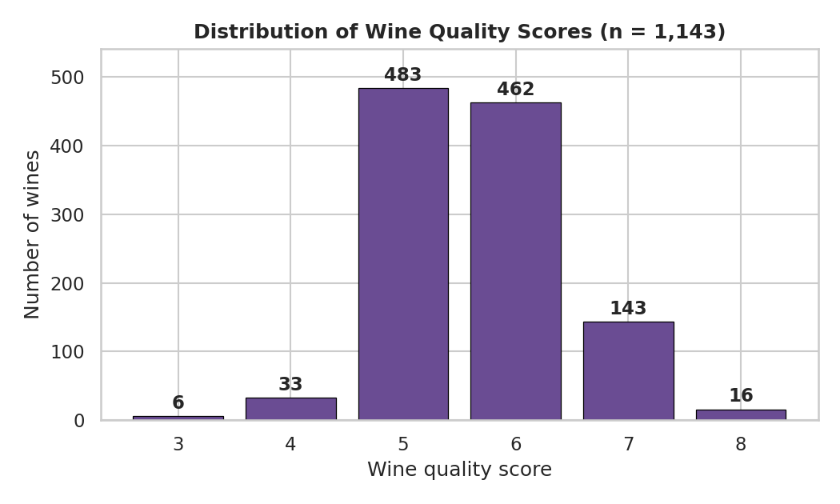
Figure 4.1: Distribution of wine quality scores in WineQT.csv
Table 4.2: Number of wines per quality score
Quality score | 3 | 4 | 5 | 6 | 7 | 8
Number of wines | 6 | 33 | 483 | 462 | 143 | 16
Share of dataset (%) | 0.5 | 2.9 | 42.3 | 40.4 | 12.5 | 1.4

The strongest linear correlations with quality are alcohol (r = +0.485), volatile acidity (r = −0.407), sulphates (r = +0.258) and citric acid (r = +0.241), as shown in Table 4.1 and in the correlation matrix in Figure 4.2. Correlation describes association only and does not establish that a feature causes a change in quality.
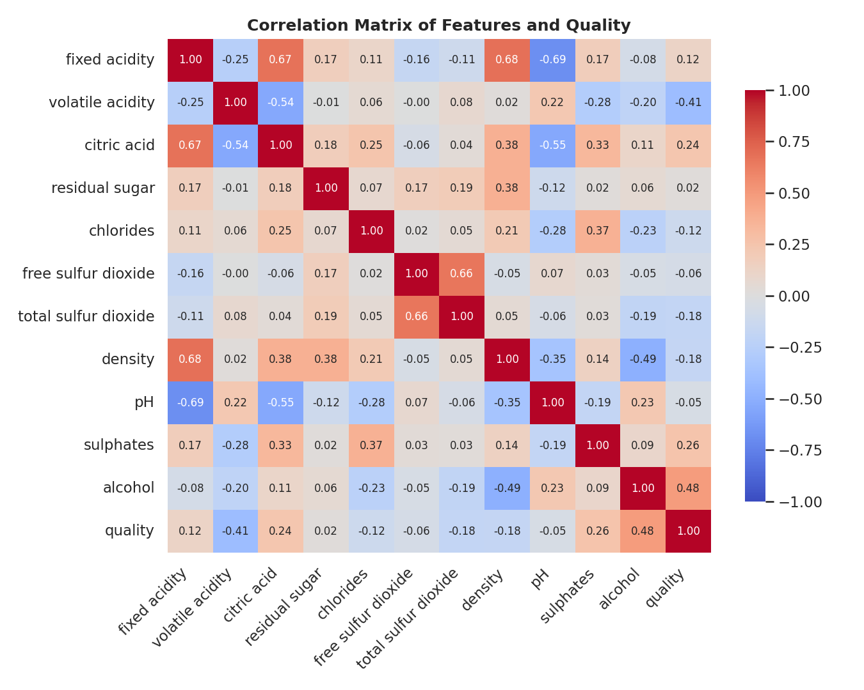
Figure 4.2: Correlation matrix of the 11 features and the quality score
Several features are also correlated with one another. In the training data, the feature pairs with an absolute correlation above 0.6 are fixed acidity with density (+0.68), fixed acidity with pH (−0.67), free with total sulfur dioxide (+0.67) and fixed acidity with citric acid (+0.66). Because correlated features share explanatory power, the coefficient assigned to one of them depends on which related features are also in the model; this matters for the coefficient analysis in Chapter 5. Figure 4.3 shows how alcohol and volatile acidity jointly relate to quality: wines with higher alcohol and lower volatile acidity tend to have higher quality scores.
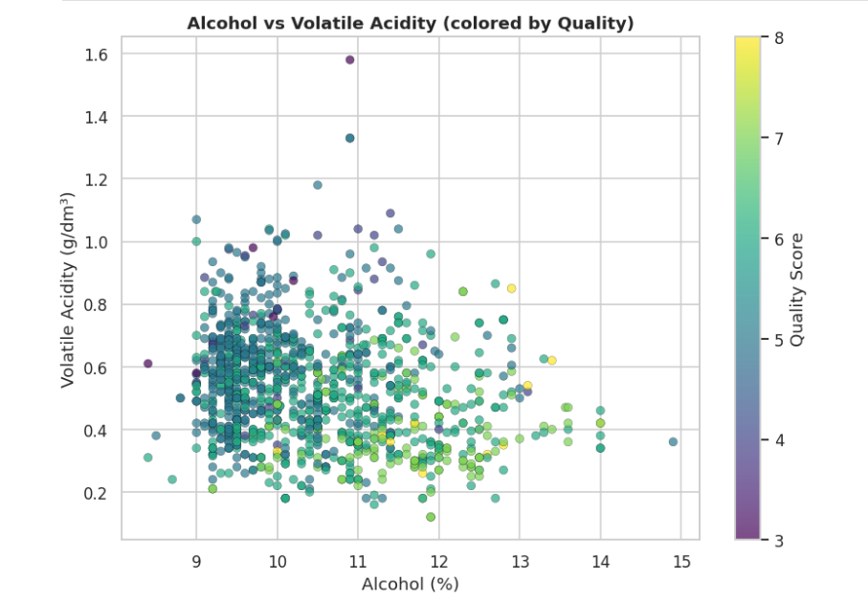
Figure 4.3: Alcohol versus volatile acidity, coloured by quality score

4.5 Feature–Target Separation and Train–Test Split
The Id column and the target are removed from the input matrix X, and quality is stored as the target y. The data is then split into 80% training and 20% test data with random_state = 42, giving 914 training samples and 229 test samples. The split is made before any scaling or tuning so that the test set stays untouched.
X = df.drop(columns=["Id", "quality"])
y = df["quality"]
X_train, X_test, y_train, y_test = train_test_split(
X, y, test_size=0.20, random_state=42)
Because of the duplicate records noted in Section 4.3, 43 of the 229 test wines (18.8%) have an exact feature-identical counterpart in the training set. This is a property of the dataset and should be kept in mind when reading the test scores.

4.6 Feature Scaling
Regularized regression penalizes coefficient size, so features measured on very different scales must be standardized. A StandardScaler is fitted on the training set only and then applied to both sets, so that no test-set statistics leak into the scaler. After scaling, the training features have a mean of 0 and a standard deviation of 1.001. The scaled test features have means between −0.105 and +0.156, which is expected because the scaler never saw the test data.
scaler = StandardScaler()
X_train_scaled = scaler.fit_transform(X_train) # fit on training data only
X_test_scaled = scaler.transform(X_test) # transform only
In the main analysis the scaler is fitted on the whole training set before GridSearchCV creates its inner folds, as in the project presentation. As a result, each validation fold has contributed slightly to the scaler statistics used in cross-validation. This affects only the cross-validation scores used to choose hyperparameters, never the test set. Section 5.6 repeats the tuning with the scaler placed inside a Pipeline to measure whether this matters.

4.7 Model Training and Hyperparameter Tuning
Each model is tuned with GridSearchCV using 5-fold cross-validation on the training data and negative mean squared error as the scoring criterion. Lasso needs much smaller regularization strengths than Ridge, because a large alpha would set every coefficient to zero, so a log-spaced grid from 10⁻⁴ to 1 is used for Lasso. For Lasso and Elastic Net, max_iter was set to 20,000 and convergence was checked explicitly: the selected models converged after 33 and 28 iterations respectively. Table 4.3 lists the grids.
Table 4.3: Hyperparameter grids searched with GridSearchCV
Model | Parameter | Values searched | Candidates
Ridge | alpha | 0.001, 0.01, 0.1, 1, 5, 10, 20, 50, 100, 200 | 10
Lasso | alpha | 25 log-spaced values from 0.0001 to 1 | 25
Elastic Net | alpha | 0.001, 0.005, 0.01, 0.05, 0.1, 0.5, 1 | 42 (7 × 6)
 | l1_ratio | 0.1, 0.2, 0.3, 0.5, 0.7, 0.9

grid = {"alpha": [0.001, 0.01, 0.1, 1, 5, 10, 20, 50, 100, 200]}
gs = GridSearchCV(Ridge(), grid, cv=5,
scoring="neg_mean_squared_error")
gs.fit(X_train_scaled, y_train)
best_ridge = gs.best_estimator_

4.8 Model Evaluation
The trained models predict quality for the 229 test wines, and four metrics are computed with scikit-learn: MAE, MSE, RMSE (the square root of MSE) and R². The same function is used for every model, so the comparison is consistent. Predictions are continuous values and are not rounded to integer scores.
def compute_metrics(y_true, y_pred):
mse = mean_squared_error(y_true, y_pred)
return {"MAE": mean_absolute_error(y_true, y_pred), "MSE": mse,
"RMSE": float(np.sqrt(mse)), "R2": r2_score(y_true, y_pred)}

4.9 Additional Checks
Besides the main analysis, the notebook contains three additional checks. First, the models were refitted at the exact hyperparameters stated in the project presentation (Ridge alpha = 50; Lasso alpha = 0.01; Elastic Net alpha = 0.05, l1_ratio = 0.2), which differ from the GridSearchCV choices for Lasso and Elastic Net. Second, the tuning was repeated with the scaler inside a Pipeline. Third, the whole procedure was repeated after removing duplicate rows. The results of these checks are given in Chapter 5.

4.10 Summary
The implementation follows a standard supervised-learning workflow: data checks, exploratory analysis, a leakage-aware split and scaling, cross-validated tuning of three regularized models, and evaluation on a held-out test set with four metrics, supplemented by robustness checks.

CHAPTER 5: RESULTS

5.1 Overview of the Result Sets
Two sets of test results are reported because the hyperparameters selected by GridSearchCV in the notebook differ from the hyperparameters stated in the project presentation for Lasso and Elastic Net. Both sets use the same data, the same 80/20 split, the same scaler and the same metrics, and both were computed in the notebook. They are presented side by side rather than selecting the more favourable one:
- Set A (GridSearchCV-selected): the hyperparameters chosen by the cross-validation grids in Table 4.3.
- Set B (presentation hyperparameters): the hyperparameters stated in the project presentation. The metrics obtained by refitting at these settings match the values reported in the presentation at three decimal places for all three models.

5.2 Results with GridSearchCV-Selected Hyperparameters (Set A)
Table 5.1 gives the hyperparameters chosen by cross-validation and their cross-validated MSE, and Table 5.2 gives the test-set metrics.
Table 5.1: Hyperparameters selected by GridSearchCV and cross-validated MSE (Set A)
Model | Selected hyperparameters | Best CV MSE (5-fold)
Ridge | alpha = 50 | 0.4295
Lasso | alpha = 0.014678 | 0.4301
Elastic Net | alpha = 0.05, l1_ratio = 0.1 | 0.4300

Table 5.2: Test-set performance with GridSearchCV-selected hyperparameters (Set A; best value per metric highlighted)
Model | Hyperparameters | MAE | MSE | RMSE | R²
Ridge | alpha = 50 | 0.4764 | 0.3743 | 0.6118 | 0.3274
Lasso | alpha = 0.014678 | 0.4729 | 0.3672 | 0.6059 | 0.3402
Elastic Net | alpha = 0.05, l1_ratio = 0.1 | 0.4761 | 0.3720 | 0.6099 | 0.3315

In Set A, Lasso has the best value on all four metrics (MAE 0.4729, MSE 0.3672, RMSE 0.6059, R² 0.3402). Its margin over the second-best model, Elastic Net, is small: 0.0040 in RMSE and 0.0087 in R². Figure 5.1 compares the models graphically; the bars start at zero, so the small differences between the models appear small, which accurately reflects the data.
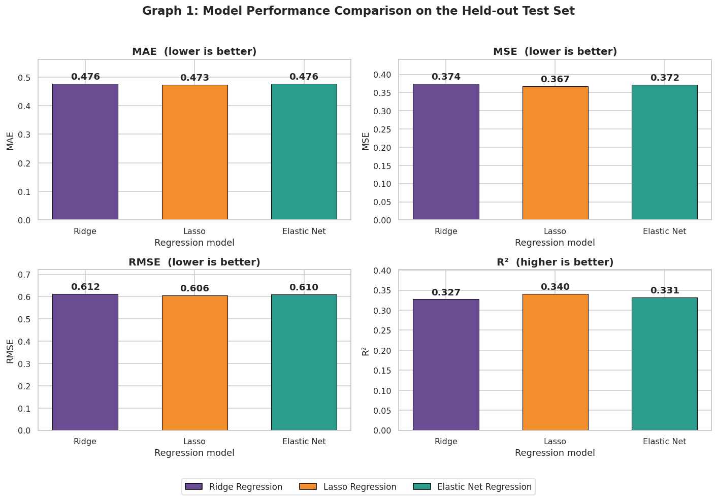
Figure 5.1: Test-set MAE, MSE, RMSE and R² of the three models (Set A)

5.3 Results at the Presentation Hyperparameters (Set B)
Table 5.3: Test-set performance at the hyperparameters stated in the presentation (Set B; best value per metric highlighted)
Model | Hyperparameters | MAE | MSE | RMSE | R²
Ridge | alpha = 50 | 0.4764 | 0.3743 | 0.6118 | 0.3274
Lasso | alpha = 0.01 | 0.4741 | 0.3699 | 0.6082 | 0.3353
Elastic Net | alpha = 0.05, l1_ratio = 0.2 | 0.4753 | 0.3692 | 0.6076 | 0.3366

In Set B, Elastic Net has the highest R² (0.3366, reported as 0.337) and the lowest MSE (0.3692, reported as 0.369) and RMSE (0.6076), while Lasso has the lowest MAE (0.4741, reported as 0.474). Ridge is identical in both sets because the same alpha (50) was selected.

5.4 Comparison of the Two Result Sets
Table 5.4: Best model for each metric under the two sets of hyperparameters
Metric | Set A: best model (value) | Set B: best model (value)
MAE (lower is better) | Lasso (0.4729) | Lasso (0.4741)
MSE (lower is better) | Lasso (0.3672) | Elastic Net (0.3692)
RMSE (lower is better) | Lasso (0.6059) | Elastic Net (0.6076)
R² (higher is better) | Lasso (0.3402) | Elastic Net (0.3366)

The label of the “best” model therefore depends on which hyperparameters are used. This is not surprising, because the models are very close. Three observations support this reading. First, across all six model–setting combinations, test R² lies between 0.327 and 0.340 and test RMSE between 0.606 and 0.612. Second, the cross-validated MSE of the three models differs by only 0.0006 (0.4295 to 0.4301), while the fold-to-fold standard deviation of the cross-validated MSE is about 0.037. Third, the cross-validation ranking (Ridge first) differs from the test ranking (Lasso first in Set A). These differences are small relative to the fold-to-fold variation of the cross-validation scores. No significance test or repeated-split analysis was carried out, so this report does not claim that the models are statistically equivalent; it concludes only that the evidence does not show any one model to be clearly superior. Both sets are therefore reported, and neither is presented as the single headline result.

5.5 Generalization: Training, Cross-Validation and Test Performance
Table 5.5: Training R², cross-validated MSE and test performance (Set A)
Model | Train R² | Best CV MSE | Test MSE | Test R²
Ridge | 0.381 | 0.4295 | 0.3743 | 0.3274
Lasso | 0.377 | 0.4301 | 0.3672 | 0.3402
Elastic Net | 0.380 | 0.4300 | 0.3720 | 0.3315

Training R² (0.377 to 0.381) is only slightly higher than test R² (0.327 to 0.340), and the test MSE is lower than the cross-validated MSE for every model. The models are therefore not strongly overfitted, but all three explain only about 33–38% of the variance, which indicates that the linear relationship between the 11 features and quality is limited. Part of the closeness of training and test scores may also reflect the duplicate records discussed in Section 4.5.

5.6 Robustness Checks
Table 5.6 reports the two robustness checks. In the first, the identical grids were tuned with the StandardScaler inside a Pipeline, so each cross-validation fold is scaled using only its own training portion. In the second, the 125 duplicate rows were removed (leaving 1,018 rows, split into 814 training and 204 test rows) and the same procedure as the main analysis was applied.
Table 5.6: Results of the robustness checks
Variant | Model | Hyperparameters | CV MSE | MAE | RMSE | R²
Main analysis (Set A) | Ridge | α=50 | 0.4295 | 0.476 | 0.612 | 0.327
Main analysis (Set A) | Lasso | α=0.01468 | 0.4301 | 0.473 | 0.606 | 0.340
Main analysis (Set A) | Elastic Net | α=0.05, l1=0.1 | 0.4300 | 0.476 | 0.610 | 0.331
Scaler inside CV (Pipeline) | Ridge | α=50 | 0.4296 | 0.476 | 0.612 | 0.327
Scaler inside CV (Pipeline) | Lasso | α=0.01468 | 0.4302 | 0.473 | 0.606 | 0.340
Scaler inside CV (Pipeline) | Elastic Net | α=0.01, l1=0.1 | 0.4301 | 0.477 | 0.615 | 0.321
Duplicates removed (n = 1018) | Ridge | α=50 | 0.3993 | 0.567 | 0.726 | 0.387
Duplicates removed (n = 1018) | Lasso | α=0.006813 | 0.3990 | 0.565 | 0.724 | 0.390
Duplicates removed (n = 1018) | Elastic Net | α=0.01, l1=0.7 | 0.3990 | 0.565 | 0.724 | 0.390

Placing the scaler inside the cross-validation loop leaves the selected Ridge and Lasso models unchanged (R² 0.327 and 0.340). Elastic Net selects a different alpha (0.01) and its test R² changes from 0.331 to 0.321, a change of about 0.010, which is of the same order as the differences between the models. After removing the duplicates, test R² is higher (0.387 to 0.390) but MAE and RMSE are also higher; this is a different and smaller test set (204 wines), so the values cannot be compared directly with the main analysis. In this variant the three models are again almost indistinguishable (R² 0.387, 0.390, 0.390).

5.7 Feature Coefficient Analysis
Coefficients are expressed on the standardized feature scale: each value is the change in predicted quality for a one-standard-deviation increase in that feature, with the other features held fixed. Table 5.7 lists the coefficients of the Set A models; features are sorted by their average absolute coefficient, and zero coefficients are shown as 0.0000.
Table 5.7: Standardized coefficients of the Set A models (zero = removed by the model)
Feature | Ridge | Lasso | Elastic Net
alcohol | +0.2650 | +0.2969 | +0.2712
volatile acidity | -0.2199 | -0.2199 | -0.2164
sulphates | +0.1551 | +0.1321 | +0.1468
chlorides | -0.0868 | -0.0767 | -0.0834
total sulfur dioxide | -0.0745 | -0.0596 | -0.0656
fixed acidity | +0.0765 | +0.0003 | +0.0536
density | -0.0675 | 0.0000 | -0.0487
pH | -0.0300 | -0.0343 | -0.0275
citric acid | -0.0346 | 0.0000 | -0.0174
free sulfur dioxide | +0.0175 | 0.0000 | +0.0067
residual sugar | +0.0069 | 0.0000 | 0.0000

Ridge keeps all 11 coefficients non-zero. Lasso sets four coefficients exactly to zero (residual sugar, free sulfur dioxide, density and citric acid) and leaves fixed acidity almost at zero (+0.0003). Elastic Net sets one coefficient to zero (residual sugar); its L2 component shrinks correlated coefficients together instead of discarding all but one of them. At the presentation hyperparameters (Set B), Lasso removes two features (residual sugar and free sulfur dioxide) and Elastic Net removes three (citric acid, residual sugar and free sulfur dioxide). The features removed by Lasso are largely those that are strongly correlated with other predictors, so their information is carried by the remaining features. In all three models alcohol has the largest positive coefficient and volatile acidity the largest negative coefficient, followed by sulphates (positive) and chlorides (negative). Coefficient magnitude is only a proxy for influence in a linear model; it is not a causal or independent importance measure, because several chemical features are correlated. Figures 5.4 and 5.5 show the coefficients graphically.

5.8 Summary of Results
- All three regularized models reach a test R² of about 0.33–0.34 (RMSE about 0.61, MAE about 0.47 on a score ranging from 3 to 8).
- With the GridSearchCV-selected hyperparameters (Set A), Lasso is best on all four metrics; with the presentation hyperparameters (Set B), Elastic Net has the best R², MSE and RMSE and Lasso the best MAE.
- The differences between the models are small relative to the fold-to-fold variation of the cross-validation scores and to the effect of small changes in the procedure, so the evidence does not show any model to be clearly superior. No significance test was carried out.
- Alcohol (positive), volatile acidity (negative), sulphates (positive) and chlorides (negative) carry the largest coefficients in all three models.
- Lasso and Elastic Net remove weak or correlated features (up to four for Lasso in Set A), while Ridge keeps all 11 features.
- Predictions are least accurate for the rare lowest and highest quality scores.

5.9 Graphical Analysis (Set A)
The following graphs were produced by the notebook for the GridSearchCV-selected models (Set A) on the 229 test wines. Each graph is shown on its own page so that the labels remain readable.

5.9.1 Actual versus Predicted Quality
Points on the dashed diagonal would be perfect predictions. Because quality is an integer score, the points form vertical stripes. The predictions of all three models stay within a narrower band (about 4.3 to 7.4) than the actual scores (4 to 8): the models pull predictions toward the middle of the quality range.
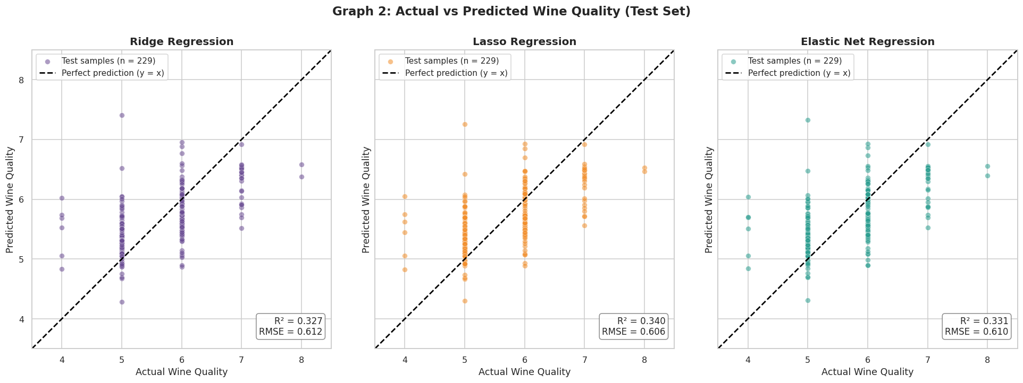
Figure 5.2: Actual versus predicted wine quality on the test set

5.9.2 Residual Distribution
The residual is the actual score minus the predicted score. For all three models the mean residual is −0.007, so the predictions are essentially unbiased on average, and the residual standard deviation is similar for Ridge (0.613), Lasso (0.607) and Elastic Net (0.611).
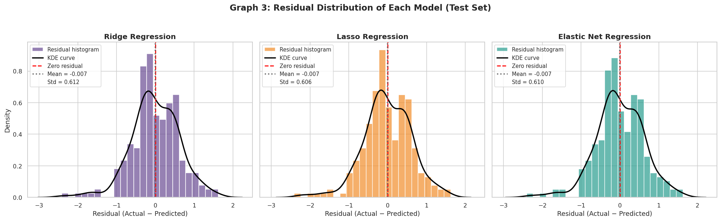
Figure 5.3: Residual distribution of each model on the test set

5.9.3 Coefficient Comparison
Figure 5.4 compares the standardized coefficients of all 11 features across the three models. A missing bar means that the coefficient was shrunk to exactly zero. The coefficients of Ridge, Lasso and Elastic Net have the same sign for most features, and differ mainly in how strongly the weaker features are shrunk.
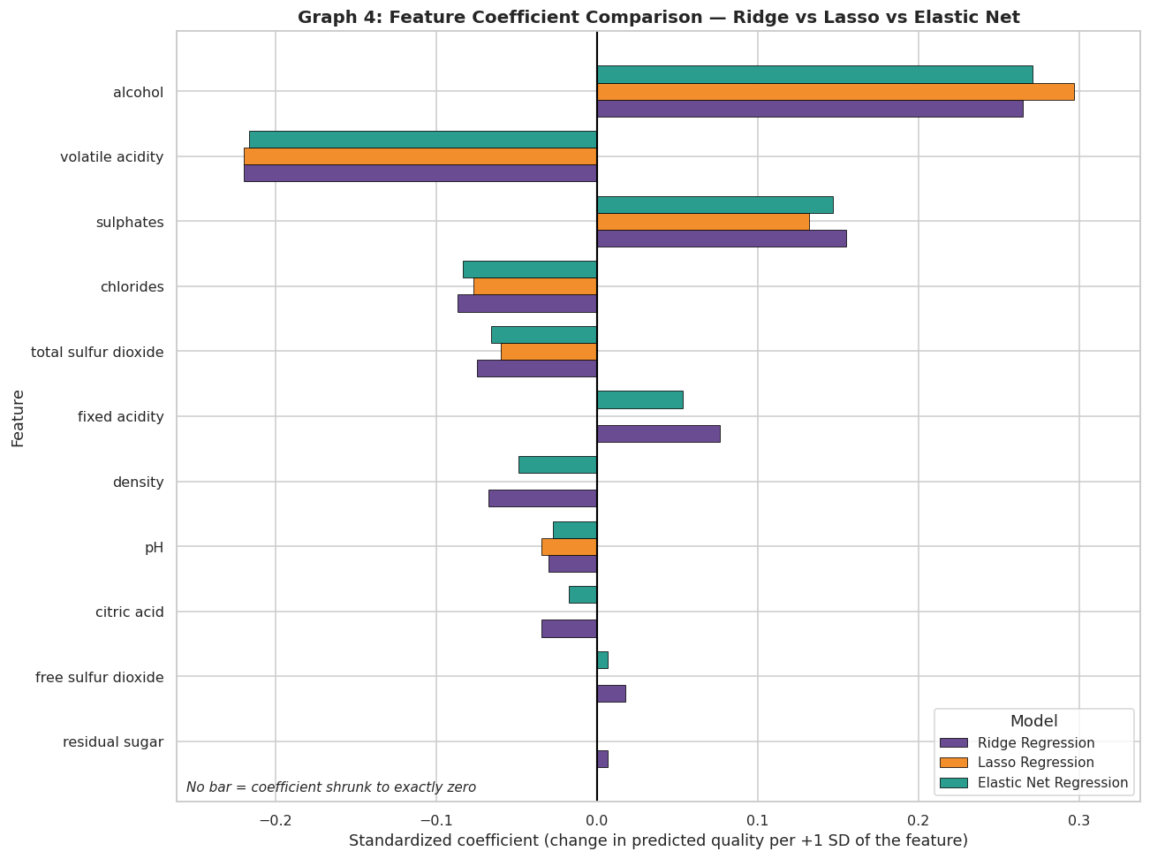
Figure 5.4: Standardized coefficients of Ridge, Lasso and Elastic Net

5.9.4 Features with the Largest Coefficients
Figure 5.5 shows the six features with the largest absolute standardized coefficients in each model. Blue bars raise the predicted quality and red bars lower it. Coefficient magnitude is used as a proxy for influence only, for the reasons given in Section 5.7.
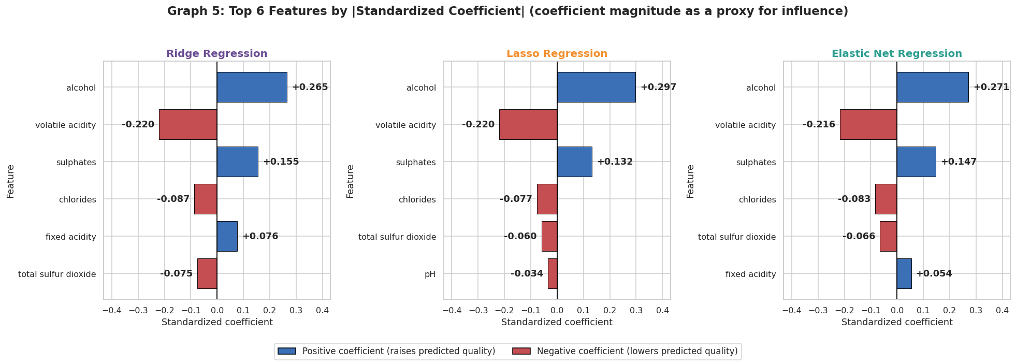
Figure 5.5: Top six features by absolute standardized coefficient for each model

5.9.5 Prediction Error by Quality Level
Figure 5.6 plots the prediction error against the actual quality. For the best-represented levels (5 and 6) the average error is small (about −0.38 and +0.21 for the three models). At the extremes the models systematically over-predict low-quality wines and under-predict high-quality wines: the average error is about −1.5 at quality 4 and about +0.74 at quality 7 and +1.5 at quality 8. The test set contains only 6 wines of quality 4 and 2 of quality 8, so the extreme values are noisy; the pattern is nevertheless consistent with regularized linear models predicting toward the mean of an imbalanced target.
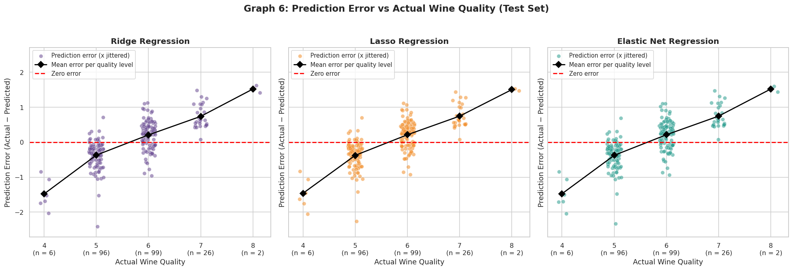
Figure 5.6: Prediction error versus actual quality for each model

CHAPTER 6: CHALLENGES AND LIMITATIONS
This chapter describes the methodological issues that are documented in the project notebook, the way each was handled, and the limitations of the project.

6.1 Issues Faced During Development
- Hidden duplicate records. Because the Id column is unique, a naive duplicate check finds no repeated rows. Ignoring Id reveals 125 duplicates (10.9% of the data), and 43 of the 229 test wines have a feature-identical wine in the training set. This can make test scores optimistic.
- Order of scaling and cross-validation. Fitting the scaler on the training data before GridSearchCV lets each validation fold influence the scaler statistics used during hyperparameter selection.
- Different hyperparameters in the notebook and the presentation. The cross-validation surface is almost flat for small alpha: the five best Lasso candidates differ in cross-validated MSE by only about 0.0003, while the fold-to-fold standard deviation is about 0.037. The alpha that wins therefore depends on which candidates are in the grid, which led to two result sets.
- Different regularization scales. Lasso needs much smaller alpha values than Ridge; a Ridge-style grid would zero out every coefficient. Lasso and Elastic Net also need more iterations to converge than the default.
- Best l1_ratio on the edge of the grid. The Elastic Net l1_ratio selected by GridSearchCV (0.1) is the smallest value in the grid, so the true optimum may lie outside the searched range.
- Correlated features. Several chemical features are strongly correlated (for example fixed acidity with density, pH and citric acid), which makes individual coefficients harder to interpret.
- Imbalanced, discrete target. Scores 5 and 6 make up 82.7% of the data, and scores 3 and 8 are very rare, so the models predict extreme qualities poorly.

6.2 Solutions Applied
- Duplicates: the main analysis keeps all rows for consistency with the presentation; the procedure was repeated on de-duplicated data (Table 5.6) and the duplicate share of the test set was reported (Section 4.5).
- Scaling order: the scaler is fitted on the training data only (so the test set is never used), and the tuning was repeated with the scaler inside a Pipeline. The Ridge and Lasso results did not change, and Elastic Net changed by about 0.010 in R².
- Two result sets: the models were refitted at the presentation hyperparameters and both sets are reported side by side (Sections 5.2 to 5.4); the models are described as very close, with no model shown to be clearly superior.
- Regularization scale and convergence: a log-spaced Lasso grid from 10⁻⁴ to 1 was used, max_iter was set to 20,000, and convergence was checked explicitly (33 and 28 iterations for the selected Lasso and Elastic Net models).
- Grid edge: the edge position of l1_ratio is reported; a wider grid is listed as future work.
- Correlated features and interpretation: coefficients are described as proxies for influence rather than causal importance, and the correlated feature pairs are reported (Section 4.4).
- Imbalanced target: the error by quality level is reported (Figure 5.6) so that the weakness at extreme scores is visible.

6.3 Limitations of the System
- Limited explanatory power. The models explain only about one third of the variance in quality (test R² 0.33–0.34); the average error is about 0.47 quality points.
- Linear models only. Ridge, Lasso and Elastic Net cannot capture non-linear relationships or interactions between features; no non-linear models were compared.
- Single split. Results are based on one 80/20 split with 229 test wines; repeated splits or repeated cross-validation were not used to estimate the variability of the test scores.
- Dataset size, imbalance and duplicates. The dataset has 1,143 records, most of them with quality 5 or 6, and about 11% of the records are duplicates.
- Subjective target. The quality score is a sensory rating, which is subjective, and the models use only physicochemical measurements.
- Association, not causation. Coefficients and correlations describe statistical associations and do not show that changing a feature would change the quality.
- Regression on an ordinal score. Predictions are continuous and were not evaluated as classification of integer quality classes.
- Academic scope. The system is intended for learning and experimental analysis and does not replace laboratory testing or expert wine evaluation. The results apply to the supplied WineQT.csv file.

CHAPTER 7: CONCLUSION AND FUTURE WORK

7.1 Conclusion
This project compared Ridge, Lasso and Elastic Net regression for predicting wine quality from 11 physicochemical features of the WineQT dataset. The workflow covered data checks, exploratory analysis, an 80/20 split, feature scaling fitted on the training data only, cross-validated hyperparameter tuning, and evaluation with MAE, MSE, RMSE and R² on a held-out test set.
The three models performed very similarly. With the hyperparameters selected by GridSearchCV, Lasso was best on all four metrics (R² = 0.340, RMSE = 0.606). With the hyperparameters stated in the project presentation, Elastic Net achieved the best R² (0.337) and MSE (0.369), and Lasso the lowest MAE (0.474). The differences between the models are small relative to the fold-to-fold variation of the cross-validation scores, so no model can be declared clearly superior on this evidence. All three explain roughly one third of the variance in quality, with a typical error of about 0.47 points.
The coefficient analysis shows that higher alcohol and sulphates are associated with higher predicted quality, while higher volatile acidity and chlorides are associated with lower predicted quality. Lasso and Elastic Net remove weak or correlated features, whereas Ridge keeps all of them. The project also showed the importance of careful evaluation: duplicate records, the order of scaling and cross-validation, and the choice of hyperparameter grid all affect how the results should be read.

7.2 Future Work
The following improvements are suggested for future work; none of them has been carried out in this project.
- Remove duplicate records before splitting, and use repeated cross-validation or repeated random splits to report the variability of the test scores.
- Widen the Elastic Net grid (smaller l1_ratio values) and place the scaler inside a Pipeline for all tuning.
- Compare the regularized linear models with non-linear models such as random forests or gradient boosting.
- Treat quality as a classification problem, or use ordinal regression, and evaluate performance on the rare quality levels separately.
- Engineer additional features (for example interactions between alcohol and acidity features) to address the limited explanatory power of linear models.
- Validate the models on other wine datasets to check how well the results generalize.

7.3 Skills Learned During Development
- Loading, inspecting and cleaning tabular data with pandas, and performing exploratory data analysis with Matplotlib and seaborn.
- Understanding L1, L2 and combined regularization, and how they affect coefficients.
- Avoiding data leakage through a train-test split before scaling and by fitting the scaler on training data only.
- Tuning hyperparameters with GridSearchCV and cross-validation, and checking convergence.
- Evaluating regression models with MAE, MSE, RMSE and R², and analysing residuals, errors and coefficients.
- Reporting results honestly, including small differences between models and the limitations of the data.
WEBSITE IMAGES
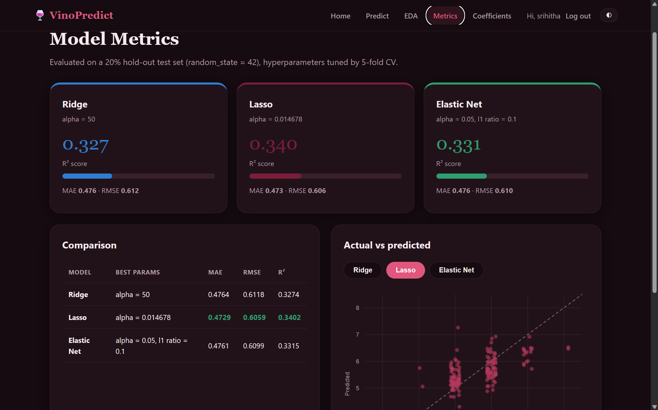

REFERENCES
- P. Cortez, A. Cerdeira, F. Almeida, T. Matos and J. Reis, “Modeling wine preferences by data mining from physicochemical properties,” Decision Support Systems, vol. 47, no. 4, pp. 547–553, 2009.
- UCI Machine Learning Repository, “Wine Quality.” https://archive.ics.uci.edu/dataset/186/wine+quality
- H. Zou and T. Hastie, “Regularization and variable selection via the elastic net,” Journal of the Royal Statistical Society: Series B, vol. 67, no. 2, pp. 301–320, 2005.
- A. E. Hoerl and R. W. Kennard, “Ridge regression: biased estimation for nonorthogonal problems,” Technometrics, vol. 12, no. 1, pp. 55–67, 1970.
- R. Tibshirani, “Regression shrinkage and selection via the lasso,” Journal of the Royal Statistical Society: Series B, vol. 58, no. 1, pp. 267–288, 1996.
- T. Hastie, R. Tibshirani and J. Friedman, The Elements of Statistical Learning: Data Mining, Inference, and Prediction, 2nd ed. New York: Springer, 2009.
- F. Pedregosa et al., “Scikit-learn: Machine learning in Python,” Journal of Machine Learning Research, vol. 12, pp. 2825–2830, 2011.
- W. McKinney, “Data structures for statistical computing in Python,” in Proceedings of the 9th Python in Science Conference, pp. 56–61, 2010.
- C. R. Harris et al., “Array programming with NumPy,” Nature, vol. 585, pp. 357–362, 2020.
- J. D. Hunter, “Matplotlib: A 2D graphics environment,” Computing in Science & Engineering, vol. 9, no. 3, pp. 90–95, 2007.
- M. L. Waskom, “seaborn: statistical data visualization,” Journal of Open Source Software, vol. 6, no. 60, p. 3021, 2021.
- scikit-learn developers, “Linear models” (user guide). https://scikit-learn.org/stable/modules/linear_model.html

