To create an application, you need to enter
- Contacts:
  - First name (input field)
  - Last name (input field)
  - Phone number (input field)
  - E-mail (optional input field)
  - Date of Birth (date selection)
  - Nationality (country dropdown selection)
  - US Citizen (Yes/No dropdown)
  - Participation in politics (Yes/No dropdown, with "Not participating" as one of the options)
- Monthly Volumes:
  - Monthly Turnover (range selection)
  - Number of incoming transactions (range selection)
  - Number of outgoing transactions (range selection)
  - Value of incoming transactions (range selection)
  - Value of outgoing transactions (range selection)
  - Maximum value of incoming payment (range selection)
  - Maximum value of outgoing payment (range selection)
- General Information:
  - Activities of the client
  - Source of Funds
  - Products
  - Delivery channels

After the creation, a pop-up window is displayed informing about the creation of the Questionnaire in the Onboarding section. You can click the button to go directly to the page of the created Questionnaire or go to other actions.
The Questionnaire can be found in the Clients/Onboarding section.

Individual customer page

Overview
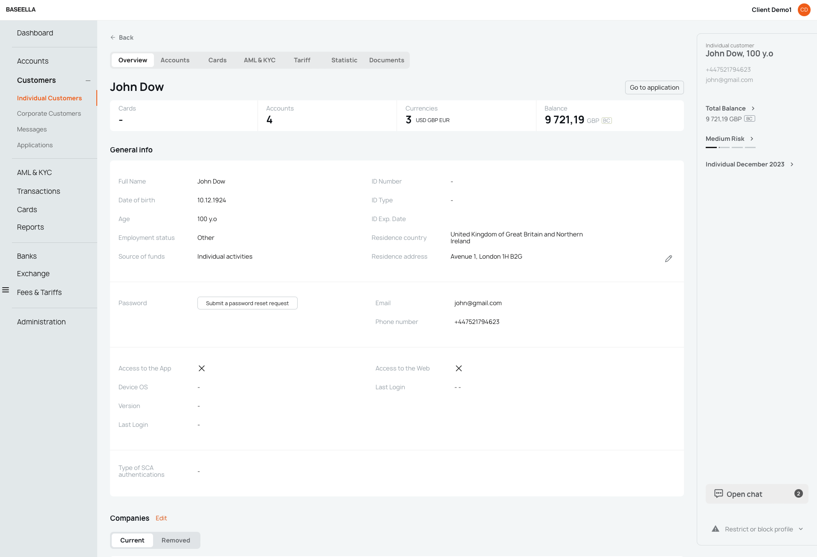

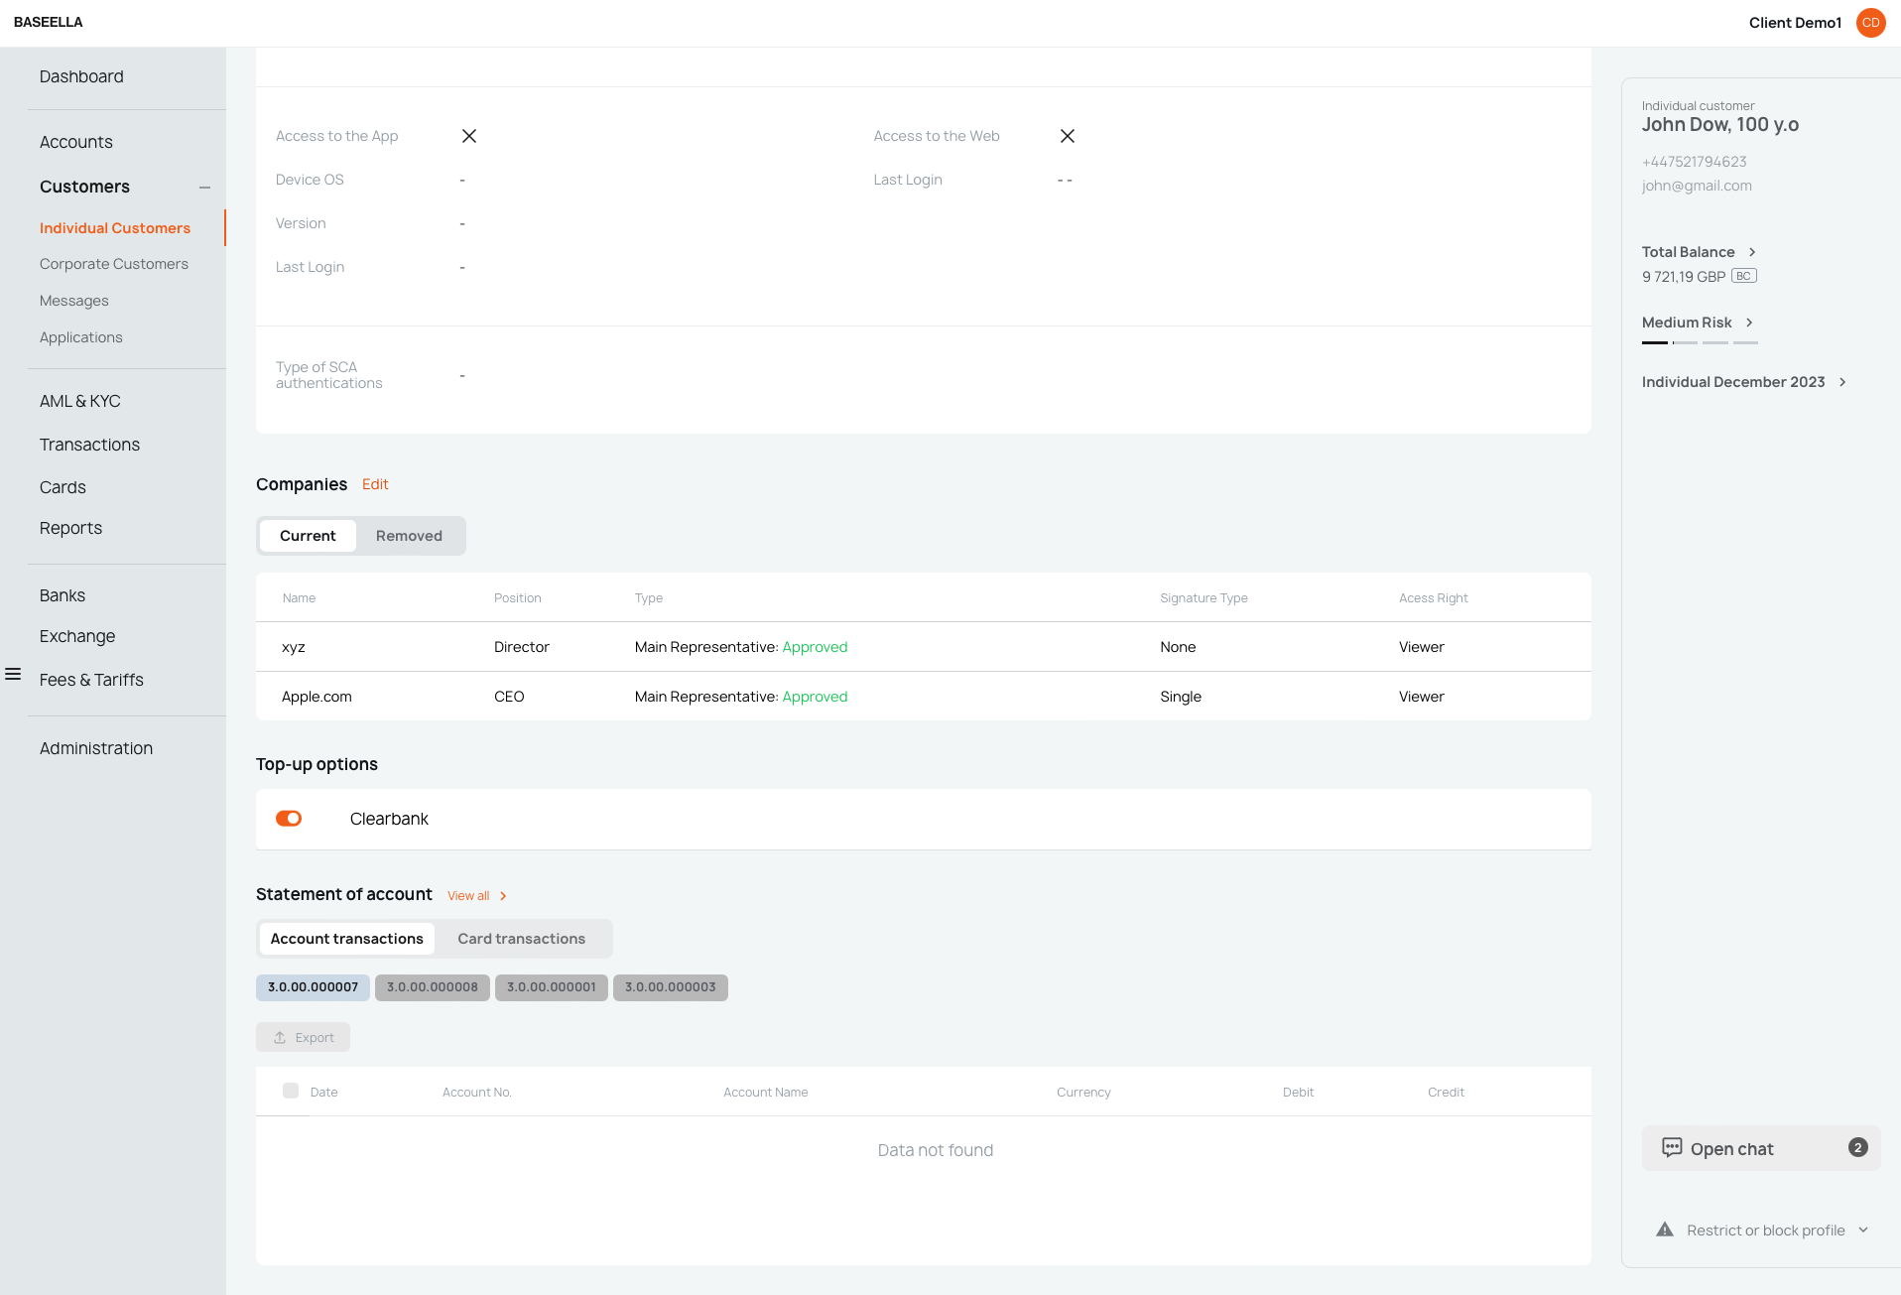

Overview consists of a set of blocks

Overview info

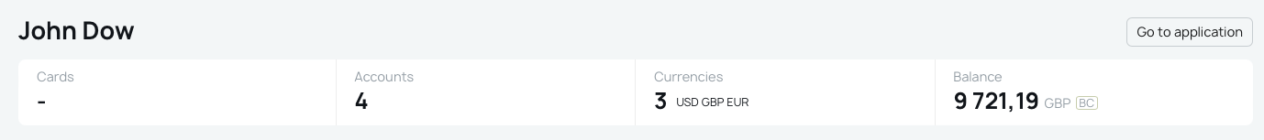

At the top
- Full name
- Go to application button - сlicking this opens the Application from which the client was created.

General data
- Number of cards issued
- Number of opened accounts
- Currencies available to the client
Balance of all accounts and cards in base currency

Corporate Application
