Introduction to Servlets, Spring Framework, and Spring Boot
Converted from the supplied PDF. The original page images are embedded below to preserve diagrams, code screenshots, examples, and formatting.
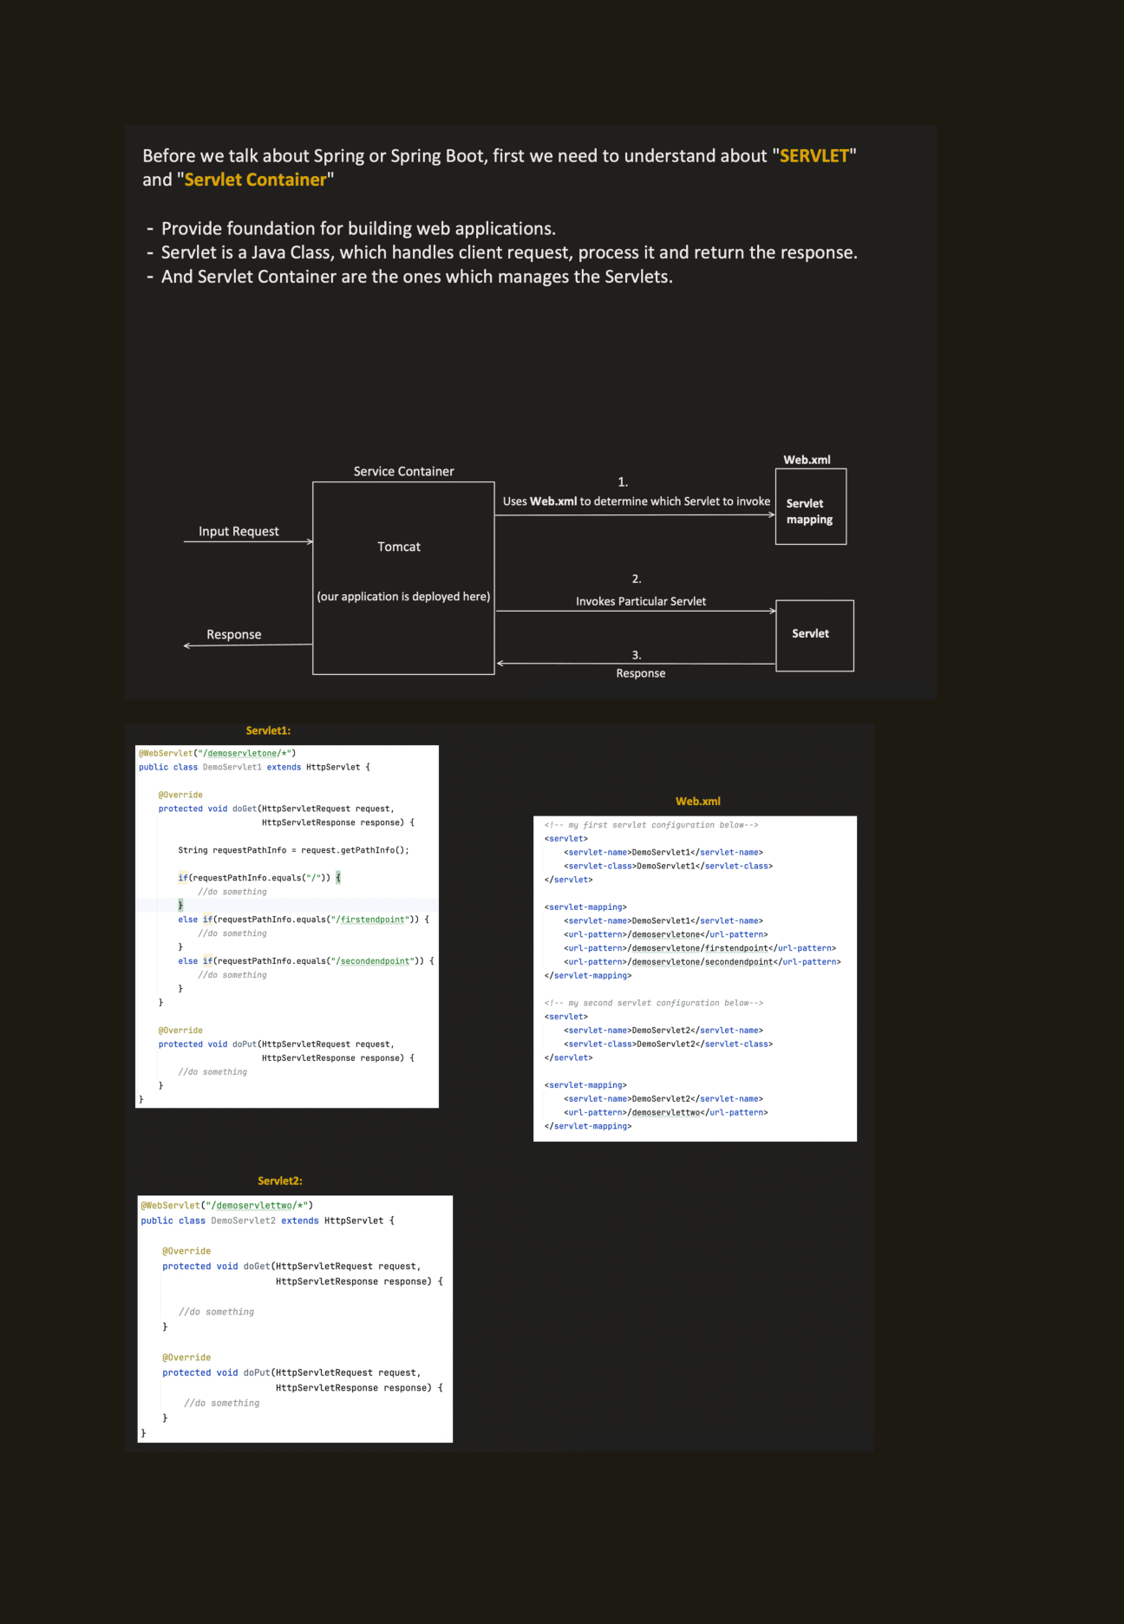

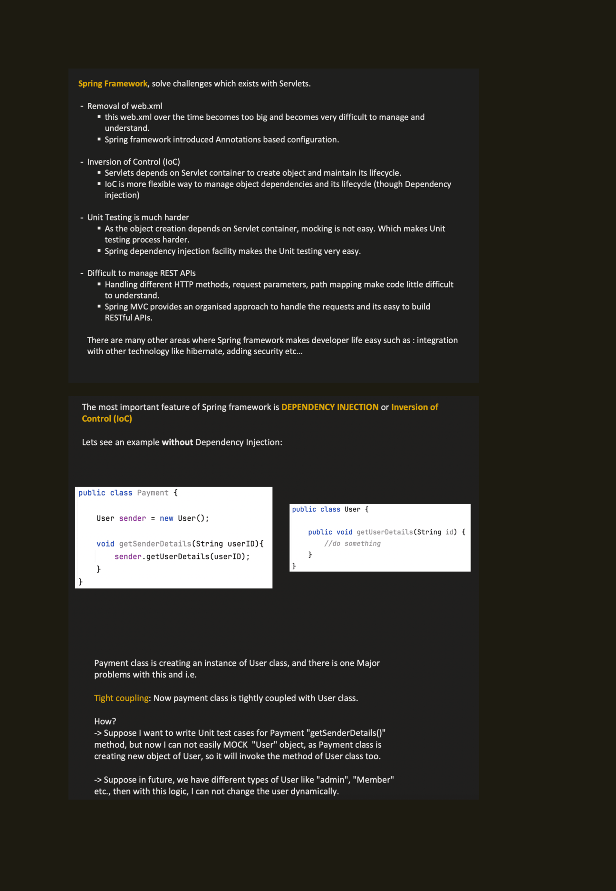

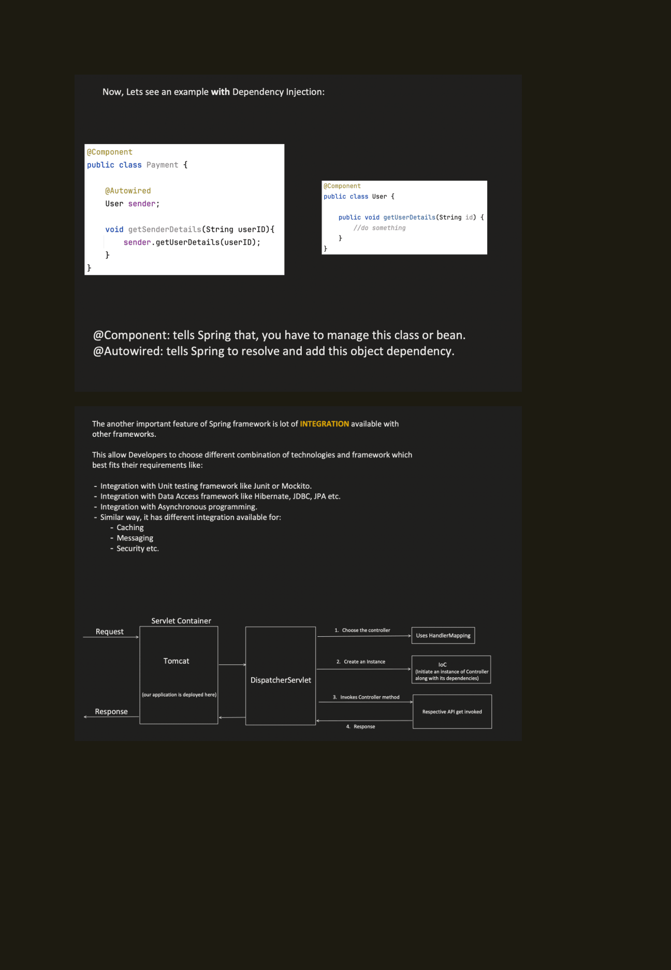

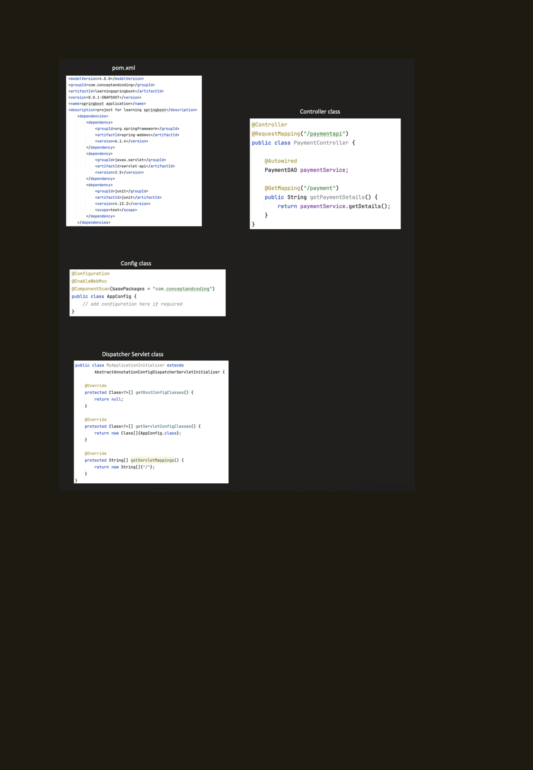

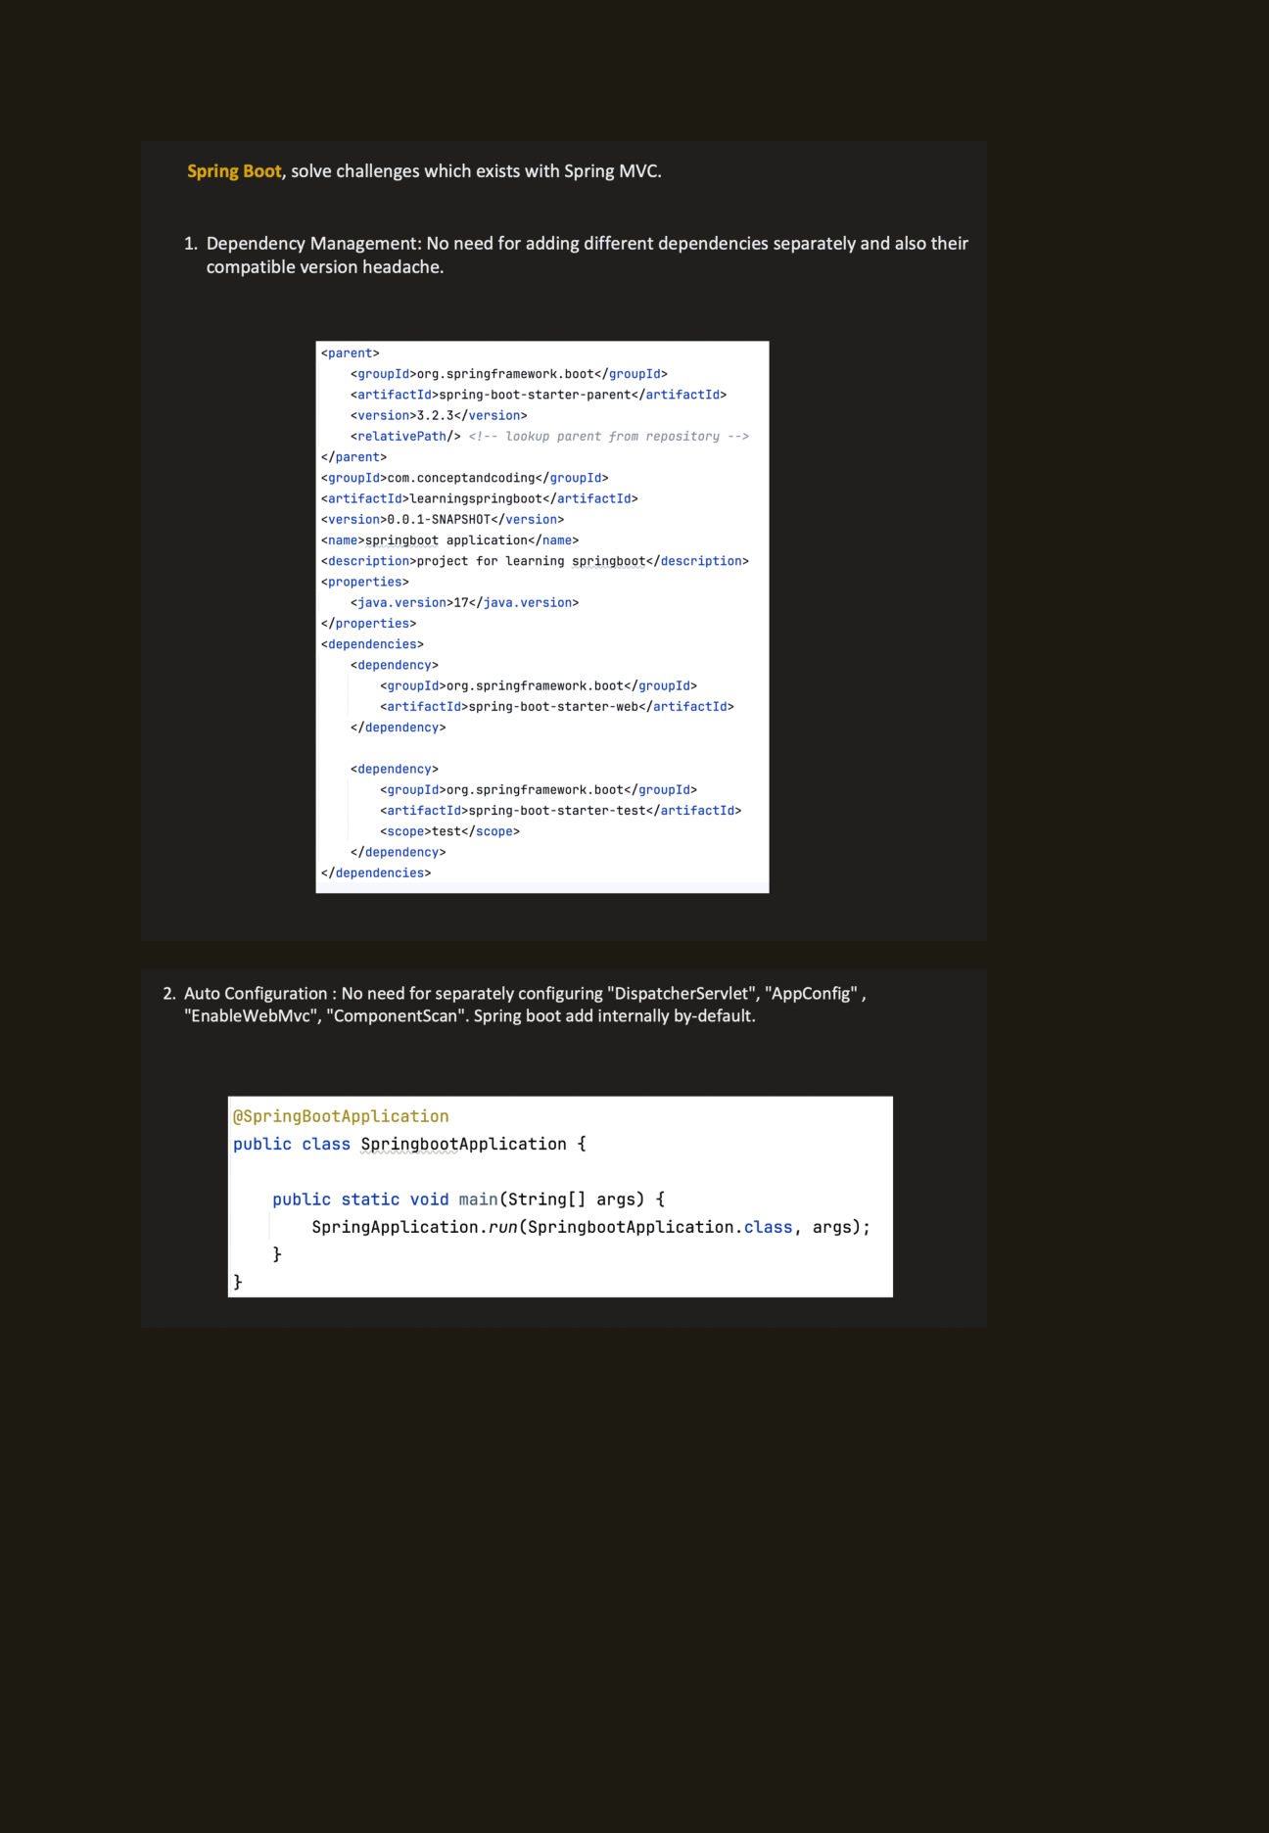

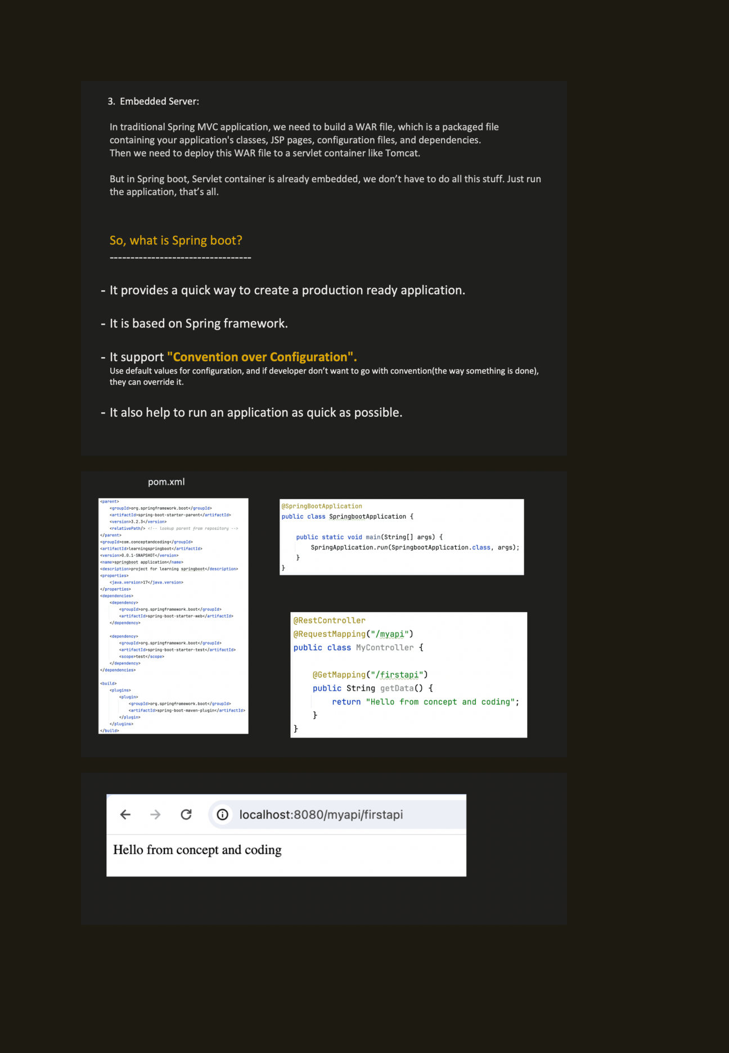

Text Notes (for searching and GitHub documentation)
Page 1 — Servlets and Servlet Container
- Before we talk about Spring or Spring Boot, first we need to understand “Servlet” and “Servlet Container”.
- Servlets provide a foundation for building web applications. A Servlet is a Java class that handles a client request, processes it, and returns a response. A Servlet Container manages the Servlets.
- The diagram shows a request entering the Tomcat Servlet Container. The container uses web.xml to determine which Servlet to invoke, invokes that Servlet, and returns the response.
- The page also includes example code screenshots for Servlet1 and Servlet2, along with web.xml servlet and servlet-mapping configuration.
Page 2 — Problems addressed by the Spring Framework
- The Spring Framework solves challenges that exist with Servlets.
- Removal of web.xml: Over time, web.xml can become too large and difficult to manage and understand. Spring introduced annotation-based configuration.
- Inversion of Control (IoC): Servlets depend on the Servlet Container to create objects and maintain their lifecycle. IoC provides a more flexible way to manage object dependencies and lifecycle through dependency injection.
- Unit testing is harder when object creation depends on the Servlet Container. Spring dependency injection makes unit testing easier.
- Managing REST APIs can be difficult when handling HTTP methods, request parameters, and path mappings. Spring MVC provides an organised approach to requests and makes RESTful APIs easier to build.
- The page introduces Dependency Injection / IoC as a key Spring feature. Its example shows Payment creating a User directly, causing tight coupling and making mocking or changing user types dynamically harder.
Page 3 — Dependency Injection and Spring integration
- The example with Dependency Injection uses @Component on the Payment and User classes and @Autowired to inject the User dependency.
- @Component tells Spring to manage the class as a bean. @Autowired tells Spring to resolve and add the object dependency.
- Spring integrates with other frameworks and technologies, including JUnit or Mockito for testing; Hibernate, JDBC, and JPA for data access; asynchronous programming; caching; messaging; and security.
- The DispatcherServlet diagram shows the request flow: choose the controller using handler mapping, create a controller instance through IoC with its dependencies, invoke the relevant controller method/API, and return a response.
Page 4 — Spring MVC project configuration
- The page contains screenshots of a pom.xml file, a Controller class, a configuration class, and a DispatcherServlet initializer class.
- The Controller screenshot shows a PaymentController with a request mapping and a PaymentDAO dependency. The configuration screenshot shows AppConfig with configuration, web MVC, and component-scan annotations. The initializer screenshot extends AbstractAnnotationConfigDispatcherServletInitializer.
Page 5 — Spring Boot features
- Spring Boot solves challenges that exist with Spring MVC.
- 1. Dependency Management: Dependencies and compatible versions do not need to be managed individually. The pom.xml screenshot shows spring-boot-starter-parent version 3.2.3 and dependencies including spring-boot-starter-web and spring-boot-starter-test.
- 2. Auto Configuration: Separate configuration of DispatcherServlet, AppConfig, EnableWebMvc, and ComponentScan is not required for a typical Spring Boot application; Spring Boot configures these by default.
- The page shows a SpringbootApplication class with a main method that calls SpringApplication.run(SpringbootApplication.class, args).
Page 6 — Embedded server and what Spring Boot is
- 3. Embedded Server: In a traditional Spring MVC application, a WAR file packages application classes, JSP pages, configuration files, and dependencies, and must be deployed to a Servlet Container such as Tomcat. In Spring Boot, the Servlet Container is embedded, so the application can simply be run.
- Spring Boot provides a quick way to create a production-ready application, is based on the Spring Framework, supports “Convention over Configuration”, and helps run an application quickly.
- Convention over Configuration means default configuration values are used, and developers can override them when needed.
- The page includes pom.xml and Spring Boot application/controller code screenshots, plus a browser result at localhost:8080/myapi/firstapi displaying “Hello from concept and coding”.

