# Welcome to the rig fixers catalogue brochure

Rig fixers is dedicated to helping you build a new computer for cheap, we do this by performing a few,cycling deals at a time which are listed on our website

## Deal 1 graphics card

### Product:

Nvidia Geforce GTX 1080

An excellent graphics card capable of running just about any modern generation game or program without issues, an excellent part for any enthusiasts build.

### Price: £200

This is an excellent deal being under half its usual price so act fast for the few days this is available!

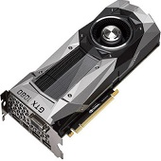

## Deal 2: keyboard

### Product:

Razer black widow elite!

This is an supremely high end keyboard with various custom functions compared to your standard keyboard as well as light up keys, bindable buttons,media controls, ergonomic wrist wrest. This keyboard is an absolute must have for long gaming sessions!

### Price: £99.99

This is over £50 off its standard price making this an excellent offer so get it before its gone!

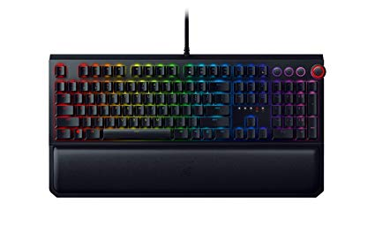

## Deal 3: mouse

## Product:

Corsair scimitar PRO

This great mouse from the reputable Corsair is an excellent choice for any gamer but especially for those embroiled in MMOs with 12 side buttons allowing you to have any function you always need within reach . As well as up to 16000 DPI allowing quick and precise movements, this mouse is also compatible with Xbox systems.

### Price

£40

This is £30 below its standard price making it a wonderful deal. 