Dr. Olivia Samotus, Eng. Mandar Jog MDa-c, Mr. Yanhong Zhu Phd, MBA, MAc

a Department of Applied Radiation and Isotopes Faculty of Science, Kasetsart University, Kamphaengpet 6th Yao Road, Bangkok, Central Thailand, 10900

b Department of Materials Science Faculty of Science, Kamphaengpet 6th Yao Road, Bangkok, Central Thailand, Thailand 10900

c Department of specialized Center of Rubber and Polymer MaterialsFaculty of Science, Kasetsart University, Bangkok, Central Thailand, Thailand 10900

**Corresponding Author**

Mandar Jog

[mandar.jog@abc.com](mailto:mandar.jog@abc.com)

**Abstract**

Background

Symptom re-emergence before re-injection negatively impacts cervical dystonia (CD) patients receiving botulinum toxin type A (BoNT-A) therapy. Confirm plus demo Longer waning time is associated with abobotulinumtoxinA (abo-BoNT-A) as compared to onabotulinumtoxinA (ona-BoNT-A)/incobotulinumtoxinA (inco-BoNT-A) formulations.

Objectives

To compare waning time and treatment outcomes when chronically injected CD patients experiencing early waning despite being optimized on BoNT-A (ona-BoNT-A/inco-BoNT-A) were converted to abo-BoNT-A.

Study methods

Thirty-three chronically injected CD participants with a waning time of ≤ 8 weeks were converted to abo-BoNT-A (1:2.5 dose ratio) for 3 injections every 12-weeks. The 2nd and 3rd injection patterns were kinematically optimized. Participants were converted back to their original BoNT-A for the 4th injection (1:2.5) using the same 3rd abo-BoNT-A pattern. Participant-perceived waning times were collected post-injections. Clinical scales (Toronto Western Spasmodic Torticollis Rating Scale; TWSTRS) and kinematic measures were collected 12-weeks post-injection and at 3 peak effect time-points[12].

Final result

Compared to baseline, waning time (12-22 days) significantly increased following all abo-BoNT-A treatments (*p*<0.005) but was not significantly different at the 4th injection (original BoNT-A reconversion). TWSTRS sub-scores significantly reduced following all abo-BoNT-A treatments (*p*<0.0001) and at peak effect following the 3rd injection compared to original BoNT-A. Dysphagia and muscle weakness were reported and comparable to safety of original BoNT-A formulations.Conclusions

Optimized patients experiencing waning had significant improvement in the peak benefit as well as the duration of effect when converted to abo-BoNT-A. This effect was toxin dependent as reconversion to the original BoNT-A using the kinematically optimized pattern failed to produce an improvement in waning.

**Introduction**

Botulinum toxin type A (BoNT-A) is an effective and safe first-line therapy for cervical dystonia (CD) [1]. However, in a recent patient perspective survey, symptom re-emergence between injections (a mean 10.5 weeks) was reported in 88% of patients with a waning time of ≤ 8 weeks in one-third of patients[2].Waning treatment effects prior to re-injection reduces quality of life as 47% of patients are somewhat satisfied, and 39% were not satisfied with their therapy as symptoms may follow a “yo-yo” pattern[3,4] 45% of patients would prefer a ≤ 10-week treatment cycle due to the short therapeutic response[4]. However, practicality of injecting patients more frequently and concerns about potential immunologically mediated resistance to BoNT-A has resulted in a standard of treating at intervals of at least 12 weeks [5-7]. Thus, a significant unmet need is a long-lasting therapy that delays symptom re-emergence and may improve patient satisfaction and outcomes.

Studies have suggested abobotulinumtoxinA (abo-BoNT-A; Dysport®, Ipsen Pharma Inc., Boulogne-Billancourt, France) may have an extended duration (ranging from 5 to 25 days) compared to the other approved BoNT-A formulations, onabotulinumtoxinA (ona-BoNT-A; Botox®, Allergan Inc., Dublin, Ireland) and incobotulinumtoxinA (inco-BoNT-A; Xeomin®, Merz Pharma GmbH, Frankfurt, Germany)[8,9] Esquenazi *et al* reported 72.6-81.5% of abo-BoNT-A treated CD patients were re-treated ≥16 weeks over 3 open-label cycles. Switching from ona-BoNT-A to abo-BoNT-A (dose ratio of 1:3 or 1:4) increased waning times by 7 to 25 days, respectively, although a higher incidence of dysphagia was reported with abo-BoNT-A.Although, dose ratios (1:2.5 and 1:3) of ona-BoNT-A to abo-BoNT-A are non-inferior from baseline to week 4, [10,11] a similar adverse effect profile was reported with the dose ratio of 1:2.5.

This current study aims to investigate whether abo-BoNT-A has a longer waning time than inco-BoNT-A/ona-BoNT-A formulations by converting CD patients with a waning time of ≤ 8 weeks to abo-BoNT-A using a 1:2.5 ratio. As an optimal selection of muscles and dosages is an important treatment outcome factor,[12] kinematic technology[13] was utilized to optimize injection patterns at the 2nd and 3rd abo-BoNT-A cycles. The 4th injection converted patients back to their original BoNT-A formulation using the same dosing pattern as the 3rd injection. Secondary efficacy endpoints including clinical scales and kinematic measures of CD were collected at all visits.

**Study workflow**

*Study population*

Eligible participants for enrollment in this pilot study were recruited from the London Movement Disorders Centre clinic. Inclusion criteria included adult patients diagnosed with isolated CD, must have received at least 3 serial BoNT-A treatments using the same injection pattern (muscles, dosages and BoNT-A formulation) prior to enrollment, perceived a waning time (the start of wearing off) of ≤ 8 weeks post-injection, wanted to convert to abo-BoNT-A, and were able to give their informed consent to participate. Exclusion criteria included the inability to complete study visits, no interest in switching to abo-BoNT-A formulation, pregnancy, known resistance to any BoNT-A, and known hypersensitivity to BoNT-A or related compounds. This study was approved by the Western University Health Sciences Research Ethics Board (REB# 115308), registered on the ClinicalTrials.gov registry (NCT04270214) and conducted under the provisions of the Declaration of Helsinki.

*BoNT-A treatments*

A total of 4 serial BoNT-A injections every 12-weeks were administered by the expert injector (Dr. Jog) under electromyographic (EMG) guidance (Clavis®, Natus Medical Incorporated, Pleasanton, California, USA) with an 1” long x 30G injectable EMG needle. Muscle targeting using surface landmarking and EMG with proper activation was utilized for all treatments. The same injector had been injecting these patients chronically. The 1st injection applied the same injection pattern (muscles and dosages) from the clinic and converted participants to abo-BoNT-A (a conversion dose ratio of 1 U (ona/inco-BoNT-A): 2.5 U (abo-BoNT-A)). The 2nd and 3rd injections administered abo-BoNT-A and injection patterns were optimized based on kinematic assessments (changes in CD severity) and participant feedback. The 4th injection used the participants’ original BoNT-A formulation from the clinic, requiring a dose conversion (ratio 1: 2.5 U), but the injection pattern used was from the kinematically optimized 3rd injection that used abo-BoNT-A. Peak effect of BoNT-A was collected 4-weeks following the last standard clinic injection (1st study visit), 3rd abo-BoNT-A injection, and 4th original BoNT-A formulation injection. Thus, a total of 7 study visits were completed (4 re-injection visits and 3 peak effect visits).

*Assessments*

The primary endpoint was the waning time, defined as participant perception of treatment effects starting to wear off, that was reported following each injection (last treatment received in the clinic and the 4 injection cycles in the study, totaling 5 waning times). Participants noted the date of waning and called, texted, or emailed the research coordinator (RC). Alternatively, if the RC did not hear from the participant, the RC contacted participants at the 8-week mark. The secondary efficacy endpoints were clinical scores, Toronto Western Spasmodic Torticollis Rating Scale (TWSTRS), and kinematic assessment of dystonic neck movements (tonic/static deviation and dynamic tremulous movements in each degree of freedom (DOF; vertical (up/down), lateral (left/right) and rotational (left/right)) as described previously. Clinical and kinematic measures were collected by the RC at all 7 study visits.

The RC attached a goniometer and a torsiometer (W180 and Z180, Biometrics Ltd., Newport, United Kingdom) to the back of each participant’s head at the inion and at the spinal segments C5-C6 using Velcro straps were utilized to capture dystonic neck/head movements. Kinematic assessment tasks involved participants to be at rest, seated and were instructed to not suppress their dystonic movements. Participants performed eyes open (10 seconds) and eyes closed (1-minute) tasks over 4-trials. Two calibration tasks were conducted, where the assessor held the participant’s head in neutral position. Raw data was captured using DataLITE sensor acquisition software (PC software version 8.7, Biometrics Ltd., Newport, United Kingdom) and analyzed using a custom algorithm written in MatLab® (R2014b, MathWorks, Natick, MA, USA) software. Documentation of any treatment-related side effects and notable changes were conducted at each visit by the RC.

*Statistical analysis*

A repeated measures analysis of variance (ANOVA) with Bonferroni corrections (SPSS® version 21.0, IBM, Armonk, NY, USA) was utilized to determine statistically significant (*p* < 0.05) changes in waning time, TWSTRS total score and sub-scores (I-III), mean tonic deviation (degrees from neutral head position per DOF) and dynamic tremulous movements (root mean square (RMS) degrees per DOF) between re-injection and peak BoNT-A effect time-points. Collected data was summarized by mean, standard deviation (SD), and median.

**Analysis outcome**

*Demographics*

Twenty-seven out of the consented 33 study participants (mean age of 59 ±12 years, 5 males and 22 females) with a mean disease duration of 12 ± 8 years (median: 11 years) completed this study. Thirteen (48%), 9 (33%) and 5 (19%) participants had tremor dominant (no tonic deviations), tonic deviation dominant (no tremor), and complex (mix of both tonic deviation and dynamic dystonia) CD phenotypes, respectively. Twenty-one (78%) and 6 (22%) participants received ona-BoNT-A or inco-BoNT-A, respectively, in the clinic, prior to study initiation.

*Waning time*

Waning time significantly increased by 26% (57±16 days; median: 61.5 days; *p* = 0.01, [95% CI -21.7, -2.2]), 37% (63±12 days;median: 63 days; *p* < 0.005, [95% CI -25.1, -10.0]), 49% (68±19 days; median: 68 days; *p* < 0.005, [95% CI -33.3, -11.7]) following the 1st, 2nd and 3rd abo-BoNT-A treatments, respectively, compared to the waning time of the original BoNT-A from clinic (45±12 days; median: 47 days) The waning time following the 4th injection (conversion back to original BoNT-A using the 3rd abo-BoNT-A injection pattern) was statistically comparable to the waning time from clinic (41±14 days; median: 38.5 days).

*Efficacy endpoints*

Mean TWSTRS total score significantly reduced by a mean of 29% (28±12 TWSTRS points; median: 28 points; *p* < 0.001, [95% CI 8.4, 19.9]) 12-weeks following all 3 abo-BoNT-A treatments compared to 12-weeks following the last clinic treatment (40±8 points; median: 40.8 points). Mean TWSTRS sub-scores for motor severity (part I), disability (part II), and pain (part III) were significantly reduced by a mean of 27% (11.9±4.7 TWSTRS points, median: 11.3 points; *p* < 0.0001, [95% CI 3.1, 7.7]), 38% (7.1±4.6 points, median: 7.7 points; *p* < 0.0001, [95% CI 2.5, 7.0]), and 25% (9.2±4.5 points, median: 9.3 points; *p* = 0.001, [95% CI 1.4, 6.3]) 12-weeks following the 1st, 2nd and 3rd abo-BoNT-A treatments compared to 12-weeks following the last clinic treatment (I: 16.2±4.4 TWSTRS points; median: 15.0 points, II: 11.5±4.0 points; median: 11.0 points, III: 12.3±3.6 points; median: 12.5 points), respectively (Figure 2a). Mean TWSTRS part I, II and III sub-scores were significantly reduced by a mean of 42% (6.1±4.8 points, median: 5.6 points; *p=* 0.005, [95% CI 0.99, 6.4]) at the peak effect of abo-BoNT-A compared to the peak effect following the last clinic treatment (10.5±3.7 points, median: 10.9 points) (Figure 2b). Mean TWSTRS part I and II sub-scores were significantly reduced by a mean of 35% (5.9±4.6 points; median: 6.0 points, *p=* 0.04, [95% CI 0.1, 5.8]) at peak abo-BoNT-A compared to the optimized, original BoNT-A 4th treatment (9.0±4.8 points; median: 9.5 points). Mean TWSTRS part I was significantly reduced by a mean of 20% (10.4±4.9 points; median: 11.0 points, *p=* 0.019, [95% CI 0.4, 5.1]) at peak effect following the optimized original BoNT-A compared to following the peak effect of the last clinic injection (13.0±4.0 points; median: 14.0 points).

Figure 1 Seventeen out of the 27 participants had tremulous/dystonic movements in at least 1 DOF. Mean rotational tremulous severity was significantly reduced by a mean of 43% (0.4±0.4 RMS degrees; median: 0.3 RMS degrees, *p=* 0.041, [95% CI 0.007, 0.46]) 12-weeks following the 1st abo-BoNT-A treatment compared to the original BoNT-A (0.7±0.7 RMS degrees; median: 0.31 RMS degrees) (Figure 3a). Mean vertical tremulous severity was significantly reduced by a mean of 50% (0.2±0.1 RMS degrees; median: 0.1 RMS degrees, *p=* 0.037, [95% CI 0.017, 0.638]) 12-weeks following the 3rd abo-BoNT-A treatment compared to the original BoNT-A (0.3±0.3 RMS degrees; median: 0.14 RMS degrees). Mean rotational tremulous severity was significantly reduced by a mean of 50% (0.3±0.4 RMS degrees, median: 0.17 RMS degrees, *p=* 0.04, [95% CI 0.018, 0.550]) at the peak effect of the 3rd abo-BoNT-A treatment and at the optimized original BoNT-A (0.3±0.4 RMS degrees, median: 0.24 RMS degrees) compared to the peak effect of the last clinic treatment (0.7±0.9 RMS degrees, median: 0.3 RMS degrees) (Figure 3b). No significant changes in lateral tremulous severity between the re-injection time-points or between the peak BoNT-A timepoints was observed.

Eighteen out of the 27 participants had tonic deviation in at least 1 DOF. A mean 49% of participants experienced alleviation of tonic deviation (head posturing) in all DOFs by the 3rd abo-BoNT-A injection compared to 8% of participants following the original BoNT-A (last clinic treatment) (Figure 3c). A mean 68% of participants experienced head posturing and returned to neutral at peak effect of the 3rd abo-BoNT-A treatment compared to a mean 23% and 40% of participants at peak effect of the last clinic and reconversion using the original BoNT-A, respectively (Figure 3d).

*BoNT-A treatments*

Table 1 Mean total dose of BoNT-A was significantly increased by a mean of 19% to 585±229 abo-BoNT-A U at the 2nd and 3rd abo-BoNT-A injections compared to the total dose from the clinic (492±191 abo-BoNT-A U converted from 197±77 ona/inco-BoNT-A U). At the 2nd abo-BoNT-A injection cycle, 20 out of 27 (74%) participants required a dose increase, 4 (14%) participants required no change, and 3 (11%) participants required a dose decrease[15]. At the 3rd abo-BoNT-A injection, 11 (41%) required a dose increase, 10 (37%) required no change, 6 (22%) required a dose decrease. Following the 3rd abo-BoNT-A, two participants required to wait an extra 4 weeks before receiving their next injection due to continued benefit. Total abo-BoNT-A dose at the 1st and at the optimized 3rd treatment cycles for each participant are summarized.

The most injected muscles included splenius capitis (81%), sternocleidomastoid (SCM) (70%), descending trapezius (55%), and levator scapulae (37%) using a mean dose of 119.0±52.8 U (range: 37.5 – 237.5 U), 101.7±41.7 U (range: 50 – 175 U), 102.2±49.3 U (range: 37.5 – 225 U), and 93.7±36.6 U (range: 50 – 175 U), respectively. Bilateral injection of the obliquus capitis inferior (OCI) muscle was included for a total of 8 (30%) participants presenting with a rotational caput tremor at a mean dose of 61.7±12.9 U (range: 50 – 75 U). The individual injection patterns of the 1st abo-BoNT-A and the optimized 3rd abo-BoNT-A treatment cycles are summarized in supplementary material (Table 2 ).

Following the completion of this study, 26 out of the 27 participants chose to continue receiving abo-BoNT-A therapy in the clinic. The reasons for continuing with abo-BoNT-A included a faster speed of onset (n=8; 31%), perceived better relief of CD symptoms (n=25; 96%), increased waning time (n=25; 96%), and gradual wear-off (n=6; 23%) compared to their original BoNT-A. One of the 27 participants continued to receive their original BoNT-A (ona-BoNT-A) in the clinic due to perceiving increased pain with abo-BoNT-A injections.

*Safety data*

Incidence of adverse events were statistically similar following the last clinic injection and the 4 study injections, displayed in (Table 2). Dysphagia and Figures 3-6 and 7 muscle weakness were the two most common adverse events across BoNT-A formulations. To minimize the likelihood of dysphagia, a decrease in the SCM dose and/or reconstitution concentration (e.g. double concentration) was Figure 7-9 applied. Concentration of reconstituted BoNT-A was changed from single (1:1; 25 U per 0.1 ml) to double (1:2; 50 U per 0.1 ml) concentration in 3 participants following the 1st injection, 1 participant following the 2nd injection, and 3 participants following the 3rd injection. Five of the 33 consented participants, with a history of dysphagia with their original BoNT-A, had worsened dysphagia following the 1st (n=3) and 2nd injection (n=2) and withdrew. Of the 5 participants who withdrew due to worsened dysphagia, waning time increased by 24 days (n =1), decreased by 15 days (n = 1), and was not measured for 3 participants. One of the 33 participants died unrelated to the treatment.

**Discussion**

This is the first known study to demonstrate abo-BoNT-A therapy in chronically injected CD patients has a significantly longer waning time (+12 – 22 days) compared to the patients’ original BoNT-A formulation (ona-BoNT-A/inco-BoNT-A) waning time of ≤ 8 weeks. Waning time continued to increase following the optimization of dosing patterns at the 2nd and 3rd abo-BoNT-A treatment cycles. As Supplementary figure 10 optimization involves changing dosages and the muscles injected and aims to improve treatment outcomes, it was necessary to convert patients back to their original BoNT-A formulation using the same optimized dose and injection pattern from the 3rd Abo-BoNT-A treatment. Following the Supplementary fig 11 conversion back to patient’s original BoNT-A and using the same ratio as the original conversion, waning time did not remain significantly increased and was statistically comparable to the duration of the patient’s original BoNT-A from the clinic, regardless of the optimized injection parameters. This suggests that abo-BoNT-A formulation and not the optimization of the injection patterns was responsible for increasing the duration of treatment effects when compared to ona-BoNT-A/inco-BoNT-A formulations. These results correspond with past open-label studies reporting mean time to retreatment was at 16 weeks and in a double-blind, placebo-controlled study reporting 72.6-81.5% of patients requiring retreatment at ≥ week 16 and 42.7-47.8% requiring retreatment at ≥ week 20.

Increases in waning time (duration of effect) was (Supplementary table 8). comparable to previously reported studies that used conversion ratios of 1:3 and 1:4,however a lower conversion ratio of 1:2.5 was utilized in our study. A dose ratio of 1:2.5 has been proposed to be optimal (less than 1:3) as previous reports of the efficacy and frequency of adverse events are similar between BoNT-A formulations and the 1:2.5 ratio may be more appropriate for CD therapy to minimize the likelihood of dose-related adverse events.[15]. Dose conversion ratios higher than 1:2.5 have been associated Supplementary Table 9 with a higher incidence of adverse events[16, 17], such as dysphagia, where a range of 120 to 300 U of abo-BoNT-A were injected into the splenius capitis and SCM muscle groups. In our study, the dosages injected into these muscle groups ranged no higher than 225 U and averaged ~ 100 U with similar incidence in dysphagia between BoNT-A formulations being reported (Table 2). Furthermore, the addition of the OCI muscles and reducing the SCM dose may be a novel approach to reduce the likelihood of dysphagia for patients presenting with caput tremulous CD. Newly targeting the OCI muscles in 8 participants may have contributed to the significant reduction in rotational tremulous activity reported at the peak effect of abo-BoNT-A and at the conversion back to original BoNT-A when compared to the clinic injection (original BoNT-A) (Figure 3b).

Treatment outcomes, severity of CD and disability associated with CD was significantly reduced following each abo-BoNT-A treatment cycle (12-weeks) and at peak effect of abo-BoNT-A when compared to the original BoNT-A effects (from clinic and conversion back cycles). Our results differ from a past study that reported non inferiority at week 4 between abo-BoNT-A and ona-BoNT-A with a 1:2.5 conversion ratio. Ranoux *et al* reported abo-BoNT-A therapy using conversion ratios of 1:3 and 1:4 was significantly tables 3-6 and 7 smore effective than ona-BoNT-A. Rystedt *et al* also reported 1:1.7 and 1:3 conversion ratios were not significantly different at week 4, but the 1:3 ratio produced a significantly better effect at week 12. [18] This suggests that a vial of Abo-BoNT-A (500 U) corresponds to 2 vials of ona-BoNT-A/inco-BoNT-A (200 U) for optimal dosing in CD and is relatively easy to accomplish in clinical practice.

Observational and randomized controlled blinded studies have shown that longer and consistent treatment effects are associated with higher patient satisfaction[19]. While our study did not formally measure patient satisfaction, 26 of the 27 participants who completed this study chose to continue to receive abo-BoNT-A therapy in the clinic. These improvements in waning time and outcomes suggest BoNT-A-naïve patients or patients with suboptimal benefit and/or shorter waning times may benefit from switching to abo-BoNT-A therapy[20].

The results of this study were limited by the lack of blinding of the BoNT-A formulation being administered. The decision to not blind the participants may have introduced a placebo effect. This may be mitigated to some extent by the reconversion to the original formulation. For future studies, patients may be blinded to control for possible placebo effects and include measures of patient satisfaction to associate with suggested longer waning times. As 2 participants waited an extra 4 weeks before their 4th injection due to continued benefit at week 12, flexible injection intervals may be considered for future trials.

This study shows that waning off early remains an issue even in patients that are optimized by an expert injector. Switching to another toxin is generally not considered as an option considering that all toxins are BoNT-A. However, the results of this study show that conversion to abo-BoNT-A improves the quality and duration of the effect and therefore should be considered as an important tool for improvement of patient quality of life. Reconversion to the prior toxin reverses this benefit, resulting in the majority of patients wanting to remain on abo-BoNT-A.

**Acknowledgement**

We would like to acknowledge the contribution by the participants who assisted in this project at the National Parkinson Foundation Centre of Excellence, London Movement Disorders Centre located in London, Ontario, Canada.

**Author contribution**

Research Project: A. Conception, B. Organization, C. Execution; (2) Statistical Analysis: A. Design, B. Execution, C. Review and Critique; (3) Manuscript: A. Writing of the first draft, B. Review and Critique.

OS: 1A, 1B, 1C, 2A, 2B, 2C, 3A

MJ: 1A, 1B, 1C, 2C, 3A, 3B

**Ethics approval and consent to participate**

The authors confirm that the approval of an Institutional Review Board was required for this work. Informed written consent was obtained from all patients. We confirm that we have read the journal’s position on issues involved in ethical publication and affirm that this work is consistent with those guidelines.

**Funding**

This study was partially funded by a research grant from Ipsen Biopharmaceuticals Canada Inc.

**Conflict of interest**

Jog is a scientific advisor and receives research financial support from the following companies: AbbVie, Allergan Inc., Boston Scientific, Ipsen, MDDT Inc., Medtronic, Merz Pharma, Novartis, and Teva Pharmaceuticals. In addition, Jog has two patents PCT/CA2013/000804 and PCT/CA2014/050893 pending that are assigned to MDDT Inc. Jog is a shareholder of MDDT Inc. MDDT Inc. has contract agreements with both Merz Pharma and Allergan on the commercial applications of TremorTek™ and Hinge Diagnostics™. Samotus reports no conflict of interests during the conduct of the study and during the original writing and editing of the manuscript. Samotus collected and analyzed the study data and co-wrote the manuscript as a researcher at the London Movement Disorders Centre – London Health Sciences Centre prior to joining Ipsen Biopharmaceuticals Canada Inc. Samotus is currently an Ipsen Biopharmaceuticals Canada employee. Jog and Samotus report no financial disclosures.

**Data availability statement**

All the data generated and used during the study is provided in the manuscript file.

**References**

1. Oral A. Is Botulinum Toxin Type A Efficacious, Safe, and Tolerable in Cervical Dystonia?: A Cochrane Review Summary With Commentary. *Am J Phys Med Rehabil* 2020;99(7):649-651.
2. Comella C, Ferreira JJ, Pain E, Azoulai M, Om S. Patient perspectives on the therapeutic profile of botulinum neurotoxin type A in cervical dystonia. *J Neurol*. 2021;268(3):903-912.
3. Jinnah HA, Comella CL, Perlmutter J, Lungu C, Hallett M, Investigators Dystonia Coalition. Longitudinal studies of botulinum toxin in cervical dystonia: why do patients discontinue therapy? *Toxicon* 2017;S0041-0101(17)30277-5.
4. Sethi KD, Rodriguez R, Olayinka B. Satisfaction with botulinum toxin treatment: a cross-sectional survey of patients with cervical dystonia. *J Med Econ* 2012;15(3):419-423.
5. Swope D, Barbano R. Treatment recommendations and practical applications of botulinum toxin treatment of cervical dystonia. *Neurol Clin* 2008;26(1 Suppl):54-65.
6. Colosimo C, Charles D, Misra VP, Maisonobe P, Om S. How satisfied are cervical dystonia patients after 3 years of botulinum toxin type A treatment? Results from a prospective, long- term observational study. *J Neurol* 2019;266(12):3038–3046.
7. Esquenazi A, Delgado MR, Hauser RA, Picaut P, Foster K, Lysandropoulos A, Gracies JM. Duration of Symptom Relief Between Injections for AbobotulinumtoxinA (Dysport®) in Spastic Paresis and Cervical Dystonia: Comparison of Evidence From Clinical Studies. *Front Neurol* 2020;11:576117.
8. Fasano A, Paramanandam V, Jog M. Use of AbobotulinumtoxinA in Adults with Cervical Dystonia: A Systematic Literature Review. *Toxins (Basel)* 2020;12(8):470.
9. Ranoux D, Gury C, Fondarai J, Mas JL, Zuber M. Respective potencies of Botox and Dysport: a double blind, randomised, crossover study in cervical dystonia. *J Neurol Neurosurg Psychiatry* 2002;72(4):459-62.
10. Yun JY, Kim JW, Kim HT, et al. Dysport and Botox at a ratio of 2.5:1 units in cervical dystonia: A double-blind, randomized study. *Mov Disord* 2015;30:206–213.
11. Jinnah HA, Goodmann E, Rosen AR, Evatt M, Freeman A, Factor S. Botulinum toxin treatment failures in cervical dystonia: causes, management, and outcomes. *J Neurol* 2016;263:1188–1194.
12. Contarino MF, Smit M, Van den Dool J, Volkmann J, Tijssen MAJ. Unmet needs in the management of cervical dystonia. *Front Neurol* 2016;7(165):1–7.
13. Samotus O, Lee J, Jog M. Personalized botulinum toxin type A therapy for cervical dystonia based on kinematic guidance. *J Neurol* 2018;265(6):1269-1278.
14. Trosch RM, Misra VP, Maisonobe P, Om S. Impact of abobotulinumtoxinA on the clinical features of cervical dystonia in routine practice. *Clin Parkin Relat Disord* 2020;3:100063.
15. Poewe W. (2002). Respective potencies of Botox and Dysport: a double blind, randomised, crossover study in cervical dystonia. Journal of neurology, neurosurgery, and psychiatry, 72(4), 430.
16. Wohlfarth, K., Sycha, T., Ranoux, D., Naver, H., & Caird, D. (2009). Dose equivalence of two commercial preparations of botulinum neurotoxin type A: time for a reassessment?. Current medical research and opinion 2009;25(7), 1573–1584.
17. Pandey, S., Kreisler, A., Drużdż, A., et al. Tremor in idiopathic cervical dystonia – possible implications for botulinum toxin treatment considering the col-cap classification. Tremor and Other Hyperkinetic Movements. 2020;10(1):13, pp. 1–8.
18. Rystedt A, Zetterberg L, Burman J, et al. A comparison of Botox 100 u/mL and Dysport 100 u/mL using dose conversion ratio 1: 3 and 1: 1.7 in the treatment of cervical dystonia: a double blind, randomized, crossover trial. *Clin Neuropharmacol* 2015;38:170-176.
19. Trosch, RM., Espay, AJ., Truong, D., et al. Multicenter observational study of abobotulinumtoxinA neurotoxin in cervical dystonia: The ANCHOR-CD registry. *J Neurol Sci* 2017;376:84-90.
20. Colosimo, C., Charles, D., Misra, VP., Maisonobe, P., Om, S., on behalf of the INTEREST IN CD2 study group. Cumulative effects of long-term treatment with abobotulinumtoxinA in cervical dystonia: Findings from a prospective, observational study. *J Neurol Sci* 2020;416:117015.

**Author Biography**

**Olivia Samotus** received her Bachelor’s degree from Nanjing University of Science and Technology (2017). She is currently a Ph.D. student in London Health Sciences Centre – Lawson Health Research Institute. Her research interest focuses on cervical dystonia.



**Legends:**

**Figure 1**. **Mean waning time following the last clinic injection (“Original BoNT-A”), the 3 abo-BoNT-A treatments and the conversion back to the original BoNT-A using the same 3rd abo-BoNT-A treatment pattern with a dose conversion ratio of 1:2.5 U (“Optimized Original BoNT-A”) are plotted.** The 1st abo-BoNT-A treatment pattern was converted using a dose ratio of 1:2.5 U from the “Original BoNT-A”. Asterisks (*) represent statistically significant differences between the time-points denoted by horizontal bars, error bars represent standard deviation.

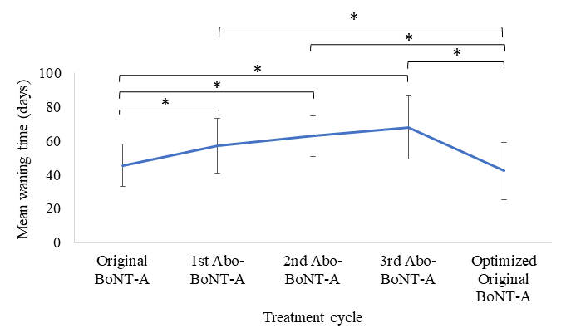

**Figure 2**. **Mean changes in TWSTRS sub-scores 12-weeks following each injection (a) and at the peak effect (b) are displayed.** TWSTRS part I, II and III represent sub-scores for CD severity, disability and pain associated with CD, respectively. Asterisks (*) represent statistically significance (*p* < 0.05) compared to Original BoNT-A or comparisons are denoted by the horizontal bars.

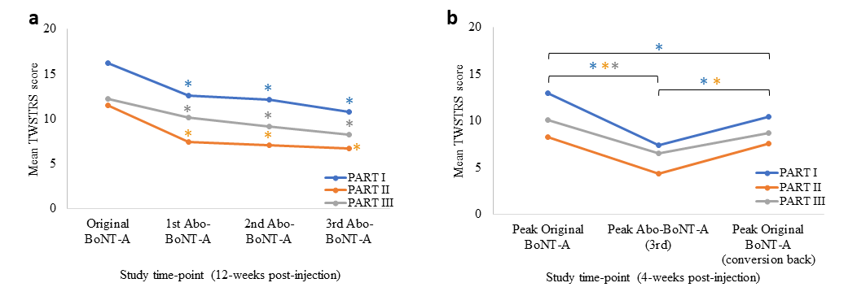

**Figure 3. Mean changes in kinematic measures 12-weeks following all abo-BoNT-A injections (a,c) and at the peak effect (b,d) are displayed**. The percent (%) of participants with neck posturing (tonic deviation) that returned to neutral were compared to participants who continued to present with neck posturing (c,d) at each time-point. Asterisks (*) represent statistically significance (*p* < 0.05) compared to Original BoNT-A or comparisons are denoted by the horizontal bars. Error bars represent standard deviation.

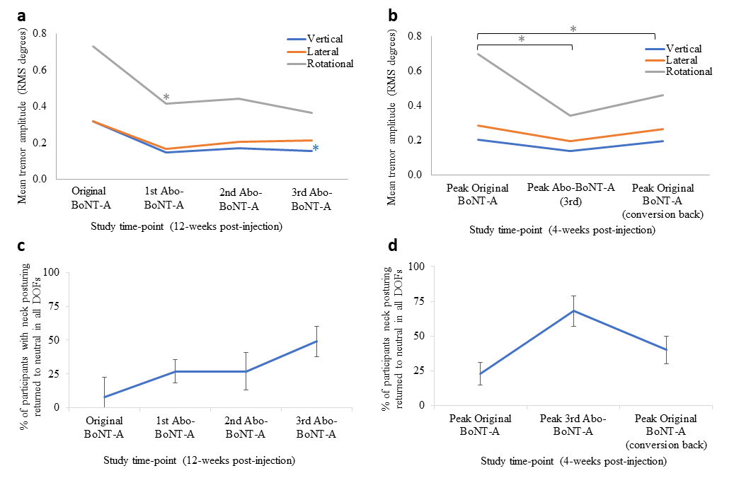

**Table 1.** Total abo-BoNT-A dose administered at the 1st and 3rd treatment cycles per participant.

|  |  |  |
| --- | --- | --- |
| **ID** | 1st Abo-BoNT-A | 3rd Abo-BoNT-A |
| **1** | 250 | 375 |
| **2** | 625 | 800 |
| **3** | 687.5 | 775 |
| **4** | 312.5 | 437.5 |
| **5** | 612.5 | 962.5 |
| **6** | 350 | 525 |
| **7** | 850 | 925 |
| **8** | 375 | 650 |
| **9** | 750 | 987.5 |
| **10** | 375 | 375 |
| **11** | 575 | 450 |
| **12** | 687.5 | 800 |
| **13** | 500 | 750 |
| **14** | 625 | 875 |
| **15** | 800 | 850 |
| **16** | 800 | 900 |
| **17** | 550 | 675 |
| **18** | 375 | 375 |
| **19** | 237.5 | 387.5 |
| **20** | 375 | 512.5 |
| **21** | 250 | 275 |
| **22** | 500 | 475 |
| **23** | 175 | 275 |
| **24** | 387.5 | 400 |
| **25** | 450 | 487.5 |
| **26** | 500 | 675 |
| **27** | 312.5 | 212.5 |
| **Mean** | **492.1** | **599.5** |
| **SD** | **191.7** | **236.2** |
| **Median** | **500.0** | **525.0** |
| **Range (min)** | **175** | **212.5** |
| **Range (max)** | **850** | **987.5** |

**Table 2.** Number of participants with adverse events during the study treatment course.

|  |  |  |  |  |  |
| --- | --- | --- | --- | --- | --- |
| **Adverse event n (%)** | **Original BoNT-A (from clinic)** | **1st Abo-BoNT-A** | **2nd Abo-BoNT-A** | **3rd Abo-BoNT-A** | **4th Original BoNT-A (same dose as 3rd Abo-BoNT-A)** |
| **Muscle weakness** | 2 (6%) | 0 | 0 | 1 (4%) | 0 |
| **Dysphagia** | 4 (12%) | 2 (7%) | 4 (13%) | 5 (18%) | 2 (7%) a |
| **Dysphagia and neck muscle weakness** | 1 (3%) | 2 (7%) | 0 | 0 | 0 |
| **Increased neck pain** | 0 | 1 (4%) | 0 | 1 (4%) | 0 |

a Five participants required a dose reduction in the SCM muscles to minimize likelihood of dysphagia. Abo-BoNT-A: abotulinumtoxinA; n: sample size