Association Between Postoperative Thrombocytopenia and Outcomes After Traumatic Brain Injury Surgery: A Cohort Study

Dr. Jianbo Xu, Yanhong Zhu MBA, PhD^{a,b}, Mr. Zhen PhD^{c} and Sr. Xiaofeng Jiang MD, MPH^{c}
ª Department of Anesthesiology, Affiliated Jinhua Hospital, Zhejiang University School of Medicine, 008C Agriculture Hall, Jinhua, Zhejiang, People's Republic of China
^{b} Department of Anesthesiology, Jiaxing, Jinhua, Zhejiang, 11023, People's Republic of China
^{c} Zhejiang University School of Medicine, 008E Agriculture Hall, Jinhua, Zhejiang, 11023, People's Republic of China
^{d} The Third Affiliated Hospital Of Qiqihar Medical University, 008C Agriculture Hall, Qiqihar 161000, People's Republic of China.
Corresponding author
Xiaofeng Jiang
Email:-xiaofengjiang@gmail.com
Mail address: Department of Anesthesiology, Affiliated Jinhua Hospital, Zhejiang University School of Medicine, Jinhua, 365 Renmin East Road, Jinhua, Zhejiang, China, Zip Code: 32100

Abstract
Background: It is well known that thrombocytopenia occurs in patients with traumatic brain injury (TBI), and its incidence increases with the severity of injury. We aimed to determine whether postoperative thrombocytopenia in patients with TBI is associated with poor clinical outcomes.
Methods: This was a retrospective cohort study of a large international database called the Medical Information Mart for Intensive Care III (MIMIC-III), which included 1093 patients who underwent TBI surgery. Hospital mortality was the primary endpoint of this study.
Results: Multivariate logistic regression analysis revealed non-thrombocytopenia was significantly associated with a decreased hospital mortality (adjusted OR 0.49; 95% CI 0.33–0.75; p =0.01). In addition, platelet counts increased over time in both survivors and non-survivors, according to GAMM. However, the platelet count increased more noticeably in the survivors than in the non-survivors and the difference in platelet count between the two groups showed a trend toward increasing within 7 days after surgery. This difference increased by 7.97 per day on average.

Trial Registry identifier: NCT04959305

Keywords: Traumatic brain injury, Critical care
Introduction
Traumatic brain injury (TBI), which includes intracranial hemorrhage (ICH), subarachnoid hemorrhage (SAH), subdural hemorrhage (SDH), and extradural hemorrhage (EDH), is becoming an increasingly common reason for intensive care unit (ICU) admission[1]. Most of these patients require a craniotomy to remove the hematoma and prevent or treat complications, such as cerebral edema , secondary ischemic injury, brain herniation, and even death [2].
It is well known that thrombocytopenia occurs in patients with TBI, and its incidence increases with the severity of injury [3-6]. Previous studies have suggested that thrombocytopenia is a significant factor in the development of new hemorrhagic changes [4, 7, 8]. Moreover, additional research has linked preoperative thrombocytopenia to increased hospital mortality rates and poor clinical outcomes after cardiac and noncardiac surgery. A few studies have already investigated the relationship between thrombocytopenia and clinical outcomes in patients with TBI, particularly the effect of early platelet changes after surgery. This study aims to add to the existing number of available studies.
In this study, we focused on patients with postoperative thrombocytopenia on the first postoperative day and observed platelet count changes within one week after surgery. We aimed to determine whether postoperative thrombocytopenia in patients with TBI is associated with increased hospital mortality rates and poor clinical outcomes.
Methods
Study population
This retrospective observation study of TBI patients were conducted from the Multiparameter– Intelligent Monitoring in Intensive Care III (MIMIC III, V.1.4), which included over 50,000 ICU patients admitted to the Beth Israel Deaconess Medical Center (BIDMC, Boston, MA, USA) between 2001 and 2012 [2, 11]. After completed the online training at the National Institutes of Health (NIH), the author Jiang (certification ID: 9322422) was approved to gain the data from MIMIC III.
Table 1 Patients with TBI (intracranial hemorrhage, subarachnoid hemorrhage, subdural hemorrhage, and extradural hemorrhage) were included in our study. The criteria for exclusion were: (1) age < 18 years old, (2) missing > 5% data, (3) Missing platelet data. Only the first ICU admission was included if patients have multiple admissions. After surgery, a platelet count of less than 150 × 10⁹ was considered to be indicative of postoperative thrombocytopenia [12-15].
Covariates and outcomes
Patients’ demographic features, laboratory variates, severity score of disease (Glasgow coma scale [GCS] [16] and comorbidities were extracted by PostgreSQL tool. For repeated measurements, such like vital signs and laboratory variables were used as mean values in the first day postoperative. The GCS was also recorded in the first day postoperative. The BMI was not captured in our study due to missing height and weight data > 30% in these TBI patients.
Furthermore, the correlation between the early change of platelet counts (7 days after surgery) and hospital mortality was analyzed. Early differences in platelet changes over time between survivors and non-survivors were studied using the generalized additive mixed model (GAMM). When some data is missing and the time between measurements is not constant, the GAMM is commonly used to analyze the results of repeated measurements [17, 18].
Results
Figure 1 we included 1093 postoperative TBI patients in this study. Among these participants, 247 were classified as thrombocytopenia, while 846 were classified as non-thrombocytopenia. The selection flowchart is presented in. And participants' baseline characteristics are displayed in Table 2. Compared to non-thrombocytopenia patients, thrombocytopenia patients tend to have lower Hb, WBC count, higher sodium, chloride, BUN, Cr, APTT, and PT value. The prevalence of diabetes, congestive heart failure and liver disease was higher among thrombocytopenia patients.
Indicated the results of a logistic or Cox regression model that was used to analyze the correlation between postoperative thrombocytopenia and clinical outcomes suggested that non-thrombocytopenia was significantly associated with a decreased hospital mortality (OR 0.54; 95% CI 0.38–0.77; p =0.01). After adjustment for confounders, in the Table 3 multivariate analysis non-thrombocytopenia remained significantly associated with a decreased hospital mortality (adjusted OR 0.49; 95% CI 0.33–0.75; p =0.01). Multivariate logistic regression models depict non-thrombocytopenia dramatically decreased ICU mortality but not 90-day mortality or 1-year mortality (Figure 3a) shorter length of ICU stay and hospital stay (Figure 3b)
shows the changes in platelet over the 7 days after surgery between hospital survivors and hospital non-survivors. Platelet counts increased over time in both survivors and non-survivors, according to GAMM. However, the platelet count increased more noticeably in the survivors than in the non-survivors. In addition, displayed the association we found between early platelet changes and hospital mortality in TBI patients. According to the findings, the platelet count in the survivors was noticeably higher than that in the non-survivors, and what's more important is that the difference in platelet count between the two groups showed a trend toward increasing within 7 days after surgery. This difference increased by 7.97 per day on average.
Discussion
Our study found that thrombocytopenia on the first postoperative day was significantly associated with an increased risk of short-term mortality in patients with TBI. Independent of other factors, postoperative thrombocytopenia was associated with increased hospital and ICU mortality as well as longer hospital and ICU stays. Moreover, changes in platelet count one week after surgery appear to be an excellent prognostic factor in patients with TBI. Both the survival and non-survival groups observed an increase in their platelet counts gradually over the course of the first week following surgery. The increase in the survival group was significantly greater compared to that of the non-survival group.
Platelet count could be a potent predictor in the prognoses of critically ill patients. Platelets play a role in the pathogenesis of several types of organ dysfunction, such as stroke, acute myocardial infarction (AMI), acute kidney injury (AKI), and massive bleeding [19-22]. There is a strong correlation between thrombocytopenia and postoperative mortality after cardiac and non-cardiac surgery. Many studies support the idea that thrombocytopenia is an important risk factor for postoperative bleeding [23]. Therefore, we hypothesized that decreased platelet counts may also be linked to poor clinical outcomes after TBI surgery. Few studies have examined the connection between thrombocytopenia and clinical outcomes in patients with TBI to the best of our knowledge. Tsuneoka et al. [3] and Engström et al. found that TBI caused a decrease in platelets, and thrombocytopenia could predict the short-term prognosis of these patients. A recent study [Acta Neurochir (Wien) 2022; 164: 2731-2740] also suggested that 12% of TBI patients treated in the ICU developed early thrombocytopenia and that thrombocytopenia was associated with an increased risk of mortality in these patients. These studies are consistent with our findings regarding the association between thrombocytopenia and short-term mortality in patients with TBI. However, a study has yet to be conducted to reflect the comprehensive dynamic changes in the patient's condition and disease progression in patients with TBI.
Therefore, to investigate temporal changes in platelets in patients with TBI and their association with short-term mortality, we employed the GAMM model. The results showed that platelet count changed over time in patients with TBI within the first week after surgery. We also discovered that the degree of platelet elevation over time varied between the survival group and non-survival group. Within one week after surgery, we noted a progressive widening of the gap between the increase in platelet count observed in the two groups (an average of 7.79 per day).
A meta-analysis found that the incidence of TBI-induced coagulopathy, including thrombocytopenia, is approximately 30%.Tissue thromboplastin is released after TBI due to its high concentration in the brain [4]. Tissue thromboplastin activates the extrinsic clotting cascade. In addition, damaged brain endothelium activates platelet release and the intrinsic coagulation cascade resulting in intravascular thrombus formation and subsequent platelet depletion [4]. These mechanisms may contribute to postoperative thrombocytopenia occurring in patients with TBI. Except for postoperative bleeding, previous studies [3] suggest that a low platelet count exacerbates perifocal cerebral edema and results in slow postoperative recovery and poor prognosis.
In addition, our study suggests that thrombocytopenia on the first day after surgery was not related to middle- and long-term outcomes such as 90-day mortality and 1-year mortality. We propose several possible explanations for this finding. We found a general trend of increased platelet count after surgery. Therefore, postoperative thrombocytopenia may not occur long-term. In addition, many other treatments, including rehabilitation, can affect middle- and long-term prognosis.
Although our findings add to the body of evidence concerning the role of platelets in determining clinical outcomes of patients with TBI, they also linked thrombocytopenia to other serious complications. However, our study had some limitations. First, this retrospective study was based on a public database (MIMIC III), and perioperative aspects such as ASA stage, perioperative blood transfusion, and duration of surgical procedure were not available for analysis. Second, BMI was not recorded in our study because there were insufficient height and weight values in the extracted data, which could introduce some bias into our findings. Third, although the overall sample size was sufficiently large, the sample size of each subgroup categorized by admission reason was insufficient for subgroup analysis. Finally, there is no information on platelet transfusions used in the MIMIC database. Therefore, the efficacy of platelet infusion cannot be evaluated.
Conclusions
In our study, we found that patients with TBI who experienced postoperative thrombocytopenia were more likely to have a poor short-term prognosis. In addition, we found that the rate of platelet growth over time varied significantly between the survival and non-survival groups. Patients with TBI who experienced a greater early increase in platelet count had a lower mortality rate.
Ethics approval and consent to participate
The datasets used for the current study come from [MIMIC-III ver.1.4] repository. The study was conducted in accordance with the Declaration of Helsinki (as revised in 2013). This project was both approved by BIDMC and the institutional review boards of Massachusetts Institute of Technology (MIT) (certification number: 9322422) and individual consent for this retrospective analysis was waived.
Availability of data and materials: The datasets of the current study are available from the corresponding author on reasonable request.
Funding Information: This study was partially funded by a research grant from Ipsen Biopharmaceuticals Canada Inc.
Competing interests: Financial interests: Jianbo Xu received lecture honoraria from Hanmi Pharm. Co. Ltd., and Boryung Pharmaceutical Co. Ltd., and consulting fees from Hanmi Pharm. Co. Ltd.china . Yanhong Zhu is an employee of Hanmi Pharm. Co., Ltd.,china . The other authors had no financial interests related to the current study.

Acknowledgements: We thank Yanhong Zhu for statistical assistance; Zhen for writing assistance; and Jianbo Xu for study management and monitoring (Hanmi Pharm. Co., Ltd.,china). Yanhong Zhu are the co-first authors of this study.
Author Contributions: J X designed the study and coordinated the study. Y Zhu provided administrative support. Zhen gave provision of study materials or patients. JX collected and assembled the data. X J analyzed and interpreted the data. All authors were participated in the manuscript writing and read and approved the final manuscript.

References
- Borsellino B, Schultz MJ, Gama de Abreu M, Robba C, Bilotta F. Mechanical Ventilation in Neurocritical Care Patients: A Systematic Literature Review. Expert Rev Respir Med 10(10):1123-32.
- Jiang X, Zhu Y, Zhen S, Wang L. Mechanical Power of Ventilation Is Associated with Mortality in Neurocritical Patients: A Cohort Study. J Clin Monit Comput.
- Tsuneoka H, Tosaka M, Nakata S, Ishii N, Osawa S, Shimauchi-Ohtaki H, et al. Emergent Surgical Evacuation of Traumatic Intracranial Hematoma in Patients with Preoperative Thrombocytopenia: Surgical Risk and Early Outcome. Acta Neurol Belg.
- Carrick MM, Tyroch AH, Youens CA, Handley T. Subsequent Development of Thrombocytopenia and Coagulopathy in Moderate and Severe Head Injury: Support for Serial Laboratory Examination. J Trauma 58(4):725-9; discussion 9-30.
- Jacoby RC, Owings JT, Holmes J, Battistella FD, Gosselin RC, Paglieroni TG. Platelet Activation and Function after Trauma. J Trauma 51(4):639-47.
- Keller MS, Fendya DG, Weber TR. Glasgow Coma Scale Predicts Coagulopathy in Pediatric Trauma Patients. Semin Pediatr Surg 10(1):12-6.
- Jeremitsky E, Omert L, Dunham CM, Protetch J, Rodriguez A. Harbingers of Poor Outcome the Day after Severe Brain Injury: Hypothermia, Hypoxia, and Hypoperfusion. J Trauma 54(2):312-9.
- Oertel M, Kelly DF, McArthur D, Boscardin WJ, Glenn TC, Lee JH, et al. Progressive Hemorrhage after Head Trauma: Predictors and Consequences of the Evolving Injury. J Neurosurg 96(1):109-16.
- Glance LG, Blumberg N, Eaton MP, Lustik SJ, Osler TM, Wissler R, et al. Preoperative Thrombocytopenia and Postoperative Outcomes after Noncardiac Surgery. Anesthesiology 120(1):62-75.
- Williams GD, Bratton SL, Ramamoorthy C. Factors Associated with Blood Loss and Blood Product Transfusions: A Multivariate Analysis in Children after Open-Heart Surgery. Anesth Analg 89(1):57-64.
- Johnson AE, Pollard TJ, Shen L, Lehman LW, Feng M, Ghassemi M, et al. Mimic-Iii, a Freely Accessible Critical Care Database. Sci Data 3:160035.
- Cheng CK, Chan J, Cembrowski GS, van Assendelft OW. Complete Blood Count Reference Interval Diagrams Derived from Nhanes Iii: Stratification by Age, Sex, and Race. Lab Hematol 10(1):42-53.
- Engström M, Romner B, Schalén W, Reinstrup P. Thrombocytopenia Predicts Progressive Hemorrhage after Head Trauma. J Neurotrauma 22(2):291-6.
- Nammas W, Dalén M, Rosato S, Gherli R, Reichart D, Gatti G, et al. Impact of Preoperative Thrombocytopenia on the Outcome after Coronary Artery Bypass Grafting. Platelets 30(4):480-6.
- Wang L, Su W, Xue J, Gong X, Dai Y, Chen J, et al. Association of Thrombocytopenia and Infection in Patients with St-Elevation Myocardial Infarction Undergoing Percutaneous Coronary Intervention. BMC Cardiovasc Disord 21(1):404.
- Teasdale G, Jennett B. Assessment of Coma and Impaired Consciousness. A Practical Scale. Lancet 2(7872):81-4.
- Zhang W, Wang Y, Li W, Wang G. The Association between the Baseline and the Change in Neutrophil-to-Lymphocyte Ratio and Short-Term Mortality in Patients with Acute Respiratory Distress Syndrome. Front Med (Lausanne) 8:636869.
- Zhao X, Wang K, Zuo P, Liu Y, Zhang M, Xie S, et al. Early Decrease in Blood Platelet Count Is Associated with Poor Prognosis in Covid-19 Patients-Indications for Predictive, Preventive, and Personalized Medical Approach. Epma j 11(2):139-45.
- Hui P, Cook DJ, Lim W, Fraser GA, Arnold DM. The Frequency and Clinical Significance of Thrombocytopenia Complicating Critical Illness: A Systematic Review. Chest 139(2):271-8.
- Kertai MD, Zhou S, Karhausen JA, Cooter M, Jooste E, Li YJ, et al. Platelet Counts, Acute Kidney Injury, and Mortality after Coronary Artery Bypass Grafting Surgery. Anesthesiology 124(2):339-52.
- Li J, Yu D, Song Y, Cheang I, Wang X. Association between Postoperative Thrombocytopenia and Outcomes after Coronary Artery Bypass Grafting Surgery. Front Surg 8:747986.
- Raith EP, Udy AA, Bailey M, McGloughlin S, MacIsaac C, Bellomo R, et al. Prognostic Accuracy of the Sofa Score, Sirs Criteria, and Qsofa Score for in-Hospital Mortality among Adults with Suspected Infection Admitted to the Intensive Care Unit. Jama 317(3):290-300.
- Weil IA, Kumar P, Seicean S, Neuhauser D, Seicean A. Platelet Count Abnormalities and Peri-Operative Outcomes in Adults Undergoing Elective, Non-Cardiac Surgery. PLoS One 14(2):e0212191.

Author Biography
Xiaofeng Jiang received her Bachelor’s degree from Nanjing University of Science and Technology (2017). She is currently a PhD. student in London Health Sciences Centre – Lawson Health Research Institute. Her research interest focuses on cervical dystonia.

Table 1. Sensitisation at ECRHS II to allergen groups in terms of change in allergic multimorbidity over a 10-year period, presented in n (%) *
 | Healthy  (n=112) * | New onset of rhinitis  (n=16) * | Remission of rhinitis  (n=26) * | Persistent rhinitis  (n=53) * | Persistent rhinitis and asthma  (n=41) * | p-value
Foods of plant origin | 16 (14.3) * | 2 (12.5) * | 6 (23.1) * | 17 (32.1) * | 20 (48.8) * | <0.001
Foods of animal origin | 2 (1.8) * | 1 (6.3) * | 0 | 0 | 1 (2.4) * | 0.358
Grass pollen | 3 (2.7) * | 4 (25) * | 1 (3.9) * | 13 (24.5) * | 21 (51.2) * | <0.001
Tree pollen | 6 (5.4) * | 7 (43.8) * | 4 (15.4) * | 17 (32.1) * | 26 (63.4) * | <0.001
Weed pollen | 2 (1.8) * | 0 | 2 (7.7) * | 5 (9.4) * | 4 (9.8) * | 0.066
Furry animals | 1 (0.9) * | 1 (6.3) * | 1 (3.9) * | 6 (11.3) * | 19 (46.3) * | <0.001
Mites | 0 | 1 (6.3) * | 3 (11.5) * | 1 (1.9) * | 0 | 0.003
Mould | 0 | 0 | 1 (3.9) * | 0 | 5 (12.2) * | 0.001
Cockroach | 2 (1.8) * | 0 | 0 | 1 (1.9) * | 0 | 1
Latex | 0 | 1 (6.3) * | 3 (11.5) * | 1 (1.9) * | 0 | 0.003
Other | 0 | 2 (12.5) * | 0 | 1 (1.9) * | 5 (12.2) * | <0.001
Sensitised to any allergen | 24 (21.4) * | 10 (62.5) * | 11 (42.3) * | 31 (58.5) * | 31 (75.6) * | <0.001
Number of positive components, median (IQ range) * | 0 | 1 (0-4) * | 0 (0-1) * | 1 (0-4) * | 5 (0.5-10) * | <0.001
ECRHS: European Community Respiratory Health Survey
*A total of 7 individuals were not included in the table due to the small group size. (Healthy developing rhinitis/asthma n=4, rhinitis developing rhinitis/asthma n=3) *

Data are Mean±SD or N (%)
TBI: traumatic brain injury; EDH: extradural hemorrhage; SDH: subdural hemorrhage; SAH: subarachnoid hemorrhage; ICH: intracranial hemorrhage; Hb: hemoglobin; WBC: white blood cell count; BUN: blood urea nitrogen; Cr: creatinine; Glu: glucose; APTT: activated partial thromboplastin time; PT: prothrombin time; HR: heart rate; MAP: mean arterial blood pressure; RR: respiratory rate; SpO₂: pulse oximetry; GCS: Glasgow coma scale; CHF: congestive heart failure; ICU: itensive care unit

Table 2. Relationship between changes (7 days within postoperative) platelet counts and hospital mortality in patients with TBI derived from a generalized additive mixed mo
del (GAMM).
 | β | 95% CI | p value
Day | 11.34 | 10.65 – 12.03 | <0.001
Death | 2.40 | -10.89 – 15.69 | 0.723
Day × death | -7.97 | -9.71 – -6.23 | <0.001
TBI: traumatic brain injury; CI, confidence interval; Day, the mean of the increasing of platelet at death = 0 over time (daily); Death, the difference of platelet at day = 1 between the group of death = 1 and the group of death = 0; Day × death, the average increasing in platelet daily under the condition of the group of death = 1 compared with the group of death = 0.

Figure Legends
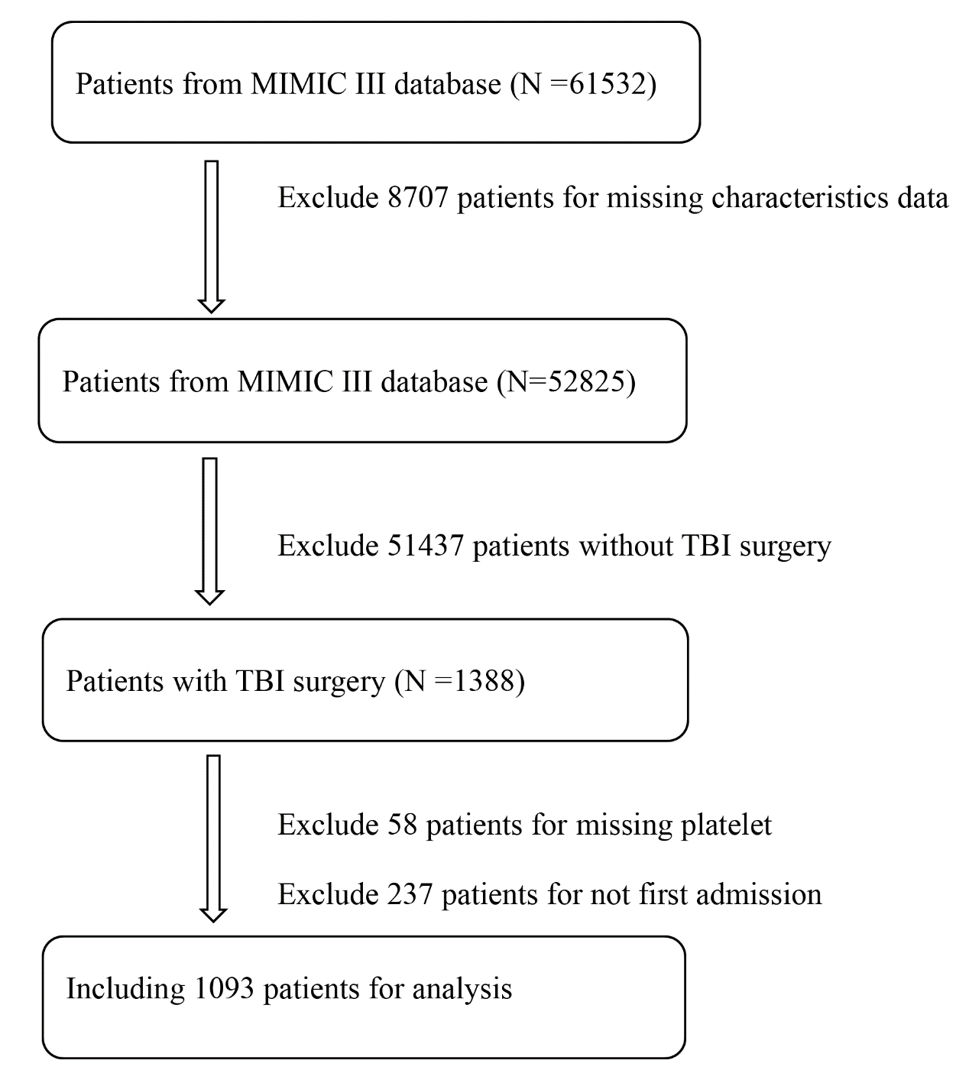
Figure 1. The procedure of data selection and exclusion. MIMIC III database: Multiparameter– Intelligent Monitoring in Intensive Care III database; TBI: traumatic brain injury.
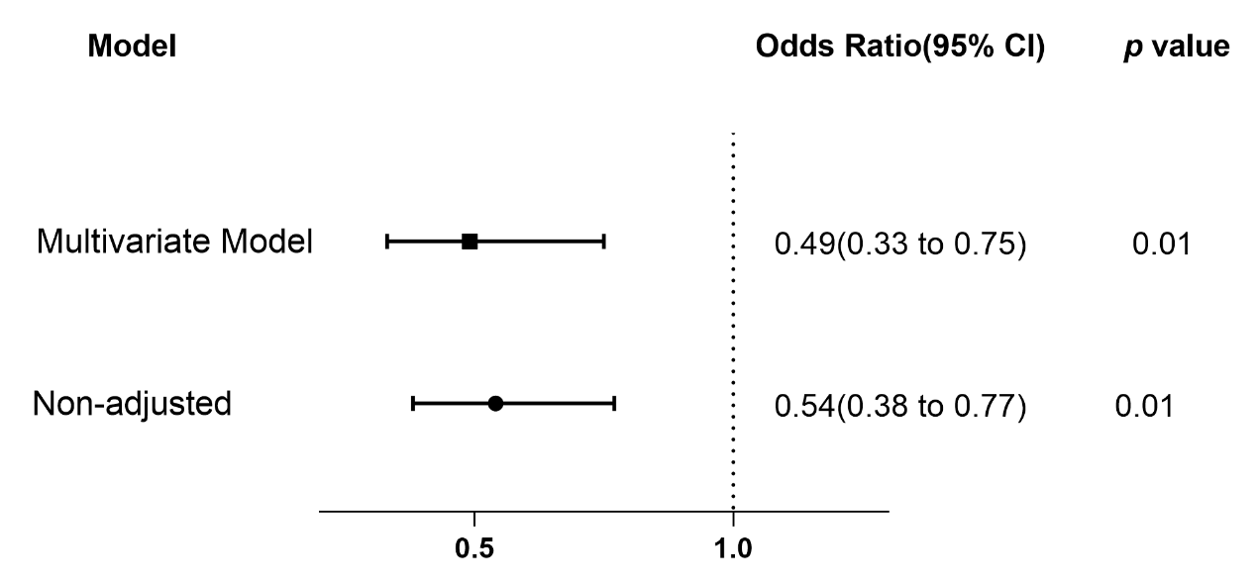
Figure 2. Associations between postoperative thrombocytopenia and hospital mortality. The odds ratio represents the odds of death decrease in non-thrombocytopenia patients compared to thrombocytopenia.

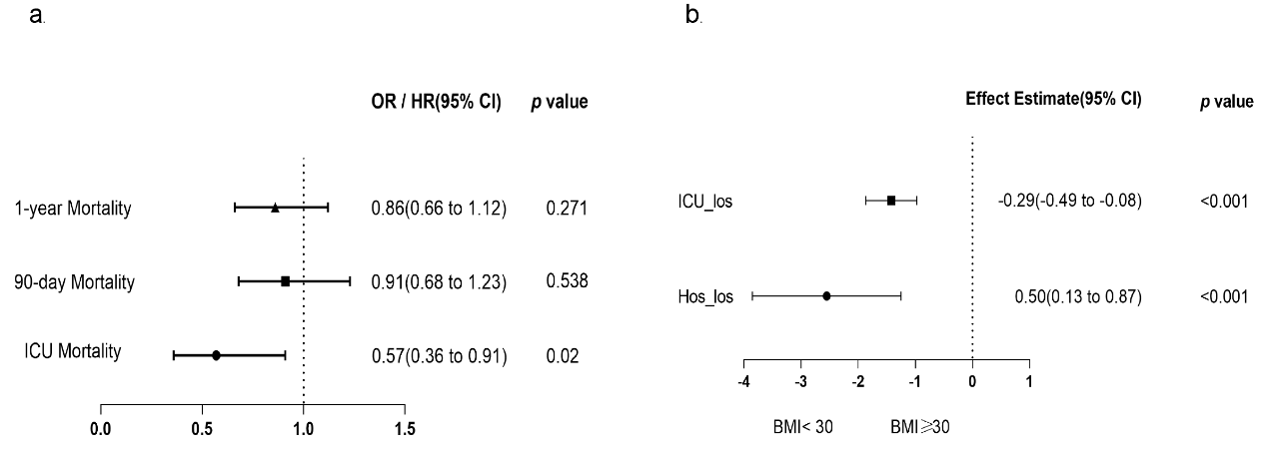
Figure. 3. Associations between postoperative thrombocytopenia and secondary outcomes. a Odds ratio represents the odds of death decrease in non-thrombocytopenia patients compared to thrombocytopenia. b Effect estimates and 95% confidence interval from the multivariable linear regression for Hos_los and ICU_los. Effect estimate refers to the change in the outcome variable of non-thrombocytopenia patients compared to thrombocytopenia. OR: Odds Ratio; HR: Hazard Ratio; CI: confidence interval; Hos_los: length of hospital stays; ICU_los: length of intensive care unit stays.

