Windows Tutorials

How to: Install MobaXterm (Windows)
Step 1: Make sure your computer is connected to the Internet.
If you are wireless on campus, be sure you are on the public wireless network (not intern).
Step 2: Download MobaXterm:
Type the following URL to your browser: http://mobaxterm.mobatek.net/download.html
On the page (as below), click on the “Download now” button under the Home Edition (Free).
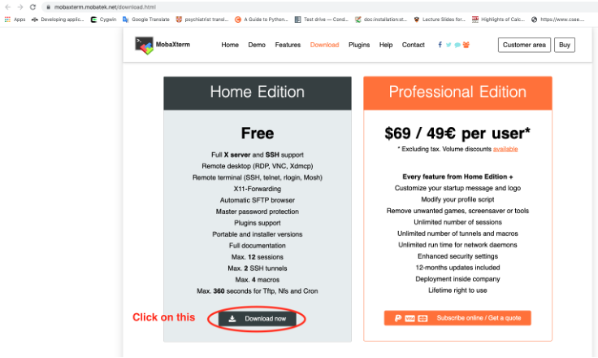
Then on the following page (shown below), click on the green button displaying the latest version of “MobaXterm Home Edition…” to start downloading the installer file. If the computer you are using is not your personal computer, the administrator privileges may be required to complete the installation.
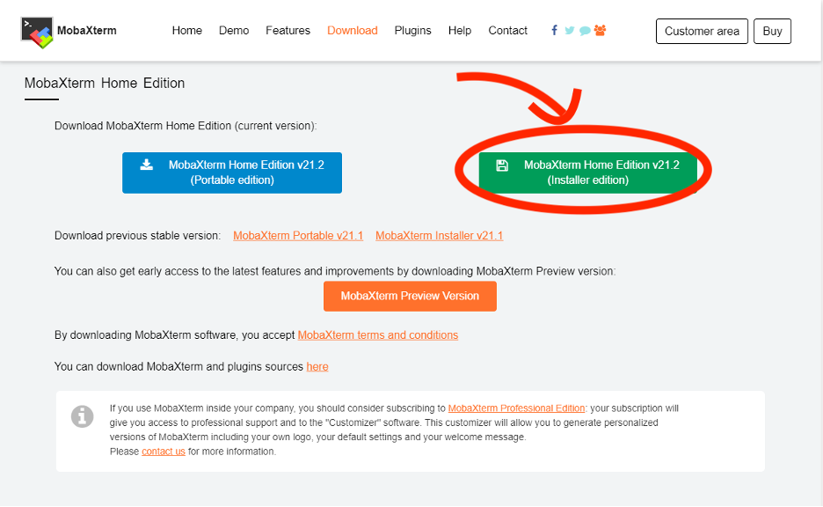
Step 3: A zip file named “MobaXterm_Installer_v21.3” has been downloaded to your computer. (This name may be slightly different depending on the specified version you downloaded in the previous step.)
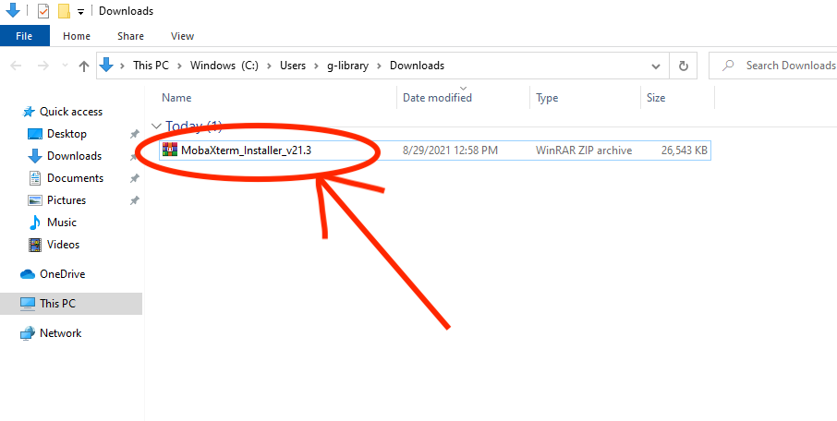
Right click on it and extract the files from it.
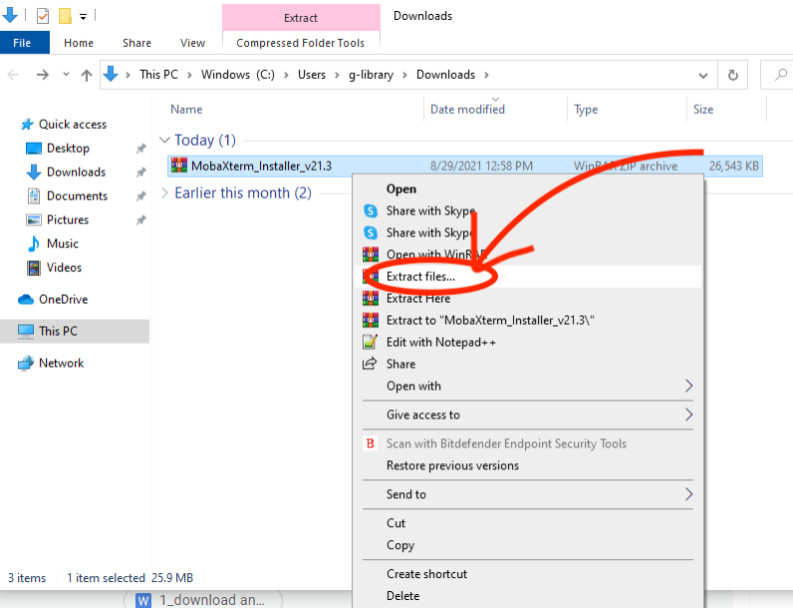
Then, a window will appear with the extraction path and options. You can change this information if preferred or just continue with the default settings. After clicking the ok button to confirm, you should see a folder appear as shown below.
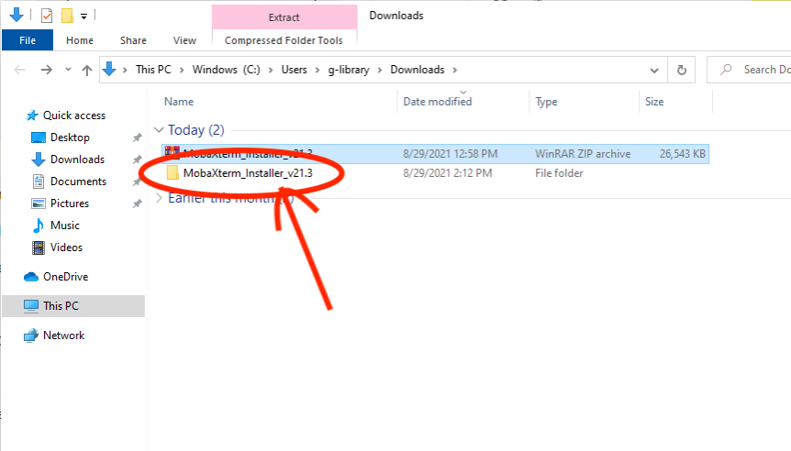
When you open this folder, you should see two files as shown below. Launch the installer by double clicking “MobaXterm_installer_21.3”.
You may get a warning which states something similar to “MobaXterm_installer_21.3” is a Windows executable, do you want to run it?” If you get such a message, choose “Yes.”
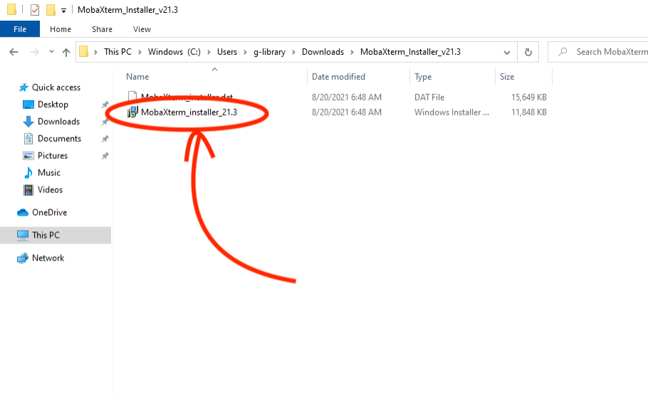
Step 4: This will open the MobaXterm Setup Wizard. Click next.
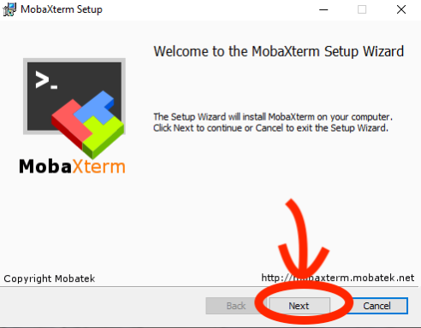
First, you will be given the User agreement. Check the box to accept and click next. In the following window, you are asked to confirm the destination folder for the installation. The simplest way is to use the default path shown by the installer, but you could change this if you have a preferred location. After pressing next, you will see the install button. After clicking this button, the program will begin installing.
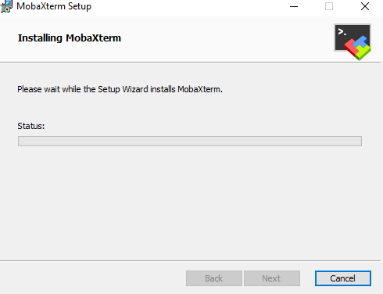
Step 5: Now you can run MobaXterm
You have successfully downloaded and installed MobaXterm. A clickable icon to open MobaXterm should have appeared on your computer. We can create a shortcut for this application in your desktop for this application, by right-clicking on the icon, click “Send to” and then select “Desktop (create shortcut)”.
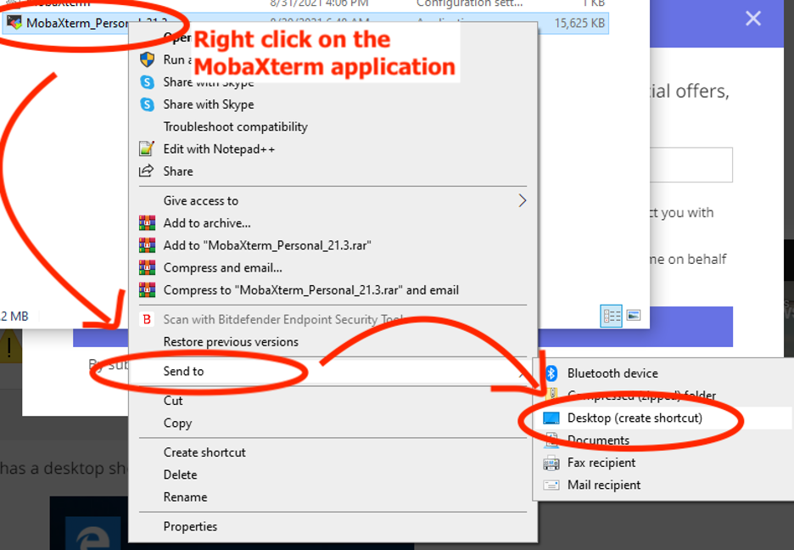
You can see that the application was originally found through the “Downloads” folder where the installation was completed, but after making the shortcut it could more conveniently be opened right from the Desktop.
From now on, you can use MobaXterm to log on to a remote server (such as storm.cis.fordham.edu). Should you have any questions as you start learning the program, the MobaXterm website provides a useful and detailed documentation guide.
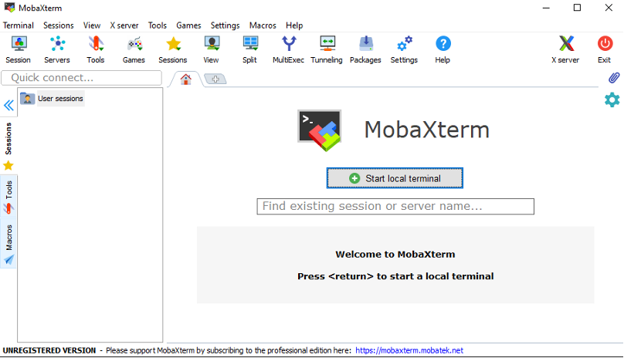

How to: Remote login using MobaXterm (Windows)
Step 1: If you haven’t installed MobaXterm, please follow the How to: install MobaXterm to install this program on your computer. You will need an account to access the remote server (storm.cis.fordham.edu for RH classes, erdos.dsm.fordham.edu for LC classes). Please speak with your instructor if you don’t have one, or have forgotten your account ID or password.
In the following examples, we will be using the account username, “cking74@storm.cis.fordham.edu” and the password, “mypass”. Remember that when you see this, you should replace it with your own details.
Step 2: First ensure that you are connected to the internet, then double click on the MobaXterm icon to start the program. The following window will appear:
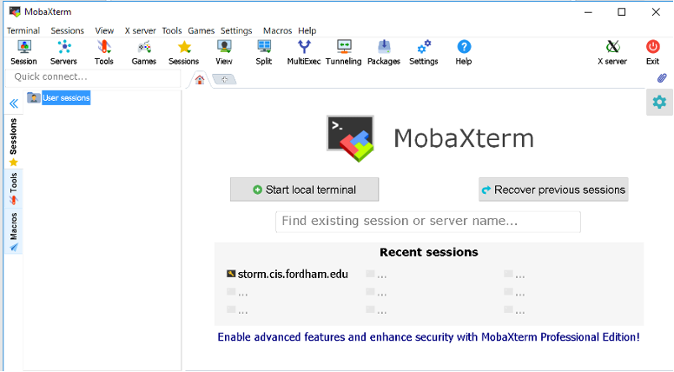
Step 3: Click on the Session button on the top left of the window:
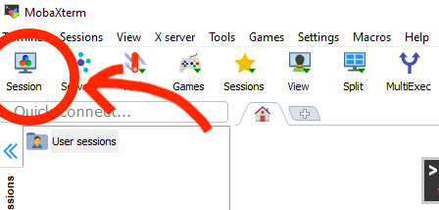
Step 4: (In the new window), first click the SSH button (top left), then in the Remote Host text box, enter the host name of the remote server to which you want to connect. (In the example shown, we enter 167.86.93.xxx (will be provide day of training) since this account is located on the storm server.)
Next, check the Specify username box and enter your username. (Here we enter cking74.) Click ok.
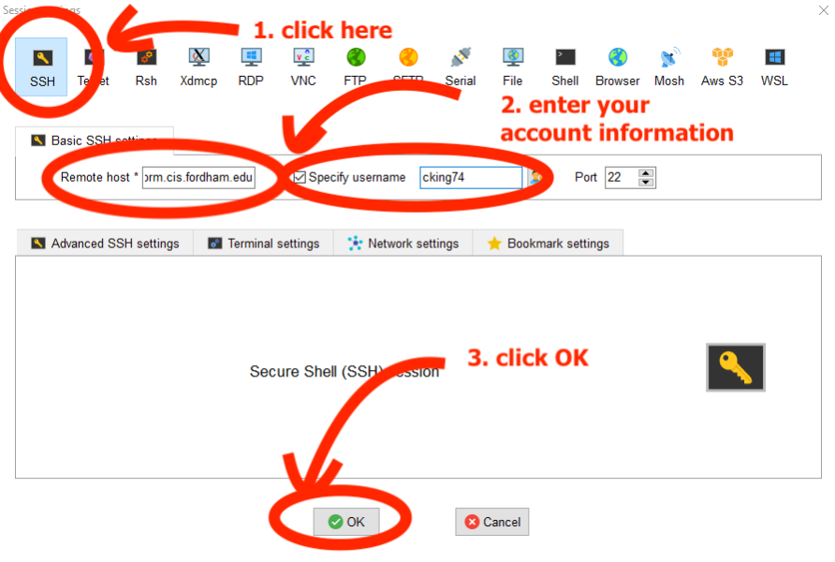
Click on advanced SSH setting then use private key and choose the private key provided in the git.
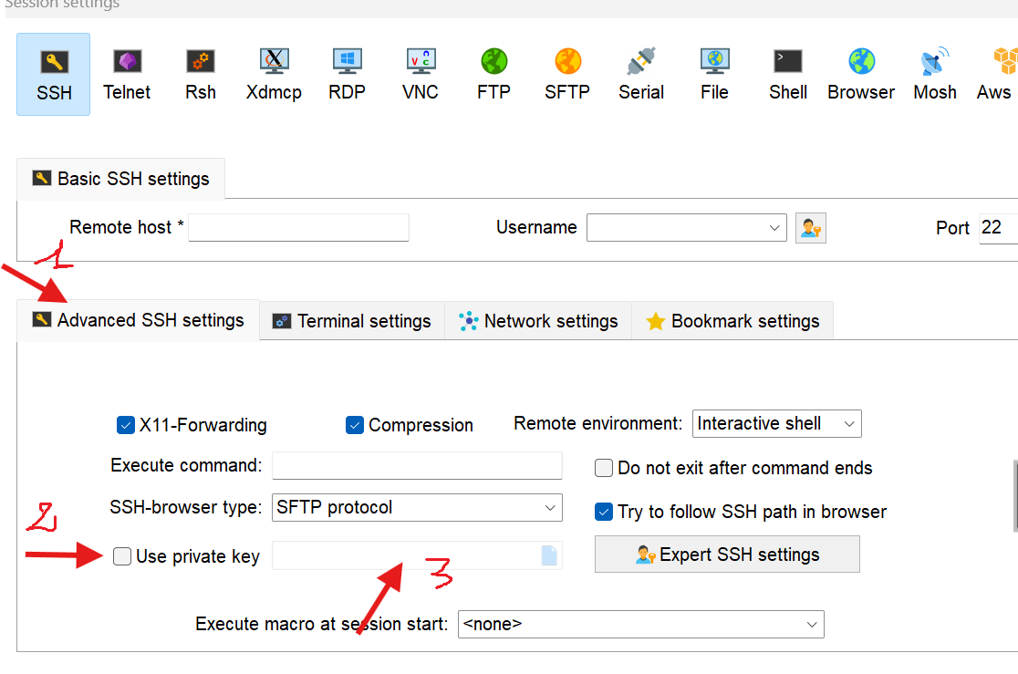
Step 5: If successful in the previous step, a terminal window will appear as shown below. You should see your username and a password prompt. Type your password –“ mypass” and press Enter. (Note that as you type your password, the cursor will not move forward and nothing will be shown for security reasons.)
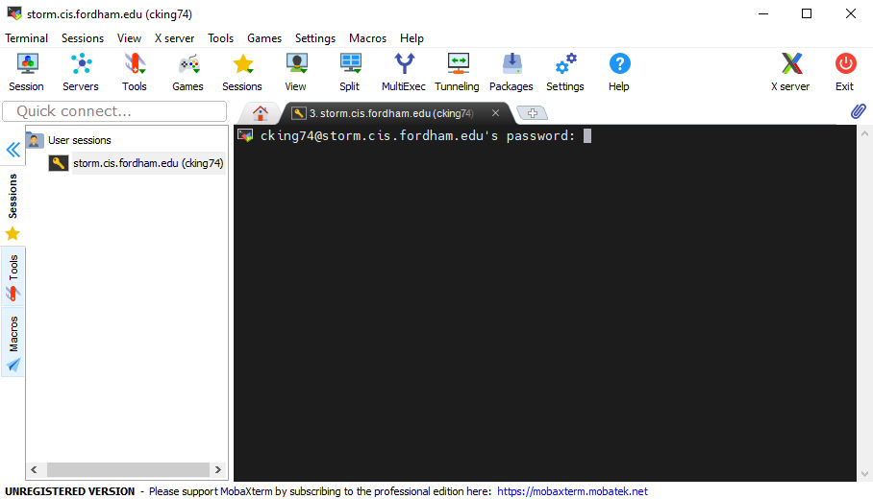
A window may pop up asking if you wish to save your password. Only do so if you are on your own private computer. If you are using any public computer, click on No.
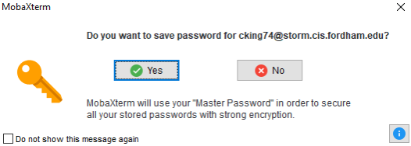
Step 6: After successfully logging on, you should see something similar to: [cking74@storm~]$ appear behind the cursor in the terminal window (with your own account information) as shown below. This indicates that you are currently accessing the server.
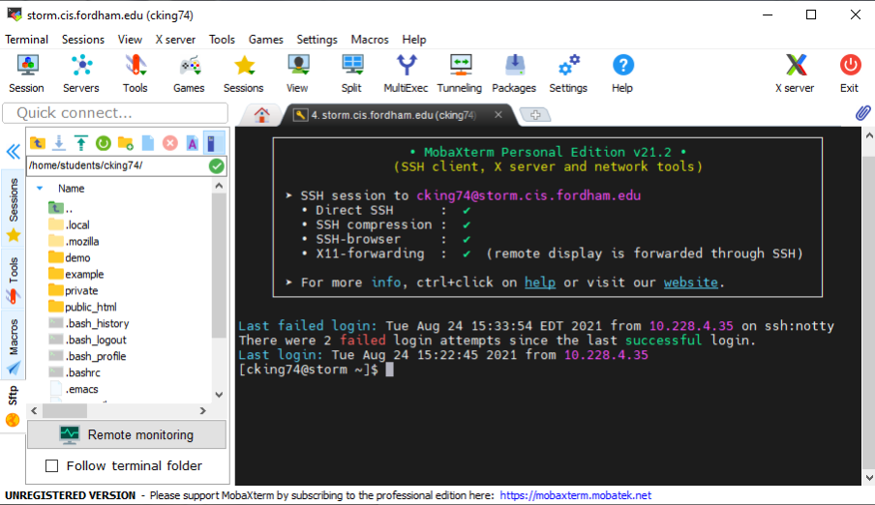
If you want to log off of the server, you can type “exit” into the terminal window and press Enter.

MAC Tutorials

How to: remote login from MAC
Step 1: To complete this tutorial, an account should have been created for on the Fordham servers and you should have been given a username and password. If you were not given these credentials, contact your instructor before proceeding to the next step. The username “cking74” will be used throughout this tutorial along with the password “mypass” which you should remember to replace with your own information.
It is also important to remember on which server your account exists in order to log in. There are two main servers for the department: storm located at the Rose Hill campus and erdos at the Lincoln Center campus. These are the machines that we will be remotely accessing.
Step 2: Next, ensure that your computer is connected to the internet and launch Terminal. Terminal comes pre-installed on Mac computers. It can easily be located by clicking on Spotlight, typing “terminal” into the search bar and double clicking on the top result.
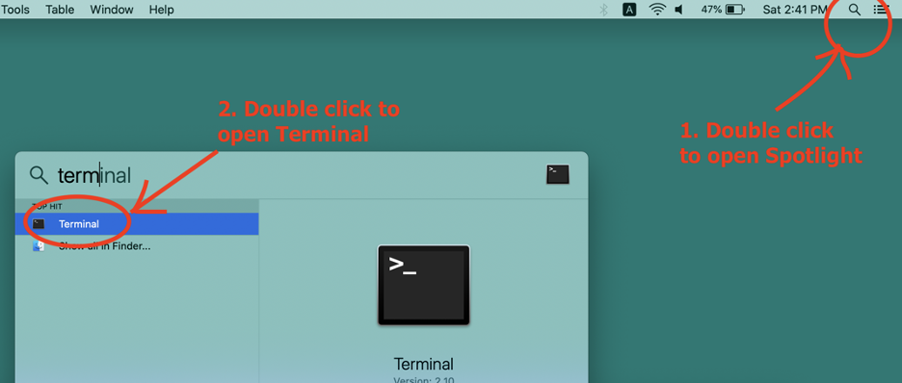
If the application does not immediately show up in the Spotlight window, you may need to adjust your search results for Spotlight. This can be done by opening Finder, navigating to the following location and checking the “Applications” box.
Applications » System Preferences » Spotlight » Search Results
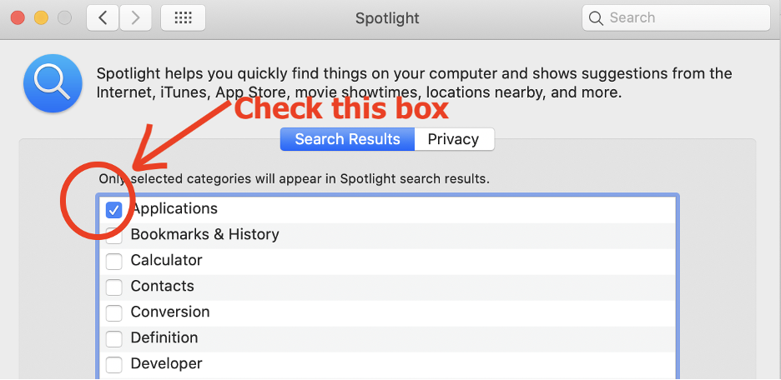
Additionally, Terminal can be found in its original location: Applications » Utilities
Once you’ve launched Terminal, a window similar to the following will pop up. This is often referred to as the command-line and we can execute commands on our computer by typing them in here.
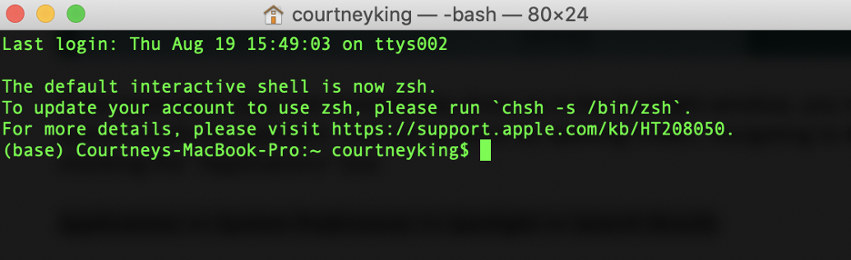
Step 3: Next, we will access the remote servers using the ssh (secure shell) command. This command should be executed along with [your user name] @ [your remote machine] as demonstrated in the example below. Note that if your account is on the storm servers, your remote machine is storm.cis.fordham.edu and if on the erdos servers, it is erdos.dsm.fordham.edu.
Proceed by typing the following command into the terminal (with your own account details) and press enter: ssh cking74@storm.cis.fordham.edu
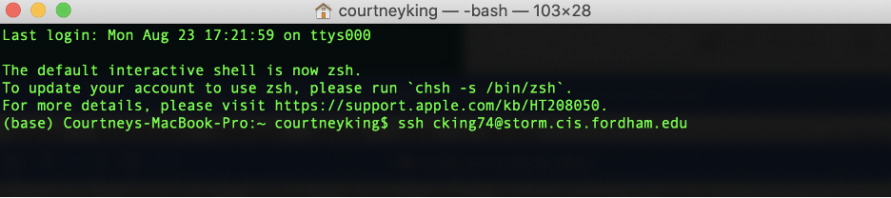
Note that if it is your first time logging on, you may be prompted with a similar message for verification:
The authenticity of host 'cking74@storm.cis.fordham.edu' cannot be established. DSA key fingerprint is
04:48:30:31:b0:f3:5a:9b:01:9d:b3:a7:38:e2:b1:0c. Are you sure you want to continue connecting (yes/no)?
If so, type yes and press enter. This is just confirming that you intend to connect to this machine and that a host key will be saved for future verification purposes. Then you will then see something like the following message:
Warning: Permanently added 'cking74@storm.cis.fordham.edu' (DSA) to the list of known hosts.
Step 4: After executing the previous command, you should be prompted for your password. Type in your password- “mypass” and press Enter. (Note that as you type your password, it will not be displayed and the cursor will not move forward for security reasons.)
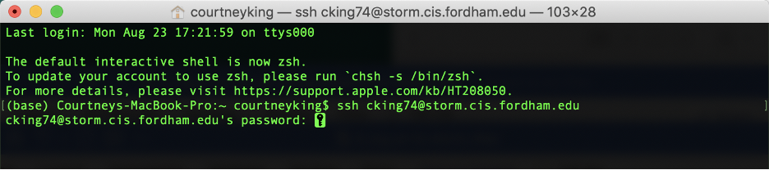
If it is your first time logging in, it is possible that the system will require you to change your password at this point. If it does, simply follow the prompts as they are given to do so. You can change your password again at any time later on using the passwd command, which is covered in the tutorial “Introduction to Linux environment”.
Step 5:
Once you have successfully logged in, you should see something similar to:
[cking74@storm ~]$
appear at the start of the line in the terminal. This indicates that you have successfully logged on to the servers.
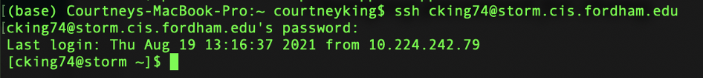

https://github.com/kasmiyassin/bioinfo_b2s_ss2026/blob/00_info/CISTutorials/docs/assets/CISWork1
https://github.com/kasmiyassin/bioinfo_b2s_ss2026/blob/00_info/CISTutorials-main/docs/assets/CISWork1.png

https://github.com/kasmiyassin/bioinfo_b2s_ss2026/blob/00_info/AccesstoServer/docs/assets/CISWork1
https://github.com/kasmiyassin/bioinfo_b2s_ss2026/blob/00_info/AccessToServer/docs/assets/CISWork1.png
https://github.com/kasmiyassin/bioinfo_b2s_ss2026/blob/00_info/AccesstoServer/docs/assets/CISWork1.png

