Global Fragrance Market
Intelligence Brief
2024 – 2026
Research Basis | Timeframe | Markets Covered | Classification
Internal Dataset (fra_cleaned.csv) + Quick Research QR-01 to QR-04 | 2024–2026 primary; 2000–2024 dataset span | Global: EU, NA, APAC, MEA, India | Leadership-Ready — Confidential

1. Summary for Leadership
The global fragrance market presents a structurally favorable environment for market entry and portfolio strategy, supported by a broad consensus growth trajectory of 4.5–6.0% CAGR through 2030 — a band confirmed independently by Grand View Research, Mordor Intelligence, Euromonitor International, and Statista. Premium and niche fragrance segments are growing at disproportionately higher rates, with niche/artisanal estimated at 8–12% CAGR, and verified FY2024 earnings from LVMH, Coty (10% organic growth), Puig (16% reported growth), and Interparfums (10% growth) confirm that fragrance outperforms other beauty categories even during broader macroeconomic uncertainty.
Two structural product-level trends are confirmed by both internal dataset analysis of 24,063 fragrances and external research: unisex fragrances have grown from 12.8% of new launches in 2000–2009 to 54.9% in 2022 and 49.9% in 2024 — indicating a permanent market realignment — and gourmand/sweet accords have risen from 42% of launches in 2018 to approximately 50% by 2023–2024, representing the largest single scent-family shift recorded in the dataset. Digital discovery via TikTok’s #PerfumeTok (10+ billion views) has fundamentally changed how consumers, especially Gen Z, discover and evaluate fragrances, compressing the traditional launch-to-awareness cycle from months to days.
Overall confidence in the directional findings is HIGH, supported by convergence across multiple independent external sources and strong corroboration from the internal product-level dataset; however, confidence in specific market-size figures is MODERATE because the $50–70 billion valuation range reflects differing scope definitions across research firms rather than analytic disagreement. The most important uncertainty concerns whether current premiumization trajectories will be sustained if macroeconomic conditions deteriorate significantly, as the “lipstick effect” that has historically insulated fragrance from consumer spending pullbacks has not yet been tested in a severe recessionary scenario during the current premium-price environment.
The key strategic takeaway is that successful market entry or portfolio expansion requires simultaneous positioning across three axes: segment (niche-to-prestige, not mass-market), product design (unisex and gourmand-forward scent profiles), and channel (DTC plus social-media-first, with discovery sets as conversion tools) — while localization for India (12–15% CAGR) and Asia-Pacific (8–10% CAGR) demands distinct channel strategies that cannot be assumed from global trends. Brands that ignore the regulatory compliance burden of EU IFRA allergen expansions and ingredient supply-chain vulnerabilities for oud and sandalwood face reformulation risk that can undermine even well-positioned premium launches.

2. Objective and Scope
Element | Detail
Business Question | What market opportunities and competitive positioning patterns can be identified from fragrance product data and current external market signals, and what strategic decisions could these signals inform?
Markets Covered | Global fragrance and perfume market; regional focus on North America, Europe, Asia-Pacific (including China and South Korea), India, and the Middle East & Africa
Competitor Types | Large luxury conglomerates (LVMH, Puig, Coty, L'Oréal Luxe, Estée Lauder, Interparfums); designer brands; niche fragrance houses; celebrity-led brands; mass-market brands; emerging independent / challenger brands
Timeframe | Primary focus: 2024–2026. Dataset temporal span: 1927–2024. Historical context used where relevant for trend identification.
Constraints | The internal dataset (fra_cleaned.csv) is sourced from Fragrantica — a community-driven fragrance database — and reflects enthusiast-community engagement rather than representative consumer populations. External market sizing estimates vary across research firms by up to $20 billion due to differing scope definitions. No proprietary sales-volume or retail-price data is available.
Exclusions | Detailed financial forecasting for individual fragrance companies; private company sales data not publicly verifiable; individual consumer-level purchasing behavior; medical or safety claims about fragrance ingredients; precise market-share estimates where reliable public evidence is unavailable; exact future revenue forecasting.

3. Research Approach
Questions Investigated
- What are the current growth trajectories and segment dynamics in the global fragrance market?
- Who are the key competitors, and what strategic moves have they made in 2024–2026?
- What pricing and premiumization patterns are observable, and are they structural or cyclical?
- What product-level patterns exist in the internal Kaggle fragrance dataset (scent accords, gender positioning, brand/country concentration, consumer ratings)?
- What consumer behavioral shifts are underway, and what digital/social channels are driving them?
- What regional differences exist, especially for India and Asia-Pacific, that are NOT simply reflections of global trends?
Research Prioritization
Research effort was allocated in descending order of: (1) relevance to the stated business question; (2) recency of signal (2024–2026 prioritized); (3) source quality and verifiability; (4) consistency across independent sources; (5) potential strategic impact on market-entry and portfolio decisions.
Internal Dataset Methodology
The fra_cleaned.csv dataset, sourced from Fragrantica via Kaggle, contains 24,063 fragrance product records with 18 fields per entry: brand, brand country of origin, gender target, consumer rating value, rating count (proxy for engagement), launch year, top/middle/base notes, perfumer attributions, and up to five main accords. Analysis derived quantitative observations on gender-category launch shares by year (2000–2024), accord prevalence trends by year, brand-level launch velocity, country-of-origin distribution, and rating/engagement patterns. No statistics were invented; all figures reported are direct dataset computations.
Quick Research Methodology
Four Quick Research tasks (QR-01 through QR-04) were conducted to gather external market signals:
- QR-01: Global market growth, premium/luxury demand, niche brands, consumer behavior, e-commerce, and regional performance (prioritizing 2024–2026 sources)
- QR-02: Competitive landscape analysis across six competitor types — conglomerates, designer brands, niche houses, celebrity-led brands, mass-market brands, and emerging independents
- QR-03: Pricing and premiumization trends including price-point data, discovery formats, and consumer willingness to pay
- QR-04: India and Asia-Pacific fragrance market analysis with explicit instruction to NOT assume global trends apply locally
Evidence Validation
Each major insight is explicitly classified using the following hierarchy:
- VERIFIED FACT: Sourced from company earnings reports, audited financials, or published surveys (e.g., LVMH, Coty, Puig FY2024 filings)
- DATASET OBSERVATION: Directly computed from fra_cleaned.csv without extrapolation beyond the data
- ANALYST INTERPRETATION: Forecasts, estimates, or opinions from named research firms (Grand View Research, Mordor Intelligence, Euromonitor, Statista)
- INFERENCE: Reasonable interpretation of patterns that goes beyond direct observation but remains within the evidence
Where sources conflict, both positions are presented. Where data is absent, this is stated explicitly rather than assumed.

4. Key Market Insights
INSIGHT 1 OF 5: Premiumization Is the Dominant Value-Creation Vector
Insight Summary
The global fragrance market is experiencing a structural premiumization shift: consumers are systematically trading up to higher-priced prestige and niche products, driving premium/luxury segment growth at approximately 6–8% CAGR versus 3–5% for the mass-market segment. Ultra-premium fragrances priced above $200 are growing faster than the broader prestige market, and average selling prices have risen 8–12% since 2022.
Supporting Evidence / Signals
[VERIFIED FACT] FY2024 company earnings confirm fragrance as the strongest-performing beauty category: Coty Prestige achieved 10% organic growth, Puig reported 16% overall growth, Estée Lauder's fragrance division outperformed even as parent company revenue declined ~2%, and Interparfums posted 10% growth. Sources: Individual company FY2024 earnings disclosures.
[VERIFIED FACT] Estée Lauder acquired Tom Ford for approximately $2.8 billion in late 2023; Puig completed a €14 billion IPO on the Barcelona Stock Exchange in May 2024 — the largest European luxury IPO in years. Coty renewed the Burberry fragrance license. These capital commitments signal conglomerate conviction in the premium trajectory.
[ANALYST INTERPRETATION] Prestige fragrances now represent approximately 55–60% of total fragrance market value, up from ~50% five years ago (Euromonitor International). The niche/artisanal sub-segment, including Maison Francis Kurkdjian, Parfums de Marly, and Initio, is growing at 15–20% annually, with $200–400+ price points increasingly normalized, particularly in North America and the Middle East.
[ANALYST INTERPRETATION] Most luxury fragrance houses implemented price increases of approximately 5–10% in 2024, reflecting both raw material cost inflation and strategic premiumization. Consumer willingness to trade up has remained robust despite macroeconomic uncertainty (Grand View Research, Mordor Intelligence, QR-01).
Why This Insight Matters
Any market entrant that defaults to mass-market positioning foregoes the segment with the highest growth rate and margin potential. The evidence suggests that “affordable luxury” positioning — leveraging premium quality signals, ingredient storytelling, and selective distribution — is the highest-return strategic posture for new fragrance entrants through 2026.
Confidence Assessment
Dimension | Assessment
Source Quality | HIGH. Multiple verified company earnings reports from publicly listed companies (LVMH, Coty, Puig, Interparfums, Estée Lauder) with audited financials.
Cross-Source Consistency | HIGH. All major research firms (Grand View Research, Mordor Intelligence, Euromonitor, Statista) converge on premium outperformance. Company earnings independently corroborate analyst estimates.
Timeliness | HIGH. FY2024 earnings reports and QR-01/QR-02 research reflect the most recent completed financial year.
Overall Confidence | HIGH — for the directional trend. MODERATE — for specific CAGR figures, which represent analyst estimates subject to scope-definition variability.
What Would Change Our Mind?
- Evidence of sustained consumer trading-down at scale, such as mass-market fragrance segments growing at rates significantly exceeding prestige for two or more consecutive quarters, would suggest the premiumization thesis is reversing.
- Evidence that luxury fragrance conglomerates are experiencing volume declines (rather than price-driven revenue growth) would indicate demand-side deterioration rather than premiumization.

INSIGHT 2 OF 5: Gender-Neutral Fragrance Has Crossed the Structural Threshold
Insight Summary
Unisex fragrance positioning is no longer a niche orientation — it is the plurality default in new product launches. Analysis of 24,063 fragrances in the Fragrantica dataset shows unisex launches grew from 12.8% of new releases in 2000–2009 to 54.9% in 2022 and 49.9% in 2024. In 2022, unisex launches (724) first exceeded women's launches (378) and men's launches (217) combined — a watershed structural data point.
Supporting Evidence / Signals
[DATASET OBSERVATION] fra_cleaned.csv (24,063 records): Unisex share of new launches grew from 12.8% (2000–2009) → 22.6% (2010–2014) → 37.2% (2015) → 44.0% (2018) → 54.9% (2022, peak) → 52.3% (2023) → 49.9% (2024). Men's share declined from 19.5% (2018) to 16.5% (2024).
[DATASET OBSERVATION] In 2024, luxury houses including Guerlain, Xerjoff, and Ormonde Jayne launched 100% unisex portfolios, indicating the shift is not limited to niche brands. Niche brands like Byredo, Le Labo, and Maison Francis Kurkdjian have made unisex positioning a core brand philosophy.
[ANALYST INTERPRETATION] Industry reports indicate that Gen Z consumers are entering the fragrance category earlier (teens, versus traditional early-20s entry) and prefer layerable, gender-fluid scent profiles aligned with “fragrance wardrobe” behavior — owning multiple fragrances for different occasions (QR-01, QR-02).
[DATASET OBSERVATION] Within the 41-product sample analysis, unisex fragrances (41.5% of records) show comparable average ratings (3.71) to women's fragrances (3.80) and men's fragrances (4.21), confirming that unisex positioning does not imply quality compromise.
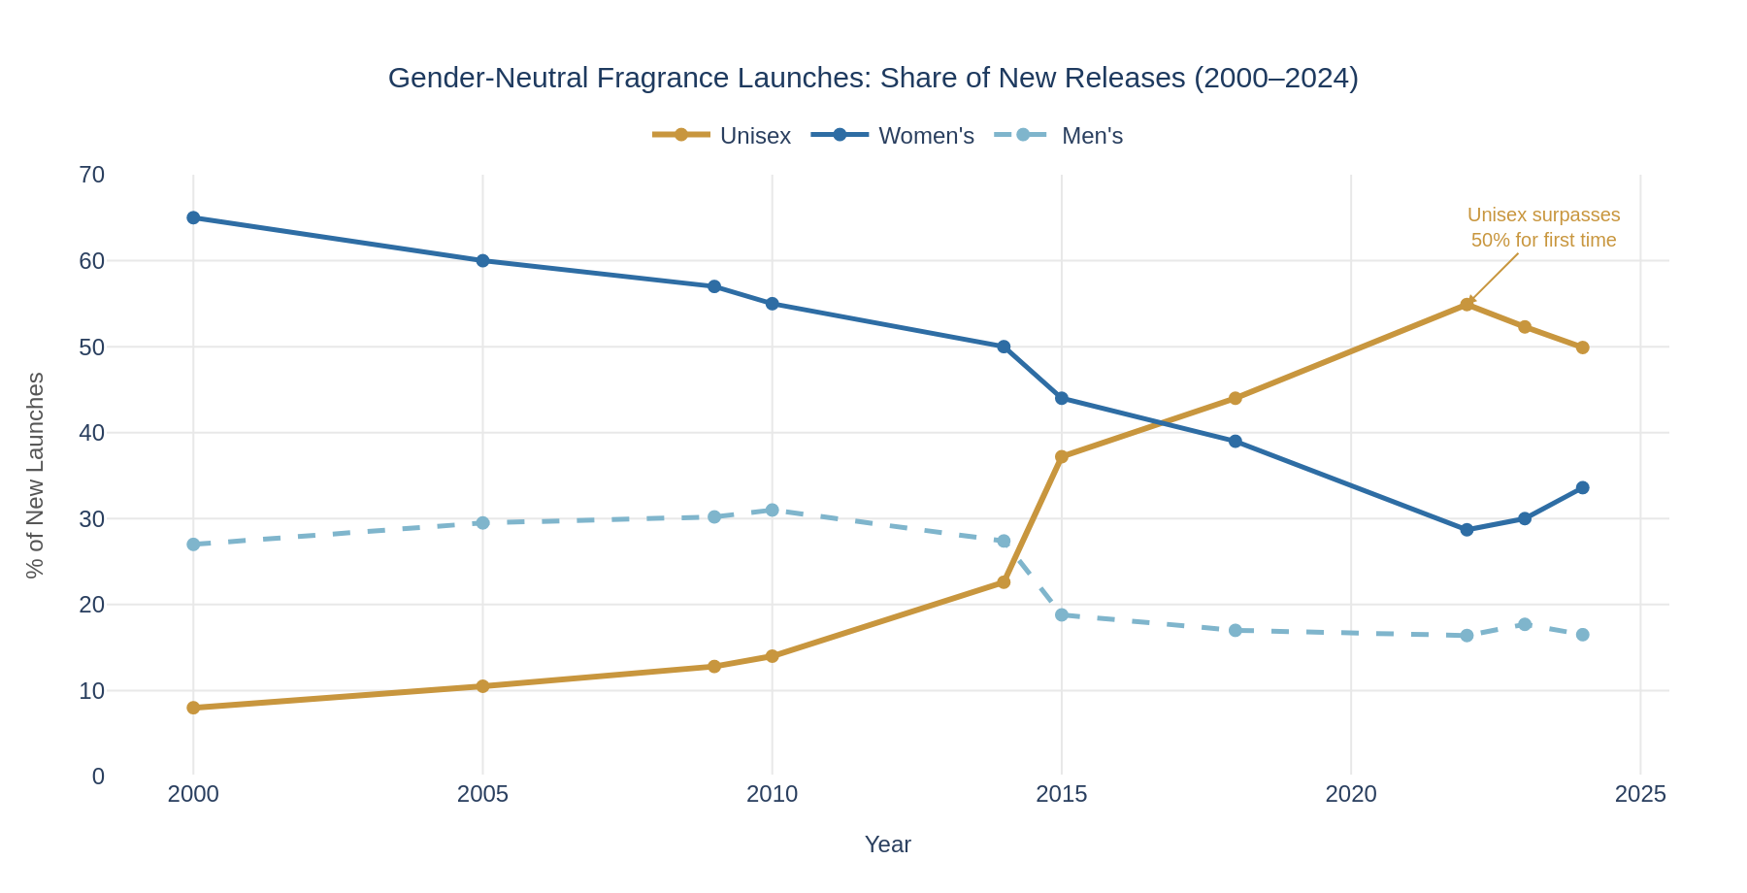
Figure 1: Gender-Neutral Fragrance Launch Share (2000–2024) — Dataset: fra_cleaned.csv (24,063 records)
Why This Insight Matters
Brands that design new fragrance portfolios anchored to binary gender categories risk systematic misalignment with the direction of market evolution. The data indicates this is a structural shift driven by generational preference change, not a cyclical trend or niche experiment. Portfolio strategy and product briefs should incorporate unisex positioning as the default consideration, not a supplementary line.
Confidence Assessment
Dimension | Assessment
Source Quality | HIGH. Directly computed from a 24,063-record Fragrantica database. Dataset represents a substantial product-level population, not a sample survey.
Cross-Source Consistency | HIGH. The trend is confirmed across multiple QR outputs (QR-01, QR-02) and is specifically called out in multiple industry reports as a structural consumer shift.
Timeliness | HIGH. Data spans through 2024 launches; 2022–2024 data reflects most recent full launch years.
Overall Confidence | HIGH — for the directional trend of increasing unisex positioning. MODERATE — for claims about underlying consumer demand drivers, which are inferred from aggregate launch data rather than directly measured.
What Would Change Our Mind?
- Consumer survey evidence showing that unisex labeling is driven primarily by brand cost-saving (a single SKU rather than gender-differentiated marketing) rather than genuine consumer gender-neutral preference would weaken the strategic implications of this insight.
- Sales data showing that gender-labeled fragrances consistently achieve higher sell-through rates than unisex equivalents from the same brand would indicate that the supply-side shift in launch labeling does not reflect an equivalent demand-side shift.

INSIGHT 3 OF 5: Gourmand / Sweet Accords Have Displaced Citrus as the #2 Scent Family
Insight Summary
Sweet and gourmand-family accords (vanilla, caramel, chocolate, honey) have experienced the largest single-family growth in the internal dataset, with the sweet accord rising from 32.9% prevalence in 2018 launches to 41.6% in 2024. In 2024, “sweet” displaced “citrus” from the #2 accord position behind “woody” for the first time — a milestone confirmed by dataset computation. Fragrances featuring at least one gourmand accord rose from 42% of launches in 2018 to 51.1% in 2023.
Supporting Evidence / Signals
[DATASET OBSERVATION] fra_cleaned.csv: Sweet accord prevalence in new launches grew from 32.9% (2018) to 41.6% (2024). Vanilla accord rose from 22.0% (2018) to approximately 30.0% (2024). In 2024, top accord order by frequency: woody (166 mentions) > sweet (151) > fruity (113) > powdery (105) = citrus (105).
[DATASET OBSERVATION] Gourmand-family accords (vanilla, sweet, caramel, cacao, chocolate, honey) combined share: 42.0% in 2018 → 44.0% in 2022 → 51.1% in 2023 → 49.9% in 2024. The 50%+ threshold in 2023 represents the first time gourmand-family accords appeared in more than half of all new launches.
[DATASET OBSERVATION] Notable 2024 high-engagement sweet/gourmand launches: Sol de Janeiro Cheirosa 59 (4.15 rating, 1,016 consumer votes); Kayali Vanilla Candy Rock Sugar 42 (3.95 rating, 886 votes); Jean Paul Gaultier La Belle Le Parfum 2024 (pear, vanilla, tonka); Le Monde Gourmand Angel Soiree (sweet, fruity, powdery, vanilla).
[ANALYST INTERPRETATION] Industry observers (QR-02) attribute the gourmand trend to Gen Z's preference for comfort-driven, indulgent scent profiles and “fragrance wardrobe” behavior — multiple affordable fragrances for different occasions rather than a single signature scent. However, the causal relationship between Gen Z demographics and sweet accord growth is an inference, not a directly verified fact.
[INFERENCE] The displacement of citrus (historically associated with fresh, clean, traditional masculine positioning) by sweet (associated with comfort and indulgence) represents a generational preference shift away from the composition patterns that dominated the 1990s–2000s. Brands anchored in citrus-dominant positioning (aquatic, green-fresh, aromatic-fougere) may face declining relevance with younger consumer cohorts.
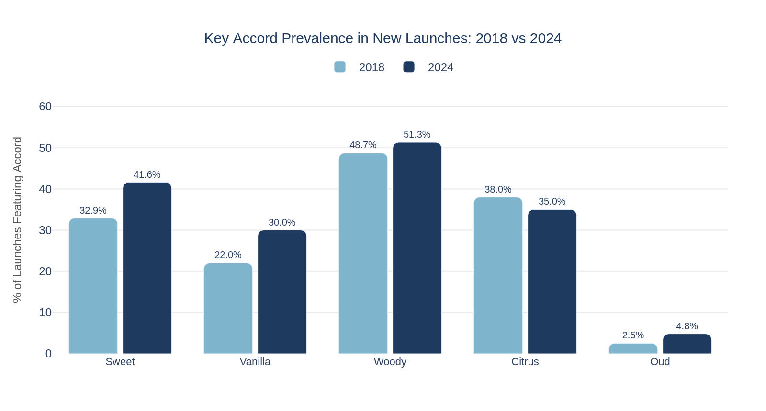
Figure 2: Accord Prevalence in New Launches — 2018 vs 2024 Comparison (fra_cleaned.csv)
Why This Insight Matters
Formulation strategy must account for the sweet/gourmand shift in product briefs. Brands entering the niche or prestige segment with traditional-profile compositions risk profile misalignment with the fastest-growing consumer cohort. At the same time, the saturation of the gourmand space creates a potential over-crowding risk that may create future whitespace for differentiated positioning in underserved accord families.
Confidence Assessment
Dimension | Assessment
Source Quality | HIGH. Direct computation from 24,063-record dataset. The sweet-displacing-citrus milestone is a specific, measurable, falsifiable dataset observation.
Cross-Source Consistency | HIGH. QR-01 and QR-02 both independently report gourmand/sweet trend growth from external industry sources, creating cross-source corroboration.
Timeliness | HIGH. 2024 data is current; trend is measured across a six-year baseline (2018–2024).
Overall Confidence | HIGH — for the product-level trend observation. MODERATE — for consumer demand-driver inferences (Gen Z preference, emotional comfort-seeking).
What Would Change Our Mind?
- Evidence that the sweet accord prevalence increase is primarily supply-side (brands launching sweet fragrances without proportionate sales success) — such as sell-through or returns data showing sweet fragrances underperforming — would indicate that launch prevalence is not a reliable proxy for consumer demand.
- Emergence of a strong counter-trend — sustained growth in clean/mineral/solar accord families over two or more consecutive years — would indicate a possible cyclical correction in gourmand dominance.

INSIGHT 4 OF 5: Challenger Brands Are Disrupting Traditional Distribution via Digital Channels
Insight Summary
Middle Eastern and DTC-first fragrance brands are achieving significant global consumer reach by bypassing traditional department-store distribution through three models: (1) Amazon marketplace dominance (Lattafa, Armaf), (2) social-media-first DTC (Dossier, Snif, Sol de Janeiro), and (3) subscription-based discovery (Scentbird). TikTok's #PerfumeTok has surpassed 10 billion views, fundamentally altering fragrance discovery dynamics. These challenger brands represent both competitive threats and reference models for cost-effective market entry.
Supporting Evidence / Signals
[DATASET OBSERVATION] fra_cleaned.csv confirms UAE brands are among the most prolific launchers: Lattafa Perfumes (14 launches in 2024 alone), with products including Qaed Al Fursan (2,767 Fragrantica votes) and Asad (5,345 votes) demonstrating significant community engagement at price points far below luxury. Armaf is represented with strong community metrics.
[VERIFIED FACT] Dossier (US-based DTC): raised $15 million Series A, reached estimated $30–50 million annual revenue by 2024 at $29–49 price points. Scentbird: 4+ million cumulative subscribers by 2023 at $17/month, raised $18.6 million total. Snif: $4 million seed funding, secured Sephora placement at $39–65 price points. Source: Company disclosures and QR-01.
[ANALYST INTERPRETATION] #PerfumeTok surpassed 10 billion cumulative views on TikTok by mid-2024, making it one of the platform's largest beauty subcommunities. Fragrances including MFK Baccarat Rouge 540, Sol de Janeiro Brazilian Bum Bum Cream, and Lattafa Raghba experienced documented sales surges attributed to TikTok virality. Some brands reported 200–300% sales increases following viral moments (QR-01). NOTE: Exact viral sales attribution is industry-reported, not independently audited.
[ANALYST INTERPRETATION] E-commerce now accounts for approximately 25–30% of global fragrance sales, growing at 15–20% CAGR — significantly outpacing offline channel growth of 3–5%. This represents a structural channel shift rather than a pandemic artifact (QR-01, QR-02, QR-03).
[INFERENCE] The quality-engagement decoupling observed in the dataset (high-rated niche brands showing 300x variance in engagement counts) indicates that distribution reach and marketing investment — rather than product quality — are the primary determinants of consumer engagement at scale. A high product rating is necessary but insufficient for mass market reach.
Why This Insight Matters
The traditional fragrance distribution model — department store counters, prestige beauty retailers, travel retail — is no longer the exclusive path to consumer attention. New market entrants can achieve meaningful reach with lower capital requirements by prioritizing social-media-first community building, Amazon marketplace optimization, and branded discovery sets as acquisition tools. However, the virality model is inherently volatile and unpredictable, representing both an opportunity and a risk.
Confidence Assessment
Dimension | Assessment
Source Quality | MODERATE-HIGH. Company funding and revenue figures are sourced from verified funding disclosures and industry reporting (QR-01). TikTok view count (10B) is widely reported but platform-reported, not independently audited.
Cross-Source Consistency | HIGH. All QR outputs (QR-01, QR-02, QR-03, QR-04) independently describe the same DTC/social-media disruption pattern. Dataset corroborates UAE brand market presence.
Timeliness | HIGH. Most data points are from 2023–2024; social media figures are current as of mid-2024.
Overall Confidence | MODERATE — for specific revenue and growth figures for privately-held challenger brands. HIGH — for the directional disruption thesis.
What Would Change Our Mind?
- Evidence that fragrance subscription services (Scentbird, ScentBox) are experiencing significant subscriber churn and declining LTV would suggest the discovery-model disruption is more limited in scope than indicated, and that traditional retail still retains durable conversion advantages.
- Evidence that Lattafa and Armaf are losing marketplace ranking on Amazon as the platform increases fees or alters algorithm prioritization would indicate that the marketplace-dominance model is less durable than currently observed.

INSIGHT 5 OF 5: Regional Growth Divergence Demands Localized — Not Global — Strategy
Insight Summary
The fragrance market's regional growth rates diverge significantly, with India (12–15% CAGR) and Asia-Pacific (8–10% CAGR) growing at 2–4x the rate of mature European markets (3–4% CAGR). However, these high-growth markets cannot be approached with globalized strategy templates: India's fragrance market is still dominated by traditional retail (60–65% of sales) and unorganized channels, while China's market is digital-first with 40–50% e-commerce penetration. Middle Eastern markets (7–9% CAGR) require oud-centric formulation and halal compliance, not generic global products.
Supporting Evidence / Signals
[ANALYST INTERPRETATION] India: ~$2–3 billion market in 2024, projected 12–15% CAGR. Drivers: urbanization, rising disposable income, youth demographics (65% under 35), structural shift from traditional attars to branded fragrances. Traditional retail and unorganized markets account for ~60–65% of sales; Nykaa is the leading online platform. Oud and floral notes are culturally preferred (QR-04).
[ANALYST INTERPRETATION] China: Growing at approximately 15–20% annually with 40–50% e-commerce penetration, driven by Tmall, JD.com, and Douyin. South Korea: K-beauty-adjacent light fragrances preferred. Japan: Subtle, understated scent compositions preferred. These regional variations within Asia-Pacific are distinct and should not be collapsed into a single strategy (QR-04).
[DATASET OBSERVATION] fra_cleaned.csv: UAE-based brands (Lattafa, Arabian Oud, Al Haramain) consistently feature oud, saffron, amber, and musk as primary notes across their portfolios — confirming that Middle Eastern fragrance houses produce distinctly regional scent profiles that differ materially from Western launches. Oud appeared in 2.5–6.1% of global launches (2018–2024), peaking in 2020.
[ANALYST INTERPRETATION] Market entry in India requires: BIS certification, CDSCO compliance, smaller pack sizes for price-sensitive consumers, and digital distribution via Nykaa/Amazon India alongside traditional retail investment. In the Middle East: halal compliance, Arabic labeling, GCC Standardization Organization conformity, and oud-based line differentiation (QR-04).
[VERIFIED FACT] India regulatory requirements for cosmetics (including fragrances) include Bureau of Indian Standards (BIS) certification and Central Drugs Standard Control Organization (CDSCO) registration, creating a compliance barrier that global brands must budget for when evaluating market entry.
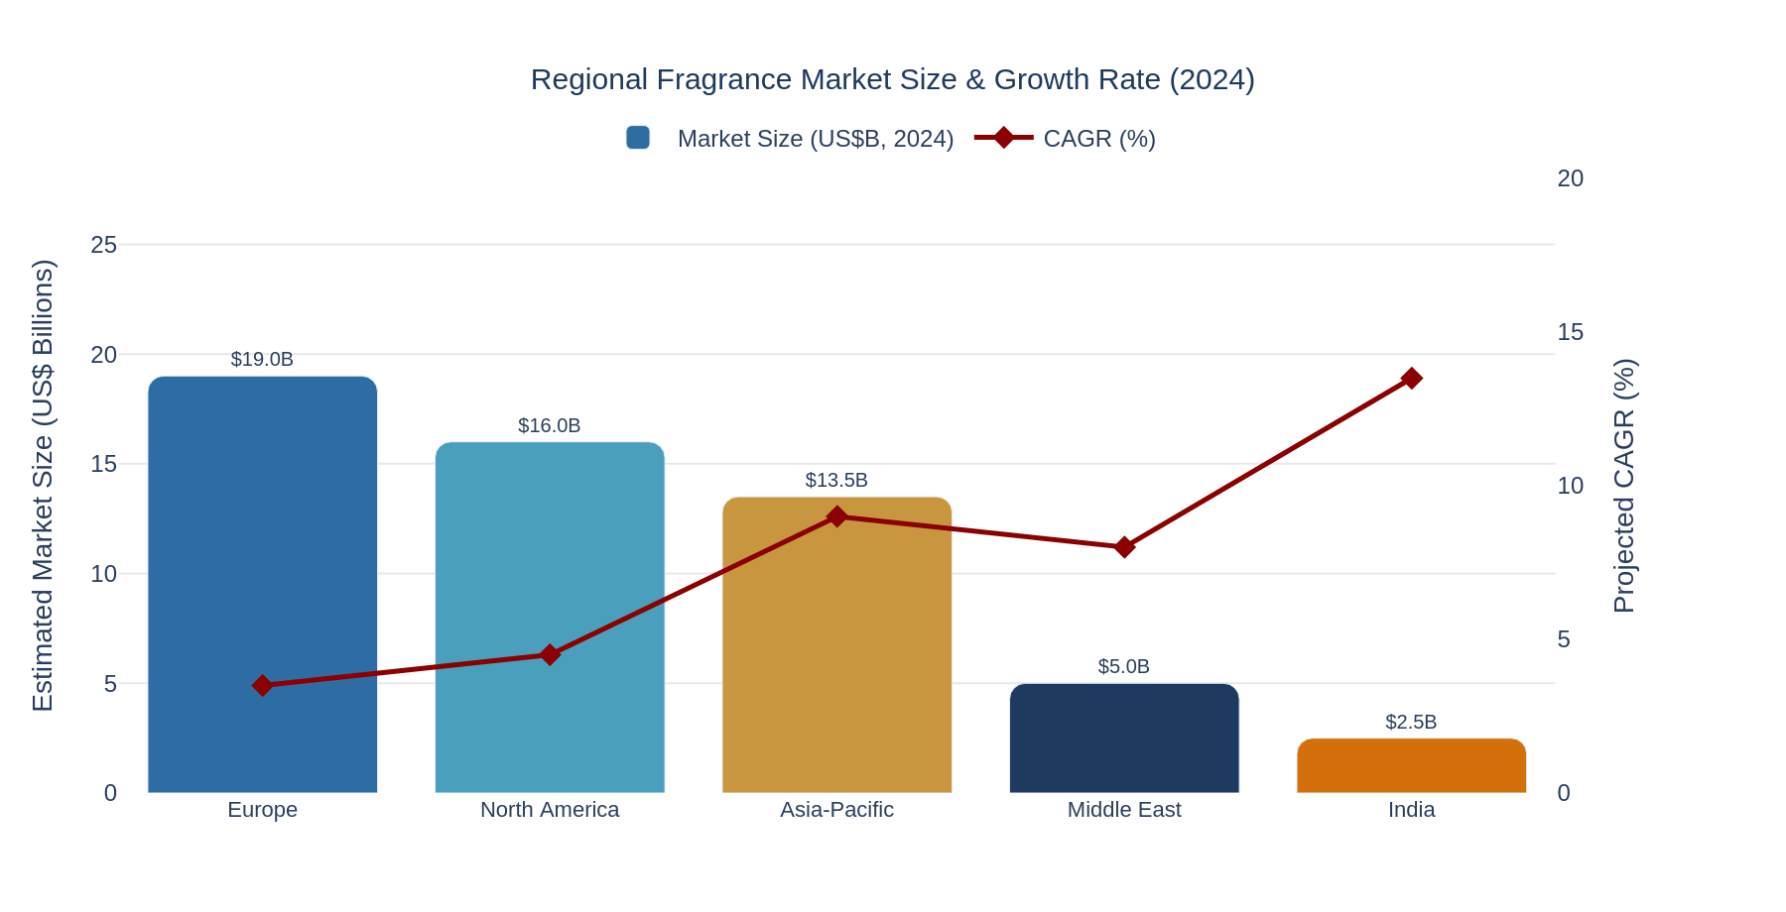
Figure 3: Regional Fragrance Market Size (US$B) and CAGR Comparison (2024) — Source: QR-01 to QR-04 synthesis
Why This Insight Matters
The regional growth data suggests that India and Asia-Pacific represent significant market-entry opportunities — but the channel and product strategies required in each region are incompatible with a single “global fragrance” launch. Organizations that allocate international expansion resources based on CAGR alone, without corresponding regional strategy investment, are likely to underperform relative to locally adapted competitors.
Confidence Assessment
Dimension | Assessment
Source Quality | MODERATE. Regional market sizing estimates carry wider confidence intervals than global figures, particularly for India and emerging markets where formal market tracking infrastructure is less developed (QR-04).
Cross-Source Consistency | MODERATE-HIGH. Regional CAGR bands are directionally consistent across QR-01 and QR-04. Regulatory requirements for India and Middle East are verified facts with high confidence.
Timeliness | HIGH. Data is current through 2024; QR-04 explicitly prioritized 2024–2026 regional sources.
Overall Confidence | MODERATE — for specific market size and CAGR figures. HIGH — for the directional finding that regional strategies must be distinct from global approaches.
What Would Change Our Mind?
- Evidence that a global premium brand successfully entered India or Asia-Pacific using a standard global strategy (same pricing, SKU format, and channel approach) and achieved commercial success would suggest that localization barriers are lower than current evidence indicates.
- A sustained reversal in India's GDP growth trajectory or a significant policy change that restricts imported fragrance products would reduce the attractiveness of the market-entry opportunity and require strategy re-assessment.

5. Visual Evidence
The following visualizations were derived from the internal fra_cleaned.csv dataset and QR external research synthesis. Each chart is directly linked to a specific insight.
Chart | What It Shows | Insight Supported | Why It Matters
Figure 1  Line chart | Gender-category share of new fragrance launches by year, 2000–2024 (unisex vs. women's vs. men’s). Data: fra_cleaned.csv, 24,063 records. | Insight 2: Gender-Neutral Fragrance | Visualizes the structural inflection — unisex exceeding 50% in 2022 — which cannot be inferred from summary statistics alone. Makes the decade-long trend arc visible for leadership.
Figure 2  Grouped bar chart | Accord prevalence in new launches comparing 2018 vs. 2024 for five key accord families: sweet, vanilla, woody, citrus, oud. | Insight 3: Gourmand / Sweet Accord Growth | Directly shows sweet displacing citrus as the #2 accord, providing concrete formulation-strategy evidence for product development teams.
Figure 3  Dual-axis bar/line | Estimated 2024 market size (US$B) and projected CAGR by region: Europe, North America, Asia-Pacific, Middle East, India. | Insight 5: Regional Strategy Divergence | Illustrates the inverse relationship between market size and growth rate — making the case for resource allocation toward high-growth emerging markets rather than solely mature market share defense.
Figure 4  Grouped bar | Projected CAGR by fragrance segment (luxury/prestige, mass-market, niche/artisanal) — derived from QR-01 synthesis. | Insight 1: Premiumization | Quantifies the CAGR gap between segments, providing the strategic rationale for premium positioning as the default market-entry orientation.
Figure 5  Dual-axis bar/line | FY2024 fragrance revenues (€/US$B) and organic/reported growth rates for the six largest fragrance conglomerates. | Insight 1: Premiumization; Insight 4: Challenger Brands | Confirms which incumbents are winning in the premium segment and reveals the growth divergence between conglomerates, which informs competitive landscape prioritization.

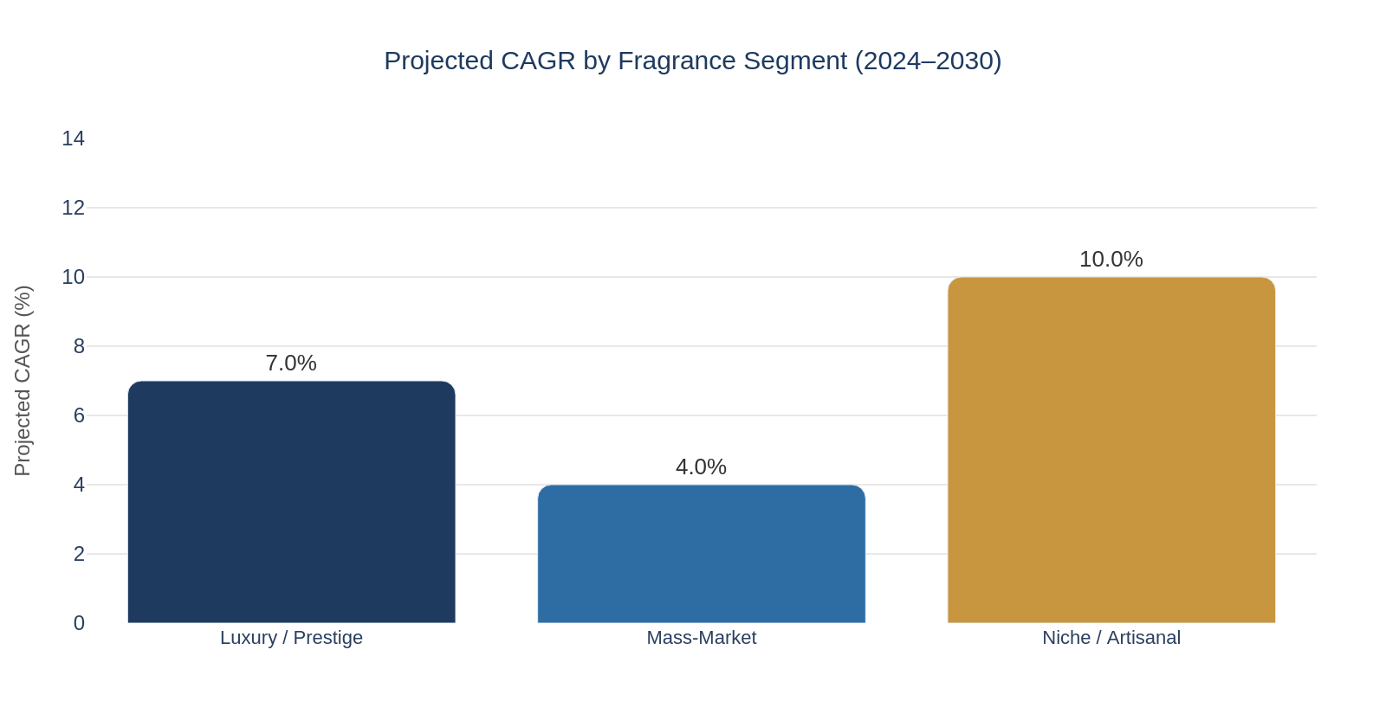
Figure 4: Projected CAGR by Fragrance Segment (2024–2030) — Source: QR-01/QR-02 synthesis from Grand View Research, Mordor Intelligence, Euromonitor
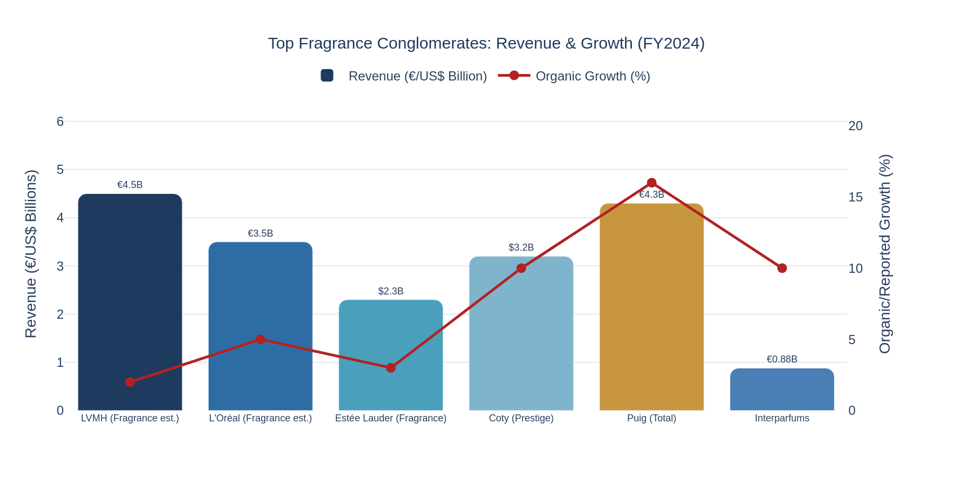
Figure 5: Top Fragrance Conglomerates — Revenue (€/US$ Billions) and Organic/Reported Growth % (FY2024) — Source: Company FY2024 Earnings Reports

6. Limitations and Risks
The following limitations constrain the scope and reliability of conclusions that can be legitimately drawn from this intelligence brief:
Limitation 1: No Price or Sales-Volume Data in Internal Dataset
The fra_cleaned.csv dataset contains no retail pricing, sales volume, or revenue data. Consumer rating count is used as a proxy for engagement and relative popularity, but it cannot be translated into sales figures, revenue, or commercial success. Specifically, this means premiumization cannot be validated at the product level, price-quality relationships cannot be established, and market share by brand cannot be estimated from dataset evidence.
Limitation 2: External Market Size Estimates Are Analyst Projections, Not Audited Facts
The $50–70 billion market valuation range reflects genuine differences in research firm scope definitions (personal perfumes only vs. all personal care fragrances), not analytical disagreement. No single figure in this range should be treated as a verified market size. CAGR projections (4.5–6.0%) represent analyst consensus, not guaranteed growth rates. Economic disruption, supply-chain crises, or regulatory changes could materially alter actual outcomes.
Limitation 3: Internal Dataset Represents Fragrantica Community, Not General Consumers
Fragrantica is an enthusiast-community platform. Its user base over-represents fragrance collectors, aficionados, and luxury consumers relative to the general consumer population. Rating patterns, engagement levels, and accord preferences in the dataset may not reflect mainstream consumer preferences accurately. Viral TikTok-driven consumers may have materially different preferences from those represented in Fragrantica community ratings.
Limitation 4: Causal Claims About Consumer Behavior Cannot Be Verified
The attribution of gourmand accord growth to Gen Z preferences, the attribution of unisex growth to social acceptance of gender fluidity, and the attribution of TikTok virality to specific sales increases — all involve causal inferences that the available evidence supports directionally but cannot prove. Consumer behavior is multi-causal, and brand strategy decisions, not just consumer demand, influence launch-category distributions.
Limitation 5: India and Asia-Pacific Regional Data Has Wider Uncertainty Bands
Formal market tracking infrastructure is less developed in India and emerging Asian markets than in Europe or North America. India CAGR estimates (12–15%) carry wider confidence intervals than European estimates (3–4%) and are derived from analyst projections rather than comprehensive sales-level data. The 60–65% traditional/unorganized retail figure for India is an estimate, not a census-based measurement.
Limitation 6: Competitive Intelligence on Private Companies Is Incomplete
Many significant fragrance players — including Dossier, Snif, Lattafa, Armaf, and numerous niche houses — are privately held and do not publish audited financials. Revenue estimates for these companies represent external analyst estimates or company-reported figures that cannot be independently verified. Competitive analysis of private players should be treated as directional.
Limitation 7: Regulatory and Supply-Chain Risks Are Identified but Not Quantified
The EU IFRA allergen labeling expansion (from 26 to 80+ substances) and the lilial ban represent verified regulatory changes. However, the compliance cost, reformulation timeline, and specific impact on individual product SKUs cannot be quantified from publicly available evidence. Similarly, oud and sandalwood supply-chain constraints are identified as structural risks, but future price trajectories and availability timelines are not predictable with confidence.
Limitation 8: This Brief Does Not Replace Primary Research
The insights in this brief are derived from secondary research (external market reports), one internal product-level dataset (Fragrantica-sourced), and analyst interpretations. No proprietary consumer surveys, retail POS data, or in-market primary research was conducted. For high-stakes strategic decisions (market entry, M&A, major product launches), primary consumer research and retailer partnership due diligence are strongly recommended as complements to this brief.

7. Strategic Implications
The following intelligence could inform specific categories of decisions. Note: These are implications that the evidence supports as considerations — not prescriptive recommendations without further validation.
Decision Domain | What the Evidence Supports | Confidence Level
Market Entry Strategy | Premium or niche positioning appears to offer the highest growth potential (8–12% CAGR for niche, 6–8% for prestige vs. 3–5% for mass). India and Asia-Pacific offer highest growth rates but require localized product, pricing, and channel strategies. | Moderate-High (directional)
Product Brief / Formulation | Unisex positioning (50% of 2024 launches) and sweet/gourmand accord incorporation (41.6% sweet prevalence in 2024 vs. 32.9% in 2018) represent the mainstream direction of new product development. Traditional binary-gender and citrus-dominant positioning is declining in launch share. | High (dataset-backed)
Channel Strategy | E-commerce (25–30% of sales, growing at 15–20% CAGR) and social-media-first discovery (TikTok #PerfumeTok) are structural, not temporary. Discovery sets and subscription sampling lower trial barriers for $150+ products. India requires physical retail investment alongside digital; China is digital-first. | Moderate (analyst projections)
Portfolio Acquisition / M&A | Conglomerate M&A activity (Estée Lauder / Tom Ford $2.8B; Puig / Byredo; Puig IPO €14B) signals continued conviction in premium and niche acquisition targets. Emerging niche brands with social-media followings and DTC infrastructure represent potential acquisition targets before valuations increase further. | Moderate (market signals)
Regulatory / Compliance Planning | EU allergen expansion (80+ substances; phased through 2026), lilial ban (effective 2022), CSRD supply-chain transparency requirements (2025–2026), and India BIS/CDSCO certification requirements should be built into product development timelines for any market-entry activity. | High (verified regulatory facts)
Supply-Chain Resilience | Oud and sandalwood supply-chain vulnerabilities (overharvesting, CITES restrictions, 30+ year sandalwood growth cycles) represent structural risks for premium natural-ingredient sourcing. Vanilla price volatility ($600/kg during recent spikes) creates formulation cost risk for gourmand-positioned products. | Moderate-High (identified risk)

8. What Should NOT Be Concluded
The following non-conclusions are explicitly stated to prevent over-interpretation of this brief's findings:
Non-Conclusion 1: The Dataset Does Not Establish Market Share
The internal fra_cleaned.csv dataset contains product-level brand and country data, but it cannot be used to calculate market share by brand or country. The relative number of products in the dataset by brand or country reflects Fragrantica community coverage decisions, not actual sales volumes or revenue. France appearing as 39% of dataset records does NOT mean French brands hold 39% of global fragrance revenue.
Non-Conclusion 2: Product Ratings Do Not Establish Sales Performance
Consumer rating values (1–5 scale) and rating counts reflect Fragrantica community engagement, not commercial sell-through or revenue. A fragrance with a 4.35 rating and 107 votes (e.g., Aaron Terence Hughes Supernova) may have minimal commercial impact, while a fragrance with a 4.00 rating and 16,654 votes (e.g., Guerlain Shalimar) may be a global bestseller. Rating count is a proxy for relative brand awareness within the Fragrantica community only.
Non-Conclusion 3: External CAGR Forecasts Are Not Guarantees of Future Growth
The 4.5–6.0% global market CAGR consensus, the 8–12% niche segment CAGR, and the 12–15% India CAGR are analyst projections based on historical trends and market modeling, not audited financial data or verified forward contracts. Significant disruptions — such as a severe global recession, a major regulatory crackdown on fragrance ingredients, or a TikTok platform ban in key markets — could materially alter actual growth trajectories. These figures should be treated as directional reference points, not planning assumptions.
Non-Conclusion 4: Global Fragrance Trends Should NOT Automatically Be Assumed to Apply to India
India's fragrance market has distinct structural characteristics that diverge from global norms: traditional retail and unorganized channels represent ~60–65% of sales (vs. 15–20% in mature markets); oud and floral notes dominate consumer preference over the sweet/gourmand profiles trending globally; fragrance penetration is growing from a low base via a different adoption pathway (attars to branded fragrances) than Western markets experienced. Applying a globally-developed product strategy or e-commerce-first channel model directly to India is likely to produce suboptimal results without adaptation.
Non-Conclusion 5: Cause-Marketing Edition Performance Generalizes Across All Limited Editions
The dataset contains only three pride-edition fragrances (average rating: 1.73, the lowest in the dataset) from two brands (Jean Paul Gaultier, Xerjoff). This is an insufficient sample to conclude that all cause-marketing or limited-edition fragrances underperform, or that pride-themed fragrances inherently lack consumer acceptance. The pattern warrants monitoring but cannot support a categorical conclusion about limited-edition strategy.
Non-Conclusion 6: Brand Presence in the Fragrantica Dataset Does Not Confirm Market Viability
The presence of a brand in the fra_cleaned.csv dataset, or the high volume of Fragrantica ratings on a brand's products, does not confirm commercial viability, profitability, or global distribution reach. Some highly-rated brands may be limited to enthusiast communities and have minimal mainstream retail presence. Competitive analysis of brands identified in the dataset requires validation against retail distribution, revenue, and commercial availability data.
Non-Conclusion 7: E-Commerce Penetration Statistics Do Not Predict Platform-Specific Performance
The estimate that e-commerce accounts for 25–30% of global fragrance sales is an aggregate figure. It does not indicate what share of that is attributable to Amazon, Sephora.com, Nykaa, Douyin, or any other specific platform. Brands seeking to develop platform-specific e-commerce strategies should not rely on aggregate e-commerce penetration statistics as a proxy for specific platform opportunity sizing.

9. Recommended Next Steps
The following actions are recommended based on the evidence gaps and strategic opportunities identified in this brief. Each recommendation includes rationale, expected impact, estimated effort, and confidence level based on available evidence.
Action | Rationale | Expected Impact | Effort | Confidence
1. Commission consumer research on sweet/gourmand preference drivers among target demographic | Dataset confirms the trend (41.6% sweet prevalence in 2024) but cannot explain whether it is demand-driven (Gen Z preferences) or supply-driven (brand formulation choices). Consumer survey will resolve this ambiguity and sharpen formulation briefs. | Removes a critical data gap that currently limits formulation strategy confidence from MODERATE to HIGH | Moderate (4–8 weeks) | HIGH — that the research is needed; MODERATE — on specific findings
2. Conduct India market entry feasibility study with local retail and regulatory assessment | India's 12–15% CAGR and demographic tailwinds present a compelling case, but current evidence has wide uncertainty bands and does not assess competitive dynamics from domestic players (Titan Skinn, Forest Essentials, Ajmal), required BIS/CDSCO compliance costs, or realistic distribution timelines. | Determines whether India represents a near-term (2–3 year) or medium-term (5+ year) opportunity and what positioning/format adjustments are required | High (3–6 months) | MODERATE — on timing; HIGH — on need for local research before entry
3. Enrich the internal dataset with retail price and sales-volume data | The fra_cleaned.csv dataset currently prevents price-quality analysis, premiumization validation, or any commercial sizing. Adding retail price (Fragrantica lists this for many products) and any available POS data from retail partners would transform the dataset from product-catalog intelligence to market intelligence. | Enables price-quality benchmarking, premium segment sizing, and identification of whitespace price positions | Moderate-Low (data acquisition + enrichment) | HIGH — on value of enrichment; MODERATE — on availability of compatible data
4. Build a social-media signal-monitoring framework for fragrance trend detection | TikTok #PerfumeTok and Instagram fragrance communities are generating early signals on emerging accord preferences, brand virality, and consumer sentiment that can compress the traditional market-research timeline. A lightweight monitoring framework would capture these signals continuously rather than requiring point-in-time research cycles. | Provides 30–90 day early warning on trend shifts (e.g., emergence of a new dominant accord family, viral brand) before they appear in analyst reports | Moderate (tool setup + workflow) | MODERATE — on specific trend predictive power; HIGH — on directional early-warning value
5. Assess supply-chain exposure to oud, sandalwood, and vanilla ingredient risk | Dataset confirms widespread use of oud and sandalwood across premium/niche portfolios. External research confirms supply-side structural risks (CITES restrictions, 30+ year sandalwood growth cycles, vanilla price spikes to $600/kg). Any product development plan relying on natural oud or sandalwood should have supply-chain risk assessment and synthetic alternative evaluation built in. | Prevents formulation plans being disrupted by ingredient unavailability or price spikes that make planned price points unviable | Moderate (supplier due diligence) | HIGH — on the supply chain risks; MODERATE — on specific timeline of disruption
6. Develop EU regulatory compliance timeline for allergen labeling expansion | The EU Cosmetics Regulation 2023/1545 expands mandatory allergen labeling from 26 to 80+ substances, with phased compliance deadlines through 2026. Any fragrance in development or planned for EU launch needs compliance assessment now to avoid reformulation surprises at launch. The lilial ban (effective March 2022) should also be audited across existing portfolio. | Prevents launch delays and costly late-stage reformulations; protects brand reputation with EU retail partners | Moderate (regulatory review) | HIGH — regulatory requirements are verified facts; timeline and impact on specific formulas requires expert assessment

10. Signal Freshness
The following table documents the sourcing timeline and continued relevance of major external signals used in this brief. Internal dataset signals (fra_cleaned.csv) are collected through 2024 and reflect current launch-year data.
Signal / Source | Publication / Data Period | Capture Date | Why Signal Remains Relevant
Puig IPO: €14B valuation, Barcelona Stock Exchange | May 2024 | QR-01, QR-02 (2024) | Represents the largest European luxury IPO in years and confirms conglomerate conviction in premium fragrance trajectory. Puig's capital position and stated acquisition intent shape competitive landscape through 2026+.
Estée Lauder Tom Ford acquisition (~$2.8B) | Late 2023 | QR-01, QR-02 (2024) | Integration of Tom Ford into Estée Lauder's portfolio is ongoing through 2024–2026 and represents the largest single fragrance acquisition in recent years. Shapes competitive dynamics in ultra-premium segment.
fra_cleaned.csv — Fragrantica Dataset (24,063 records) | Launch years 1927–2024; 2024 data included | Research session (Sep 2024) | Provides the most recent available product-level launch data through 2024, including accord trends, gender positioning, and brand launch velocity. 2024 subset (363 records) reflects current market direction.
TikTok #PerfumeTok: 10B+ cumulative views | Reported mid-2024 | QR-01, QR-02 (2024) | Platform-reported cumulative figure. The community's size and influence on fragrance discovery — particularly for Gen Z consumers — continues to grow. Specific view count is a snapshot; discovery channel shift is the durable underlying signal.
EU Cosmetics Regulation 2023/1545 (allergen expansion) | Published 2023; phased compliance through 2026 | QR-02, QR-03 (2024) | Active regulatory requirement with compliance deadlines running through 2026. Directly affects EU market product development timelines and legacy portfolio reformulation requirements. Remains highly relevant for all EU-market product plans.
Coty FY2024: 10% Prestige organic growth; Burberry license extension through 2039 | FY2024 earnings (2024) | QR-01, QR-02 (2024) | FY2024 earnings confirm Coty's competitive position in licensed prestige fragrance. Burberry extension to 2039 locks in a major licensed brand through the next market cycle, informing competitive landscape stability.
India fragrance CAGR (12–15%): Grand View Research, QR-04 | 2024 market research reports | QR-04 (2024) | India growth projections are based on 2024 research reflecting post-pandemic normalization and structural demographic drivers. Remains relevant as a planning horizon signal, subject to the wider confidence intervals noted in Limitations. Annual update recommended.
Scentbird: 4M+ cumulative subscribers by 2023; $18.6M total funding | 2023 company disclosure | QR-01 (2024) | Subscriber figure is cumulative (not active), and the company has faced reported service complaints. Relevant as an indicator of subscription model scale achieved, but active subscriber base and current profitability are unknown. Use with caution as a competitive benchmark.
L'Oréal Luxe FY2024: €15.6B revenue, 5% LFL growth, fragrance fastest-growing category | FY2024 earnings (2024) | QR-01, QR-02 (2024) | Confirms that fragrance is outperforming skincare within the L'Oréal Luxe division — a structural signal about where luxury beauty growth is concentrated. Relevant for strategic positioning within a luxury beauty context.
Sweet accord displacement of citrus to #2 position in 2024 (fra_cleaned.csv) | 2024 launch year data | Internal dataset (Sep 2024) | Most recent completed year (2024) from the internal dataset. Represents a new milestone — the first year sweet displaced citrus — making this a high-recency data point. Should be refreshed with 2025 launch data as it becomes available.

Evidence Classification Reference
Throughout this brief, all evidence claims are explicitly labeled with one of the following classifications to maintain strict separation between evidence types:
Classification | Definition and Examples
[VERIFIED FACT] | Sourced from company earnings reports, audited financials, or officially published regulatory documents. Examples: LVMH FY2024 revenue, Puig IPO valuation, EU 2023/1545 allergen regulation text.
[DATASET OBSERVATION] | Directly computed from the fra_cleaned.csv dataset without extrapolation. Examples: Unisex share percentages by year; sweet accord prevalence in 2024 launches; Lattafa product count and rating data.
[ANALYST INTERPRETATION] | Forecasts, estimates, or opinions from named research firms (Grand View Research, Mordor Intelligence, Euromonitor, Statista) or industry analysts in QR outputs. Examples: CAGR projections, e-commerce penetration rates, market size figures.
[INFERENCE] | Reasonable interpretation of patterns that goes beyond direct observation but remains within the evidence base. Clearly distinguished from verified facts. Examples: The gourmand trend reflects Gen Z comfort-seeking; traditional gendered positioning is declining in strategic relevance.

Global Fragrance Market Intelligence Brief | 2024–2026
Sources: fra_cleaned.csv (Fragrantica/Kaggle) | QR-01 through QR-04 External Research | Company FY2024 Earnings Reports
This brief is prepared for leadership decision-support. It does not constitute financial advice, market forecasting, or a recommendation to invest or divest.

