**1.PROBLEM DEFIINITION AND DATA MODELLING**

**A) PROBLEM STATEMENT:**

A textile management factory requires a comprehensive system to manage its operations efficiently. The system should handle various aspects including tracking machines, managing workers, monitoring production, maintaining inventory, processing orders, and analyzing financial performance.

Objectives:

Machine Management: Develop a module to register and manage the machines in the factory. Each machine is identified by a unique identifier and has specific capacity attributes.

Worker Management: Implement a system to record worker details such as name, age, gender, and Aadhar number. Workers should be associated with their respective addresses.

Production Tracking: Create a mechanism to register the production of cloth by workers. Each production entry should include details like production date, quantity, and associated worker.

Inventory Management: Develop a module to manage inventory, including tracking the quantity and rate of each type of cloth produced.

Customer Management: Implement functionalities to register customers, including both individual and corporate entities. Each customer should be associated with a unique identification number and an address.

Order Processing: Develop a system to process orders placed by customers. Each order should include details like order date, items ordered, quantity, and billing information.

**B) ER MODEL:**

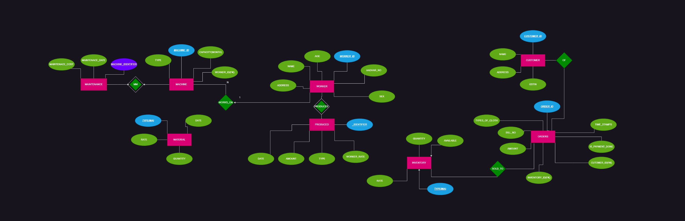

**C) REVISED PROBLEM STATEMENT:**

Additional Requirements:

User Interface: Design a user-friendly interface for the system, allowing easy navigation and efficient data entry.

Reporting: Implement reporting functionalities to generate various reports such as production summaries, inventory status, and financial statements.

Deliverables: Detailed system design documentation including entity-relationship diagrams, database schema, and system architecture. User manuals and documentation for system users and administrators.

**D) REVISED ER MODEL:**

