**3.TRIGGERS AND PROCEDURE**

**a) Designing Front end, for the Input operations, Output deliverables/objectives to be performed as stated in the revised problem.**

For frontend, we have used next.js technology for performing the crud operations.

We need to make sure that there are form based inputs, and then also there is pagination to see the data. Here are the outputs:

1. Create

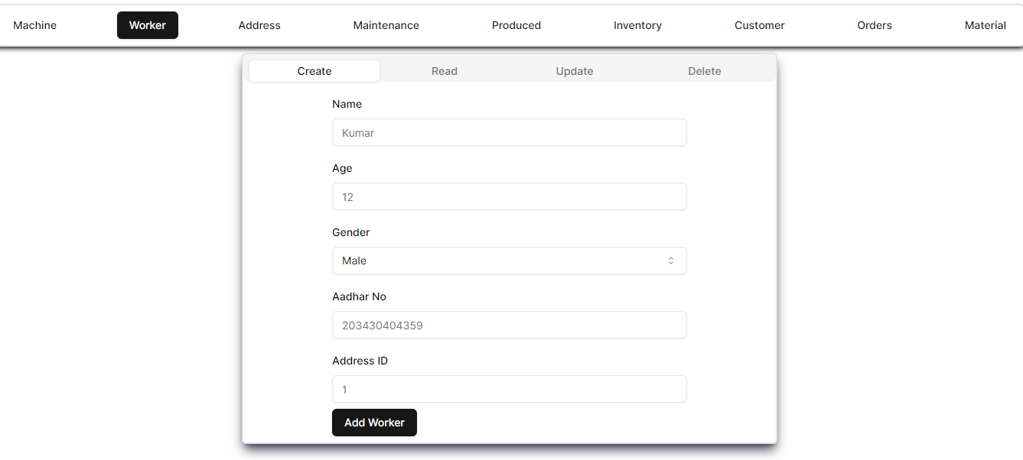

1. Read

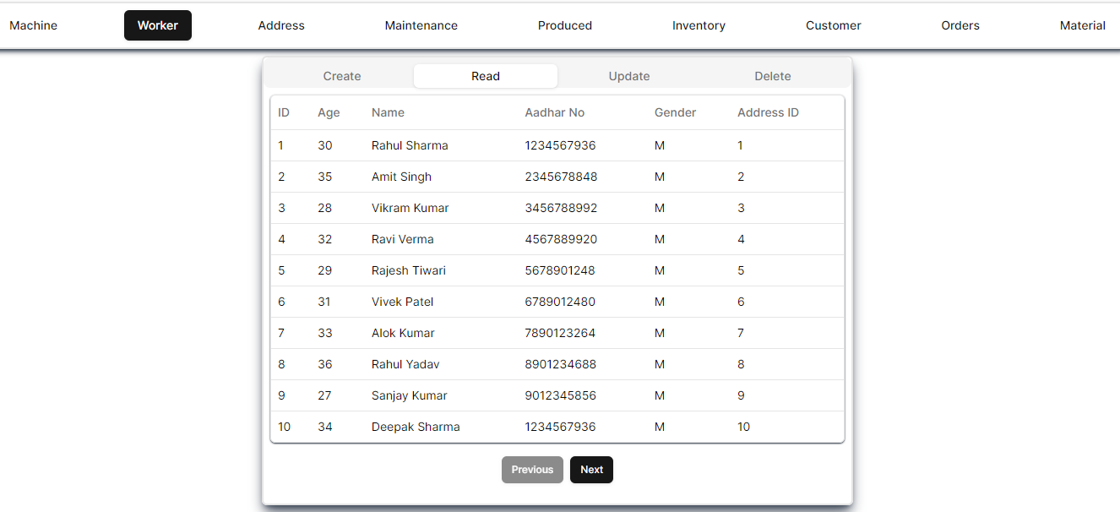

1. Update

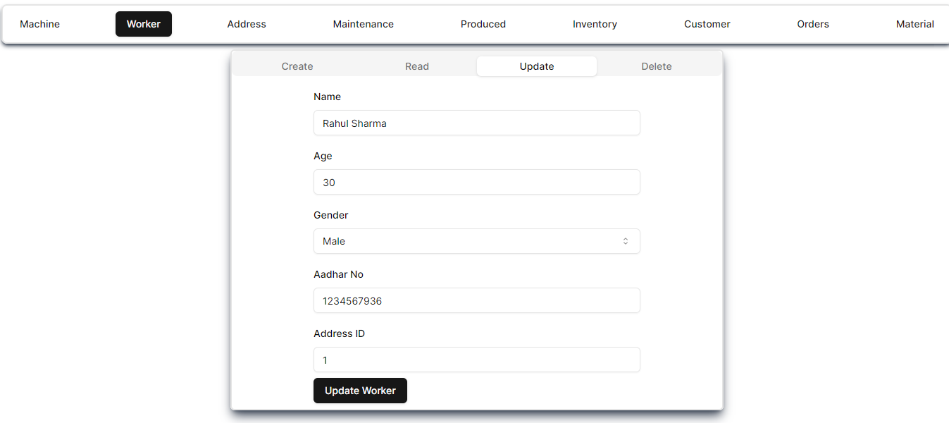

1. Delete

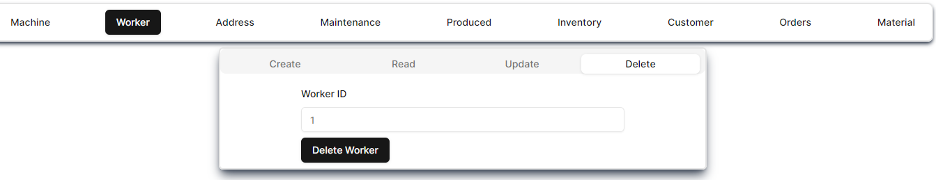

**b) REPORTS GENERATION –**

Reports and Visualization are done using Power BI software.

To achieve this connect the created database to Power BI then Create visualizations using the various tools in the software.

Then it is also possible to export these visuals as pdf using Power BI itself.

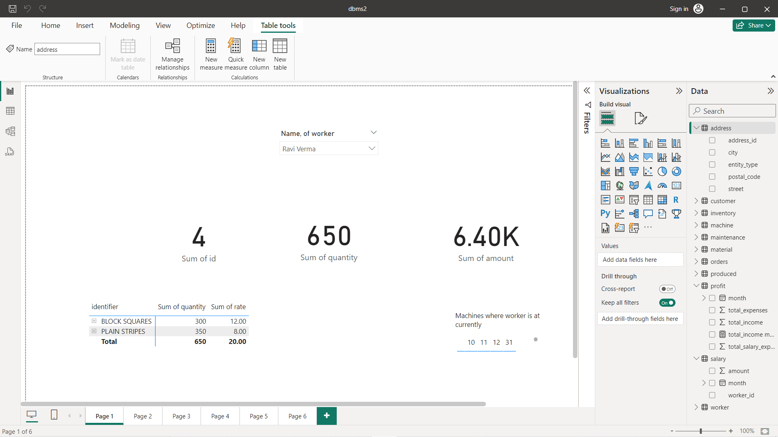

Creating visuals using Power BI

Following are the reports and visualizations for our problem statement:

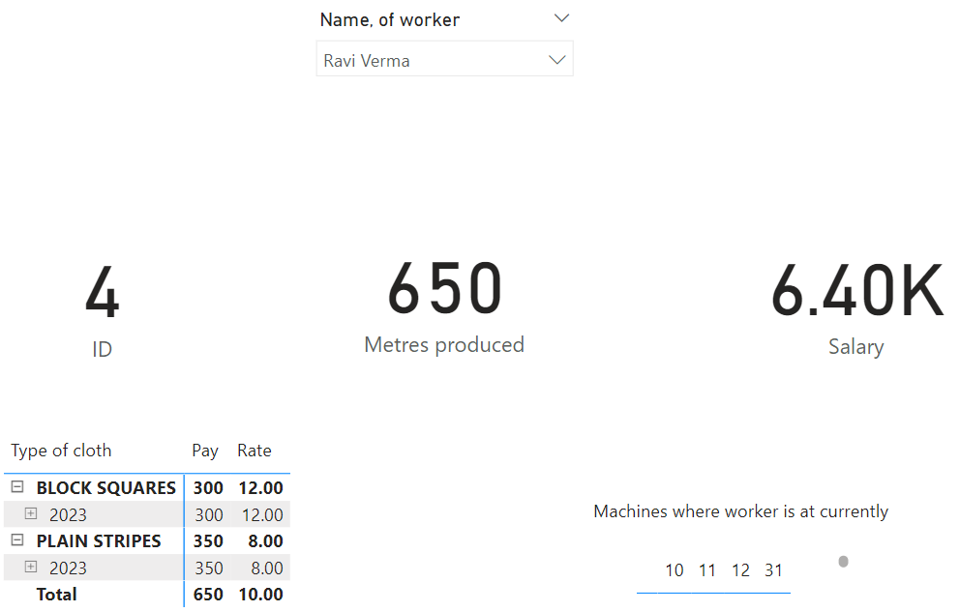

This allows for us to view various information about the workers like the salary to be paid and the amount they produced.

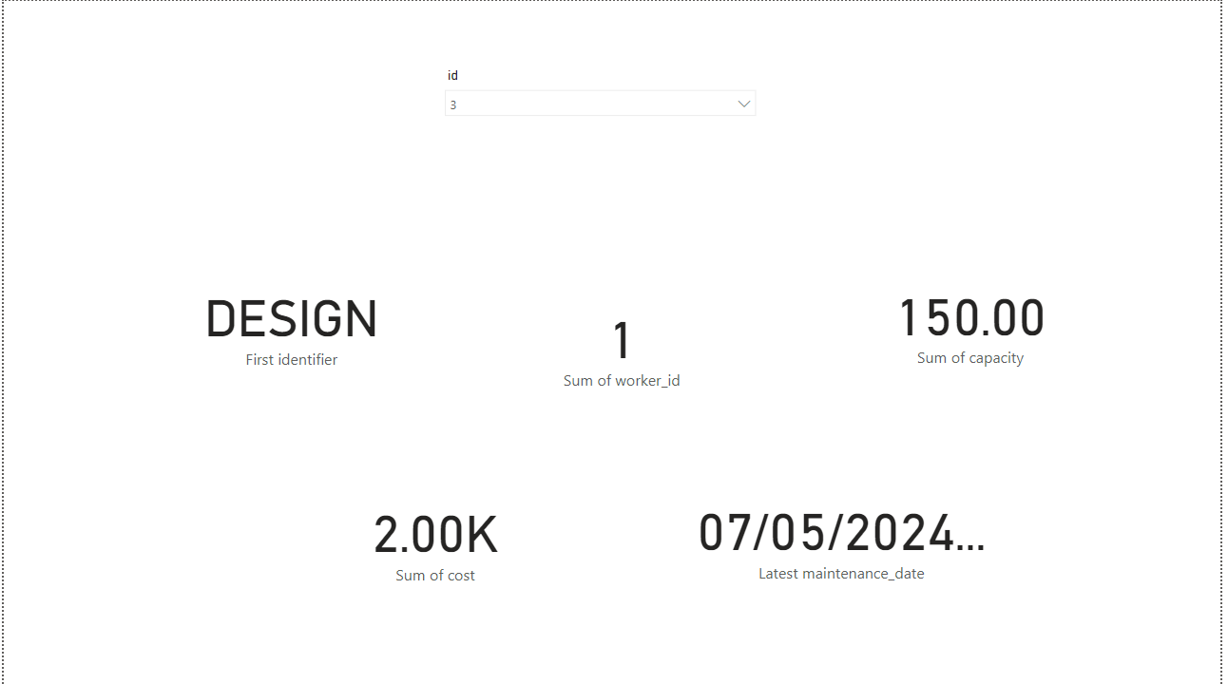

This one allows us to view information about the machines present including maintenance information.

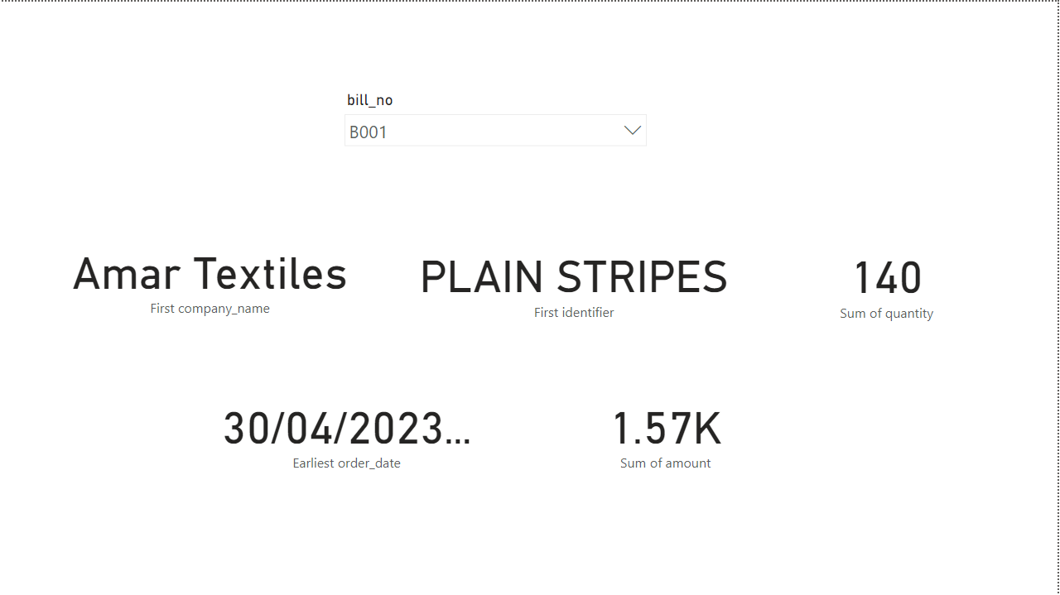

This one allows us to generate information about bills for the orders that come in to the firm.

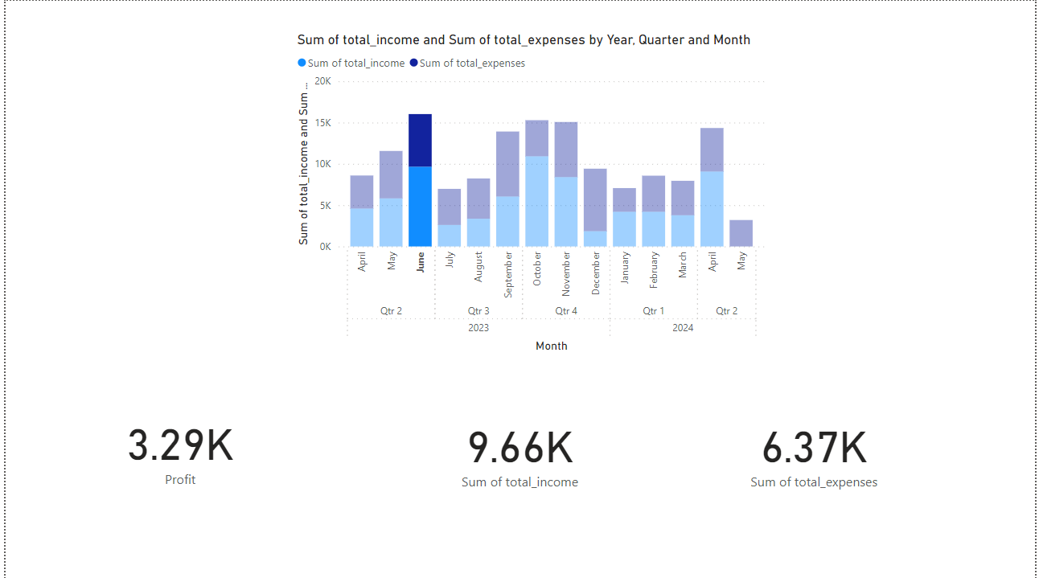

This allows us to visualize and know the profit per month using expenses and income.

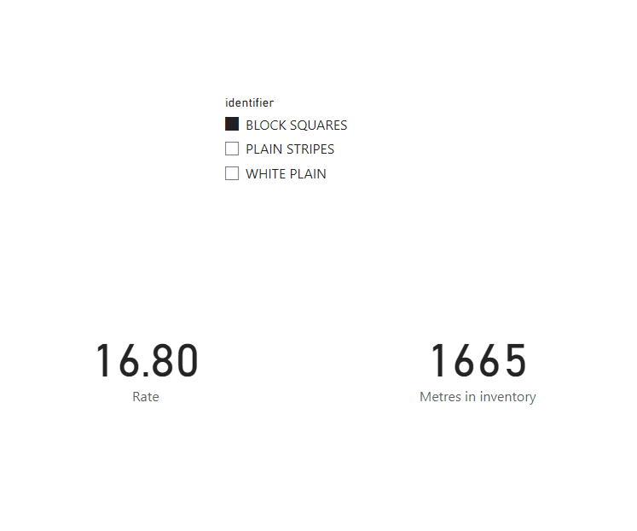

This allows us to view the inventory in a good way.

Now these visuals can be exported to pdf using the Power BI software itself.

Here’s the pdf:

