ONE-WAY HASH FUNCTION AND MAC CRYPTOGRAPHY Lab manual

Hashing and Message Authentication with Ethics Integration
Lab Exercise Revision Institution: Colorado School of Mines
(The original lab was from the SEED Labs; the following contributors significantly revised it for clarity, relevance, and ethics integration.)
Lab Manual Revision Contributors:
Zinedine Boumghar*, Chuan Yue@
(*: Graduate student and research/teaching assistant; @: Faculty.)

Hashing and Message Authentication LAB EXERCISE
Lab Description: You will utilize the open-source cryptographic library, OpenSSL, to perform different message digest (non-keyed hash value and keyed hash value) generation tasks. You will experiment with the Password-Based Key Derivation Function Version 2 (PBKDF2). Meanwhile, you will develop programs to break the one-way property and the collision-free property of cryptographic hash functions on a “modified hash function”. This lab consists of five STEPs.
When you answer the detailed questions in this lab, please provide screenshots of your commands, messages, file contents, and other materials that are relevant. Please also check and meet all explanation, analysis, and/or discussion related requirements.
The high-level learning outcomes and the corresponding assessment of this lab are summarized as follows. In other words, upon completion of this lab, students should be able to:
- Examine the functionality of OpenSSL message digest generation using both non-keyed and keyed cryptographic hash algorithms.
  - Assessed by the tasks and outputs specified in STEPs 1, 2, 3.
- Develop a program for securely using Password-Based Key Derivation Function Version 2 (PBKDF2).
  - Assessed by the tasks and outputs specified in STEP 4.
- Develop programs capable of brute-forcing the one-way property and the collision-free property on a “modified hash function”.
  - Assessed by the tasks and outputs specified in STEP 5.
- Explain the difference between the one-way property and the collision-free property; namely, their difficulty in breaking.
  - Assessed by the tasks and outputs specified in STEP 5.
- Improve ethical competency including ethical knowledge, sensitivity, and judgment.
  - Assessed by the tasks and outputs specified in STEPs 4 and 5.
Lab Environment: Ideally Linux Kernel v5.15.0 (such as Ubuntu v20.04.6) or higher (e.g., pre-installed on Colorado School of Mines Isengard isengard.mines.edu or your own machine)
Lab Files that are Needed: N/A
Lab Resources that are Recommended: HexEd.it Website (or any other hex file editor you are comfortable with) the PyCryptoDome Python Library (if you choose to write your program in Python)

LAB EXERCISE/STEP 1 (Download and Install OpenSSL)
Download and install version 1.1.1 or higher of OpenSSL from the official download webpage. Alternatively, you can clone the OpenSSL GitHub repository if you’re having trouble unrolling the downloaded tar file; afterward, follow the steps provided in the INSTALL.md file of the OpenSSL directory. If you’re working with a Linux environment (e.g., Mines Isengard), chances are you already have it installed and ready to use (without extra downloading or installation). You can verify this by running the following command in your terminal.
~$ openssl version

LAB EXERCISE/STEP 2 (GENERATE non-keyed hash values)
For this task, you will be testing various one-way hash algorithms supported by OpenSSL. First, create a plaintext file that OpenSSL will generate a hash value for. You are required to include your full name in the plaintext; meanwhile, the file should be at least 64 bytes (characters) long, and should contain a simple message in readable English with alphanumeric characters only.
Then, use the following openssl dgst command to generate a hash value for the file. To see the manuals for more information, you can enter man openssl, man dgst, and openssl dgst -help into your terminal.
~$ openssl dgst <dgsttype> <input filename>
Please replace the <dgsttype> argument with a specific one-way hash algorithm, such as -md5, -sha1, -sha256, -sha512, or -sha3-512, as well as <input filename> as appropriate per the following requirements.
In this task, you should use at least 3 different one-way hash algorithms (note that different hash value sizes can be considered as different algorithms), and the size of each hash value should be at least 256 bits. Note that you can use the command “openssl list -digest-algorithms” to find the available algorithms.

Please answer Questions 1, 2, and 3:
Question 1: (3 points)
What were the contents of the plaintext file (note that you are required to include your full name in the plaintext) you created for your OpenSSL message digest (hash value) creation?

Question 2: (5 points)
What were the message digest commands you ran for your chosen one-way hash algorithms? What were the computed hash values after running each command?

Question 3: (2 points)
What are your observations when comparing the computed hash values of different algorithms on the same input file? Be sure to discuss the lengths of the hash values and the values themselves.

LAB EXERCISE/STEP 3 (GENERATE KEYED HASH values)
OpenSSL also supports generating a keyed hash (i.e., hash-based MAC, or HMAC) for a file. This can be done by adding the -hmac option to the command used in STEP 2.
~$ openssl dgst <dgsttype> -hmac <key> <input filename>
Note that you may have to enclose the key with quotation marks if it contains non-alphanumeric characters (e.g.: spaces).

Using the plaintext file you created in STEP 2 to generate keyed hash values. In this task, you should also try at least 3 different one-way hash algorithms (note that different hash value sizes can be considered as different algorithms), and the size of each hash value should be at least 256 bits. Meanwhile, you should test keys of at least three different lengths (specifically, one character or 8 bits, 30 characters, and 80 characters) on each algorithm. So, you will run at least nine commands.

Please answer Questions 4 and 5:
Question 4: (5 points)
What were the keyed hash commands you ran for each keyed hash algorithm? What were the computed hash values after running each command?

Question 5: (5 points)
Do we have to use a key with a fixed size for HMAC? If yes, what is the key size? If not, what does HMAC do with keys to provide this flexibility?

LAB EXERCISE/STEP 4 (Experiment with Password-Based Key Derivation Function Version 2 (PBKDF2))
You have experimented with the pseudorandom number generation for cryptographic uses (e.g., 128-bit AES keys) in Lab1. You have also experimented with the keyed hash generation in Step 3 above; note that although the HMAC key is composed of hardcoded alphanumeric characters when you use the openssl command line, you should generate and use a key that is random and unpredictable when you use HMAC APIs to write a program.
In real-world applications, you or systems often need to derive a cryptographic key based on a strong password, instead of directly using a password as the key. For example, the strong password of your Linux or Windows account (or of your web browser or mobile app account) is often used to derive a strong cryptographic key as the master key, which is used to encrypt other keys or sensitive information.
Such a process has indeed been specified in RFC 2898 as Password-Based Key Derivation Function Version 1 (PBKDF1) and Version 2 (PBKDF2). In 2010, NIST has further approved (in its Special Publication SP 800-132 titled “Recommendation for Password-Based Key Derivation”) PBKDF2 as the PBKDF using HMAC with any approved hash function as the Pseudorandom Function (PRF). That’s why you can find the support of PBKDF2 in many cryptographic libraries and find the uses of PBKDF2 APIs in many software systems.
NIST SP 800-132 only contains 18 pages of content. We strongly recommend you read its details when you use PBKDF2 in your real software development tasks. Its Section 5.3 provides the PBKDF2 algorithm (as shown below in Figure 1 for your reference), and its Section 5.4 provides two typical options of using a PBKDF2-derived master key to further protect sensitive data as hinted above.
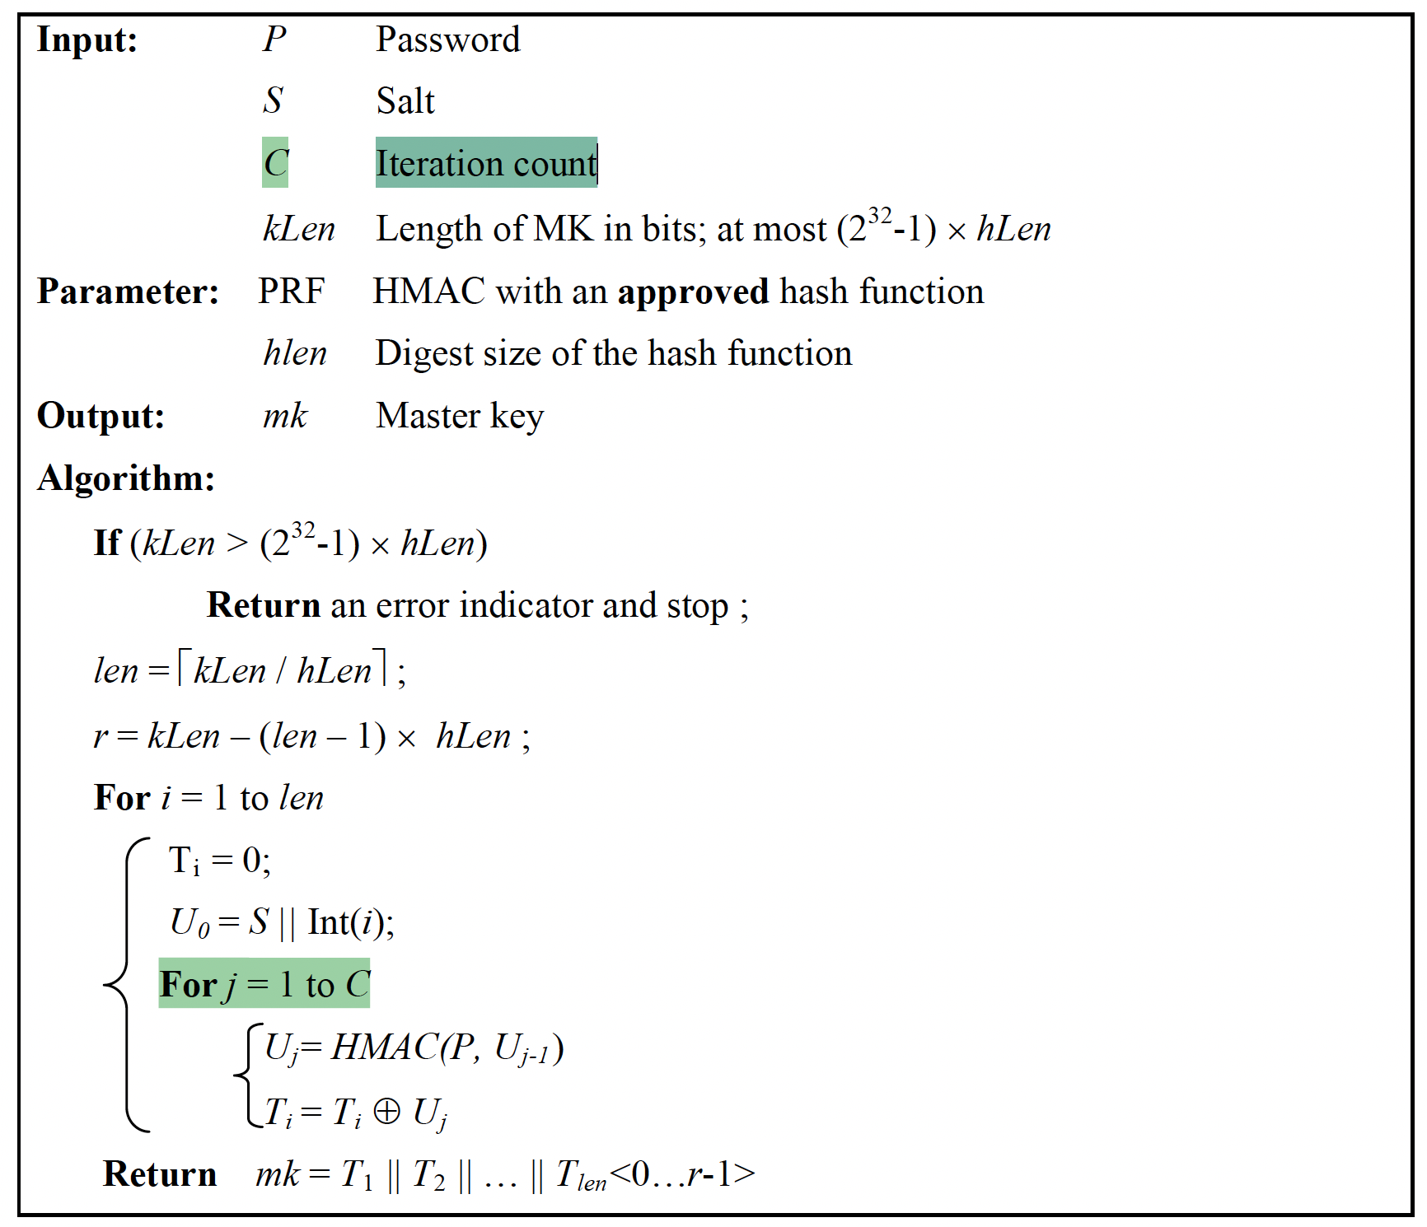
Figure 1: The Password-Based Key Derivation Function Version 2 (PBKDF2) described in the 2010 NIST Special Publication SP 800-132 titled “Recommendation for Password-Based Key Derivation”.
Also note that in the 2013 CryptoLint research paper “An Empirical Study of Cryptographic Misuse in Android Applications” that you read and summarized, although PBKDF was not explicitly mentioned, Password-Based Encryption (PBE) mentioned in it indeed uses a key derived based on PBKDF (should be PBKDF2) and an underlying encryption scheme (e.g., aes-128-cbc).
In either RFC 2898, NIST SP 800-132, or the 2013 CryptoLint research paper, it is mentioned something like that “a minimum iteration count of 1,000 is recommended.” The iteration count is C as highlighted in Figure 1.
Please answer Questions 6 and 7:
Question 6: (5 points)
Why did the designers of the PBKDF2 algorithm (as shown in Figure 1) use a “For j = 1 to C” loop to call the HMAC function C times instead of just one time? What could be the tradeoffs between using a very large vs. a very small iteration count C value?

Question 7:
You’ve been hired by the IT department of our school as a student employee to write a function or method (in any of your preferred programming language, e.g., Python, Java, C, or JavaScript) that will take a user-supplied password with at least 12 characters as the input and generate a 128-bit key (e.g., for aes-128-cbc) as an output. Your supervisor at the IT department is aware of PBKDF2, and asks you to use the PBKDF2 API in some reputable cryptographic library with the recommended minimum iteration count of 1,000 in your implementation. Your supervisor states that your function or method should further meet these three requirements: (1) generate a key within one second, which is a perfectly tolerable delay to end users; (2) securely generate and use a random salt with sufficient length in each key derivation, and return the salt in use together with the generated key; (3) use a NIST approved hash function with a sufficient hash value length as the Pseudorandom Function (PRF) in HMAC calculation.
Note that you can simply assume that the system you are using for the development and evaluation of your function or method is identical to that of end users (i.e., they have the identical computation power). Also note that you do not need to implement the PBKDF2 algorithm but simply use the PBKDF2 API in some reputable cryptographic library (e.g., https://www.pycryptodome.org/src/protocol/kdf in the PyCryptoDome Python Library), unless you find enjoyment in doing so and would further provide the correctness, security strength, and efficiency analysis of your implementation.

Question 7 (a): (15 points)
What is the complete code for your function or method, and what are your corresponding evaluation results? Specifically, please show and justify that your function or method meets all requirements mentioned above.

Question 7 (b): (15 points)
Drawing from your earlier conclusion in Question 6 and what you learned from the ACM Code of Ethics and Professional Conduct (e.g., from our CSCI 128 Computer Science for STEM or related courses; if you did not learn anything about it, please read its “General Ethical Principles” and “Professional Responsibilities” sections at https://www.acm.org/code-of-ethics), do you have any reasons to be concerned about using the minimum iteration count of 1,000 in your implementation? If yes, what is your program’s code and what is your corresponding experiment for determining an appropriate iteration count value (make sure to show the value and your experimental result; make sure to consider that perfectly tolerable “one second” delay hint) in your PBKDF2 API call? Would you report and justify your iteration count selection to your supervisor at the IT department? What ethical justifications do you have for your actions?

LAB EXERCISE/STEP 5 (COMPARE ONE-WAY PROPERTY AND COLLISION-FREE PROPERTY)
For this task, you will investigate the difference between two important properties in hash functions: one-way property and collision-free property. To do this, you perform brute-force attacks to see how long it takes to break each of these properties. Instead of using the OpenSSL command-line tool, you’re required to use a Crypto library of your choice to write code and generate message digests. Note that the “collision-free property” in this task is the “strong collision resistant property” we discussed in the class, while the “one-way property” in this task can also be conveniently experimented with by simply considering the “weak collision resistant property" we discussed in the class if you prefer.
You have a great degree of freedom when it comes to choosing a library. OpenSSL provides a C programming language API called EVP, which works as a high-level interface to cryptographic functions. Alternatively, you could use the instructor’s recommendation, the PyCryptoDome Python Library. This library is simple to install and provides great documentation for various cryptographic tasks including hashing (https://www.pycryptodome.org/src/hash/hash). The only requirement for your library is that it can complete the task described below.
You will be creating two separate programs that each employs the brute-force method. Both programs will use your chosen Crypto library to create message digests (hash values) from each input tested/guessed.
Your first program will brute force the one-way property of hash functions. In other words, given a hash value, your program will exhaustively search to find an input (note that it must be different from the original input if you experiment with the “weak collision resistant property") that results in the exact hash value.
Your second program will brute-force the collision-free property of hash functions. In other words, your program will exhaustively generate, store, and compare the hash values of different inputs. It will continue to do this and must stop once it generates the same hash value from any two different inputs that it has tried at that moment, indicating that a collision has occurred.
Of course, cryptographic hash functions are very resilient to brute-force attacks on those two properties. To make this task feasible, please “reduce” the length of the hash value comparison to 24 bits. In other words, in both programs, please use a same SHA2 or SHA3 hash function available in your Crypto library to generate hash values with a length of at least 256 bits, but you only need to find a collision or match in the most significant 24 bits of the function’s returned hash value. Let’s refer to such a function as a “modified hash function”.
Some important notes to keep in mind:
- Even with the above 24-bit constraint or confinement, your programs can take a significant amount of time (or even fail) to complete their brute-force attacks if your implementation is inefficient or contains bugs.
- A same SHA2 or SHA3 hash function should be used in both programs, so that you can have a fair comparison of their results.
- If you choose to use the C programming language and the libcrypto library within OpenSSL, this link provides an example: https://wiki.openssl.org/index.php/EVP_Message_Digests.

Please answer Questions 8, 9, 10, and 11:
Question 8: (15 points)
How many trials did it take for your first program to brute force the one-way property of the “modified hash function”? Here, the number of trails means the total number of different inputs that your program has used to eventually generate the first match to the given hash value. Please run your program at least 10 times (i.e., 10 runs), each with a different given hash value for which the first collision or match is being sought. Please report the number of trials for each run and the average number of trails for all runs. Meanwhile, please provide the screenshots of your entire program’s code, and the execution of your program with at least one run’s output.

Question 9: (15 points)
How many trials did it take for your second program to brute force the collision-free property of the “modified hash function”? Here, the number of trails means the total number of different inputs that your program has used to eventually generate the first collision or match (based on any two different inputs). Please run your program at least 10 times (i.e., 10 runs), each with a different input space for which the first collision or match is being sought. Please report the number of trials for each run and the average number of trails for all runs. Meanwhile, please provide the screenshots of your entire program’s code, and the execution of your program with at least one run’s output.

Question 10: (5 points)
Based on your understanding of the one-way and collision-free properties of cryptographic hash functions and your answers to Questions 8 and 9, which property is easier to break using a brute-force attack? Please mathematically explain your answer (hint: what is the expected number of trials needed to break each property for a hash function with the n-bit hash value output?)

Question 11: (10 points)
When following good security practices, authentication systems or services will store users’ account passwords as hash values (rather than plaintexts). Each hash value should be generated using a strong cryptographic hash function with a user’s account password and an account-specific random value (called a “salt”) as the input, i.e., through a salted-hashing process. Please search online and further learn about the typical salted-hashing process if it is unclear to you.

Assume that you are doing a summer intern in an e-commerce company. You found that the company’s user authentication system provides a convenient password recovery feature to users. That is, if any user forgets about their account password, the system can securely send the password to the user’s email account.

Drawing from your earlier answers to Questions 8~10 and what you learned from the ACM Code of Ethics and Professional Conduct (e.g., from our CSCI 128 Computer Science for STEM or related courses; if you did not learn anything about it, please read its “General Ethical Principles” and “Professional Responsibilities” sections at https://www.acm.org/code-of-ethics), do you have any reasons to be concerned that hashing was not used in the company’s user authentication system? Would you report your concerns to your supervisor in the company and further provide your recommendation to improve the password storage scheme of the user authentication system? If yes, what is your recommendation (please provide a working code example that securely stores a user’s password, and provide its demo execution along with results) and your explanation? What ethical justifications do you have for your actions?

What To Submit

Please answer all the 11 questions in this lab exercise. Please feel free to directly reuse this Word document to provide and submit your answers. Please submit additional materials (if specified in an individual question) in zipped files.

