secret key encryption cryptography Lab manual
Secret Key Encryption with Ethics Integration
Lab Exercise Revision Institution: Colorado School of Mines
(The original lab was from the SEED Labs; the following contributors significantly revised it for clarity, relevance, and ethics integration.)
Lab Manual Revision Contributors:
Zinedine Boumghar*, Chuan Yue@
(*: Graduate student and research/teaching assistant; @: Faculty.)

Secret key Encryption LAB EXERCISE
Lab Description: You will utilize the open-source cryptographic library, OpenSSL, to perform different symmetric-key encryption and decryption tasks. You will learn the strengths and weaknesses of various block cipher modes of operation, analyze their padding requirements, and understand how they work to perform encryption and decryption. Meanwhile, you will write a program that calls cryptographic APIs from a library (of your choice) to brute force a key. You will also experiment with the pseudorandom number generation code for cryptographic uses. This lab consists of seven STEPs.
When you answer the detailed questions in this lab, please provide screenshots of your commands, messages, file contents, and other materials that are relevant. Please also check and meet all explanation, analysis, and/or discussion related requirements.
The high-level learning outcomes and the corresponding assessment of this lab are summarized as follows. In other words, upon completion of this lab, students should be able to:
- Examine the functionality of OpenSSL encryption and decryption.
  - Assessed by the tasks and outputs specified in STEPs 1 and 2.
- Analyze the strengths and weaknesses of various block cipher modes (of operation) in different situations.
  - Assessed by the tasks and outputs specified in STEPs 3 and 4.
- Explain the padding requirements for certain block cipher modes.
  - Assessed by the tasks and outputs specified in STEP 5.
- Develop a program capable of breaking a key given the plaintext, ciphertext, and additional information about the key and cipher used.
  - Assessed by the tasks and outputs specified in STEP 6.
- Identify pseudorandom number generation APIs that are for cryptographic uses.
  - Assessed by the tasks and outputs specified in STEP 7.
- Improve ethical competency including ethical knowledge, sensitivity, and judgment.
  - Assessed by the tasks and outputs specified in STEPs 3 and 7.

Lab Environment: Ideally Linux Kernel v5.15.0 (such as Ubuntu v20.04.6) or higher (e.g., pre-installed on Colorado School of Mines Isengard isengard.mines.edu or your own machine)
Lab Files that are Needed: pic_original.bmp and a simple English word dictionary words.txt; both are provided on the lab assignment webpage.
Lab Resources that are Recommended: HexEd.it Website (or any other hex file editor you are comfortable with) the PyCryptoDome Python Library (if you choose to write your program in Python)

LAB EXERCISE/STEP 1 (Download and Install OpenSSL)
Download and install version 1.1.1 or higher of OpenSSL from the official download webpage. Alternatively, you can clone the OpenSSL GitHub repository if you’re having trouble unrolling the downloaded tar file; afterward, follow the steps provided in the INSTALL.md file of the OpenSSL directory. If you’re working with a Linux environment (e.g., Mines Isengard), chances are you already have it installed and ready to use (without extra downloading or installation). You can verify this by running the following command in your terminal.
~$ openssl version

LAB EXERCISE/STEP 2 (Encrypt Using Different Ciphers and Modes)
For this task, you will be testing various encryption algorithms and modes to familiarize yourself with OpenSSL commands. First, create a plaintext file whose contents will be encrypted with OpenSSL. You are required to include your full name in the plaintext; meanwhile, the file should be at least 64 bytes (characters) long, and should contain a simple message in readable English with alphanumeric characters only.
Then, use the following openssl enc command to encrypt the file. To view the manuals for more information, enter man openssl, man enc, or openssl enc -help into your terminal.
~$ openssl enc <cipher> -e -in <input filename> \
-out <output filename> -K <key in hexadecimal> \
-iv <initialization vector in hexadecimal>
Please replace the <cipher> argument with a specific cipher-and-mode combination, such as -aes-128-cbc or -des-ecb, as well as <input filename> and <output filename> as appropriate. Additionally, you should provide a key and an initialization vector (if needed by the cipher or mode) of the appropriate length for your cipher choice. How you generate the key (and the initialization vector if needed) is up to you.
In this task, you should try at least 3 different cipher-and-mode combinations. Be sure to both encrypt the plaintext and decrypt the ciphertext when testing a cipher-and-mode combination.

Please answer Questions 1, 2, and 3:
Question 1: (3 points)
What were the contents of the plaintext (note that you are required to include your full name in the plaintext) you created for your OpenSSL encryption?

Question 2: (5 points)
What were the encryption commands you ran for your chosen cipher-and-mode combinations? What were the contents of the ciphertext after running each command?

Question 3: (5 points)
What were the decryption commands you ran for your chosen cipher-and-mode combinations? What were the contents of the plaintext after running each command? (Hint: You only need to change one flag and switch two arguments for decryption!)

LAB EXERCISE/STEP 3 (Compare ECB Mode To CBC Mode)
You’ve been tasked with handling an image file, pic_original.bmp, containing some sensitive information for the company you work at. Therefore, your job is to encrypt this file so that only people with the decryption key (e.g., company employees) can recover the original image.

First, please encrypt the file using the ECB (Electronic Code Book) and CBC (Cipher Block Chaining) modes, respectively. The cipher can be AES with the key size 128 bits; you can use other symmetric ciphers, but must avoid insecure ones such as DES.

Next, treat each encrypted file as a normal .bmp picture file and use picture viewing software to display it. However, for a picture file with the .bmp format, the first 54 bytes contain header information about the picture that is needed for it to be opened properly. To fix this, you will replace the header of an encrypted file with the header of the original picture file. In simpler terms, copy the first 54 bytes of the original pic_original.bmp file over the first 54 bytes in each encrypted picture file. To do this, use a hex editor tool to directly modify the binary file. We recommend using the browser-based editor HexEd.it.

E.g., open a file in HexEd.it, make the necessary changes mentioned above (note that copying/pasting may not work directly, so you would need to type the first 54 bytes of the original pic_original.bmp file into each encrypted picture file), and then export the file to be opened with your picture-viewing software (which can simply be a browser, i.e., you can simply drag the file to a browser window).

Please answer Questions 4, 5, 6, 7, and 8:
Question 4: (5 points)
What was the encryption command you ran to test the ECB mode? After encrypting it and fixing the header with your hex editor, what was the resulting picture? Please also include a picture of the header being modified using your editor of choice.

Question 5: (5 points)
What was the encryption command you ran to test the CBC mode? After encrypting it and fixing the header with your hex editor, what was the resulting picture? Please also include a picture of the header being modified using your editor of choice.

Question 6: (2 points)
Analyze the encrypted pictures from both modes. Can you derive information about the original picture from either of the encrypted pictures?

Question 7: (5 points)
Which of the two modes, if any, would you avoid using to encrypt a file containing sensitive information of your company or our school? If you identified one or both modes, explain the reasoning behind your decision in terms of the mode’s security issues.

Question 8: (10 points)
While exploring the choices for your designated task, you happen to learn that Bob, an employee at the Student Center of our school, regularly uses AES-128 encryption on a document containing students’ sensitive information (including ID, date of birth, and GPA, etc.). When you ask him which encryption mode he uses, he replies that he just uses an open-source Java program with the default option (as shown below) and has no idea or concept about the exact mode (as he never took a cryptography course or learned more details about it, although he was a CS student):
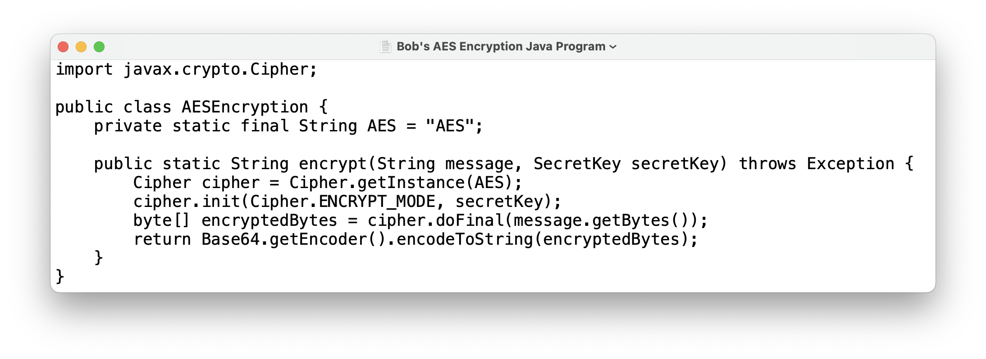
Out of curiosity, you further ask Bob to check the version of the
Java Runtime Environment (JRE) he is using, and found it to be JRE 14.

Please further analyze this case (e.g., by searching online) based on the provided information. Drawing from your earlier conclusion in Question 7 and what you learned from the ACM Code of Ethics and Professional Conduct (e.g., from our CSCI 128 Computer Science for STEM or related courses; if you did not learn anything about it, please read its “General Ethical Principles” and “Professional Responsibilities” sections at https://www.acm.org/code-of-ethics), do you have any reasons to be concerned? If yes, would you provide some concrete suggestions (please specify) to Bob, and what ethical justifications do you have for your actions?

LAB EXERCISE/STEP 4 (Corrupt Ciphertext and Attempt Decryption Afterward)
Ensure that your plaintext file from STEP 2 is at least 64 bytes long with your full name included. Or you can create a new plaintext file that meets these requirements.
Once the plaintext is ready, you will perform the following exercise. First, encrypt the file with the AES-128 cipher using each of the following modes once: ECB, CBC, CFB, and OFB, individually, to generate four encrypted files. Make sure to keep the key and initialization vector (if needed) used in each encryption. Unfortunately, while handling each encrypted file, a single bit in the 30th byte of the file got corrupted. You can replicate this scenario by using your hex editor from STEP 3 to edit any bit in the 30th byte in each encrypted file.

Please answer Questions 9, 10, 11, and 12:
Question 9: (2 points)
What hex editor did you use to corrupt the ciphertext files? How did you ensure that only a single bit in the 30th byte was corrupted? Provide screenshots or descriptions of using the hex editor to corrupt the ciphertext files.

Question 10: (3 points)
If the encrypted files were to be decrypted with the corruption present, how much information do you predict could be recovered with each mode?

Question 11: (5 points)
Proceed to decrypt your 4 corrupted ciphertext files using the corresponding mode, key, and IV (if needed) for each file. Provide screenshots that show the difference in your plaintext before and after decryption for each mode. Were your predictions in Question 10 correct or incorrect? What explanations justify your observations of the decrypted plaintext?

Question 12: (2 points)
What are the overall conclusions you can draw about how much data can be recovered with each mode when one bit in one block is corrupted?

LAB EXERCISE/STEP 5 (Design An Experiment To Study Padding Schemes)
As we’ve studied in class, when the size of the plaintext is not a multiple of the block size, the block cipher may need to pad the text. The openssl manual states that openssl uses the PKCS#5 or PKCS#7 (depending on the version of openssl) standard by default for its padding. In this task, you will verify this is the case as well as test which block cipher modes do and do not use paddings.

Please answer Questions 13 and 14:
Question 13: (5 points)
Design an experiment to confirm that openssl uses the PKCS#5 or PKCS#7 standard padding by default. Outline the steps in this experiment and the reasoning behind your design. How will your experiment confirm the PKCS#5 or PKCS#7 usage?

Question 14: (8 points)
Create two new plaintext files, one with a length of 20 bytes and one with a length of 32 bytes. Use your experiment from Question 13 and AES-128 encryption to determine the length and value of the padding for both files when your mode of operation is ECB, CBC, CFB, and OFB, respectively. Report which modes have paddings, and which do not. For those that don’t need paddings, please explain why.

LAB EXERCISE/STEP 6 (Write A Program Using a Crypto Library)
Throughout this lab, you’ve been using the openssl tool to encrypt and decrypt messages with the command line interface. For this task, you will now be using a Crypto library of your choice to write a program for encrypting and decrypting messages.

You have a great degree of freedom when it comes to choosing a library. OpenSSL provides a C programming language API called EVP, which works as a high-level interface to cryptographic functions. Alternatively, you could use the instructor’s recommendation, the PyCryptoDome Python Library. This library is simple to install and provides great documentation for various cryptographic tasks. Its reference code for the CBC mode can be found at https://www.pycryptodome.org/src/cipher/classic#cbc-mode. The only requirement for your library is that it can complete the task described below.

You have been given a plaintext and a ciphertext that you know was generated using aes-128-cbc. You also know that the numbers used in the IV are all zeros (not the ASCII character ‘0’ but the 0-bit value). Another clue you’ve learned is that the key used to encrypt this plaintext is an English word shorter than 16 characters. That is to say, the word can be found in a typical English dictionary (please make sure to use the provided words.txt) and has less than 16 characters. Since the word is less than 16 characters (i.e., less than 128 bits), space characters (hexadecimal value of 0x20) are appended to the end of the word to form a key of 128 bits. Your goal is to write a program that can determine (i.e., brute force) the key from the information or clues provided. The plaintext and ciphertext are the following:
Plaintext (21 characters long): This is a top secret.
Ciphertext (in hex format): c34c12baffcb609d5b63da20d2cbf058
c8e26f3903ab070b99f18d6fbcdfcd19

Some important notes to keep in mind:
- If you choose to store the plaintext message in a file and feed the file to your program, ensure the file length remains 21 characters long. Some editors add a special character to the end of the file. If that happens, you can use your hex editor tool to remove the character.
- In this task, you are supposed to write your own program that uses APIs in a Crypto library of a certain programming language. No credit will be given for a shell or script program that simply calls openssl commands to do the task.
- Read the documentation for your library of choice carefully. Many often provide detailed examples and explanations of how to perform encryption and decryption. Be patient and try to enjoy this self-study process. Also pay careful attention to the data types and encoding schemes no matter which language and library you choose to use, as they can easily incur errors in your code.
- Instead of immediately determining the key used in this task, a good strategy is for you to first use a known key (e.g., the English word “nice” which is also in words.txt) to experiment with your encryption and decryption code to ensure its correctness. You can then use your correct code to brute force the key used in this task.
- If you choose to use the C programming language and the libcrypto library within OpenSSL, this link provides an example: https://wiki.openssl.org/index.php/EVP_Symmetric_Encryption_and_Decryption.
- No matter which programming language you will use, make sure to use either PKCS#5 or PKCS#7 as your message padding method; they are equivalent for this programming task, and typically either PKCS#5 or PKCS#7 is the default method in many crypto libraries.

Please answer Questions 15 and 16:
Question 15: (2 points)
What is the name and version of the library you’re using and what license does it have? Please provide links to the documentation homepage and license information. Under the library’s license, would you be allowed to create a program that uses the library to perform penetration testing on your own home network? Would this license let you sell this program as a service to companies?

Question 16: (15 points)
What is the key (i.e., the English word) used to generate the ciphertext in the problem? Meanwhile, please provide the screenshots of your entire program’s code, and the execution of your program with the correct output.

LAB EXERCISE/STEP 7 (Experiment with pseudorandom number generation APIs for cryptographic uses in Python, Java, C, or Javascript)

Generating pseudorandom numbers for cryptographic uses is one of the most common tasks of security software. For example, in many cases, encryption keys aren’t provided by the users by hand but are instead generated within the software. The randomness and unpredictability of a key are extremely important; otherwise, attackers will predict or derive the key to defeat the encryption scheme.

However, as simple as it sounds, many developers fail to generate secure random numbers, even those with prior experience creating random number sequences. To give you an idea, a developer who has worked with Monte Carlo simulation or game development understands the important role randomness plays in providing good data. Therefore, they may employ the same techniques used in Monte Carlo simulation or game development to make encryption keys.

You’ve been hired by the IT department of our school as a student employee to help maintain a Python program, which uses AES to encrypt the business credit cards of our school. You found that this Python program uses the following code to generate the 128-bit AES keys:
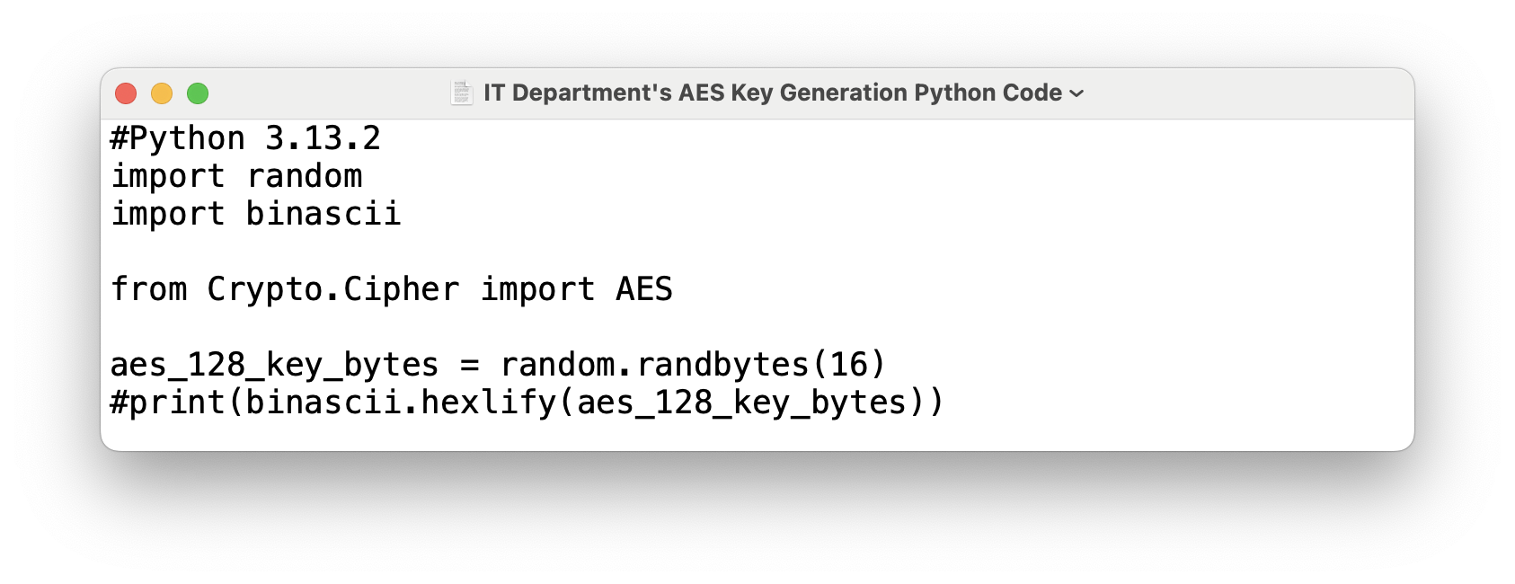
Please answer Questions 17, 18, 19, and 20:
Question 17: (5 points)
What is the major security problem with the IT department's AES key generation Python code shown above?

Question 18: (5 points)
Drawing from your earlier conclusion in Question 17 and what you learned from the ACM Code of Ethics and Professional Conduct (e.g., from our CSCI 128 Computer Science for STEM or related courses; if you did not learn anything about it, please read its “General Ethical Principles” and “Professional Responsibilities” sections at https://www.acm.org/code-of-ethics), would you report your identified security problem to your supervisor at the IT department and further provide your recommendation to improve the Python code? If yes, what is your recommendation (i.e., the detailed revision of the code, together with your explanation of the code and your verification of its execution), and what ethical justifications do you have for your actions?

Question 19: (5 points)
Could the similar security problem exist in programs written in other languages such as Java, C, and JavaScript? You need to justify your answer by providing an insecure version and a secure version code snippets of pseudorandom number generation (for 128-bit AES key generation) using any programming language other than Python.

Question 20: (3 points)
Drawing from your earlier conclusion in Question 19 and what you learned from the ACM Code of Ethics and Professional Conduct (e.g., from our CSCI 128 Computer Science for STEM or related courses; if you did not learn anything about it, please read its “General Ethical Principles” and “Professional Responsibilities” sections at https://www.acm.org/code-of-ethics), would you raise your concerns and suggest your supervisor at the IT department to further inspect the available code of other programs written in different languages for potentially identifying the similar security problem? If yes, what ethical justifications do you have for your actions?

What To Submit

Please answer all the 20 questions in this lab exercise. Please feel free to directly reuse this Word document to provide and submit your answers. Please submit additional materials (if specified in an individual question) in zipped files.

