FSServer

Analysis and design
Here are the feature requirements for the server
- run as a daemon and log all activity to a file
- accept tcp connections
- handle satellite requests atomically and send response to TCP clients
- execute server scripts and send response to TCP clients
Lets go through them one by one and:

Run as a daemon and log all activity to a file
A unix daemon is a process whos parent process id is 1. This is covered in the implementation section.

Accept TCP connections
Clients can connect to the server with the TCP protocol over an internet socket.
We could implement pull-behaviour where each request is answered with exactly one response or we could implement push-behaviour where data can be pushed to the client without being requested. It is not obvious which of these behaviours we should implement so lets choose the pull-behaviour for now.
The server could accept one or multiple connections at a time. We want to ensure that only one command is send to the satellite at a time, so lets accept only one connection for now until that does not suffice.

Handle satellite requests atomically and send response to TCP clients
Only one satellite command can be executed at a time. If we use a request queue whos enqueue and dequeue operations are atomic we can implement this behaviour without race conditions.

Execute server scripts and send response to TCP clients
Some tasks, such as uploading a binary file to the satellite, are so common that they should be available from every client. Instead of implementing them in every client, the server should implement them and execute them when requested by the client.
The scripts can be written in any language that is supported on the server environment. To capture the output of a script, the server will open up a pseudo terminal and have control og its standard output and input. The script is executed in the pseudo terminal and any output can be send to the client.

One or multiple TCP connection
Now this leads to the following scenario. A client connects to server and requests to execute script X. Beacuse of the pull behaviour we decided upon earlier the client will now wait for the script to finish with the response. If script X needs to interact with the satellite, it must connect to the server and do some requests but the server only accepts one tcp connection at a time, so we have a deadlock situation.
ONE CONNECTION DEADLOCK ILLUSTRATION
So there is a need for the following: Server handles multiple TCP clients and their requests simultaneously. Satellite commands over the serial connection must not be simultaneous.

Lock mechanism
With multiple clients new concerns must be dealt with. Consider the scenario where two clients execute a server script each. The script consists of 4 satellite commands and although we can ensure that only one satellite command are being executed at a time, we can not ensure that the 4 commands are executed sequentially.
MULTIPLE SATELLITE COMMANDS ILLUSTRATION
We need a way to lock the server to prevent multiple executing scripts from stepping on each others feet. So after connecting to the server a client must issue a “lock” request and will receive a session token if the lock succeeded or an message indicating that the server is already locked.
When finished a “unlock” request can be sent to unlock the server. Things can go wrong and leave the server in a locked state, so there will be implemented a timeout on the token. After each request this timeout will be reset. If the token gets timed out, a broadcast message will be sent to all connected clients.
LOCK ILLUSTRATION
It is important to note that two scripts requested by clients using the same token will be executed simultaneously.

Partial responses
Another thing to consider is the output of the server scripts. Imagine for instance an upload script that prints to standard out after each 10% of the upload is done. The client would like to follow this progress in real time as opposed to seeing the total output of a script when execution has finished. So in the case of the upload script we would at least be sending 10 partial responses to one request.
This along with the timeout broadcast leads to the need for pushing data to clients and we must therefore implement the push-behaviour in favor of the pull-behaviour.
PARTIAL RESPONSES ILLUSTRATION

Data formats
Now that we have a design that covers all features, lets look at the data format. The data will be formatted in JSON.
The client must be able to send a message to the server and react to the received response. There must be a way of determining wether incoming data is a response to some outgoing data. As there are none of such information in the order of outgoing and incoming data, a request must be stamped with a unique identification key that can be used by the server to stamp the response. The data format must at least have the following parameters:
- Request: {“id”:KEY, “data”:REQUEST}
- Response {“id”:KEY, “data”:RESPONSE}
Example of an “lock” request:
- Request: {“id”:”1”,”data”:”lock”}
- Response: {“id”:”1”,”data”:”7KFdnNXBYi8nmuWV”}
If the client has locked the server, the token is sent along the request like this:
- Request: {“id”:”1”,”data”:”reset”,”token”:”7KFdnNXBYi8nmuWV”}
Besides from from being able to respond to incoming requests, the server also needs to push data to the client independently of any requests. The client must be able to determine the type of the data to handle it correctly. The format must at least look like:
- Message: {“type”:TYPE}
Example of an “token timout” message:
- Message: {“type”:”server_unlocked”}
For format consistency and faster processing on the client side, the response format will also have the type parameter:
- Response: {“type”:”response”, “id”:KEY,”data”:DATA}
The server must also be able to send more than one response to a given request. This can be solved with the following format:
Req: {“id”:”2”, “data”:”run_script upload filepath”, “token”:”7KFdnNXBYi8nmuWV”}
- Res: {“type”:”response”, “id”:”2”, “data”:”10% done”, “partial”:”true”}
- Res: {“type”:”response”, “id”:”2”, “data”:”100% done”, “partial”:”true”}
- Res: {“type”:”response”, “id”:”2”, “data”:””}

Arguments and validation
Satellite commands can have arguments such as “address”, “length” etc. These arguments must be validated before being send to the satellite. Arguments are typical memory addresses and other hexadecimal values. It would be convenient to use both hexadecimal (“0xff”) and decimal (“15“) values as arguments. If an argument is invalid or missing the client must be informed and the request must not be executed.

Implementation
TODO
Explains key parts in the implementation:
ruby, eventmachine server, blocking vs. non-blocking, safe script execution, parsing in ruby, commands, satellite io, broadcasting, pseudo-tty's, token handling and timeout, logging, serialport request/response as atomic operation, command request validation

Testplan
To verify that the overall solution is working properly, the following test have been conducted on the individual subsystems.
FSServer
- Daemonization
- Custom logfile
- Multiple TCP clients
- Lock mechanism, token timeout and broadcast
- Command parsing
- Atomically satellite commands
- Command request validation and response
- Serialport c interface
- Upload script
FSGui
- command sequences
  - new, save, load
  - export to local script
  - stop on error
- autolock
- local script
- server script
- health panel

FSClient
- Single command
- Interactive mode

FSServer

Daemonization
Actions
Open terminal
Run `./fsdaemon start`
Run `ps axo comm,ppid | grep fsdaemon`
Expected result
After first command, the prompt becomes immediately ready for input
Second command returns `fsdaemon 1` to indicate that there is a running process with the name fsdaemon whos parent process is 1.
Result
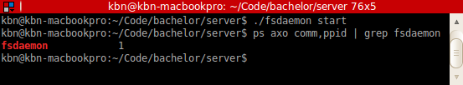

Custom logfile
Actions
Open terminal
Run `du -sk test.log`
Run `./fsdaemon start -- --logfile=`pwd`/test.log`
Run `du -sk test.log`
Expected result
Fist command tries to determine the size of test.log. It will fail as there is no such file.
Second command runs the server, touches the logfile and writes initial log messages.
Third command succeeds with a size greater than 1.
Result
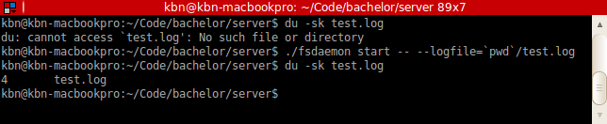

Multiple tcp clients
Actions
Open three terminals
Run `./fsserver` in terminal 1
Run `fsclient -i` in terminal 2
Run `fsclient -i` in terminal 3
Expected result
Fist command starts the server and logs to standard out.
Second command runs an interactive fsclient, the server will log this connection.
Third command runs another interactive fsclient, the server will also log this connection.
Result

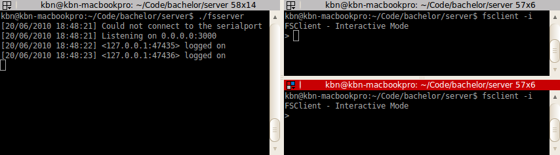
Lock mechanism, token timeout and broadcast
Actions
Open three terminals
Run `./fsserver` in terminal 1
Run `fsclient -i` in terminal 2
Run `fsclient -i` in terminal 3
Run `lock` in terminal 2
Run `lock` in terminal 3
Run `unlock` in terminal 2
Run `lock` in terminal 3
Run `lock` in terminal 2
Wait for server to timeout token
Run `flush_stdout` in terminal 2
Run `flush_stdout` in terminal 3
Expected
Lock in terminal 2 will succeed
Lock in terminal 3 will fail
Unlock in terminal 2 will succeed
Lock in terminal 3 will succeed
Lock in terminal 2 will fail
Flush stdout will print a “server_unlocked” broadcast message and a “must lock server” response
Result

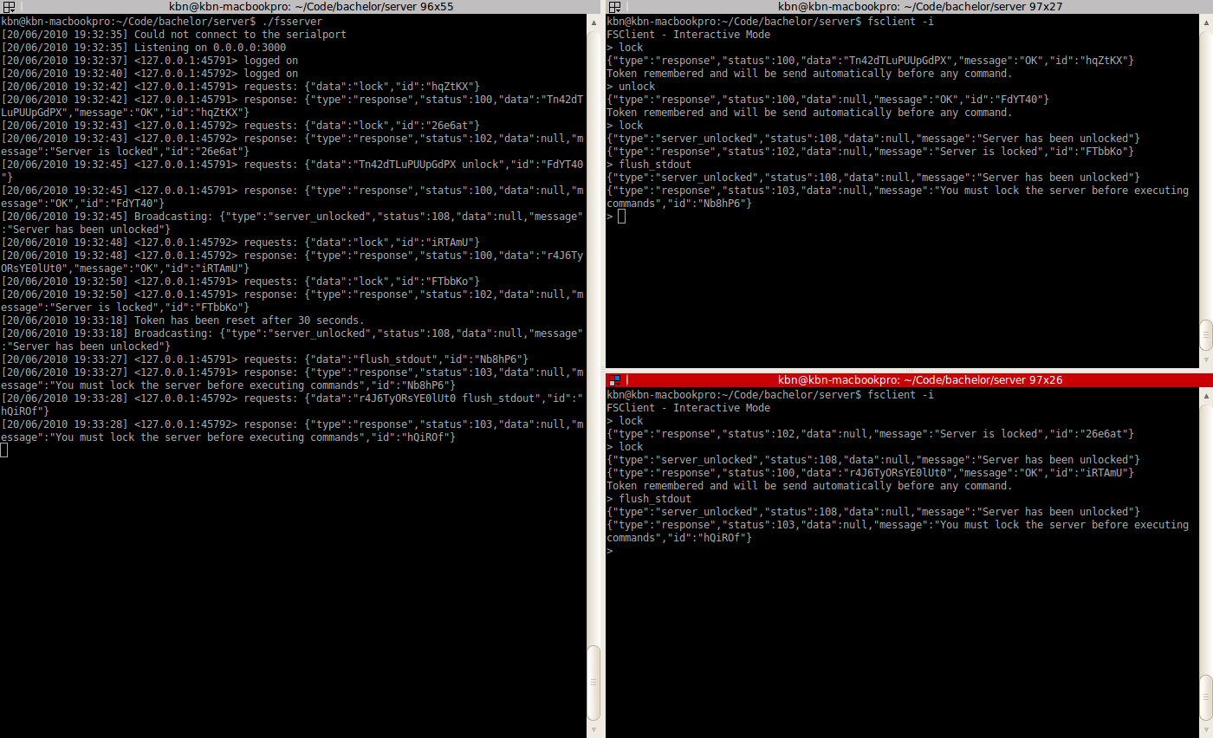
Command parsing
Unit tests for the CommandParser class have been implemented in tests/lib/command_parser_test.rb. The unit tests verifies the following behaviour:
- Should parse “lock” without token
- Should parse “reset” with token
- Should not parse “unknown_command”
- Should not parse “reset” with wrong number of arguments
Result
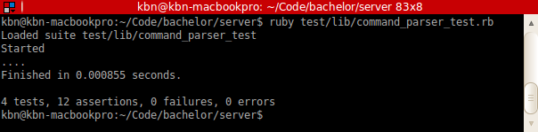
- Processing queue request/response as atomic operation
- Command request validation and response
- Serialport c interface
- Upload script

FSGui
- command sequences
  - new, save, load
  - export to local script
  - stop on error
- autolock
- local script
- server script
- health panel

FSClient
- Single command
- Interactive mode

