Testplan
To verify that the overall solution is working properly, the following test have been conducted on the individual subsystems.
FSServer
- Daemonization
- Custom logfile
- Multiple TCP clients
- Lock mechanism, token timeout and broadcast
- Command parsing
- Atomically satellite commands
- Command request validation and response
- Serialport c interface
- Upload script
FSGui
- command sequences
  - new, save, load
  - export to local script
  - stop on error
- autolock
- local script
- server script
- health panel

FSClient
- Single command
- Interactive mode

FSServer

Daemonization
Actions
Open terminal
Run `./fsdaemon start`
Run `ps axo comm,ppid | grep fsdaemon`
Expected result
After first command, the prompt becomes immediately ready for input
Second command returns `fsdaemon 1` to indicate that there is a running process with the name fsdaemon whos parent process is 1.
Result
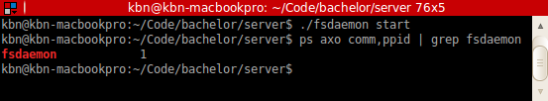

Custom logfile
Actions
Open terminal
Run `du -sk test.log`
Run `./fsdaemon start -- --logfile=`pwd`/test.log`
Run `du -sk test.log`
Expected result
Fist command tries to determine the size of test.log. It will fail as there is no such file.
Second command runs the server, touches the logfile and writes initial log messages.
Third command succeeds with a size greater than 1.
Result
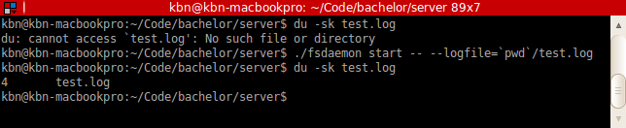

Multiple tcp clients
Actions
Open three terminals
Run `./fsserver` in terminal 1
Run `fsclient -i` in terminal 2
Run `fsclient -i` in terminal 3
Expected result
Fist command starts the server and logs to standard out.
Second command runs an interactive fsclient, the server will log this connection.
Third command runs another interactive fsclient, the server will also log this connection.
Result

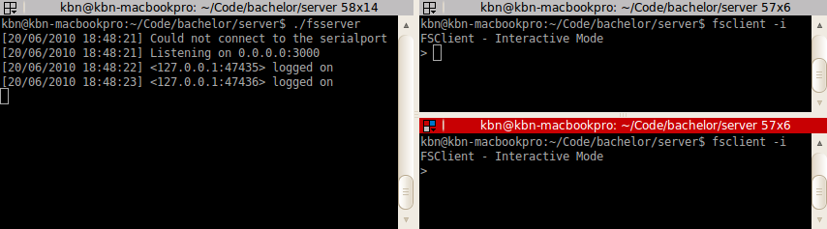
Lock mechanism, token timeout and broadcast
Actions
Open three terminals
Run `./fsserver` in terminal 1
Run `fsclient -i` in terminal 2
Run `fsclient -i` in terminal 3
Run `lock` in terminal 2
Run `lock` in terminal 3
Run `unlock` in terminal 2
Run `lock` in terminal 3
Run `lock` in terminal 2
Wait for server to timeout token
Run `flush_stdout` in terminal 2
Run `flush_stdout` in terminal 3
Expected
Lock in terminal 2 will succeed
Lock in terminal 3 will fail
Unlock in terminal 2 will succeed
Lock in terminal 3 will succeed
Lock in terminal 2 will fail
Flush stdout will print a “server_unlocked” broadcast message and a “must lock server” response
Result

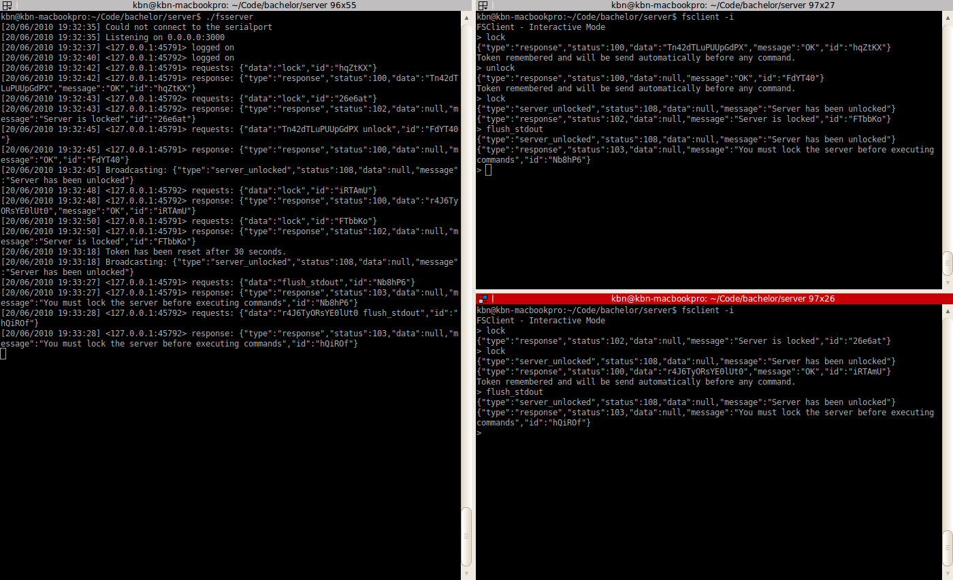
Command parsing
Unit tests for the CommandParser class have been implemented in tests/lib/command_parser_test.rb. The unit tests verifies the following behaviour:
- Should parse “lock” without token
- Should parse “reset” with token
- Should not parse “unknown_command”
- Should not parse “reset” with wrong number of arguments
Result
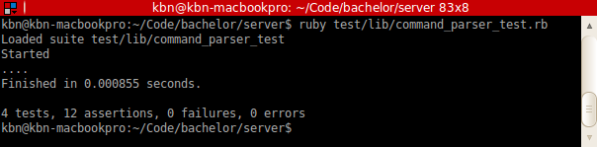
- Processing queue request/response as atomic operation
- Command request validation and response
- Serialport c interface
- Upload script

FSGui
- command sequences
  - new, save, load
  - export to local script
  - stop on error
- autolock
- local script
- server script
- health panel

FSClient
- Single command
- Interactive mode

