Failsafe Control for DTUSat-2

Kasper Bjørn Nielsen, s052808

DRAFT REPORT

Abstract
The DTUSat-2 project is a student satellite project at DTU. Any software being run on the satellite could potentially make the satellite unresponsive if a serious error occured. Therefore, a failsafe mode has been developed which should catch theses failures so that the DTUSat-2 staff can investigate errors and prevent them from happening again by uploading new software.
To operate the failsafe mode the staff needs both a console tool and a graphical user interface. It is the purpose of this project to investigate possible solutions and produce the software necesarry for the staff to be able to operate the satellite when in failsafe mode.

Preface
This bachelor thesis documents the Failsafe Control for DTUSat-2 software. It is aimed at the DTUSat-2 staff and should give any staff member a thorough overview of the requirements, design decisions, implementation specifics, test results, installation instructions and operating instructions of the software produced.
A big thanks should go out to my supervisor Hans Henrik Løvengreen who has been very helpful with all aspects of the project.

Lyngby, 28th June, 2010

________________________________
Kasper Bjørn Nielsen, s052808
Table of Contents
Abstract 2
Preface 3
Introduction 5
Thesis Statement 5
Approach 5
Outline of Chapters 6
Requirements Specification 8
General analysis and design 9
Context 9
Analysis and design discussion 9
Console program - FSClient 9
GUI 10
Command Combinations 11
Graphical representation of the health status 12
Chosen design 13
FSServer 14
Requirements Specification 14
Analysis and design 14
Implementation 19
FSClient 22
Requirements Specification 22
Analysis and design 22
Implementation 23
There are no contraints to program speed so the FSClient has been implemented in ruby. 23
Fsclient uses rubys standard command “$stdin.gets” to prompt the user for input. 23
The TCP connection has been implemented with eventmachine. 23
FSGui 24
Requirements Specification 24
Analysis and design 24
Implementation 28
Upload Script 30
Analysis and Design 30
Implementation 30
Tests and Results 31
Test Stragedy 31
FSServer 32
FSGui 42
FSClient 43
Test Summary 44
Conclusion 45
Perspective 46
Appendix A – User Guide 47
FSServer 47
FSClient 47
FSClient 48
Upload script 48
Appendix B – Failsafe Commands 48
Appendix C – Source Code 49

Introduction
The DTUSat-2 is a student satellite project of several departments at DTU. The goal of the project is to implement a spaceborne radio-tracking system capable of locating birds on intercontinental migration routes.
When the satellite has been launched and is orbiting earth, it is practically impossible to press a reset button in case of a hardware or software failure. Therefore, unforseen failures that make the satellite unresponsive, must be handled. This is achieved by constantly monitoring for failures and unresponsiveness.
There are two main programs on the satellite. The nominal mode, which is the full functioning autonomous program that normally runs on the satellite. This mode performs the tasks necessary for tracking birds.
If a failure is detected the software will reboot into the unautonomous failsafe mode which is a small program consisting of just 20 commands. In this mode it is possible to investigate what went wrong and to upload new software.
Operating software to the satellite's nominal mode have already been developed. There is a console program called fsterm which was used in DTUSat-1 project to operate the failsafe mode, but this program is no longer sufficient as new commands have been added and a graphical user interface (GUI) has become a requirement.

Thesis Statement
The purpose of this project is to implement a software solution that makes it possible for the DTUSat-2 staff to operate the satellite when in failsafe mode. Especially it should provide:
- Interaction via a console.
- Interaction via a desktop computer via a GUI. The GUI must be easy to get up and running.
- Flexible tools for specific tasks, such as uploading new software, running tests and performing diagnostics
- A graphical representation of the state of the satellite and its subsystems.
Conditions for the project:
- The final software must run on the Ground Station which is the computer responsible for the radio communication with the satellite.
- Communication with the satellite must go through an already given protocol layer written in C.
- Strive for platform independence but favor UNIX.

Approach
There are many people involved with the DTUSat-2 project, working on different parts at the same time. The failsafe software was not implemented at the start of this project, so no detailed documentation of communication interfaces, byteordeing etc. was available. Furthermore, some feature requirements was added during the implementation process.
These conditions make it cumbersome to achieve a satisfying solution with a rigid classical analysis-implement-test approach. Instead the process has been of a more iterative and agile nature. An iteration was typically one week in length and started with a supervisor meeting where we agreed on the next week's workload based on an evaluation of the previous week's work.

Outline of Chapters
The report consists of 9 chapters. Here is an outline of the individual chapters.

Requirements Specification
States the requirements of the project

General analysis and design
Analyses the requirements of the project, discusses alternative designs and presents the chosen design which is divided in four key parts: FSServer, FSClient, FSGui and user scripts.

FSServer
Analyses the requirements to the server part, discusses alternative designs and presents the chosen design. Explains non-trivial part of the implementation.

FSClient
Analyses the requirements to the client part, discusses alternative designs and presents the chosen design. Explains non-trivial part of the implementation.

FSGui
Analyses the requirements to the gui part, discusses alternative designs and presents the chosen design. Explains non-trivial part of the implementation.

Upload script
Analyse the requirements to the upload script part, discuss alternative designs and presents the chosen design. Explains the implementation.

Tests and results
Describes the test stragedy, the test cases and the test results

Conclusion
Summarizes what has been done, which goals have been met and gives a perspective for the future of the project.

Appendix A – User Guide
Contains installation and operation instructions for the individual subsystems.

Appendix B – Failsafe Commands
Contains a list of the 20 failsafe commands

Appendix C – Source Code
Contains the entire source code

Requirements Specification
This chapter deals with the requirements of the project.
A good way to evaluate the success of a project is to state some measurable requirements that can be tested for when the system has been been implemented.
Before stating the requirements they must be identified. The requirements are directly dictated by or based on meetings with my supervisor who is a member of the DTUSat-2 staff.
The requirements to this project are:
- The user must be able to operate the satellite in failsafe mode from a desktop computer via a console program or a GUI.
- Command combinations
  - must be able to combine several commands in conditionals and loops.
  - must be able to save, load and execute these combinations
  - must be flexible to create and change
- Console program
  - must take a command and its arguments as parameters on the command line
  - must have an interactive mode. This mode must prompt the user for a command, execute it, print the result and prompt again.
- GUI
  - must show a graphical representation of the satellites health status
  - must create, save, load, export and execute command combinations
  - must provide a graphical tool to put together command sequences (without conditionals and loops)
  - must be easy to install and run
- Upload script
  - must take a file and a memory address as parameters and upload to the satellite at the given memory address.
  - must notify the user with the progress
- Protocol layer
  - must use the protocol layer so that the datalink implementation can be changed later on

General analysis and design
Before implementing the system a good design must be chosen. The design should be based on thorough analysis and discussion of alternative solutions. This chapter deals with the analysis and design of the system. First the context of the final system is stated. Then the requirements specification is broken down and an analysis mixed with a design discussion is given for each requirement.
The chapter concludes with a summary of the chosen design and an overview of its main components.

Context
To design the system it is crucial to know the context of it.
The satellites Failsafe Mode (FS)
The failsafe program on the satellite is basically a request-response loop. Requests and responses are simple binary formatted streams of data. The failsafe commands and their formats are listed in appendix B.
Ground Station (GS)
When orbiting earth, communication with the satellite goes through a radio. This radio is controlled by a computer called the Ground Station. GS runs a UNIX variant as operation system. To operate the failsafe mode communication must therefore go through the Ground Station computer.
There is a protocol layer for the datalink that must be used for communication with the radio.
The staffs desktop computers
The software must be operational from the staffs desktop computers.

Analysis and design discussion
In the follow each requirement is analysed. Challenges and possible solutions are discussed along the way.

The analysis is of an iterative nature. For each iteration the overall design will be enhanced to incorporate the requirement.

Console program - FSClient
We could solve this requirement with a console program named fsclient running on the Ground Station. Fsclient could take a satellite command and its arguments as parameters and send it via the radio interface of the Ground Station to the statellite. This is basically how fsclient for the DTUSat-1 works.
As fsclient would be installed on the Ground Station the staff members must use the physical computer or have access to it via SSH for instance.
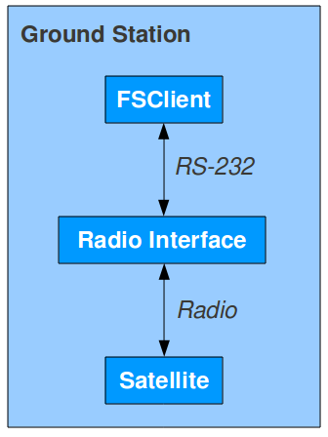Illustration 1: fsclient on the Ground Station

GUI
There are many posibilities when it comes to implementing a GUI but regardless of the choice there must be communication with the satellite over the radio. One way to solve this is to let the GUI connect to the Ground Station via SSH and use fsclient each time it must send a failsafe request.
A drawback to this solution is that not all GUI frameworks and operating systems have support for SSH out of the box.

TCP Interface to the radio
Alternatively there could be a TCP server on the Ground Station that listens for failsafe commands from connected TCP clients and have them forwarded to the radio. With this TCP server, called fsserver, we effectively have a TCP interface to the satellite and the advantage here is that all major GUI frameworks and all major operating systems have TCP support making this solution far more flexible than the SSH solution.

Command Combinations
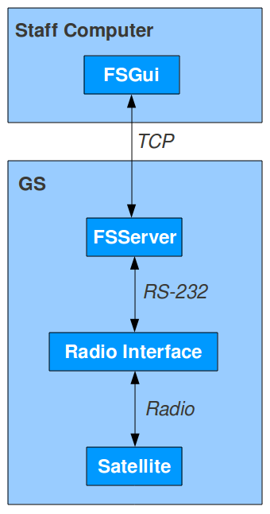Illustration 2: TCP Interface to the radio
The failsafe software has a set of basic commands which by themselves are of limited use but becomes powerful when combined. As we cannot know which failures might occur in the future, it is critical that there is a flexible way of combining these commands in conditionals and loops.

One solution is to combine the commands in the GUI. Then we would need to construct individual GUI elements for concepts like a command, a command sequence, an if statement and its branches, a loop statement and its body and so forth. This solution is hard to extend with a switch-statement in two years time when someone needs it – and impossible to do without the source code.

The use of script languages to combine commands
Alternatively there is a far more flexible solution to this challenge when it is recognized that conditionals and loops already have been implemented numerous times in script languages such as Ruby, Python or TCL and that they can be used to achieve the required flexibility.

Send failsafe commands from a script using UNIX
It is necessary that the scripts can communicate with the Ground Station. To solve this each script could implement a TCP client, but that would mean two things. One, a TCP client for each specific language would be needed before they could be used to write failsafe scripts. This is inflexible. Two, there would exist several implementation of the TCP client which is error-prone.

Is there anything all scripting languages have in common? Well, if we assume that the scripts are being run on a UNIX system, they will have exactly that in common. All languages have built-in libraries for running a UNIX console command and manipulating the output. So, we could use fsclient to pass failsafe commands through. Fsclient will just handle the TCP connection to the Ground Station and forward the commands.

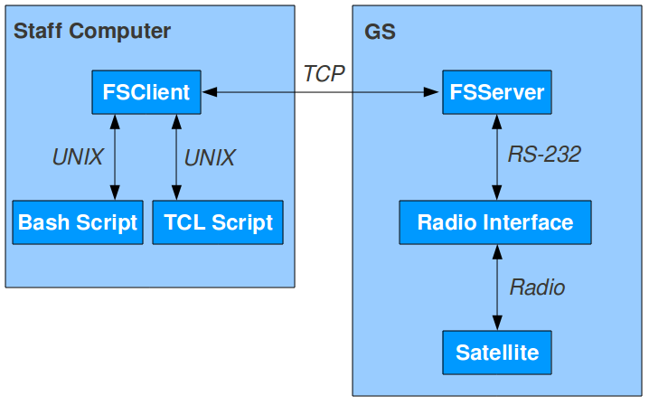Illustration 3: FSClient and executing scripts
FSServer must be aware of multiple TCP clients and ensure that commands from various TCP clients are not executed at the same time. This challenge will be dealt with in the FSServer Chapter.

Graphical representation of the health status
The failsafe software has a command called HEALTH_STATUS which will return a set of numbers representing the state of the subsystems. These numbers will be interpreted as temperature, current voltages, on/off etc in the GUI.
The GUI must provide a graphical representation of the subsystems and their health status.

Chosen design
Here is a wrap up of the final design that consists of four key elements:
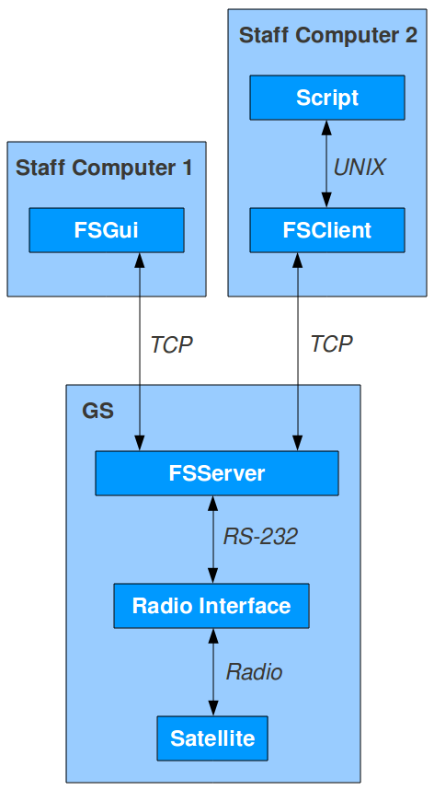Illustration 4: Chosen design
- FSServer
  - Installed on GS
  - A TCP server
  - Send failsafe commands via the datalink
  - Send failsafe response back to TCP clients
  - Ensure atomicity of failsafe commands
- FSClient
  - Installed on the staff's desktop computers
  - Unix program
  - A TCP client to FSServer
  - Forward failsafe commands from other unix programs to the server
  - Interactive mode
- FSGui
  - Installed on the staff's desktop computers
  - Runs on unix and windows systems
  - A TCP client to FSServer
  - No installation required, just download and double-clik
  - Create, save, load, export command sequences
  - Execute failsafe scritps
  - View graphical representation of the health status
- Scripts
  - Any script or programming language that can execute unix commands
  - Combine failsafe commands in conditionals and loops
Now that there is an overall design, lets proceed with an analysis, design and implementation part of the individual parts.

FSServer
This chapter will deal with the requirements specification, analysis, design and non-trivial implementation details of FSServer.

Requirements Specification
The requirements for FSServer are:
- must be installed on GS
- must accept TCP connection
- must send failsafe commands via the datalink
- must send failsafe responses back to TCP clients
- must ensure atomicity of failsafe commands
In addition to these requirements, the following requirements was identified when the overall design was agreed upon:
- must run as a daemon and log all activity to a file
- must execute scripts on GS and from a TCP client and immediately send any response back to the TCP client
- must validate failsafe commands

Analysis and design
Lets go through the requirements one by one. For each requirement we will enhance the design to incorporate the requirement.

Must be installed on GS
Trivial constraint.

Must accept TCP connections
Clients can connect to the server with the TCP protocol over an internet socket.
The server could accept one or multiple connections at a time. We want to ensure that only one command is send to the satellite at a time, so lets accept only one connection for now.

Must send failsafe commands via the datalink and send response back to clients
We could implement pull-behaviour where each request is answered with exactly one response or we could implement push-behaviour where data can be pushed to the client without being requested. It is not obvious which of these behaviours we should implement so lets choose the pull-behaviour for now.

Must ensure atomicity of failsafe commands
Only one satellite command can be executed at a time. If we use a request queue with atomic enqueue and dequeue operations we can implement this behaviour without race conditions.

Must run as a daemon and log all activity to a file
A unix daemon is a process with a parent process id of 1. When starting the server, the staff must be able to decide whether to run it as a daemon or to run it as a normal process.
The logfile could be a predefined file, but we should let the staff decide by providing an option when starting the server.

Must execute scripts on GS and from a TCP client and send any response back to the TCP client
Some tasks, such as uploading a binary file to the satellite, are so common that they should be available for every client. Instead of implementing these tasks in every client, the server should implement them and execute them when requested by the client.
The scripts can be written in any language that is supported by the server environment. To capture the output of a script, the server will open a pseudo terminal that has control of standard output and input. The script is executed in the pseudo terminal and any output can be send to the client.

One or multiple TCP connection
Now consider the following scenario. A client connects to the server and requests to execute script X. Because of the pull behaviour we decided upon earlier the client will now wait for the script to finish with the response. If script X needs to interact with the satellite, it must connect to the server and do some requests but the server only accepts one TCP connection at a time, and we have a deadlock situation.

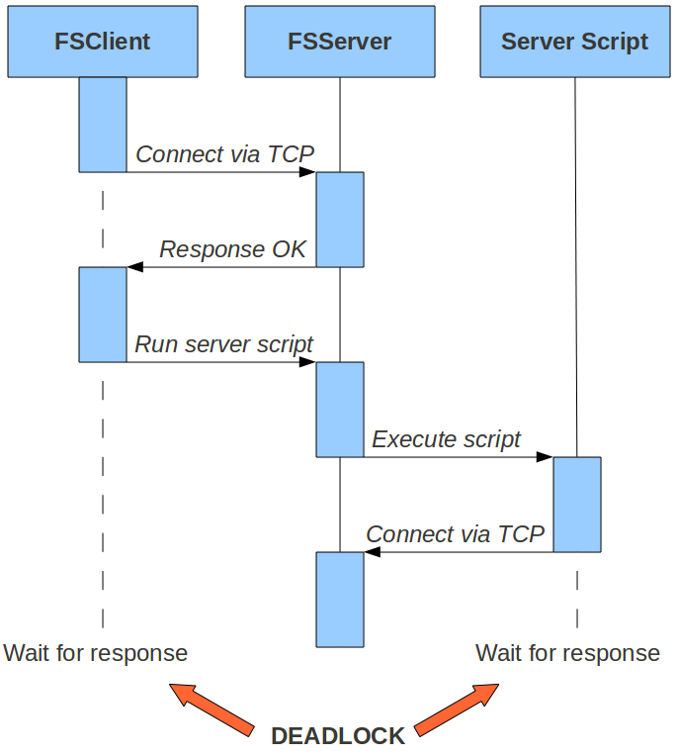
So there is a need for handling multiple TCP clients and their requests simultaneously. Satellite commands over the serial connection must not be simultaneous however!

Blocking vs. non-blocking execution
In a program a non-blocking execution of a statement will not wait for the result of that statement before proceeding with the execution of the next statement. A blocking execution of a statement will wait for the result before proceeding.
In order to handle multiple TCP clients concurrently the server must execute the requests in a non-blocking fashion.

Lock mechanism
With multiple clients new concerns must be dealt with. Consider the scenario where two clients execute a server script each. The script consists of 2 satellite commands and although we can ensure that only one satellite command are being executed at a time, we can not ensure that the 2 commands are executed sequentially.
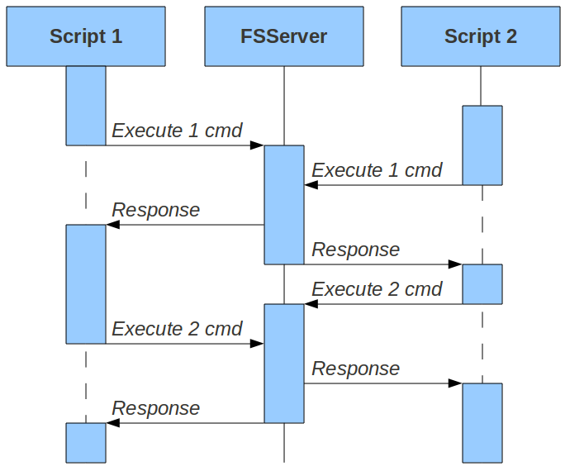
We need a way to lock the server to prevent multiple executing scripts from stepping on each others toes. So after connecting to the server a client must first issue a lock request and will receive a session token if the lock succeeded or a message indicating that the server is already locked.
When finished an unlock request can be sent to unlock the server. Things can go wrong however and leave the server in a locked state, so there will be implemented a timeout on the token. After each request this timeout will be reset. If the token gets timed out, a broadcast message will be sent to all connected clients.
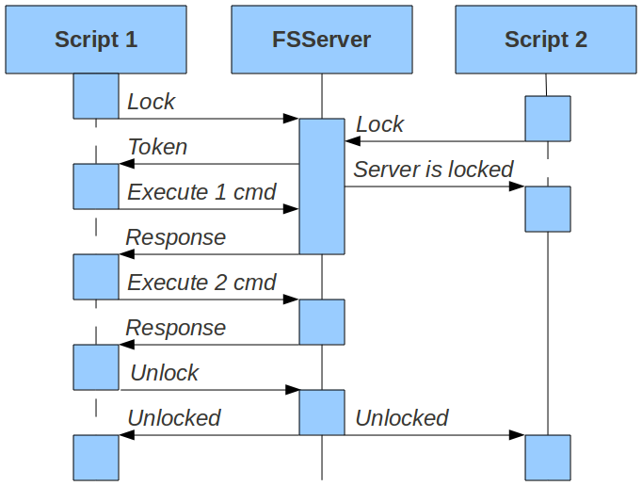
It is important to note that two scripts requested by clients using the same token will be executed simultaneously!

Partial responses
Another thing to consider is the output of the server scripts. Imagine for instance an upload script that prints to standard out each time 10% of the upload is done. The client would like to follow this progress in real time as opposed to seeing the total output of a script when execution has finished. So in the case of the upload script we would at least be sending 10 partial messages in response to one request.
This along with the timeout broadcast leads to the need for pushing data to clients and we must therefore implement the push-behaviour in favor of the pull-behaviour.
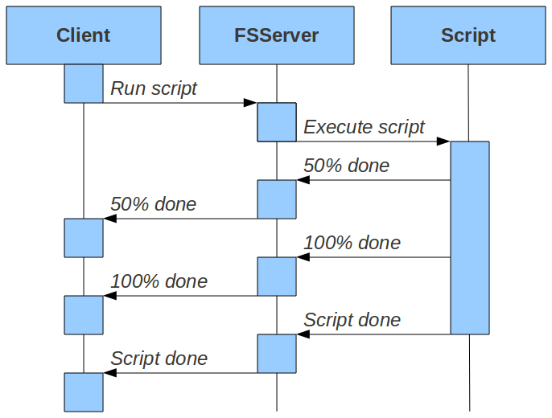

Must validate failsafe commands
Failsafe commands can have arguments such as “address”, “length” etc. These arguments must be validated before being send to the satellite. Arguments are typically memory addresses and other hexadecimal values. It would be convenient to use both hexadecimal (“0xff”) and decimal (“255“) values as arguments. If an argument is invalid or missing the client must be informed and the request must not be executed.

Data format
Now that we have a design that covers all features, lets look at the data format. We have several choices here. We could go with a simple text format, XML or JSON.
The client must be able to send a message to the server and react to the received response. There must be a way of determining whether incoming data is a response to some outgoing data. As there are no such information in the order of the outgoing and the incoming data, a request must be stamped with a unique identification key that can be used by the server to stamp the response. The data format must at least have two parameters then, a stamp and the data.
If we use a simple text format we would need a separator to distinguish the parameters. Then we would have to care about escaping certain characters etc. Instead we should consider using the semantically equal XML or JSON formats. We will be using JSON.
- Request: {“id”:KEY, “data”:REQUEST}
- Response {“id”:KEY, “data”:RESPONSE}
Example of an “lock” request:
- Request: {“id”:”1”,”data”:”lock”}
- Response: {“id”:”1”,”data”:”7KFdnNXBYi8nmuWV”}
If the client has locked the server, the token is sent along the request like this:
- Request: {“id”:”1”,”data”:”reset”,”token”:”7KFdnNXBYi8nmuWV”}
Besides from being able to respond to incoming requests, the server also needs to push data to the client independently of any requests. The client must be able to determine the data type to handle it correctly. The format must at least look like:
- Message: {“type”:TYPE}
Example of an “token timout” message:
- Message: {“type”:”server_unlocked”}
For format consistency and faster processing on the client side, the response format will also have the type parameter:
- Response: {“type”:”response”, “id”:KEY,”data”:RESPONSE}
The server must also be able to send more than one response to a given request. This can be solved with the following format:
Req: {“id”:”2”, “data”:”run_script upload filepath”, “token”:”7KFdnNXBYi8nmuWV”}
- Res: {“type”:”response”, “id”:”2”, “data”:”50% done”, “partial”:”true”}
- Res: {“type”:”response”, “id”:”2”, “data”:”100% done”, “partial”:”true”}
- Res: {“type”:”response”, “id”:”2”, “data”:””}

Implementation
This section deals with the non-trivial implementation details.

Language and libraries
There are no contraints to the programming language and as the server will neither be cpu- or io intensive the server has been implemented in Ruby. It could have been implemented in C or Java, and probably should have if there where any requirements to speed.
Ruby has a standard library with support for basic things like sockets, threads, system etc. There is a packaging tool called rubygems with which one can install third party libraries called gems.
Instead of reinventing a TCP server, a serialport wrapper and a JSON parser we will be using production ready ruby gems that has been tested over long periods of time by many people and have been accepted within the ruby community.

Third-party gems
- Eventmachine - Instead of the relatively slow socket support in the standard library we will be using the evetnmachine gem. Eventmachine is a library for implementing non-blocking TCP servers and clients.
- JSON - provides a JSON parser class.
- Serialport – provides a class for using RS-232 serial ports.
- Daemons - provides an easy way to wrap existing ruby scripts to be run as a daemon and to be controlled by simple start/stop/restart commands.

Safe script execution
When executing server scripts from a client we must be very careful about the parameters. Consider the scenario were a client sends this request: “run_script scriptname param1;rm -rf /”. If we are not careful and just pass along the parameters without escaping the semicolon, the result of this command will delete all files on the server, that the currently running user has permissions for.
Ruby has a wrapper for the UNIX command execve. Execve can create new UNIX processes and will safely pass arguments along.
Ruby's pseudo tty library uses the execve wrapper to execute console commands.

Failsafe Commands
A failsafe command is a Ruby class that can have an initialize, a validate and an execute method. Initialize takes the arguments for the command, validate will validate the arguments and execute will execute the command.
All commands inherits common code from the AbstractCommand class. This class implements some common validations, a default initialize method, a default validate method and a default execute method.

Parsing
When the server gets a new request, it is parsed with the JSON gem. The id and token are easily looked up in the resulting Ruby hash. The data field is first split on spaces to separate the command from its arguments. The command is then camelized which means that the first character and any characters immediately after an underscore is capitalized. The underscores are then removed. Each command has a corresponding camelized Ruby class.
For example:
The server receives this request: {“id”:”1”,”token”:”abcdefg”, “data”:”run_script filepath arg1 arg2”}
First it is parsed as JSON. This results in a Ruby hash where we immediately lookup the id and the token. The data is then split on spaces:
cmd, *arguments = parsed_request[“data”].split
Ruby has a function called eval that takes a string as a parameter and executes that string as Ruby code. To get an instance of the camelized class to a run_script command we can execute the following:
eval(cmd.camelize+“.new(*arguments)”)
which is equivalent to:
eval(“RunScript.new(*arguments)”)
When this string is executed by eval, the initialization code for RunScript will be called with all the arguments.
Options are also extracted. If an argument begins with a dash (“-”) then it will be split on equal-signs and stored in an options hash.
Again we must be very careful when executing a string from an unknown place. In this way a user could create an instance of any Ruby class and pass any arguments to it. To deal with this, we encapsulate all valid commands in a module called Commands. So now the eval looks like:
eval(“Commands::#{cmd.camelize}.new(*arguments)”)

Validation
When the command has been parsed the server will call the validate method before calling the execute method. If the validate method fails the execute method will never be called, instead a failed validation message is sent to the client.
Common validations are implemented in the AbstractCommand class and uses some extensions to the String class. The most common validation is to ensure that the argument is addressable. To be addressable the value must be given as a hex or a decimal value. The validation ensures that the value is not greater than 0xffffffff.

Satellite IO
The server will have to communicate with the radio link on GS when communicating with the satellite.
During development however a development board has been used. This board has a RS-232 interface, so the serialport gem has been used to write an serialport implementation that adheres to the protocol layer interface.

Request queue with atomic enqueue and dequeue operations
It is important that only one command is being sent at any given time to the satellite. Therefore, a ProcessingQueue module has been implemented. A processing queue has an array of requests, a mutex and a boolean value to indicate that the processing has already started. When enqueueing, the request is put into the queue when the mutex becomes available. Then the processesing loop is started unless it has already been started.
The queue is when the mutex becomes available and the request is processed. As soon as the processing is done the mutex is released and the processing is started again until there is no more requests left in the queue.

Option for satellite commands
--timeout=SEC
There is a timeout for each executing satellite command. It is set to 5 seconds by default but can be changed per request with the timeout options e.g. “reset” and “reset --timeout=20” are both valid commands. The former will timeout after 5 seconds and the latter will timout after 20 seconds.
--no-response
Sometimes we do not care about the response for a command and would like to skip it in order to save execution time and batterylife. The option looks like this: “reset –no-response”.

Broadcasting
Broadcasting can be done by maintaining a global array of connected clients. A message can then be sent to each client.

Token handling and timeout
The TokenHandler class is responsible for timing out the token. It has a token variable, which is just a string. The server is unlocked if this value is nil. When setting the token variable a timer will be started. If the timer runs out the token variable will be set to nil and a broadcast message is sent to all connected clients.

Logging
When starting the server one can indicate to use a logfile for the server output. If none is indicated the server will print its output to standard out.

FSClient
This chapter will deal with the requirements specification, analysis, design and non-trivial implementation details of FSClient.

Requirements Specification
The requirements for FSClient are:
- must be installed on the staff's desktop computers
- must be a unix program
- must be a TCP client to FSServer
- must forward failsafe commands from other unix scripts to the server
- must have an interactive mode
In addition to these requirements, the following requirements was identified when the overall design was agreed upon:
- must have a data_only mode
- must have an auto_lock mode

Analysis and design
Lets go through the requirements one by one. For each requirement we will enhance the design to incorporate the requirement.

Must be installed on the staff's desktop computers
Trivial constraint.

Must be a unix program
Trivial constraint.

Must be a TCP client to FSServer
Trivial constraint

Must forward failsafe commands from other unix scripts to the server
Fsclient will take a failsafe command and its arguments as parameters, send it over TCP to the server and print the response to standard out.

Must have an interactive mode
In interactive mode, it prompts the user for a failsafe command, sends it to the server, retreives the response, prints the response and prompts the user again until the user enters exit. The –interactive option will do this.

Must have a data_only option
Sometimes we don't want to see the entire response message but just the data field. The –data-only option will do this.

Must have an auto_lock option
There should also be an option for auto locking when starting the interactive mode. The –auto-lock option will do this.

Implementation
This section deals with the non-trivial implementation details.

There are no contraints to program speed so the FSClient has been implemented in ruby.

Fsclient uses rubys standard command “$stdin.gets” to prompt the user for input.

The TCP connection has been implemented with eventmachine.

FSGui
This chapter will deal with the requirements specification, analysis, design and non-trivial implementation details of FSGui.

Requirements Specification
The requirements for FSGui are:
- must be installed on the staff's desktop computers
- must run on unix and windows systems
- must be a TCP client to FSServer
- must not need installation, just download and double-clik
- must create, save, load, export command sequences
- must execute failsafe scritps
- must view graphical representation of the health status
In addition to these requirements, the following requirement was identified when the overall design was agreed upon:
- must be able to retrieve a list of server scripts and execute them with custom arguments
- must be able to execute local scripts
- must have an auto_lock option
- must indicate connection and lock state

Analysis and design
Lets go through the requirements one by one. For each requirement we will enhance the design to incorporate the requirement.

Must be installed on the staff's desktop computers
Trivial constraint

Must run on unix and windows systems
There exists a number of cross-platform GUI frameworks we could use like Java swing or Xulrunner.
Xulrunner is Mozilla's cross-platform and open source framework. Xulrunner has the advantage that it is very easy to build complex and appealing GUIs in no time. The disadvantage is that the framework takes up 20 MB of harddisk space and is not included on UNIX og Windows by default. Furthermore, it lacks some systemwise features like spawning new processes and executing console commands.
The advantage with Java is that it runs on most systems and once you have the java virtual machine installed it is fairly easy to just pack an executable jar file and run it with a double click.
The FSGui will be implemented in JAVA using the Swing Framework.

Must be a TCP client to FSServer
When the program starts the user must indicate the address and port of the FSServer.
With a 30 sec token timeout the user will experience lock errors often enough to be annoying. Therefore, it must be possible to set an autolock option. It must also be clear to the user whether the server is locked or not and whether a connection has been made to FSServer or not.

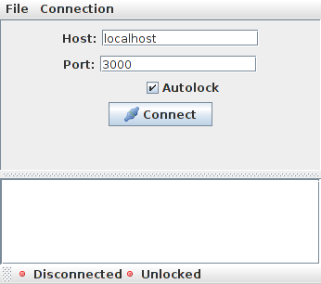
Must not need installation, just download and double-clik
The FSGui will be packed as an executable jar file. The only requirement to the staff computers is that they have a Java Virtual Machine installed.

Must send failsafe commands
Java has built-in support for sockets and TCP.

Must create, save, load and export command sequences
For easy and fast testing, simple command sequences can be composed in the GUI. There are no conditionals or loops and the sequence will stop executing if one of the commands fails for one reason or another. It is possible to save and load sequences and to export a sequence to a Ruby script.
Sequences can be saved, loaded and exported to scripts.
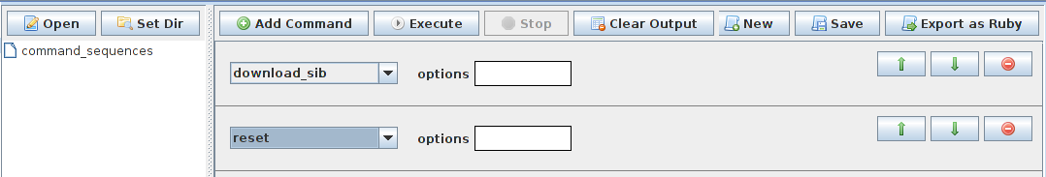

Must view graphical representation of the health status
The satellite can read various health information from the individual subsystems and send them back to earth. Which data the subsystems will actually yield and how that data should be interpreted is not agreed upon as of this writing.
Instead the development board, that was used in place of the real satellite, simulates this data by reading several voltages and currents. When the real data is available the staff should be able to modify the source code of this project and fairly quickly replace the development data with the real data.
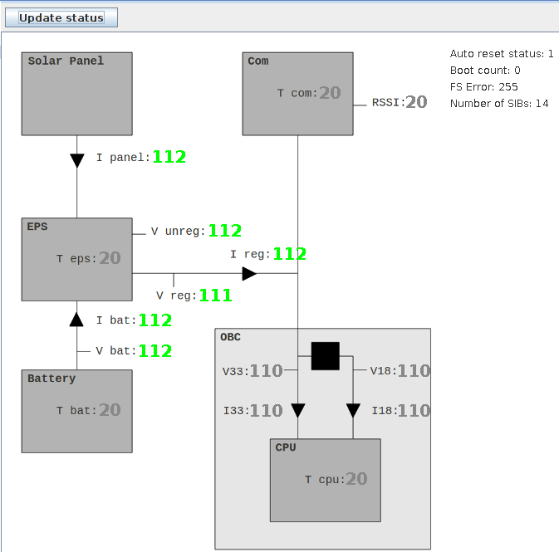

Must be able to execute local scripts
In addition to running a script in the console it should also be possible to run and see the output of that script from within the GUI. The scripts are organized in a filetree and the user should be able to set the root of the filetree, navigate through the filetree, selecting a script, passing arguments to it and executing it.
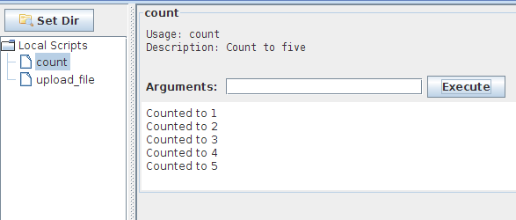

Must be able to retrieve a list of server scripts and execute them with custom arguments
FSGui can retrieve a list of available server scripts that the user can choose from. FSServer will implement the available_scripts command to retreive this information. Once retrieved the GUI builds a tree of the scripts for easy navigation.
When a script has been clicked on in the tree, a script description and a textfield for passing arguments are presented to the user. An execute button will execute the script on the server, any response data will be appended just below the script.
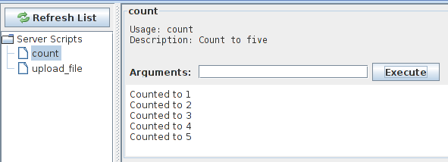

Must have an auto_lock option
An auto_lock option is available in the connect panel and from the menubar.

Must indicate connection and lock state
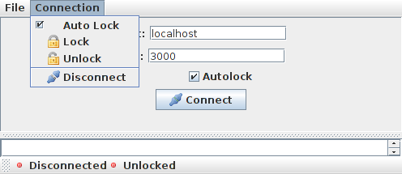
There is a statusbar in bottom of the window indicating whether there is a connection or not and whether the server is locked by the gui or not.

Implementation
Lets look at the non-trivial part of the implementation.

FSController
At the heart of the FSGui is the FSController singleton class which is responsible for creating the TCP socket, building the swing gui and setting up the data handlers. Because of its bigbrother like nature it is also extensively used in other classes to reference other parts of the program.

Local Scripts
Java has a built-in class called ProcessBuilder that can create a process given a list of the command and its arguments. It will execute and capture the output of the process. We will use this class to execute local scripts.

Socket and Socket Callbacks
The built-in class Socket will be used to create the TCP connection and to read/write on the socket. To prevent cluttering in FSController the Socket will be wrapped in a class called FSSocket that will perform callbacks to a class that implements the FSSocketObserver interface when interesting events happen, such as on connection, on disconnection, on incomming data etc. The FSController implements this interface and will therefore be able to act on these events.

Data Handlers and request callbacks
When we send a request to the server we will often expect some kind of response. As the solution is push driven we cannot know when the response will come. We cannot send the request and then immediately wait for the response on the socket, potentially throwing away responses to other requests. We have to send the request and just hope that the response will come.
When the response finally do come, we won't know what to do with it. So along with sending a request we most associate it with a callback that should be executed upon a received response.
This is done with a FSCallback which is an interface consisting of one method called onResponse that takes a FSResponse as its parameter. The callback is registered in the requestCallbacks Hashtable where an entriy consists of the requests id as key and the callback as a value.
A class called FSSocketReader will constantly be reading the socket and whenever a message has been read it is first sent to the appropriate data handler and if it is a response, the response handler will look for the id in the requestCallbacks and execute the callback.
When the client gets an incoming message FSGui determines the type of the message and dispatches it to the appropriate data handler. Data handlers must therefore be setup before connecting to the server.
The response handler
When sending a request one specifies what piece of code to run when the response is received.
The response handler looks at the id parameter and matches it to the corresponding request and dispatches the data to that piece of code.
The token timeout handler
This handler just notifies the user by changing the “locked”-icon in the GUI.

JSON Parsing
Java does not have built-in support for JSON, so a third-party library called JSONObject has been used.

Generating unique ids for the requests
Unique id generation is handled by FSSocket and is appended the the request before sending it off to the server. It is a fairly simple algorithm that uses Java's builtin SecureRandom and BigInteger classes. The produced id is a 5 digit integer. The odds of two requests having the same id is 1 to 10000 which is assumed to be acceptable.

Command Sequences
The command sequences are saved in a simple json format. A sequence of the following commands:
- health_status
- download 0x40000000 512
Will be saved as the following JSON data:
[
{"command":"health_status", "arguments":[""]},
{"command":"download","arguments":["0x40000000","512",""]}
]
NOTE: The empty string in the end of each argument is the options textfield.

Upload Script
This chapter analyses the requirements and discuss various design alternatives of the upload script. The implementation details of the chosen design will follow.

Analysis and Design
The upload script should take a filepath and a memory address as parameters. It must be smart enough to divide the file in parts of the maximum data size and upload them to the satellite starting from the given memory address.
During upload the user must be notified with the overall progress.

Implementation
The script is an executable file written in ruby with the following path “scripts/upload_file”.
It takes three arguments: token, filepath and address.
It validates that these three arguments have been given, that the file exists and that the address is a valid address.
Then it determines the size of the file, and how many individual uploads there is needed to upload the entire file.
For each upload the bytes to be uploaded are read from the file and uploaded via fsclient.
The progress is printed.
If the upload went well the next part of the file will be uploaded.
If the upload went bad the script is stopped and the user is notified.

Maximum data size of 20 bytes
The upload script has a maximum data size of 20 B instead of the allowed 1020 B. This is because the current implementation of the failsafe software has some problems with data being send too fast. The current workaround is to sleep for 0.2 seconds inbetween each byte written. It will takes 204 seconds to upload 1020 bytes and in that time space the satellite will reset and the command will fail. In contrast it takes 4 seconds to upload 20 bytes.
The maxumum data size should be changed when the issue has been fixed in the failsafe software.

Tests and Results
Now that the implementation is complete, we should test that meets the requirements of the system and ultimately give us an idea of the success of the project.
This chapter will start by stating the test stragedy. Then the test cases and their results for the individual subsystems is given.
The chapter ends with a summary of the tests and an overall evalutaion of the success of the project.

Test Stragedy
The stragedy is to perform functional tests of all requirements. The tests are combined in integration tests as some requirements span over the individual subsystems.
Unit testing will be performed on the command validations.
Lastly all commands have been tested with fsclient.

FSServer
This section contains the test cases and the results for FSServer.

Daemonization
The following integration test have been conducted.
Action | Expected | Result
Open terminal
Run `./fsdaemon start` | the prompt becomes immediately ready for input | success
Run `ps axo comm,ppid | grep fsdaemon` | returns `fsdaemon 1` to indicate that there is a running process with the name fsdaemon whos parent process is 1. | success

Custom logfile
The following integration test have been conducted.
Action | Expected | Result
Open terminal
Run `du -sk test.log` | Try to determine the size of test.log. It will fail as there is no such file. | success
Run `./fsdaemon start -- --logfile=`pwd`/test.log` | Runs the server, touches the logfile and writes initial log messages. | success
Run `du -sk test.log` | Succeeds with a size greater than 1 | success

Multiple tcp clients, lock mechanism, token timeout, no-response and broadcast
The following integration test have been conducted.
Action | Feature to test | Expected | Result
Open up three terminals  Run `./fsserver` in terminal 1  Run `fsclient -i` in terminal 2 and 3 | Multiple tcp clients | The server will log that both clients have connected | success
Run `lock` in terminal 2 | lock | Lock will succeed | success
Run `lock` in terminal 3 | lock | Lock will fail | success
Run `unlock` in terminal 2 | lock | Unlock will succeed | success
Run `lock` in terminal 3 | lock | Lock will succeed | success
Run `lock` in terminal 2 | lock | Lock will fail | success
Wait for server to timeout token  Run `flush_stdout` in terminal 2 and 3 | Token timeout, broadcast | Will print a “server_unlocked” broadcast message and a “must lock server” response | success
Run `lock` in terminal 2  Run `health_status`  Run `health_status --no-response` | no-response | First health_status will return the health data, second will just return an OK | success

Command parsing
Unit tests for the CommandParser class have been implemented in “tests/lib/command_parser_test.rb”. The unit tests verifies the following behaviour:
Description | Request | Expected id, token, command and options | Result
Should parse lock without token | {"id":"1", "data":"lock"} | “1”,  nil,  Commands::Lock | success
Should parse with token | {"id":"1", "token":"0123456789abcdef", "data":"reset"} | “1”,  “0123456789abcdef”,  Commands::Reset | success
Should not parse unknown commands | {"id":"1", "token":"0123456789abcdef", "data":"blast_venus"} | “1”,  “0123456789abcdef”,  Commands::Unknown | success
Should not parse with wrong number of arguments | {"id":"1", "token":"0123456789abcdef", "data":"reset invalid_argument"} | “1”,  “0123456789abcdef”,  Commands::WrongNumberOfArguments | success
Should extract options | {"id":"1", "token":"0123456789abcdef", "data":"reset --timeout=20 --no-response"} | “1”,  “0123456789abcdef”,  Commands::Reset,  {"timeout"=>"20", "no-response"=>true} | success

Satellite commands are executed sequentially
To verify that the satellite requests is executed sequentially the following integration test have been conducted.
Action | Expected | Result
Run fsserver
Lock the server and execute a health_status command from two fsclients with the same token like this:  `TOKEN=fsclient -d lock`  `fsclient --token=$TOKEN health_status& fsclient --token=$TOKEN health_status&` | In the server log, we should see that both requests has been accepted simultaneously but that the writes to the datalink are executed sequentially | success

Command validation
Common validations are implemented in the AbstractCommand class. The validations use methods implemented in “lib/ext/string.rb” and the unit tests are implemented in “test/lib/ext/string_test.rb”
The most common validations are that an argument is of a certain length and that it is addressable. The unit tests verifies that following values are or are not addressable:
Value | Expected | Result
0x01234567 | TRUE | success
0x89ABCDEF | TRUE | success
0x89abcdef | TRUE | success
0xff | TRUE | success
0x01234556789abcdef | FALSE | success
0x100000000 | FALSE | success
-0x1 | FALSE | success
0xfg | FALSE | success
0x0.2 | FALSE | success
0x0,2 | FALSE | success
0 | TRUE | success
4294967295 | TRUE | success
4294967296 | FALSE | success
-1 | FALSE | success
a | FALSE | success
0.1 | FALSE | success
0,1 | FALSE | success
address | FALSE | success

Spaced hex
When sending a value to the satellite it expects it to have a certain data length. To ensure that the decimal value 2 will be send to the satellite as 4 bytes the method “spaced_hex” have been implemented in “lib/ext/string.rb”. The following values have been tested:
Bytes | Value | Expected | Result
8 | 0x00000000 | 00 00 00 00 | success
8 | 0x0 | 00 00 00 00 | success
8 | 0xff | 00 00 00 ff | success
8 | 0xff000000 | ff 00 00 00 | success
8 | 0xffeeddcc | ff ee dd cc | success
8 | 0xffffffff | ff ff ff ff | success
8 | 0x123456789 | NotAddressableError | success
8 | -0x1 | NotAddressableError | success
8 | 0 | 00 00 00 00 | success
8 | 255 | 00 00 00 ff | success
8 | 512 | 00 00 02 00 | success
8 | 1024 | 00 00 04 00 | success
8 | 2048 | 00 00 08 00 | success
8 | 4294967295 | Ff ff ff ff | success
8 | 4294967296 | NotAddressableError | success
8 | -1 | NotAddressableError | success
4 | 0 | 00 00 | success
4 | 255 | 00 ff | success
4 | 0x10000 | NotAddressableError | success
16 | 0xffffffffffffffff | ff ff ff ff ff ff ff ff | success
16 | 0x0 | 00 00 00 00 00 00 00 00 | success
3 | 0 | NotDividableByTwo | success

Commands
The individual commands have been tested with the fsclient. It is possible to test for the expected debug message, but not always the data (checksum, ram_test etc). Expected data have been stated where it makes sense. The id and type attributes have been removed from the responses to keep it simple.

Calculate Check Sum (address, length)
Fsclient arguments | calculate_check_sum 0 128
Datalayer write | 0a 00 08 00 00 00 00 00 80 00 00 00 CD
Expected | Return code = 0x0a
Datalayer read | 0a ff 04 00 15 04 92 a7h
Response | {"status":10,"data":2811364373,"message":"ACK"}
Result | Test success

Call Function (address, parameter)
This one needs some explaining. The following command will timeout instead of returning with a response. What happens is, that the function located at address 0x00000000 happens to be the reset function. The reset function will fire and never return anything. The debug port tells us what is going on:

* Packet received
* Call function command received

Init SPS/SIB
Error decrement SIB
* Fail-safe startup
Fsclient arguments | call_function 0 0
Datalayer write | 03 00 08 00 00 00 00 00 00 00 00 00 CD
Expected | Should timeout due to reset
Datalayer read | Timeout
Response | {"status":106,"data":null,"message":"Timeout"}
Result | Test success

Copy To Flash (from address, to address, length)
Fsclient arguments | copy_to_flash 0x40000000 128000 512
Datalayer write | 06 00 0c 00 00 00 00 40 00 f4 01 00 00 02 00 00 CD
Expected | Response code = 0xff (No error)
Datalayer read | ff ff 00 00
Response | {"status":255,"data":"","message":"No error"}
Result | Test success

Copy To Ram (from address, to address, length)
Fsclient arguments | copy_to_ram 128000 0x40003000 512
Datalayer write | 07 00 0c 00 00 f4 01 00 00 30 00 40 00 02 00 00 CD
Expected | Response code = 0xff (No error)
Datalayer read | ff ff 00 00
Response | {"status":255,"data":””,"message":"No error"}
Result | Test success

Delete Flash Block (address)
Fsclient arguments | delete_flash_block 128000
Datalayer write | 0b 00 04 00 00 f4 01 00 CD
Expected | Response code = 0xff (No error)
Datalayer read | ff ff 00 00
Response | {"status":255,"data":””,"message":"No error"}
Result | Test success

Download (address, length)
Fsclient arguments | download 0x40000000 10
Datalayer write | 09 00 08 00 01 30 00 40 00 02 00 00 CD
Expected | Response code = 0x09 and 10 bytes of data
Datalayer read | 09 ff 0a 00 0f 1c 1f ee 24 e5 b9 ce 1c 41
Response | {"status":9,"data":[15,28,31,238,36,229,185,206,28,65],"message":"ACK"}
Result | Test success

Download Sib
Fsclient arguments | download_sib
Datalayer write | 10 00 00 00 CD
Expected | Response code = 0x10 and 32 bytes of data
Datalayer read | 10 ff 20 00 ef be ed fe 00 00 00 00 00 00 00 00 00 00 00 00 00 00 00 00 00 00 00 00 00 00 00 00 b1 e5 50 4b
Response | {"status":16,"data":[239,190,237,254,0,0,0,0,0,0,0,0,0,0,0,0,0,0,0,0,0,0,0,0,0,0,0,0,177,229,80,75],"message":"ACK"}
Result | Test success

Execute (address)
Calling execute with address 0x00000000 will reset the satellite. But instead of timing out like the call_function, execute does not need to wait for a function return and therefor will not timeout.
Fsclient arguments | execute 0
Datalayer write | 10 00 00 00 CD
Expected | Response code = 0xff (no error)
Datalayer read | ff ff 00 00
Response | {"status":255,"data":"","message":"No error"}
Result | Test success

Flash Test (address)
Fsclient arguments | flash_test 128000
Datalayer write | 0f 00 04 00 00 f4 01 00 CD
Expected | Response code = 0xff (no error), data should be on of the following:  - 0x00000000 (Flash block OK)  - 0xaa000000 (Flash prepare block error)  - 0xbb000000 (Flash erase block command error)  - 0xcczzzzzz (Flash erase block + offset of error)  - 0xdd000000 (Flash write block command error)  - 0xffzzzzzz (Flash write block error + offset of error)
Datalayer read | ff ff 00 00
Response | {"status":255,"data":[null],"message":"No error"}
Result | Test failure!  The data is not what was expected. The debug output looks like this:  * FLASH test command received  * Flash - OK  * ACK response  There is no indication of an error, so either the failsafe documentation is not up-to-date with the implementation or vice verca.

Health Status
Fsclient arguments | health_status
Datalayer write | 13 00 00 00 CD
Expected | Response code = 0x13 and 16 bytes of data
Datalayer read | 13 ff 14 00 01 00 ff 0e 71 00 71 00 72 00 6e 00 71 00 71 00 00 00 00 00
Response | {"status":19,"data":[1,0,255,14,113,113,114,110,113,113],"message":"ACK"}
Result | Test failure!  20 bytes is has been read instead of 16 bytes. Only the 16 first of these bytes are used in the response.  There is no indication of an error, so either the failsafe documentation is not up-to-date with the implementation or vice verca.

List Scripts
Fsclient arguments | list_scripts
Datalayer write | N/A
Expected | Response code = 100 and any available scripts as data
Datalayer read | N/A
Response | {"status":100,"data":[{"help":"Usage: count\nDescription: Count to five\n","path":"count"},{"help":"Usage: upload_file token filepath address\nDescription: Upload a file to an address in the satellites memory\nArguments:\n\tfilepath (string)\n\taddress (hexadecimal)\n","path":"upload_file"}],"message":"OK"}
Result | Test success!

Lock Scripts
Fsclient arguments | lock
Datalayer write | N/A
Expected | Response code = 100 and the token as data
Datalayer read | N/A
Response | {"status":100,"data":"eoAeDC5NiBr1Ea5o","message":"OK"}
Result | Test success!

Ram Test (address, length)
Fsclient arguments | ram_test 0x40003000 512
Datalayer write | 0e 00 08 00 00 30 00 40 00 02 00 00 CD
Expected | Response code = 0x0e and the data should be one of the following:  - 0x00000000 – no error, Ram area OK  - 0xaazzzzzz – data bus error + error pattern  - 0xbbzzzzzz – address bus error + address offset  - 0xcczzzzzz – memory area error + address offset
Datalayer read | 0e ff 04 00 00 00 00 00
Response | {"status":14,"data":[0],"message":"ACK"}
Result | Test success!

Read register (address)
Read register reads 4 bytes starting from the address given. It does not check the that the address refers the an actial register so I have tested with an internal Ram address.
Fsclient arguments | read_register 0x40000000
Datalayer write | 0c 00 04 00 00 00 00 40 CD
Expected | Response code = 0x0c and 4 bytes of data. The data should be interpreted as an 4 byte little endian
Datalayer read | 0c ff 04 00 0f 1c 1f ee
Response | {"status":12,"data":3995016207,"message":"ACK"}
Result | Test success!

Read sensor (address)
Fsclient arguments | read_sensor 1
Datalayer write | 14 00 04 00 01 00 00 00 CD
Expected | Response code = 0x14 and 4 bytes of data. The data should be interpreted as an 4 byte little endian
Datalayer read | 14 ff 04 00 72 02 00 00
Response | {"status":20,"data":626,"message":"ACK"}
Result | Test success!

Reset
Fsclient arguments | reset
Datalayer write | 01 00 00 00 CD
Expected | Should timeout due to reset
Datalayer read | Timeout
Response | {"status":106,"data":null,"message":"Timeout"}
Result | Test success!

Reset Sib
Fsclient arguments | reset_sib
Datalayer write | 12 00 00 00 CD
Expected | Should timeout due reset sib
Datalayer read | Timeout
Response | {"status":106,"data":null,"message":"Timeout"}
Result | Test success!

Run Script
Fsclient arguments | run_script count
Datalayer write | N/A
Expected | Should receive 5 partial messages, one per second, and one last message indicating that the script is done.
Datalayer read | N/A
Response | {"status":100,"data":"Counted to 1\r\n","message":"OK","partial":true}  {"status":100,"data":"Counted to 2\r\n","message":"OK","partial":true}  {"status":100,"data":"Counted to 3\r\n","message":"OK","partial":true}  {"status":100,"data":"Counted to 4\r\n","message":"OK","partial":true}  {"status":100,"data":"Counted to 5\r\n","message":"OK","partial":true}  {"status":100,"data":null,"message":"OK"}
Result | Test success!

Set Autoreset (value)
Fsclient arguments | set_autoreset 01
Datalayer write | 04 00 01 00 01 CD
Expected | Response code = 0xff
Datalayer read | ff ff 00 00
Response | {"status":255,"data":"","message":"No error"}
Result | Test success!

Sleep (seconds)
Fsclient arguments | sleep 3
Datalayer write | N/A
Expected | Send a response after 3 seconds
Datalayer read | N/A
Response | {"status":100,"data":null,"message":"OK"}
Result | Test success!

Unlock
Fsclient arguments | unlock
Datalayer write | N/A
Expected | Send an unlock response
Datalayer read | N/A
Response | {"status":108,"data":null,"message":"Server has been unlocked"}
Result | Test success!

Unlock Flash
Fsclient arguments | unlock_flash
Datalayer write | 05 00 00 00 CD
Expected | Response code = 0xff
Datalayer read | ff ff 00 00
Response | {"status":255,"data":"","message":"No error"}
Result | Test success!

Upload (address, data)
Fsclient arguments | upload 0x40003000 0xffeeffeeffeeff
Datalayer write | 08 00 0b 00 00 30 00 40 ff ee ff ee ff ee ff CD
Expected | Response code = 0xff
Datalayer read | ff ff 00 00
Response | {"status":255,"data":"","message":"No error"}
Result | Test success!

Upload Sib (data)
Fsclient arguments | upload_sib 0xefbeedfe000000000000000000000000000000000000000000000000
Datalayer write | 11 00 1c 00 ef be ed fe 00 00 00 00 00 00 00 00 00 00 00 00 00 00 00 00 00 00 00 00 00 00 00 00 CD
Expected | Response code = 0xff
Datalayer read | fc ff 00 00
Response | {"status":252,"data":"","message":"Flash write error"}
Result | Test failure!  The sib being uploaded is the one retrieved with the download_sib command, but without the checksum (the last 4 bytes).  Either the failsafe documentation is not up-to-date with the implementation or vice verca.

Write register (address)
Write register writes 4 bytes starting from the address given. It does not check the address so I have tested an address in the internal Ram.
Fsclient arguments | write_register 0x40003000 0xffffffff
Datalayer write | 0d 00 08 00 00 30 00 40 ff ff ff ff CD
Expected | Response code = 0xff
Datalayer read | ff ff 00 00
Response | {"status":255,"data":””,"message":"No error"}
Result | Test success!

FSGui
To verify that the gui works as expected I have conducted the following integration test.
Action | Feature to test | Expected | Result
Open the gui, make sure the autlock option is checked, click “connect” | Connect, autolock | The gui connects and locks the server. | Success
Choose the server scripts tab,  Click refresh list,  Choose Count,  Click execute | Server Script | 5 messages should be displayed in the script panel | Success
Click on the command sequence tab,  Click “Add command” twice | Add command | Two commands should be added to the sequence | Success
Choose “health_status” for the first command and “sleep” for the second. | change command, | The dropdown boxes changes to the commands. Arguments fields are added. | Success
Move sleep command up,  move sleep command down | move up,  move down  remove command | Sleep commands moves up, sleep command moves down, sleep command gets remove | Success
Click “execute” | execute | The interface gets locked, the result gets printed in the command | Success
Click “save”. Save as “test.json” | save | A save dialog is opened, the file is saved | Success
Click “new”. Click “OK” to the confirmation dialog | new | A confirmation dialog is show, the sequence is cleared after confirmation. | Success
Set dir to the directory of “test.json”.  Choose “test.json” from the filetree. Click “open”. | Set dir, load | A health command is added the sequence. | Success
Click “Export as Ruby”. Enter description, enter fsclient path, Save as “test” | export | A save dialog is opened, a description dialog is opened, a fsclient path dialog is opened, the exported file is saved. | Success
Choose “local scripts”, set the root dir to the directory of the exported script, choose the file, click “Execute” | Run exported script,  local scripts | The health_status is printed in the command panel | Success
Choose the health status tab, and click update status | Health status | The health status data should be inserted in the picture | Success

FSClient
To verify that fsclient works as expected I have conducted the following integreation test. Before performing the test start the server and open a console.
Action | Feature to test | Expected | Result
TOKEN=`fsclient -d lock`;  echo $TOKEN | Data only option | Fsclient should only return the data attribute and echo it in the stored bash variable TOKEN. | Success
fsclient –token=$TOKEN health_status | Single command | Should print the health_status from the satellite. | Success
fsclient –token=$TOKEN unlock | unlock | Should unlock the server | Success
fsclient -ia | Interactive mode, auto_lock | Should go into interactive mode and lock the server | Success
health_status | Interactive mode | Should print the health_status from the satellite. | Success
unlock | Interactive mode | Should unlock | Success
exit | Interactive mode | Should exit | Success

Upload File script
To test the upload_file script I have uploaded the file “test/greeting.txt” which contains the follow message:
Hi,
I am going to space ... and back again ...
Fsclient arguments | run_script upload_file test/greeting.txt 0x40003000
Expected | The script should split up the file in appropriate sizes and upload the file chunk by chunk. To monitor the progress a message should be send whenever a part has been uploaded.
Responses | {"status":100,"data":"Max data size is: 20 B\r\n","partial":true}  {"status":100,"data":"File size is 48 B and will be split over 3 uploads.\r\n","partial":true}  {"status":100,"data":"0% Done. Uploading part 1/3 ...\r\n","partial":true}  {"status":100,"data":"33% Done. Uploading part 2/3 ...\r\n","partial":true}  {"status":100,"data":"66% Done. Uploading part 3/3 ...\r\n","partial":true}  {"status":100,"data":"100% Done. Upload succeeded\r\n","partial":true}  {"status":100,"data":null}  This is what it looks like in the GUI:  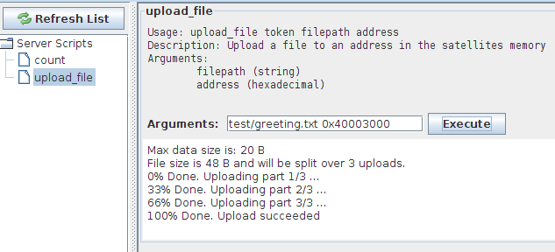
Result | Test success!

To verify that the file actually has been uploaded we can download the data back again and interpret the bytes as characters. The ruby code is implemented in “test/download_chars.rb”:

Ruby code: | require 'rubygems'  require 'json'  token = JSON.parse(`fsclient lock`)["data"]  bytes = JSON.parse(`fsclient --token=#{token} download 0x40003000 48`)['data']  puts bytes.pack("c"*48) # Interpret as 48 characters
Expected | Hi,  I am going to space ... and back again ...
Output | Hi,  I am going to space ... and back again ...
Result | Test success!

Test Summary
This section will summarize the test results.

FSServer test results
All integration tests passed.
All unit tests passed.
22 command tests passed. The following 3 command tests failed:
- Flash Test – Does not return a test result in the data.
- Health Status - 20 bytes is read from the datalink instead of 16 bytes.
- Upload Sib – Flash Write Error when uploading a new sib
FSServer works as expected and according to the requirements, the failsafe commands flash_test, health_status and upload_sib does not however.

FSGUI test results
All tests passed.
FSGui works as expected and according to the requirements

FSClient test results
All tests passed.
Fsclient works as expected and according to the requirements

Upload Script test results
All tests passed.
The upload scripts works as expected and according to the requirements

Overall test results
All but 3 tests passed. The 3 tests are concerned with the response of some failsafe commands and does not deal with the implementation of this project. This indicates that the documentation of the failsafe software is not in sync with the implementation of vice verca.
The result is that the overall system works as expected and according to the requirements, but that the documentation of 3 failsafe commands is not uptodate with the implementation or vice verca.

Conclusion
The requirements of the project have been dictated by or based on meetings with the DTUSat-2 staff. Based on these requirements an overall design was chosen among various alternatives. The overall design was broken into four parts, a server part, a command client part, a GUI part and a custom scripts part. Each part was further analysed, discussed and designed before being implemented.
The system was testet with tests cases that covered all requirements. All but 3 tests passed. The 3 tests was concerned with failsafe commands responses. The result is that the overall system works as expected and according to the requirements, but that the documentation of 3 failsafe commands is not uptodate with the implementation or vice verca. Therefore, this project can be considered a success.
Ultimately the staff of the DTUSat-2 project is able to operate the satellite in failsafe mode from their desktop computers with the software of this project.

Perspective
Authentication
This projects has not dealt with user access to the server. There is no access constraints to who can log on to the server and send commands to the satellite. This should be considered.
Encryption
The data between the FSServer and the TCP clients are not encrypted. This could fairly easy be achieved by using SSL or TLS.
State of the software
Although the software meet all requirements, some modifications needs to made before the software can be considered production ready.
- The FSServer currently only communicates with the development board via a serialport implementation of the protocol layer. This should be substituted with a radio implementation.
- There is an issue when uploading data to the development board that are currently being worked-around with a sleep of 0.2 seconds inbetween each byte being written. This may not be a problem with the radio implementation but should be tested and the sleep should be removed when fixed.

Appendix A – User Guide
Contains installation and operation instructions for the individual subsystems.

FSServer
Installation instructions on Ubuntu
FSServer needs ruby and some additional rubygems to run. Here are the commands to install the server.
- sudo apt-get install ruby1.8 ruby1.8-dev rubygems1.8
- sudo gems install eventmachine json daemons
Operation instructions
To run FSServer as a normal process, listen on localhost:3000 and print the log messages to standard out run this command:
- ./fsserver
You can pass the following options to fsserver:
- --host=HOST (default is '0.0.0.0')
- --port=PORT (default is 3000)
- --timeout=TIMEOUT (default is 30)
- --logfile=LOGFILE (default is stdout)
To run the server as a daemon run this command:
- ./fsdaemon start
options to daemon mode are given after an extra double dash like this:
- ./fsdaemon start -- --option1=VALUE1 --options2=VALUE

FSClient
Installation instructions on Ubuntu
The fsclient needs ruby, the eventmachine gem and the JSON gem. To install run this command:
- sudo apt-get install ruby1.8 ruby1.8-dev rubygems1.8
- sudo gems install eventmachine json
It is convenient to add the path of the fsclient executable to the PATH variable and a requirement to do so on the Ground Station in order for the upload script to work properly.
Operation instructions
Fsclient's help:
Usage: fsclient [options] <command [command_args ... ]>
--host=HOST Server host (default is 0.0.0.0)
--port=PORT Server port (default is 3000)
--token=TOKEN Token
--timeout=SEC Timeout option to command
-i, --interactive Interactive mode
-d, --data-only Only print data parameter
-a, --auto-lock Auto lock in interactive mode
-n, --no-response No-response option to command

FSClient
Installation instructions
Install a Java Virtual Machine for your system.
Operation instructions
Double click the executable jarfile

Upload script
Installation instructions
Needs ruby, the JSON gem and a working fsclient that has been added to the PATH environment variable.
Operation instructions
upload_file's help:
Usage: upload_file token filepath address
Description: Upload a file to an address in the satellites memory
Arguments:
filepath (string)
address (hexadecimal)

Appendix B – Failsafe Commands
A list of the 20 failsafe commands
- calculate_check_sum (address, length)
- call_function (address,parameter)
- copy_to_flash (from,to,length)
- copy_to_ram (from,to,length)
- delete_flash_block (address)
- download (address, length)
- download_sib
- execute (address)
- flash_test (address)
- health_status
- ram_test (address, length)
- read_register (address)
- read_sensor (address)
- reset
- reset_sib
- set_autoreset (value)
- unlock_flash
- upload (address, data)
- upload_sib (data)
- write_register (address, data)

Appendix C – Source Code
Contains the entire source code

