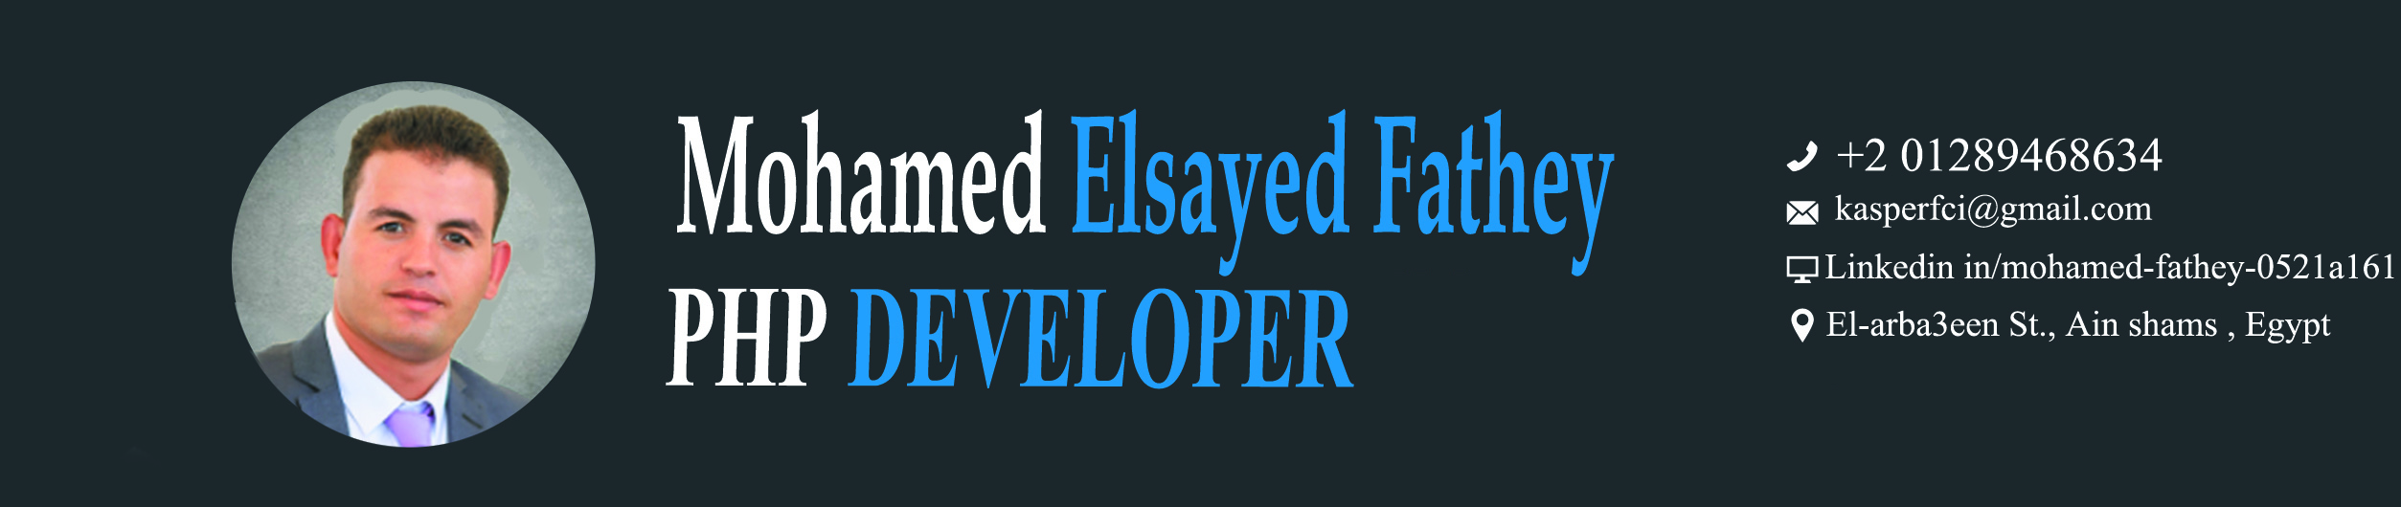

OBJECTIVE
Targeting a developer opportunity where I can offer all my abilities, knowledge, Experience and all my best to be Integrated and collaborated with my team to present the perfect web application.

WORK EXPERIENCE

PHP Developer
. ICs web solutions
. BackEnd Developing including PHP, MySQL
Oct 2012 : Apr 2013

- E- commerce Shop with PHP & MySQL & Jquery &HTML5 & CSS3
- Online Election
- Now working on Travels (trip advisor web site)

Freelancer PHP Developer
Oct 2016 : Till Now

EDUCATION & COURSES


- Graduation Project E- Election with Excellent Degree.

Bachelor in Computer Science
Sep 2008: Jul2012

- Web developing diploma with PHP – MySQL – HTML – CSS -- JavaScript

Web Developing Diploma
Mar 2012: Jun 2012

MY WORKS
- Languages and Libraries used
- PHP – MySQL
- Jquery – CSS3 – HTML – HTML5 - Bootstrap
- HTML

. E-Election web site
. E-Shop web site
. Vacations web site

- Arabic : Native Language
- English : level 11 out of 12 in grammar and 6 out of 8 in speaking
- French : Beginner

LANGUAGES SKILLS

