oving7.R

Kasper

2021-11-10

Del 3:

#4  
# Les inn krabbedata  
library("xlsx")  
krabber <- read.xlsx(file = "krabbe.xlsx", sheetIndex = 1)  
  
#5  
# Konstruere krabbeM og krabbeF vektor  
Gender <- krabber$Gender  
Size <- krabber$Size  
TypeM <- Gender == "m"  
TypeF <- Gender == "f"  
krabbeM <- Size[TypeM]  
krabbeF <- Size[TypeF]  
  
#6  
# Transformere dataene  
log.krabbeM <- log(krabbeM)  
log.krabbeF <- log(krabbeF)  
  
#7  
# Skalert Histogram for ordinære og log-transformerte verdier  
par(mfrow = c(2,2))  
hist(krabbeM, freq = FALSE, breaks = 10, main = "Hanner")  
hist(krabbeF, freq = FALSE, breaks = 10, main = "Hunner")  
hist(log.krabbeM, freq = FALSE, breaks = 10, main = "log(Hanner)")  
hist(log.krabbeF, freq = FALSE, breaks = 10, main = "log(Hunner)")

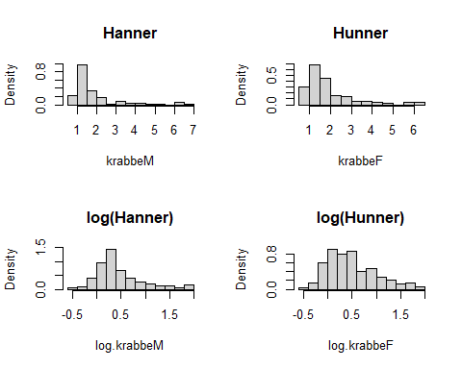

par(mfrow = c(2,2))  
qqnorm(krabbeM, main = "Hanner")  
qqline(krabbeM, col = "red")  
  
qqnorm(krabbeF, main = "Hanner")  
qqline(krabbeF, col = "red")  
  
qqnorm(log.krabbeM, main = "Hanner")  
qqline(log.krabbeM, col = "red")  
  
qqnorm(log.krabbeM, main = "Hanner")  
qqline(log.krabbeM, col = "red")

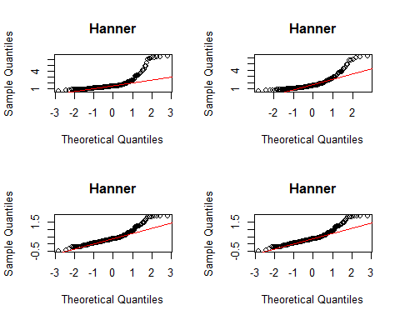

#8  
test <- t.test(log.krabbeM, log.krabbeF, alternative = "two.sided")  
test

##   
## Welch Two Sample t-test  
##   
## data: log.krabbeM and log.krabbeF  
## t = -0.68328, df = 356.34, p-value = 0.4949  
## alternative hypothesis: true difference in means is not equal to 0  
## 95 percent confidence interval:  
## -0.1336004 0.0647028  
## sample estimates:  
## mean of x mean of y   
## 0.4533574 0.4878062

#9  
# Gjennomsnitt,standardavvik og antall i hver gruppe  
x1 <- mean(log.krabbeM)  
x2 <- mean(log.krabbeF)  
s1 <- sd(log.krabbeM)  
s2 <- sd(log.krabbeF)  
n1 <- length(log.krabbeM)  
n2 <- length(log.krabbeF)  
  
# t-observator for to-utvalgs t-test  
T.observator <- (x1 - x2)/sqrt(s1^2/n1 + s2^2/n2)  
  
# Ta en titt p˚a de forskjellige størrelsene  
x1

## [1] 0.4533574

x2

## [1] 0.4878062

s1

## [1] 0.4811181

s2

## [1] 0.4999335

n1

## [1] 216

n2

## [1] 170

T.observator

## [1] -0.6832817

#10  
# pverdi  
a = n1 - 1  
b = n2 - 1  
min_ab = min(a,b)  
  
frihetsgrader <- min_ab  
pverdi <- 2*(1 - pt(abs(T.observator), df = frihetsgrader))  
pverdi

## [1] 0.4953645

Del 3:

1. Ja, de er nærmere normalfordelt enn de originale dataene. Nei fordi de er ikke helt normalfordelt.